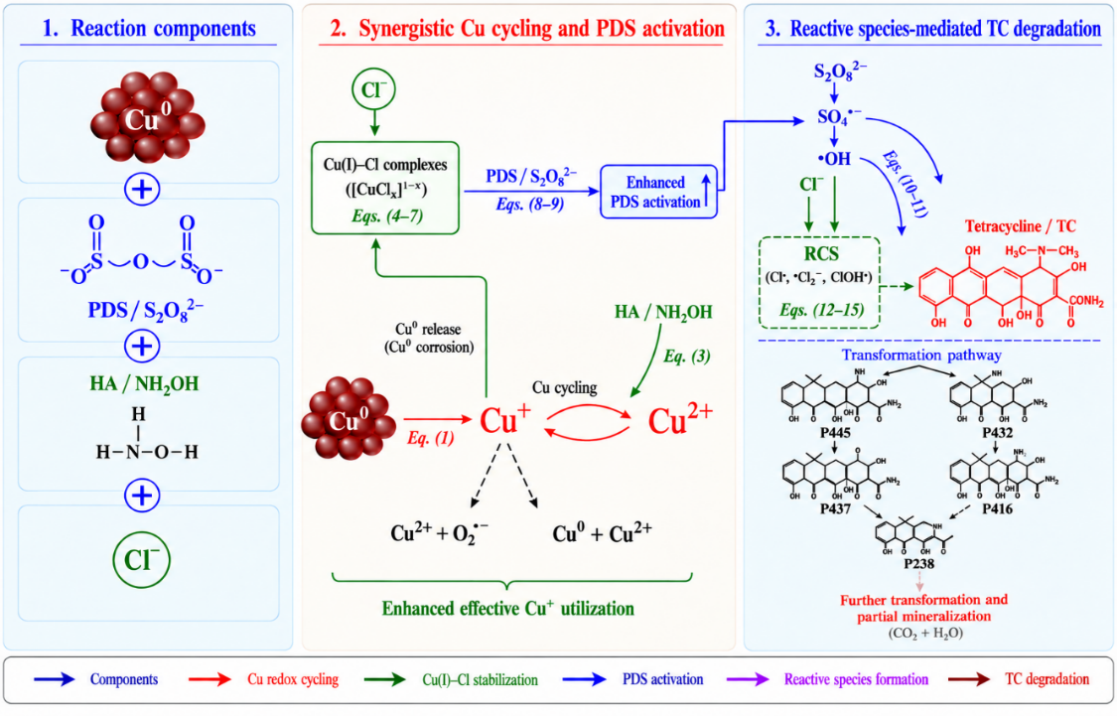
Reaction pathways of PDS activation and reactive species generation in the Cu⁰/PDS/HA/Cl⁻ system.
No. | Reaction | Rate or equilibrium parameter | References
1 | 2Cu⁰ + 2H⁺ → 2Cu⁺ + H₂ | NA | [9]
2 | Cu⁰ + S₂O₈²⁻ → Cu⁺ + SO₄•⁻ + SO₄²⁻ | NA | [9]
3 | 2Cu²⁺ + NH₂OH → 2Cu⁺ + HNO + 2H⁺ | ND | [32]
4 | Cu⁰ + Cu²⁺ + 2Cl⁻ → 2CuCl | ND/NA | [32]
5 | Cu⁺ + Cl⁻ ⇌ CuCl | logβ₁ = 3.10 | [32]
6 | Cu⁺ + 2Cl⁻ ⇌ CuCl₂⁻ | logβ₂ = 5.68 | [32]
7 | Cu⁺ + 3Cl⁻ ⇌ CuCl₃²⁻ | logβ₃ = 5.02 | [32]
8 | Cu⁺ + S₂O₈²⁻ → Cu²⁺ + SO₄•⁻ + SO₄²⁻ | k = 1.0 × 10⁷ M⁻¹ s⁻¹ | [46]
9 | CuCl_{x}^{(1-x)} + S₂O₈²⁻ → Cu²⁺ + xCl⁻ + SO₄•⁻ + SO₄²⁻ | ND | [9]
10 | SO₄•⁻ + H₂O → •OH + SO₄²⁻ + H⁺ | k = 2.0 × 10² s⁻¹ | [32]
11 | SO₄•⁻ + OH⁻ → •OH + SO₄²⁻ | k = 6.5 × 10⁷ M⁻¹ s⁻¹ | [32]
12 | SO₄•⁻ + Cl⁻ → SO₄²⁻ + Cl• | k = 2.7 × 10⁸ M⁻¹ s⁻¹ | [32]
13 | Cl⁻ + •OH → ClOH•⁻ | k = 4.3 × 10⁹ M⁻¹ s⁻¹ | [30]
14 | ClOH•⁻ + H⁺ → Cl• + H₂O | k = 2.1 × 10¹⁰ M⁻¹ s⁻¹ | [30]
15 | Cl• + Cl⁻ → Cl₂•⁻ | k = 6.5 × 10⁹ M⁻¹ s⁻¹ | [30]
Note: NA indicates that the reaction is not applicable to a homogeneous second-order rate constant because it is heterogeneous or surface-mediated. ND indicates that the parameter has not been directly determined or reported. β represents the cumulative formation constant of Cu(I)-chloride complexes.

