Supporting Information (SI)
Rapid tetracycline degradation by a hydroxylamine/chloride-enhanced zero-valent copper/peroxydisulfate system under near-neutral conditions
Quan Yuª, Renjian Deng^{a, b *}, Xin Liu^{c}, Baolin Houª, Saijun Zhou^{a, b}, Chuang Wang^{a, b}, Xifeng Wang^{a, b}, Bozhi Ren^{a, b}, Sihui Li^{d}, Wei Huang^{d}
ª School of Civil Engineering, Hunan University of Science and Technology, Xiangtan, Hunan 411201, China
^{b} Hunan Province Key Laboratory of Coal Resources Clean Utilization and Mine Environment Protection, Xiangtan, Hunan 411201, China
^{c} Hunan Province Key Laboratory of Pollution Control and Resource Reuse Technology, University of South China, Hengyang 421001, China
^{d} Xiangtan Zhonghuan Water Affairs Co. Ltd., Xiangtan, Hunan, 411100, China
* Corresponding author.
School of Civil Engineering, Hunan University of Science and Technology, Xiangtan, Hunan 411201, China
E-mail addresses: waterdrj@hnust.edu.cn; deng800912@163.com (R. Deng)
Texts S1–S3; Tables S1–S3; Figures S1–S4.

Text S1. Determination of TC by HPLC.
The concentration of tetracycline (TC) was determined using a high-performance liquid chromatography system (Agilent 1260, Agilent Technologies, USA) equipped with a UV detector, an autosampler, and a C18 column (5 μm × 2.1 mm × 100 mm). The mobile phase consisted of 0.1% acetic acid aqueous solution and methanol at a volume ratio of 62:38. The flow rate was 0.27 mL/min, and the injection volume was 50 μL. The detection wavelength was set at 356 nm. Before HPLC analysis, the withdrawn samples were immediately quenched with sodium thiosulfate solution and filtered through a 0.45 μm membrane to remove suspended Cu⁰ particles.

Text S2. EPR procedure.
Electron paramagnetic resonance (EPR) spectroscopy was used to identify the radical species generated in the Cu⁰/PDS/HA/Cl⁻ system. 5,5-Dimethyl-1-pyrroline N-oxide (DMPO) was used as the spin-trapping agent. In a typical EPR experiment, TC, Cl⁻, HA, PDS and DMPO were first mixed, and Cu⁰ was then added to initiate the reaction. The reaction conditions were as follows: [TC]₀ = 5 mg/L, [Cu⁰]₀ = 0.05 g/L, [HA]₀ = 0.3 mmol/L, [PDS]₀ = 0.1 mmol/L, [Cl⁻]₀ = 3 mmol/L, pH₀ = 5.0 ± 0.1, and T = 25 ± 1 °C. After a short reaction time, the suspension was rapidly transferred into a 100 μL capillary tube and inserted into the cavity of the EPR spectrometer (A200, Bruker, Germany) for immediate analysis. The signals assigned to DMPO–SO₄ and DMPO–OH were recorded to assess radical formation in the Cu⁰/PDS/HA/Cl⁻ system. Spin-adduct signals were interpreted together with the quenching tests; the DMPO–OH signal alone was not treated as definitive evidence for •OH.

Text S3. LC-MS analysis of TC degradation products.
The degradation products of tetracycline (TC) were analyzed using a liquid chromatography–mass spectrometry system (Agilent 1260/6550, Agilent Technologies, USA) in positive ion mode. The mobile phase consisted of 0.1% formic acid aqueous solution and methanol. The flow rate was 0.3 mL/min, and the injection volume was 5 μL. The gradient elution program was as follows: 0–1 min, 5% methanol; 1–8 min, 5%–95% methanol; 8–13 min, 95% methanol; 13–14 min, 95%–5% methanol; and 14–15 min, 5% methanol. The capillary temperature was 350 °C, the m/z scanning range was 50–1000, and the voltage was 4000 V.
Table S1. Analytical methods and instruments used in this study.
Analyte / parameter | Analytical method | Instrument | Detection condition | Purpose
pH | Potentiometric method | PHS-25 pH meter, Shanghai INESA Scientific Instrument Co., Ltd., China | — | Solution pH
Tetracycline (TC) | High-performance liquid chromatography | Agilent 1260 HPLC, Agilent Technologies, USA | See Text S1 | Residual TC concentration
Cu⁺ | Neocuproine colorimetry | TU-1901 UV–vis spectrophotometer, Beijing Purkinje General Instrument Co., Ltd., China | 455 nm | Dissolved Cu⁺
Total dissolved copper (TDC) | Neocuproine colorimetry after reduction by excess HA | TU-1901 UV–vis spectrophotometer, Beijing Purkinje General Instrument Co., Ltd., China | 455 nm | Copper release
Hydroxylamine (HA) | Spectrophotometry | TU-1901 UV–vis spectrophotometer, Beijing Purkinje General Instrument Co., Ltd., China | 705 nm | HA consumption
NO₃⁻ and NO₂⁻ | Ion chromatography | Dionex ICS-600, Thermo Fisher Scientific Inc., USA | — | HA oxidation products
Total dissolved nitrogen (TDN) | Total nitrogen analysis | TN-3C/3D analyzer, Shenzhen Changhong Instrument Co., Ltd., China | — | Nitrogen balance
Total organic carbon (TOC) | Total organic carbon analysis | TOC-VCPH analyzer, Shimadzu, Japan | — | Mineralization assessment
Reactive radicals | Electron paramagnetic resonance spectroscopy | A200 EPR spectrometer, Bruker, Germany | DMPO spin trapping; see Text S2 | Radical signals
TC degradation products | Liquid chromatography–mass spectrometry | Agilent 1260/6550 LC-MS, Agilent Technologies, USA | See Text S3 | Degradation intermediates
Table S2. Characteristics of actual water samples used in this study.
Category | pH | DOC (mg/L) | Cl⁻ (mg/L) | SO₄²⁻ (mg/L) | NO₃⁻ (mg/L) | PO₄³⁻ (mg/L)
Ultrapure water | 7.0 | 0.35 | ≤0.1 | ≤0.1 | ≤0.1 | ≤0.1
Tap water | 7.4 | 2.59 | 8.30 | 29.90 | 5.10 | ≤0.1
Surface water | 7.6 | 3.80 | 21.80 | 36.50 | 13.40 | ≤0.1
Table S3. Information of TC and its degradation intermediates detected by LC-MS.
Compound | RT (min) | Molecular formula | m/z | Proposed structure
P-445 | 4.07 | C₂₂H₂₄N₂O₈ | 445.1611 | 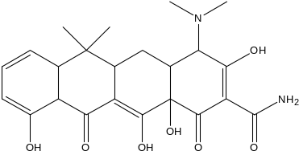
P-465 | 4.534 | C₂₁H₂₁N₂O₈Cl | 465.1200 | 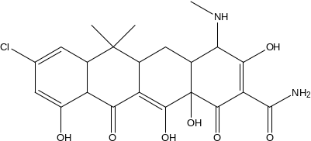
P-437 | 2.173 | C₂₁H₂₁N₂O₇Cl | 437.1952 | 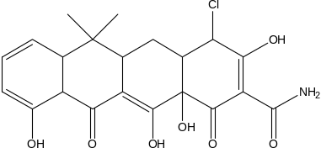
P-432 | 7.426 | C₂₁H₂₂NO₇ | 432.2400 | 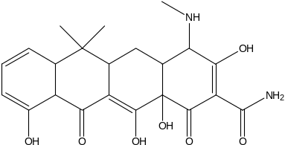
P-416 | 7.426 | C₂₀H₂₀NO₇ | 416.2167 | 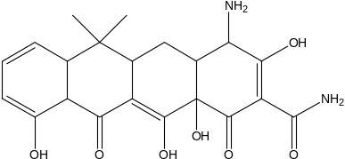
P-238 | 7.763 | C₁₃H₁₆O₄ | 238.1451 | 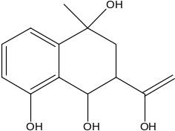
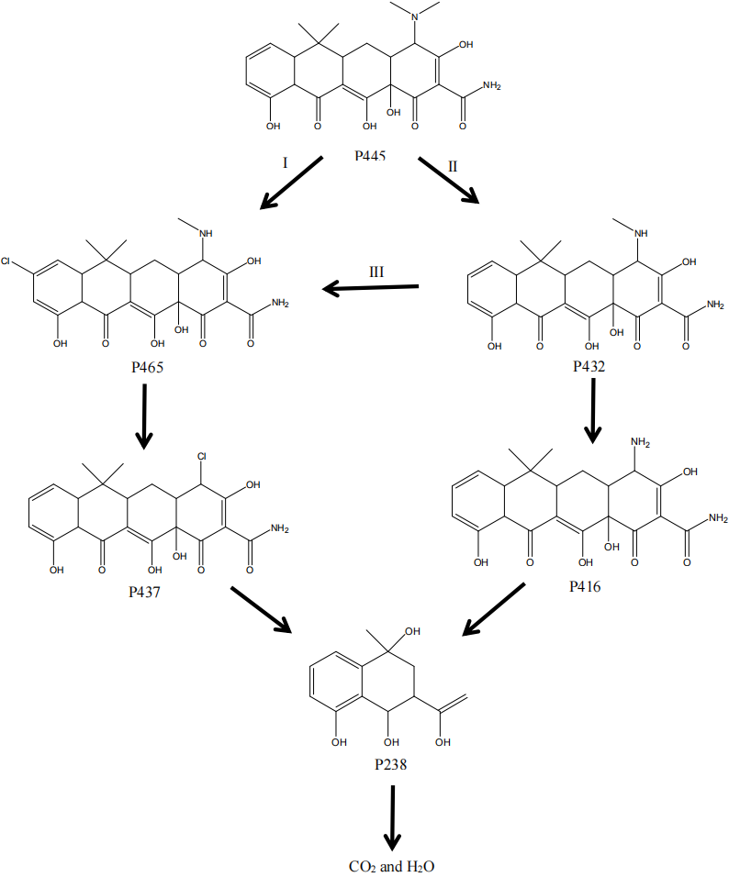
Figure S1. Possible degradation pathway of TC in the Cu⁰/PDS/HA/Cl⁻ system. The pathway is proposed from LC-MS assignments and does not imply complete mineralization.

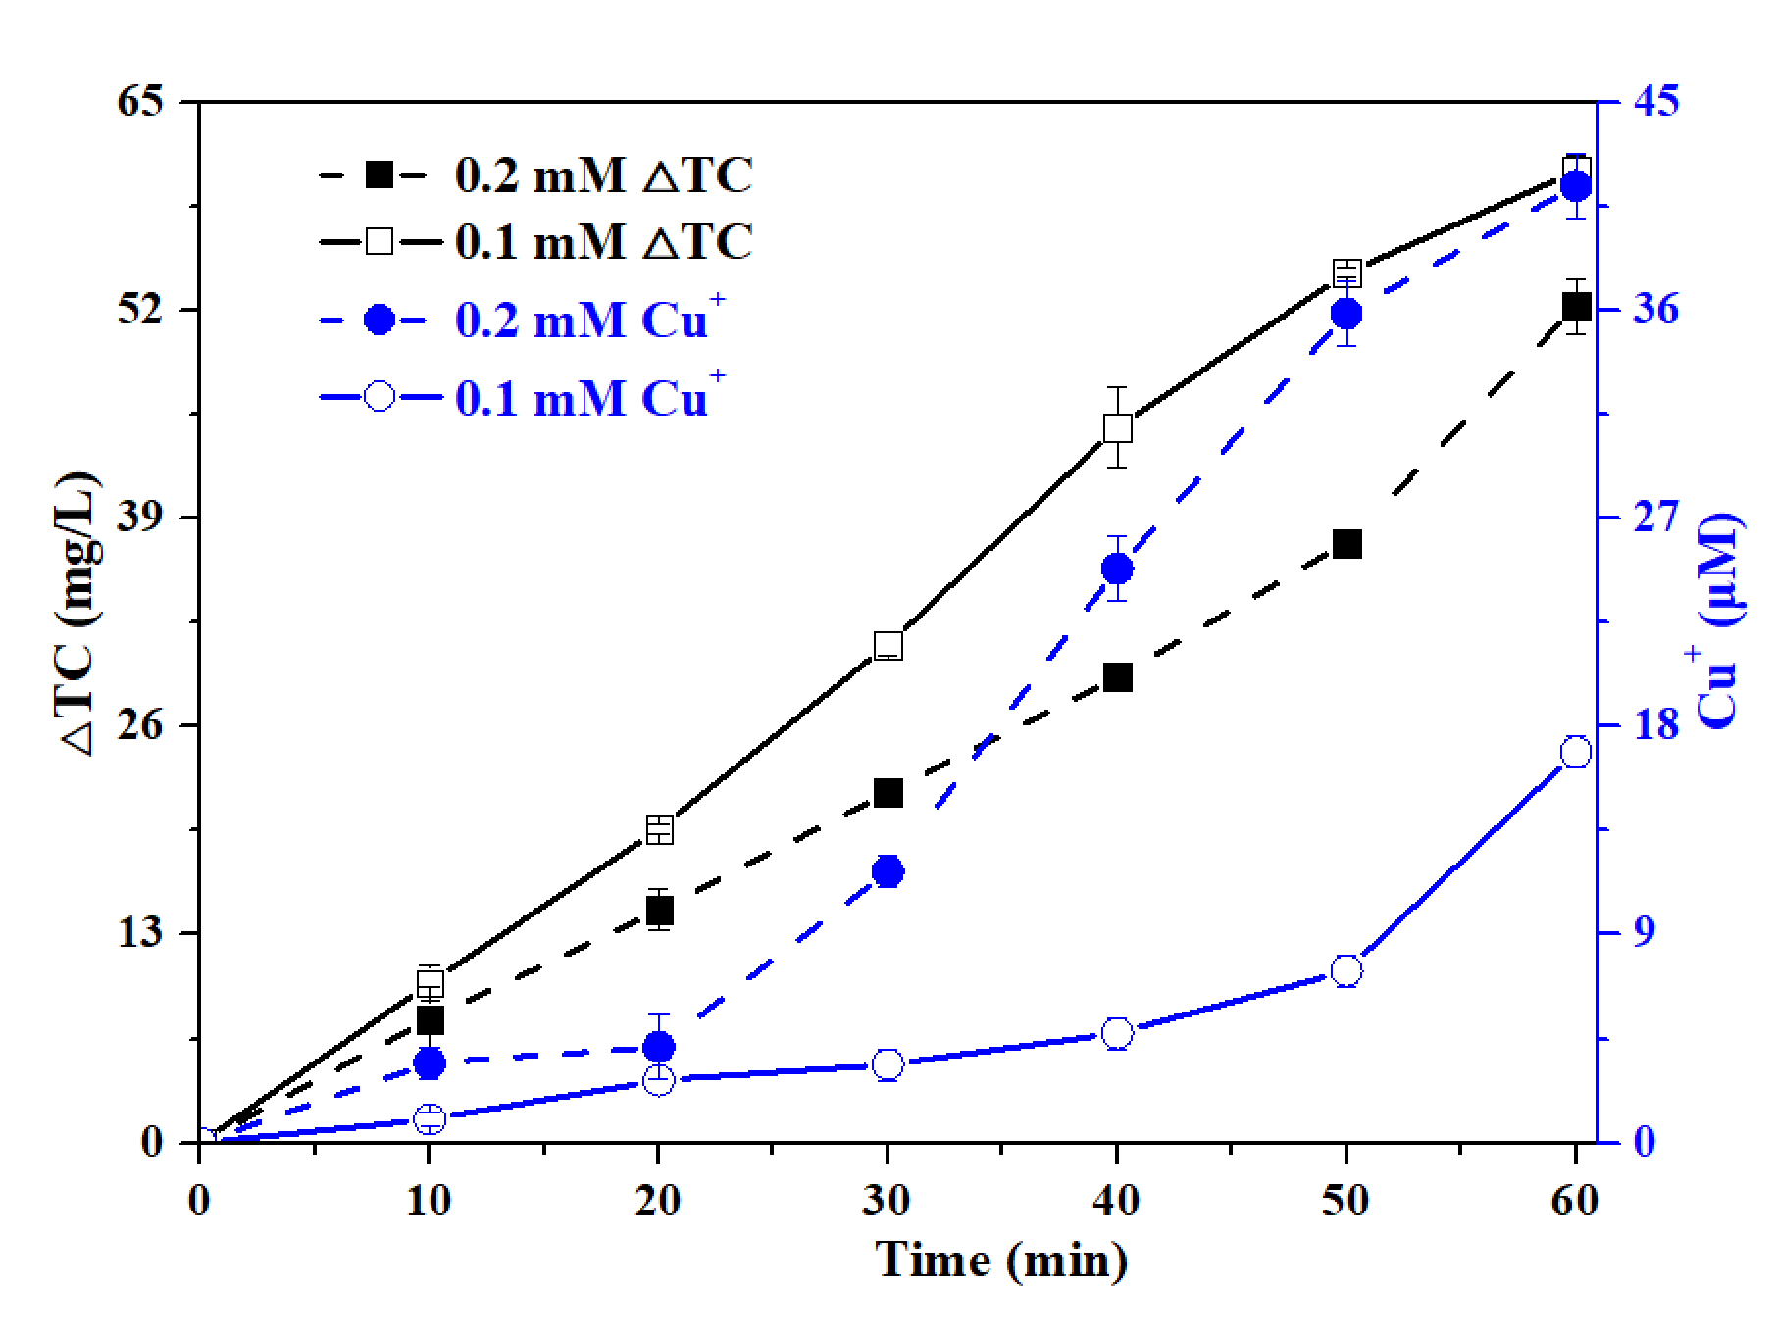
Figure S2. Changes in TC concentration (ΔTC) and Cu⁺ accumulation at Cu²⁺ concentrations of 0.1 and 0.2 mmol/L in the chloride/Cu⁰/Cu²⁺ system. Conditions: [Cu⁰]₀ = 0.2 g/L, [Cl⁻]₀ = 5 mmol/L, initial pH = 3.0 ± 0.1, and room temperature.
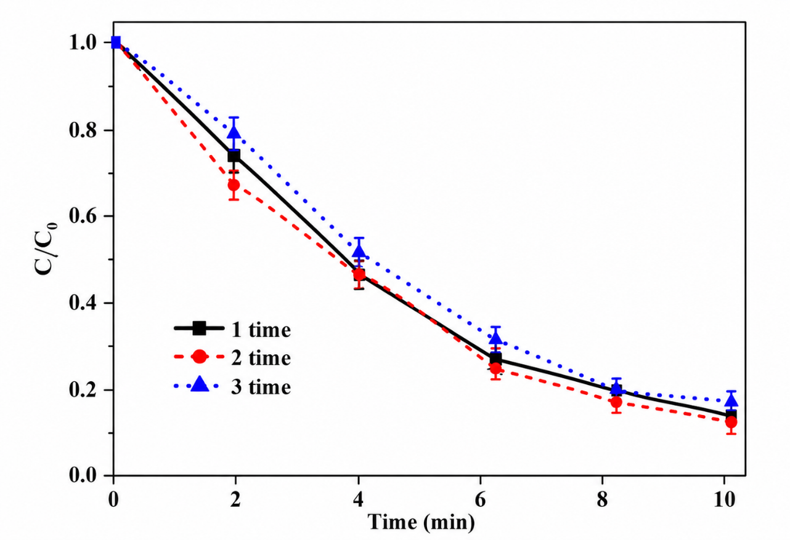
Figure S3. Reusability of Cu⁰ in the Cu⁰/PDS/HA/Cl⁻ system for TC degradation. Reaction conditions: [TC]₀ = 5 mg/L, [Cu⁰]₀ = 0.05 g/L, [HA]₀ = 0.3 mmol/L, [PDS]₀ = 0.1 mmol/L, [Cl⁻]₀ = 3 mmol/L, pH = 5.0 ± 0.1, T = 25 ± 1 °C.
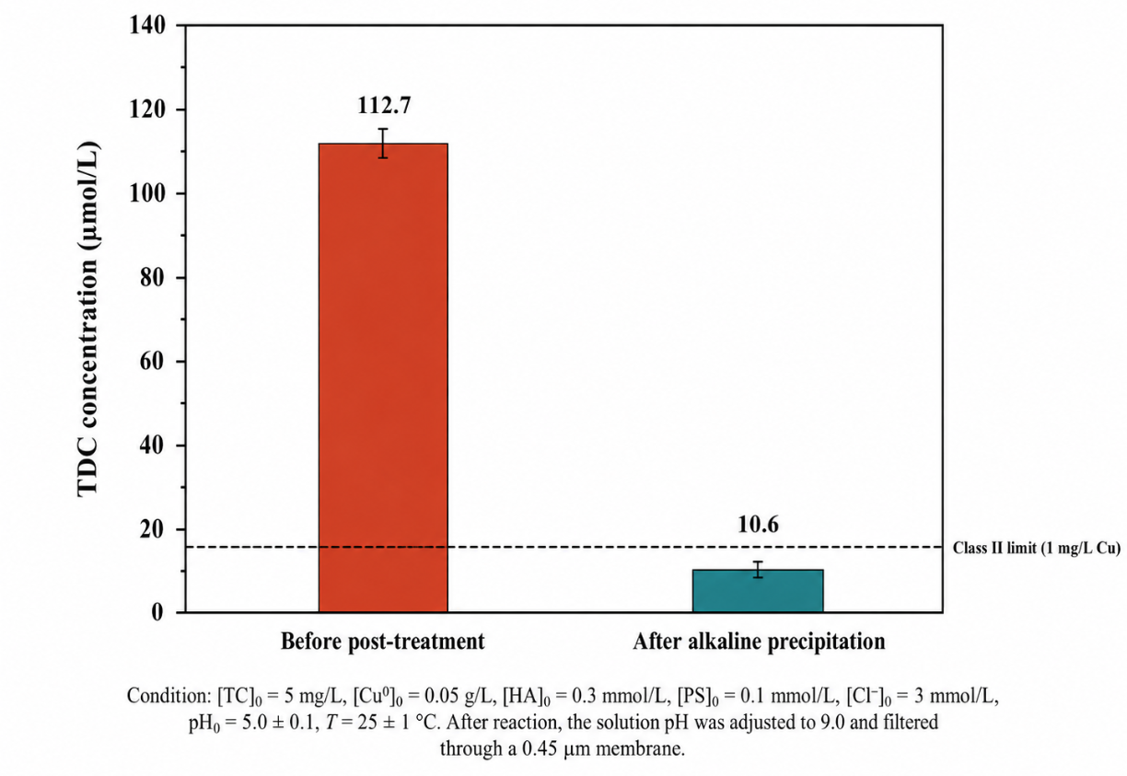
Figure S4. Total dissolved copper before and after alkaline precipitation and filtration in the Cu⁰/PDS/HA/Cl⁻ system. The dashed 1 mg/L copper benchmark refers to surface water environmental quality, rather than a wastewater discharge limit. PS in the supplied figure denotes PDS.

