Supplementary Information
Small reorganization energy acceptors enable low energy losses in non-fullerene organic solar cells

Yanan Shi ^{a,b,1}, Yilin Chang ^{a,b,1}, Kun Lu ^{a,b,}*, Zhihao Chen ^{c}, Jianqi Zhang ª, Yangjun Yan ^{a,b}, Dingding Qiu ^{a,b}, Yanan Liu ^{a,b}, Muhammad Abdullah Adil ª, Wei Ma ^{d}, Xiaotao Hao^{c,*}, Lingyun Zhu ^{a,}*, and Zhixiang Wei ^{a,b,}*

Contents
- Materials and Synthesis Procedures
- Method Details
- Supplementary Discussion
- Supplementary Figures
- Supplementary Tables

- Materials and Synthesis Procedures
The chemical name of materials:
Qx-1: 2, 2'-((2Z,2'Z)-((13,14-bis(2-butyloctyl)-6,7-diphenyl-3,10-diundecyl-13,14 dihydrothieno [2'',3'':4',5']thieno[2',3':4,5]pyrrolo[3,2 f]thieno[2'',3'':4',5']thieno[2',3':4,5]pyrrolo[2,3-h]quinoxaline-2,11-diyl)bis(methaneylylidene))bis(5,6-difluoro-3-oxo-2,3-dihydro-1H-indene-2,1-diylidene))dimalononitrile.
Qx-2: 2,2'-((2Z,2'Z)-((10,11-bis(2-butyloctyl)-7,14-diundecyl-10,11 dihydrodibenzo[a,c]thieno [2'',3'':4',5']thieno[2',3':4,5]pyrrolo[3,2-h]thieno[2'',3'':4',5']thieno[2',3':4,5]pyrrolo[2,3-j]phenazine-8,13-diyl)bis(methaneylylidene))bis(5,6-difluoro-3-oxo-2,3-dihydro-1H-indene-2,1-diylidene)) dimalononitrile.
BTP-C4C6: 12,13-bis(2-butyloctyl)-3,9-diundecyl-12,13-dihydro-[1,2,5]thiadiazolo[3,4-e]thieno [2'',3'':4',5']thieno[2',3':4,5]pyrrolo[3,2-g]thieno[2',3':4,5]thieno[3,2-b]indole.
Qx-1 core: 13,14-bis(2-butyloctyl)-6,7-diphenyl-3,10-diundecyl-13,14-dihydrothieno [2'',3'':4',5'] thieno[2',3':4,5]pyrrolo[3,2-f]thieno[2'',3'':4',5']thieno[2',3':4,5]pyrrolo[2,3-h]quinoxaline.
Qx-2 core: 10,11-bis(2-butyloctyl)-7,14-diundecyl-10,11-dihydrodibenzo[a,c]thieno[2'',3'':4',5'] thieno[2',3':4,5]pyrrolo[3,2-h]thieno[2'',3'':4',5']thieno[2',3':4,5]pyrrolo[2,3-j]phenazine.
Qx-1-CHO: 13,14-bis(2-butyloctyl)-6,7-diphenyl-3,10-diundecyl-13,14-dihydrothieno [2'',3'':4',5']thieno[2',3':4,5]pyrrolo[3,2-f]thieno[2'',3'':4',5']thieno[2',3':4,5]pyrrolo[2,3-h]quinoxaline-2,11-dicarbaldehyde.
Qx-2-CHO: 10,11-bis(2-butyloctyl)-7,14-diundecyl-10,11-dihydrodibenzo[a,c]thieno[2'',3'':4',5'] thieno[2',3':4,5]pyrrolo[3,2-h]thieno[2'',3'':4',5']thieno[2',3':4,5]pyrrolo[2,3-j]phenazine-8,13-dicarbaldehyde.
Compound 5: 2-(5,6-difluoro-3-oxo-2,3-dihydro-1H-inden-1-ylidene)malononitrile.
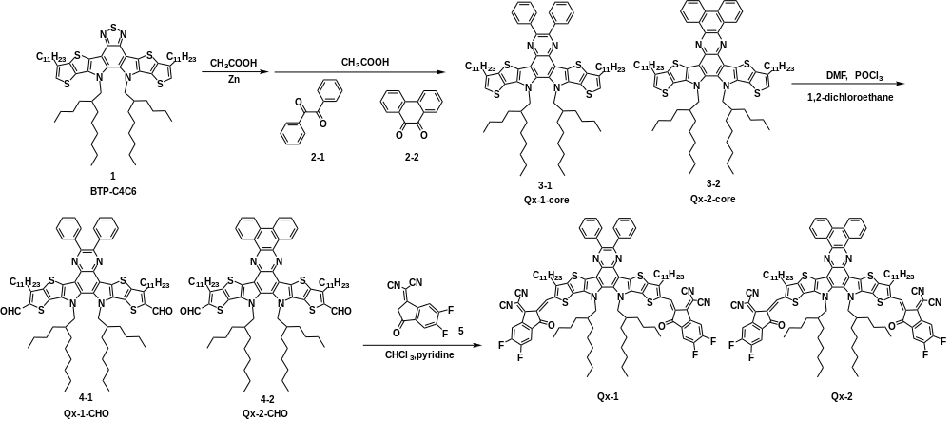
Scheme. 1. Synthetic routes of Qx-1 and Qx-2.
The synthetic route of acceptors Qx-1 and Qx-2 is illustrated in Scheme 1. After compound 1 (BTP-C4C6) is reduced, compound 3-1 (Qx-1 core) or compound 3-2 (Qx-2 core) is obtained by Schiff base reaction with compound 2-1 (benzil) or compound 2-2 (phenanthrene-9,10-dione).^{1, 2} Compound 3-1 (Qx-1 core) or compound 3-2 (Qx-2 core) with the newly prepared Vilsmeier reagent (DMF and POCl₃) in 1,2-dichloroethane produced compound 4-1 (Qx-1-CHO) or compound 4-2 (Qx-2-CHO), respectively.³ The target molecules Qx-1 and Qx-2 were synthesized by a Knoevenagel reaction between compound 4-1 or compound 4-2 (Qx-2-CHO) and electron-withdrawing end-groups in a high yield over 80%. Compound 1 and compound 5 were purchased from Hyper Chemical Company. Compound 2-1 and compound 2-2 and were purchased from Bide Pharmatech Ltd. Unless otherwise specified, all medicines are purchased commercial sources and used directly without further purification. All the reagents and solvents used in the experiment are analytical purity and are used directly without purification.
Compound 3-1 (Qx-1 core): To a solution of compound 1(1.00 g, 0.923mmol) in acetic acid (50 mL) was added zinc powder (2.40 g, 36.91mmol) in one portion. Then the mixture solution was heated to 90°C for 5 h. After the solution was cooled at room temperature, the solid was removed by filtration. Transfer the filtrate to a three-tip flask containing compound 2-1 (776mg, 3.69mmol), then the mixture solution was heated to 110°C for 20 h. After cooling to room temperature, washed with saturated salt water and methylene chloride. The solvent was removed under reduced pressure. The crude product was subsequently purified by column chromatography on silica gel to afford compound 3-1 as yellow oily solid (280mg, 25% yield). ¹H NMR (400 MHz, CDCl3) δ 7.74 (d, J = 6.4 Hz, 4H), 7.38 – 7.30 (m, 6H), 6.93 (s, 2H), 4.59 (d, J = 7.9 Hz, 4H), 2.78 (t, J = 7.6 Hz, 4H), 1.80 (dt, J = 14.6, 7.4 Hz, 4H), 1.19 (d, J = 5.4 Hz, 44H), 0.83 – 0.77 (m, 22H), 0.60 (tt, J = 7.3, 5.4 Hz, 18H).
Compound 3-2 (Qx-2 core): was synthesized by similar procedure as compound 3-1 between compound 1 and compound 2-2. The final product were obtained as yellow solid (260mg, 23% yield). ¹H NMR (400 MHz, CDCl3) δ 9.78 (d, J = 7.4 Hz, 2H), 8.73 (d, J = 8.1 Hz, 2H), 7.91 (dd, J = 30.3, 7.5 Hz, 4H), 7.07 (s, 2H), 4.73 (d, J = 7.7 Hz, 4H), 2.97 (s, 4H), 2.00 (d, J = 14.7 Hz, 4H), 1.51 (d, J = 45.8 Hz, 26H), 1.29 (s, 26H), 0.96 (s, 14H), 0.89 (t, J = 6.1 Hz, 9H), 0.65 (dd, J = 16.7, 7.9 Hz, 9H).
Compound 4-1 (Qx-1-CHO): Compounds 3-1 (200 mg; 0.163mmol) were dissolved into 1,2-dichloroethane (20 ml) in a three-neck flask. The solution was flushed with nitrogen in 0°C for 30 min. Then, add POCl₃ (0.25 mL) and DMF (0.25 mL) to the solution, then let the solution temperature return to room temperature for 1h. Next, the solution was reacted at 85 °C for 16 h under nitrogen protection. After that the mixture was poured into ice water (50 mL), neutralized with aqueous AcONa. Washed with saturated salt water and dichloromethane. The solvent was removed under reduced pressure. The crude product was subsequently purified by column chromatography on silica gel to afford compound 4-1 as orange solid (176mg, 84% yield). ¹H NMR (400 MHz, CDCl3) δ 10.18 (s, 2H), 7.85 – 7.80 (m, 4H), 7.48 – 7.43 (m, 6H), 4.74 (t, J = 11.6 Hz, 4H), 3.25 (t, J = 7.6 Hz, 4H), 1.95 (dd, J = 14.9, 7.6 Hz, 4H), 1.45 – 1.21 (m, 36H), 1.14 – 0.86 (m, 36H), 0.70 – 0.64 (m, 12H).
Compound 4-2 (Qx-2-CHO): was synthesized by similar procedure as compound 4-1 with compound 3-2. The final product were obtained as orange solid (184mg, 88% yield). ¹H NMR (400 MHz, CDCl3) δ 10.21 (s, 2H), 9.73 (dd, J = 8.0, 1.1 Hz, 2H), 8.74 (d, J = 8.1 Hz, 2H), 7.93 (ddd, J = 15.1, 11.5, 4.5 Hz, 4H), 4.76 (d, J = 7.9 Hz, 4H), 3.35 (t, J = 7.6 Hz, 4H), 2.09 – 1.98 (m, 4H), 1.63 – 1.19 (m, 36H), 1.19 – 0.90 (m, 27H), 0.89 – 0.80 (m, 9H), 0.70 – 0.59 (m, 12H).
Qx-1: Compound 4-1 (176mg, 0.137mmol) and compound 5 (189mg, 0.822mmol) were dissolved into dry chloroform (60mL) in a three-neck flask. The solution was flushed with nitrogen for 20 min. After 0.8mL pyridine were added, the mixture was stirred at 65°C overnight. After cooling to room temperature, the reaction mixture was poured into water and extracted several times with chloroform. Then the solvent was removed under reduced pressure, and the crude product was purified by column chromatography on silica gel to yield Qx-1 as black solid (183mg, 78% yield). ¹H NMR (400 MHz, CDCl3) δ 9.20 (s, 2H), 8.60 (dd, J = 9.8, 6.5 Hz, 2H), 7.80 (d, J = 3.7 Hz, 4H), 7.72 (t, J = 7.5 Hz, 2H), 7.47 (s, 6H), 4.84 (s, 4H), 3.29 (s, 4H), 2.21 (s, 2H), 1.90 (s, 4H), 1.53 – 0.80 (m, 64H), 0.80 – 0.60 (m, 12H). MALDI-TOF MS (m/z): 1710.082.
Qx-2: was synthesized by similar procedure as Qx-1 between compound 4-2 and compound 5. The final product were obtained as black solid (196mg, 80% yield). ¹H NMR (400 MHz, CDCl3) δ 9.50 – 9.43 (m, 2H), 9.01 (s, 2H), 8.64 (d, J = 7.5 Hz, 2H), 8.31 – 8.21 (m, 2H), 7.95 – 7.85 (m, 4H), 7.55 (dd, J = 9.6, 4.8 Hz, 2H), 4.95 (d, J = 7.6 Hz, 4H), 3.25 (t, J = 7.0 Hz, 4H), 2.42 (s, 2H), 1.91 (dt, J = 15.1, 7.7 Hz, 4H), 1.55 – 0.89 (m, 64H), 0.87 – 0.61 (m, 18H). MALDI-TOF MS (m/z): 1707.694.
Method Details
Molecular structure characterization
¹H NMR was obtained on a Bruker DMX-400 NMR Spectrometer (operating at 400 MHz, using CDCl₃ as solvent using tetramethylsilane as internal standard). Mass spectra were measured by Bruker microflex MALDI-TOF mass spectrometer.

Single-crystal growth
Single crystal of Qx-1 and Qx-2 were grown by the liquid diffusion method at room temperature. An appropriate amount of methanol is transferred to a concentrated chloroform solution, which will form crystals over time. Single crystal diffraction was collected at low temperatures protected by liquid nitrogen in accordance with standard procedures for reducing X-ray radiation damage through use single crystal X-ray diffractometer (model is XtaLAB PRO 007HF(Mo), manufactured by Rigaku). The X-ray crystallographic coordinates for structures reported of Qx-1 and Qx-2 have been deposited at the Cambridge Crystallographic Data Centre (CCDC), under deposition numbers 2120380–2120381.

Molecular properties characterization
The UV-vis absorption was measured by Perkin Elmer Lambda 950 spectrophotometer.
The electrochemical cyclic voltammetry (CV) was conducted an electrochemical workstation (VMP3 Biologic, France) with a Pt disk coated with blend film, a Pt plate, and an Ag⁺/Ag electrode acting as the working, counter, and reference electrodes, respectively, in a 0.1mol/L tetrabutylammonium phosphorus hexafluoride (Bu₄NPF₆) acetonitrile solution. The experiments were calibrated with the standard ferrocene/ferrocenium (Fe) redox system and assumption that the energy level of Fe is 4.8 eV below vacuum, through using the formula E_{HOMO/LUMO} = -e(E_{ox/red} -E^{1/2}(Fe/Fe⁺) + 4.8) (eV) through the onset oxidation (E_{ox}) and reduction (E_{red}) potentials.^{4, 5}

Computational details
In the calculations, the alkyl chains in the acceptor molecules were replaced by ethyl groups for simplification. The geometry optimizations and frequency analyses of all the molecules were performed by using Density Functional theory (DFT) for the S0 and anion states and using time-dependent DFT (TDDFT) for the S₁ state. Here, the long-range corrected (LRC) functional ωB97XD and 6-31G (d, p) basis set were employed.
Moreover, to obtain a more reliable description of the electronic properties, the range separation parameter (ω) of the LRC functional was optimized by changing ω to minimize the value of $J\left(ω\right)$,⁶⁻⁸
$J\left(ω\right)=J_{IP}\left(ω\right)+J_{EA}\left(ω\right)$ (S1)
$J_{IP}(ω)=\left|E_{+}\left(ω\right)-E_{0}\left(ω\right)+ε_{0}^{H}\left(ω\right)\right|$ (S2)
$J_{EA}(ω)=\left|E_{0}\left(ω\right){-E}_{-}\left(ω\right)+ε_{-}^{H}\left(ω\right)\right|$ (S3)
where $ε_{0}^{H}$ and $ε_{-}^{H}$ are the HOMO energies in the neutral and anionic states, respectively. The optimal ω value is 0.096, 0.097 and 0.105 for the Qx-1, Qx-2 and Y6 molecule, respectively.
The vibrational frequencies of the optimized geometries for the S₀, S₁ and anion states are all positive, indicating that all the obtained geometries are stable. The results of vibration calculations were used to calculate the reorganization energies for the electronic transitions among the S₀, S₁ and anion states with the MOMAP code.⁹ All the calculations for the electronic structure properties were carried out with the Gaussian 09 program.¹⁰

Device fabrication and measurement.
All the PSC devices were fabricated by using an conversional structure of Indium tin oxide(ITO)/poly(3,4-ethylenedioxythiophene:poly(styrenesulfonate)(PEDOT:PSS) /PM6:SMA/poly[(9,9-bis(3’-((N,N-dimethyl)-N-ethylammonium)propyl)-2,7 fluorene)-alt-5,5′-bis(2,2′-thiophene)-2,6-naphthalene-1,4,5,8-tetracaboxylic-N,N′-di(2ethylhexyl)imide]dibromide(PNDIT-F3N-Br)/Ag, where PNDIT-F3N-Br and PEDOT:PSS were respectively used as electron-transport and hole-transport interlayer. The ITO glass substrates were cleaned sequentially under sonication with detergent, deionized water , ethyl alcohol and isopropyl alcohol. After oxygen plasma cleaning for 15 min, the PEDOT:PSS layer was deposited by spin-coating under 3500 rpm for 30 s on top of the ITO substrate with thermal annealled for 15 minutes at 150 ℃. The blended solution was prepared by mixing PM6 and acceptors into chloroform (CF) with the addition of a small amount of chloronaphthalene (0.6 %, v/v), the mix solution stirred at 50 °C in chloroform for 1.5 h until they dissolved. The optimal device conditions of Qx-1 and Qx-2 were prepared by mixing donor and acceptors in a 1:1.5 and1:1.3 weight ratio, respectively, into chloroform (CF) with the addition of a small amount of 1-chloronaphthalene (CN) (0.6 %, v/v) and under thermal annealing at 100 °C and 110°C for 10 min, respectively. The ETLs dissolved in methanol at a concentration of 0.5 mg/ml was spun onto the blend layer at 3000 rpm for 30 s. Finally, 160 nm-thick Ag were deposited onto the ETLs layer under vacuum at a pressure of 3 × 10⁻⁶mbar. Except for the fabrication of PEDOT:PSS layer, the other the processes were all carried out in an nitrogen-filled glovebox. A solar simulator was used for J–V curves measurement under AM 1.5 G (100mWcm⁻²). Newport Oriel PN 91150 V Sibased solar cell was applied for light intensity calibration. J–V measurement signals were recorded by a Keithley 2400 source-measure unit. Device area of each cell was approximately 4mm². Oriel Newport system (Model 66902) equipped with a standard Si diode was used for EQEs test in air condition.
The J_{sc} and V_{oc} under different light intensity. In organic solar cell devices, the relationship between J_{sc} and P_{light} can be expressed by the formula J_{sc}∝(P_{light})^{α}, where α is the power exponent. When the value of α in the formula approaches 1, the bimolecular recombination in the device can be ignored.¹¹ the V_{oc} and ln(P_{light}) can be fitted to a straight line, and the slope of the fitted line should be kT/q (where k is Boltzmann’s constant, T is the Kelvin temperature, and q is the elementary charge).¹²
Figure S8a shows that these small molecule acceptor devices all had α values over 0.990 and the bimolecular recombination in the device can be ignored. Besides, in Figure S8b, the V_{oc} and ln(P_{light}) can be fitted to a straight line. The slope of the fitted line these small molecule receptor devices were all close to kT/q (1.136kT/q); hence, the trap-assisted recombination can be suppressed.
The dependence of the photocurrent density (J_{ph}) on the effective voltage (V_{eff}) was also tested to analyze exciton dissociation and charge collection. J_{ph} was obtained from J_{ph} = J_{L} – J_{D} (J_{L} and J_{D} are the current densities under illumination and dark conditions), and V_{eff} was calculated from V_{eff} = V₀ ‒ V (V₀ is the voltage when J_{L} = J_{D} and V is the applied voltage).¹³ Under short-circuit conditions, the exciton dissociation (P_{diss} = J_{ph}/J_{sat}, where J_{sat} represents the saturation photocurrent density).
Mobility measurements are the same for solar cell devices. The electron mobility was acquired with the device structure of Al/active layer or neat acceptors/PNDIT-F3N-Br/Al, the hole mobility was obtained by preparing the structure of ITO/PEDOT:PSS/active layer/MoOx/Ag. The current density-voltage (J-V) curves in the range of 0-5 V were obtained by a Keithley 2420 Source-Measure Unit in the dark. Electron and hole motilities were measured with electron- and hole-only devices by using the SCLC model¹⁴, which can be calculated by fitting the results in the equation:
$J=\frac{9}{8}ε_{r}ε_{0}μ_{0}\frac{{(V-V_{bi}^{})}^{2}}{L^{3}}exp\left(β\sqrt{\frac{V-V_{bi}}{L}}\right)$ (S4)
where J is the current density, L is the film thickness of active layer, μ is the hole mobility, ε_{r} is the relative dielectric constant of the transport medium. It is assumed to be 3, which is typical for conjugated organic materials. ε₀ is the permittivity of free space, V is the internal voltage in the device and V = V_{appl} - V_{r} - V_{bi}, where V_{appl} is the applied voltage to the device, V_{r} is the voltage drop due to contact resistance and series resistance across the electrodes, and V_{bi} is the built-in voltage due to the relative work function difference of the two electrodes.

Morphology characterization
All morphologies were characterized by films prepared under the same conditions.
Transmission electron microscopy (TEM) images were acquired on Tecnai G2 F20 U-TWIN TEM instrument.
The atomic force microscopy (AFM) characterization was performed by Bruker Multimode 8 in ScanAsyst Mode in air.
Grazing incidence wide angle x-ray scattering (GIWAXs) measurement was conducted at the beamline of 7.3.3 at the Advanced Light Source (ALS). Samples were prepared on Si/PEDOT: PSS substrates.
Resonant Soft X-ray Scattering (RSoXS): RSoXS transmission measurements were performed at beamline 11.0.1.2^{[2]} at the Advanced Light Source (ALS). (Samples for were prepared on a PSS modified Si substrate under the same conditions as those used for device fabrication, and then transferred by floating in water to a 1.5 mm × 1.5 mm, 100 nm thick Si₃N₄ membrane supported by a 5 mm × 5 mm, 200 μm thick Si frame (Norcada Inc.). 2-D scattering patterns were collected on an in-vacuum CCD camera (Princeton Instrument PI-MTE). The sample detector distance was calibrated from diffraction peaks of a triblock copolymer poly(isoprene-b-styrene-b-2-vinyl pyridine), which has a known spacing of 391 Å. The beam size at the sample is approximately 100 μm by 200 μm.

Exciton and Charge Dynamics
The excitation and emission spectra, the time-resolution photoluminescence (TRPL) spectrum and absolute quantum yield (QY) test by transient/steady state fluorescence spectrometer, manufactured by Edinburgh Instruments, model number is FLS1000. The photoluminescence (PL) spectrum of film and solution use xenon lamp to excite light source, use 750nm pump for film excitation, and use 600nm pump for solution excitation. Absolute quantum yield using an integrating sphere and a blank quartz plate as a reference to measure the absolute quantum yield.
The exciton annihilation method was used to measure exciton diffusion constants. This method employs ultrafast TA spectroscopy to measure exciton lifetimes as a function of excitation density. Annihilation occurs when excitons collide and exchange energy, thus the diffusion constant is readily obtained from the bimolecular rate constant for a series of known excitation densities. A series of excitation fluences dependent decays are globally fit to a rate equation accounting for bimolecular (exciton annihilation) and monomolecular decay pathways, assuming that annihilation destroys both excitons;
$\frac{dn(t)}{dt}=-kn\left(t\right)-\frac{1}{2}γn^{2}(t)$ (S5)
$n\left(t\right)=\frac{n\left(0\right)e^{(-kt)}}{1+\frac{γ}{2k}n\left(0\right)[1-e^{\left(-kt\right)}]}$ (S6)
where n(t) is the singlet exciton density as a function of time after the laser excitation, k is the monomolecular decay rate and γ is the singlet-singlet bimolecular exciton annihilation rate.
The bimolecular rate constant is then used to determine the 3D exciton diffusion coefficiet;$D=\frac{γ}{8πR}$ (S7)
where D is the diffusion constant and R is the effective interaction or annihilation radius of singlet excitons which is the separation at which the annihilation occurs.¹⁵
TA measurements were performed on an Ultrafast Helios pump-probe system in collaboration with a regenerative amplified laser system from Coherent. An 800 nm pulse with a repetition rate of 1k Hz, a length of 100 fs, and an energy of 7 mJ per pluse, was generated by an Ti:sapphire amplifier (Astrella, Coherent). Then the 800 nm pulse was separated into two parts by a beam splitter. One part was coupled into an optical parametric amplifier (TOPAS, Coherent) to generate the pump pulses at various wavelength. The other part was focused onto a sapphire plate and a YAG plate to generate white light supercontinuum as the probe beams with spectra covering 420-800nm and 750-1600 nm, respectively. The time delay between pump and probe was controlled by a motorized optical delay line with a maximum delay time of 8 ns. The pump pulse is chopped by a mechanical chopper with 500 Hz and then focused on to the mounted sample with probe beams. The probe beam was collimated and focused into a fiber-coupled multichannel spectrometer with CCD sensor. The energy of pump pulse was measured and calibrated by a power meter (PM400, Thorlabs). All samples used for PL and TA measurements were obtained by spin-coating the neat and blend solutions on the quartz substrates. Pump wavelength was set to 400nm and 800nm to selectively excite the donor and acceptors in blend films.

Energy loss
Highly sensitive EQE was measured using an integrated system (PECT-600, Enlitech), where the photocurrent was amplified and modulated by a lock-in instrument. EQE_{EL} measurements were performed by applying external voltage/current sources through the devices (ELCT-3010, Enlitech). EQE_{EL} measurements were performed for all devices according to the optimal device preparation conditions.

- Supplementary Discussion
As shown in Figure S2b, after thermal annealing the films of Qx-1and Qx-2 produce obvious red shift, which indicates that thermal annealing can enhance molecular stacking and stronger π-π intermolecular interaction. In addition, the extinction coefficients of the three acceptors and the blend film absorption with PM6 are shown in Figure S2c-S2d. Although Qx-1 exhibits a higher absorbance coefficient near 800nm, Qx-2 has a stronger absorbency near 650nm, so these two acceptors have obtained comparable short-circuit current (J_{sc}) parameters in devices when blend with PM6.
As shown in Figure S3, Both Qx-1 and Qx-2 mainly show the tightly overlapping packing mode of end groups-intermediate cores (EG-core; dimer 1) and the parallel packing mode of end groups-end groups (EG-EG; dimer 2), which build good transmission channel for the transfer of charge transport. Compared with other acceptors crystal structure have reported, such as Y6, L8-BO and other Y-system acceptors all lead to 3D interpenetrating networks,^{16, 17} whereas Qx-1 and Qx-2 all show traditional 1D connections in the crystal. Traditional concepts believe that 3D interpenetrating networks mode is more conducive to the transfer of charges than 1D connections mode. However, in this work come up with a counter-intuitive conclusion, it is proved that any stacking mode that can transport perpendicularly to the interface layer is beneficial in the active layer of OSC. The backbone of Qx-1 exhibits a little non-planer structure, due to the steric hindrance between the two benzene rings in the core. As shown in Figure S3 and Figure S4, Qx-1 shows a tighter packing in the crystal, which will lead to the higher FF parameters in devices.
As shown in Figure S8 and Table S8, the electron mobility of single material Qx-1 and Qx-2 is higher than that of Y6.
Figure S9a shows that these small molecule acceptor devices all had α values over 0.990 and the bimolecular recombination in the device can be ignored. Besides, in Figure S9b, the V_{oc} and ln(P_{light}) can be fitted to a straight line. The slope of the fitted line these small molecule receptor devices were all close to kT/q (1.136kT/q); hence, the trap-assisted recombination can be suppressed. The exciton dissociation and charge collection of devices were investigated through the dependence of the photocurrent density (J_{ph}) on the effective voltage (V_{eff}) (Figure S9c).¹³ Under short-circuit conditions, the ratio values of exciton dissociation based on Qx-1 and Qx-2 were 97.6%, 97.0%, respectively. These two systems are conducive to obtaining efficient exciton dissociation and charge extraction.
The $E_{loss}$ in organic solar cells can be divided into three parts ¹⁸ as follows:
$E_{loss}$= $E_{g}^{pv}$- q$V_{OC}$ (S8)
= ($E_{g}^{pv}$ - q$V_{ OC}^{SQ}$) + (q$V_{ OC}^{SQ}$ - q$V_{ OC}^{rad}$) + ( q$V_{ OC}^{rad}$ - q$V_{OC}$) (S9)
= ($E_{g}^{pv}$ - q$V_{ OC}^{SQ}$) + q$∆V_{ OC}^{rad, below gap}$+ q${∆V}_{ OC}^{non-rad}$ (S10)
= q${∆V}_{1}$+ q${∆V}_{2}$+ q${∆V}_{3}$ (S11)
= ${∆E}_{1}$+ ${∆E}_{2}$+ ${∆E}_{3}$ (S12) $E_{g}^{pv}=\frac{\int_{a}^{b}{E_{g}.P\left(E_{g}\right).dE_{g}}}{\int_{a}^{b}{P\left(E_{g}\right).dE_{g}}}$ (S13)
In this formula, q is the elementary charge; $V_{ OC}^{SQ}$ is the maximum voltage in the Shockley–Queisser (SQ) limit model, and $V_{ OC}^{rad}$ is the open-circuit voltage with only radiative recombination in the device. The integral boundaries a and b are selected where P(a) = P(b) = 0.5max[P(E_{g})]. The selection of integral boundaries serves to exclude the inﬂuence of noisy data and negative value of P(Eg), and is not physically motivated. While the factor 0.5 in the in the choice of a and b is fairly arbitrary, slightly different choices would not strongly affect the result except for very noisy data¹⁹.
Figure S13b-f shows increasing the temperature of thermal annealing also did not stimulate the crystallinity of Qx-1 in the blend film.
As shown in Figure S14d-e and Figure S14g-h, the Qx-1 and Qx-2 blend films exhibit clearly fibrous structures in AFM images with root-mean-square (RMS) values of 1.66 and 0.898 nm, which is beneficial for charge transportation and achieve higher J_{sc} and FF.^{20, 21} It can be seen in the neat films in Figure S14a-S14c that the fibrous structures in the blend films is mainly derived from the aggregation characteristics of PM6. The non-planar structure and poor miscibility of Qx-1 lead to greater roughness, on the contrary Qx-2 planer structure and better miscibility result in less roughness. The TEM of the optimal blend films are shown in Figure S14f and Figure S14i. Consistent with the results of AFM, the planar structure of Qx-2 is more conducive to breaking the strong self-aggregation of PM6.
Resonance soft X-ray scattering (R-SoXS) was used to detect the phase separation information of the two systems (Figure S15). We obtained the high-contrast scattering information of these organic materials under 285.2 eV X-rays. The PM6:Qx-1 and PM6:Qx-2 systems showed scattering peaks at q = 0.07 and 0.15 nm⁻¹, respectively, indicating that the phase region size of PM6: Qx-2 (21.63 nm) is smaller than that of PM6:Qx-1 (43.56 nm). However, the phase purity of PM6:Qx-2 system is lower than that of PM6:Qx-1, which is 0.91 and 1, respectively.
Transient absorption spectroscopy (TAS) is used to further explore the diffusion behavior of exciton and charge dynamics by exciton-exciton annihilation (EEA) method.^{22, 23} The diffusion behavior of exciton and charge dynamics by exciton-exciton annihilation (EEA) method.^{22, 23} The radiative and non-radiative deactivations with an intrinsic exciton lifetime constant (k) and the bimolecular exciton-exciton annihilation with a bimolecular decay rate coefficient (γ) were considered to be the two main quenching channels of extion. The values of k and γ can be used to calculate the exciton diffusion coefficient (D).
We further investigate on the photo-induced charge transfer (CT) process of the active layer by measuring the transient absorption (TA) spectra of the neat and blend film, as shown in Figure S18 and Figure S19. Pump wavelength was set to 400nm and 800nm to selectively excite the donor and acceptors in blend films. The TA images with pump wavelength of 800nm in the VIS and NIR regions of these blend films are shown in Figure S19. As the traces of donor and acceptors can be well separated, the hole transfer dynamics can be extracted near 630nm. The blend films of Qx-2 exhibited a faster hole transfer rate, the blend film of Qx-1 is the second fastest, the blend film of Y6 is the slowest. This result is agreeing with the higher mobility of Qx-2.

- Supplementary Figures
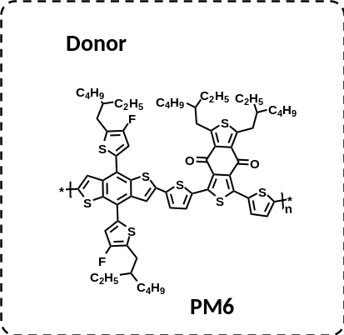
Figure. S1 The chemical structures of PM6 polymer donor.

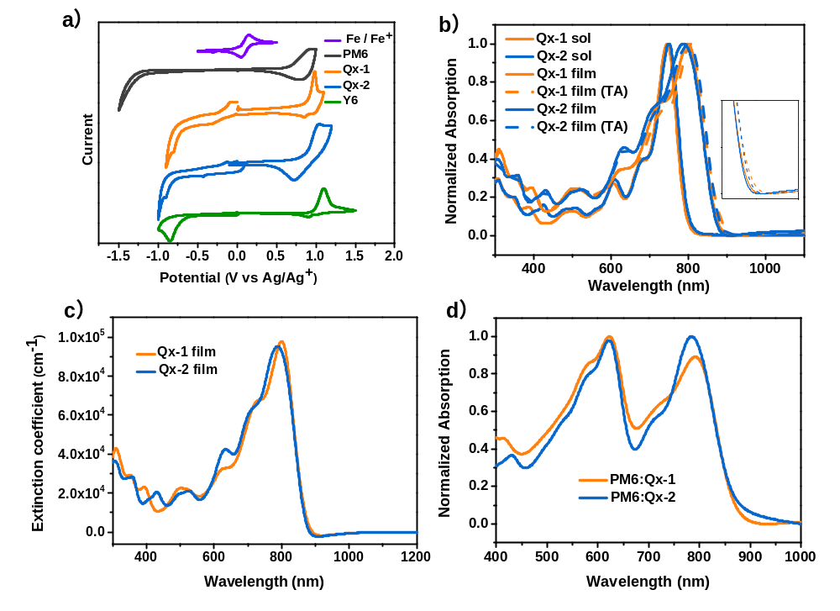
Figure. S2 (a) Electrochemical cyclic voltammetry curves of these acceptors films measured in 0.1 mol L⁻¹Bu₄NPF₆ acetonitrile solutions. (b)Normalized absorption spectra of Qx-1, Qx-2 solution, films and thermal annealing films. (c) Extinction Coefficient in film of Qx-1and Qx-2; (d) Normalized absorption spectra of blend films of Qx-1and Qx-2.
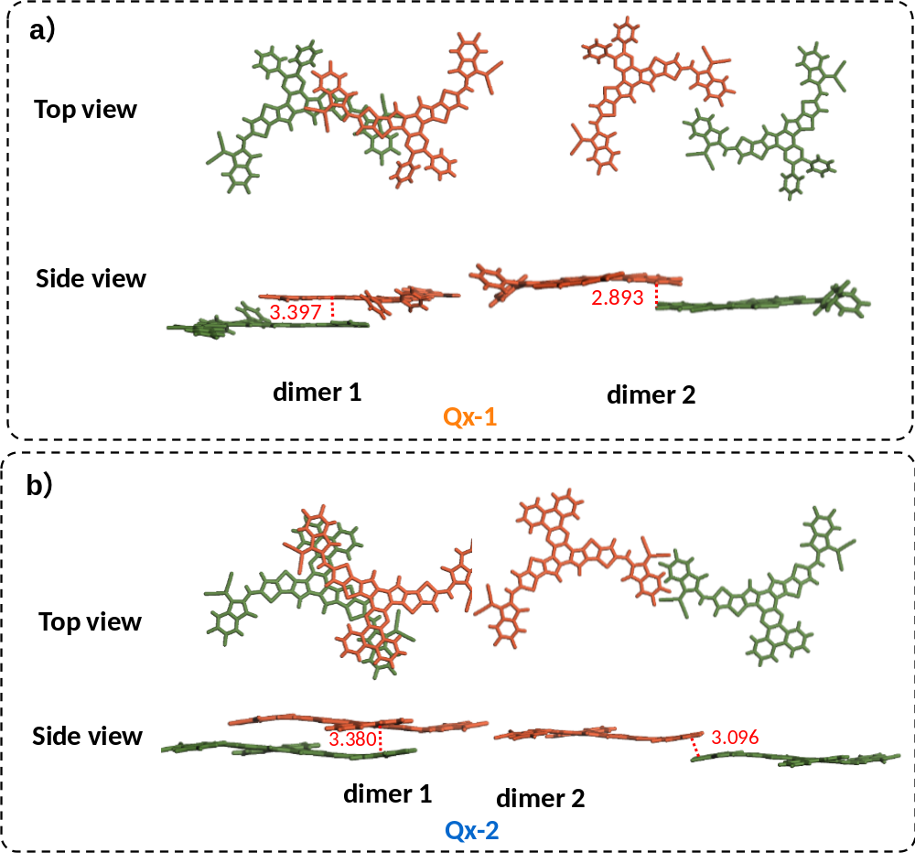
Figure. S3 The main view of molecular packing sketch of Qx-1 and Qx-2 according to single-crystal data.

Figure. S4 The TEM images of single crystals.
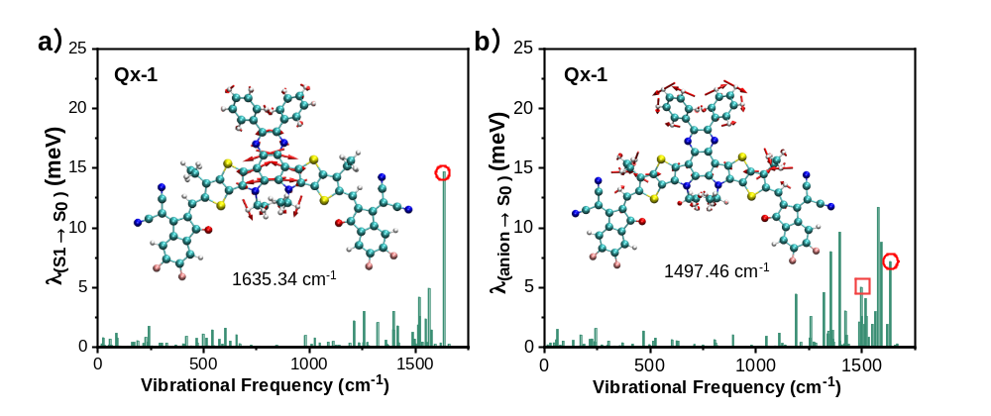
Figure S5 Contributions of each vibrational modes to the reorganization energy for the S₁ → S₀ and anion → S₀ transitons in Qx-1 accetpor. Illustration of the displacement vectors for the vibrational normal modes marked by circles (at 1635 cm⁻¹ ) and squares (at 1497 cm⁻¹) are inserted. The length of displacement vectors stands for the magnitude of vibrational strengh.

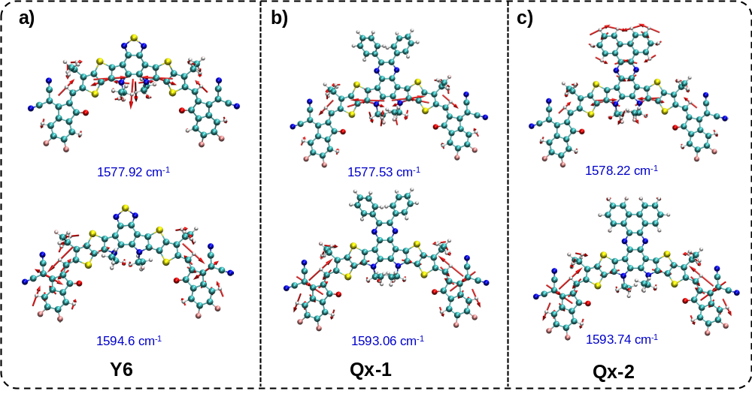
Figure S6 Two other important displacement vectors that contribute to the reorganization energy for anion → S₀ transitons in Y6, Qx-1 and Qx-2 accetpor. The length of displacement vectors stands for the magnitude of vibrational strengh.

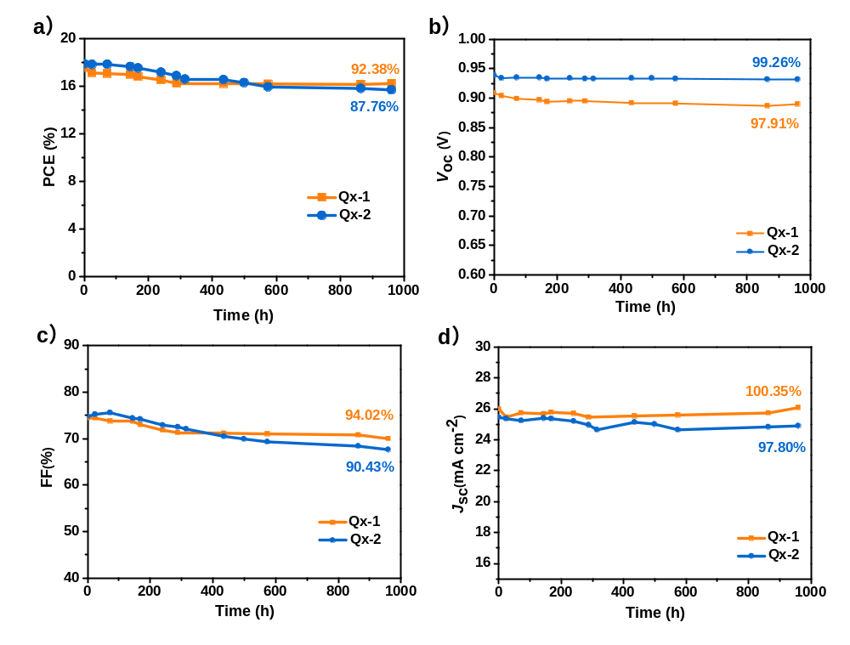
Figure. S7 The stability about detailed parameters of placement in glove box with PM6 as the donor.
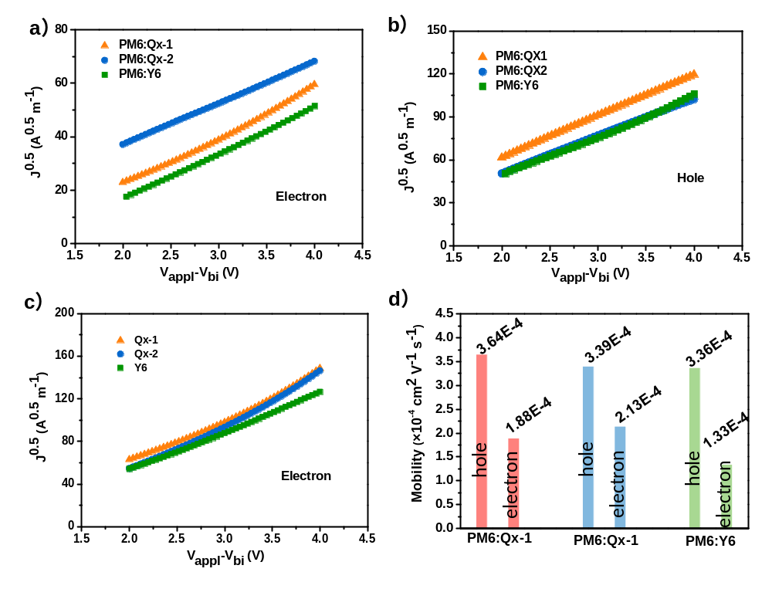
Figure. S8 Electron and hole mobility of the neat and blend films.
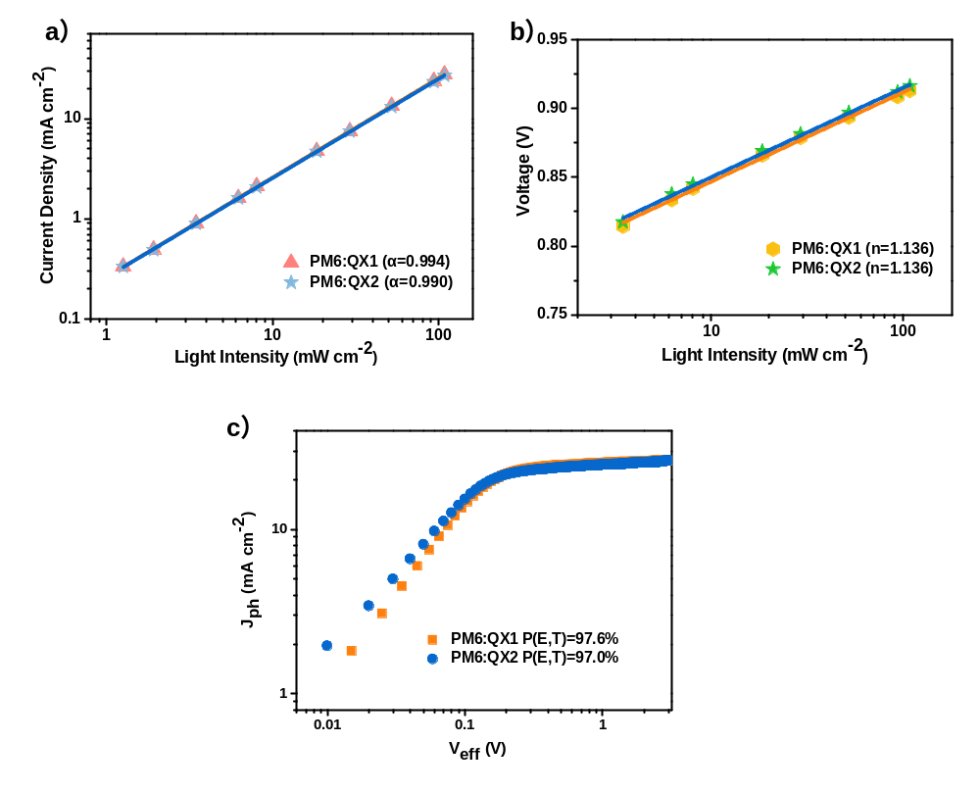
Figure. S9 (a-b) Light intensity dependence of J_{sc} and V_{oc}; and (c) Dependence of the photocurrent density (J_{ph}) on the effective voltage (V_{eff}).

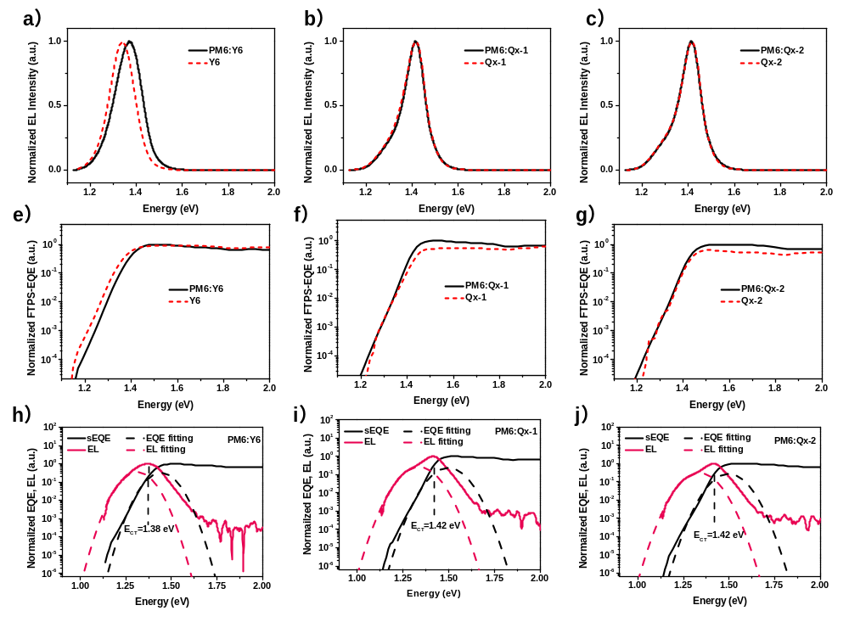
Figure. S10 (a-c) Normalized EL curves of blend and corresponding single component solar cells; (e-g) Fourier-transform photocurrent spectroscopy-EQE (FTPS-EQE) of blend and corresponding single component solar cells; (h-j) Normalized FTPS-EQE and EL spectra of the devices.

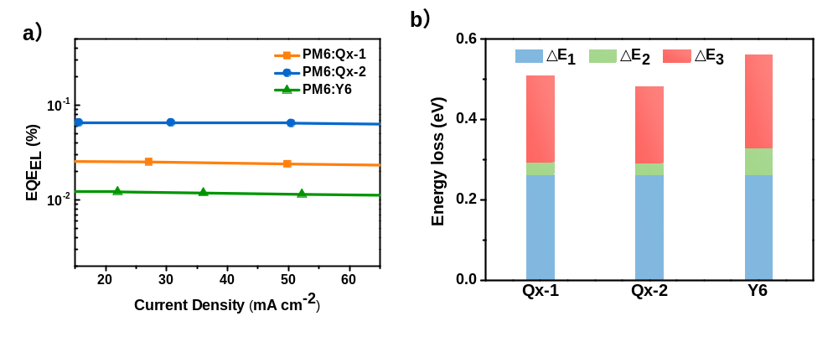
Figure. S11 (a)Electroluminescence quantum efficiency of optimal blend films at different injected currents; (b) Schematic for the energy loss of solar cells.

Figure. S12 (a-e) The 2D GIWAXS patterns of the films; (f) In-plane and out-of-plane cuts of the films with GIWAXS patterns.

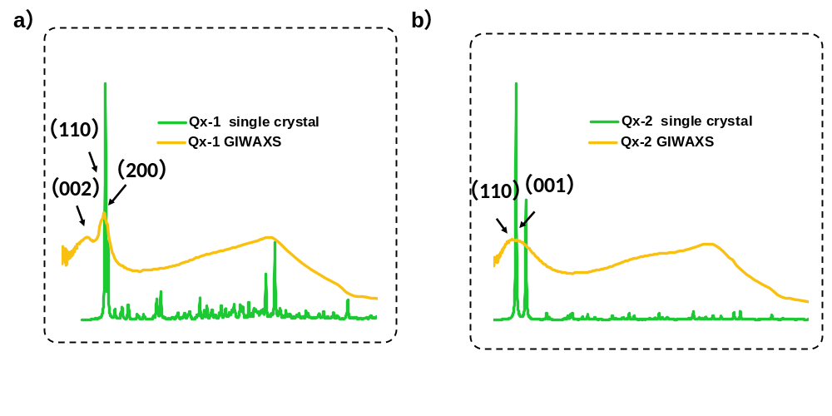
Figure. S13 The crystal plane parameter data of single crystal and GIWAXS.

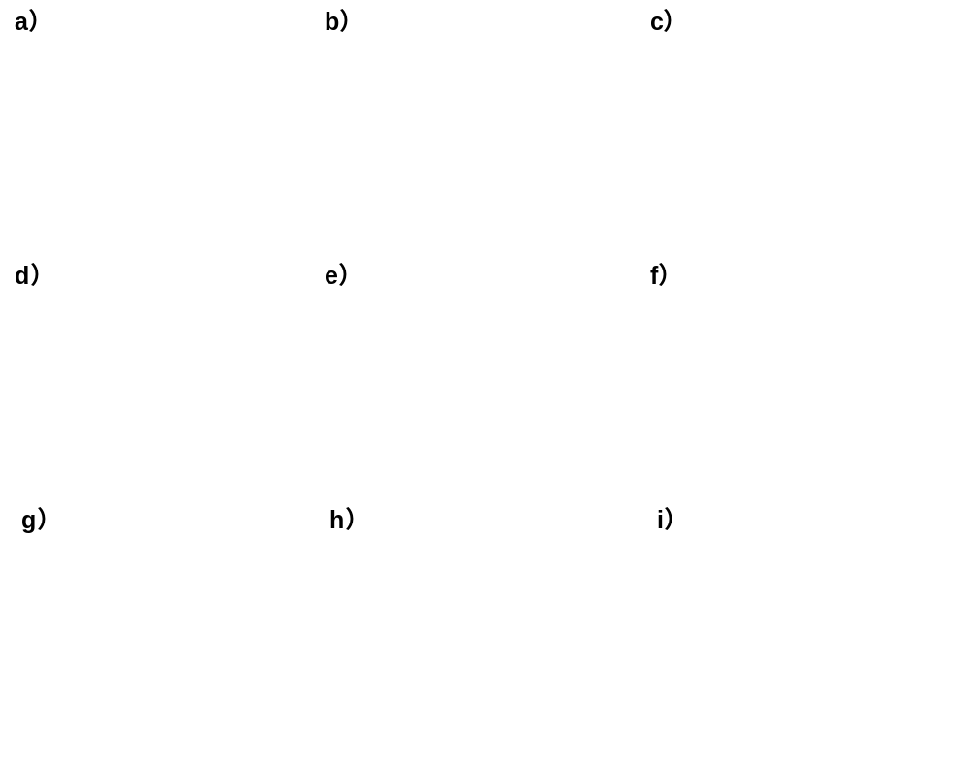
Figure. S14 (a-e; g-h) AFM images for neat films and optimal blend films; (f; i) TEM images for optimal blend films.

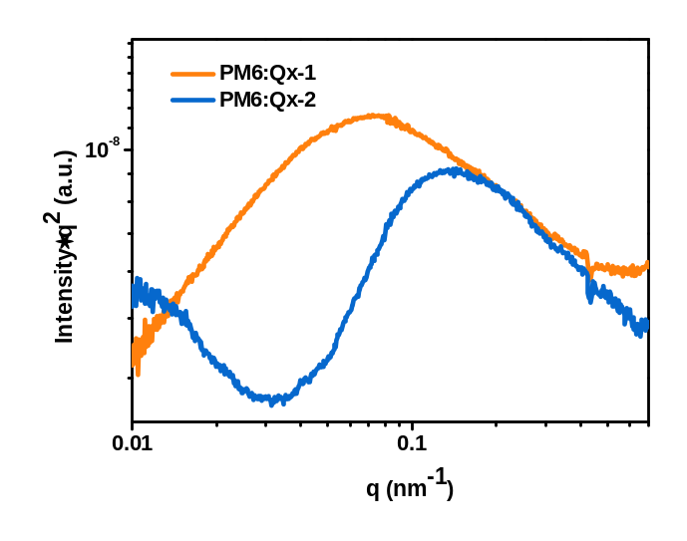
Figure. S15 R-SoXS profiles for optimal blend films.

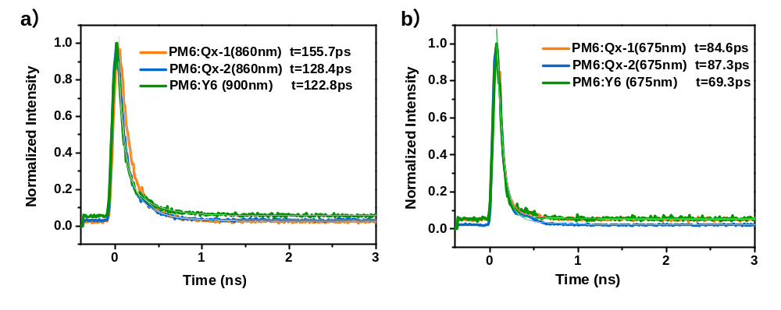
Figure. S16 (a-b) The time-resolution photoluminescence (TRPL) spectrum of blend films under the probe of 875nm.

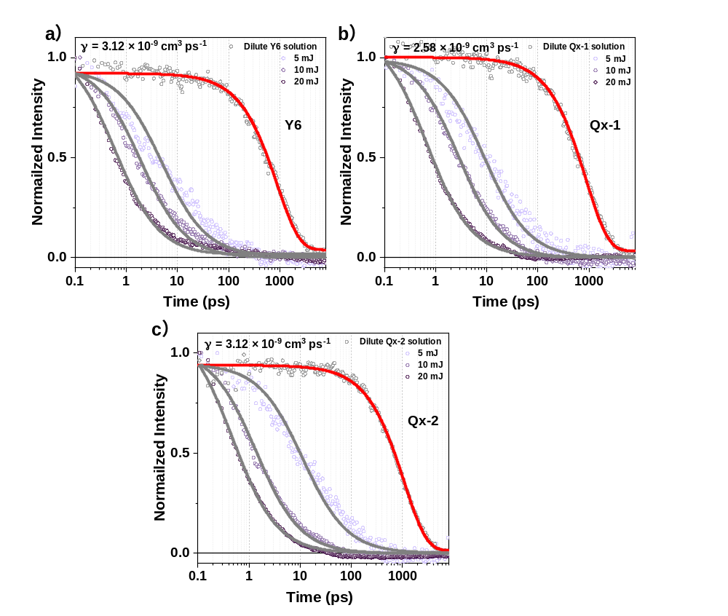
Figure. S17 The decay dynamics excitons of 910nm in the dilute solution and the neat films of Qx-1, Qx-2 and Y6 under the excitation of 800 nm with different excitation intensity.

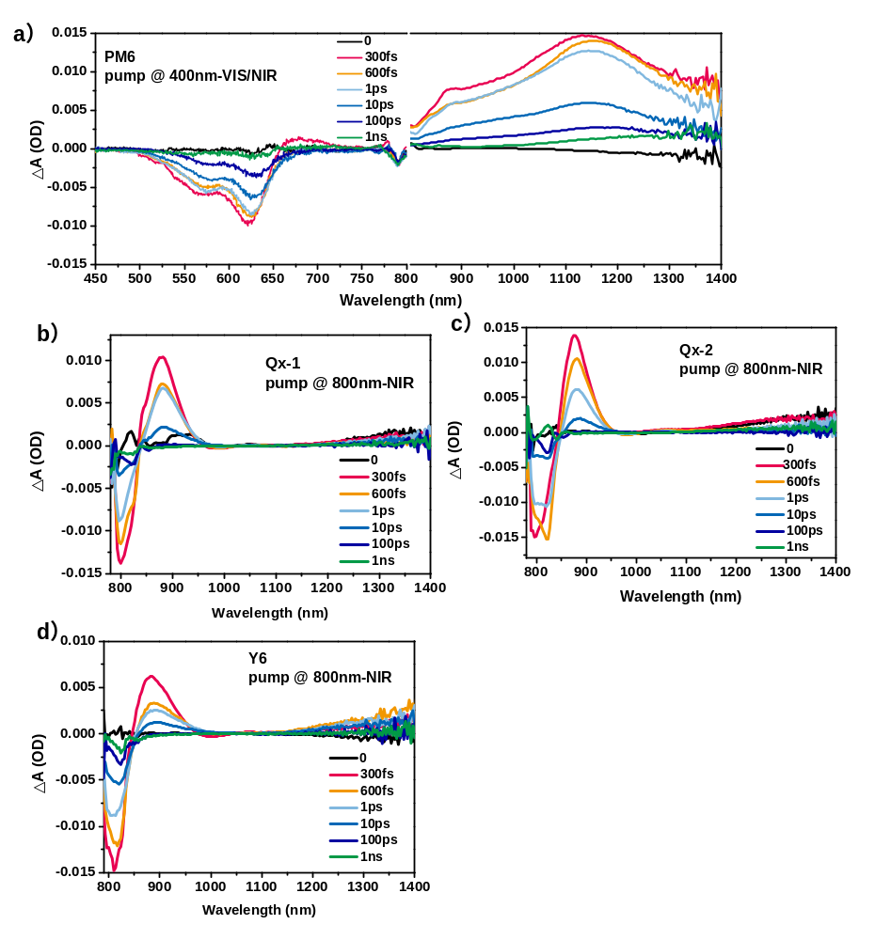
Figure. S18 (a)TA spectra of PM6 film with various decay times under 400 nm excitation; (b-d) TA spectra of neat acceptor films with various decay times under 800 nm excitation.

Figure. S19 (a-c) TA spectra of blend films with various decay times under 400 nm excitation; (d-f) TA spectra of blend films with various decay times under 800 nm excitation; (g-i) TA image of blend films with various decay times under 800 nm excitation.

- Supplementary Tables
Table. S1 Optical and Electrochemical Properties of Qx-1, Qx-2 and Y6.
Material | λ$\begin{matrix}sol \\ max\end{matrix}$ª  (nm) | λ$\begin{matrix} film \\ max\end{matrix}$ª (nm) | λ$\begin{matrix} film \\ edge\end{matrix}$ª (nm) | E$\begin{matrix} opt. \\ g \end{matrix}$  (TA) (eV) | E$\begin{matrix} \\ HOMO \end{matrix}$  (eV) | E$\begin{matrix} \\ LUMO \end{matrix}$  (eV)
Qx-1 | 744.86 | 810.41 | 911.38 | 1.36 | -5.58 | -3.98
Qx-2 | 748.81 | 805.10 | 910.46 | 1.36 | -5.54 | -3.86
Y6 | 732.97 | 818.47 | 931.91 | 1.33 | -5.65 | -4.05

Table. S2 Crystal data and structure refinement for Qx-1 and Qx-2.
Identification code | Qx-1 | Qx-2
Empirical formula | C104 H112 F4 N8 O2 S4 | C104 H110 F4 N8 O2 S4
CCDC number | 2120380 | 2120381
Formula weight | 1710.33 | 1708.31
Temperature/K | 179.99(10) | 180
Crystal system | monoclinic | monoclinic
Space group | P 2/n (13) | C 2/c
a/Å | 24.6430(9) | 22.9289(12)
b/Å | 13.8507(2) | 27.7156(9)
c/Å | 28.8718(6) | 17.7637(5)
α/° | 90 | 90
β/° | 103.942(3) | 112.837(4)
γ/° | 90 | 90
Volume/Å³ | 9564.3(4) | 10403.7(8)
Z | 4 | 4
ρcalcg/cm³ | 1.271 | 1.292
μ/mm⁻¹ | 0.245 | 0.355
F(000) | 3864 | 4236.9
Crystal size/mm³ | 0.63*0.10*0.02 | 0.65*0.04*0.03
Radiation | MoKα (λ=0.71073) | MoKα (λ=0.71073)
2Θ range for data collection/° | 2.3570 to 29.0340 | 2.358 to 25.027
Index ranges | -29 ≤ h ≤ 29,  -16 ≤ k ≤ 16,  -34 ≤ l ≤ 34 | -27 ≤ h ≤ 27,  -32 ≤ k ≤ 32,  -21 ≤ l ≤ 21
Reflections collected | 22321 | 47779
Independent reflections | 16910 | 9205
Goodness-of-fit on F² | 1.068 | 1.088
Final R indexes [I>=2σ (I)] | R1 = 0.0959,  wR2 = 0.2333 | 22.9289(12)R1 = 0.0813,  wR2 = 0.2193
Final R indexes [all data] | R1 = 0.1246  wR2 = 0.2184 | R1 =0.1099  wR2 =0.2014
Table. S3 Changes in the molecular state of the ground state (S₀), the lowest singlet excited state (S₁) and the ionic state during the photo-electric conversions.
Photo-electric conversions | Electronic process | Molecular state (D) | Molecualr state (A)
Exciton generation | DA → DA* | / | S₀ (A) → S₁(A)
Exciton generation | or DA → D*A | S₀ (D) → S₁(D) | /
Exciton diffusion | D*A → DA* | S₁ (D) → S₀(D) | S₀ (A) → S₁(A)
Exciton diffusion | or DA*→ D*A | S₀ (D) → S₁(D) | S₁ (A) → S₀(A)
Exciton dissociation | DA* → D⁺A⁻ | S₀(D) → cation(D) | S₁ (A) → anion (A)
Exciton dissociation | or D*A→ D⁺A⁻ | S₁(D) → cation(D) | S₀ (A) → anion (A)
Charge transport | D⁺ ↔ D | cation(D) ↔ S₀(D) | /
Charge transport | A⁻ ↔ A | / | anion (A) ↔ S₀ (A)
Charge recombination | D⁺A⁻ → DA | cation(D) → S₀(D) | anion (A) → S₀ (A)

Table. S4 Device optimization for PM6:Qx-1 blends.
D/A | additives | Thermal annealing (℃) | V_{OC}(V) | J_{SC} (mA cm⁻²) | FF(%) | PCE(%)
1:1.2 | 0.5%CN | 100 (10min) | 0.915 | 24.44 | 73.49 | 16.43
1:1.3 | 0.5%CN | 100 (10min) | 0.916 | 24.54 | 73.41 | 16.50
1:1.4 | 0.5%CN | 100 (10min) | 0.915 | 25.00 | 74.40 | 17.02
1:1.5 | 0.5%CN | 100 (10min) | 0.915 | 25.59 | 73.29 | 17.17
1:1.6 | 0.5%CN | 100 (10min) | 0.911 | 24.73 | 75.39 | 16.99
1:1.5 | 0.5%CN | 100 (10min) | 0.915 | 25.59 | 73.29 | 17.17
1:1.5 | 0.6%CN | 100 (10min) | 0.911 | 26.09 | 75.46 | 17.94
1:1.5 | 0.7%CN | 100 (10min) | 0.919 | 25.08 | 76.55 | 17.63
1:1.5 | 0.6%CN | 90 (10min) | 0.920 | 24.85 | 75.43 | 17.23
1:1.5 | 0.6%CN | 120 (10min) | 0.910 | 22.51 | 71.01 | 14.54
1:1.5 | 0.6%CN | 140 (10min) | 0.923 | 21.04 | 69.62 | 13.52
1:1.5 | 0.6%CN | 160 (10min) | 0.928 | 19.63 | 69.68 | 12.70
1:1.5 | 0.6%CN | 180 (10min) | 0.921 | 18.93 | 66.67 | 11.62

Table. S5 Device optimization for PM6:Qx-2 blends.
D/A | additive | Thermal annealing (℃) | V_{OC}(V) | J_{SC} (mA cm⁻²) | FF(%) | PCE(%)
1:1.1 | 0.5%CN | 110 (10min) | 0.941 | 24.30 | 72.94 | 16.67
1:1.2 | 0.5%CN | 110 (10min) | 0.936 | 25.35 | 73.91 | 17.53
1:1.3 | 0.5%CN | 110 (10min) | 0.938 | 25.43 | 75.17 | 17.92
1:1.4 | 0.5%CN | 110 (10min) | 0.942 | 24.65 | 72.58 | 16.85
1:1.3 | 0.4%CN | 110 (10min) | 0.949 | 25.34 | 70.55 | 16.97
1:1.3 | 0.55%CN | 110 (10min) | 0.934 | 26.47 | 73.69 | 18.22
1:1.3 | 0.6%CN | 110 (10min) | 0.934 | 26.53 | 73.73 | 18.22
1:1.3 | 0.7%CN | 110 (10min) | 0.938 | 25.00 | 74.69 | 17.52
1:1.3 | 0.6%CN | 100 (10min) | 0.938 | 23.63 | 74.41 | 16.49
1:1.3 | 0.6%CN | 120 (10min) | 0.934 | 25.44 | 73.65 | 17.51
1:1.3 | 0.6%CN | 140 (10min) | 0.926 | 23.85 | 72.62 | 16.03
1:1.3 | 0.6%CN | 160 (10min) | 0.931 | 23.96 | 71.05 | 15.85
1:1.3 | 0.6%CN | 180 (10min) | 0.903 | 23.24 | 68.12 | 14.30
Table. S6 Device parameters for high performance binary OSCs in the literature.
Material-1 | Material-2 | Voc(V) | PCE(%) | FF | Jsc (mA cm⁻²) | Energy loss (eV) | Ref. (SI)
AQx2 | PM6 | 0.86 | 16.64 | 0.76 | 25.4 | 0.54 | 2
BTP-4Cl | PM6 | 0.87 | 16.5 | 0.75 | 25.4 | 0.533 | ²⁴
BTP-4F-12 | PM6 | 0.86 | 16.2 | 0.76 | 25.3 | 0.539 | ²⁵
BTP-Ec9 | PM6 | 0.84 | 17.8 | 0.81 | 26.2 | 0.561 | ²⁶
BTP-Ec11 | PM6 | 0.85 | 16.9 | 0.77 | 25.7 | 0.549 | ²⁶
Y18 | PM6 | 0.84 | 16.52 | 0.76 | 25.7 | 0.53 | ²⁷
BTIC-2Cl-yCF3 | PM6 | 0.84 | 16.31 | 0.77 | 25.1 | 0.60 | ²⁸
L8-BO | PM6 | 0.87 | 18.32 | 0.82 | 25.72 | 0.55 | ¹⁷
Y6 | PM6 | 0.84 | 16.61 | 0.76 | 25.91 | 0.56 | ¹⁷
L8-HD | PM6 | 0.88 | 17.39 | 0.79 | 25.08 | 0.55 | ¹⁷
L8-OD | PM6 | 0.89 | 16.26 | 0.75 | 24.57 | 0.53 | ¹⁷
BTP-4F-P2EH | PM6 | 0.88 | 18.22 | 0.80 | 25.85 | 0.57 | ²⁹
BTP-C9-N4F | PM6 | 0.85 | 17.0 | 0.76 | 26.3 | 0.54 | ³⁰
L8-BO-F | PM6 | 0.934 | 16.82 | 0.77 | 23.42 | 0.513 | ³¹
BTP-S2 | PM6 | 0.945 | 16.37 | 0.72 | 24.07 | 0.53 | ³²

Table. S7 Device parameters for high performance ternary OSCs in the literature.
Material-1 | Material-2 | Material-3 | Voc(V) | PCE(%) | FF | Jsc  (mA cm⁻²) | Energy loss (eV) | Ref. (SI)
BTIC-2Cl-yCF3 | PM6 | PC71ThBM | 0.85 | 17.12 | 0.78 | 25.8 | 0.56 | ²⁸
BTP-eC9 | PM6 | PM6-Si30 | 0.870 | 18.27 | 0.78 | 26.22 | 0.51 | ³³
BTP-4F-12 | PM6 | MeIC | 0.863 | 17.4 | 0.79 | 25.4 | 0.526 | ²⁵
BTP-eC9 | PM6 | HDO-4Cl | 0.866 | 18.86 | 0.81 | 25.4 | 0.53 | ³⁴
eC9-2Cl | PBQx-TF | F-BTA3 | 0.879 | 19.0 | 0.809 | 26.4 | 0.551 | ³⁵
Y6 | PM6 | TiC12 | 0.853 | 17.25 | 0.754 | 26.80 | 0.55 | ³⁶
BTP-eC9 | PM6 | L8-BO-F | 0.853 | 18.66 | 0.8 | 27.35 | 0.519 | ³¹
Y6 | PM6 | DRTB-T-C4 | 0.854 | 17.05 | 0.81 | 24.68 | 0.559 | ³⁷
Y6 | PM6 | S3 | 0.856 | 17.53 | 0.79 | 25.86 | 0.579 | ³⁸
Y6 | PM6 | ZY-4Cl | 0.88 | 17.6 | 0.75 | 25.7 | 0.538 | ³⁹

Table. S8 The hole mobility and electron mobility.
Films | μ_{e} (cm² V⁻¹ s⁻¹) | μ_{h} (cm² V⁻¹ s⁻¹) | μ_{h}/μ_{e}
PM6:Qx-1 | 1.88*10⁻⁴ | 3.64*10⁻⁴ | 1.94
PM6:Qx-2 | 2.13*10⁻⁴ | 3.39*10⁻⁴ | 1.59
PM6:Y6 | 1.33*10⁻⁴ | 3.36*10⁻⁴ | 2.53
Qx-1 | 4.56*10⁻⁴ | - | -
Qx-2 | 6.98*10⁻⁴ | - | -
Y6 | 3.42*10⁻⁴ | - | -
Table. S9 The quantum yield (QY) of Qx-1, Qx-2 and Y6.
Materials | Qx-1 | Qx-2 | Y6
QY (800-950nm） | 7.65% | 12.34% | 6.42%

Table. S10 The related parameters of decay dynamics excitons.
Samples | t₀ [ps] | k [s⁻¹ × 10⁹] | γ [cm³ ps⁻¹ × 10⁻⁹] | D [cm² s⁻¹× 10⁻³] | L [nm]
Y6 | 896.2 | 1.12 | 3.12 | 1.24 | 10.6
Qx-1 | 878.8 | 1.14 | 2.58 | 1.03 | 9.5
Qx-2 | 1089.0 | 0.91 | 3.65 | 1.45 | 12.6

Reference
1. H. J. Song, T. H. Lee, M. H. Han, J. Y. Lee&D. K. Moon Synthesis of Donor-Acceptor polymers through control of the chemical structure: Improvement of PCE by planar structure of polymer backbones Polymer 54, 1072-1079 (2013).
2. Z. C. Zhou, et al. Subtle Molecular Tailoring Induces Significant Morphology Optimization Enabling over 16% Efficiency Organic Solar Cells with Efficient Charge Generation Adv. Mater. 32, 1906324 (2020).
3. D. Z. Mo, et al. Alkyl chain engineering of chlorinated acceptors for elevated solar conversion J. Mater. Chem. A 8, 8903-8912 (2020).
4. Q. J. Sun, H. Q. Wang, C. H. Yang&Y. F. Li Synthesis and electroluminescence of novel copolymers containing crown ether spacers J. Mater. Chem. 13, 800-806 (2003).
5. H. Bin, et al. 11.4% Efficiency non-fullerene polymer solar cells with trialkylsilyl substituted 2D-conjugated polymer as donor Nat. Commun. 7, 13651 (2016).
6. T. Stein, H. Eisenberg, L. Kronik&R. Baer Fundamental gaps in finite systems from eigenvalues of a generalized Kohn-Sham method Phys. Rev. Lett. 105, 266802 (2010).
7. L. Pandey, C. Doiron, J. S. Sears&J. L. Bredas Lowest excited states and optical absorption spectra of donor-acceptor copolymers for organic photovoltaics: a new picture emerging from tuned long-range corrected density functionals Phys. Chem. Chem. Phys. 14, 14243-14248 (2012).
8. X. Shen, G. Han&Y. Yi The nature of excited states in dipolar donor/fullerene complexes for organic solar cells: evolution with the donor stack size Phys. Chem. Chem. Phys. 18, 15955-15963 (2016).
9. Z. Shuai Thermal Vibration Correlation Function Formalism for Molecular Excited State Decay Rates Chinese J. Chem. 38, 1223-1232 (2020).
10. M. J. Frisch, et al. Gaussian 09 Rev. D.01.) (2016).
11. L. J. Koster, M. Kemerink, M. M. Wienk, K. Maturova&R. A. Janssen Quantifying bimolecular recombination losses in organic bulk heterojunction solar cells Adv. Mater. 23, 1670-4 (2011).
12. A. K. Kyaw, et al. Intensity dependence of current-voltage characteristics and recombination in high-efficiency solution-processed small-molecule solar cells ACS Nano 7, 4569-77 (2013).
13. G. Li, et al. Efficient modulation of end groups for the asymmetric small molecule acceptors enabling organic solar cells with over 15% efficiency J. Mater. Chem. A 8, 5927-5935 (2020).
14. P. W. M. Blom, M. J. M. deJong&J. J. M. Vleggaar Electron and hole transport in poly(p-phenylene vinylene) devices Appl. Phys. Lett. 68, 3308-3310 (1996).
15. S. Chandrabose, et al. High Exciton Diffusion Coefficients in Fused Ring Electron Acceptor Films J. Am. Chem. Soc. 141, 6922-6929 (2019).
16. G. C. Zhang, et al. Delocalization of exciton and electron wavefunction in non-fullerene acceptor molecules enables efficient organic solar cells Nat. Commun. 11, 3943 (2020).
17. C. Li, et al. Non-fullerene acceptors with branched side chains and improved molecular packing to exceed 18% efficiency in organic solar cells Nat. Energy 6, 605-613 (2021).
18. J. Z. Yao, et al. Quantifying Losses in Open-Circuit Voltage in Solution-Processable Solar Cells. Phys. Rev. Appl. 4, 014020 (2015).
19. Y. M. Wang, et al. Optical Gaps of Organic Solar Cells as a Reference for Comparing Voltage Losses Adv. Energy Mater. 8, 10 (2018).
20. H. Fu, Z. Wang&Y. Sun Polymer Donors for High-Performance Non-Fullerene Organic Solar Cells Angew. Chem. Int. Ed. Engl. 58, 4442-4453 (2019).
21. T. Liu, et al. Optimized Fibril Network Morphology by Precise Side-Chain Engineering to Achieve High-Performance Bulk-Heterojunction Organic Solar Cells Adv. Mater. 30, e1707353 (2018).
22. A. Classen, et al. The role of exciton lifetime for charge generation in organic solar cells at negligible energy-level offsets Nat. Energy 5, 711-719 (2020).
23. Y. Firdaus, et al. Long-range exciton diffusion in molecular non-fullerene acceptors Nat. Commun. 11, 5220 (2020).
24. Y. Cui, et al. Over 16% efficiency organic photovoltaic cells enabled by a chlorinated acceptor with increased open-circuit voltages Nat. Commun. 10, (2019).
25. X. L. Ma, et al. Achieving 17.4% Efficiency of Ternary Organic Photovoltaics with Two Well-Compatible Nonfullerene Acceptors for Minimizing Energy Loss Adv. Energy Mater. 10, 2001404 (2020).
26. Y. Cui, et al. Single-Junction Organic Photovoltaic Cells with Approaching 18% Efficiency Adv. Mater. 32, 1908205 (2020).
27. C. Zhu, et al. Tuning the electron-deficient core of a non-fullerene acceptor to achieve over 17% efficiency in a single-junction organic solar cell Energy Environ. Sci. 13, 2459-2466 (2020).
28. H. Chen, et al. 17.1 %-Efficient Eco-Compatible Organic Solar Cells from a Dissymmetric 3D Network Acceptor Angew. Chem. Int. Ed. 60, 3238-3246 (2021).
29. J. Q. Zhang, et al. Alkyl-Chain Branching of Non-Fullerene Acceptors Flanking Conjugated Side Groups toward Highly Efficient Organic Solar Cells Adv. Energy Mater. 2102596 (2021).
30. Y. N. Shi, et al. Optimizing the Charge Carrier and Light Management of Nonfullerene Acceptors for Efficient Organic Solar Cells with Small Nonradiative Energy Losses Sol. RRL 5, 2100008 (2021).
31. Y. H. Cai, et al. A Well-Mixed Phase Formed by Two Compatible Non-Fullerene Acceptors Enables Ternary Organic Solar Cells with Efficiency over 18.6% Adv. Mater. 33, 2101733 (2021).
32. S. X. Li, et al. Asymmetric Electron Acceptors for High-Efficiency and Low-Energy-Loss Organic Photovoltaics Adv. Mater. 32, 2001160 (2020).
33. W. H. Peng, et al. Using Two Compatible Donor Polymers Boosts the Efficiency of Ternary Organic Solar Cells to 17.7% Chem. Mater. 33, 7254-7262 (2021).
34. P. Q. Bi, et al. Reduced non-radiative charge recombination enables organic photovoltaic cell approaching 19% efficiency Joule 5, 2408-2419 (2021).
35. Y. Cui, et al. Single-Junction Organic Photovoltaic Cell with 19% Efficiency Adv. Mater. 33, 2102420 (2021).
36. W. Tang, et al. 17.25% high efficiency ternary solar cells with increased open-circuit voltage using a high HOMO level small molecule guest donor in a PM6:Y6 blend J. Mater. Chem. A 9, 20493-20501 (2021).
37. Y. H. Zeng, et al. Exploring the Charge Dynamics and Energy Loss in Ternary Organic Solar Cells with a Fill Factor Exceeding 80% Adv. Energy Mater. 11, 2101338 (2021).
38. Q. S. An, et al. Two compatible polymer donors contribute synergistically for ternary organic solar cells with 17.53% efficiency Energy Environ. Sci. 13, 5039-5047 (2020).
39. B. H. Jiang, et al. Realizing Stable High-Performance and Low-Energy-Loss Ternary Photovoltaics through Judicious Selection of the Third Component Sol. RRL 5, 2100450 (2021).

