Structural and mechanistic effects in one-electron oxidation of model disulfides
Monika Borkowska¹, Piotr Filipiak¹, Marta Ignasiak-Kciuk¹, Michael J. Davies^{2*}, Tomasz Pedzinski^{1*}

Supplementary Information

Table S1
Peak areas and relative yields of detected photoproducts of DHDT oxidation (peak areas taken from HPLC chromatograms with spectrophotometric detection)
No. | Product | Peak Area | Products’ yield contribution %
1 | P1 | 0.43 | 62.4
1 | P1 | 0.53 | 62.4
2 | P2 | 0.08 | 11.1
2 | P2 | 0.09 | 11.1
3 | P3 | 0.12 | 18.8
3 | P3 | 0.17 | 18.8
4 | P4 | 0.06 | 7.7
4 | P4 | 0.05 | 7.7
4 | P4 | 1.15 | 7.7
4 | P4 | 0.27 | 7.7

Table S2
Peak areas and relative yields of detected photoproducts of CA oxidation (peak areas taken from HPLC chromatograms with spectrophotometric detection)
No. | Product | Peak Area | Products’ yield contribution %
6 | P5 | 0.08 | 7.3
7 | P6 | 0.07 | 10.1
7 | P6 | 0.07 | 10.1
8 | P7 | 0.45 | 82.6
8 | P7 | 0.44 | 82.6
8 | P7 | 0.10 | 82.6

Table S3 (all masses are monoisotopic masses from HR-MS spectra)
Comp. | Retention time [min] | Elemental composition | Determined mass  [MH+] | Calculated mass  [MH+] | R [ppm]
P1 | 13.6  14.1  14.3 | C₈H₁₄O₄S₄ | 302.9857  302.9862  302.9859 | 302.9853 | 1.26  2.91  1.92
P2 | 16.4  17.0 | C₈H₁₄O₄S₅ | 334.9579  334.9578 | 334.9574 | 1.52  1.22
P3 | 18.2  18.8 | C₈H₁₂O₃S₅ | 316.9476 | 316.9468 | 2.44
P4 | 20.5  22.3 | C₄H₆O₂S₄ | 214.9326  214.9330 | 214.9329 | -1.35  0.52
P5 | 11.4 | C₁₈H₂₂N₂O₃S₂ | 379.1145 | 379.1150 | -1.32
P6 | 12.4  12.7 | C₁₈H₁₉NO₃S | 330.1170 | 330.1164 | -1.82
P7 | 12.0  12.4 | C₁₆H₁₅NO₃ | 270.1123  270.1128 | 270.1130 | -2.59  -0.74

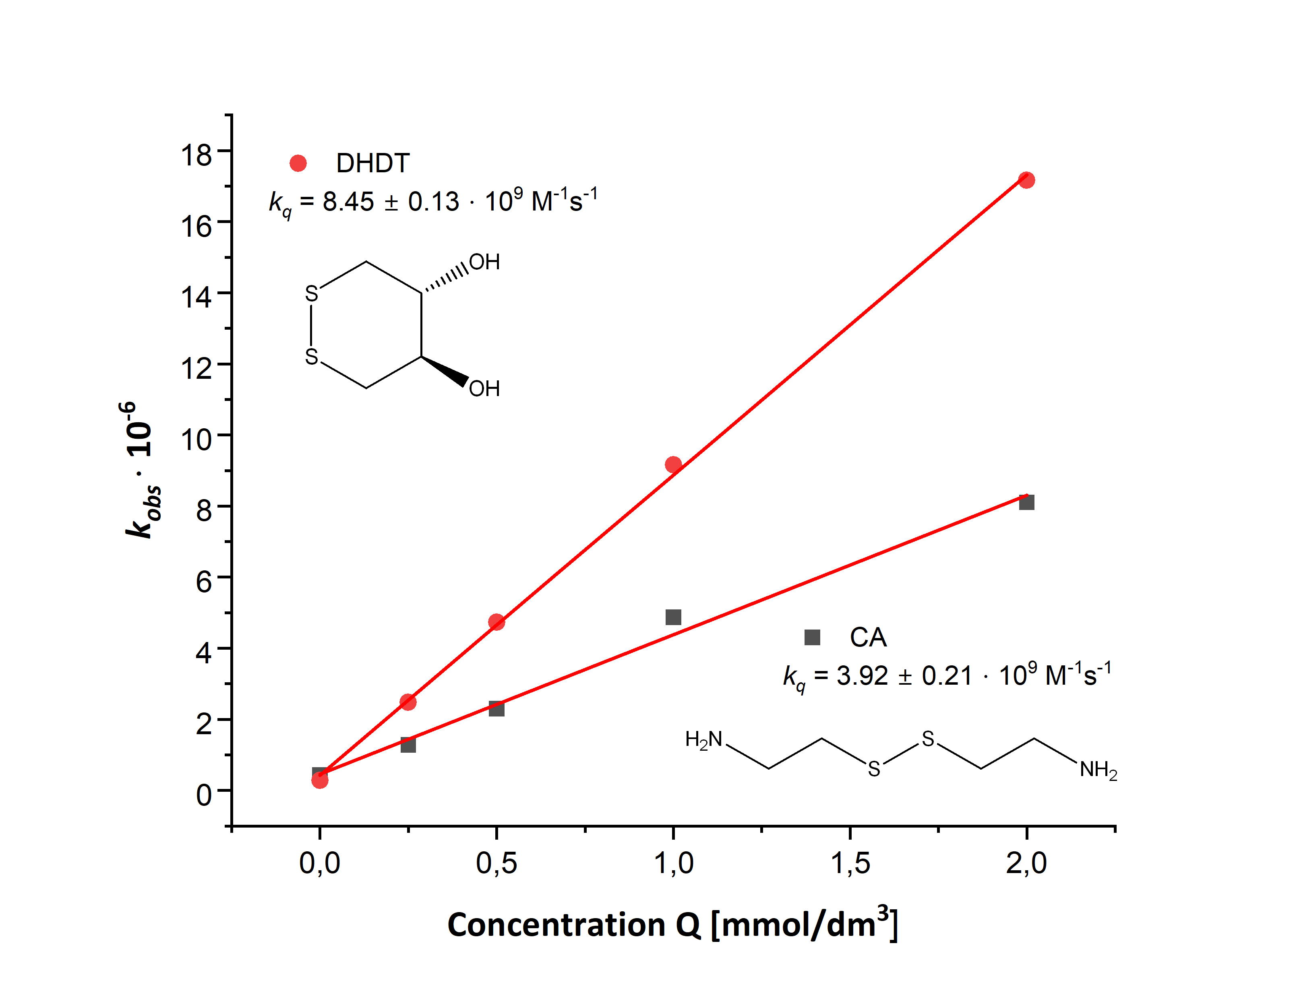
Figure S1 Stern-Volmer plots for 3CB triplet-sensitized oxidation of DHDT and CA

Figure S2 Suggested structures of encounter complexes between DHDT/CA and 3CB* and the following reactions resulting in photoproducts P1 (A) and P5 (B)

