Scheme 1 Overview of early events of disulfide oxidation. Upon oxidation the initial disulfide radical-cation decays via one of three primary reaction pathways: deprotonation, disulfide (S-S) bond cleavage, or C-S bond cleavage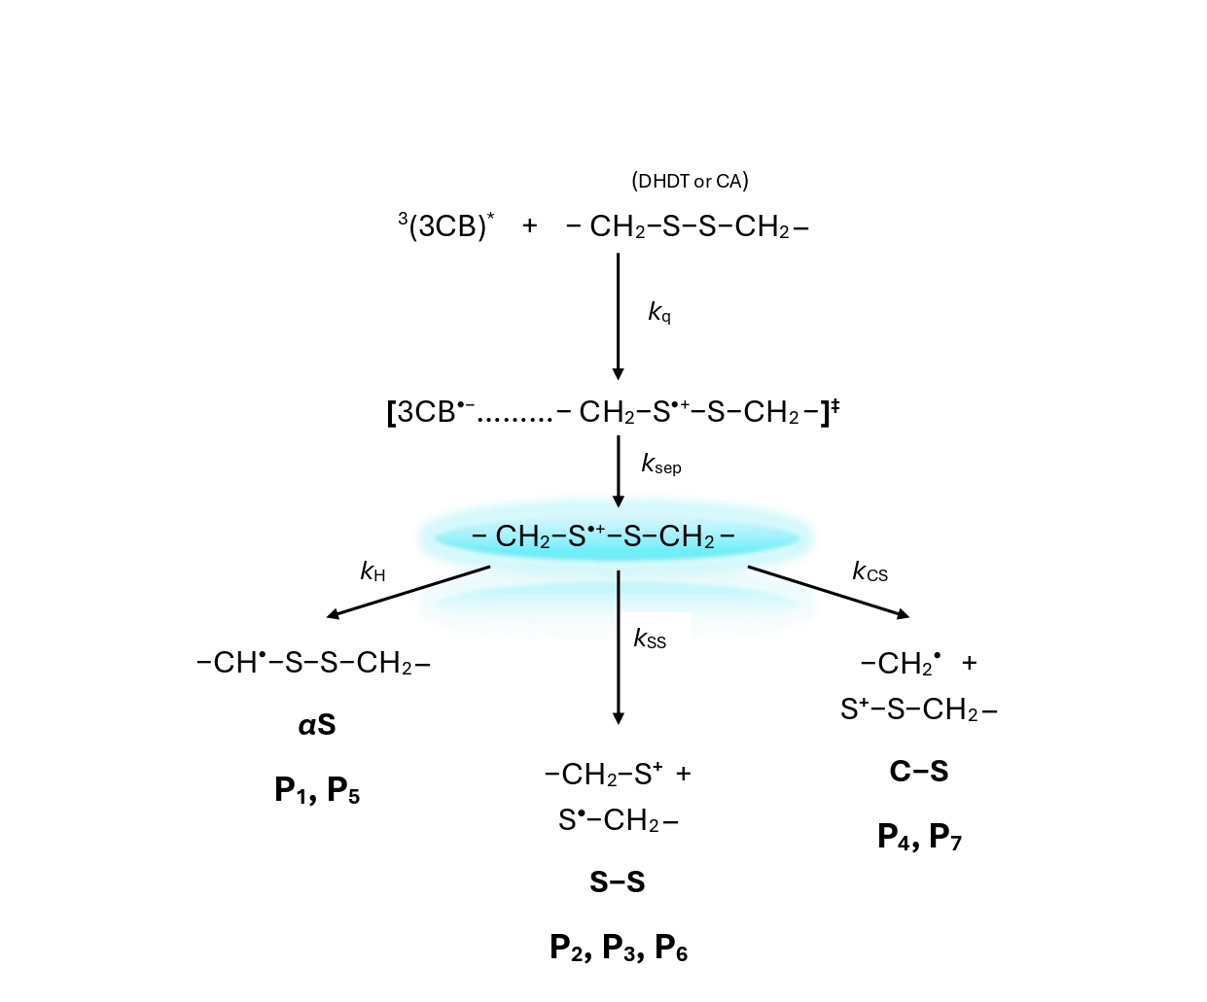

Scheme 2 Proposed mechanisms of oxidation of trans-4,5-Dihydroxy-1,2-dithiane (DHDT) induced by the excited triplet state of the photosensitizer 3-carboxybenzophenone (³3CB*) based on stable products analyses by LC-MS.
Scheme 3 Proposed mechanisms of oxidation of cystamine (CA) induced by the excited triplet state of the photosensitizer 3-carboxybenzophenone (³3CB*) based on stable products analyses by LC-MS.

