Genetic analysis of DNA methylation in dyslipidemia: a case-control study
Shuai Liu ^{1,2†}, Yang Li^{1,2†}, Xian Wei^{1,2}, Dilare Adi^{1,2}, Yong-Tao Wang^{1,2}, Min Han^{1,2}, Fen Liu^{1,2}, Bang-Dang Chen^{1,2}, Xiao-Mei Li^{1,2}, Yi-Ning Yang^{1,2}, Zhen-Yan Fu^{1,2*}, Yi-Tong Ma^{1,2*}
* Correspondence author
† Equal contributors
1 Department of Cardiology, First Affiliated Hospital of Xinjiang Medical University, Urumqi, China.
2 Xinjiang Key Laboratory of Cardiovascular Disease Research, Urumqi, China.

Study aim(s)

Exploring whether the DNA methylation of AMFR, FBXW7, INSIG1, INSIG2, MBTPS1 and GRINA genes are related to dyslipidemia.

Study population
Upon reviewing case-control studies on DNA methylation, the sample sizes of the case and control groups ranged from 80 to 90. Therefore, this study recruited 100 dyslipidemia participants as the dyslipidemia group and randomly enrolled 100 age-and sex-matched participants as the control group. Two hundred samples were tested for DNA methylation. This study recruited 100 participants as the dyslipidemia group and 80 participants as the control group due to sample contamination (Fig. 1)

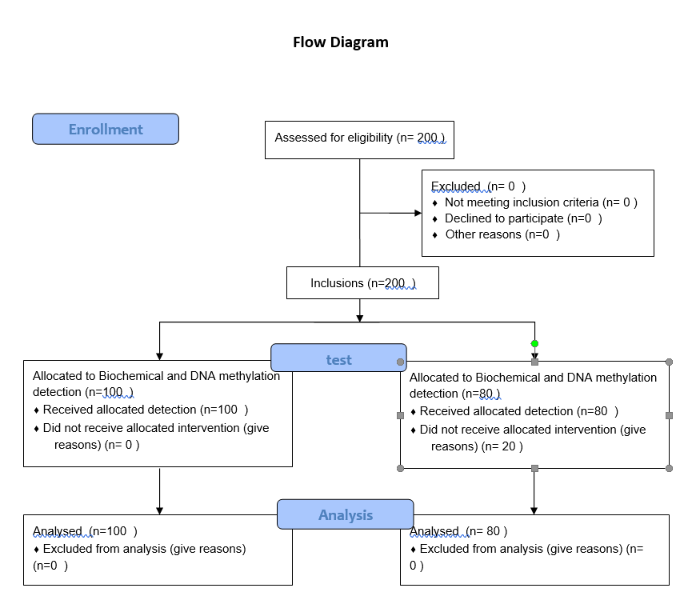

The definition of dyslipidemia was a fasting TG level ≥ 1.7 mmol/L, TC level ≥ 5.2 mmol/L, LDL level ≥ 3.1 mmol/L, or HDL level ＜ 1.0 mmol/L. The inclusion criteria were those who have not taken anti-inflammatory, lipid-lowering or other anti-heart failure treatments recently. The exclusion criteria were as follows: 1. Those complicated with acute heart failure, malignant arrhythmia, or other heart diseases such as heart valve disease; 2. Those combined with severe cerebrovascular, liver, kidney, and lung tissue diseases; 3. Those combined with systemic infectious diseases, malignant tumors or thyroid disease; 4. Those combined with blood , Immune, endocrine, nervous system or severe mental illness.

DNA isolation and epi-genotyping
Venous blood samples were taken from participants in the morning after fasting overnight for biochemical detection and methylation analysis.
We selected CpG islands located in the proximal promoter of AMFR, FBXW7, INSIG1, INSIG2, MBTPS1 and GRINA genes for methylation analysis.
The criteria as follows: (1) 200 bp minimum length;(2) 50% or higher GC content; (3) 0.60 or higher ratio of observed/expected dinucleotides CpG.
Ultimately, Three regions from CpG islands of AMFR, three from that of FBXW7, three from that of INSIG1,one from that of INSIG2, two from that of MBTPS1 and two from that of GRINA were selected and sequenced
The percentage of methylated cytosine relative to the total tested cytosines were calculated as the methylation level at each CpG site. The average methylation level of all detected CpG sites in the gene was taken as the average methylation level.

Statistical analysis
SPSS22.0 was used for data analysis, and the Kolmogorov-Smirnov method was used to test the normality of the measurement data. The measurement data conforming to the normal distribution are expressed as the mean ± standard deviation. The comparison of the means between the two groups uses two independent samples. t test. The overall methylation level of each group of DNA samples is expressed as mean±standard deviation. The non-normally distributed measurement data used the median (interquartile range), and the Mann Whitney U test was used for comparison between groups. For counting data, it is expressed as the number of cases (percentage). Apply Chi-square test or Fisher's exact test. P<0.05 indicates statistical difference.
Data were analyzed using IBM SPSS Statistics Version 22.0 (Armonk, NY: IBM Corp.). A two-tailed value of P ＜ 0.05 was considered statistically significant.

Outcome(s)
Compared with participants without dyslipidemia, patients with dyslipidemia GRINA gene had higher methylation levels (2.68 vs 2.36, p = 0.04). The methylation haplotype with significant abundance in the GRINA is ttttttttttttcttttttttttt(p=0.017).

Contact details for further information
Shuai Liu.
Xinjiang Medical University Affiliated First Hospital
CHINA.
18199889463@163.com.

Organizational affiliation of the study
Department of Cardiology, First Affiliated Hospital of Xinjiang Medical University, Urumqi, China.
Xinjiang Key Laboratory of Cardiovascular Disease Research, Urumqi, China.

Anticipated completion date
20 June 2019

Funding sources
This work was supported by National Natural Science Foundation (91957208, 81970380) and Key laboratory built by provincial and Ministry (SKL-HIDCA-2019-4).

Conflicts of interest
None
Contributor ship statement
Shuai Liu and Yang Li contributed equally to this work. Shuai Liu and Yang Li were responsible for the statistical analysis and wrote this paper. Xian Wei, Dilare Adi and Yong-Tao Wang were responsible for the entry of population data and the extraction of blood samples. Min Han, Fen Liu and Bang-Dang Chen were responsible for genotyping and sequencing gene DNA methylation. Yong-Tao Wang and Han Min provided the database. Xiao-Mei Li were responsible for quality control during the experiment. Zhen yan Fu and Yi-Ning Yang has strictly reviewed the scientificity and authenticity of the article. Yi-Tong Ma is accountable for all aspects of the work and funding.
Data sharing statement
The data sets generated and analyzed during the current study are available from the corresponding author upon reasonable request.

Language
English

Country
China

