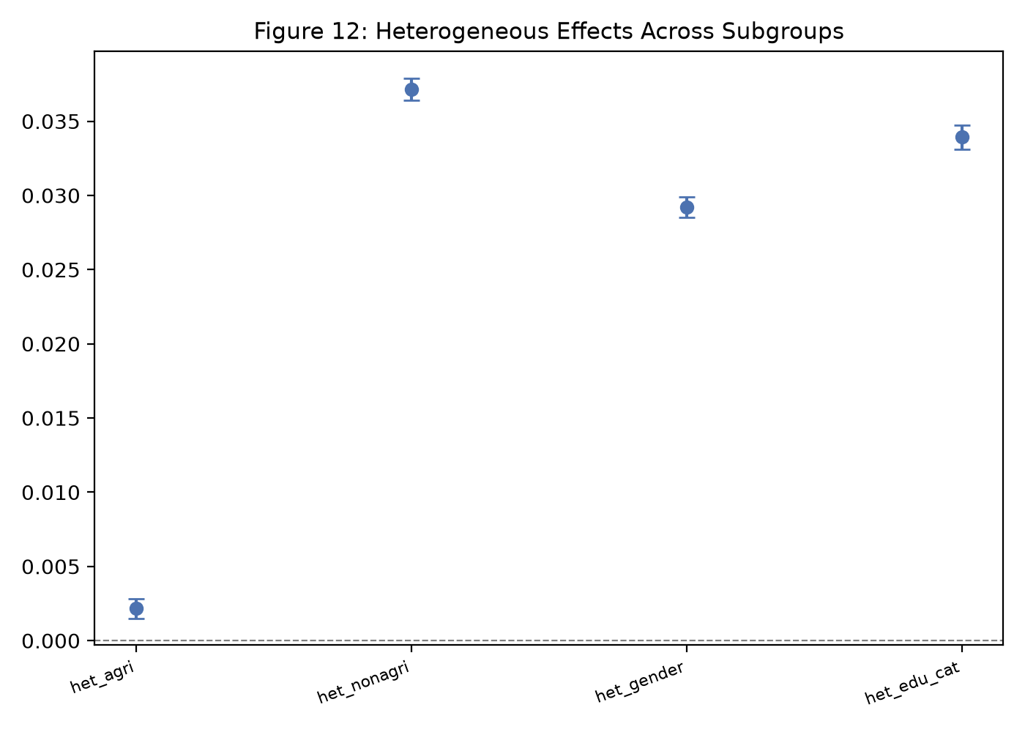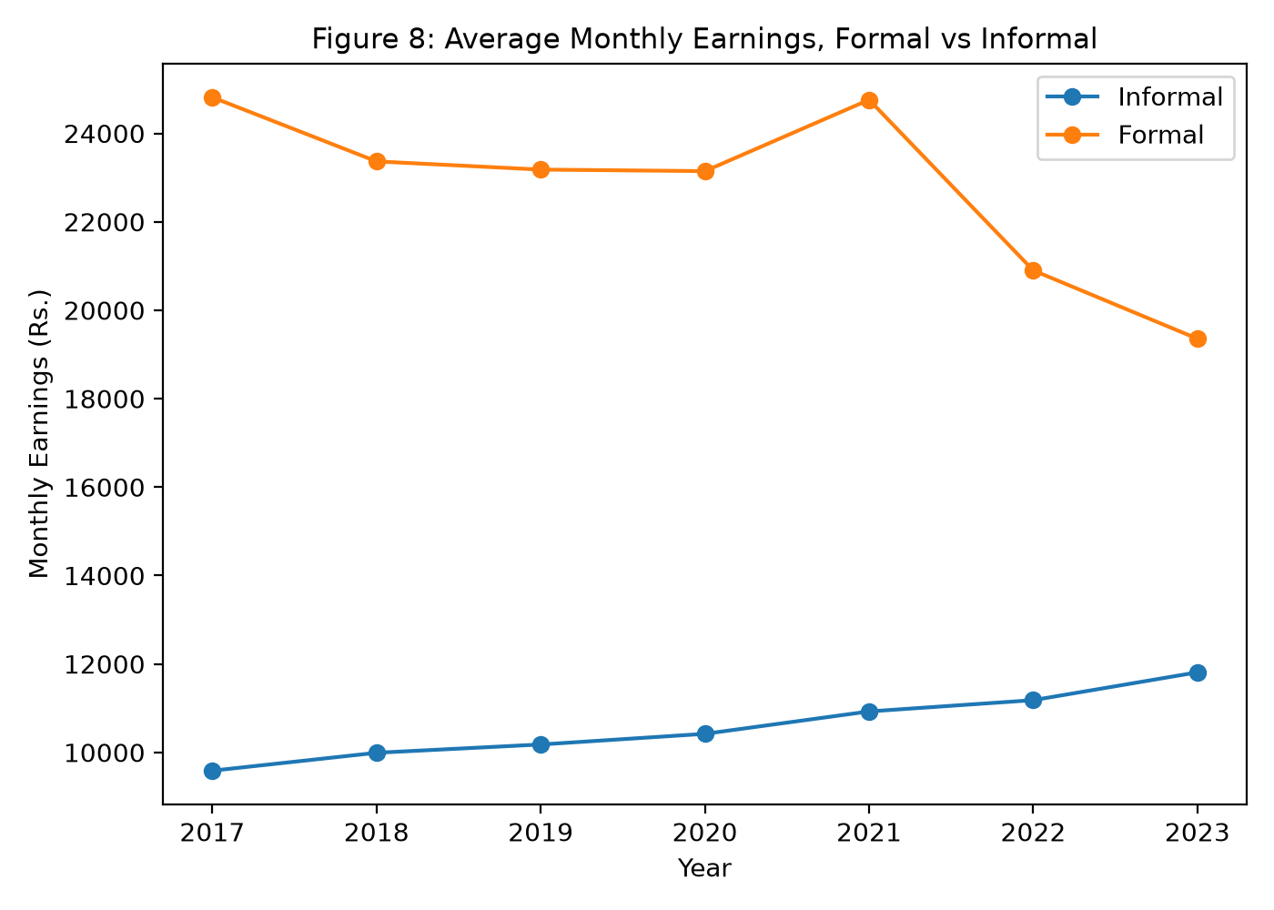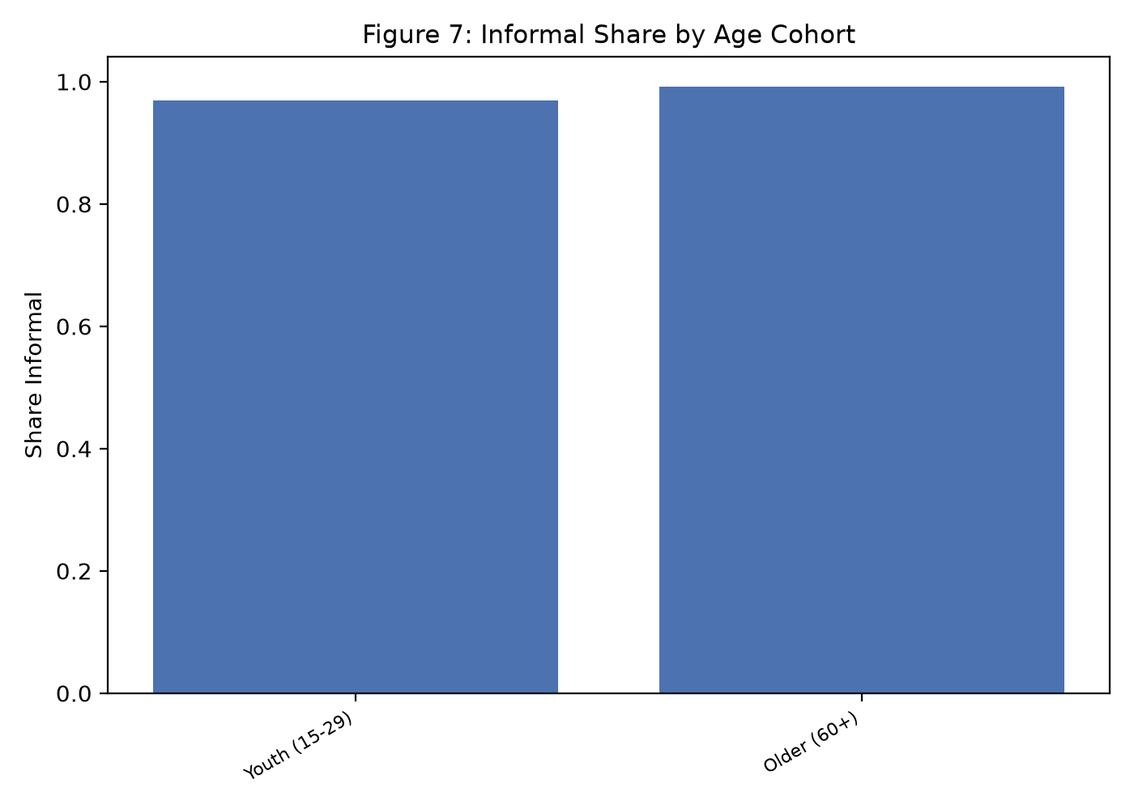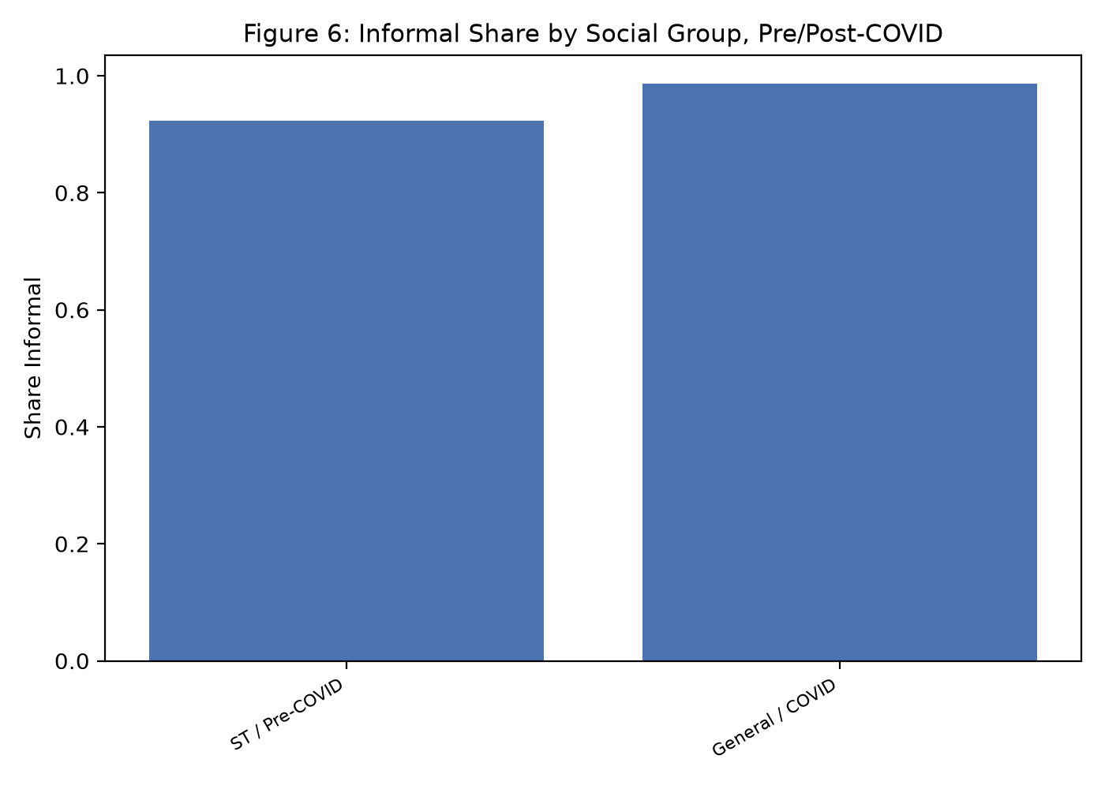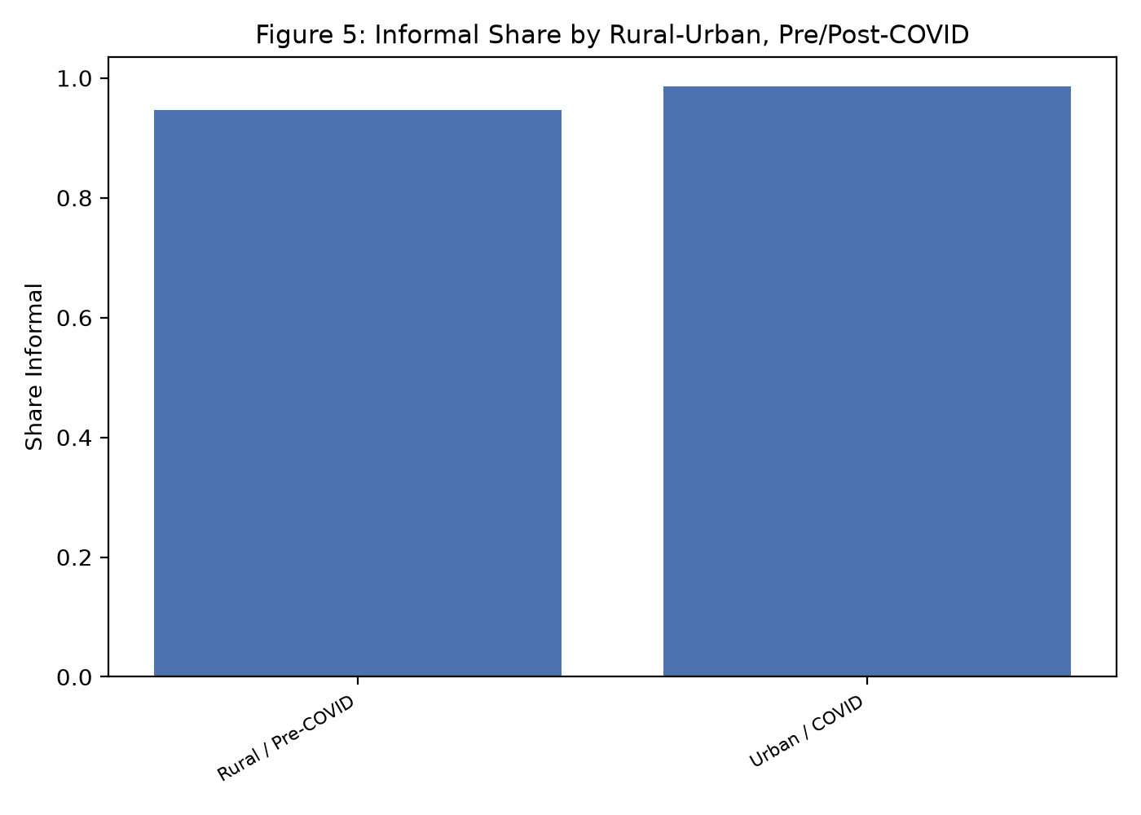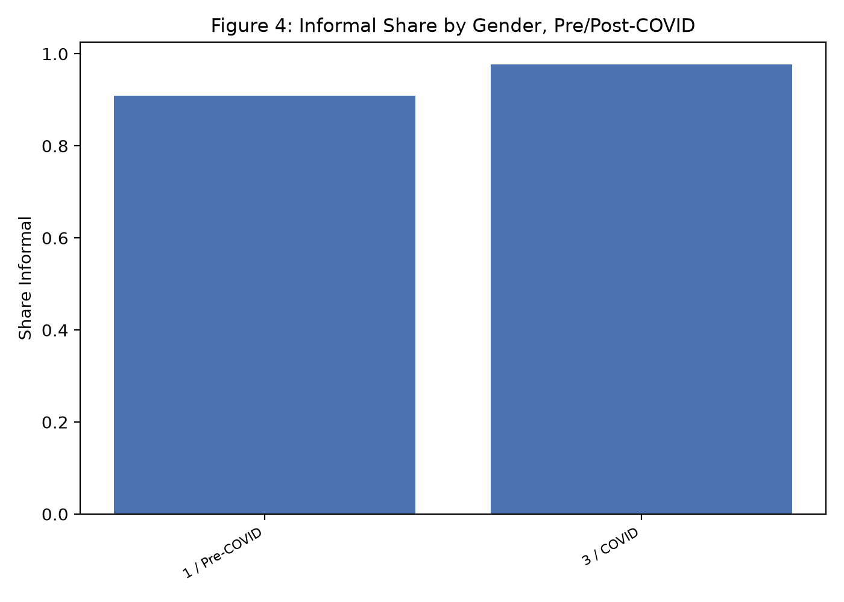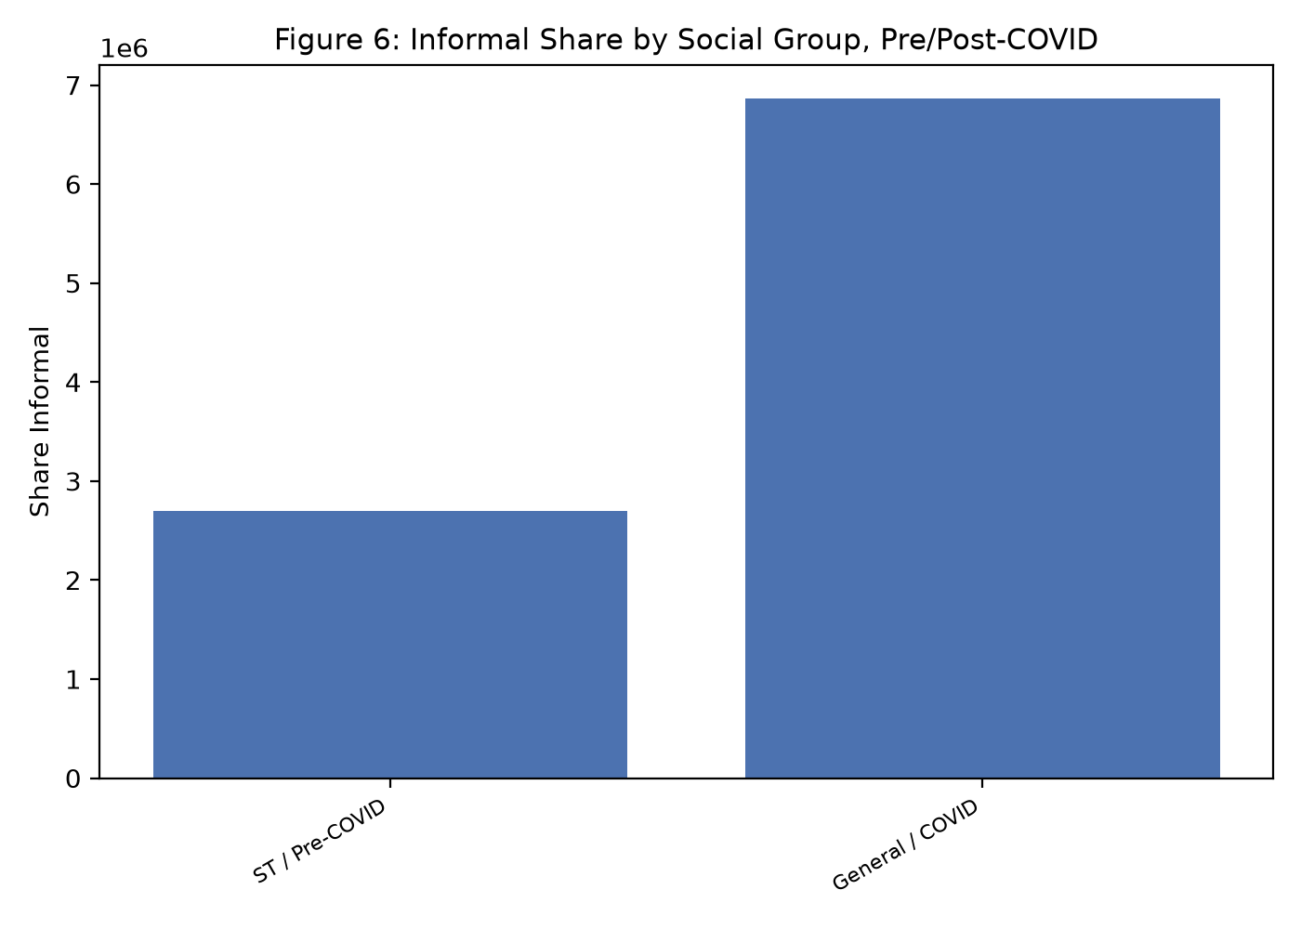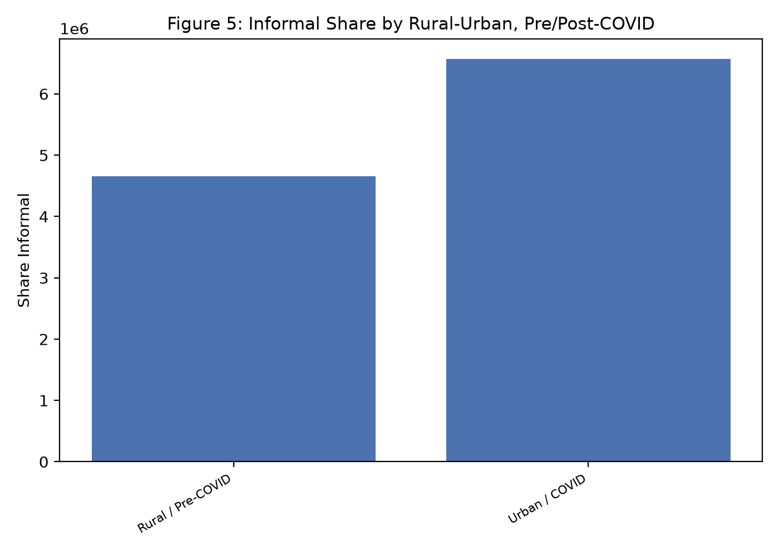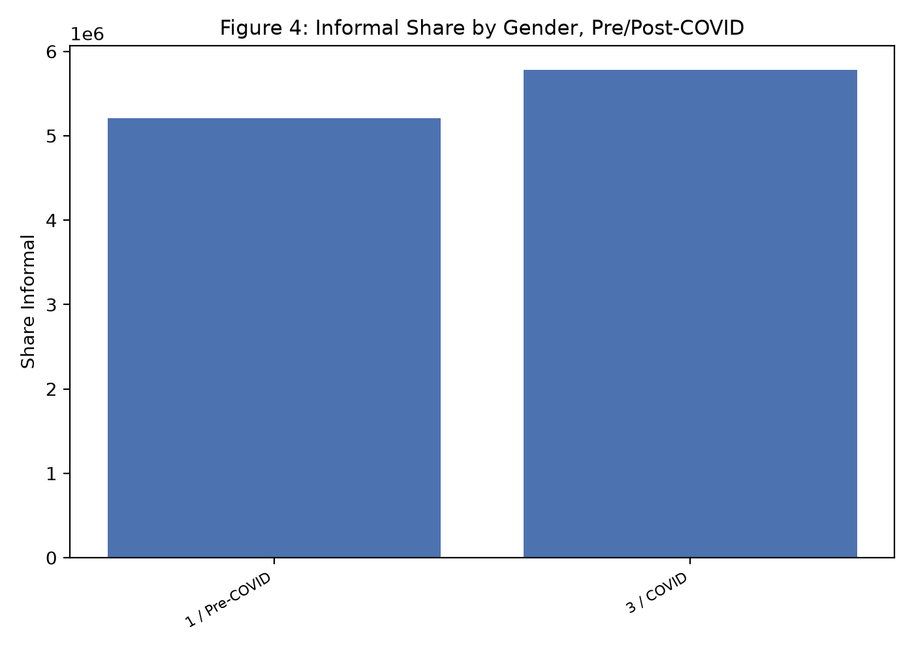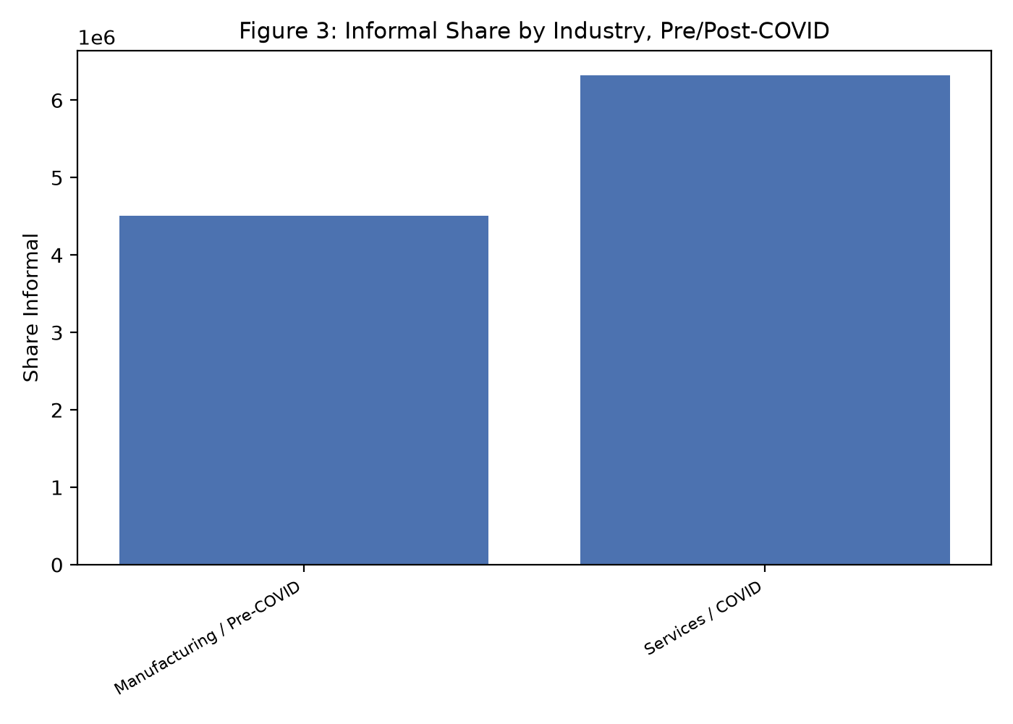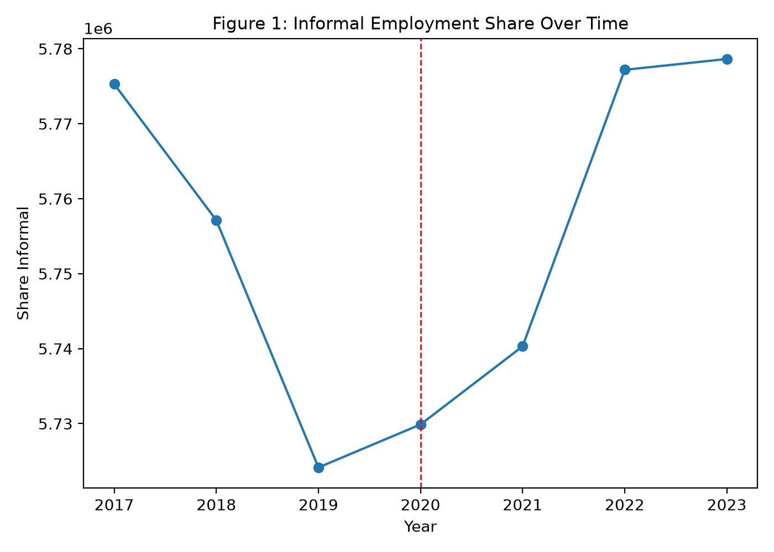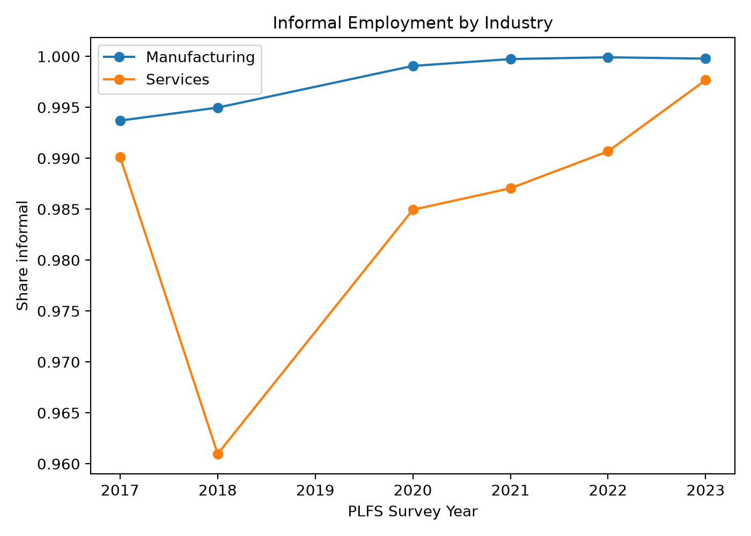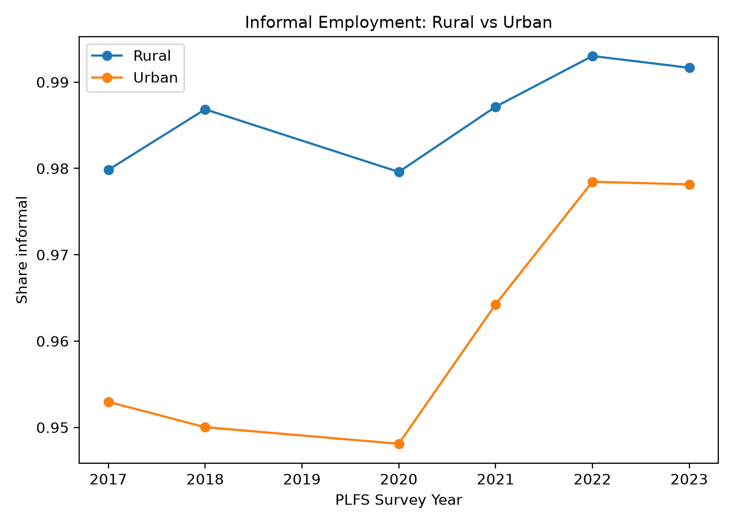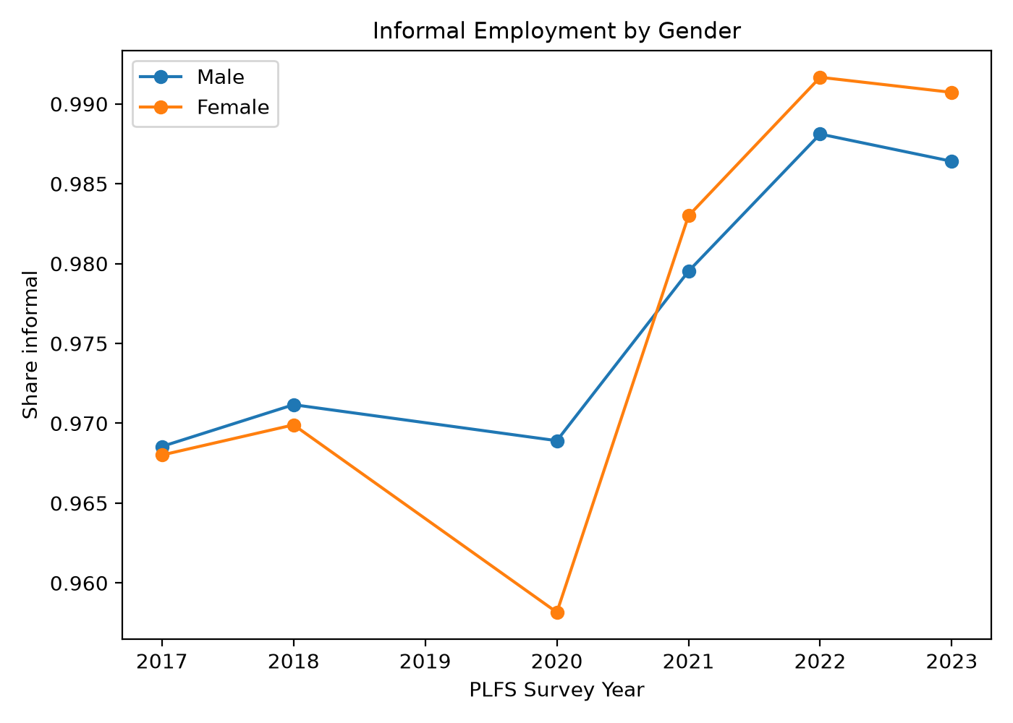

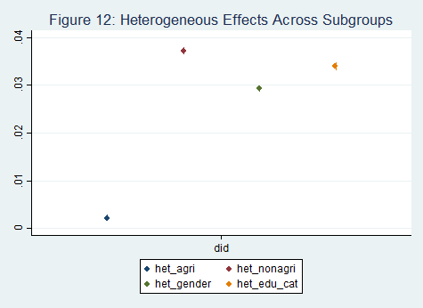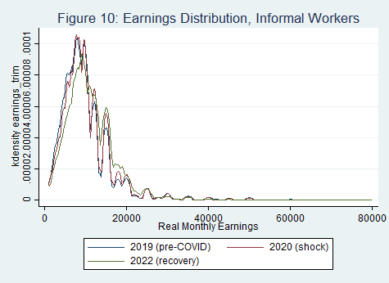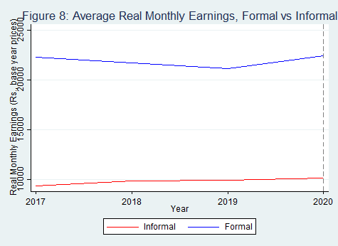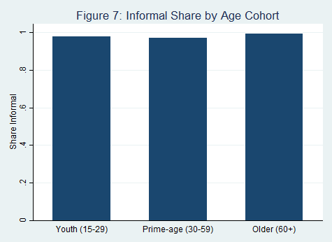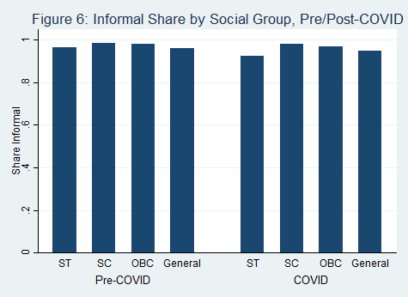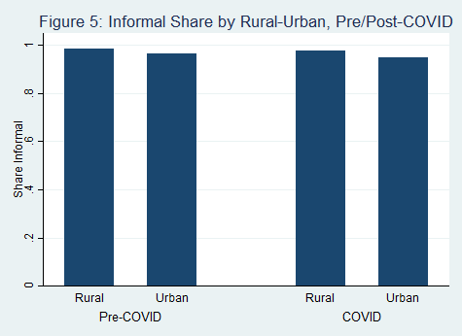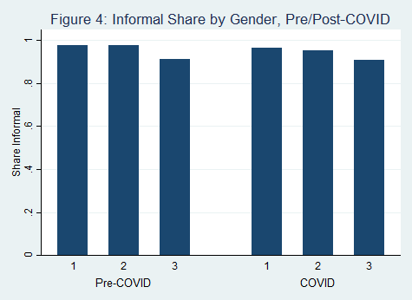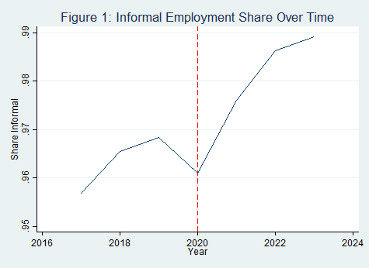

Appendix: Composite Regression Tables
This appendix reports the full set of regression models estimated for this paper. Every table below was reconstructed directly from the underlying Stata estimation output, because the esttab commands in the original log failed to execute (error "0bn: operator invalid") before ever writing a table file -- none of the intended composite tables were actually produced. Robust standard errors clustered at the state level are reported in parentheses. Significance: *** p<0.01, ** p<0.05, * p<0.10. State, caste, and survey-year fixed effects are included in every specification unless noted otherwise; their coefficients are omitted from the table for space and are available on request.

Table A1. COVID-19 and Informal Employment in India
Variable | Employment | Informality | Gender | Rural-Urban | Education | Social Group
COVID-19 (2020) | 0.0442*** | -0.0014 | 0.0009 | 0.0026 | -0.0133 | -0.0046
 | (0.0042) | (0.0057) | (0.0052) | (0.0053) | (0.0102) | (0.0063)
COVID x Female |  |  | -0.0124**
 |  |  | (0.0056)
COVID x Urban |  |  |  | -0.0100
 |  |  |  | (0.0079)
COVID x Low Education |  |  |  |  | 0.0192**
 |  |  |  |  | (0.0088)
COVID x Disadvantaged |  |  |  |  |  | 0.0097**
 |  |  |  |  |  | (0.0046)
Female | -0.4890*** | 0.0007 | 0.0023 | 0.0008 | 0.0008 | 0.0008
 | (0.0245) | (0.0019) | (0.0019) | (0.0020) | (0.0019) | (0.0019)
Urban | -0.0502*** | -0.0127*** | -0.0127*** | -0.0112*** | -0.0128*** | -0.0138***
 | (0.0080) | (0.0036) | (0.0036) | (0.0026) | (0.0037) | (0.0041)
Age | 0.0031*** | -0.0003*** | -0.0003*** | -0.0003*** | -0.0003*** | -0.0004***
 | (0.0005) | (0.0001) | (0.0001) | (0.0001) | (0.0001) | (0.0001)
Age 25-34 | 0.1741*** | -0.0029 | -0.0029 | -0.0029 | -0.0029 | -0.0031
 | (0.0059) | (0.0018) | (0.0018) | (0.0018) | (0.0018) | (0.0018)
Low Education | 0.0957*** | 0.0442*** | 0.0442*** | 0.0442*** | 0.0413*** | 0.0450***
 | (0.0089) | (0.0074) | (0.0074) | (0.0074) | (0.0066) | (0.0076)
State, Caste & Year FE | Yes | Yes | Yes | Yes | Yes | Yes
Observations | 1,936,240 | 297,367 | 297,367 | 297,367 | 297,367 | 297,367
R-squared | 0.2806 | 0.0468 | 0.0470 | 0.0470 | 0.0473 | 0.0457
Dependent variables: Employment (col. 1), informal employment conditional on being employed (cols. 2-6). Col. 2 is the baseline informality specification; cols. 3-6 add interactions of COVID-19 with gender, urban residence, low education, and a composite disadvantaged-group indicator respectively.

Table A2. Pre-COVID Informality Exposure and COVID-19
Variable | Employment | Informal Employment | High Exposure | Recovery
Pre-COVID Exposure | -0.2908*** | -0.0925* |  | -0.1112*
 | (0.0660) | (0.0484) |  | (0.0551)
COVID-19 (2020) | 0.0572*** | 0.0086 | 0.0019
 | (0.0095) | (0.0091) | (0.0058)
Post-COVID (2021-23) |  |  |  | 0.0079
 |  |  |  | (0.0100)
High-Exposure Region |  |  | -0.0030
 |  |  | (0.0064)
Exposure x COVID | -0.0447 | -0.0309
 | (0.0310) | (0.0320)
High Exposure x COVID |  |  | -0.0062
 |  |  | (0.0066)
Exposure x Post-COVID |  |  |  | 0.0228
 |  |  |  | (0.0243)
Female | -0.4889*** | 0.0005 | 0.0008 | 0.0006
 | (0.0245) | (0.0018) | (0.0019) | (0.0018)
Urban | -0.0025 | 0.0027 | -0.0098*** | 0.0029
 | (0.0148) | (0.0064) | (0.0029) | (0.0063)
Age | 0.0030*** | -0.0003*** | -0.0003*** | -0.0003***
 | (0.0005) | (0.0001) | (0.0001) | (0.0001)
Age 25-34 | 0.1743*** | -0.0029 | -0.0029 | -0.0029
 | (0.0059) | (0.0018) | (0.0018) | (0.0018)
Low Education | 0.0954*** | 0.0442*** | 0.0442*** | 0.0443***
 | (0.0089) | (0.0074) | (0.0074) | (0.0074)
State, Caste & Year FE | Yes | Yes | Yes | Yes
Observations | 1,936,240 | 297,367 | 297,367 | 297,367
R-squared | 0.2810 | 0.0475 | 0.0469 | 0.0475
Col. 1-2 interact continuous pre-COVID exposure with the COVID-2020 indicator; col. 3 uses a binary high-exposure indicator; col. 4 uses the post-COVID period (2021-2023) indicator in place of the single COVID-2020 shock year, capturing recovery-period effects.

Table A3. Post-COVID Recovery: Employment and Informality
Variable | Employment | Informality
Post-COVID (2021-23) | 0.0671*** | 0.0155**
 | (0.0079) | (0.0071)
Female | -0.4890*** | 0.0007
 | (0.0245) | (0.0019)
Urban | -0.0502*** | -0.0127***
 | (0.0080) | (0.0036)
Age | 0.0031*** | -0.0003***
 | (0.0005) | (0.0001)
Age 25-34 | 0.1741*** | -0.0029
 | (0.0059) | (0.0018)
Low Education | 0.0957*** | 0.0442***
 | (0.0089) | (0.0074)
State, Caste & Year FE | Yes | Yes
Observations | 1,936,240 | 297,367
R-squared | 0.2806 | 0.0468
Uses the post-COVID period indicator (2021-2023) in place of the single 2020 shock year, testing whether effects persisted into the recovery rounds rather than being confined to the initial lockdown year. Compare with cols. 1-2 of Table A1.

Table A4. Employment Benefits: Paid Leave and Social Security Coverage
Variable | Paid Leave | Social Security | SS x Exposure
COVID-19 (2020) | -0.0298*** | -0.0382 | -0.2799**
 | (0.0105) | (0.0505) | (0.1149)
Pre-COVID Exposure |  |  | -1.0055*
 |  |  | (0.5633)
Exposure x COVID |  |  | 0.7256***
 |  |  | (0.2177)
Female | -0.0587*** | -0.0437 | -0.0472
 | (0.0134) | (0.0364) | (0.0366)
Urban | -0.1279*** | -0.3316*** | -0.1886***
 | (0.0135) | (0.0405) | (0.0629)
Age | -0.0038*** | -0.0083*** | -0.0083***
 | (0.0004) | (0.0012) | (0.0013)
Age 25-34 | -0.0245*** | -0.0941*** | -0.0937***
 | (0.0060) | (0.0199) | (0.0198)
Low Education | 0.3828*** | 1.0622*** | 1.0607***
 | (0.0145) | (0.0517) | (0.0517)
State, Caste & Year FE | Yes | Yes | Yes
Observations | 407,546 | 407,549 | 407,549
R-squared | 0.2605 | 0.1373 | 0.1378
Dependent variables: eligibility for paid leave (col. 1) and coverage by any social security benefit (cols. 2-3), conditional on employment. Col. 3 interacts pre-COVID informality exposure with the COVID-2020 indicator.

Table A5. Earnings Effects
Variable | Log Earnings | Log Earnings x Gender
COVID-19 (2020) | 0.1158*** | 0.1030***
 | (0.0119) | (0.0123)
COVID x Female |  | 0.0691***
 |  | (0.0223)
Female | -0.7524*** | -0.7615***
 | (0.0496) | (0.0516)
Urban | 0.3444*** | 0.3443***
 | (0.0298) | (0.0298)
Age | 0.0035*** | 0.0035***
 | (0.0010) | (0.0010)
Age 25-34 | 0.0129 | 0.0130
 | (0.0130) | (0.0130)
Low Education | -0.4151*** | -0.4151***
 | (0.0197) | (0.0197)
State, Caste & Year FE | Yes | Yes
Observations | 732,600 | 732,600
R-squared | 0.3522 | 0.3523
Dependent variable: log monthly earnings, conditional on reporting non-missing earnings. Col. 2 interacts COVID-2020 with gender.

Table A6. Sectoral Heterogeneity: COVID-19 Effects by Industry Group
Variable | Informality
COVID-19 (2020) | 0.0112**
 | (0.0047)
Manufacturing | -0.0187***
 | (0.0062)
Construction | 0.0037
 | (0.0024)
Trade | 0.0081**
 | (0.0036)
Transport/Storage | 0.0033
 | (0.0022)
Accommodation/Food | 0.0117***
 | (0.0039)
Other Services | -0.0433***
 | (0.0061)
COVID x Manufacturing | -0.0122
 | (0.0079)
COVID x Construction | -0.0035
 | (0.0026)
COVID x Trade | -0.0191***
 | (0.0046)
COVID x Transport/Storage | -0.0161**
 | (0.0060)
COVID x Accommodation/Food | -0.0055
 | (0.0033)
COVID x Other Services | -0.0334**
 | (0.0137)
Female | 0.0144***
 | (0.0024)
Urban | -0.0051
 | (0.0035)
Age | -0.0002***
 | (0.0001)
Age 25-34 | -0.0025
 | (0.0018)
Low Education | 0.0353***
 | (0.0064)
State, Caste & Year FE | Yes
Observations | 276,738
R-squared | 0.0634
Dependent variable: informal employment. Reference industry group is agriculture. Interaction terms report the differential COVID-19 effect for each industry relative to the agricultural baseline.

Table A7. Logit Robustness Checks
Variable | Informality (Logit) | Informality x Gender (Logit)
COVID-19 (2020) | -0.0672 | 0.0221
 | (0.1840) | (0.1728)
COVID x Female |  | -0.4387***
 |  | (0.1200)
Female | -0.0146 | 0.0821
 | (0.0948) | (0.0960)
Urban | -0.5238*** | -0.5219***
 | (0.1149) | (0.1148)
Age | -0.0188*** | -0.0188***
 | (0.0025) | (0.0025)
Age 25-34 | -0.1502** | -0.1506**
 | (0.0741) | (0.0748)
Low Education | 2.2263*** | 2.2249***
 | (0.1236) | (0.1236)
State, Caste & Year FE | Yes | Yes
Observations | 297,367 | 297,367
R-squared | 0.2070 | 0.2075
Logit re-estimation of the main informality specification (Table A1, cols. 2 and 3); coefficients are log-odds, not marginal effects. Reported to check that the linear probability model results are not an artifact of the functional form.

Table A8. Additional Robustness and Placebo Tests
Variable | Extended COVID Window | Placebo Shock | Placebo x Exposure
COVID-19 (extended) | 0.0076
 | (0.0054)
Placebo shock |  | 0.0033 | 0.0291**
 |  | (0.0057) | (0.0112)
Pre-COVID Exposure |  |  | -0.0195
 |  |  | (0.0493)
Placebo x Exposure |  |  | -0.0787**
 |  |  | (0.0288)
Female | 0.0007 | 0.0036 | 0.0036
 | (0.0019) | (0.0025) | (0.0024)
Urban | -0.0127*** | -0.0162*** | -0.0071
 | (0.0036) | (0.0035) | (0.0085)
Age | -0.0003*** | -0.0008*** | -0.0008***
 | (0.0001) | (0.0002) | (0.0002)
Age 25-34 | -0.0029 | -0.0020 | -0.0021
 | (0.0018) | (0.0026) | (0.0027)
Low Education | 0.0442*** | 0.0577*** | 0.0577***
 | (0.0074) | (0.0109) | (0.0109)
State, Caste & Year FE | Yes | Yes | Yes
Observations | 297,367 | 89,380 | 89,380
R-squared | 0.0468 | 0.0638 | 0.0646
Col. 1 uses an extended COVID-period definition (covid_extended). Cols. 2-3 are placebo tests using a fabricated pre-period 'shock' indicator (placebo) that should show no significant effect if the main results are genuinely COVID-specific rather than an artifact of the estimation strategy; col. 3 additionally interacts the placebo indicator with pre-COVID exposure.

Table A9. Gender-Disaggregated Subsample and Interaction Estimates
Variable | Women Only | Men Only | Full Sample (sex interaction)
COVID-19 (2020) | -0.0103 | 0.0006 | 0.0009
 | (0.0101) | (0.0051) | (0.0052)
Sex=2 (Female) |  |  | 0.0023
 |  |  | (0.0019)
Sex=3 |  |  | -0.0643
 |  |  | (0.0798)
COVID x Sex=2 |  |  | -0.0124**
 |  |  | (0.0056)
COVID x Sex=3 |  |  | 0.0856
 |  |  | (0.0814)
Urban | -0.0149*** | -0.0117*** | -0.0127***
 | (0.0037) | (0.0036) | (0.0036)
Age | -0.0002*** | -0.0004*** | -0.0003***
 | (0.0001) | (0.0001) | (0.0001)
Age 25-34 | -0.0024 | -0.0030 | -0.0029
 | (0.0018) | (0.0021) | (0.0018)
Low Education | 0.0520*** | 0.0421*** | 0.0442***
 | (0.0071) | (0.0076) | (0.0074)
State, Caste & Year FE | Yes | Yes | Yes
Observations | 64,605 | 232,762 | 297,399
R-squared | 0.0515 | 0.0467 | 0.0470
Cols. 1-2 estimate the baseline informality specification separately on the female and male subsamples. Col. 3 uses the full sample with a three-category sex variable (2=female, 3=other/third gender where identified) interacted with COVID-2020, relative to the male reference category.

Table A10. Event-Study Estimates: Year x Pre-COVID Exposure
Dependent variable: informal employment. Each row reports the coefficient on the interaction between a single survey year and continuous pre-COVID informality exposure, with 2019 (the last full pre-COVID round) as the omitted reference year. The 'Year' column reports the corresponding year main effect. Robust standard errors clustered at the state level in parentheses.
Survey Year | Year main effect | Year x Exposure
2017 | -0.0209 | 0.0162
 | (0.0157) | (0.0356)
2018 | 0.0084 | -0.0635
 | (0.0105) | (0.0391)
2020 | -0.0025 | -0.0446
 | (0.0111) | (0.0446)
2021 | -0.0039 | -0.0134
 | (0.0101) | (0.0367)
2022 | 0.0043 | -0.0130
 | (0.0067) | (0.0216)
Observations | 297,367
R-squared | 0.0477

