Supplementary Information

Heat-transport networks reveal life-cycle organization and a warm–cold asymmetry of marine temperature extremes
Gyuchang Lim¹ and Jong-Jin Park^{1,2,}*
¹Kyungpook Institute of Oceanography, Kyungpook National University, Daegu, Korea
²School of Earth System Sciences, Kyungpook National University, Daegu, Korea
*Correspondence: jjpark@knu.ac.kr

Contents
- Supplementary Methods 1 — Reanalysis data and layer-mean fields
- Supplementary Methods 2 — Event detection and object construction
- Supplementary Methods 3 — Object catalogue, filters and sample sizes
- Supplementary Methods 4 — Peak definitions, normalized life-cycle time and windows
- Supplementary Methods 5 — The layer anomaly heat budget in flux form
- Supplementary Methods 6 — Network construction
- Supplementary Methods 7 — Network metrics
- Supplementary Methods 8 — Direction-randomized null model
- Supplementary Methods 9 — Per-object features and statistical methods
- Supplementary Methods 10 — Kinematic and directional diagnostics
- Supplementary Methods 11 — Software, reproducibility and validation against the four-event Letter
- Supplementary Note 1 — Budget closure and its limitations
- Supplementary Note 2 — The class of the edge-weight distribution
- Supplementary Note 3 — Example networks at the peak
- Supplementary Note 4 — Size dependence and the largest events
- Supplementary Note 5 — Equivalence of the three peak definitions
- Supplementary Note 6 — Geometric baseline of the external inflow fraction and the flux per boundary face
- Supplementary Note 7 — Sensitivity to the definition of node strength and opposite-sign anomalies
- Supplementary Figs. 1–12
- Supplementary Tables 1–17
- Supplementary References

Supplementary Methods

Supplementary Methods 1 — Reanalysis data and layer-mean fields
Fields. We use daily mean potential temperature T and horizontal velocity (u, v) of the Copernicus GLORYS12V1 global ocean reanalysis¹ (1/12° grid, 50 vertical levels, of which the 18 uppermost, 0.49–47.4 m, intersect the 0–50 m layer) and daily net surface heat flux from ERA5² (sum of net shortwave, net longwave, sensible and latent heat fluxes, positive into the ocean) over 34–45°N, 127–144°E for 1 January 1993 to 31 December 2022 (10,957 days). ERA5 fluxes (0.25°) are regridded to the GLORYS grid by bilinear interpolation (interp2, method linear, in e02b_add_nhf.m of the Sci. Rep. pipeline). The East/Japan Sea basin mask of ref.³ removes the Pacific side of the Tsushima/Korea, Tsugaru and Soya straits and the Okhotsk Sea; the GLORYS land–sea mask defines land.
Layer means. For any field X(z), the 0–H layer mean with H = 50 m is the thickness-weighted average
X̄ = (1/H) ∫_{−H}⁰ X dz ≈ Σ_{k} w_{k} X_{k} / Σ_{k} w_{k}, (S1)
where w_{k} is the part of the thickness of level k (bounded by the mid-points between adjacent GLORYS levels) that lies above 50 m; levels below the deepest wet level are excluded and the mean is set to missing where the wet thickness is below 90% of H (i.e. in water shallower than about 45 m). This is the Tm50 definition of refs.^{3,4}. The temperature at the base of the layer, T_{b} = T(−50 m), is obtained by linear interpolation between the levels at 47.4 and 55.8 m. The layer-mean velocity (ū, v̄) and T_{b} were produced once for the whole period and stored as a compressed cache (make_layer_cache.m / f01_make_layer_cache.py; int16 with 10⁻⁴ m s⁻¹ and 10⁻³ K precision), which limits the velocity round-off to below 0.1% of typical layer speeds.
Background and anomalies. For every cell the Tm50 time series is decomposed as T̄ = T_{bg} + T′ with T_{bg} = T_{seas}(doy) + b (t − t̄), where b is the least-squares linear trend over 1993–2022 (mean-preserving, so that the seasonal climatology is unchanged) and T_{seas} is the day-of-year climatology of the detrended series computed from a ±5-day window and smoothed with a 31-day running mean⁵; 29 February is folded into the 365-day calendar. The same decomposition, with the same window and smoothing, is applied to T_{b} (giving T_{b}′, with the trend of the base temperature estimated separately). The surface net heat flux is decomposed with the seasonal climatology only (same window and smoothing, no trend term), so that Q′ is not detrended; the climatological flux Q_{c} enters the residual term R_{bg} of Supplementary Methods 5. Velocities are not decomposed: the network uses the full layer velocity, because the anomaly is carried by the total flow.
Grid metrics. Cell areas A, face lengths L (east faces: R_{E} Δφ; north faces: R_{E} cos φ_{face} Δλ), the spherical divergence and gradient operators and the distance of every cell to the nearest land cell (Euclidean distance transform on the GLORYS mask, in km) are computed on the 1/12° grid (R_{E} = 6,371 km).

Supplementary Methods 2 — Event detection and object construction
Cell events. Following Hobday et al.⁵, a cell is in an MHW (MCS) state on days when T′ exceeds (falls below) the 90th (10th) percentile of the detrended day-of-year distribution (±5-day window, 31-day smoothing) for at least 5 consecutive days, with gaps of at most 2 days merged. These exceedance days [t_{s0}, t_{e0}] define the standard event duration.
Life-cycle extension. As in ref.⁴, each cell event is extended backward from t_{s0} and forward from t_{e0} to the nearest local extremum of T′ (minimum for MHWs, maximum for MCSs) within 20 days, giving the extended membership interval [t_{s}, t_{e}] ⊇ [t_{s0}, t_{e0}]. The extension captures the growth of the anomaly before it crosses the threshold and its decay after it falls below it, which is where the network changes from externally fed to internally redistributing (main text Fig. 2).
Objects. Cell events in eight-connected cells whose exceedance (standard) intervals [t_{s0}, t_{e0}] overlap or are adjacent in time are united into a space–time object by connected-component labeling³; the extended intervals determine only the daily membership of a cell within its object, not the linking of cells into objects. The whole catalogue contains 4,377 MHW and 4,968 MCS objects. On day t the members of an object are the cells whose extended interval contains t; the exceeding cells are those whose exceedance interval contains t. The daily membership N(t) is the number of member cells; it rises from a few cells at onset to N_{peak} and falls back at termination (Supplementary Fig. 1c).

Supplementary Methods 3 — Object catalogue, filters and sample sizes
For every object we record the first and last extended days (life-cycle length), the first and last exceedance days (exceedance duration), N(t), N_{peak} = max N(t) and its day, the footprint (all cells ever members) and its area, the distance to the coast of the peak cell of ref.³ (the cell with the largest anomaly amplitude) and the fraction of footprint cells farther than 50 km from the coast (Supplementary Data 1, sheet catalog_summary; the per-object catalogue is in output/catalog_all.csv).
Main filter. Objects enter the main set if (i) the peak cell is at least 50 km from the nearest land cell, so that neither the coastal wall nor the shelf affects the network; (ii) N_{peak} ≥ 50 cells (≈ 3,600 km²), so that the daily graphs have enough nodes for the topological metrics to be meaningful and the null model to have a non-degenerate distribution; (iii) the life cycle lasts at least 15 days, so that early-growth, near-peak and late-decay windows each contain several days; and (iv) the exceedance duration is at most 200 days, which removes 24 MHW and 21 MCS objects that are multi-year chains of merged events. This gives 375 MHWs and 297 MCSs; every phenomenon × season class contains at least 64 objects (Supplementary Table 1).
Processing set. Networks were computed for the union of all filter settings used in the sensitivity analysis (offshore ≥ 30 km, N_{peak} ≥ 20, life cycle ≥ 10 d, exceedance ≤ 365 d; 849 MHWs and 784 MCSs), so that the sensitivity analysis (Supplementary Methods 9.9) selects subsets of an identical set of daily graphs.

Supplementary Methods 4 — Peak definitions, normalized life-cycle time and windows
Three peak days are defined for every object from its daily graphs (Supplementary Fig. 1c):
- P_{n}, the day of maximum membership N(t) (the "largest single object" definition);
- P_{i}, the day of maximum area-integrated anomaly of the exceeding member cells, I(t) = Σ_{exceeding} max(q, 0) A (in K km²), i.e. the day of maximum "day × temperature" content; this is the main definition;
- P_{a}, the day on which the peak cell of the object attains its maximum anomaly³.
The normalized life-cycle time is defined separately in the two phases,
τ = (k − k_{p})/k_{p} for k ≤ k_{p}, τ = (k − k_{p})/(K − 1 − k_{p}) for k > k_{p}, (S2)
where k = 0, …, K − 1 indexes the days of the life cycle and k_{p} the peak day, so that τ = −1 at onset, 0 at the peak and +1 at the end. The three windows are early growth (τ < −0.25), near peak (|τ| ≤ 0.25) and late decay (τ > 0.25); "onset" and "end" are the first and last three days. Topological metrics are evaluated only on days with N ≥ 10 member cells; objects with fewer than 8 life-cycle days or with max N < 10 have no features. Season is assigned by the calendar month of the peak day (DJF, MAM, JJA, SON). The lags between the three definitions and the equivalence of the results are documented in Supplementary Note 5, Supplementary Fig. 9 and Supplementary Table 8.

Supplementary Methods 5 — The layer anomaly heat budget in flux form
Layer budget. Integrating the temperature equation ∂T/∂t = −∇_{h}·(uT) − ∂(wT)/∂z + D over the layer −H ≤ z ≤ 0, with w = 0 at the surface and the retained surface heat flux Q_{r} entering at the top, gives for the layer-mean temperature
ρ₀c_{p}H ∂T̄/∂t = −ρ₀c_{p}H ∇_{h}·(ū T̄) − ρ₀c_{p}H ∇_{h}·⟨u″T″⟩ + ρ₀c_{p} w_{b} T_{b} + Q_{r} + ρ₀c_{p}H D̄, (S3)
where ⟨u″T″⟩ is the covariance of the vertical deviations of velocity and temperature from their layer means (the shear–stratification covariance), w_{b} = w(−H) is the vertical velocity at the base of the layer (positive upward) and D̄ collects diffusion and mixing. Vertically integrating the continuity equation over the layer gives
w_{b} = H ∇_{h}·ū, (S4)
so that the base velocity is diagnosed from the divergence of the layer-mean flow; it is positive (upwelling into the layer) where the layer flow is divergent. The surface heat flux retained in the layer is Q_{r} = Q_{net} − f_{SW} Q_{SW}, where the fraction of net shortwave radiation that penetrates below 50 m, f_{SW} = R e^{−H/ζ1} + (1 − R) e^{−H/ζ2} = 0.048 for the Jerlov type-I water of Paulson and Simpson⁶ (R = 0.58, ζ₁ = 0.35 m, ζ₂ = 23 m), is removed before the climatology and the anomaly are formed (the anomaly of Q_{r} is denoted Q′).
Anomaly budget in closed form. Let T̄ = B + T′, where B is the cell-wise background (day-of-year climatology plus linear trend, both fixed for 1993–2022) and T′ the anomaly; similarly T_{b} = B_{b} + T_{b}′ at the base and Q_{r} = Q_{c} + Q′, where Q_{c} is the day-of-year climatology of the retained surface flux (the surface flux is not detrended). Substituting into (S3) and collecting on the right every term that is not an anomaly flux gives, without approximation,
ρ₀c_{p}H ∂T′/∂t = −ρ₀c_{p}H ∇_{h}·(ū T′) + ρ₀c_{p} w_{b} T_{b}′ + Q′ + R_{bg} + R_{cov} + R_{mix}, (S5)
R_{bg} = −ρ₀c_{p}H ū·∇_{h}B + ρ₀c_{p} w_{b} (B_{b} − B) + Q_{c} − ρ₀c_{p}H ∂B/∂t, (S5a)
where (S4) has been used to write −∇_{h}·(ūB) + w_{b}B/H = −ū·∇_{h}B + (w_{b}/H)(B_{b} − B) up to the B_{b} term that appears explicitly, R_{cov} = −ρ₀c_{p}H ∇_{h}·⟨u″T″⟩ and R_{mix} = ρ₀c_{p}H D̄. R_{bg} is the budget of the background field under the actual flow of the day: the advection of the background gradient by the total flow (the anomalous part of which, −ū′·∇_{h}B, was previously denoted G′), the vertical exchange of background temperature, the climatological surface flux and the seasonal tendency of the background. Because B is a smooth fit and not a solution of (S3), R_{bg} does not vanish; its climatological-mean parts balance only on average. Multiplying (S5) by the cell area A and by the sign s (s = +1 for MHWs and −1 for MCSs, so that q = sT′) converts it into a statement about the heat content anomaly ρ₀c_{p}HAq of a cell (in J) and the fluxes across its faces (in W):
ρ₀c_{p}HA dq/dt = Σ_{faces} F_{in} − Σ_{faces} F_{out} + F_{SUB} + F_{ATM} + R, (S6)
where the horizontal, subsurface and atmospheric fluxes are defined in Supplementary Methods 6 and R = s A (R_{bg} + R_{cov} + R_{mix}), with R_{mix} also containing the data-assimilation increments of the reanalysis and any mismatch between the ERA5 forcing and the surface fluxes seen by GLORYS12. The network represents the first four terms exactly. The residual is not computed term by term: it is defined diagnostically as R_{diag} = ρ₀c_{p}HA dq/dt − (s_{in} − s_{out}), which makes (S6) an identity, so that the closure analysis of Supplementary Note 1 measures how much of the tendency the resolved transport reproduces rather than testing a closed model. For MCSs, q = −T′ and a positive net convergence in K day⁻¹ denotes a strengthening of the cold anomaly.
Discretisation. The divergence of the flux of q is discretized in flux form on the C-like arrangement of cell faces: the flux across the east face of cell (j, i) is evaluated from the arithmetic means of ū and q in the two cells sharing the face, and similarly for north faces (Supplementary Methods 6). Summing the face fluxes of a cell reproduces the spherical finite-volume divergence used in the heat-budget analyses of refs.^{3,4} exactly, so that the net strength s_{in} − s_{out} of a node equals the discretized heat-flux convergence (the incident strength s_{in} + s_{out} used for hubs is a different quantity; Supplementary Methods 7). The divergence in (S4) is computed with the GLORYS land mask (no-flux through land faces) before the basin mask is applied, so that the straits are not treated as walls.
Dependence on the background field. The network is built from the anomaly q = sT′, and T′ depends on the background B that is subtracted. A change δB of the background changes the anomaly to T′ − δB and its tendency to ∂T′/∂t − ∂δB/∂t: the physical temperature budget (S3) is unchanged, while the anomaly tendency, the anomaly fluxes on the edges and R_{bg} transform together so that the anomaly budget remains exact with the new background. Nothing in the graph is invariant, however: every edge weight changes with q, and an edge reverses wherever the old and the new face anomaly have opposite signs (q_{old} q_{new} < 0). We tested one perturbation numerically: the daily networks of the four events of the companion Letter and of 59 further objects drawn at random from the main set (29 MHWs, 30 MCSs) were recomputed with anomalies defined relative to the seasonal climatology alone, so that the 30-year linear trend of each cell is retained in the anomaly instead of being part of the background, on the fixed catalogue and with the fixed life-cycle windows. This changes T′ by a median of 0.35 K (up to 1.2 K), about one third of the median anomaly of the member cells (1.1 K). The daily metrics are empirically stable under this perturbation (Supplementary Fig. 10, Supplementary Table 12): the correlation across the life cycle between the two versions has a median of 0.99 for the external inflow fraction, 0.95 for the largest-SCC fraction, 0.94 for the flow hierarchy, 0.95 for the top-10% share and 0.998 for the net convergence; the near-peak window means differ by a median of 0.000–0.007 and, for 90% of the objects, by less than 0.013 (SCC fraction), 0.018 (hierarchy), 0.010 (external fraction) and 0.013 (top-10% share), an order of magnitude below the spread between objects (standard deviation 0.05–0.18), whereas the quantities that depend on the ranking of individual nodes and edges are more sensitive (90th-percentile differences of 0.032 for the Gini coefficient, 0.111 for the daily σ_{log w} and 0.112 for the hub persistence; median day-to-day correlation 0.71 for the latter). For the four Letter events the near-peak external fraction, SCC fraction, hierarchy and top-10% share agree to within 0.02 and the closure correlations to within 0.01, whereas the daily σ_{log w} changes by up to 0.06 and the hub persistence by up to 0.03. The detrended anomaly is used throughout because the catalogue of ref.³ is defined on it. Other choices of the climatological window or smoothing, and a re-detection of the catalogue under a different background, were not tested; the stability reported here is an empirical result for the one perturbation tested, not a mathematical invariance.

Supplementary Methods 6 — Network construction
For every day t of every processed object a weighted directed graph G_{t} = (V_{t}, E_{t}, w) is built (Supplementary Fig. 1a, b).
Nodes. V_{t} consists of (i) the member cells on day t (the member nodes, of which there are N), (ii) all ocean cells of the basin that are eight-connected neighbors of a member cell but are not members (the ring nodes), and (iii) two reservoir nodes ATM and SUB representing the atmosphere above and the ocean below 50 m. Member and ring cells for which T′, ū or v̄ is missing are dropped.
Horizontal edges. For every pair of adjacent cells (a, b) that are both nodes and of which at least one is a member, the anomaly heat flux across their common face is
F_{ab} = ρ₀ c_{p} H ū_{face} q_{face} L_{face}, ū_{face} = ½(ū_{a} + ū_{b}), q_{face} = ½(q_{a} + q_{b}), (S7)
with ū_{face} the face-normal component (ū for east faces, v̄ for north faces), L_{face} the spherical face length, ρ₀ = 1,026 kg m⁻³ and c_{p} = 4,000 J kg⁻¹ K⁻¹. If F_{ab} > 0 the edge is a → b, otherwise b → a, with weight w = |F_{ab}|. Edges of weight below 1 kW are discarded (this removes only faces where q or ū vanishes). Ring–ring faces are not edges, so the ring nodes act as sources and sinks of the object and are not connected among themselves.
Reservoir edges. For every member cell m, the atmospheric edge carries F_{ATM} = s Q′_{m} A_{m} (ATM → m if positive, m → ATM otherwise) and the subsurface edge carries F_{SUB} = ρ₀c_{p} w_{b,m} (s T_{b,m}′) A_{m} (SUB → m if positive), with w_{b} from (S4). Ring cells have no reservoir edges (their vertical and surface exchanges are outside the object budget).
Node balance. With these definitions the in- and out-strengths of a member node, s_{in} = Σ_{e→m} w_{e} and s_{out} = Σ_{m→e} w_{e}, satisfy the discrete form of (S6),
ρ₀c_{p}HA_{m} dq_{m}/dt = s_{in}(m) − s_{out}(m) + R_{m}, (S8)
so that the network convergence of a node, C_{m} = (s_{in} − s_{out})/(ρ₀c_{p}HA_{m}) in K day⁻¹, is directly comparable with the observed tendency dq_{m}/dt (centred difference over the adjacent days). The object-mean network convergence C(t) = ⟨C_{m}⟩_{members} and the object-mean tendency ⟨dq_{m}/dt⟩_{members} are stored for every day; their correlation across the life cycle is the closure correlation r of an object and 1 − var(⟨dq/dt⟩ − C)/var(⟨dq/dt⟩) is the fraction of the tendency variance reproduced without any fitted coefficient (Supplementary Note 1).
Relation to the four-event Letter. The construction is identical to that of the companion Letter⁷, which analyzed four representative events with the same code base; recomputing those events with the present pipeline reproduces their daily metrics to within 0.01 (the differences arise from the int16 storage of the layer velocities). The present pipeline adds the daily quantities needed for the three peak definitions, the direction-randomized null model and the gridded accumulators of Fig. 6.

Supplementary Methods 7 — Network metrics
The topological metrics (SCC, hierarchy, betweenness, backbone, modularity) are evaluated on the member subgraph: the member nodes and the horizontal edges between them (m edges, total internal flux Φ = Σ w, which counts the same heat each time it crosses a face). The strength-based metrics (Gini coefficient, hubs) use the incident horizontal strength of a member node, which includes the faces it shares with ring cells; the two definitions are stated explicitly below and their difference is quantified in Supplementary Note 7. Metrics that require a graph are computed on days with N ≥ 3 members and m ≥ 2 edges and used in the statistics only on days with N ≥ 10.
Internal flux and external inflow fraction. Φ is the sum of the weights of member–member edges. The gross inflow to the members from outside the object is I_{ext} = I_{ring} + I_{ATM} + I_{SUB}, the sums of the weights of edges from ring nodes, from ATM and from SUB into member nodes. The external inflow fraction is
ε = I_{ext} / (Φ + I_{ext}), (S9)
the fraction of all heat transported into member cells on that day that comes from outside the object rather than from other members. It is a share of gross inflow, not a net supply of heat and not a partition of the causes of the event. The complementary outflows (O_{ring}, O_{ATM}, O_{SUB}) are stored as well.
Geometric baseline and per-face transport ratios. Because the interior faces of a compact object scale with its area and the boundary faces with its perimeter, ε decreases with size even for a spatially uniform flux. Let B be the number of boundary faces, i.e. of 4-neighbor faces between a member cell and an ocean cell outside the object, and E_{geo} the number of interior faces, i.e. of 4-neighbor faces between two member cells, both counted directly from the daily mask (f16_geometry_faces.py; the lattice identity 4N = 2E_{geo} + B + B_{land}, with B_{land} the faces against land, holds exactly on every object-day). The ring-only fraction ε_{ring} = I_{ring}/(Φ + I_{ring}) expected if every face carried the same flux with a random direction is obtained by noting that each interior face then contributes once to the gross inflow of some member and that half of the boundary faces bring inflow:
ε_{geo} = (B/2) / (E_{geo} + B/2), (S9a)
where E_{geo} is distinguished from the number of active member–member edges E = m of the graph, which excludes faces with |F| < 1 kW: the two are equal on 96.9% of the 46,650 object-days of the geometry file, and where they differ the threshold removes a median of 0.4% and at most 8.3% of the interior faces (object-days with ≥10 cells; the smallest objects, on which no graph is computed, are not counted as threshold losses). E_{geo} is used in all geometric quantities so that the denominators are defined on the same support for both phenomena. The number of ring cells, which an earlier version used as a proxy for B, exceeds B by 8% at the median and differs from it by more than 4% on 77.4% of the object-days (ring/B = 1.5 for objects of fewer than 10 cells), because the 8-neighbor ring contains diagonal cells that share no face with the object. The ratio ε_{ring}/ε_{geo} is not a per-face quantity: with a = B/(2E_{geo}) and r the ratio of the inflow per boundary face to the flux per interior face, ε_{ring}/ε_{geo} = r(1 + a)/(1 + ar), which varies with the object's geometry at constant r (Supplementary Note 6). The per-face ratio is the odds ratio
r_{in} = [ε_{ring}/(1 − ε_{ring})] / [ε_{geo}/(1 − ε_{geo})] = (2 I_{ring}/B) / (Φ/E_{geo}), (S9b)
which assumes that B/2 of the boundary faces carry inflow (N_{in}/B = 0.45–0.51 in the four Letter events), and the two-way exchange ratio
r_{ex} = ((I_{ring} + O_{ring})/B) / (Φ/E_{geo}), (S9c)
which makes no such assumption. Both are defined on days with Φ > 0, E_{geo} > 0 and B > 0; within a window they are summarized by the median over the valid days of the object, and the number of objects with a valid value is reported for every window (Supplementary Table 15). The baseline accounts for the number of faces only; compactness, position and velocity are not controlled.
Flux concentration. The top-10% edge-flux share is the fraction of Φ carried by the ⌈0.1 m⌉ strongest member–member edges. The Gini coefficient of node strength is computed from the incident horizontal strengths S_{m} = s_{in}^{h} + s_{out}^{h} of the N member nodes (sums over all horizontal edges incident on the node, including faces shared with ring cells) sorted in increasing order, G = 2 Σ_{i} i S_{(i)}/(N Σ_{i} S_{(i)}) − (N + 1)/N. The width of the edge-weight distribution, σ_{log w}, is the standard deviation of ln w over the member–member edges; the per-object value is pooled over all life-cycle days with a graph (the daily value is also stored), and the analogous quantity for node strengths, σ_{log S}, is the mean over near-peak days.
Recirculation and hierarchy. A strongly connected component (SCC) of a directed graph is a maximal set of nodes that are mutually reachable along directed edges⁸. The largest-SCC fraction is |SCC_{max}|/N. Edges whose two endpoints lie in the same SCC lie on at least one directed cycle; the flow hierarchy⁹ is the fraction of edges that do not lie on any cycle, h = 1 − m_{cyc}/m, and the flux fraction on cycles is Σ_{cyc} w/Φ. A perfectly tree-like (feed-forward) transport has h = 1 and SCC fraction 1/N; a fully recirculating one has h = 0 and SCC fraction 1.
Bottlenecks. The weighted betweenness centrality¹⁰ of node i is the number of shortest directed paths between all ordered pairs of other nodes that pass through i, with the path length of an edge defined as d_{e} = w_{max}/w_{e} (strong edges are short), normalized by (N − 1)(N − 2). The maximum betweenness b_{max} over the member nodes measures the degree to which the transport is channeled through a single node; the Gini coefficient of betweenness is stored as an auxiliary quantity.
Hubs and their persistence. The hubs of a day are the ⌈0.05 N⌉ member nodes of largest incident horizontal strength S_{m} (a hub is a cell with large horizontal throughput, whether it exchanges with the interior or with the surroundings; a cell on a corridor can have a large throughput and a small net convergence). The hub persistence is the Jaccard index J_{t} = |H_{t} ∩ H_{t−1}|/|H_{t} ∪ H_{t−1}| between the hub sets of consecutive days with a graph (undefined on the first such day).
Backbone. The disparity filter¹¹ keeps an edge (i → j) if its weight is statistically incompatible with a uniform distribution of the strength of at least one of its endpoints: with p_{ij} = w_{ij}/s_{out}(i) and k the out-degree of i, the edge is kept if (1 − p_{ij})^{k−1} < α, or the corresponding condition holds on the in-side of j with its in-degree; α = 0.3. The backbone flux share is the fraction of Φ on kept edges. For Fig. 6 the kept edges are accumulated on the grid by the direction of the face they cross (east, west, north or south).
Community structure. Louvain modularity¹² of the undirected weighted graph obtained by summing the weights of antiparallel edges is stored as an auxiliary quantity; on a lattice it is dominated by geometry and is not used in the main text.
Gridded accumulators. For every kind, the following are accumulated over all processed objects on the 1/12° grid: member cell-days, hub cell-days, the daily network convergence of member cells separately for the growth phase (days before P_{i}) and the decay phase, and the backbone edge-days by face direction. Fig. 6 shows hub-days per member-day, the backbone edge-days per member-day (normalized by the exposure of each cell) with the local mean direction, and the growth-phase net convergence per member-day for cells with at least 20 member-days of the main-set objects. Overlapping objects contribute repeatedly to a cell, so the maps describe where the population's hubs, backbones and convergence concentrate rather than independent events.

Supplementary Methods 8 — Direction-randomized null model
On a lattice, part of the recirculation measured by the SCC fraction is a consequence of the geometry alone: with m edges of random orientation on a compact set of cells, directed cycles are inevitable. To isolate the information carried by the circulation, the direction of every member–member edge is reversed independently with probability ½ while its weight, its position and the whole lattice are kept; the SCC fraction and the flow hierarchy of the randomized graph are computed and the procedure is repeated 20 times per day. The null expectation is the mean over the 20 realizations (its standard deviation is stored), and the SCC excess of a day is the observed SCC fraction minus the null mean; the hierarchy deficit is the null hierarchy minus the observed hierarchy. A positive SCC excess means that the actual velocity field organizes the transport into closed loops more than random directions would; a negative excess means that the flow is more feed-forward (more hierarchical) than random. The per-object SCC excess is the window mean of the daily values. Because both the observed and the randomized graphs share the same lattice and weights, the comparison does not depend on any parametric model of the weights. The null is combinatorial: it preserves the lattice and the weights but not the continuity of the flow or its spatial correlation, so that it is a benchmark for the directional information of the graph rather than a dynamically consistent alternative circulation. The Monte Carlo standard error of the 20-realization null mean is 0.02 per day (median over objects, from the stored standard deviations), small against the median daily |excess| of 0.14 and reduced further in the window means over 10–30 days.

Supplementary Methods 9 — Per-object features and statistical methods
9.1 Features. For each object and each peak definition, the daily metrics are averaged within the early-growth, near-peak and late-decay windows (Supplementary Methods 4); the onset and end values are the means of the first and last three days; additional features are the 5-day running minimum of ε and running maxima of the SCC fraction, the pooled σ_{log w}, the closure correlation and variance fraction, the sizes N_{peak}, I_{peak} and Φ_{peak} (life-cycle maxima), the season and year of the peak, and the numbers of growth and decay days. Features are computed for the three peak definitions separately (object_features_{Pn,Pi,Pa}.csv); the main set with P_{i} is object_features_main.csv (Supplementary Data 1).
9.2 Life-cycle tests. For each phenomenon (and each phenomenon × season class with at least 15 objects) the change of a metric between two windows is tested per object with the paired Wilcoxon signed-rank test (SciPy¹³, one-sided in the direction expected from the four-event Letter⁷ for ε, SCC, SCC excess, hierarchy, betweenness and hub persistence; two-sided for the concentration metrics; N ≥ 10 days only). We report the medians of the two windows, the median of the paired differences with a 95% confidence interval from the year-block bootstrap (9.6), the fraction of objects whose difference has the expected sign (for two-sided tests this fraction is not defined and is omitted), and the p-values adjusted by the Benjamini–Hochberg procedure¹⁴ across the tests of each phenomenon × season class (Supplementary Table 2). Event-level frequencies, including the fraction of objects in which the near-peak value lies beyond both the early-growth and the late-decay value and the fraction with an actual sign reversal of the net convergence, are given in Supplementary Table 13. Where the object-level test and the year-block confidence interval disagree, the interval is the primary measure of uncertainty, because the signed-rank test treats objects as independent.
9.3 Warm–cold contrasts. Near-peak features of MHWs and MCSs are compared with the two-sided Mann–Whitney U test and Cliff's δ¹⁵ = P(x_{MHW} > x_{MCS}) − P(x_{MHW} < x_{MCS}) as effect size (|δ| ≈ 0.15, 0.33 and 0.47 correspond to small, medium and large effects). The false-discovery rate is controlled across the 14 features within each stratum (all objects; each season; each size quartile, with quartiles of log₁₀ N_{peak} defined on the pooled main set). For the all-object stratum, two further tests are made (Supplementary Table 3): (i) a within-year permutation test (9.5), and (ii) an ordinary-least-squares model of the feature on a phenomenon indicator, log₁₀ N_{peak} and season dummies with cluster-robust standard errors clustered by calendar year (statsmodels¹⁶), whose phenomenon coefficient is the size- and season-adjusted MHW − MCS difference ("size-adjusted p").
9.4 Seasonal differences. Within each phenomenon, the four seasonal classes of a feature are compared with the Kruskal–Wallis test (FDR across features) and the summer–winter difference with a Mann–Whitney test and Cliff's δ (JJA − DJF; Supplementary Table 4).
9.5 Within-year permutation. The dependence of events within a year (a persistent basin-scale anomaly can spawn several objects) is respected by permuting the MHW/MCS labels only among objects whose peaks fall in the same calendar year, recomputing the difference of medians, and repeating 1,000 times; the p-value is (c + 1)/(1,001) where c is the number of permuted differences at least as large in magnitude as the observed one.
9.6 Year-block bootstrap. Confidence intervals of medians (life-cycle differences, null excess) are obtained by resampling the 30 calendar years with replacement, taking all objects whose peak falls in each drawn year, computing the statistic and repeating 2,000 times; the 2.5th and 97.5th percentiles are reported. The same block bootstrap with 500 resamples of the mean provides the 95% bands of the composites (Figs. 2, 5c; Supplementary Figs. 4, 5), which are built by averaging each object's daily values in 20 bins of τ and then averaging over objects.
9.7 Null-model tests. The per-object SCC excess and hierarchy deficit are tested against zero with one-sided Wilcoxon signed-rank tests (alternative: greater than zero) and summarized by the median, its year-block confidence interval and the fraction of positive objects, for all objects and per season (Supplementary Table 5).
9.8 Scaling. log₁₀ Φ_{peak} is regressed on log₁₀ N_{peak} and on log₁₀ I_{peak} (ordinary least squares; slope, standard error, Pearson r), and the near-peak topology metrics are regressed on log₁₀ N_{peak}; Spearman correlations on the raw variables are given alongside (Supplementary Table 6, Supplementary Fig. 6). N_{peak}, I_{peak} and Φ_{peak} are run maxima that may fall on different days (the run maximum of N falls on the P_{i} day in only 19–21% of objects); Supplementary Table 16 therefore repeats the fits with the quantities evaluated on the P_{i} day, adds the mean edge flux Φ/E, and gives year-block bootstrap confidence intervals (1,000 resamples of calendar years) for all exponents.
9.9 Sensitivity analysis. The main tests (life-cycle change near peak versus early growth; MHW–MCS contrast of near-peak features with the size-adjusted model; SCC excess against zero) are repeated for all 432 combinations of peak definition (P_{n}, P_{i}, P_{a}), offshore distance of the peak cell (30, 50, 75, 100 km), size threshold (N_{peak} ≥ 20, 50, 100, 200), life-cycle threshold (10, 15, 30 d) and exceedance-duration cut-off (120, 200, 365 d), without the bootstrap and permutation steps. For each test and feature we report the median and range of the effect across settings, the fraction of settings whose median effect has the same sign as the overall median, the fraction with p < 0.05 and the fraction that are both (Supplementary Table 7; Fig. 7b shows the last two; Supplementary Fig. 7; full results in Supplementary Data 1). A one-sided signed-rank test can be significant while the median difference has the opposite sign when the distribution of differences is skewed; this occurs only for MHWs in the 108 settings that include objects as small as 20 cells, where the member subgraph is too small for a meaningful strongly connected component. The 432 settings are nested subsets of one catalogue, not independent replications.
9.10 Multiple comparisons and reporting. All p-values are two-sided unless the alternative is stated; FDR-adjusted values are denoted p_{FDR}. Exact p-values below 10⁻⁴ are given in scientific notation; values that underflow double precision are reported as < 10⁻³⁰⁰. Effect sizes (Cliff's δ, median differences with confidence intervals, fractions of objects) are reported alongside every p-value.

Supplementary Methods 10 — Kinematic and directional diagnostics
The diagnostics below are computed from the same GLORYS12 velocity field as the network; the correlations between them and the network metrics therefore describe associations within one data set and are not independent evidence of a causal mechanism.
Vorticity, speed and coherence. On the P_{i} peak day of each main-set object, the relative vorticity of the layer-mean flow, ζ = ∂v̄/∂x − ∂ū/∂y, is computed with centred differences (one-sided next to land) and normalized by the local Coriolis parameter f = 2Ω sin φ. For the member cells (at least five cells with finite ζ) we compute the mean and median of ζ/f, the fraction of cyclonic cells (ζ > 0), the mean |ζ/f|, the mean speed ⟨|ū|⟩ and the flow coherence
c = |⟨ū⟩| / ⟨|ū|⟩, (S10)
the magnitude of the mean velocity vector divided by the mean speed, which is 1 for a parallel flow through the object and tends to 0 for a purely rotational or disordered flow. Warm–cold contrasts of these diagnostics and their Spearman correlations with the near-peak network features are given in Supplementary Table 9 and Fig. 8.
Backbone direction. From the gridded backbone accumulators (Supplementary Methods 7) the local direction vector of the persistent transport at a face is (u_{bb}, v_{bb}) = ((n_{E} − n_{W})/n, (n_{N} − n_{S})/n), where n_{E}, … are the numbers of backbone edge-days crossing the face eastward, … and n their sum; the resultant length R = (u_{bb}² + v_{bb}²)^{1/2} is 1 when every backbone edge at that face has the same direction. Supplementary Table 11 gives the pooled fractions of backbone edge-days by direction and the mean of R over faces with at least 10 backbone edge-days (0.50 for MHWs and 0.41 for MCSs, quoted in the main text).

Supplementary Methods 11 — Software, reproducibility and validation
The pipeline is written in Python 3.11 (NumPy, SciPy¹³, pandas, h5py, netCDF4, python-igraph¹⁷ for graph algorithms, statsmodels¹⁶ for the regression models, Matplotlib for figures); the layer cache is produced in MATLAB or Python. The scripts are, in order, f02_catalog.py (catalogue and filters), f03_run_networks.py (daily graphs, metrics, null model and accumulators for the 1,633 objects of the processing set; about 10 min on two cores), f04_stats.py (features, tests, composites and the 432-setting sensitivity grid; about 20 min), f06_tables.py, f07_vorticity.py, f08_si_data.py, f12_background_test.py/f13_background_fig.py (background perturbation), f16_geometry_faces.py (boundary-face counts from the object masks), f17_geometry_ratio.py (per-face transport ratios, their statistics and the synthetic test), f14_review_checks.py (event-level frequencies, closure diagnostics, scaling intervals, null Monte Carlo error), f18_grl_checks.py (checks on the four events of the companion Letter), and then the figure and table scripts f05_figures.py, f08_si_figures.py, f15_review_figs.py, f09_si_tables.py and f19_grl_si_tables.py, which read the outputs of the preceding steps; the four-event networks of the companion Letter are rebuilt with f11_grl_data.py before f18. The two f03 workers are run in parallel and joined (wait) before f04; their per-object run logs are deposited with the outputs. The steps from f16 onward (f16, f17, f14, f18, then the figure and table scripts) were re-run in this order from the stored outputs of f02–f04 on 13–14 October 2026; a full run from the layer cache was not repeated for this version. All random procedures (null model, bootstrap, permutation) use a fixed seed (20260923). Per-object daily metrics (1,633 files), per-object features, all test results and the source data of every figure are deposited with the code, an environment file and the run order (Code availability); the figure files are vector PDFs with embedded fonts and 600 dpi PNGs, provided separately from the manuscript.

Supplementary Notes

Supplementary Note 1 — Budget closure and its limitations
The network represents the four transport terms of (S6) exactly and leaves the diagnostic residual R outside. R collects (Supplementary Methods 5) the budget of the background field under the actual flow, R_{bg}, including the advection of the background gradient; the horizontal divergence of the shear–stratification covariance within the layer, R_{cov}, which is a transport across faces that the layer-mean product ū q does not resolve; and mixing and assimilation increments, R_{mix}. These terms were not computed separately, so their relative contributions are not known; the level-wise comparison that would isolate R_{cov} is left for future work.
Supplementary Fig. 8 and Supplementary Table 14 quantify the closure for the main set. The comparison is between the mean net convergence C(t) of the member cells of the day and their mean anomaly tendency ⟨dq/dt⟩; it is not a budget of the heat content of the moving object, which would include the cells joining and leaving the object. The two are correlated across the life cycle with a median r of 0.73 (MHWs) and 0.74 (MCSs); 81–82% of objects have r > 0.5 and 56–58% have r > 0.7, with a moderately lower closure in summer (median r 0.67 and 0.62 in JJA versus 0.75 and 0.81 in DJF), when the stratification and therefore the unresolved covariance transport are strongest (Supplementary Fig. 8a). Without any fitted coefficient the network reproduces a median 34% (MHWs) and 38% (MCSs) of the variance of the mean tendency, 1 − Var(R)/Var(dq/dt) (Supplementary Fig. 8b, Supplementary Table 1); the median bias of R is +0.008 and +0.020 K day⁻¹, its root-mean-square value 0.097 and 0.095 K day⁻¹ against tendency standard deviations of 0.106 and 0.111 K day⁻¹, and the regression slope of the tendency on C is 0.65 and 0.70 (Supplementary Table 14). The distribution of the variance fraction is broad and a minority of small objects have negative values (a large residual of the opposite sign), which is why the correlation rather than the variance fraction is used as the closure diagnostic; the correlation coefficient r and the variance fraction are reported separately and should not be interchanged (r² is the variance explained by a fitted linear relation, which is not what the network provides). Closure does not depend on event size (Supplementary Fig. 8d).
The warm–cold asymmetry is not a closure artifact in the following sense. The near-peak SCC excess is uncorrelated with the closure correlation within each phenomenon (Spearman ρ = −0.04, p = 0.49 for MHWs and −0.09, p = 0.11 for MCSs; Supplementary Fig. 8c), and among the well-closed objects (r > 0.7) the median SCC excess is −0.068 for MHWs and +0.031 for MCSs (Mann–Whitney p = 8 × 10⁻⁴), the same contrast as in the full set. No significant monotonic association between closure and topology is detected across objects; their independence was not tested, and the result does not show that a graph including the unresolved transport would have the same topology. The sensitivity of the topology to the one background perturbation that was tested is described in Supplementary Methods 5 (Supplementary Fig. 10).

Supplementary Note 2 — The class of the edge-weight distribution
The weights of the member–member edges on the P_{i} peak days of all 672 main-set objects (95,515 MHW and 66,193 MCS edges) span three orders of magnitude, 10⁹–10¹² W (Supplementary Fig. 3a). The complementary cumulative distribution of the normalized weight w/⟨w⟩ is closely exponential up to about five times the mean and falls faster beyond it (Supplementary Fig. 3b); a lognormal with the same log-moments overestimates the tail by more than an order of magnitude. Among the candidate forms considered (exponential, lognormal, power-law tail), the weight distribution therefore has an exponential rather than a heavy tail, as in spatially embedded flow networks such as power grids^{18,19} and unlike the scale-free degree or weight distributions of many non-spatial networks; a lognormal is itself unbounded, and the finite maximum of a finite sample does not establish a bounded distribution, so the statement is about the absence of a power-law tail within the tested forms and cut-offs, with pooled daily samples that are not independent. Node strengths behave similarly (Supplementary Fig. 3c). This is consistent with the near-identical concentration metrics of the two phenomena (top-10% share ≈ 0.26, Gini ≈ 0.31), which vary mainly with size (Fig. 4): on a lattice with light-tailed weights, the share of the strongest 10% of links is set by the width of the weight distribution, and the width (σ_{log w}) increases only weakly with N_{peak} (Supplementary Table 6). The main-text quantity "σ of log edge flux" is the standard deviation of ln w and is used as a distribution-free measure of width; it does not presuppose a lognormal form.

Supplementary Note 3 — Example networks at the peak
Supplementary Fig. 2 shows the peak-day networks of the four events analyzed in the companion Letter⁷, rebuilt with the present pipeline. The winter MHW of 2017/18 (Supplementary Fig. 2a; N = 760) has a compact recirculating core of 32% of its nodes on the day shown, embedded in a through-flow in the northern Japan Basin; the summer MCS of 2012 (Supplementary Fig. 2b; N = 357) is a single cyclonic recirculation over the Yamato Basin in which 70% of the nodes belong to the largest SCC and only 28% of the edges are off cycles. The summer MHW of 2020 (Supplementary Fig. 2c) is elongated across the northern Japan Basin with two through-flow branches and a small core (SCC 0.23), and the winter MCS of 2014/15 (Supplementary Fig. 2d) is almost perfectly hierarchical on its peak day (SCC 0.02, hierarchy 0.99): a cold pool carried coherently through the northern Japan Basin by a nearly parallel flow. The four examples thus span the range of the population and illustrate that the warm–cold asymmetry reported in the main text is a statistical difference in the balance of recirculation and through-flow, not a categorical one; individual MCSs can be entirely feed-forward and individual MHWs strongly recirculating.

Supplementary Note 4 — Size dependence and the largest events
All concentration metrics increase with event size (Fig. 4; Spearman ρ = 0.5–0.6 for the top-10% share and the Gini coefficient; Supplementary Table 6), in the same way for MHWs and MCSs, and the external inflow fraction decreases with size (ρ = −0.60 for MHWs and −0.55 for MCSs), because a larger object has a smaller perimeter-to-area ratio. The recirculation metrics increase weakly with size for MHWs (ρ = 0.20) and not at all for MCSs (ρ = 0.09), so the warm–cold contrast in recirculation is largest for small and intermediate objects: Cliff's δ of the SCC fraction is −0.21, −0.28 and −0.27 in the three smallest size quartiles and −0.05 (not significant) in the largest (Supplementary Table 10). In the sensitivity grid the contrast is lost only in the settings restricted to N_{peak} ≥ 200 (Supplementary Fig. 7), for which the median SCC excess over the null is positive for both phenomena (+0.11 for MHWs and MCSs alike), whereas it is negative for MHWs at all smaller size thresholds (−0.10 to −0.01) and changes sign for MCSs between the N_{peak} ≥ 20 (−0.03) and ≥ 50 (+0.03) settings. Events of this size (≳ 1.5 × 10⁴ km²) extend over several circulation features—warm-current branches, the frontal zone of the northern basin and interior gyres at once—so that their networks contain both through-flow and recirculating parts irrespective of the sign of the anomaly. The contrast that distinguishes warm from cold anomalies is thus a property of the mesoscale, of objects comparable to one or a few eddies, consistent with the eddy control of event growth found in the heat-budget analyses^{3,4}. The lognormal-width contrast behaves oppositely: it is absent for small objects and strongest for the largest quartile (δ = +0.28), i.e. large MHWs have a broader spectrum of link strengths than large MCSs.

Supplementary Note 5 — Equivalence of the three peak definitions
The day of maximum membership P_{n} precedes the day of maximum integrated anomaly P_{i} by a median of one day (interquartile range −4 to +3 d) in both phenomena; 74% (MHWs) and 70% (MCSs) of the objects have |P_{n} − P_{i}| ≤ 5 d and 95%/87% have |P_{n} − P_{i}| ≤ 10 d (Supplementary Fig. 9a, Supplementary Table 8a). The amplitude peak P_{a} coincides with P_{i} in the median and lies within ±5 d in 70%/61% of the objects (Supplementary Fig. 9b). The slight lead of the size peak over the intensity peak reflects the fact that the anomaly of the core continues to intensify for a day or two after the object has stopped expanding. Because the near-peak window spans a quarter of each phase (typically ±7–10 days), the three definitions select overlapping windows and give the same population statistics: the composites are indistinguishable (Supplementary Fig. 5) and the warm–cold contrasts agree to within 0.05 in Cliff's δ for every feature (Supplementary Fig. 9c, Supplementary Table 8b), with the largest difference for the external inflow fraction (δ = −0.18, −0.21 and −0.23 for P_{n}, P_{i} and P_{a}), which is smallest at the intensity peak. The conclusions of the main text therefore do not depend on whether the peak is defined by the size of the single object, by its integrated "day × temperature" content, or by the maximum cell anomaly.

Supplementary Note 6 — Geometric baseline of the external inflow fraction and the flux per boundary face
The U-shaped course of the external inflow fraction ε (Fig. 2c) can arise from geometry alone: a small object has almost as many boundary faces as interior faces, a large compact object has far fewer. The baseline ε_{geo} of (S9a), with the boundary faces B counted from the daily masks, makes this explicit. In the main set it follows the same course as ε, with medians of 0.72–0.75 at onset, 0.28 in early growth, 0.18–0.19 near the peak, 0.30 in late decay and 0.75 at termination (Supplementary Fig. 11a,b; Supplementary Table 15), and it accounts for the size dependence of ε (Spearman ρ with N_{peak} of −0.58/−0.57 for the baseline against −0.60/−0.55 for ε; Supplementary Fig. 11g).
Why the ratio of fractions is not used. An earlier version of this analysis reported ε_{ring}/ε_{geo} as the flux of a boundary face relative to that of an interior face. It is not: a synthetic disc that grows from 1 to 12 cells in radius and shrinks again, with the same flux on every face and half of the boundary faces carrying inflow, gives ε_{ring}/ε_{geo} = 1 only when the boundary and interior fluxes are equal; with a boundary flux of 0.7 times the interior flux, ε_{ring}/ε_{geo} ranges from 0.85 (radius 1) to 0.71 (radius 12) and back, a spurious U-shape produced by the changing geometry at constant per-face flux, whereas the per-face ratios r_{in} and r_{ex} of (S9b,c) are exactly 0.7 at every step (Supplementary Fig. 11c; with random face directions, r_{in} = 0.70 ± 0.07–0.21 depending on size). The quantities reported here are therefore r_{in} and r_{ex}.
Life cycle. Both ratios are below 1 through most of the life cycle and lowest near the peak (Supplementary Fig. 11d,e; Supplementary Table 15). r_{in} has medians of 0.97 (MHWs; 318 of 375 objects with a valid value) and 0.96 (MCSs; 239 of 297) in the first three days, 0.84 and 0.89 in early growth, 0.67 and 0.77 near the peak, 0.74 and 0.80 in late decay and 0.89 and 0.90 in the last three days (313 and 240 valid objects); r_{ex} has medians of 0.95/0.96, 0.80/0.86, 0.69/0.77, 0.83/0.88 and 0.96/0.93. Near the peak, r_{in} is below 1 in 94% (MHWs) and 91% (MCSs) of the objects and below its early-growth value in 80% and 77% (paired median differences −0.15 and −0.13, year-block 95% intervals −0.18 to −0.12 and −0.15 to −0.10; r_{ex}: 75% and 68%, −0.09 and −0.09), and below its late-decay value in 68% and 57% (r_{ex}: 76% and 73%). The inflow per boundary face is higher in early growth than in late decay (r_{in} 0.84 versus 0.74 and 0.89 versus 0.80; paired p < 10⁻⁴; Supplementary Fig. 11i), whereas the two-way exchange is nearly symmetric (r_{ex} 0.80 versus 0.83 and 0.86 versus 0.88), consistent with net inflow across the boundary during growth. In the four events of the companion Letter, for which the face anomalies are available, the ratio of the mean flux per active boundary face to that per active interior face factorizes exactly into an anomaly factor, a velocity–length factor and a covariance factor; near the peak the anomaly factor is 0.61–0.70 in all four events, the velocity–length factor is below one only in the summer MHW (0.70; 1.01–1.29 in the other three) and the covariance factor is 0.94–1.06, so that the deficit (r_{ex} = 0.41–0.79) is associated with weaker rim anomalies in all four events and with a weaker rim flow in one, neither factor being uniquely responsible⁷; this decomposition was not computed for the population.
Warm–cold contrast. The per-face ratios sharpen the warm–cold contrast of the external fraction: near the peak r_{in} is 0.77 for MCSs and 0.67 for MHWs (Cliff's δ = −0.35, Mann–Whitney p = 1 × 10⁻¹⁴, within-year permutation p = 5 × 10⁻⁴, size- and season-adjusted p = 2 × 10⁻⁹) and r_{ex} 0.77 versus 0.69 (δ = −0.28, p = 4 × 10⁻¹⁰, permutation p = 5 × 10⁻⁴, adjusted p = 5 × 10⁻⁷), whereas the baselines are nearly equal (0.19 for both; δ = −0.08, p = 0.06, permutation p = 0.25) and ε itself differs with δ = −0.21 (Supplementary Fig. 11f). For r_{in} the contrast has the same sign in every season (δ = −0.39 in DJF, −0.46 in MAM, −0.35 in JJA and −0.18 in SON; Mann–Whitney p ≤ 6 × 10⁻⁵ except in SON, p = 0.051, a borderline value without multiplicity correction) and in every quartile of N_{peak} (δ = −0.21, −0.43, −0.32 and −0.45 from the smallest to the largest; p ≤ 0.026; Supplementary Fig. 11h); for r_{ex} the strata give δ = −0.26, −0.43, −0.33 and −0.10 (SON p = 0.27) and −0.14 (smallest quartile, p = 0.13), −0.38, −0.24 and −0.35, so that the r_{ex} contrast is not significant in autumn and in the smallest quartile (Supplementary Table 15c). Both ratios decrease with size (Spearman ρ with N_{peak} of −0.35 and −0.22 for r_{in} in MHWs and MCSs), less steeply than the baseline (−0.58 and −0.57; Supplementary Fig. 11g); the phenomenon effect survives the size adjustment above. These tests were run after the 14-feature family of Supplementary Table 3 was fixed and are reported separately from it, with raw p values; the year-block bootstrap uses 500 resamples for the composites and 1,000 for the window summaries, and the per-face ratios were computed for the main set only, not for the 432-setting sensitivity grid. Within-object controls for compactness, position and velocity, and a fixed- or expanding-mask experiment, were not attempted; the baseline accounts for the number of faces only.

Supplementary Note 7 — Sensitivity to the definition of node strength and opposite-sign anomalies
The Gini coefficient and the hubs use the incident horizontal strength of a member cell, which includes the faces it shares with ring cells, whereas the SCC, hierarchy, betweenness and backbone use the member–member subgraph (Supplementary Methods 7). The population was not recomputed with an internal-only strength; the four events of the companion Letter, for which the daily node and edge tables are stored, were (Supplementary Fig. 12, Supplementary Table 17). With internal-only strength the Gini coefficient is higher by 0.01–0.05 in every window (0.01–0.03 near the peak) because the boundary cells, which lose their ring faces, become weaker; the day-to-day hub persistence changes by 0.00–0.06 (medians 0.28–0.69 against 0.33–0.69); and the two same-day top-5% hub sets overlap with a median Jaccard similarity of 0.52–0.80, so that the identity of individual hubs, but not the aggregate statistics, depends on whether boundary faces are counted. The offsets are similar for the two MHWs and the two MCSs (Gini +0.01 to +0.03 near the peak), so the absence of a warm–cold contrast in the Gini coefficient is unlikely to depend on the definition, but this has not been verified for the population.
Because membership extends to the local extremum of the anomaly before onset and after termination, a member cell can carry an anomaly of the sign opposite to the event (q < 0) on part of its days, and ring cells frequently do. In the four Letter events the share of member cell-days with q < 0 is 3.7–22% (largest for the winter MHW) and the share of ring cell-days 10–28% (Supplementary Table 17). On such faces the edge points in the direction of the anomaly heat flux ρ₀c_{p}H ū q, which is opposite to the flow; the budget (S6) remains exact, but the description of an edge as pointing in the direction in which the event anomaly is carried holds only where q > 0.

Supplementary Figures
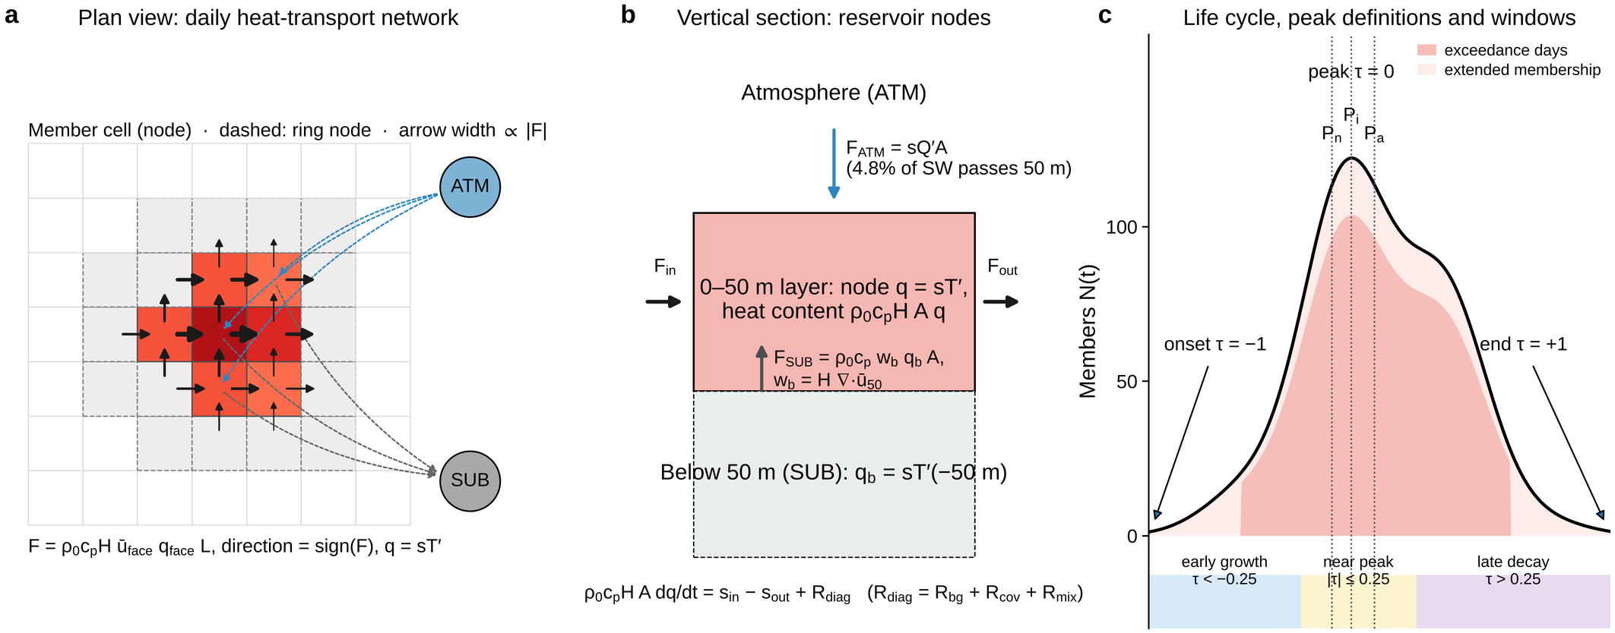
Supplementary Fig. 1 | Construction of the daily heat-transport network and life-cycle definitions. a, Plan view. Member cells of an object on a given day (shaded by q = sT′) and the surrounding ring of ocean cells (dashed) are nodes; every face between two nodes of which at least one is a member carries the anomaly heat flux F = ρ₀c_{p}H ū_{face} q_{face} L (arrows, width proportional to |F|), directed along the transport of the anomaly. Two reservoir nodes, ATM and SUB, exchange heat with every member cell (dashed arrows; only three are drawn). b, Vertical section. The node holds the anomaly heat content of the 0–50 m layer; F_{ATM} is the anomaly of the net surface heat flux retained in the layer and F_{SUB} the vertical anomaly flux through the base, with the base velocity diagnosed from the divergence of the layer flow (equation S4). The node balance (equation S8), ρ₀c_{p}HA dq/dt = s_{in} − s_{out} + R_{diag}, makes the net node strength equal to the heat-flux convergence; the diagnostic residual R_{diag} collects the background, vertical-covariance and mixing terms. c, Membership N(t) of a schematic object: exceedance days (dark) are extended to the local extrema of the anomaly (light); the three peak definitions P_{n} (maximum N), P_{i} (maximum integrated anomaly) and P_{a} (maximum cell amplitude) are marked, and the normalized time τ (equation S2) defines the early-growth, near-peak and late-decay windows.
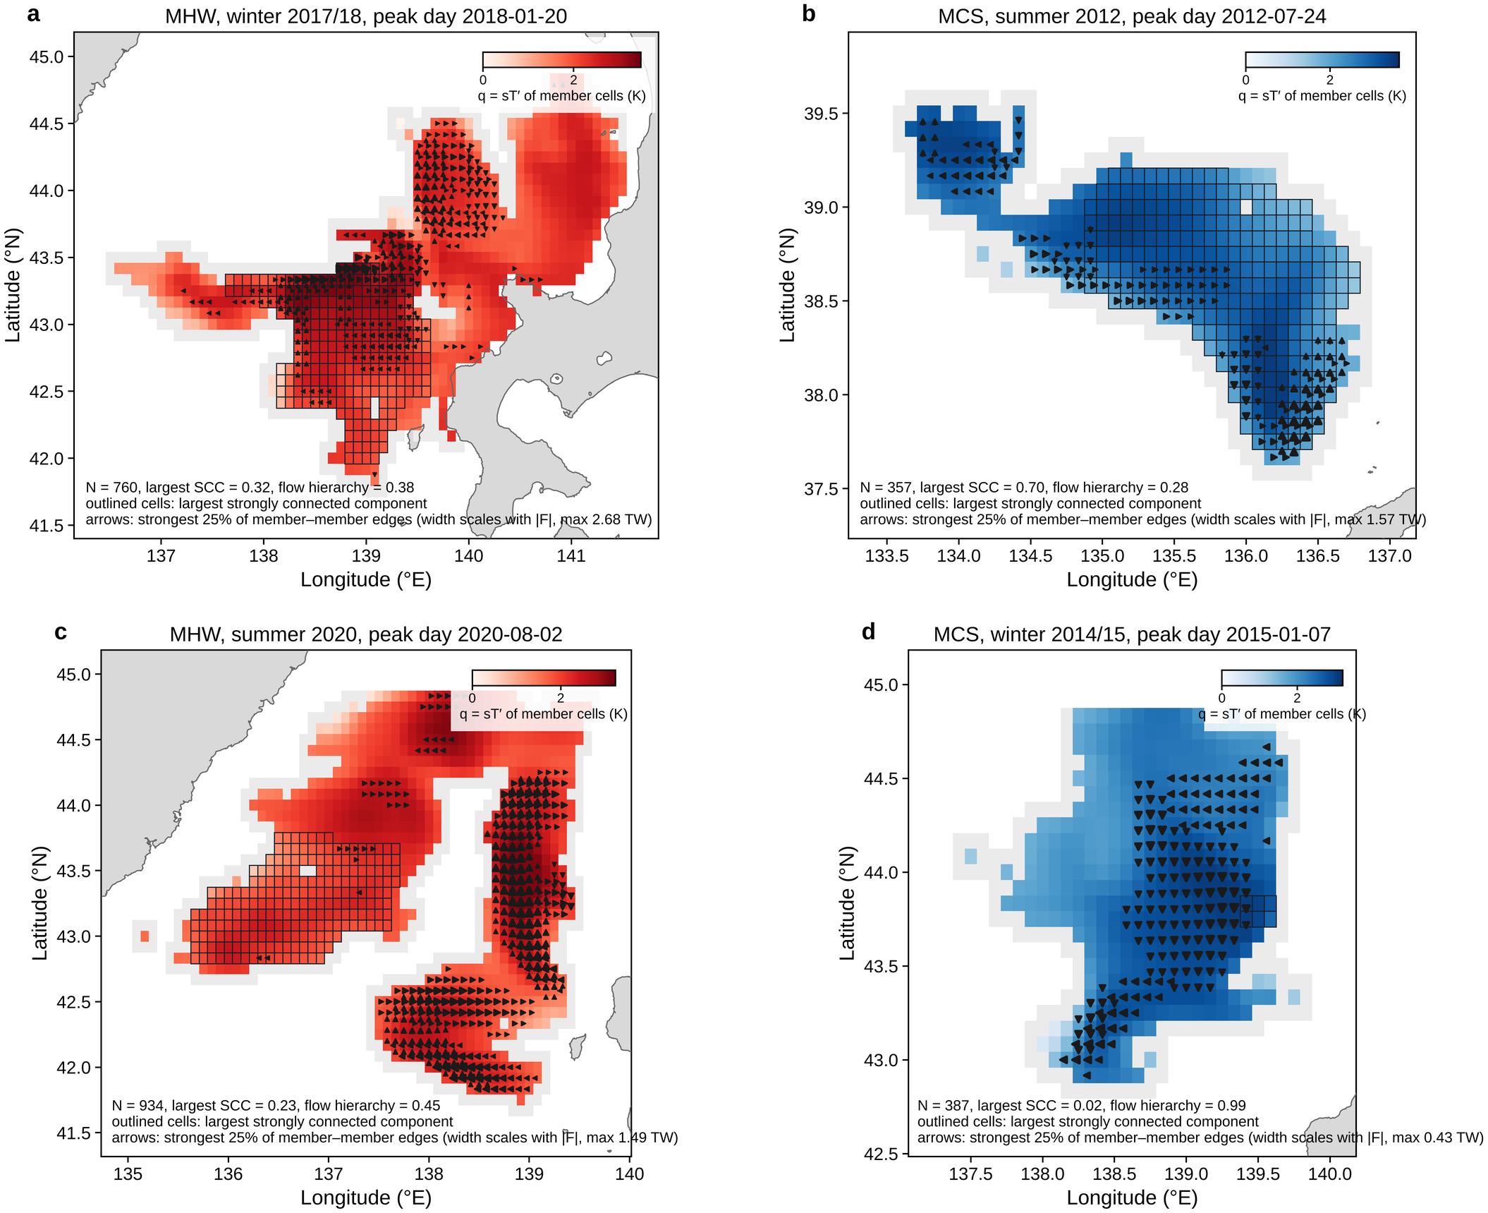
Supplementary Fig. 2 | Peak-day networks of the four events of the companion Letter. Member cells are shaded by the anomaly q (color bar in each panel; red scale for MHWs, blue for MCSs; ring cells grey), cells belonging to the largest strongly connected component are outlined, and the strongest 25% of member–member edges are drawn as arrows whose width scales with the flux. a, MHW of winter 2017/18 (object 3130) on 20 January 2018. b, MCS of summer 2012 (object 2406) on 24 July 2012. c, MHW of summer 2020 (object 2626) on 2 August 2020. d, MCS of winter 2014/15 (object 3762) on 7 January 2015. The number of member nodes N, the largest-SCC fraction and the flow hierarchy of the day are given in each panel; the coastline is grey.
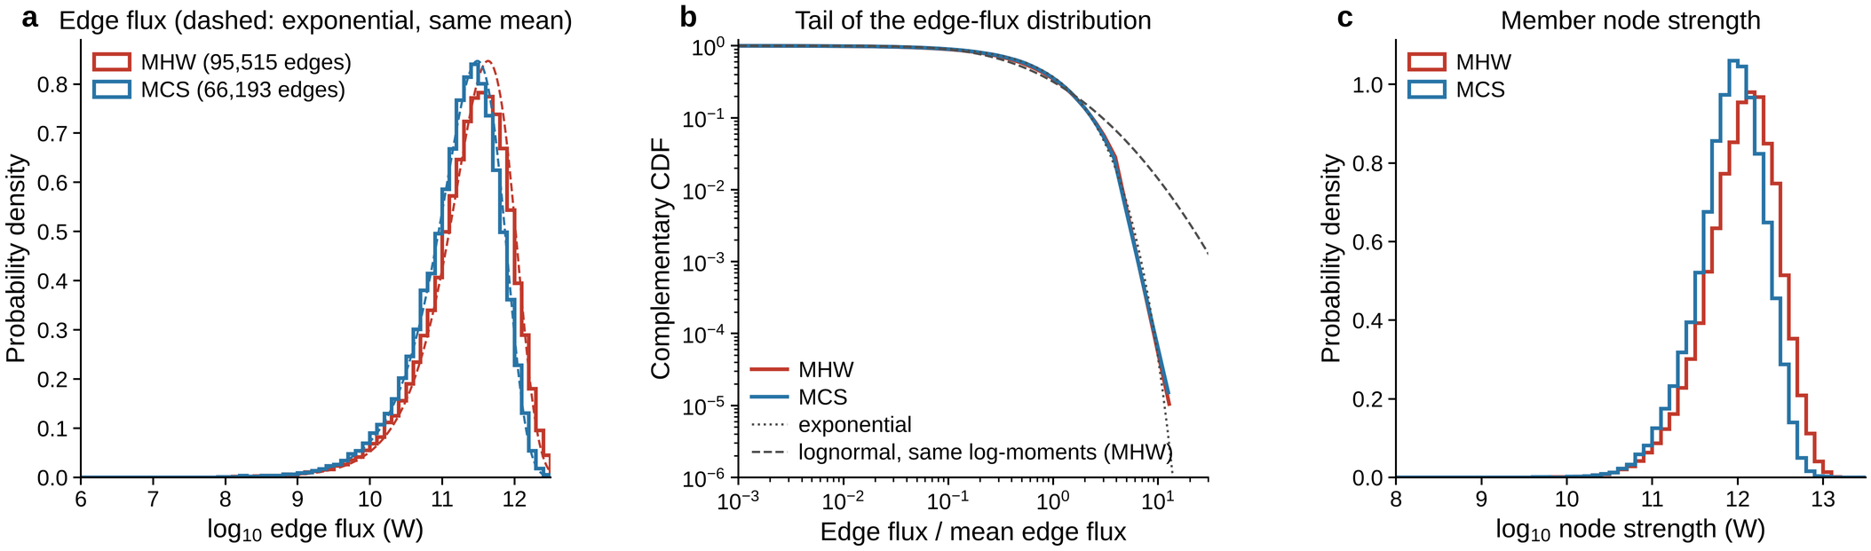
Supplementary Fig. 3 | Distribution of edge weights and node strengths on the peak days of all main-set objects. a, Probability density of log₁₀ of the member–member edge flux (W) pooled over the P_{i} peak days of 375 MHWs (red) and 297 MCSs (blue); dashed curves are the densities expected if the flux were exponentially distributed with the observed mean. b, Complementary cumulative distribution of the edge flux normalized by its mean, on logarithmic axes, with an exponential (dotted) and a lognormal with the same log-moments (dashed, MHW) for reference. c, Probability density of log₁₀ of the horizontal node strength (W) of the member nodes.
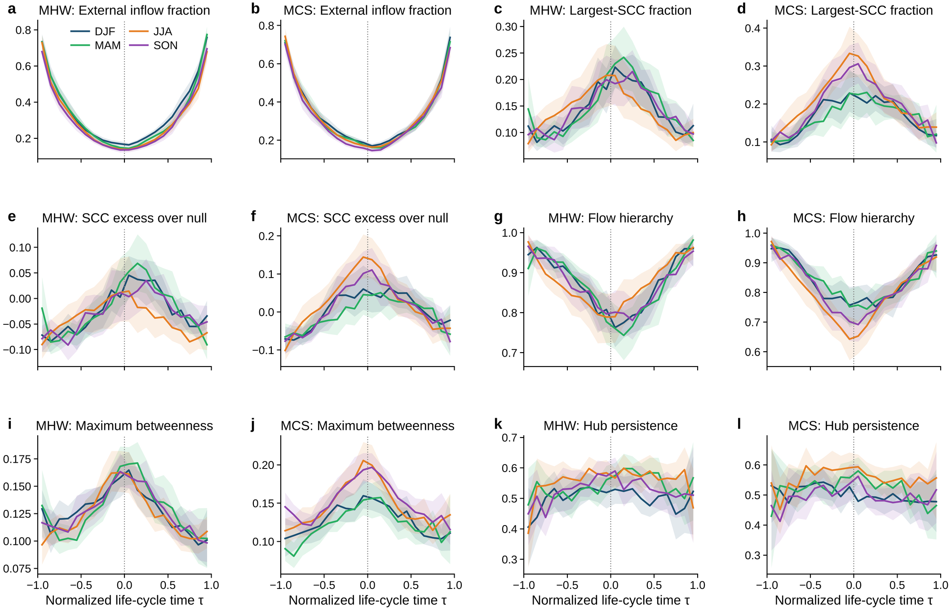
Supplementary Fig. 4 | Seasonal life-cycle composites. Composites on normalized life-cycle time τ of the external inflow fraction, largest-SCC fraction, SCC excess over the null, flow hierarchy, maximum betweenness and hub persistence for MHWs (left panel of each pair) and MCSs (right), separately for objects peaking in DJF (blue), MAM (green), JJA (orange) and SON (purple); shading, year-block bootstrap 95% confidence bands of the mean. Panels a–l as labeled.
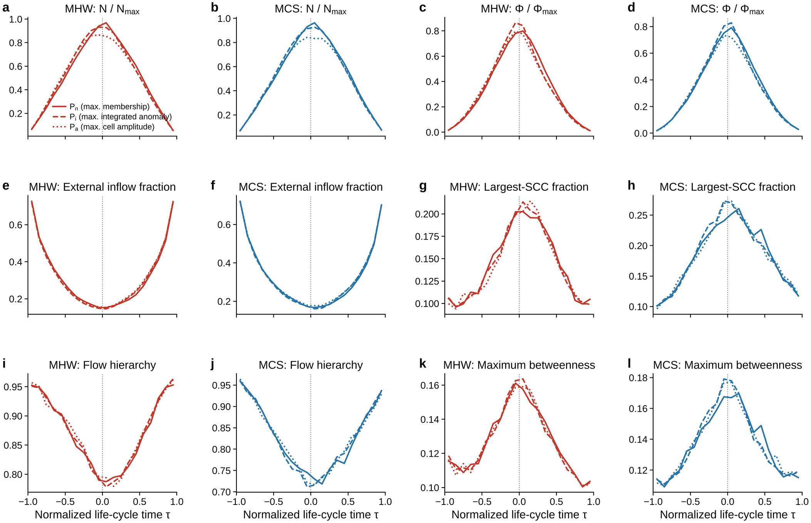
Supplementary Fig. 5 | Composites for the three peak definitions. Composites of normalized membership, normalized internal flux, external inflow fraction, largest-SCC fraction, flow hierarchy and maximum betweenness for MHWs (red) and MCSs (blue) with the life cycle normalized around P_{n} (solid), P_{i} (dashed) and P_{a} (dotted). Panels a–l as labeled.
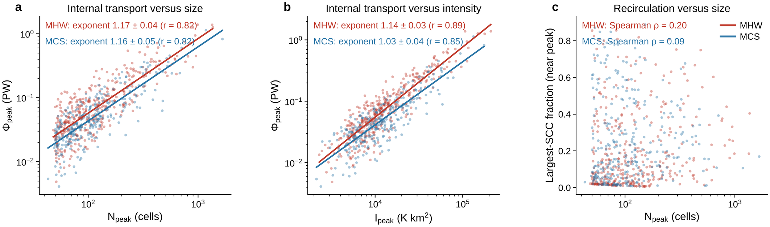
Supplementary Fig. 6 | Scaling of internal transport and recirculation with event size and intensity. a, Peak internal flux Φ_{peak} versus peak membership N_{peak} with power-law fits (exponents ± s.e.). b, Φ_{peak} versus peak integrated anomaly I_{peak}. c, Near-peak largest-SCC fraction versus N_{peak} with Spearman correlations. Red, MHWs; blue, MCSs.
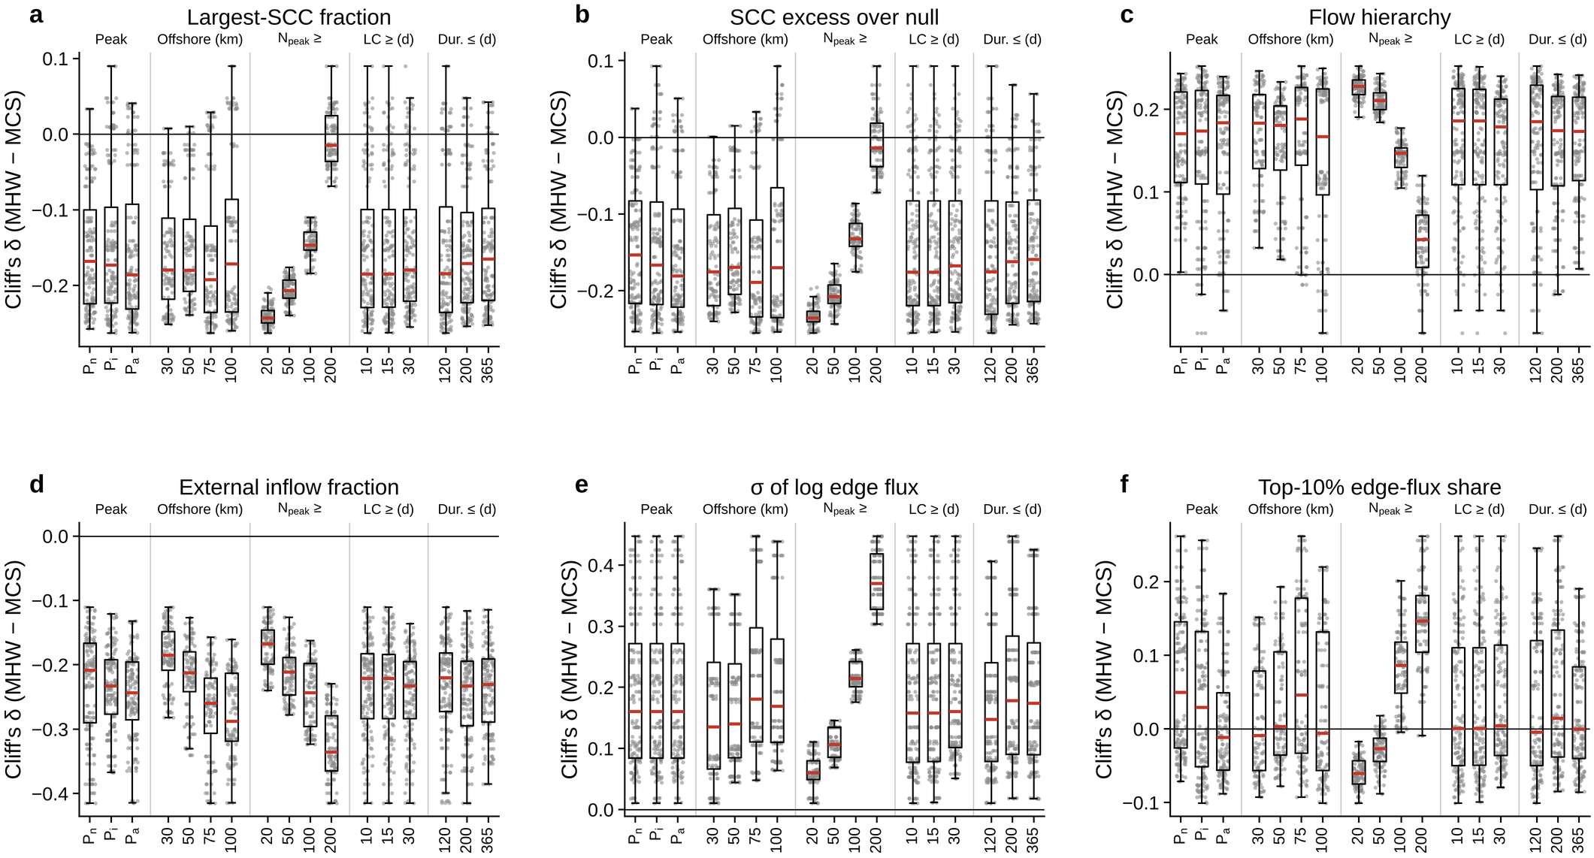
Supplementary Fig. 7 | Warm–cold contrasts by sensitivity factor. For six near-peak features (a–f), Cliff's δ (MHW − MCS) over the 432 settings, grouped by the level of each factor: peak definition, offshore distance of the peak cell, size threshold N_{peak}, life-cycle threshold (LC) and exceedance-duration cut-off (Dur.). Boxes show the median (red) and quartiles over the other factors, whiskers the 5th–95th percentiles and dots the individual settings. The recirculation contrasts (a–c) vanish only for the size threshold N_{peak} ≥ 200; the external-inflow contrast (d) strengthens with the offshore distance and with size; the lognormal-width contrast (e) strengthens with size; the top-10% share (f) shows no consistent contrast.
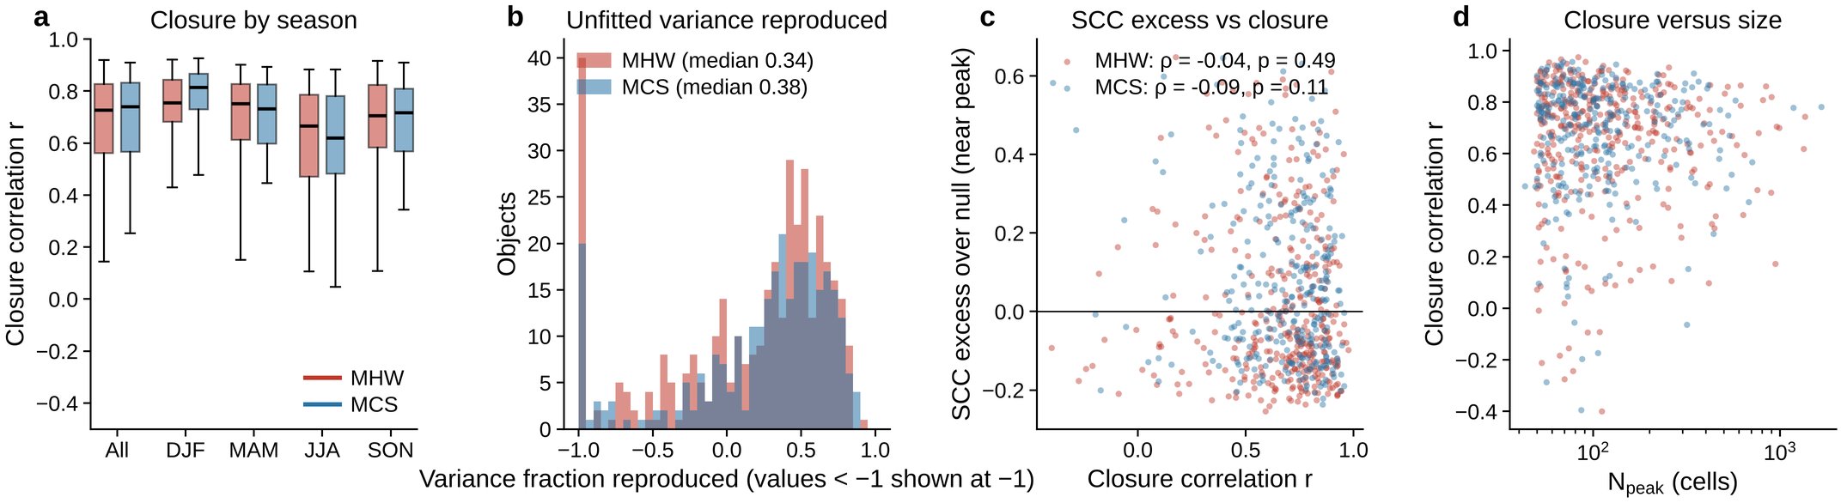
Supplementary Fig. 8 | Budget closure. a, Closure correlation r between the object-mean network convergence and the observed tendency of the object-mean anomaly across the life cycle, for all main-set objects and by season of the peak (boxes: median, quartiles, 5–95%). b, Fraction of the tendency variance reproduced by the network convergence without a fitted coefficient (values below −1 are shown at −1). c, Near-peak SCC excess over the null versus closure correlation, with Spearman correlations (no significant monotonic association). d, Closure correlation versus N_{peak}. Red, MHWs; blue, MCSs.
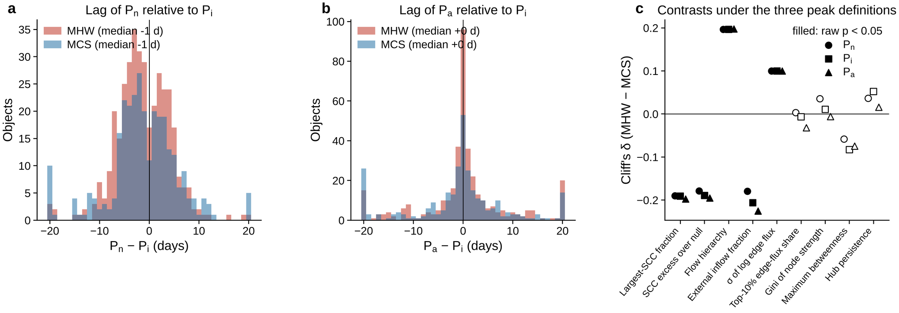
Supplementary Fig. 9 | Lags between the peak definitions and independence of the contrasts. a, Distribution of P_{n} − P_{i} (days; values beyond ±20 d collected in the end bins). b, Distribution of P_{a} − P_{i}. c, Cliff's δ (MHW − MCS) of nine near-peak features for the three peak definitions (circles P_{n}, squares P_{i}, triangles P_{a}; filled symbols, raw two-sided Mann–Whitney p < 0.05, without FDR adjustment).
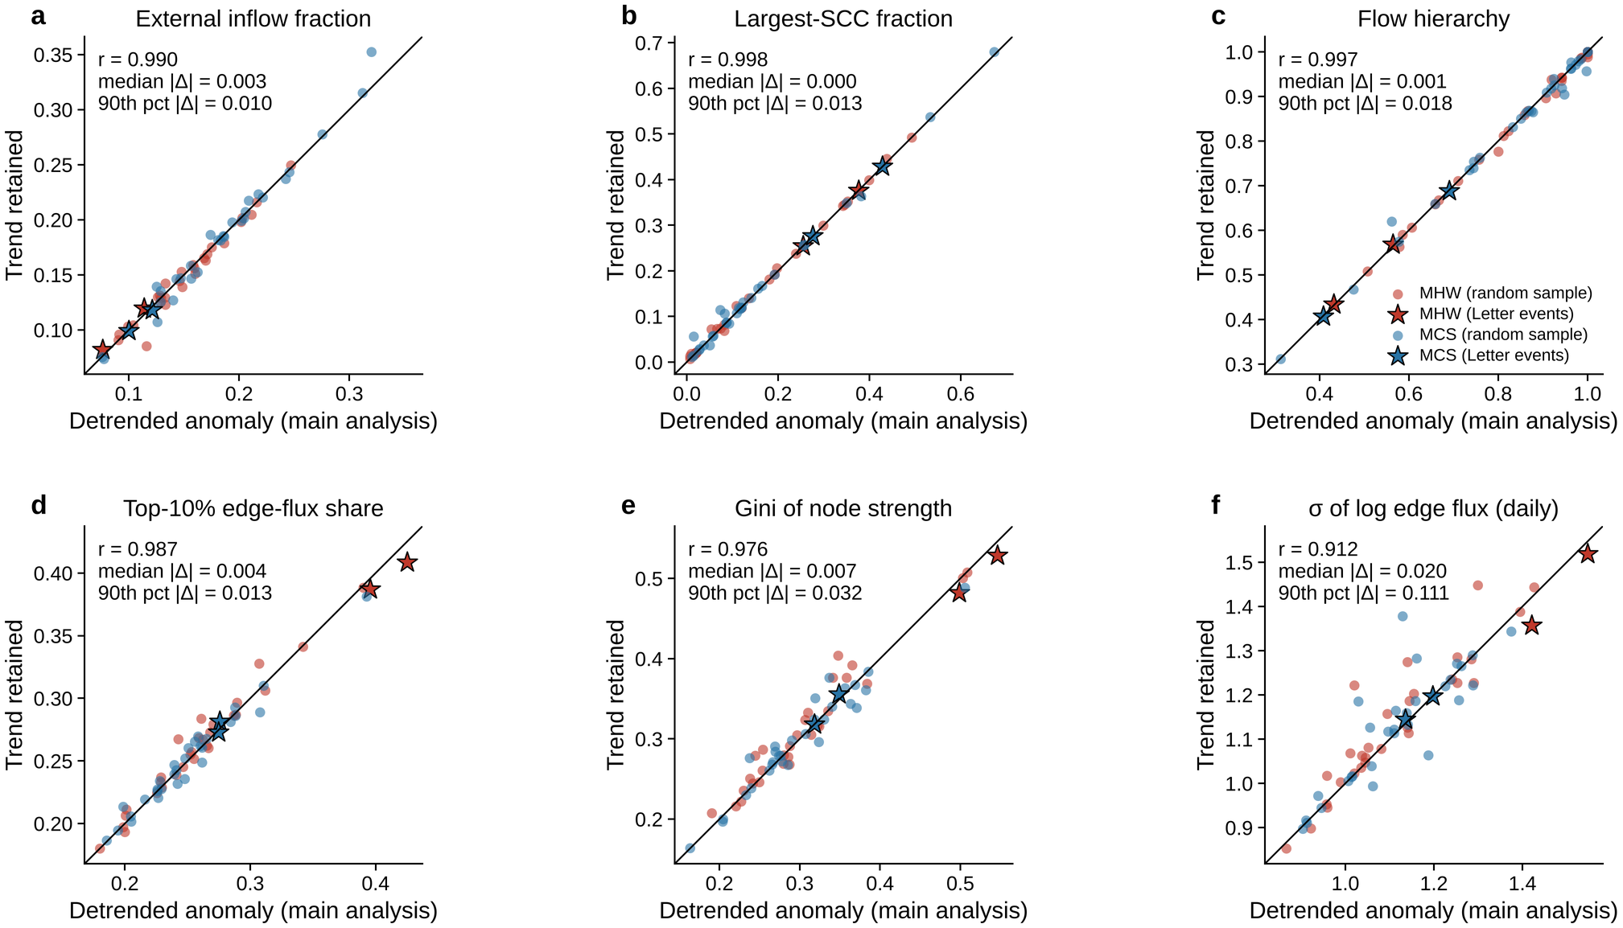
Supplementary Fig. 10 | Sensitivity of the network topology to the tested background perturbation. Near-peak window means of six network features for 63 objects (the four events of the companion Letter, stars, and 59 objects drawn at random from the main set, dots; red, MHWs; blue, MCSs) computed with the anomaly defined relative to the seasonal climatology plus linear trend (horizontal axis; the main analysis) and relative to the seasonal climatology alone (vertical axis; trend retained), on the fixed catalogue and with fixed life-cycle windows. The line is the identity; r is the correlation across objects and |Δ| the absolute difference between the two versions. a, External inflow fraction. b, Largest-SCC fraction. c, Flow hierarchy. d, Top-10% edge-flux share. e, Gini coefficient of node strength. f, Daily σ of log edge flux.
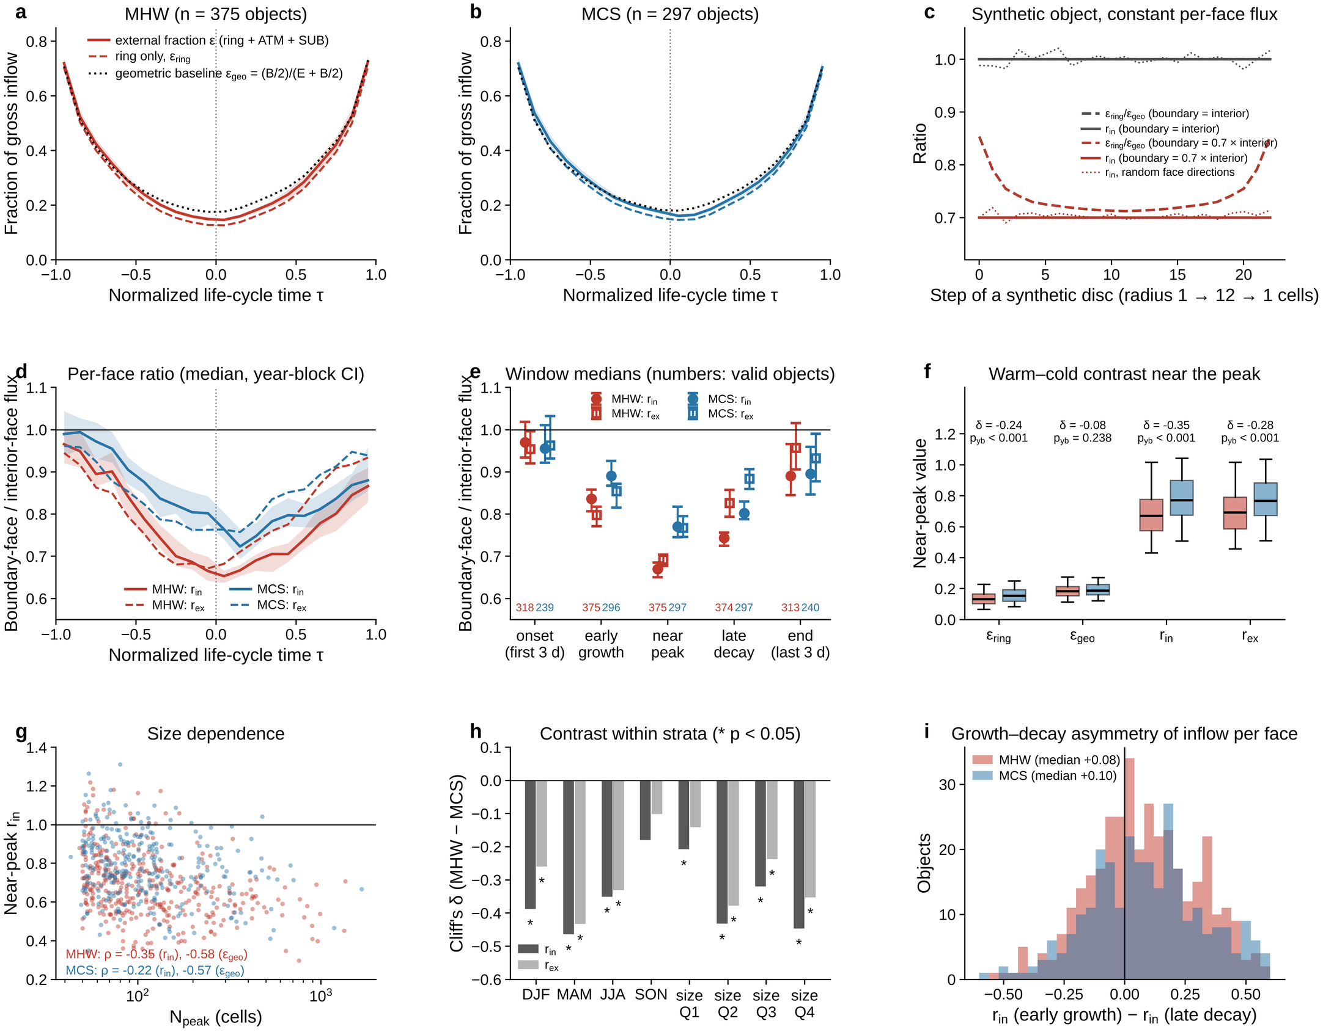
Supplementary Fig. 11 | Geometric baseline of the external inflow fraction and the flux per boundary face (Supplementary Note 6). a, b, Composites on normalized life-cycle time τ of the external inflow fraction (ring + ATM + SUB; solid, with year-block 95% bands of the mean), the ring-only fraction ε_{ring} (dashed) and the geometric baseline ε_{geo} = (B/2)/(E_{geo} + B/2) (dotted; B boundary faces and E_{geo} interior faces, both counted from the mask) for MHWs (a) and MCSs (b). c, Synthetic disc growing from 1 to 12 cells in radius and shrinking again with the same flux on every face: the ratio of fractions ε_{ring}/ε_{geo} (dashed) and the per-face ratio r_{in} (solid) for a boundary flux equal to (grey) and 0.7 times (red) the interior flux; dotted, r_{in} with random face directions (mean of 200 draws). d, Composites of r_{in} (solid, median over objects of the per-object bin median, with year-block 95% band from 500 resamples) and r_{ex} (dashed) along τ. e, Window medians of r_{in} (circles) and r_{ex} (squares) with 95% year-block confidence intervals (1,000 resamples); the numbers give the objects with a valid value (Φ > 0, E_{geo} > 0, B > 0) in each window (onset and end are the first and last three days; early growth, near peak and late decay are the windows of Supplementary Methods 4 restricted to days with ≥10 member cells). f, Near-peak ε_{ring}, ε_{geo}, r_{in} and r_{ex} of MHWs (red) and MCSs (blue): boxes, median and quartiles; whiskers, 5th–95th percentiles; Cliff's δ (MHW − MCS) and the within-year permutation p (p_{yb}) above each pair. g, Near-peak r_{in} versus N_{peak} with Spearman correlations of r_{in} and of ε_{geo} with N_{peak}. h, Cliff's δ of the near-peak r_{in} (dark) and r_{ex} (light) contrast within seasons and within quartiles of N_{peak} (asterisks, Mann–Whitney p < 0.05). i, Distribution over objects of the difference between the early-growth and the late-decay r_{in}.
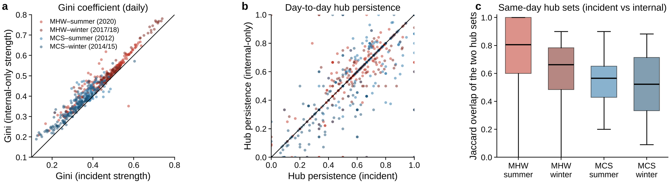
Supplementary Fig. 12 | Sensitivity to the definition of node strength in the four events of the companion Letter (Supplementary Note 7). Daily values on days with ≥10 member cells. a, Gini coefficient of node strength computed from the incident horizontal strength (including faces shared with ring cells; main analysis) against the Gini coefficient computed from the internal-only strength (member–member edges). b, Day-to-day hub persistence (Jaccard similarity of consecutive top-5% hub sets) for the two definitions. c, Jaccard overlap of the two same-day top-5% hub sets. Lines in a and b are the identity. The internal-only Gini coefficient exceeds the incident one by 0.01–0.05 (phase means; Supplementary Table 17), the hub persistence differs by 0.00–0.06, and the same-day hub sets overlap with median Jaccard similarities of 0.52–0.80.

Supplementary Tables
Supplementary Table 1 | Sample sizes and basic properties of the analysed objects for the processing set, the main set and the size/offshore variants of the main set (peak definition P_i).
Selection | Phenomenon | n | DJF/MAM/JJA/SON | Median N_peak (cells) | Median life cycle (d) | Median Φ_peak (TW) | Median closure r | Fraction r > 0.5
Processing set (≥30 km, N_peak ≥ 20, ≥10 d, ≤365 d) | MHW | 849 | 226/191/208/224 | 48 | 43 | 26.4 | 0.74 | 0.81
Processing set (≥30 km, N_peak ≥ 20, ≥10 d, ≤365 d) | MCS | 784 | 211/165/200/208 | 45 | 49 | 20.5 | 0.74 | 0.81
Main set (≥50 km, N_peak ≥ 50, ≥15 d, ≤200 d) | MHW | 375 | 103/85/101/86 | 98 | 56 | 63.5 | 0.73 | 0.81
Main set (≥50 km, N_peak ≥ 50, ≥15 d, ≤200 d) | MCS | 297 | 80/64/79/74 | 95 | 66 | 43.2 | 0.74 | 0.82
Main set with N_peak ≥ 20 | MHW | 765 | 203/176/180/206 | 48 | 44 | 26.6 | 0.75 | 0.82
Main set with N_peak ≥ 20 | MCS | 667 | 180/141/171/175 | 44 | 49 | 19.9 | 0.75 | 0.81
Main set with N_peak ≥ 50 | MHW | 375 | 103/85/101/86 | 98 | 56 | 63.5 | 0.73 | 0.81
Main set with N_peak ≥ 50 | MCS | 297 | 80/64/79/74 | 95 | 66 | 43.2 | 0.74 | 0.82
Main set with N_peak ≥ 100 | MHW | 186 | 48/40/49/49 | 172 | 68 | 123.6 | 0.71 | 0.83
Main set with N_peak ≥ 100 | MCS | 148 | 46/31/36/35 | 149 | 82 | 81.4 | 0.73 | 0.85
Main set with N_peak ≥ 200 | MHW | 82 | 20/12/22/28 | 318 | 91 | 258.6 | 0.7 | 0.79
Main set with N_peak ≥ 200 | MCS | 56 | 18/12/15/11 | 308 | 106 | 167.5 | 0.73 | 0.86
Main set with offshore ≥ 30km | MHW | 404 | 109/90/113/92 | 95 | 56 | 62.6 | 0.72 | 0.81
Main set with offshore ≥ 30km | MCS | 345 | 92/75/92/86 | 97 | 65 | 46.4 | 0.72 | 0.83
Main set with offshore ≥ 50km | MHW | 375 | 103/85/101/86 | 98 | 56 | 63.5 | 0.73 | 0.81
Main set with offshore ≥ 50km | MCS | 297 | 80/64/79/74 | 95 | 66 | 43.2 | 0.74 | 0.82
Main set with offshore ≥ 75km | MHW | 309 | 88/66/83/72 | 98 | 57 | 65.8 | 0.73 | 0.82
Main set with offshore ≥ 75km | MCS | 230 | 70/51/58/51 | 100 | 67 | 43.4 | 0.75 | 0.85
Main set with offshore ≥ 100km | MHW | 262 | 71/59/72/60 | 95 | 60 | 66.3 | 0.72 | 0.81
Main set with offshore ≥ 100km | MCS | 178 | 53/41/41/43 | 102 | 70 | 46.4 | 0.73 | 0.84

Supplementary Table 2 | Life-cycle tests between windows (main set, all seasons): paired Wilcoxon signed-rank tests, year-block bootstrap 95% confidence intervals of the median difference and Benjamini–Hochberg FDR across the tests of each phenomenon.
Phenomenon | Metric | Comparison | Expected sign | n | Median a | Median b | Median difference [95% CI] | Fraction of objects with expected sign | p (Wilcoxon) | p_FDR
MHW | External inflow fraction | near peak vs early growth | a < b | 375 | 0.152 | 0.28 | -0.125 [-0.135, -0.113] | 0.97 | 1.4 × 10⁻⁶² | 9.9 × 10⁻⁶²
MHW | External inflow fraction | near peak vs late decay | a < b | 374 | 0.152 | 0.278 | -0.125 [-0.134, -0.120] | 0.96 | 2.2 × 10⁻⁶² | 1.0 × 10⁻⁶¹
MHW | External inflow fraction | near peak vs onset (first 3 d) | a < b | 375 | 0.152 | 0.736 | -0.575 [-0.599, -0.555] | 0.99 | 1.8 × 10⁻⁶³ | 2.5 × 10⁻⁶²
MHW | Largest-SCC fraction | near peak vs early growth | a > b | 375 | 0.111 | 0.079 | +0.019 [+0.003, +0.042] | 0.58 | 3.8 × 10⁻¹¹ | 5.9 × 10⁻¹¹
MHW | Largest-SCC fraction | near peak vs late decay | a > b | 374 | 0.111 | 0.094 | +0.002 [-0.009, +0.025] | 0.51 | 3.5 × 10⁻⁵ | 4.5 × 10⁻⁵
MHW | SCC excess over null | near peak vs early growth | a > b | 375 | -0.057 | -0.074 | +0.016 [+0.001, +0.046] | 0.57 | 2.3 × 10⁻⁹ | 3.2 × 10⁻⁹
MHW | Flow hierarchy | near peak vs early growth | a < b | 375 | 0.896 | 0.945 | -0.040 [-0.064, -0.020] | 0.64 | 1.1 × 10⁻²⁰ | 3.1 × 10⁻²⁰
MHW | Flow hierarchy | near peak vs late decay | a < b | 374 | 0.897 | 0.928 | -0.024 [-0.045, -0.011] | 0.58 | 2.9 × 10⁻¹² | 5.1 × 10⁻¹²
MHW | Maximum betweenness | near peak vs early growth | a > b | 375 | 0.14 | 0.116 | +0.029 [+0.020, +0.036] | 0.70 | 2.7 × 10⁻²⁰ | 6.4 × 10⁻²⁰
MHW | Maximum betweenness | near peak vs late decay | a > b | 374 | 0.14 | 0.112 | +0.031 [+0.026, +0.037] | 0.71 | 1.5 × 10⁻¹⁹ | 2.9 × 10⁻¹⁹
MHW | Hub persistence | near peak vs early growth | a > b | 375 | 0.563 | 0.524 | +0.021 [-0.001, +0.054] | 0.55 | 6.3 × 10⁻⁵ | 7.4 × 10⁻⁵
MHW | Top-10% edge-flux share | near peak vs early growth | a ≠ b | 375 | 0.256 | 0.252 | +0.012 [+0.002, +0.019] | — | 0.003 | 0.003
MHW | Gini of node strength | near peak vs early growth | a ≠ b | 375 | 0.314 | 0.338 | -0.012 [-0.021, -0.002] | — | 0.0005 | 0.0005
MHW | Network convergence (K d⁻¹) | early growth vs late decay | a > b | 374 | 0.058 | -0.056 | +0.120 [+0.115, +0.135] | 0.93 | 2.7 × 10⁻⁵⁵ | 9.3 × 10⁻⁵⁵
MCS | External inflow fraction | near peak vs early growth | a < b | 296 | 0.171 | 0.303 | -0.130 [-0.142, -0.119] | 0.97 | 3.5 × 10⁻⁵⁰ | 2.4 × 10⁻⁴⁹
MCS | External inflow fraction | near peak vs late decay | a < b | 297 | 0.171 | 0.278 | -0.102 [-0.119, -0.095] | 0.94 | 3.2 × 10⁻⁴⁸ | 1.5 × 10⁻⁴⁷
MCS | External inflow fraction | near peak vs onset (first 3 d) | a < b | 297 | 0.171 | 0.774 | -0.587 [-0.615, -0.547] | 1.00 | 9.4 × 10⁻⁵¹ | 1.3 × 10⁻⁴⁹
MCS | Largest-SCC fraction | near peak vs early growth | a > b | 296 | 0.19 | 0.107 | +0.058 [+0.039, +0.068] | 0.66 | 1.3 × 10⁻¹⁵ | 2.3 × 10⁻¹⁵
MCS | Largest-SCC fraction | near peak vs late decay | a > b | 297 | 0.189 | 0.141 | +0.029 [+0.006, +0.046] | 0.59 | 1.2 × 10⁻⁸ | 1.5 × 10⁻⁸
MCS | SCC excess over null | near peak vs early growth | a > b | 296 | 0.029 | -0.043 | +0.057 [+0.039, +0.077] | 0.65 | 8.3 × 10⁻¹⁵ | 1.3 × 10⁻¹⁴
MCS | Flow hierarchy | near peak vs early growth | a < b | 296 | 0.78 | 0.913 | -0.084 [-0.108, -0.067] | 0.73 | 1.7 × 10⁻²³ | 4.7 × 10⁻²³
MCS | Flow hierarchy | near peak vs late decay | a < b | 297 | 0.78 | 0.866 | -0.051 [-0.073, -0.027] | 0.65 | 6.9 × 10⁻¹⁴ | 9.7 × 10⁻¹⁴
MCS | Maximum betweenness | near peak vs early growth | a > b | 296 | 0.149 | 0.119 | +0.034 [+0.025, +0.039] | 0.71 | 5.6 × 10⁻¹⁷ | 1.1 × 10⁻¹⁶
MCS | Maximum betweenness | near peak vs late decay | a > b | 297 | 0.148 | 0.118 | +0.029 [+0.021, +0.034] | 0.70 | 3.2 × 10⁻¹⁹ | 7.4 × 10⁻¹⁹
MCS | Hub persistence | near peak vs early growth | a > b | 296 | 0.561 | 0.538 | +0.034 [+0.011, +0.057] | 0.56 | 0.003 | 0.003
MCS | Top-10% edge-flux share | near peak vs early growth | a ≠ b | 296 | 0.26 | 0.249 | +0.012 [+0.007, +0.018] | — | 2.1 × 10⁻⁵ | 2.5 × 10⁻⁵
MCS | Gini of node strength | near peak vs early growth | a ≠ b | 296 | 0.313 | 0.327 | -0.011 [-0.021, -0.000] | — | 0.005 | 0.005
MCS | Network convergence (K d⁻¹) | early growth vs late decay | a > b | 296 | 0.033 | -0.083 | +0.120 [+0.106, +0.138] | 0.95 | 3.3 × 10⁻⁴⁷ | 1.2 × 10⁻⁴⁶

Supplementary Table 3 | Warm–cold contrasts of near-peak features (main set): two-sided Mann–Whitney U tests with Cliff's δ (MHW − MCS), FDR across features, within-year label permutation (1,000 permutations) and the phenomenon coefficient of an OLS model with log10 N_peak and season as covariates (year-clustered standard errors).
Near-peak feature | n (MHW/MCS) | Median MHW | Median MCS | Cliff's δ | p (Mann–Whitney) | p_FDR | p (within-year permutation) | Size-adjusted MHW − MCS | p (size-adjusted) | log10 N_peak coefficient
Top-10% edge-flux share | 375/297 | 0.256 | 0.259 | -0.007 | 0.883 | 0.883 | 0.344 | -0.0017 | 0.390 | +0.080 (1.6 × 10⁻⁶⁰)
Gini of node strength | 375/297 | 0.314 | 0.313 | 0.011 | 0.810 | 0.872 | 0.944 | -0.0019 | 0.529 | +0.126 (8.7 × 10⁻⁶⁶)
σ of log edge flux | 375/297 | 1.315 | 1.293 | 0.1 | 0.026 | 0.053 | 0.06 | 0.0217 | 0.034 | +0.083 (9.7 × 10⁻¹¹)
σ of log node strength | 375/297 | 0.703 | 0.676 | 0.055 | 0.223 | 0.345 | 0.2 | 0.0137 | 0.102 | +0.305 (2.9 × 10⁻⁷¹)
Largest-SCC fraction | 375/297 | 0.111 | 0.189 | -0.191 | 2.1 × 10⁻⁵ | 6.9 × 10⁻⁵ | 0.001 | -0.0562 | 0.0005 | +0.063 (0.030)
SCC excess over null | 375/297 | -0.057 | 0.028 | -0.189 | 2.5 × 10⁻⁵ | 6.9 × 10⁻⁵ | 0.001 | -0.0599 | 0.0001 | +0.148 (1.7 × 10⁻⁸)
Flow hierarchy | 375/297 | 0.896 | 0.78 | 0.197 | 1.2 × 10⁻⁵ | 5.4 × 10⁻⁵ | 0.001 | 0.0665 | 0.0002 | -0.146 (7.3 × 10⁻⁶)
Maximum betweenness | 375/297 | 0.14 | 0.148 | -0.083 | 0.065 | 0.114 | 0.176 | -0.0116 | 0.019 | -0.046 (7.5 × 10⁻⁶)
Hub persistence | 375/297 | 0.563 | 0.561 | 0.052 | 0.246 | 0.345 | 0.854 | 0.0146 | 0.051 | +0.074 (1.7 × 10⁻⁶)
External inflow fraction | 375/297 | 0.152 | 0.171 | -0.206 | 4.2 × 10⁻⁶ | 5.4 × 10⁻⁵ | 0.001 | -0.0157 | 0.0002 | -0.093 (4.1 × 10⁻⁴⁴)
External inflow fraction (early growth) | 375/296 | 0.28 | 0.303 | -0.149 | 0.0009 | 0.002 | 0.012 | -0.0193 | 0.002 | -0.095 (2.1 × 10⁻¹⁴)
Backbone flux share | 375/297 | 0.493 | 0.488 | 0.037 | 0.410 | 0.478 | 0.546 | 0.0025 | 0.654 | -0.007 (0.502)
Modularity | 375/297 | 0.689 | 0.693 | -0.039 | 0.387 | 0.478 | 0.336 | -0.0082 | 4.9 × 10⁻⁵ | +0.184 (< 10⁻³⁰⁰)
Flux fraction on cycles | 375/297 | 0.092 | 0.188 | -0.2 | 8.6 × 10⁻⁶ | 5.4 × 10⁻⁵ | 0.001 | -0.069 | 0.0004 | +0.181 (7.8 × 10⁻⁷)

Supplementary Table 4 | Seasonal differences within each phenomenon (Kruskal–Wallis across the four seasons, FDR across features) and the JJA-versus-DJF contrast.
Phenomenon | Near-peak feature | Median DJF | Median MAM | Median JJA | Median SON | p (Kruskal–Wallis) | p_FDR | Cliff's δ JJA − DJF | p (JJA vs DJF)
MHW | Top-10% edge-flux share | 0.258 | 0.268 | 0.249 | 0.251 | 0.034 | 0.16 | -0.14 | 0.075
MHW | Gini of node strength | 0.32 | 0.327 | 0.303 | 0.292 | 0.065 | 0.182 | -0.13 | 0.104
MHW | σ of log edge flux | 1.323 | 1.344 | 1.301 | 1.293 | 0.134 | 0.211 | -0.01 | 0.881
MHW | σ of log node strength | 0.717 | 0.757 | 0.668 | 0.666 | 0.011 | 0.08 | -0.12 | 0.152
MHW | Largest-SCC fraction | 0.111 | 0.114 | 0.097 | 0.116 | 0.487 | 0.568 | -0.11 | 0.171
MHW | SCC excess over null | -0.053 | -0.045 | -0.075 | -0.075 | 0.113 | 0.211 | -0.16 | 0.050
MHW | Flow hierarchy | 0.89 | 0.889 | 0.915 | 0.895 | 0.434 | 0.568 | 0.11 | 0.155
MHW | Maximum betweenness | 0.141 | 0.144 | 0.137 | 0.147 | 0.81 | 0.81 | -0.03 | 0.678
MHW | Hub persistence | 0.541 | 0.555 | 0.586 | 0.57 | 0.064 | 0.182 | 0.21 | 0.010
MHW | External inflow fraction | 0.168 | 0.149 | 0.139 | 0.144 | 0.0003 | 0.004 | -0.3 | 0.0002
MHW | External inflow fraction (early growth) | 0.283 | 0.301 | 0.26 | 0.286 | 0.115 | 0.211 | -0.14 | 0.083
MHW | Backbone flux share | 0.5 | 0.505 | 0.488 | 0.473 | 0.136 | 0.211 | -0.05 | 0.563
MHW | Modularity | 0.687 | 0.692 | 0.685 | 0.692 | 0.682 | 0.734 | -0.02 | 0.798
MHW | Flux fraction on cycles | 0.093 | 0.114 | 0.07 | 0.088 | 0.448 | 0.568 | -0.11 | 0.161
MCS | Top-10% edge-flux share | 0.266 | 0.264 | 0.259 | 0.248 | 0.076 | 0.207 | -0.16 | 0.089
MCS | Gini of node strength | 0.324 | 0.312 | 0.312 | 0.304 | 0.141 | 0.207 | -0.12 | 0.181
MCS | σ of log edge flux | 1.286 | 1.303 | 1.283 | 1.295 | 0.596 | 0.642 | 0.05 | 0.571
MCS | σ of log node strength | 0.7 | 0.676 | 0.676 | 0.632 | 0.138 | 0.207 | -0.11 | 0.248
MCS | Largest-SCC fraction | 0.178 | 0.129 | 0.25 | 0.202 | 0.107 | 0.207 | 0.18 | 0.051
MCS | SCC excess over null | 0.03 | -0.044 | 0.067 | 0.029 | 0.132 | 0.207 | 0.14 | 0.129
MCS | Flow hierarchy | 0.795 | 0.867 | 0.739 | 0.781 | 0.184 | 0.235 | -0.16 | 0.085
MCS | Maximum betweenness | 0.135 | 0.129 | 0.159 | 0.164 | 0.001 | 0.008 | 0.25 | 0.006
MCS | Hub persistence | 0.505 | 0.566 | 0.608 | 0.558 | 0.0006 | 0.008 | 0.38 | 3.3 × 10⁻⁵
MCS | External inflow fraction | 0.181 | 0.177 | 0.171 | 0.147 | 0.003 | 0.013 | -0.15 | 0.103
MCS | External inflow fraction (early growth) | 0.319 | 0.314 | 0.302 | 0.276 | 0.124 | 0.207 | -0.08 | 0.400
MCS | Backbone flux share | 0.494 | 0.489 | 0.483 | 0.479 | 0.962 | 0.962 | -0 | 0.993
MCS | Modularity | 0.707 | 0.692 | 0.693 | 0.689 | 0.148 | 0.207 | -0.11 | 0.230
MCS | Flux fraction on cycles | 0.174 | 0.145 | 0.255 | 0.195 | 0.313 | 0.365 | 0.14 | 0.120

Supplementary Table 5 | Recirculation relative to the direction-randomized null model: per-object SCC excess (observed − null) and hierarchy deficit (null − observed), medians with year-block 95% confidence intervals and one-sided Wilcoxon tests against zero.
Phenomenon | Season | Quantity | n | Median [95% year-block CI] | Fraction > 0 | p (Wilcoxon, > 0)
MHW | All | SCC excess, near peak | 375 | -0.057 [-0.078, -0.032] | 0.39 | 0.794
MHW | All | SCC excess, early growth | 375 | -0.074 [-0.080, -0.068] | 0.22 | 1.000
MHW | All | SCC excess, late decay | 374 | -0.052 [-0.061, -0.043] | 0.31 | 1.000
MHW | All | Hierarchy deficit (null − observed), near peak | 375 | -0.162 [-0.191, -0.148] | 0.29 | 1.000
MHW | DJF | SCC excess, near peak | 103 | -0.053 [-0.066, -0.006] | 0.42 | 0.452
MHW | DJF | SCC excess, early growth | 103 | -0.079 [-0.097, -0.074] | 0.18 | 1.000
MHW | DJF | SCC excess, late decay | 102 | -0.041 [-0.052, -0.030] | 0.32 | 0.995
MHW | DJF | Hierarchy deficit (null − observed), near peak | 103 | -0.143 [-0.171, -0.092] | 0.3 | 0.999
MHW | MAM | SCC excess, near peak | 85 | -0.045 [-0.075, +0.036] | 0.42 | 0.418
MHW | MAM | SCC excess, early growth | 85 | -0.062 [-0.077, -0.041] | 0.15 | 1.000
MHW | MAM | SCC excess, late decay | 85 | -0.043 [-0.074, -0.010] | 0.36 | 0.947
MHW | MAM | Hierarchy deficit (null − observed), near peak | 85 | -0.148 [-0.189, -0.064] | 0.29 | 0.997
MHW | JJA | SCC excess, near peak | 101 | -0.075 [-0.110, -0.027] | 0.33 | 0.925
MHW | JJA | SCC excess, early growth | 101 | -0.068 [-0.101, -0.055] | 0.29 | 1.000
MHW | JJA | SCC excess, late decay | 101 | -0.081 [-0.092, -0.057] | 0.2 | 1.000
MHW | JJA | Hierarchy deficit (null − observed), near peak | 101 | -0.200 [-0.233, -0.153] | 0.25 | 1.000
MHW | SON | SCC excess, near peak | 86 | -0.075 [-0.113, -0.011] | 0.4 | 0.714
MHW | SON | SCC excess, early growth | 86 | -0.095 [-0.114, -0.061] | 0.24 | 1.000
MHW | SON | SCC excess, late decay | 86 | -0.049 [-0.068, -0.025] | 0.36 | 0.968
MHW | SON | Hierarchy deficit (null − observed), near peak | 86 | -0.185 [-0.222, -0.128] | 0.3 | 1.000
MCS | All | SCC excess, near peak | 297 | +0.028 [-0.010, +0.059] | 0.54 | 1.9 × 10⁻⁵
MCS | All | SCC excess, early growth | 296 | -0.043 [-0.062, -0.030] | 0.35 | 1.000
MCS | All | SCC excess, late decay | 297 | -0.022 [-0.038, +0.004] | 0.43 | 0.731
MCS | All | Hierarchy deficit (null − observed), near peak | 297 | -0.069 [-0.104, -0.037] | 0.4 | 0.979
MCS | DJF | SCC excess, near peak | 80 | +0.030 [-0.027, +0.079] | 0.54 | 0.026
MCS | DJF | SCC excess, early growth | 79 | -0.060 [-0.072, -0.005] | 0.38 | 0.983
MCS | DJF | SCC excess, late decay | 80 | -0.016 [-0.034, +0.033] | 0.45 | 0.291
MCS | DJF | Hierarchy deficit (null − observed), near peak | 80 | -0.065 [-0.131, -0.014] | 0.36 | 0.998
MCS | MAM | SCC excess, near peak | 64 | -0.044 [-0.076, +0.049] | 0.44 | 0.400
MCS | MAM | SCC excess, early growth | 64 | -0.046 [-0.070, -0.016] | 0.31 | 0.999
MCS | MAM | SCC excess, late decay | 64 | -0.021 [-0.035, +0.025] | 0.44 | 0.532
MCS | MAM | Hierarchy deficit (null − observed), near peak | 64 | -0.130 [-0.181, -0.047] | 0.33 | 0.971
MCS | JJA | SCC excess, near peak | 79 | +0.067 [+0.020, +0.135] | 0.63 | 0.0002
MCS | JJA | SCC excess, early growth | 79 | -0.043 [-0.073, -0.009] | 0.39 | 0.641
MCS | JJA | SCC excess, late decay | 79 | -0.028 [-0.053, +0.022] | 0.43 | 0.843
MCS | JJA | Hierarchy deficit (null − observed), near peak | 79 | -0.033 [-0.072, +0.044] | 0.48 | 0.224
MCS | SON | SCC excess, near peak | 74 | +0.029 [-0.046, +0.165] | 0.51 | 0.007
MCS | SON | SCC excess, early growth | 74 | -0.036 [-0.074, -0.011] | 0.32 | 0.985
MCS | SON | SCC excess, late decay | 74 | -0.028 [-0.057, +0.016] | 0.41 | 0.715
MCS | SON | Hierarchy deficit (null − observed), near peak | 74 | -0.073 [-0.157, +0.085] | 0.41 | 0.676

Supplementary Table 6 | Scaling of peak internal transport Φ_peak and of near-peak topology with event size N_peak and intensity I_peak (ordinary least squares on log-transformed variables where indicated; Spearman correlations on the raw variables).
Set | y | x | Model | n | Slope b ± s.e. | Intercept a | Pearson r | p | Spearman ρ | p (Spearman)
MHW | Φ_peak | N_peak | log y = a + b log x | 375 | 1.165 ± 0.042 | -3.572 | 0.823 | 8.4 × 10⁻⁹⁴ | 0.77 | 7.0 × 10⁻⁷⁵
MHW | Φ_peak | I_peak | log y = a + b log x | 375 | 1.144 ± 0.030 | -5.837 | 0.895 | 8.0 × 10⁻¹³³ | 0.863 | 2.0 × 10⁻¹¹²
MHW | Largest-SCC fraction | N_peak | y = a + b log10 x | 375 | 0.109 ± 0.035 | -0.029 | 0.161 | 0.002 | 0.204 | 6.7 × 10⁻⁵
MHW | Top-10% share | N_peak | y = a + b log10 x | 375 | 0.088 ± 0.006 | 0.078 | 0.621 | 1.9 × 10⁻⁴¹ | 0.585 | 7.8 × 10⁻³⁶
MHW | Gini | N_peak | y = a + b log10 x | 375 | 0.139 ± 0.009 | 0.028 | 0.612 | 6.6 × 10⁻⁴⁰ | 0.578 | 9.0 × 10⁻³⁵
MHW | Max. betweenness | N_peak | y = a + b log10 x | 375 | -0.030 ± 0.012 | 0.217 | -0.132 | 0.011 | -0.121 | 0.019
MHW | σ of log edge flux | N_peak | y = a + b log10 x | 375 | 0.109 ± 0.026 | 1.095 | 0.213 | 3.1 × 10⁻⁵ | 0.228 | 8.5 × 10⁻⁶
MCS | Φ_peak | N_peak | log y = a + b log x | 297 | 1.158 ± 0.047 | -3.677 | 0.822 | 5.5 × 10⁻⁷⁴ | 0.788 | 5.1 × 10⁻⁶⁴
MCS | Φ_peak | I_peak | log y = a + b log x | 297 | 1.029 ± 0.037 | -5.503 | 0.851 | 1.5 × 10⁻⁸⁴ | 0.811 | 1.1 × 10⁻⁷⁰
MCS | Largest-SCC fraction | N_peak | y = a + b log10 x | 297 | -0.005 ± 0.045 | 0.263 | -0.007 | 0.906 | 0.089 | 0.127
MCS | Top-10% share | N_peak | y = a + b log10 x | 297 | 0.065 ± 0.007 | 0.128 | 0.491 | 1.9 × 10⁻¹⁹ | 0.511 | 4.0 × 10⁻²¹
MCS | Gini | N_peak | y = a + b log10 x | 297 | 0.102 ± 0.010 | 0.106 | 0.512 | 3.0 × 10⁻²¹ | 0.504 | 1.4 × 10⁻²⁰
MCS | Max. betweenness | N_peak | y = a + b log10 x | 297 | -0.067 ± 0.016 | 0.304 | -0.231 | 5.9 × 10⁻⁵ | -0.16 | 0.006
MCS | σ of log edge flux | N_peak | y = a + b log10 x | 297 | 0.037 ± 0.024 | 1.222 | 0.089 | 0.127 | 0.093 | 0.111
Both | Φ_peak | N_peak | log y = a + b log x | 672 | 1.171 ± 0.032 | -3.638 | 0.817 | 2.8 × 10⁻¹⁶² | 0.766 | 1.1 × 10⁻¹³⁰
Both | Φ_peak | I_peak | log y = a + b log x | 672 | 1.101 ± 0.024 | -5.72 | 0.867 | 5.1 × 10⁻²⁰⁵ | 0.826 | 3.3 × 10⁻¹⁶⁹
Both | Largest-SCC fraction | N_peak | y = a + b log10 x | 672 | 0.060 ± 0.028 | 0.098 | 0.083 | 0.032 | 0.147 | 0.0001
Both | Top-10% share | N_peak | y = a + b log10 x | 672 | 0.079 ± 0.004 | 0.098 | 0.572 | 1.3 × 10⁻⁵⁹ | 0.553 | 4.8 × 10⁻⁵⁵
Both | Gini | N_peak | y = a + b log10 x | 672 | 0.124 ± 0.007 | 0.059 | 0.575 | 2.6 × 10⁻⁶⁰ | 0.546 | 1.6 × 10⁻⁵³
Both | Max. betweenness | N_peak | y = a + b log10 x | 672 | -0.045 ± 0.010 | 0.254 | -0.178 | 3.3 × 10⁻⁶ | -0.141 | 0.0003
Both | σ of log edge flux | N_peak | y = a + b log10 x | 672 | 0.082 ± 0.018 | 1.141 | 0.173 | 6.8 × 10⁻⁶ | 0.182 | 2.0 × 10⁻⁶

Supplementary Table 7 | Sensitivity summary over the 432 combinations of peak definition (P_n, P_i, P_a), offshore distance (30, 50, 75, 100 km), size threshold (N_peak ≥ 20, 50, 100, 200), life-cycle threshold (10, 15, 30 d) and exceedance-duration cut-off (120, 200, 365 d). The full set of 432 results is provided in Supplementary Data 1.
Test | Phenomenon | Feature | Settings | Median effect | Effect range | Fraction same sign as median | Fraction p < 0.05 | Fraction significant with same sign | Fraction size-adjusted p < 0.05
Warm–cold contrast (Cliff's δ) | MHW vs MCS | Backbone flux share | 432 | 0.026 | [-0.084, +0.302] | 0.64 | 0.16 | 0.08 | 0.31
Warm–cold contrast (Cliff's δ) | MHW vs MCS | Maximum betweenness | 432 | -0.057 | [-0.127, +0.112] | 0.76 | 0.23 | 0.23 | 0.36
Warm–cold contrast (Cliff's δ) | MHW vs MCS | Flux fraction on cycles | 432 | -0.18 | [-0.253, +0.104] | 0.92 | 0.65 | 0.65 | 0.57
Warm–cold contrast (Cliff's δ) | MHW vs MCS | External inflow fraction (early growth) | 432 | -0.139 | [-0.450, -0.055] | 1 | 0.75 | 0.75 | 0.50
Warm–cold contrast (Cliff's δ) | MHW vs MCS | External inflow fraction | 432 | -0.229 | [-0.415, -0.110] | 1 | 1 | 1 | 0.90
Warm–cold contrast (Cliff's δ) | MHW vs MCS | Gini of node strength | 432 | 0.054 | [-0.099, +0.305] | 0.62 | 0.28 | 0.2 | 0.50
Warm–cold contrast (Cliff's δ) | MHW vs MCS | Flow hierarchy | 432 | 0.181 | [-0.071, +0.252] | 0.96 | 0.69 | 0.69 | 0.65
Warm–cold contrast (Cliff's δ) | MHW vs MCS | Hub persistence | 432 | 0.008 | [-0.122, +0.119] | 0.57 | 0.04 | 0.04 | 0.15
Warm–cold contrast (Cliff's δ) | MHW vs MCS | σ of log node strength | 432 | 0.131 | [-0.055, +0.423] | 0.83 | 0.5 | 0.5 | 0.69
Warm–cold contrast (Cliff's δ) | MHW vs MCS | Modularity | 432 | -0.033 | [-0.345, +0.078] | 0.72 | 0.14 | 0.14 | 0.94
Warm–cold contrast (Cliff's δ) | MHW vs MCS | SCC excess over null | 432 | -0.175 | [-0.255, +0.093] | 0.9 | 0.62 | 0.62 | 0.60
Warm–cold contrast (Cliff's δ) | MHW vs MCS | Largest-SCC fraction | 432 | -0.182 | [-0.263, +0.090] | 0.89 | 0.69 | 0.69 | 0.55
Warm–cold contrast (Cliff's δ) | MHW vs MCS | σ of log edge flux | 432 | 0.161 | [+0.011, +0.448] | 1 | 0.78 | 0.78 | 0.74
Warm–cold contrast (Cliff's δ) | MHW vs MCS | Top-10% edge-flux share | 432 | 0.002 | [-0.101, +0.262] | 0.51 | 0.16 | 0.06 | 0.43
Life-cycle effect (near peak − early growth) | MCS | Maximum betweenness | 432 | 0.025 | [+0.011, +0.038] | 1 | 1 | 1 | —
Life-cycle effect (near peak − early growth) | MCS | External inflow fraction | 432 | -0.121 | [-0.143, -0.095] | 1 | 1 | 1 | —
Life-cycle effect (near peak − early growth) | MCS | Flow hierarchy | 432 | -0.096 | [-0.166, -0.045] | 1 | 1 | 1 | —
Life-cycle effect (near peak − early growth) | MCS | Gini of node strength | 432 | -0.003 | [-0.014, +0.019] | 0.67 | 0.35 | 0.34 | —
Life-cycle effect (near peak − early growth) | MCS | Hub persistence | 432 | 0.034 | [-0.002, +0.063] | 0.99 | 0.85 | 0.85 | —
Life-cycle effect (near peak − early growth) | MCS | SCC excess over null | 432 | 0.058 | [+0.023, +0.115] | 1 | 1 | 1 | —
Life-cycle effect (near peak − early growth) | MCS | Largest-SCC fraction | 432 | 0.058 | [+0.027, +0.123] | 1 | 1 | 1 | —
Life-cycle effect (near peak − early growth) | MCS | Top-10% edge-flux share | 432 | 0.016 | [+0.007, +0.026] | 1 | 0.97 | 0.97 | —
Life-cycle effect (near peak − early growth) | MHW | Maximum betweenness | 432 | 0.026 | [+0.017, +0.039] | 1 | 1 | 1 | —
Life-cycle effect (near peak − early growth) | MHW | External inflow fraction | 432 | -0.118 | [-0.134, -0.098] | 1 | 1 | 1 | —
Life-cycle effect (near peak − early growth) | MHW | Flow hierarchy | 432 | -0.048 | [-0.129, +0.000] | 0.84 | 1 | 0.84 | —
Life-cycle effect (near peak − early growth) | MHW | Gini of node strength | 432 | -0.006 | [-0.026, +0.022] | 0.56 | 0.52 | 0.47 | —
Life-cycle effect (near peak − early growth) | MHW | Hub persistence | 432 | 0.032 | [+0.011, +0.084] | 1 | 0.99 | 0.99 | —
Life-cycle effect (near peak − early growth) | MHW | SCC excess over null | 432 | 0.033 | [-0.009, +0.106] | 0.78 | 0.97 | 0.78 | —
Life-cycle effect (near peak − early growth) | MHW | Largest-SCC fraction | 432 | 0.027 | [-0.011, +0.096] | 0.75 | 1 | 0.75 | —
Life-cycle effect (near peak − early growth) | MHW | Top-10% edge-flux share | 432 | 0.013 | [-0.001, +0.031] | 1 | 0.8 | 0.8 | —
SCC excess over null, near peak | MCS | SCC excess, near peak | 432 | 0.042 | [-0.051, +0.130] | 0.75 | 0.84 | 0.75 | —
SCC excess over null, near peak | MHW | SCC excess, near peak | 432 | -0.041 | [-0.116, +0.164] | 0.7 | 0.45 | 0.15 | —

Supplementary Table 8 | (a) Lags between the three peak definitions in the main set.
Phenomenon | Lag | n | Median lag (d) [IQR] | Fraction within ±5 d | Fraction within ±10 d | Fraction with first before second
MHW | P_n − P_i | 375 | -1 [-4, +2] | 0.74 | 0.95 | 0.58
MHW | P_a − P_i | 375 | +0 [-2, +2] | 0.7 | 0.79 | 0.35
MHW | P_n − P_a | 375 | -2 [-6, +3] | 0.56 | 0.8 | 0.58
MCS | P_n − P_i | 297 | -1 [-5, +3] | 0.7 | 0.87 | 0.56
MCS | P_a − P_i | 297 | +0 [-3, +3] | 0.61 | 0.76 | 0.42
MCS | P_n − P_a | 297 | -1 [-6, +5] | 0.49 | 0.72 | 0.53

Supplementary Table 8 | (b) Warm–cold contrasts of near-peak features for each peak definition (main filter).
Near-peak feature | P_n: median MHW / MCS | P_n: Cliff's δ (p) | P_i: median MHW / MCS | P_i: Cliff's δ (p) | P_a: median MHW / MCS | P_a: Cliff's δ (p)
Largest-SCC fraction | 0.097 / 0.183 | -0.190 (2.3 × 10⁻⁵) | 0.111 / 0.189 | -0.191 (2.1 × 10⁻⁵) | 0.111 / 0.185 | -0.198 (1.1 × 10⁻⁵)
SCC excess over null | -0.053 / 0.028 | -0.179 (6.7 × 10⁻⁵) | -0.057 / 0.028 | -0.189 (2.5 × 10⁻⁵) | -0.057 / 0.015 | -0.195 (1.3 × 10⁻⁵)
Flow hierarchy | 0.906 / 0.800 | +0.196 (1.2 × 10⁻⁵) | 0.896 / 0.780 | +0.197 (1.2 × 10⁻⁵) | 0.896 / 0.799 | +0.197 (1.1 × 10⁻⁵)
External inflow fraction | 0.159 / 0.175 | -0.180 (6.2 × 10⁻⁵) | 0.152 / 0.171 | -0.206 (4.2 × 10⁻⁶) | 0.157 / 0.177 | -0.226 (4.9 × 10⁻⁷)
External inflow fraction (early growth) | 0.286 / 0.314 | -0.128 (0.004) | 0.280 / 0.303 | -0.149 (0.0009) | 0.284 / 0.303 | -0.159 (0.0004)
σ of log edge flux | 1.315 / 1.293 | +0.100 (0.026) | 1.315 / 1.293 | +0.100 (0.026) | 1.315 / 1.293 | +0.100 (0.026)
σ of log node strength | 0.731 / 0.693 | +0.083 (0.066) | 0.703 / 0.676 | +0.055 (0.223) | 0.720 / 0.692 | +0.066 (0.141)
Top-10% edge-flux share | 0.259 / 0.259 | +0.003 (0.946) | 0.256 / 0.259 | -0.007 (0.883) | 0.257 / 0.260 | -0.032 (0.474)
Gini of node strength | 0.321 / 0.317 | +0.035 (0.431) | 0.314 / 0.313 | +0.011 (0.810) | 0.318 / 0.322 | -0.006 (0.890)
Maximum betweenness | 0.141 / 0.144 | -0.058 (0.193) | 0.140 / 0.148 | -0.083 (0.065) | 0.139 / 0.150 | -0.075 (0.096)
Hub persistence | 0.558 / 0.559 | +0.036 (0.418) | 0.563 / 0.561 | +0.052 (0.246) | 0.554 / 0.560 | +0.016 (0.729)

Supplementary Table 9 | Peak-day kinematic diagnostics of the member cells: MHW–MCS contrasts and Spearman correlations with near-peak recirculation (SCC excess over null) and flow hierarchy.
Peak-day kinematic diagnostic | Median MHW | Median MCS | Cliff's δ | p (Mann–Whitney) | ρ with SCC excess (MHW) | ρ with Flow hierarchy (MHW) | ρ with SCC excess (MCS) | ρ with Flow hierarchy (MCS) | ρ with SCC excess (both) | ρ with Flow hierarchy (both)
Mean ζ/f of member cells | -0.057 | 0.058 | -0.936 | 1.1 × 10⁻⁹⁶ | -0.26 (4.5 × 10⁻⁷) | +0.22 (1.1 × 10⁻⁵) | +0.40 (3.9 × 10⁻¹³) | -0.40 (6.1 × 10⁻¹³) | +0.11 (0.003) | -0.13 (0.0009)
Fraction of cyclonic cells | 0.236 | 0.787 | -0.924 | 3.6 × 10⁻⁹⁴ | -0.15 (0.004) | +0.14 (0.009) | +0.28 (8.9 × 10⁻⁷) | -0.28 (9.8 × 10⁻⁷) | +0.12 (0.001) | -0.13 (0.0006)
Mean absolute relative vorticity, mean(|ζ/f|) | 0.088 | 0.085 | 0.055 | 0.222 | +0.25 (5.9 × 10⁻⁷) | -0.20 (0.0001) | +0.44 (1.3 × 10⁻¹⁵) | -0.43 (8.8 × 10⁻¹⁵) | +0.32 (1.0 × 10⁻¹⁷) | -0.29 (3.1 × 10⁻¹⁴)
Mean layer speed (m s⁻¹) | 0.178 | 0.128 | 0.314 | 2.6 × 10⁻¹² | -0.04 (0.425) | +0.12 (0.021) | +0.20 (0.0005) | -0.17 (0.004) | +0.01 (0.706) | +0.04 (0.313)
Flow coherence c (equation S10) | 0.687 | 0.59 | 0.176 | 9.0 × 10⁻⁵ | -0.64 (4.4 × 10⁻⁴⁴) | +0.64 (9.6 × 10⁻⁴⁵) | -0.65 (3.0 × 10⁻³⁷) | +0.64 (4.8 × 10⁻³⁶) | -0.66 (1.3 × 10⁻⁸⁴) | +0.66 (1.1 × 10⁻⁸³)

Supplementary Table 10 | Warm–cold contrasts (Cliff's δ, MHW − MCS, with FDR-adjusted p) within seasons and within quartiles of log10 N_peak (quartiles defined on the pooled main set).
Near-peak feature | DJF | MAM | JJA | SON | Size Q1 (smallest) | Size Q2 | Size Q3 | Size Q4 (largest)
n (MHW/MCS) | 103/80 | 85/64 | 101/79 | 86/74 | 91/67 | 94/83 | 89/80 | 101/67
Largest-SCC fraction | -0.13 (0.232) | -0.06 (0.712) | -0.30 (0.001) | -0.23 (0.066) | -0.21 (0.089) | -0.28 (0.004) | -0.27 (0.018) | -0.05 (0.714)
SCC excess over null | -0.15 (0.211) | -0.01 (0.989) | -0.36 (0.0005) | -0.21 (0.066) | -0.23 (0.089) | -0.30 (0.002) | -0.25 (0.018) | -0.04 (0.714)
Flux fraction on cycles | -0.16 (0.208) | -0.09 (0.712) | -0.31 (0.001) | -0.21 (0.066) | -0.21 (0.089) | -0.30 (0.002) | -0.25 (0.018) | -0.08 (0.594)
Flow hierarchy | +0.13 (0.232) | +0.07 (0.712) | +0.32 (0.001) | +0.23 (0.066) | +0.21 (0.089) | +0.29 (0.002) | +0.26 (0.018) | +0.07 (0.606)
External inflow fraction | -0.16 (0.208) | -0.24 (0.155) | -0.32 (0.001) | -0.15 (0.251) | -0.17 (0.170) | -0.36 (0.0005) | -0.13 (0.292) | -0.29 (0.014)
External inflow fraction (early growth) | -0.15 (0.208) | -0.12 (0.609) | -0.25 (0.009) | -0.07 (0.654) | -0.08 (0.512) | -0.25 (0.011) | -0.17 (0.164) | -0.10 (0.462)
Maximum betweenness | +0.04 (0.829) | +0.09 (0.712) | -0.25 (0.009) | -0.21 (0.066) | -0.01 (0.950) | -0.22 (0.027) | -0.12 (0.321) | +0.03 (0.714)
σ of log edge flux | +0.16 (0.208) | +0.15 (0.526) | +0.08 (0.592) | +0.02 (0.889) | +0.01 (0.950) | -0.01 (0.912) | +0.15 (0.239) | +0.28 (0.014)
σ of log node strength | +0.03 (0.855) | +0.17 (0.482) | -0.01 (0.920) | +0.03 (0.889) | -0.09 (0.472) | -0.05 (0.695) | +0.06 (0.764) | +0.25 (0.030)
Top-10% edge-flux share | -0.02 (0.868) | +0.05 (0.778) | -0.06 (0.687) | -0.02 (0.889) | -0.15 (0.216) | -0.01 (0.912) | -0.05 (0.789) | +0.11 (0.432)
Gini of node strength | +0.01 (0.894) | +0.07 (0.712) | -0.04 (0.755) | +0.00 (0.990) | -0.13 (0.271) | -0.10 (0.368) | -0.00 (0.989) | +0.15 (0.276)
Hub persistence | +0.12 (0.257) | +0.01 (0.989) | -0.04 (0.755) | +0.11 (0.432) | +0.17 (0.170) | +0.06 (0.610) | -0.03 (0.942) | -0.03 (0.714)

Supplementary Table 11 | Directional statistics of the persistent backbone edges accumulated over all main-set objects (Fig. 6): fractions of backbone edge-days pointing east, west, north and south, and the mean resultant length of the local backbone direction.
Phenomenon | Member cell-days | Backbone edge-days | Fraction E / W / N / S | Fraction E or N | Pooled resultant length | Mean per-cell resultant length (cells with ≥ 10 backbone edge-days)
MHW | 3,960,864 | 2,090,619 | 0.40 / 0.19 / 0.31 / 0.10 | 0.71 | 0.3 | 0.50 (n = 12,072)
MCS | 4,730,002 | 2,554,668 | 0.40 / 0.19 / 0.17 / 0.24 | 0.57 | 0.22 | 0.40 (n = 12,315)

Supplementary Table 12 | Dependence on the background field: comparison of the daily network metrics of 63 objects (the four Letter events and 59 random main-set objects) computed with the detrended anomaly (main analysis) and with the trend retained. Columns give the correlation across the life cycle between the two versions (median and 10th percentile over objects, fraction of objects above 0.8), the absolute difference Δ of the near-peak and early-growth window means (median and 90th percentile over objects) and, for scale, the standard deviation of the near-peak mean across objects.
Daily metric | Median day-to-day correlation | 10th percentile of correlation | Fraction of objects with r > 0.8 | Median abs. Δ of near-peak mean | 90th pct abs. Δ near peak | 90th pct abs. Δ early growth | s.d. between objects (near peak)
External inflow fraction | 0.99 | 0.86 | 0.97 | 0.003 | 0.01 | 0.027 | 0.053
Largest-SCC fraction | 0.95 | 0.38 | 0.76 | 0 | 0.013 | 0.04 | 0.153
SCC excess over null | 0.9 | 0.56 | 0.67 | 0.007 | 0.018 | 0.044 | 0.158
Flow hierarchy | 0.94 | 0.28 | 0.7 | 0.001 | 0.018 | 0.045 | 0.177
Top-10% edge-flux share | 0.95 | 0.51 | 0.75 | 0.004 | 0.013 | 0.041 | 0.05
Gini of node strength | 0.93 | 0.56 | 0.68 | 0.007 | 0.032 | 0.081 | 0.078
σ of log edge flux (daily) | 0.87 | 0.62 | 0.62 | 0.02 | 0.111 | 0.187 | 0.144
Maximum betweenness | 0.96 | 0.75 | 0.83 | 0.001 | 0.005 | 0.013 | 0.053
Hub persistence | 0.71 | 0.29 | 0.3 | 0.023 | 0.112 | 0.175 | 0.152
Backbone flux share | 0.97 | 0.83 | 0.9 | 0.004 | 0.019 | 0.038 | 0.085
Network convergence (K d⁻¹) | 1 | 0.98 | 0.98 | 0.006 | 0.024 | 0.03 | 0.059

Supplementary Table 13 | Event-level frequency of the life-cycle changes (main set): number and fraction of objects in which the window means satisfy the stated condition (windows: onset = first 3 days, early growth τ < −0.25, near peak |τ| ≤ 0.25, late decay τ > 0.25, end = last 3 days; topological metrics use days with ≥10 member cells only). These frequencies complement the population-level tests of Supplementary Table 2.
Phenomenon | Condition | Objects
MHW | External inflow fraction: near peak < early growth | 365/375 (97.3%)
MHW | External inflow fraction: near peak < early growth and < late decay | 352/374 (94.1%)
MHW | External inflow fraction: near peak < onset (first 3 d) and < end (last 3 d) | 373/375 (99.5%)
MHW | External inflow fraction > 0.5 at onset and at end | 284/375 (75.7%)
MHW | Net convergence: early growth > late decay | 346/374 (92.5%)
MHW | Net convergence: early growth > 0 and late decay < 0 (sign reversal) | 265/374 (70.9%)
MHW | Largest-SCC fraction: near peak > early growth | 219/375 (58.4%)
MHW | Largest-SCC fraction: near peak > early growth and > late decay | 158/374 (42.2%)
MHW | SCC excess over null: near peak > early growth | 215/375 (57.3%)
MHW | SCC excess over null: near peak > early growth and > late decay | 153/374 (40.9%)
MHW | Flow hierarchy: near peak < early growth | 241/375 (64.3%)
MHW | Flow hierarchy: near peak < early growth and < late decay | 180/374 (48.1%)
MHW | Maximum betweenness: near peak > early growth | 261/375 (69.6%)
MHW | Maximum betweenness: near peak > early growth and > late decay | 203/374 (54.3%)
MHW | Hub persistence: near peak > early growth | 205/375 (54.7%)
MHW | Hub persistence: near peak > early growth and > late decay | 145/374 (38.8%)
MHW | Top-10% edge-flux share: near peak > early growth | 220/375 (58.7%)
MHW | Top-10% edge-flux share: near peak > early growth and > late decay | 139/374 (37.2%)
MHW | Gini of node strength: near peak > early growth | 164/375 (43.7%)
MHW | Gini of node strength: near peak > early growth and > late decay | 83/374 (22.2%)
MCS | External inflow fraction: near peak < early growth | 286/296 (96.6%)
MCS | External inflow fraction: near peak < early growth and < late decay | 269/296 (90.9%)
MCS | External inflow fraction: near peak < onset (first 3 d) and < end (last 3 d) | 291/297 (98.0%)
MCS | External inflow fraction > 0.5 at onset and at end | 221/297 (74.4%)
MCS | Net convergence: early growth > late decay | 281/296 (94.9%)
MCS | Net convergence: early growth > 0 and late decay < 0 (sign reversal) | 214/296 (72.3%)
MCS | Largest-SCC fraction: near peak > early growth | 194/296 (65.5%)
MCS | Largest-SCC fraction: near peak > early growth and > late decay | 143/296 (48.3%)
MCS | SCC excess over null: near peak > early growth | 192/296 (64.9%)
MCS | SCC excess over null: near peak > early growth and > late decay | 144/296 (48.6%)
MCS | Flow hierarchy: near peak < early growth | 216/296 (73.0%)
MCS | Flow hierarchy: near peak < early growth and < late decay | 165/296 (55.7%)
MCS | Maximum betweenness: near peak > early growth | 211/296 (71.3%)
MCS | Maximum betweenness: near peak > early growth and > late decay | 155/296 (52.4%)
MCS | Hub persistence: near peak > early growth | 166/296 (56.1%)
MCS | Hub persistence: near peak > early growth and > late decay | 124/296 (41.9%)
MCS | Top-10% edge-flux share: near peak > early growth | 183/296 (61.8%)
MCS | Top-10% edge-flux share: near peak > early growth and > late decay | 113/296 (38.2%)
MCS | Gini of node strength: near peak > early growth | 131/296 (44.3%)
MCS | Gini of node strength: near peak > early growth and > late decay | 57/296 (19.3%)

Supplementary Table 14 | Closure diagnostics of the diagnostic residual R = ⟨dq/dt⟩ − C between the member-cell mean anomaly tendency and the mean net network convergence C (main set; medians and interquartile ranges over objects; the sample unit is the object, statistics within an object are computed over its life-cycle days).
Objects | n | r (all edges), median [IQR] | r (horizontal edges only) | 1 − Var(R)/Var(dq/dt) | Bias of R (K d⁻¹) | RMSE of R (K d⁻¹) | SD of dq/dt (K d⁻¹) | SD of C (K d⁻¹) | Regression slope dq/dt on C | Fraction r > 0.5 | Fraction with positive variance fraction
MHW | 375 | 0.73 [0.56, 0.83] | 0.64 [0.47, 0.76] | 0.34 [-0.14, 0.55] | +0.008 [-0.018, +0.026] | 0.097 [0.069, 0.130] | 0.106 | 0.112 | 0.65 [0.47, 0.83] | 0.81 | 0.68
MCS | 297 | 0.74 [0.57, 0.83] | 0.61 [0.36, 0.76] | 0.38 [0.05, 0.58] | +0.020 [-0.002, +0.046] | 0.095 [0.073, 0.125] | 0.111 | 0.11 | 0.70 [0.52, 0.84] | 0.82 | 0.77
All | 672 | 0.73 [0.56, 0.83] | 0.63 [0.42, 0.76] | 0.36 [-0.05, 0.57] | +0.012 [-0.010, +0.036] | 0.097 [0.071, 0.129] | 0.108 | 0.111 | 0.66 [0.48, 0.84] | 0.82 | 0.72

Supplementary Table 15 | (a) External inflow fraction, geometric baseline and per-face transport ratios by life-cycle window (main set; Supplementary Note 6). ε is the external inflow fraction (ring + ATM + SUB), ε_ring = I/(Φ + I) the ring-only fraction, ε_geo = (B/2)/(E_geo + B/2) the value of ε_ring expected if every face carried the same flux with a random direction, where E_geo is the number of interior faces and B the number of boundary faces, both counted directly from the daily object mask; r_in = (2I/B)/(Φ/E_geo) is the ring inflow per boundary face (with B/2 inflow faces expected) relative to the interior flux per face, equal to the odds ratio [ε_ring/(1 − ε_ring)]/[ε_geo/(1 − ε_geo)], and r_ex = ((I + O)/B)/(Φ/E_geo) the two-way exchange per boundary face relative to the interior flux per face; neither is a mean over inflowing faces only. Φ is the sum over active edges (|F| ≥ 1 kW), which coincide with the interior faces on 96.9% of object-days. The ratios are defined on days with Φ > 0, E_geo > 0 and B > 0; within an object a window is summarized by the mean (fractions) or the median (ratios) over its valid days; the table gives medians over objects with 95% year-block bootstrap intervals (1,000 resamples), the number of objects with a valid value, and the number and share of valid objects with a ratio below one.
Phenomenon | Window | Objects with a valid ratio / total | ε (all), median [95% CI] | ε_ring | ε_geo | r_in | r_ex | Valid objects with r_in < 1 | Valid objects with r_ex < 1
MHW | onset (first 3 d) | 318 / 375 | 0.736 [0.717, 0.768] | 0.715 [0.695, 0.748] | 0.722 [0.694, 0.750] | 0.970 [0.934, 1.019] | 0.954 [0.920, 0.996] | 171/318 (54%) | 178/318 (56%)
MHW | early growth | 375 / 375 | 0.280 [0.268, 0.291] | 0.252 [0.245, 0.261] | 0.284 [0.270, 0.290] | 0.836 [0.807, 0.858] | 0.798 [0.772, 0.818] | 289/375 (77%) | 319/375 (85%)
MHW | near peak | 375 / 375 | 0.152 [0.145, 0.161] | 0.132 [0.126, 0.137] | 0.182 [0.174, 0.189] | 0.670 [0.651, 0.685] | 0.692 [0.677, 0.704] | 353/375 (94%) | 353/375 (94%)
MHW | late decay | 374 / 375 | 0.278 [0.264, 0.292] | 0.250 [0.243, 0.268] | 0.304 [0.292, 0.320] | 0.743 [0.725, 0.756] | 0.826 [0.794, 0.857] | 330/374 (88%) | 302/374 (81%)
MHW | end (last 3 d) | 313 / 375 | 0.752 [0.723, 0.782] | 0.725 [0.703, 0.764] | 0.750 [0.722, 0.772] | 0.890 [0.845, 0.966] | 0.957 [0.906, 1.015] | 183/313 (58%) | 166/313 (53%)
MCS | onset (first 3 d) | 239 / 297 | 0.774 [0.716, 0.803] | 0.752 [0.706, 0.790] | 0.750 [0.722, 0.764] | 0.956 [0.922, 1.010] | 0.963 [0.932, 1.033] | 128/239 (54%) | 127/239 (53%)
MCS | early growth | 296 / 297 | 0.303 [0.291, 0.320] | 0.281 [0.267, 0.295] | 0.285 [0.276, 0.295] | 0.890 [0.868, 0.926] | 0.855 [0.815, 0.871] | 206/296 (70%) | 233/296 (79%)
MCS | near peak | 297 / 297 | 0.171 [0.166, 0.177] | 0.154 [0.147, 0.158] | 0.187 [0.182, 0.194] | 0.770 [0.745, 0.818] | 0.767 [0.746, 0.795] | 269/297 (91%) | 276/297 (93%)
MCS | late decay | 297 / 297 | 0.278 [0.270, 0.288] | 0.260 [0.251, 0.272] | 0.296 [0.286, 0.305] | 0.802 [0.788, 0.830] | 0.884 [0.859, 0.906] | 258/297 (87%) | 222/297 (75%)
MCS | end (last 3 d) | 240 / 297 | 0.729 [0.696, 0.789] | 0.718 [0.676, 0.771] | 0.750 [0.694, 0.757] | 0.895 [0.847, 0.959] | 0.932 [0.878, 0.990] | 146/240 (61%) | 140/240 (58%)

Supplementary Table 15 | (b) Paired differences of the per-face ratios between windows, on the objects with valid values in both windows (Wilcoxon signed-rank test; 95% year-block bootstrap interval of the median difference, 1,000 resamples).
Phenomenon | Ratio | Comparison (paired, common support) | n | Median difference [95% year-block CI] | Objects with negative difference | Wilcoxon p
MHW | r_in | near peak − early growth | 375 | -0.155 [-0.174, -0.122] | 80% | 6.9 × 10⁻³⁹
MHW | r_in | near peak − late decay | 374 | -0.068 [-0.080, -0.045] | 68% | 4.0 × 10⁻¹⁴
MHW | r_in | near peak − onset | 318 | -0.272 [-0.350, -0.234] | 77% | 9.6 × 10⁻³¹
MHW | r_in | near peak − end | 313 | -0.217 [-0.284, -0.174] | 71% | 9.6 × 10⁻²³
MHW | r_in | early growth − late decay | 374 | +0.077 [+0.044, +0.110] | 36% | 4.9 × 10⁻¹¹
MHW | r_ex | near peak − early growth | 375 | -0.093 [-0.109, -0.081] | 75% | 2.3 × 10⁻²⁶
MHW | r_ex | near peak − late decay | 374 | -0.114 [-0.132, -0.102] | 76% | 1.1 × 10⁻³⁰
MHW | r_ex | near peak − onset | 318 | -0.270 [-0.318, -0.232] | 76% | 3.1 × 10⁻²⁹
MHW | r_ex | near peak − end | 313 | -0.270 [-0.331, -0.213] | 78% | 5.7 × 10⁻³⁰
MHW | r_ex | early growth − late decay | 374 | -0.025 [-0.049, +0.002] | 55% | 0.073
MCS | r_in | near peak − early growth | 296 | -0.125 [-0.149, -0.103] | 77% | 4.3 × 10⁻²⁴
MCS | r_in | near peak − late decay | 297 | -0.041 [-0.060, -0.004] | 57% | 0.004
MCS | r_in | near peak − onset | 239 | -0.199 [-0.243, -0.147] | 71% | 7.7 × 10⁻¹⁵
MCS | r_in | near peak − end | 240 | -0.133 [-0.215, -0.076] | 63% | 4.7 × 10⁻¹⁰
MCS | r_in | early growth − late decay | 296 | +0.101 [+0.061, +0.131] | 34% | 2.3 × 10⁻¹⁰
MCS | r_ex | near peak − early growth | 296 | -0.085 [-0.127, -0.059] | 68% | 2.3 × 10⁻¹⁵
MCS | r_ex | near peak − late decay | 297 | -0.119 [-0.133, -0.088] | 73% | 1.2 × 10⁻²⁰
MCS | r_ex | near peak − onset | 239 | -0.213 [-0.239, -0.163] | 73% | 5.3 × 10⁻¹⁶
MCS | r_ex | near peak − end | 240 | -0.181 [-0.244, -0.125] | 72% | 2.5 × 10⁻¹⁶
MCS | r_ex | early growth − late decay | 296 | -0.029 [-0.067, +0.004] | 56% | 0.096

Supplementary Table 15 | (c) Warm–cold contrasts of the near-peak and early-growth fractions and per-face ratios (two-sided Mann–Whitney p without multiple-testing adjustment, within-year label permutation p with 2,000 permutations, and the phenomenon coefficient of an OLS model with log10 N_peak and season as covariates with year-clustered standard errors), with Spearman correlations with log10 N_peak, and the near-peak contrasts of r_in and r_ex within seasons and within quartiles of log10 N_peak (raw Mann–Whitney p). These tests were run on the main set only, after the 14-feature family of Supplementary Table 3 was fixed, and are reported separately from it; the 432-setting sensitivity analysis of Supplementary Table 7 does not include the per-face ratios.
Feature | Stratum | n MHW / MCS | Median MHW / MCS | Cliff's δ | p (Mann–Whitney, raw) | p (within-year permutation) | p (size- and season-adjusted) | Spearman ρ with log N_peak, MHW / MCS
ε near peak | all | 375 / 297 | 0.152 / 0.171 | -0.206 | 4.2 × 10⁻⁶ | 0.0005 | 0.0002 | -0.60 / -0.55
ε_ring near peak | all | 375 / 297 | 0.132 / 0.154 | -0.238 | 1.1 × 10⁻⁷ | 0.0005 | 2.0 × 10⁻⁶ | -0.63 / -0.55
ε_geo near peak | all | 375 / 297 | 0.182 / 0.187 | -0.085 | 0.059 | 0.238 | 0.218 | -0.58 / -0.57
r_in near peak | all | 375 / 297 | 0.670 / 0.770 | -0.347 | 1.1 × 10⁻¹⁴ | 0.0005 | 1.8 × 10⁻⁹ | -0.35 / -0.22
r_ex near peak | all | 375 / 297 | 0.692 / 0.767 | -0.282 | 3.5 × 10⁻¹⁰ | 0.0005 | 5.5 × 10⁻⁷ | -0.33 / -0.21
r_in early growth | all | 375 / 296 | 0.836 / 0.890 | -0.209 | 3.4 × 10⁻⁶ | 0.002 | 0.0002 | -0.32 / -0.21
r_ex early growth | all | 375 / 296 | 0.798 / 0.855 | -0.187 | 3.0 × 10⁻⁵ | 0.002 | 0.001 | -0.29 / -0.20
r_in near peak | DJF | 103 / 80 | 0.651 / 0.772 | -0.387 | 7.2 × 10⁻⁶ | — | — | —
r_in near peak | MAM | 85 / 64 | 0.614 / 0.760 | -0.464 | 1.3 × 10⁻⁶ | — | — | —
r_in near peak | JJA | 101 / 79 | 0.696 / 0.868 | -0.351 | 5.4 × 10⁻⁵ | — | — | —
r_in near peak | SON | 86 / 74 | 0.697 / 0.738 | -0.179 | 0.051 | — | — | —
r_in near peak | size quartile 1 | 91 / 67 | 0.749 / 0.858 | -0.207 | 0.026 | — | — | —
r_in near peak | size quartile 2 | 94 / 83 | 0.679 / 0.799 | -0.432 | 7.5 × 10⁻⁷ | — | — | —
r_in near peak | size quartile 3 | 89 / 80 | 0.671 / 0.758 | -0.32 | 0.0003 | — | — | —
r_in near peak | size quartile 4 | 101 / 67 | 0.609 / 0.729 | -0.446 | 1.0 × 10⁻⁶ | — | — | —
r_ex near peak | DJF | 103 / 80 | 0.688 / 0.759 | -0.26 | 0.003 | — | — | —
r_ex near peak | MAM | 85 / 64 | 0.658 / 0.761 | -0.433 | 6.3 × 10⁻⁶ | — | — | —
r_ex near peak | JJA | 101 / 79 | 0.703 / 0.816 | -0.33 | 0.0001 | — | — | —
r_ex near peak | SON | 86 / 74 | 0.726 / 0.737 | -0.101 | 0.271 | — | — | —
r_ex near peak | size quartile 1 | 91 / 67 | 0.757 / 0.820 | -0.141 | 0.130 | — | — | —
r_ex near peak | size quartile 2 | 94 / 83 | 0.685 / 0.792 | -0.378 | 1.5 × 10⁻⁵ | — | — | —
r_ex near peak | size quartile 3 | 89 / 80 | 0.701 / 0.752 | -0.238 | 0.008 | — | — | —
r_ex near peak | size quartile 4 | 101 / 67 | 0.621 / 0.732 | -0.352 | 0.0001 | — | — | —

Supplementary Table 16 | Scaling exponents with 95% year-block bootstrap confidence intervals (1,000 resamples of calendar years), for the run-maximum definitions used in Supplementary Table 6 and for quantities evaluated on the same day (the P_i peak day), including the mean edge flux Φ/E.
Phenomenon | y | x | n | Exponent b (log y = a + b log x) | 95% year-block CI | Pearson r (log–log)
MHW | Φ_peak (run maximum) | N_peak (run maximum) | 375 | 1.165 | [1.091, 1.244] | 0.82
MHW | Φ_peak (run maximum) | I_peak (run maximum) | 375 | 1.144 | [1.085, 1.211] | 0.89
MHW | Φ on the P_i peak day | N on the P_i peak day | 375 | 1.194 | [1.112, 1.292] | 0.81
MHW | Φ on the P_i peak day | I on the P_i peak day | 375 | 1.169 | [1.104, 1.248] | 0.87
MHW | Φ on the P_i peak day | E on the P_i peak day | 375 | 1.129 | [1.051, 1.215] | 0.81
MHW | Mean edge flux Φ/E on the P_i peak day | N on the P_i peak day | 375 | 0.137 | [0.052, 0.219] | 0.16
MHW | Fraction of objects whose run maximum of N falls on the P_i peak day | (Φ: fraction whose run maximum of Φ falls on the P_i day) | 375 | 0.21 | Φ: 0.25
MCS | Φ_peak (run maximum) | N_peak (run maximum) | 297 | 1.158 | [1.051, 1.252] | 0.82
MCS | Φ_peak (run maximum) | I_peak (run maximum) | 297 | 1.029 | [0.953, 1.098] | 0.85
MCS | Φ on the P_i peak day | N on the P_i peak day | 297 | 1.176 | [1.070, 1.281] | 0.79
MCS | Φ on the P_i peak day | I on the P_i peak day | 297 | 1.075 | [0.988, 1.147] | 0.82
MCS | Φ on the P_i peak day | E on the P_i peak day | 297 | 1.124 | [1.021, 1.218] | 0.79
MCS | Mean edge flux Φ/E on the P_i peak day | N on the P_i peak day | 297 | 0.122 | [0.017, 0.218] | 0.13
MCS | Fraction of objects whose run maximum of N falls on the P_i peak day | (Φ: fraction whose run maximum of Φ falls on the P_i day) | 297 | 0.19 | Φ: 0.11

Supplementary Table 17 | Sensitivity of the strength-based metrics to the definition of node strength (incident horizontal strength including faces shared with ring cells, as used in the main analysis, versus internal-only strength computed from member–member edges) for the four events of the companion Letter; the share of cell-days on which the anomaly q = sT′ of a member or ring cell has the sign opposite to the event; and the geometric checks used for Supplementary Note 6: the ratio of the number of boundary faces B (counted from the mask) to the number of ring cells (median, daily range and share of days on which the two differ by more than 4%), the share of boundary faces that carry inflow (N_in/B) and the share of boundary faces that are active edges (|F| ≥ 1 kW).
Event | Gini near peak: incident / internal-only | Gini growth phase: incident / internal-only | Gini decay phase: incident / internal-only | Hub persistence (median): incident / internal-only | Jaccard overlap of same-day hub sets (median) | Member cell-days with q < 0 | Ring cell-days with q < 0 | B / n_ring: median (daily range; share of days off by > 4%) | N_in / B (median) | Active boundary faces / B (median)
MHW–summer (2020) | 0.546 / 0.572 | 0.448 / 0.481 | 0.433 / 0.481 | 0.600 / 0.600 | 0.8 | 8.8% | 18.0% | 0.97 (0.71–1.07; 55%) | 0.48 | 1
MHW–winter (2017/18) | 0.499 / 0.511 | 0.542 / 0.577 | 0.454 / 0.485 | 0.617 / 0.617 | 0.66 | 22.0% | 28.3% | 1.04 (0.50–1.35; 84%) | 0.45 | 0.963
MCS–summer (2012) | 0.349 / 0.376 | 0.354 / 0.403 | 0.402 / 0.407 | 0.688 / 0.688 | 0.57 | 9.5% | 18.4% | 0.97 (0.50–1.17; 60%) | 0.48 | 1
MCS–winter (2014/15) | 0.318 / 0.337 | 0.298 / 0.344 | 0.303 / 0.327 | 0.333 / 0.275 | 0.52 | 3.7% | 10.4% | 0.96 (0.50–1.09; 63%) | 0.51 | 1

Supplementary References
1. Lellouche, J.-M. et al. The Copernicus global 1/12° oceanic and sea ice GLORYS12 reanalysis. Front. Earth Sci. 9, 698876 (2021).
2. Hersbach, H. et al. The ERA5 global reanalysis. Q. J. R. Meteorol. Soc. 146, 1999–2049 (2020).
3. Lim, G. & Park, J.-J. Lifecycle-dependent roles of mesoscale heat transport in marine heatwaves and cold-spells in the East Sea (Japan Sea). Preprint at https://doi.org/10.21203/rs.3.rs-10840770/v1 (2026).
4. Bian, C. et al. Oceanic mesoscale eddies as crucial drivers of global marine heatwaves. Nat. Commun. 14, 2970 (2023).
5. Hobday, A. J. et al. A hierarchical approach to defining marine heatwaves. Prog. Oceanogr. 141, 227–238 (2016).
6. Paulson, C. A. & Simpson, J. J. Irradiance measurements in the upper ocean. J. Phys. Oceanogr. 7, 952–956 (1977).
7. Lim, G. & Park, J.-J. Marine heatwaves and cold spells as evolving heat-transport networks: life-cycle topology in the East/Japan Sea. Preprint at [ESS Open Archive / EarthArXiv DOI to be added once the Letter is posted] (2026).
8. Tarjan, R. Depth-first search and linear graph algorithms. SIAM J. Comput. 1, 146–160 (1972).
9. Luo, J. & Magee, C. L. Detecting evolving patterns of self-organizing networks by flow hierarchy measurement. Complexity 16, 53–61 (2011).
10. Freeman, L. C. A set of measures of centrality based on betweenness. Sociometry 40, 35–41 (1977).
11. Serrano, M. Á., Boguñá, M. & Vespignani, A. Extracting the multiscale backbone of complex weighted networks. Proc. Natl Acad. Sci. USA 106, 6483–6488 (2009).
12. Blondel, V. D., Guillaume, J.-L., Lambiotte, R. & Lefebvre, E. Fast unfolding of communities in large networks. J. Stat. Mech. P10008 (2008).
13. Virtanen, P. et al. SciPy 1.0: fundamental algorithms for scientific computing in Python. Nat. Methods 17, 261–272 (2020).
14. Benjamini, Y. & Hochberg, Y. Controlling the false discovery rate: a practical and powerful approach to multiple testing. J. R. Stat. Soc. B 57, 289–300 (1995).
15. Cliff, N. Dominance statistics: ordinal analyses to answer ordinal questions. Psychol. Bull. 114, 494–509 (1993).
16. Seabold, S. & Perktold, J. statsmodels: econometric and statistical modeling with Python. In Proc. 9th Python in Science Conf. 92–96 (2010).
17. Csárdi, G. & Nepusz, T. The igraph software package for complex network research. InterJournal Complex Syst. 1695 (2006).
18. Amaral, L. A. N., Scala, A., Barthélémy, M. & Stanley, H. E. Classes of small-world networks. Proc. Natl Acad. Sci. USA 97, 11149–11152 (2000).
19. Barthélemy, M. Spatial networks. Phys. Rep. 499, 1–101 (2011).

