Supporting information
A handy and accessible tool for identification of Sn(II) in toothpaste: Inclination to an eco-friendly environment
Shampa Kundu,ª Khai-Nghi Truong,^{b} Shrabani Saha,ª Kari Rissanen^{b} and Prithidipa Sahoo*ª

ªDepartment of Chemistry, Visva-Bharati University, Santiniketan, 731235 West Bengal, India
^{b}University of Jyvaskyla, Department of Chemistry,P.O. Box 35, Survontie 9 B, 40014 Jyväskylä, Finland

Email: prithidipa@hotmail.com

Table of Content

1. NMR Studies S2
2. Mass Spectrum of CNP S3
3. Crystallographic Data S3
4. ¹H NMR Titration Spectrum of CNP with Sn²⁺ S5
5. ¹³C NMR Titration Spectrum of CNP with Sn²⁺ S5
6. UV-Vis Titration S6
7. Job’s Plot for Determining the Stoichiometry of Interaction by Absorbance Method S6
8. Calculation of Binding Constants of CNP Towards Sn²⁺ S7
9. Calculation of Limit of Detection (LOD) of CNP with Sn²⁺ S7
10. pH Titration Curve of CNP upon Addition of Sn²⁺ S8
11. Absorbance Comparative Studies of CNP with Different Metal Ions S9
12. Details of Energy Calculations Using Density Functional Theory (DFT) S10
13. Partial HRMS of the mixed assay system S11
14. Preparation of Toothpaste Solution S12
15. References S12
1. NMR Studies
¹H NMR of CNP in DMSO-d₆:
Figure S1. ¹H NMR of CNP in DMSO-d₆ (400 MHz, 25°C).
¹³C NMR of CNP in DMSO-d₆:
Figure S2. ¹³C NMR of CNP in DMSO-d₆ (100 MHz, 25°C)
2. Mass Spectrum of CNP
Figure S3. HRMS of CNP.
3. Crystallographic Data
Crystal data for CNP (obtained via slow evaporation from CH₃CN at 3 °C): CCDC-2110993, C₂₅H₂₀N₂O, M = 364.43 gmol^{–1}, yellow rod, 0.17 × 0.04 × 0.04 mm³, monoclinic, space group P2₁/n(No. 14), a = 16.2442(16) Å, b = 6.0442(5) Å, c =18.9730(18) Å, α = 90°, β = 94.569(3)°, γ = 90°, V = 1856.9(3) Å³, Z = 4, D_{calc} = 1.304 gcm^{–3}, F(000) = 768, µ = 0.627 mm^{–1}, T = 120(2) K, θ_{max} = 73.29°, 13456 total reflections, 2148 with I_{o}> 2σ(I_{o}), R_{int} = 0.0920, 3513 data, 254 parameters, no restraints, GooF = 1.011, R₁ = 0.0550 and wR₂ = 0.1179 [I_{o}> 2σ(I_{o})], R₁ = 0.1029 and wR₂ = 0.1407 (all reflections), 0.264< d∆ρ <-0.258 eÅ^{–3}.
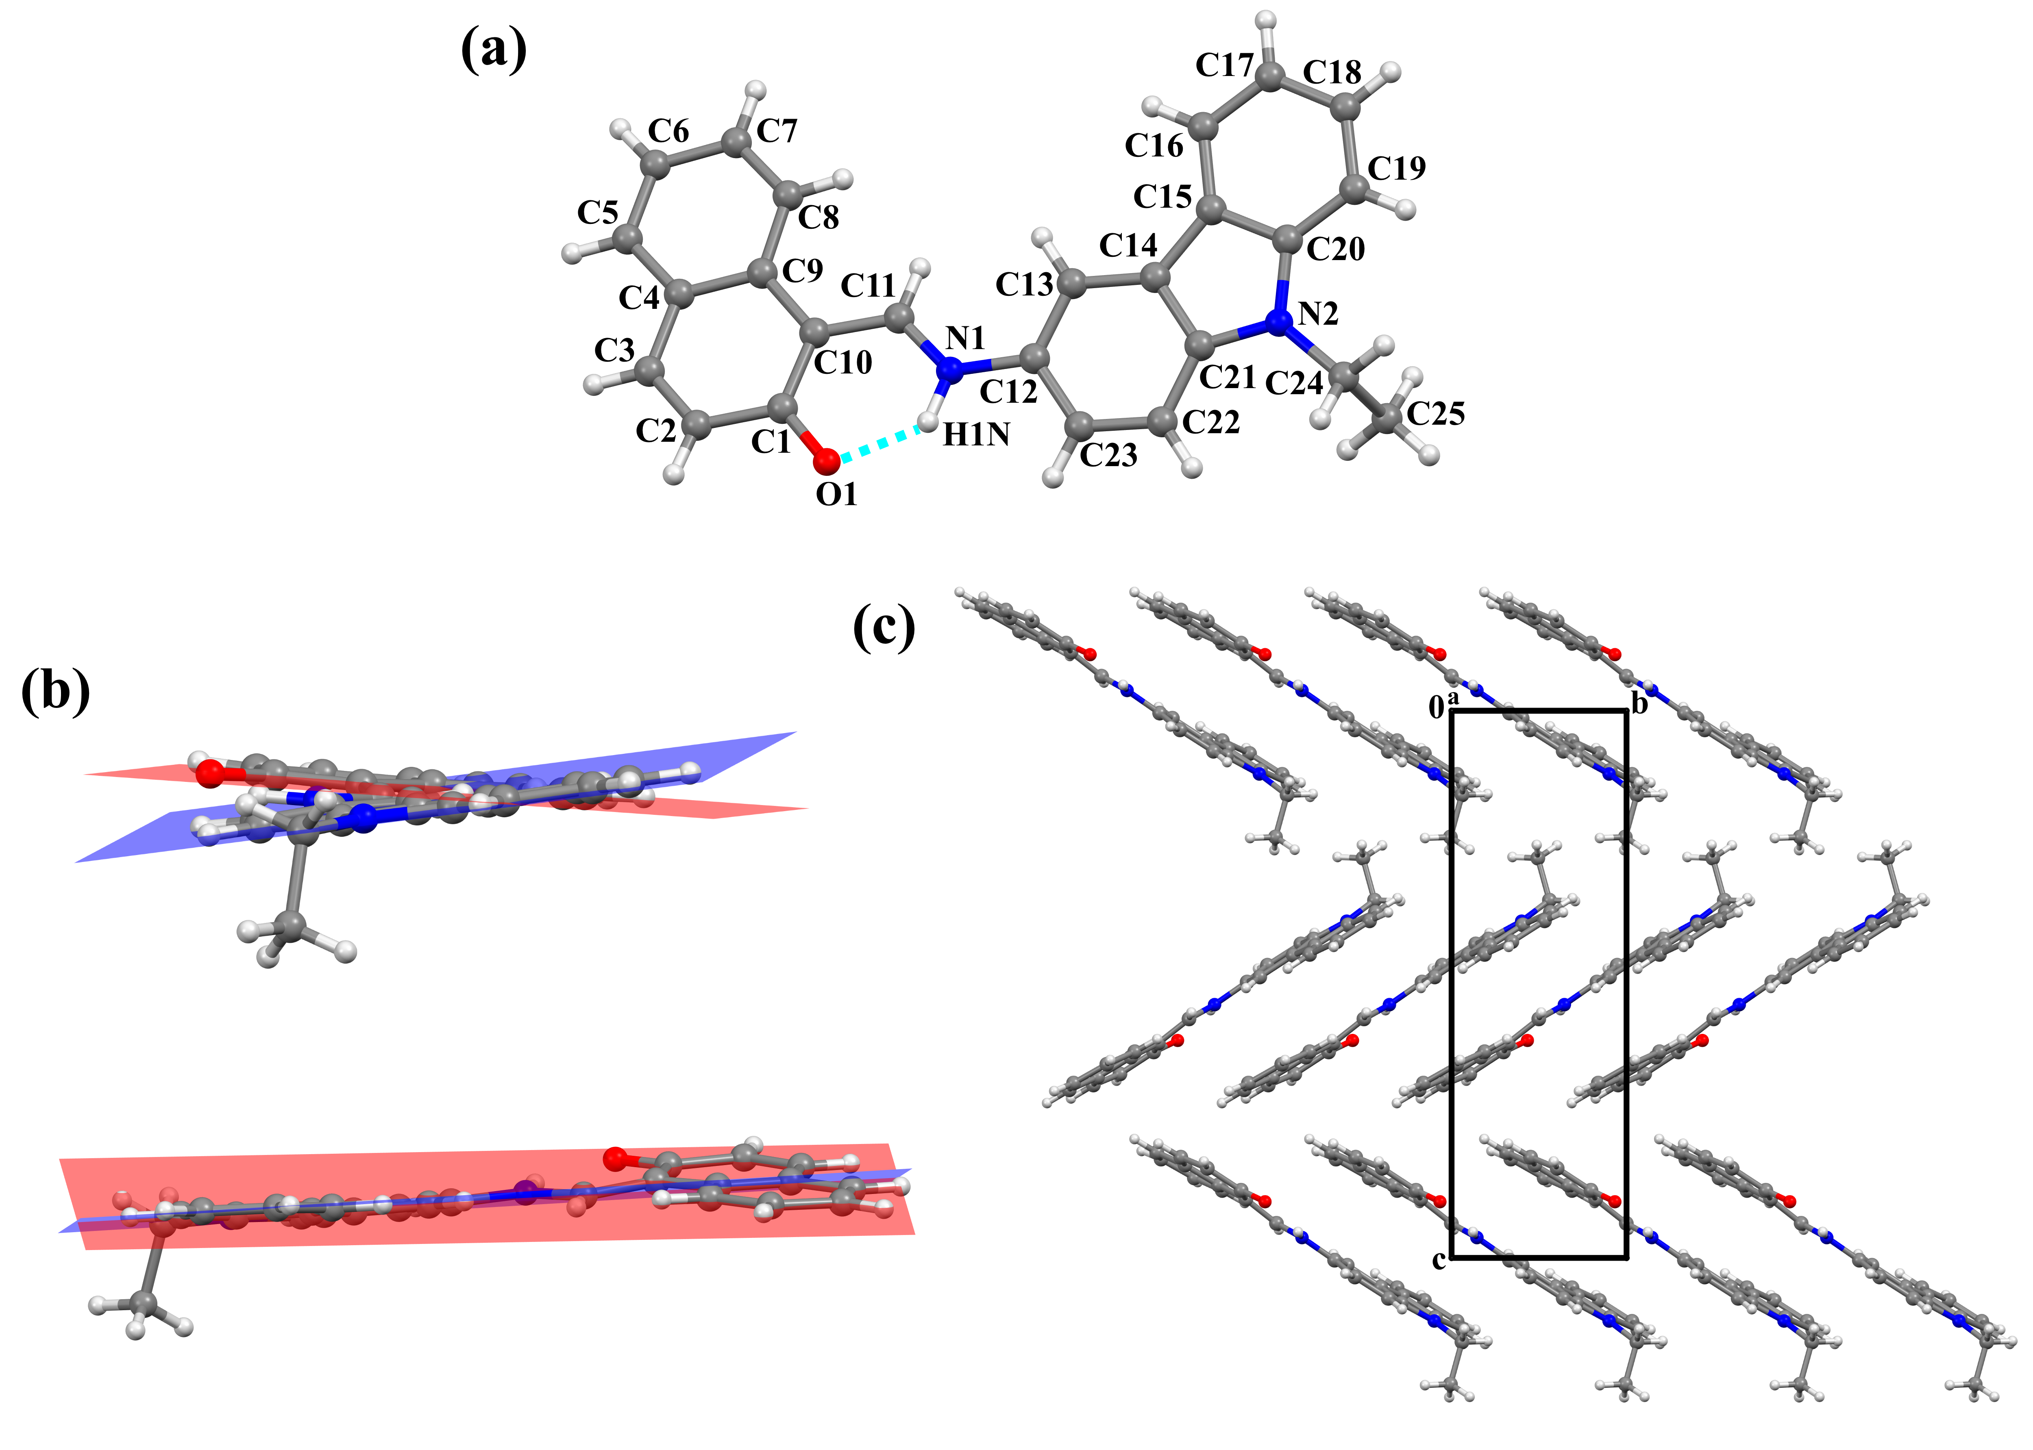
Figure S4. (a) Ball-and-stick model of CNP (with atom numbering); (b) different views of CNP displaying the deviation from neighbouring heterocyclic ring mean planes using the programme MERCURY^{[1]}; and (c) crystal packing of CNP showing π…π stacking of neighboring molecules. Selected bond distances (Å) and angle (°): O1−C1 1.282(3), C1−C10 1.427(4), C10−C11 1.407(4), C11−N1 1.324(3), N1−H1N 0.9600, O1…N1 2.550(3), O1…H1N−N1 134.04(9).

4. ¹H NMR Titration Spectrum of CNP with Sn²⁺
Figure S5.¹H NMR titration [400MHz] of CNP in DMSO-d₆ at 25°C and the corresponding changes after the addition of Sn²⁺ (SnCl₂.2H₂O) in D₂O from (i) only CNP, (ii) CNP+ 0.5 equivalent of Sn²⁺, and (iii) CNP+ 1 equivalent of Sn²⁺.
5. ¹³C NMR Titration Spectrum of CNP with Sn²⁺
Figure S6.¹³C NMR titration [100 MHz] of CNP in DMSO-d₆ at 25°C and the corresponding changes after addition of Sn²⁺in D₂O where (i) only CNP, and (ii) CNP + 1 equivalent of Sn²⁺.
6. UV-Vis Titration
A stock solution of CNP (1 μM) was prepared in acetonitrile:water (1:8, v/v). Sn²⁺ solutions of different concentrations were prepared in Millipore water. All experiments were carried out in acetonitrile:water (1:8, v/v), buffered with 10 mM phosphate buffer (pH 7.0). During the titration, each time 1 μM solution of CNP was filled in quartz optical cell of 1 cm optical path length and Sn²⁺ solution was added into the quartz optical cell gradually using a micropipette until saturation. Spectral data were recorded immediately after the addition of Sn²⁺solution.
7. Job’s Plot for Determining the Stoichiometry of Interaction by Absorbance Method
Figure S7. Job’s plot of CNP (c =1µM) with Sn²⁺ (1 µM) in acetonitrile: water (1:8, v/v) at neutral pH value (pH 7.0, 10 mM phosphate buffer) by absorbance method, which indicate 1:1 stoichiometry for CNP with Sn²⁺.Standard deviations are represented by error bar (n=3).

8. Calculation of Binding Constants of CNP towards Sn²⁺
Figure S8. Linear regression analysis for the calculation of binding constant values of CNP towards Sn²⁺.
The association constant (K_{a}) of CNP for sensing Sn²⁺ was determined from the equation: K_{a} = intercept/slope. From the linear fit graph we get intercept= 0. 3438, and slope = 9.59076×10⁻⁷.Thus we get, K_{a} = (0.3438) / (9.59076×10⁻⁷) = 0.35 × 10⁶ M⁻¹.

9. Calculation of Limit of Detection (LOD) of CNP with Sn²⁺

The detection limit of the chemosensor CNP for Sn²⁺was calculated on the basis of UV-Vis titration. The limit of detection (LOD) of CNP for sensing Sn²⁺ was determined from the following equation^{[2,3]}:
LOD = K × SD/S
where K = 2 or 3 (we take 3 in this case); SD is the standard deviation of the blank receptor solution; S is the slope of the calibration curve.

Figure S9. Linear fit curve of CNP at 454 nm with respect to Sn²⁺concentration. Standard deviations are represented by error bar (n=3).
From the linear fit graph, we get slope = 302769.5658, and SD value is 0.00858.Thus using the above formula we get the Limit of Detection = 8.5×10⁻⁸ M, i.e.85 nM. Therefore CNP can detect Sn²⁺up to this very lower concentration by colorimetric technique.

10. pH Titration Curve of CNP upon Addition of Sn²⁺
Figure S10. Effect of pH value on the absorbance of CNP(1 μM) in the absence of Sn²⁺ (green line) and in the presence of Sn²⁺ (10 μM, pink line).
11. Absorbance Comparative Studies of CNP with Different Metal Ions
Figure S11. Photograph of colorimetric changes of CNP (1µM) to various metal ions (10 µM) [From left to right: 1) Only CNP; CNP with 2) Sn²⁺, 3) Sn⁴⁺, 4) Cd²⁺, 5) Pb²⁺, 6) Hg²⁺, 7) Mg²⁺, 8) Mn²⁺, 9) Ca²⁺, 10) Ba²⁺, 11) Sr²⁺, 12) Co²⁺, 13) Ni²⁺, 14) Pt²⁺, 15) Pd²⁺, 16) Pd⁰, 17) Fe²⁺, 18) Cu²⁺, 19) 20) Zn²⁺, 21) Fe³⁺, 22) Al³⁺, 23) Cr³⁺, 24) Ru³⁺, 25) Au³⁺, 26) Zr⁴⁺, 27) Hf⁴⁺, 28) Li⁺,29) Na⁺, 30) K⁺, 31) Ag⁺ in acetonitrile:water (1:8, v/v, pH 7.0, 10 mM phosphate buffer) solution].

Figure S12. Histogram representing competitive absorbance spectra of CNP with various metal ions at 454 nm in H₂O:CH₃CN (8:1, v/v) at neutral pH (pH 7.0, 10 mM phosphate buffer).
12. Details of Energy Calculations Using Density Functional Theory (DFT)
Binding of CNP with Sn²⁺ has been investigated by quantum chemical calculations at the DFT level LANL2DZ/6-31G** method basis set implemented at Gaussian 09 program. Solvent effects were incorporated using CPCM solvent model.
Figure S13. Energy optimized geometries of CNP and CNP-Sn²⁺ complex obtained at the LANL2DZ/6-31G** levels of theory with CPCM solvation (H₂O).
Table S1. Details of the geometry optimization in Gaussian 09 program.
Details | CNP | CNP-Sn²⁺
Calculation method | B3LYP | B3LYP
Basis set | 6-31G** | 6-31G**
E(CAM-B3LYP) (a.u.) | -1149.500 | -2073.384
Charge, Multiplicity | 0, 1 | 0,1
Solvent (CNPCM) | Water | Water

Table S2. Selected electronic excitation energies (eV), oscillator strengths (f), main configurations of the low-lying excited states of all the molecules and complexes. The data were calculated by TDDFT//B3LYP/6-31G(d,p) based on the optimized ground state geometries.

Molecules | Electronic Transition | Excitation  Energyª | f^{b} | Composition^{c} (%)
CNP | S₀ → S₁ | 3.0226 eV 410.19 nm | 0.5188 | H → L (69.6%)
CNP | S₀ → S₅ | 4.0902 eV 303.12 nm | 0.1057 | H → L+3 (11%)
[CNP-Sn²⁺] | S₀ → S₁ | 2.7637 eV 448.62nm | 0.3563 | H → L (70.2%)
[CNP-Sn²⁺] | S₀ → S₂ | 3.2342 eV 383.36 nm | 0.0589 | H-1 → L (21%)
ªOnly selected excited states were considered. The numbers in parentheses are the excitation energy in wavelength. ^{b}Oscillator strength. ^{c}H stands for HOMO and L stands for LUMO.

Table S3. Energies of the highest occupied molecular orbital (HOMO) and lowest unoccupied
molecular orbital (LUMO)

Species | E_{HOMO} (a.u.) |  | E_{LUMO} (a.u.) | ∆E(a.u.) |  | ∆E(eV) |  | ∆E(kcal/mol)
CNP | -0.19108 |  | -0.06231 | 0.12877 |  | 3.50 |  | 80.80
[CNP-Sn²⁺] | -0.20265 | -0.08466 |  | 0.11799 | 3.21 |  | 74.04

13. Partial HRMS of the mixed assay system
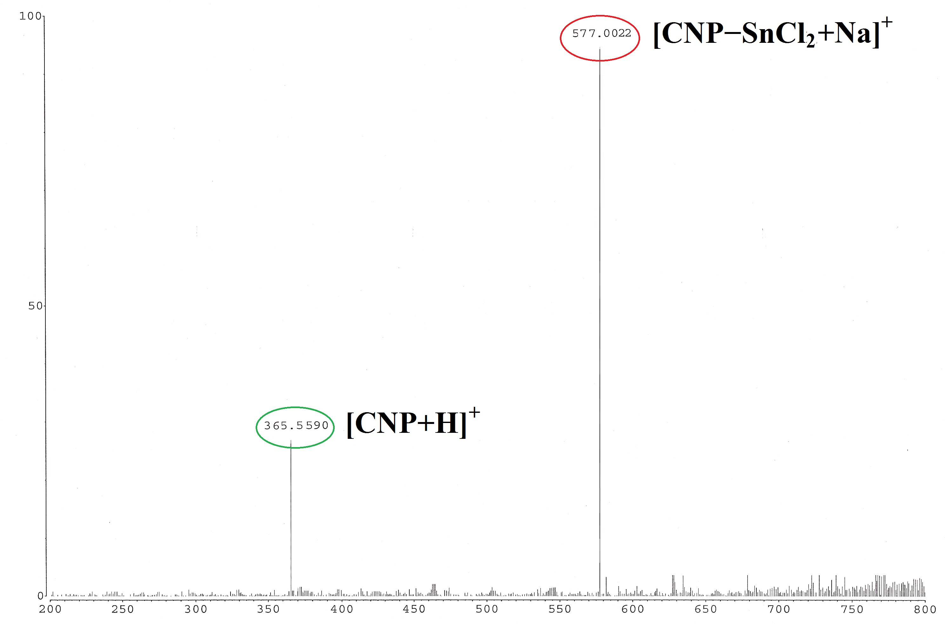
Figure S14. Partial HRMS spectra of [CNP-Sn²⁺] mixture in acetonitrile.

14. Preparation of Toothpaste Solution
Commercially available toothpastes from three different brands (T1, T2, T3) were taken for this experiment.0.1g of each toothpaste sample was dissolved in 3 ml double distilled water. Next, this mixture was filtered and the filtrate was treated as toothpaste solution. The toothpaste solutions from different toothpaste samples were subjected to colorimetric analysis at pH 7.0 (10 mM phosphate buffer) to estimate the amount of Sn²⁺ present therein.

15. Reference
- MERCURY (version 4.2.0). Program Package for 3D structure visualization of crystal structures, exploration of crystal packing and statistical analysis of CSD search data, 2019.
- L. Long, D. Zhang, X. Li, J. Zhang, C. Zhang, L. Zhou, Anal. Chim. Acta. 2013, 775,100-105.
- M. Zhu, M. Yuan, X. Liu, J. Xu, J. Lv, C. Huang, H. Liu, Y. Li, S. Wang, D. Zhu, Org. Lett. 2008, 10,1481-1484.

