Supplementary Information
Interfacial Tunneling Enables High-Gain SWIR Photodetection in Asymmetric n-i-n PbS Quantum Dot Devices
Zeyao Han¹, Boxiong Zhang¹, Chengjie Deng², Hua Zhang¹, Tao Meng¹, Mei Liu¹, Xingyi Li¹, Li Zhang¹, Yuxuan Liu³, Junyu Li⁴, Mingyang Wei^{5,*}, Liang Gao^{2,*}, Bin Sun^{1,*}

1 State Key Laboratory of Flexible Electronics (LoFE), Institute of Advanced Materials (IAM), School of Materials Science and Engineering, Nanjing University of Posts and Telecommunications (NJUPT), Nanjing 210023, PR China
2 Wuhan National Laboratory for Optoelectronics (WNLO) and School of Optical and Electronic Information, Huazhong University of Science and Technology, Wuhan 430070, P. R. China.
3 Wuhan InRight Technology Co., Ltd., Wuhan 430075, P. R. China.
4 Joint International Research Laboratory of Information Display and Visualization, School of Electronic Science and Engineering, Southeast University, Nanjing, 210096 China.
5 Department of Materials Science and Engineering, National University of Singapore,
Singapore 117575, Singapore
*E-mail: highlight@hust.edu.cn, weimingy@nus.edu.sg, iambsun@njupt.edu.cn;

Experimental Section

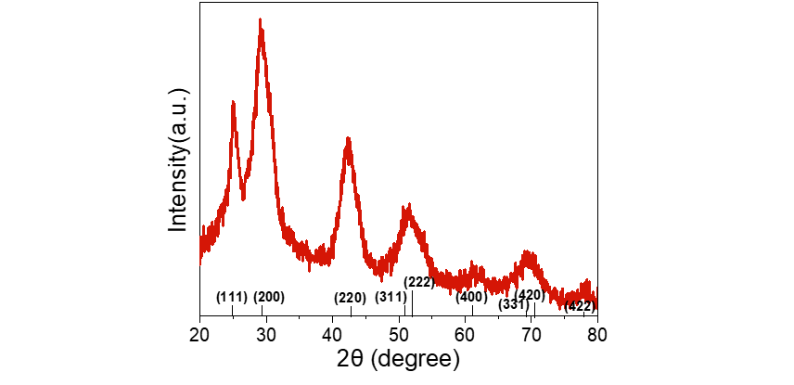
Figure S1. X-ray diffraction (XRD) pattern of the synthesized PbS colloidal quantum dots.

Figure S2. X-ray photoelectron spectroscopy (XPS) spectra of the synthesized PbS colloidal quantum dots.

Figure S3. Ultraviolet photoelectron spectroscopy (UPS) spectra of (a) C₆₀, (b) PbS CQDs, (c) SnO₂ and (d) ZnO functional layers.

Figure S4. Responsivity curves of the n-i-n and p-i-n devices.

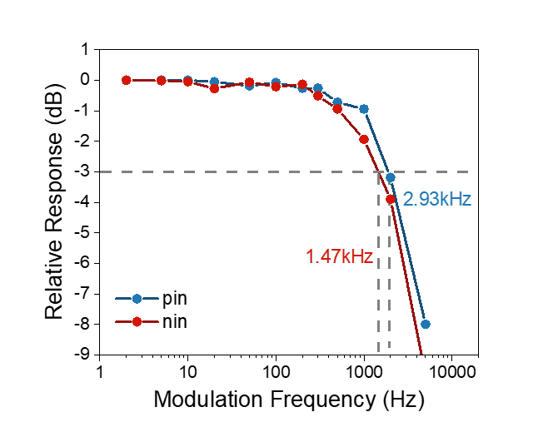
Figure S5. -3 dB bandwidth of the n-i-n and p-i-n devices.

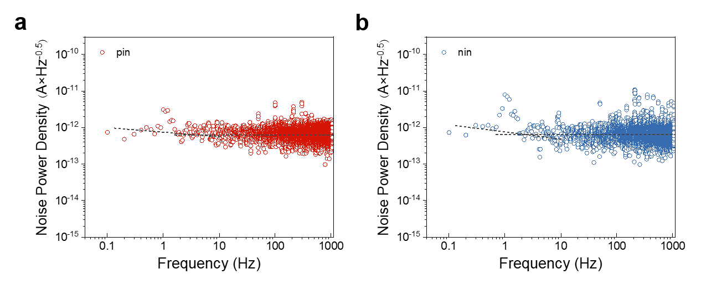
Figure S6. Noise current power density of the asymmetric n-i-n and the control p-i-n devices.

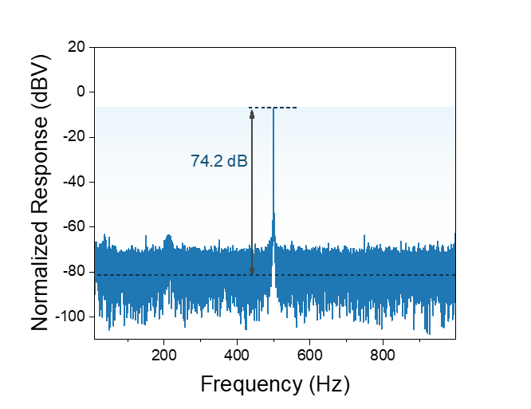
Figure S7. Signal to noise ratio of the traditional p-i-n at a signal frequency of 500 Hz.
Figure S8. Noise equivalent power (NEP) spectra of the traditional p-i-n and asymmetric n-i-n devices.
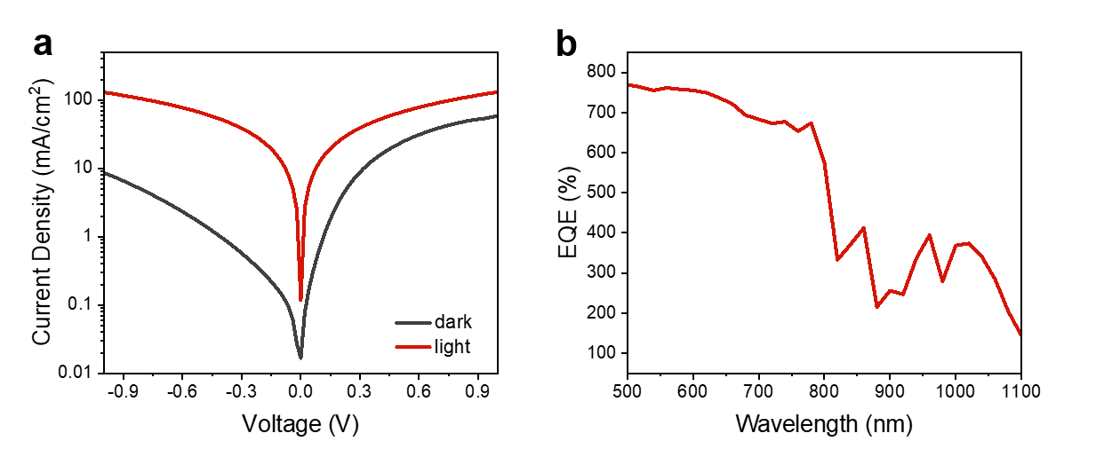
Figure S9. (a) J-V curves and (b) EQE curve of the device with the structure of fully symmetric ITO/ZnO/PbS/ZnO/Ag.
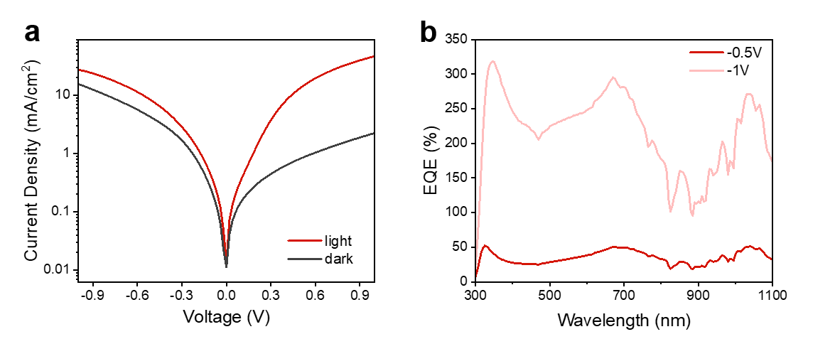
Figure S10. (a) J-V curves and (b) EQE curve of the device with the structure of fully symmetric ITO/SnO₂/PbS/SnO₂/Ag.

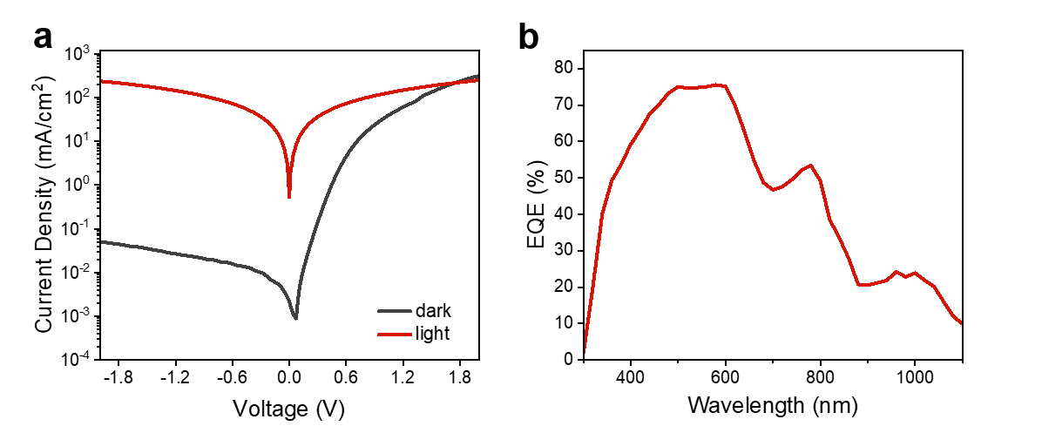
Figure S11. (a) J-V curves and (b) EQE curve of the device with the structure of ITO/PbS/C₆₀/SnO₂/Ag.

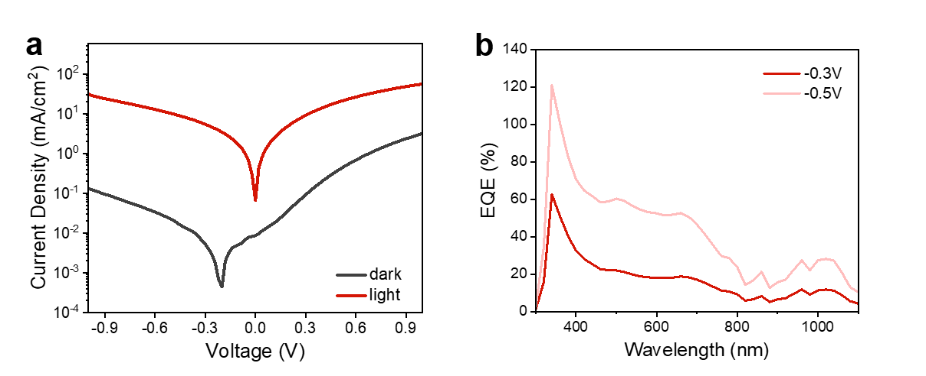
Figure S12. (a) J-V curves and (b) EQE curve of the device with the structure of ITO/ZnO/C₆₀/PbS/C₆₀/SnO₂/Ag.

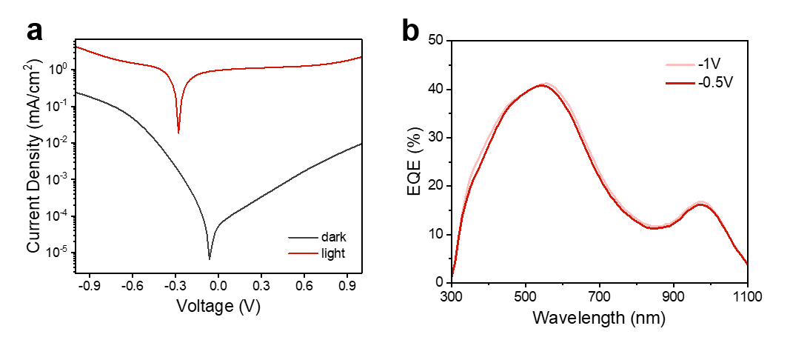
Figure S13. (a) J-V curves and (b) EQE curve of the control n-i-n device utilizing smaller size PbS QDs, with a response at ~980 nm.
Figure S14. (a) J-V curves and (b) EQE curve of the n-i-n device using the larger PbS QDs with absorption peak at 1650 nm.

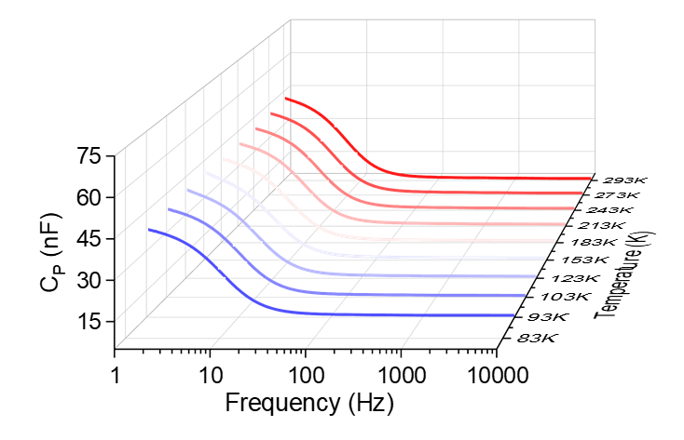
Figure S15. Capacitance-frequency spectrum of the asymmetric n-i-n device.

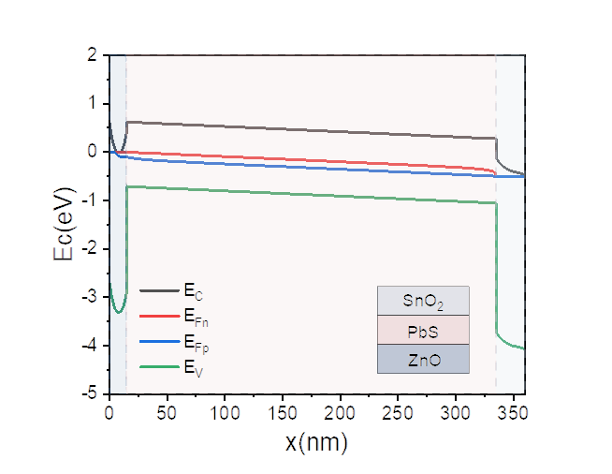
Figure S16. SCAPS simulated energy band diagram for the n-i-n device lacking the C₆₀ layer under reverse bias.
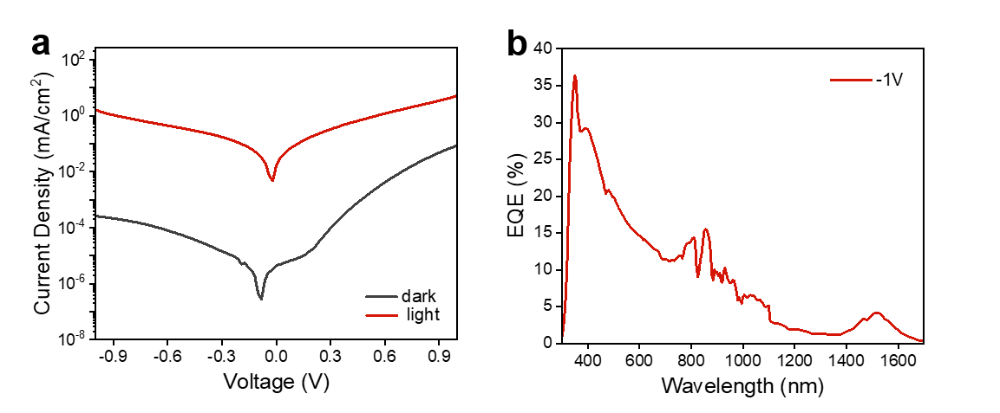
Figure S17. (a) J-V curves and (b) EQE curve of the control device utilizing conventional PCBM as the electron transport layer.
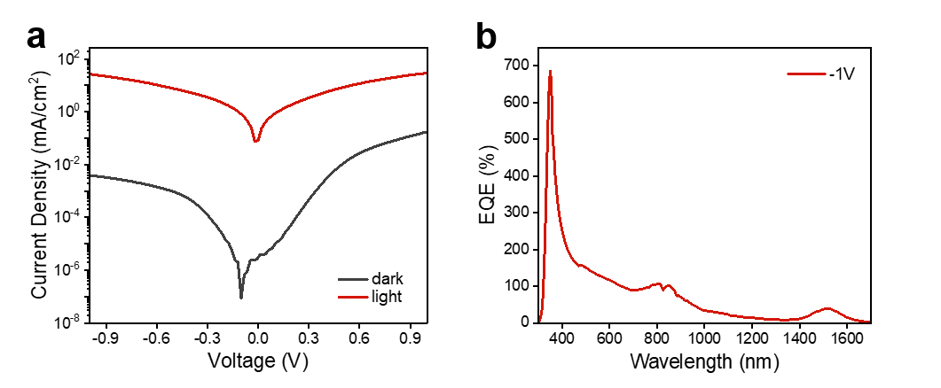
Figure S18. (a) J-V curves and (b) EQE curve of the device incorporating an ultra-thin 3 nm C₆₀ layer.

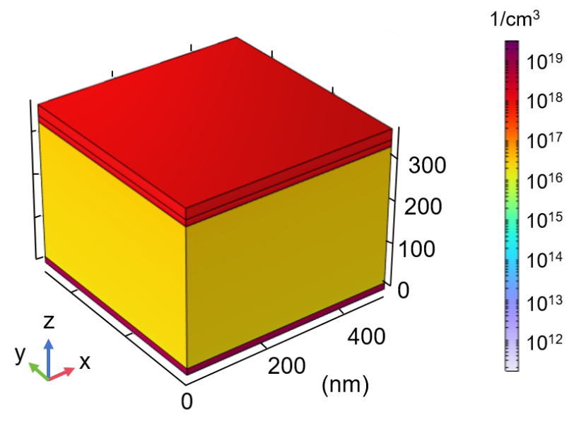
Figure S19. COMSOL 3D simulation of electron concentration within the asymmetric n-i-n device under a forward bias of 1 V.
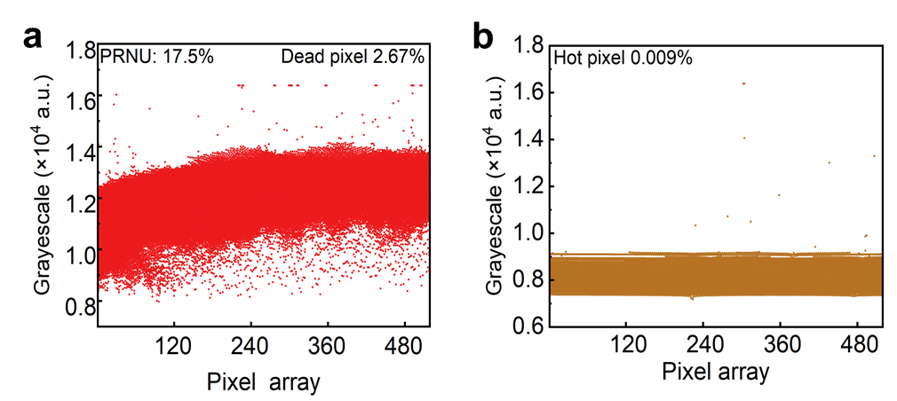
Figure S20. (a) Scatter plot of the pixel grayscale values under uniform illumination. (b) Scatter plot of the pixel grayscale values in the dark, demonstrating an exceptionally low hot pixel rate of 0.009%.

Table S1. Performance list of PbS CQD photodetectors
Device structure | Ligand | Spectral range (nm) | Detectivity (Jones) | Bandwidth | LDR (dB) | Light direction | Year/ Ref.
ITO/ZnO NCsPbS QD/TAPC/MoO₃/Ag | BDT | 400–1500 | 7.0×10¹³ ^{[M]} | 117 Hz | / | back | 2015¹
ITO/PEDOT:PSS/PbS QD:ZnO QD:P3HT:PCBM/Al | ZnO QD/P3HT/PCBM(Blend) | 300–1000 | 1.01×10¹² ^{[M]} | 2.2 kHz | 70 | back | 2014²
ITO/ ZnO/PbS CQD/Spiro-OMeTAD /Au | PbI₂/PbBr₂/NH₄Ac | 400–1650 | 1.4×10¹² ^{[M]} | 16 kHz | / | back | 2019³
ITO/PEDOT:PSS/PbS NQD/ZnO/Al | EDT | 350–1100 | 1.45×10¹² ^{[M]} | 4.4 kHz | 60 | back | 2012⁴
ITO/NiO/PbS QD/ZnO/Al | BDT | 400–1400 | 1.2×10¹² ^{[M]} | 35 kHz | 67 | back | 2014⁵
Au/P3HT/Al | P3HT | 300–1200 | 2.1×10¹² ^{[C]} | 3 Hz | / | back | 2015⁶
Glass/PbS-TBAI/PBDB-T:PBI-Por/Al | TBAI | 400–1000 | 1.12×10¹³ ^{[C]} | 0.83 Hz | 65 | back | 2018⁷
ITO/ZnO/PbI₂/PbS–TBAI/PbS–EDT/Au | TBAI/EDT | 300–980 | 1.3×10¹³ ^{[C]} | 5 kHz | 101 | back | 2017⁸
ITO/PbS CQD/Al | BDT | 400–1800 | 1×10¹² ^{[C]} | 1.2 MHz | / | back | 2009⁹
ITO/PEDOT:PSS/ PbS-QD:P3HT:PCBM/Al | P3HT/ PCBM (Blend) | 400–1850 | 2.3×10⁹ ^{[C]} | 2.5 kHz | / | top | 2009¹⁰
Graphene/PbS | EDT | 300–2000 | 1×10¹² ^{[C]} | 350 Hz | >80 | top | 2017¹¹
‘M’ means measured detectivity and ‘C’ means calculated detectivity.

REFERENCES
1. Lee, J. W., Kim, D. Y. & So, F. Unraveling the gain mechanism in high performance solution-processed PbS infrared PIN photodiodes. Adv. Funct. Mater. 25, 1233–1238 (2015).
2. Dong, R. et al. An ultraviolet-to-NIR broad spectral nanocomposite photodetector with gain. Adv. Opt. Mater. 2, 549–554 (2014).
3. Sliz, R. et al. Stable colloidal quantum dot inks enable inkjet-printed high-sensitivity infrared photodetectors. ACS Nano 13, 11988–11995 (2019).
4. Pal, B. N. et al. High-sensitivity p-n junction photodiodes based on PbS nanocrystal quantum dots. Adv. Funct. Mater. 22, 1741–1748 (2012).
5. Manders, J. R. et al. Low-noise multispectral photodetectors made from all solution-processed inorganic semiconductors. Adv. Funct. Mater. 24, 7205–7210 (2014).
6. Yoo, J., Jeong, S., Kim, S. & Je, J. H. A stretchable nanowire UV-Vis-NIR photodetector with high performance. Adv. Mater. 27, 1712–1717 (2015).
7. Wei, Y. et al. Hybrid organic/PbS quantum dot bilayer photodetector with low dark current and high detectivity. Adv. Funct. Mater. 28, 1706690 (2018).
8. Qiao, K. et al. Efficient interface and bulk passivation of PbS quantum dot infrared photodetectors by PbI2 incorporation. RSC Adv. 7, 52947–52954 (2017).
9. Clifford, J. P. et al. Fast, sensitive and spectrally tunable colloidal-quantum-dot photodetectors. Nat. Nanotechnol. 4, 40–44 (2009).
10. Rauch, T. et al. Near-infrared imaging with quantum-dot-sensitized organic photodiodes. Nat. Photonics 3, 332–336 (2009).
11. Goossens, S. et al. Broadband image sensor array based on graphene-CMOS integration. Nat. Photonics 11, 366–371 (2017).

