Supplementary Materials
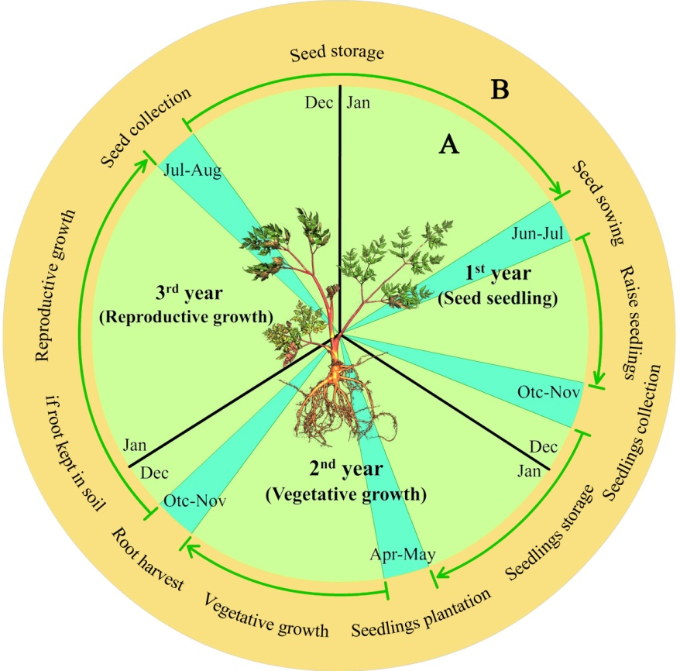
Fig. S1 Growth and development of A. sinensis in a commercial production process.

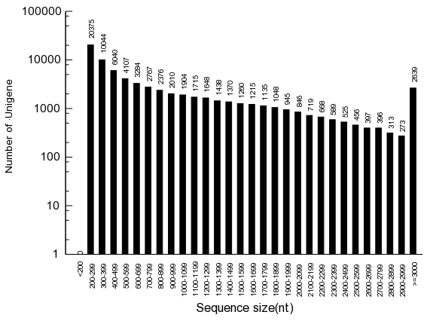
Fig. S2 Length distribution of assembled unigenes.

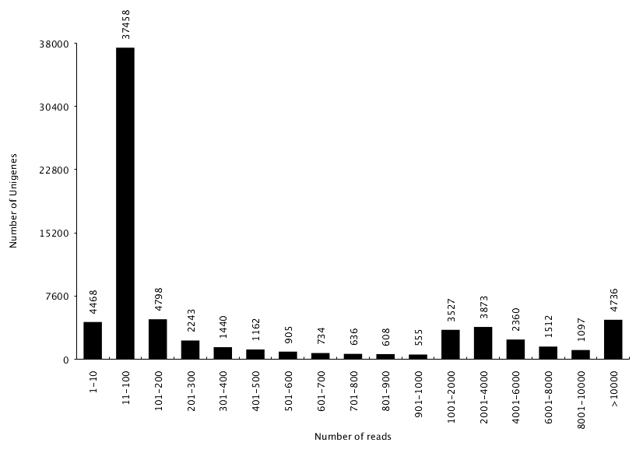
Fig. S3 Read distribution of unigenes

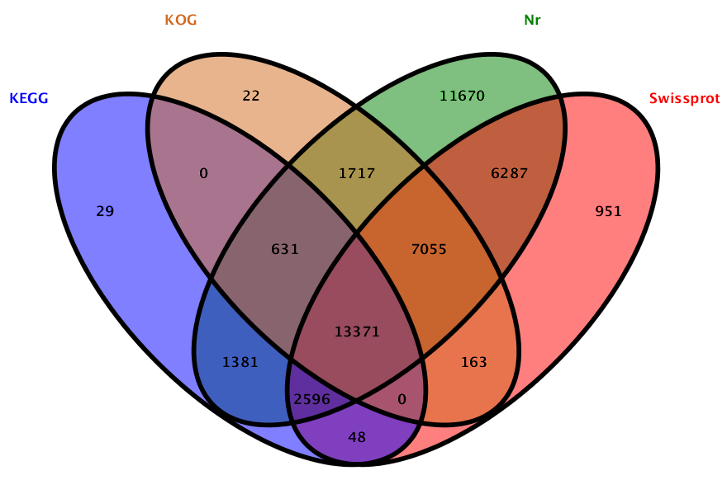
Fig. S4 Basic annotation for all unigenes.

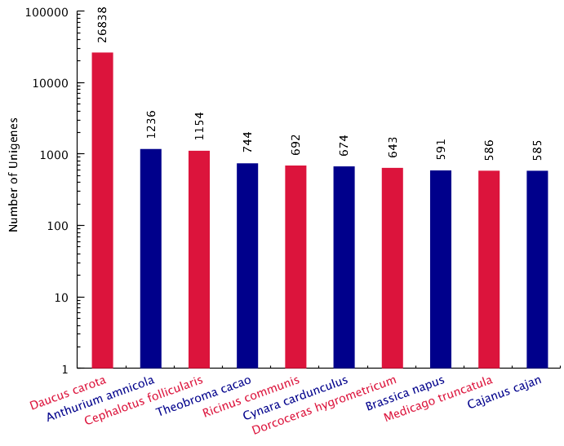
Fig. S5 Top 10 plant species distribution of the total homologous sequences.

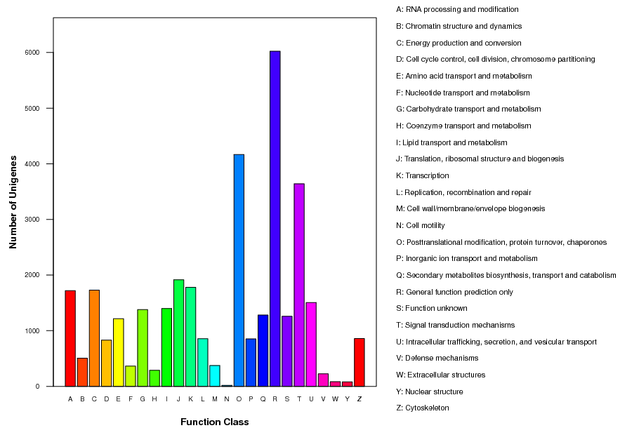
Fig. S6 Distribution of unigenes in the transcriptome with KOG functional classification. Sequences have a KOG classification among 25 categories. Note: [A] RNA processing and modification; [B] Chromatin structure and dynamics; [C] Energy production and conversion; [D] Cell cycle control, cell division, chromosome partitioning; [E] Amino acid transport and metabolism; [F] Nucleotide transport and metabolism; [G] Carbohydrate transport and metabolism; [H] Coenzyme transport and metabolism; [I] Lipid transport and metabolism; [J] Translation, ribosomal structure and biogenesis; [K] Transcription; [L] Replication, recombination and repair; [M] Cell wall/membrane/envelope biogenesis; [N] Cell motility; [O] Posttranslational modification, protein turnover, chaperones; [P] Inorganic ion transport and metabolism; [Q] Secondary metabolites biosynthesis, transport and catabolism; [R] General function prediction only; [S] Function unknown; [T] Signal transduction mechanisms; [U] Intracellular trafficking, secretion, and vesicular transport; [V] Defense mechanisms; [W] Extracellular structures; [Y] Nuclear structure; [Z] Cytoskeleton.

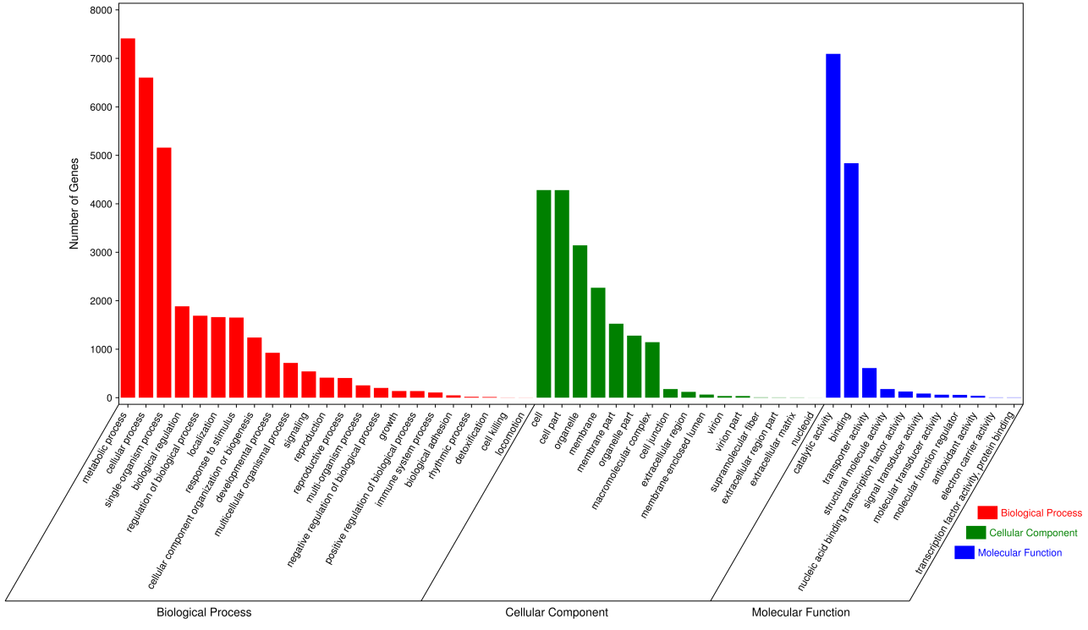
Fig. S7 Functional classifications of GO terms of all assembled unigenes. Note: The results are summarized in three main categories: biological process, cellular component, and molecular function. The right y-axis indicates the number of genes in a category. The left y-axis indicates percentage of a specific category of genes.

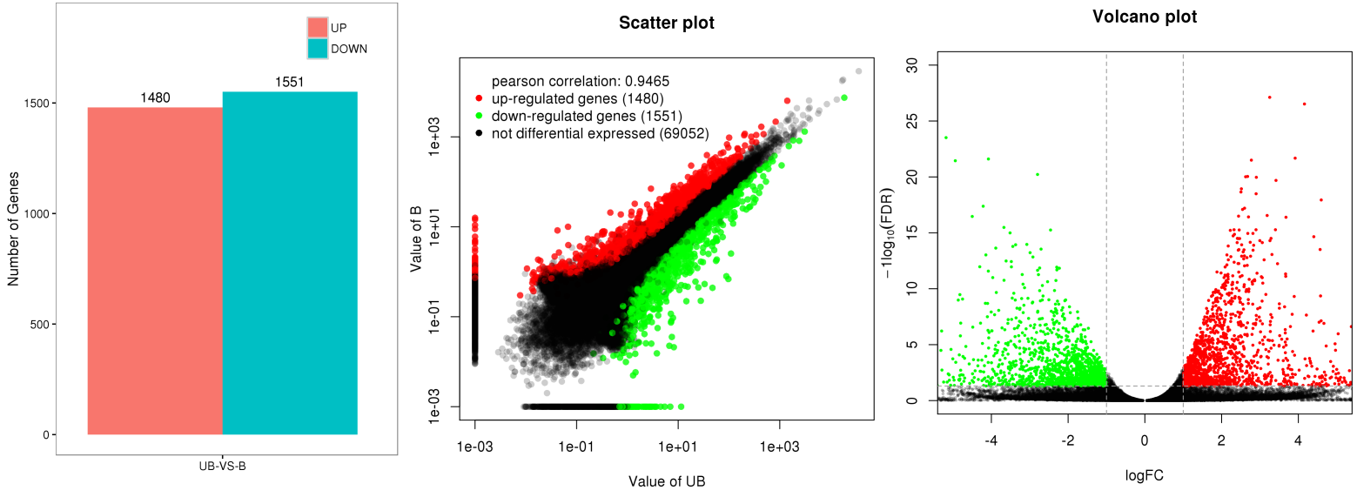

Fig. S8 Number of DEGs, correlation and volcano plot for unbolted versus bolted plants. Note: A total of 2,645 DEGs were obtained after excluding 386 repeated genes from the originally generated 3,031 genes.

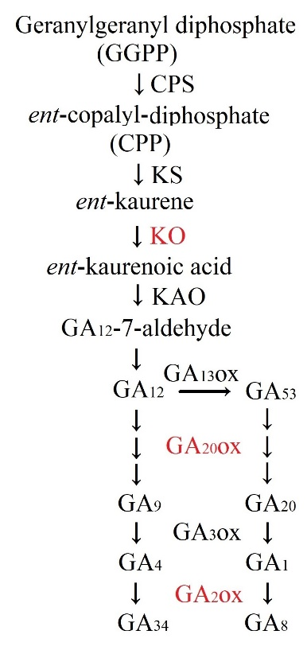
Fig. S9 The GA biosynthesis pathways and the differentially expressed genes are highlighted in red.

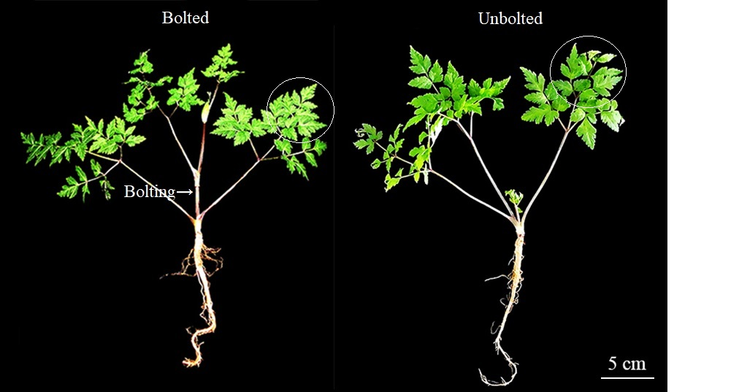
Fig. S10 Two-year-old bolted and unbolted plants of A. sinensis. Bar represents 5 cm.

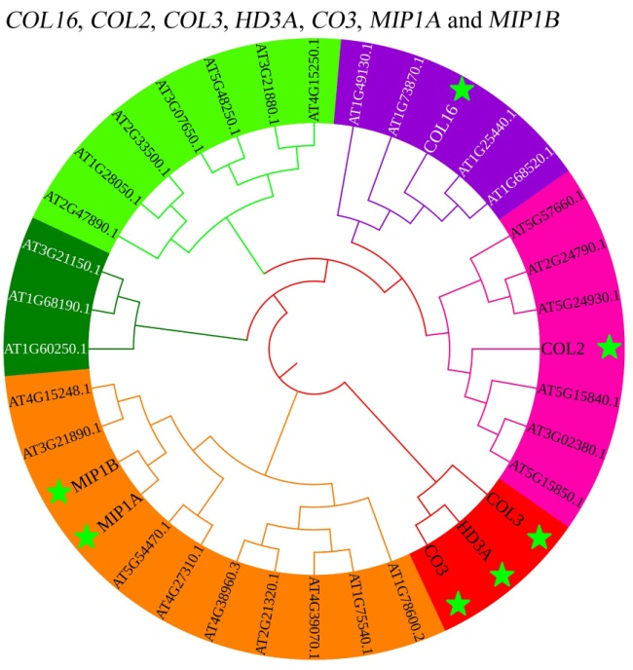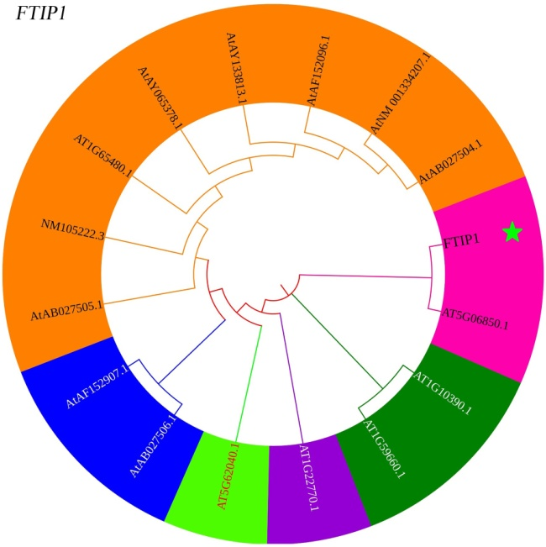
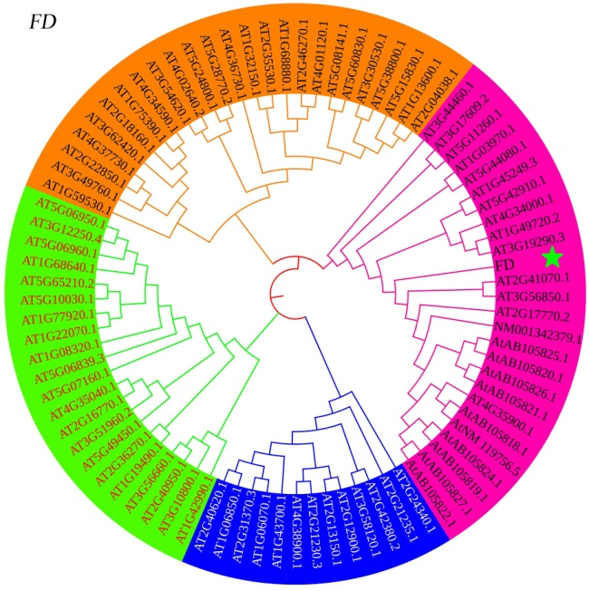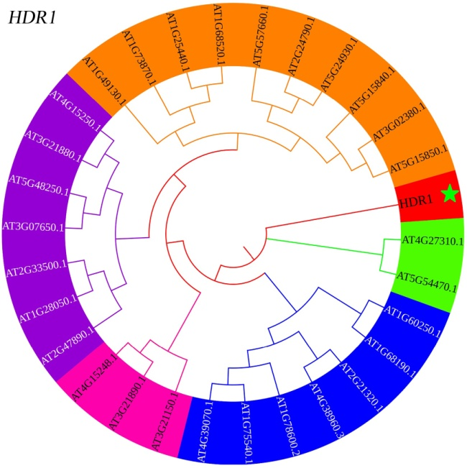
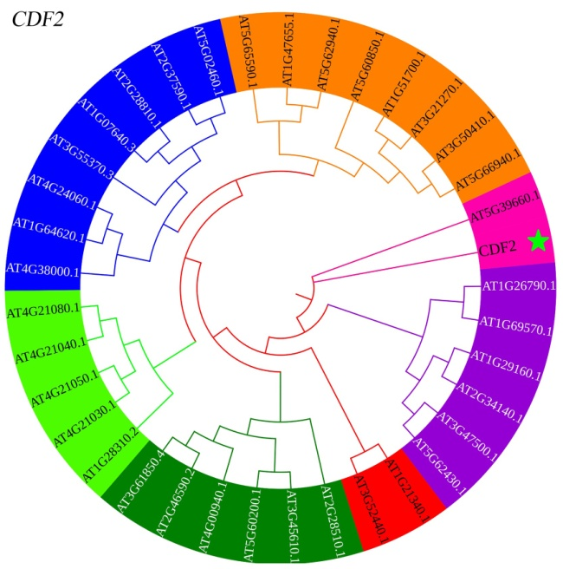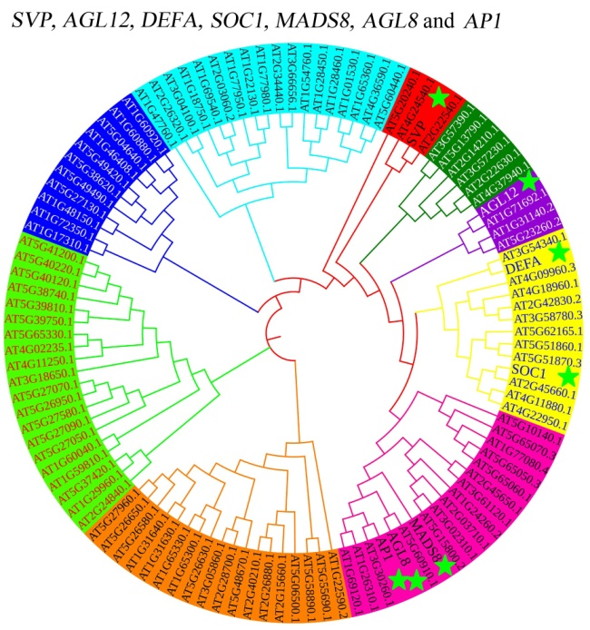

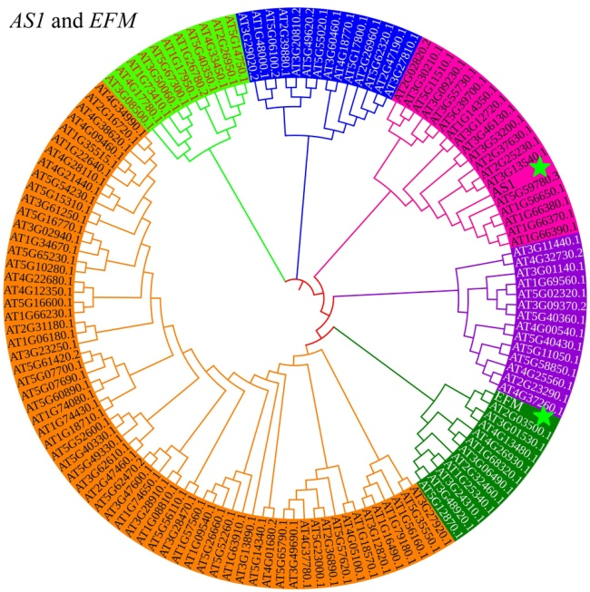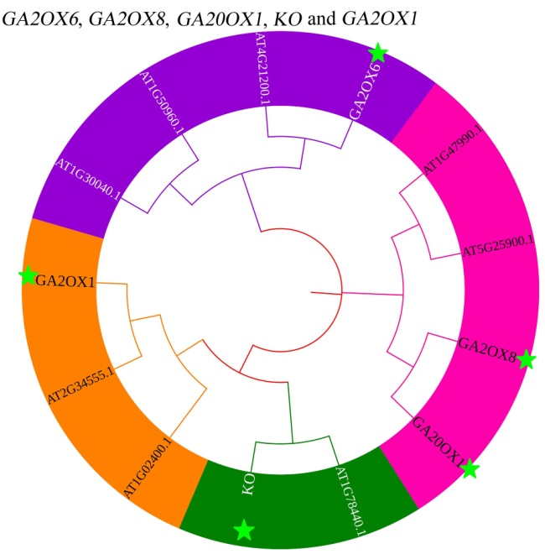
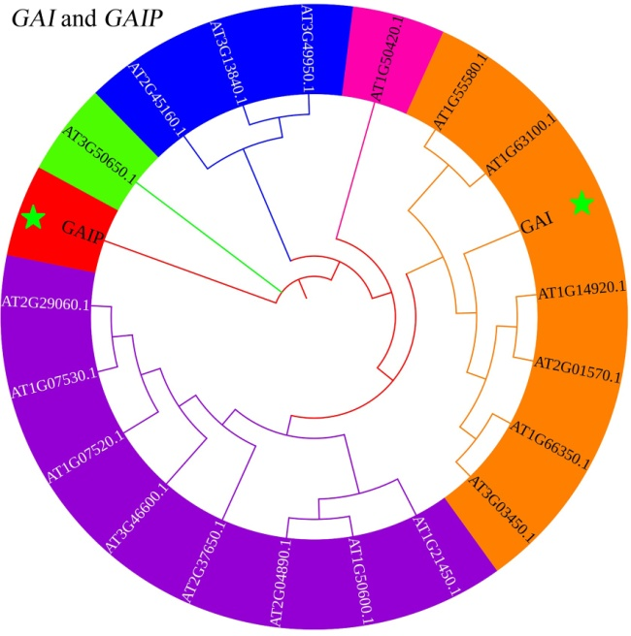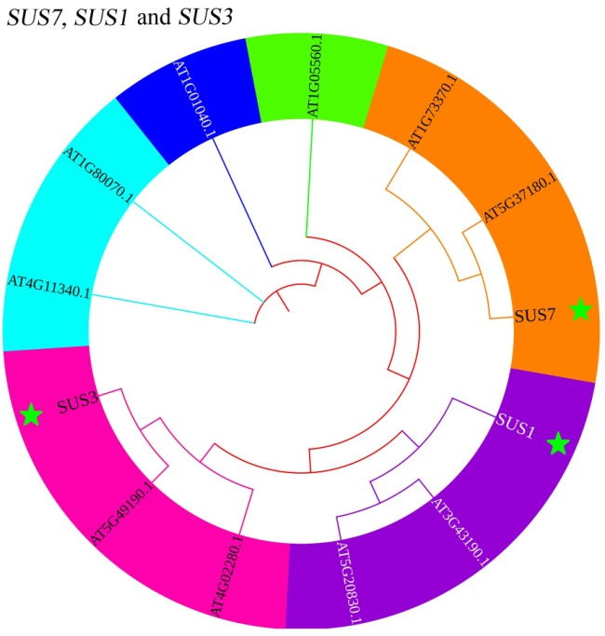
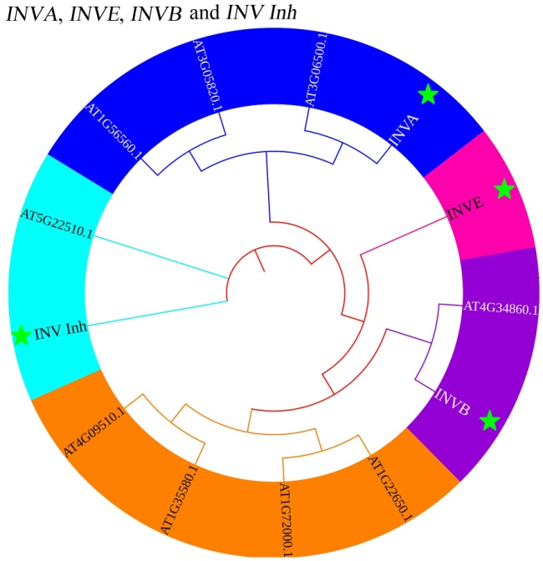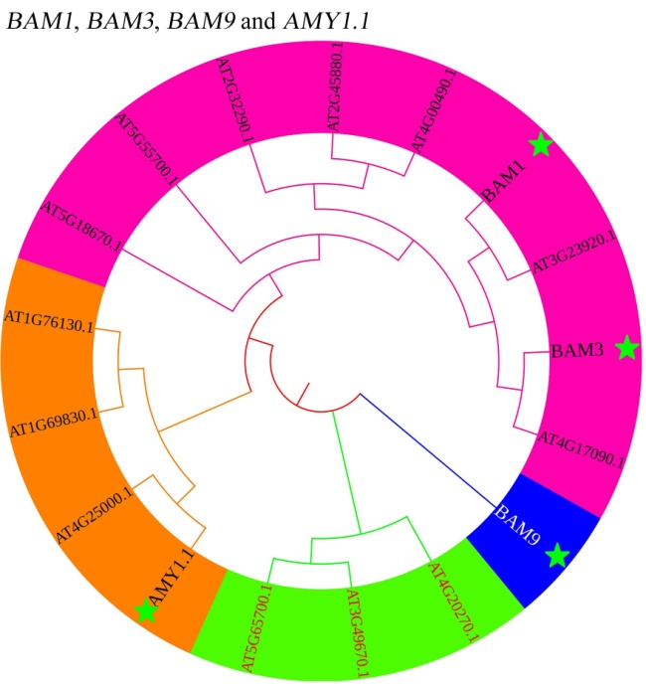
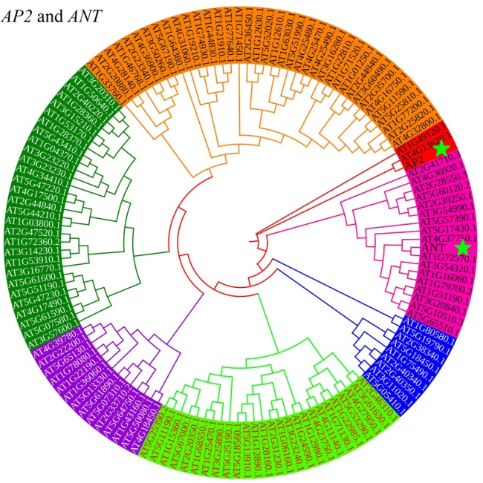
Fig. S11 The cluster analysis of the 40 DEGs comparing with the families in Arabidopsis thaliana.

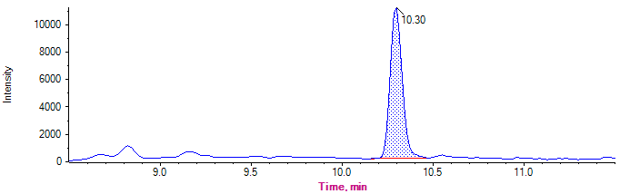
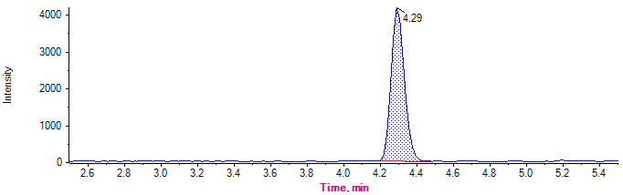
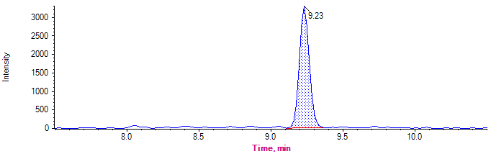
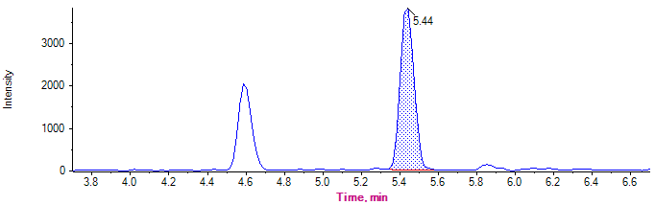
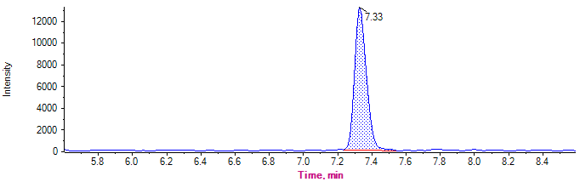
GA₉-5.29 ng/mL
GA₁-5.35 ng/mL
GA₄-6.05 ng/mL
GA₈-5.18 ng/mL
GA₂₀-5.14 ng/mL

Fig. S12 Representative chromatograms of reference standard of GA₁, GA₄, GA₈, GA₉ and GA_{20.}

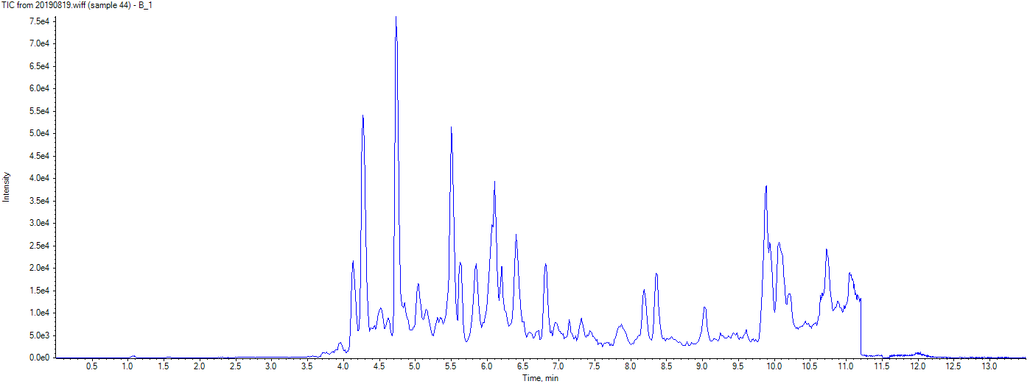
A
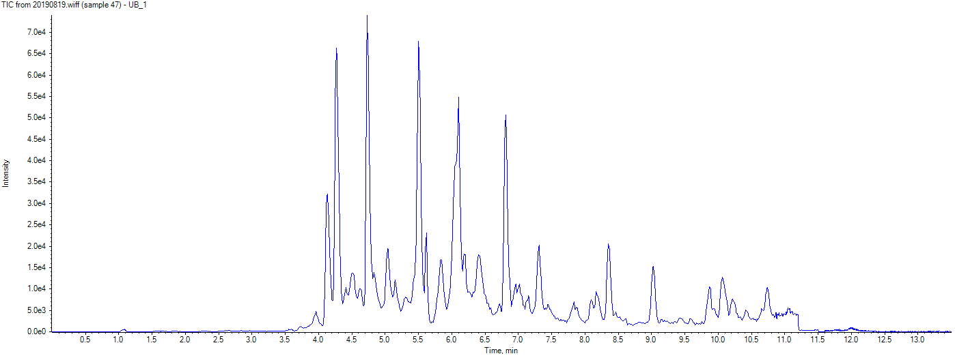
B
Fig. S13 Representative chromatograms of bolted (A) and unbolted plants (B) of A. sinensis.

Table S1. Calibration curves of GA₁, GA₄, GA₈, GA₉ and GA₂₀
GAs | Calibration curves | Related coefficient
GA₁ | y = 3549.48823 x + 133.18755 | (r = 0.9923)
GA₄ | y = 2527.09342 x + 574.86954 | (r = 0.9905)
GA₈ | y = 4004.18848 x + 320.37962 | (r = 0.9934)
GA₉ | y = 9565.89109 x + 339.64459 | (r = 0.9949)
GA₂₀ | y = 12108.82863 x + 1112.84346 | (r = 0.9928)

