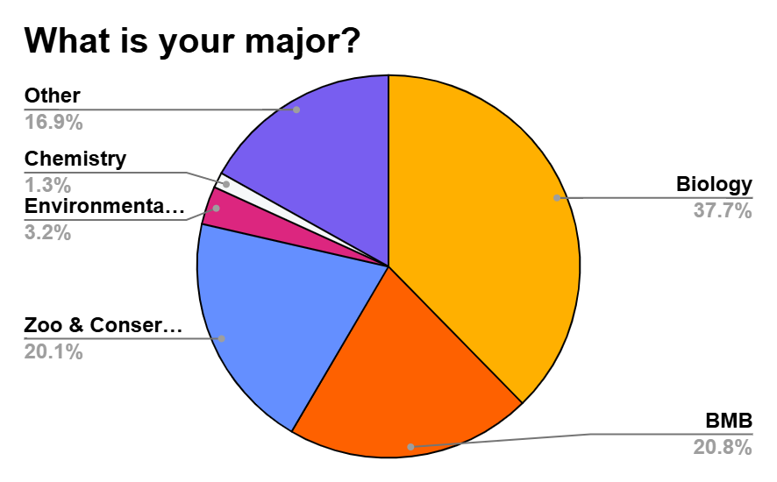
S1. Major Demographics. A majority of students indicated they were Biology majors at 37.7% of the class (n = 62) and 20.8% indicated their major was Biochemistry and Molecular Biology. The third most popular major amongst students was Zoo and Conservation Science at 20.1%.

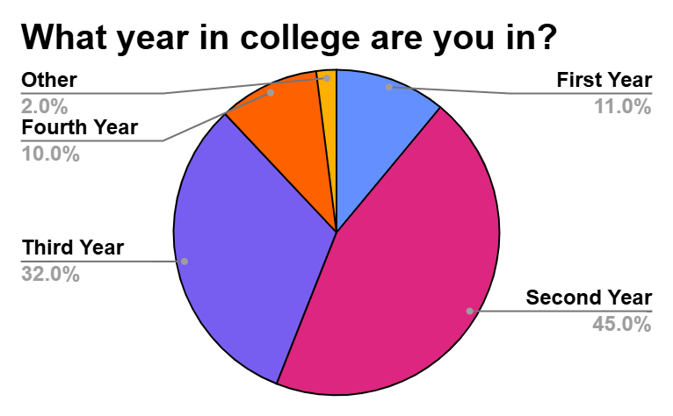
S2. Year in College Demographic. The majority of the class indicated that they were in their second year at 45% (n = 62). 32% of the class indicated that they were in their third year of college. 11% of students indicated that they were in their first year and 10% of the class were fourth year students.

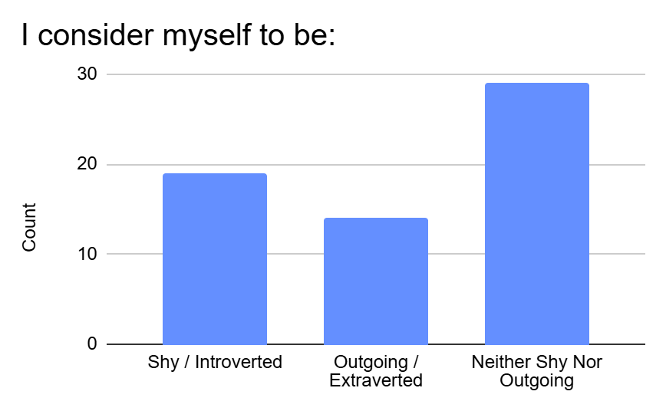
S3: Personality demographics. The majority of the class indicated that they did not consider themselves to be shy or outgoing (29, n = 62). The rest of the class indicated they considered themselves to be shy/introverted, 19 students, or outgoing/extraverted at 14 students.

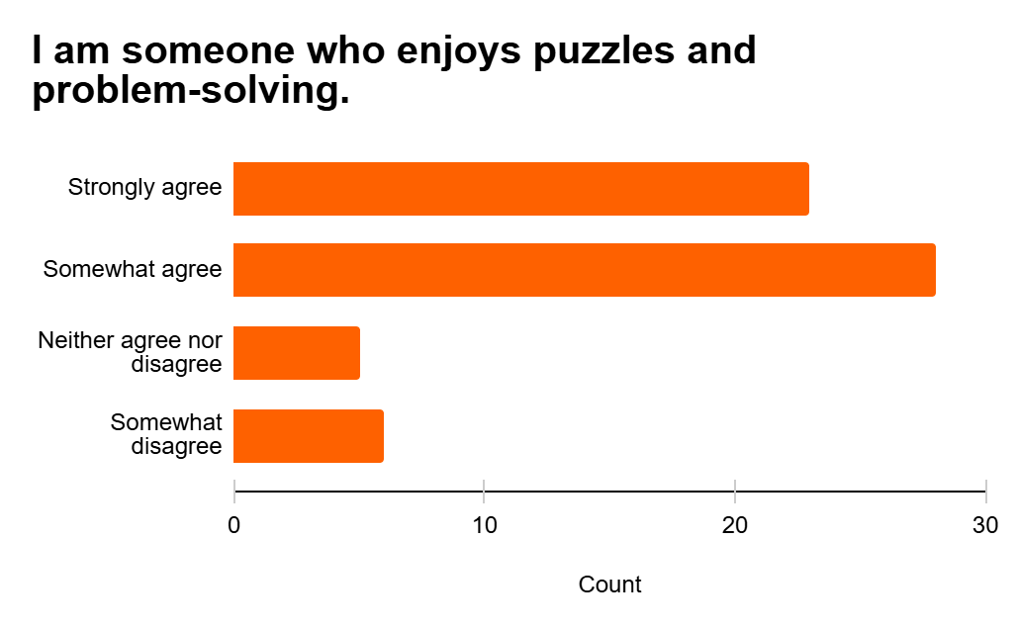
S4: Students indicate enjoying puzzles and problem-solving. A strong majority of students indicate strongly agreeing (23, n = 62) and somewhat agreeing (28, n = 62) that they enjoy puzzles and problem-solving.

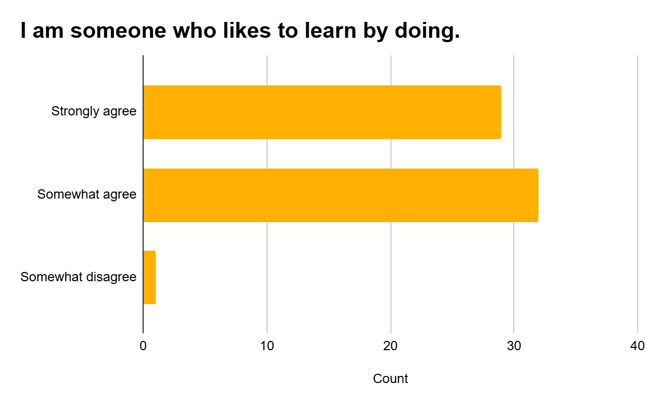
S5: Learning by doing Demographics. 29 students (n = 62) strongly agreed that they are someone who enjoys learning by doing. 32 students somewhat agreed that they enjoy learning by doing. Only 1 student somewhat disagreed that they do not like to learn by doing.

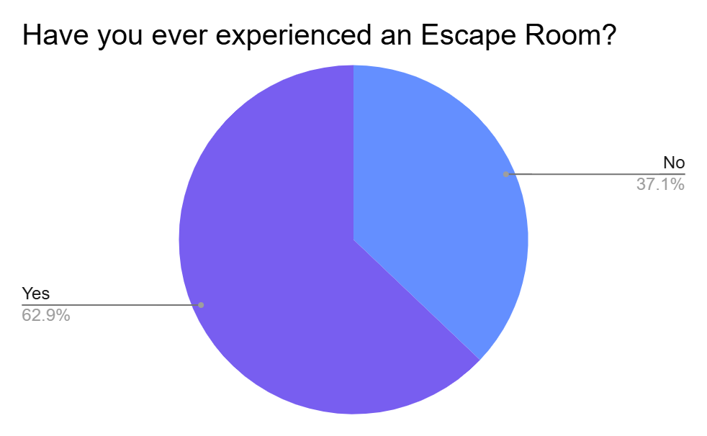
S6: Students indicate if they have participated in an Escape Room. Majority of students (62.9%, n = 62) indicated that they have experienced an Escape Room previously with the rest of the class at 37.1% stating they had not experienced an Escape Room.

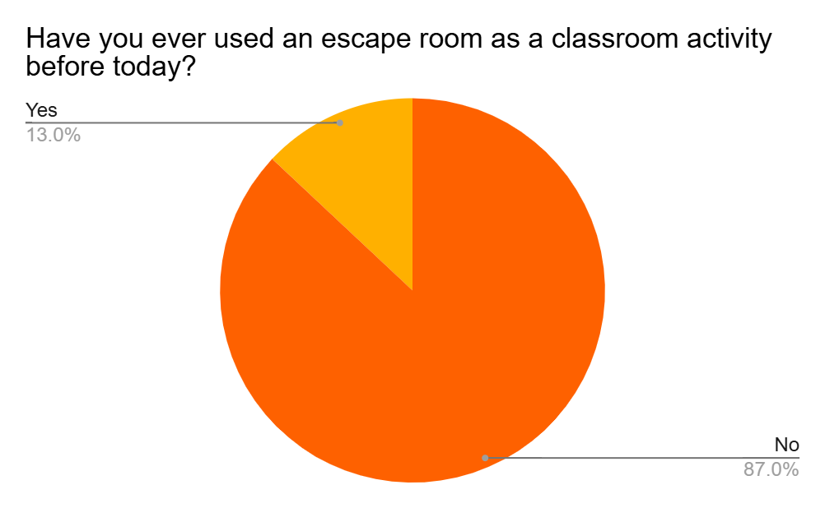
S7: Using an escape room as a class activity. The majority of the class, at 87% of students, indicated that they had not used an escape room as a classroom activity.

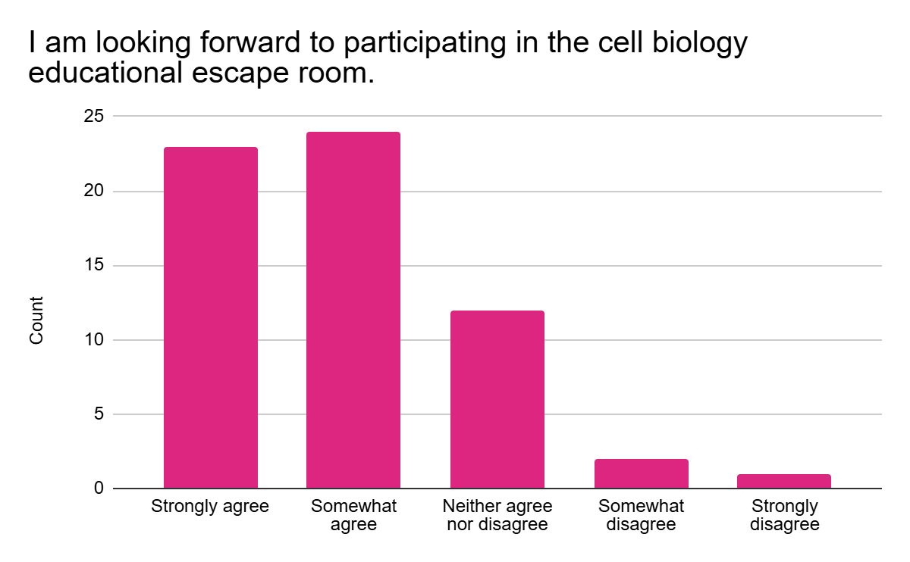
S8: Excited for participating in the educational escape room. 23 students (n = 62) strongly agreed that they were looking forward to participating in the cell biology educational escape room. 24 students somewhat agreed to looking forward to participate in the educational escape room, and only 1 student strongly disagreed with the statement.

