Supplementary figure 1 One rabbit from loosening group developed fracture. a, ⁶⁸Ga-FAPI; b, ¹⁸F-FDG
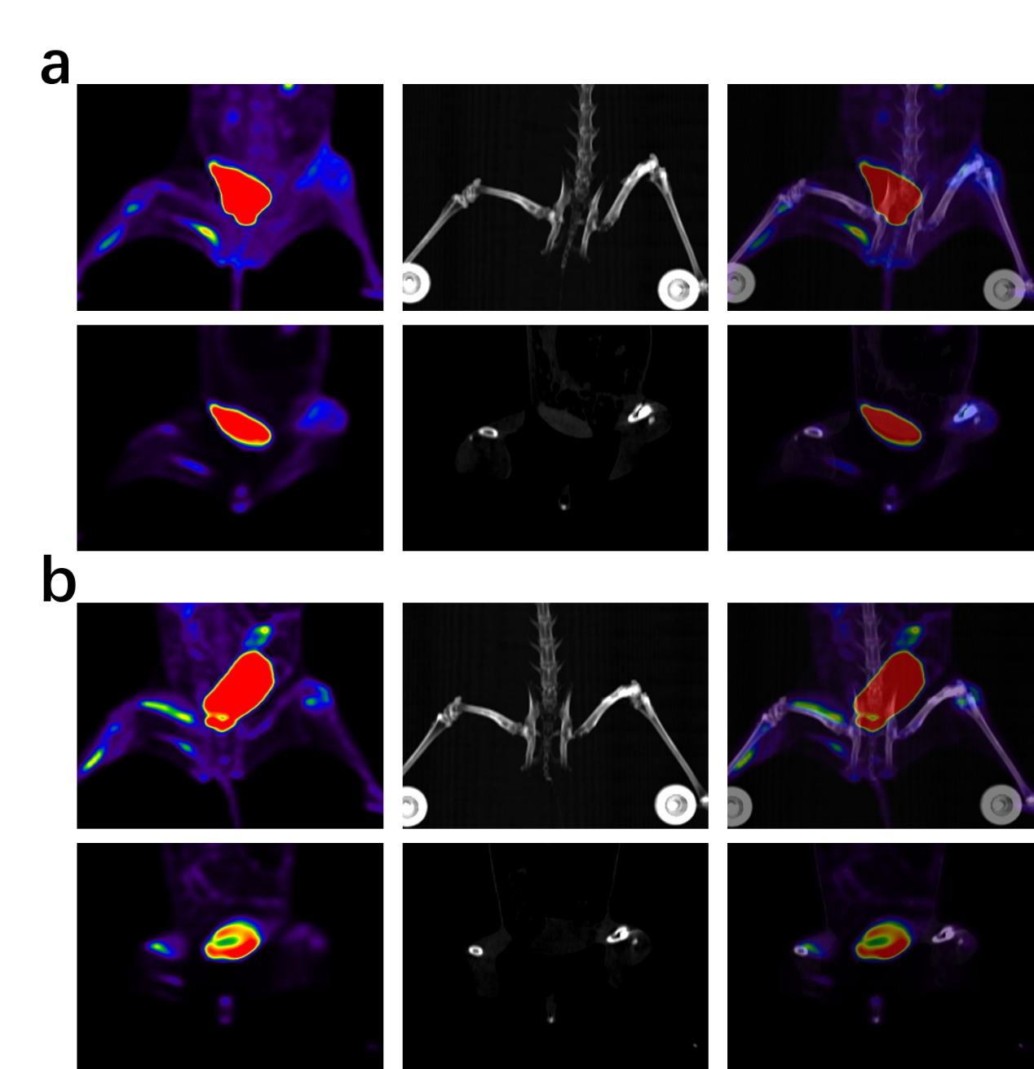

Supplementary figure 2 Clinical representative images. a, loosening of acetabular component; b, infection of acetabular component; c, loosening of femoral stem prosthesis; d, infection of femoral stem prosthesis.
