SUPPLEMENTAL MATERIAL

Automated Radiosynthesis of [¹⁸F]Fluoroedaravone for Clinical Research on a Commercially Available Trasis AllinOne Radiosynthesizer

Arijit Ghosh^{1*}, Joana Marie A. Almazan¹, Ivan E. Wang¹, Allison J. Clay¹, Spenser R. Simpson², Kiel D. Neumann² and Amy L. Vāvere¹

¹ Molecular Imaging Core, Department of Radiology, St. Jude Children’s Research Hospital, Memphis, TN USA.
² Department of Radiology, St. Jude Children’s Research Hospital, Memphis, TN USA.

*Corresponding author:
Arijit Ghosh, PhD
Molecular Imaging Core
Department of Radiology
Mail Stop 220
Memphis, TN, USA 38112
Tel: +1 (901) 595-7921
Email: arijit.ghosh@stjude.org
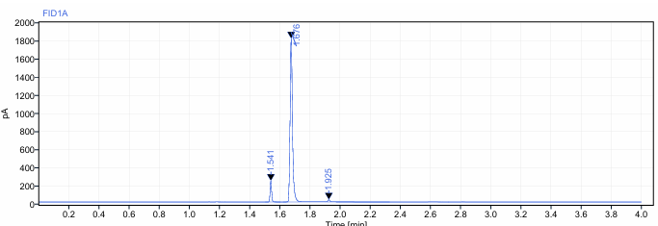
Figure 1: Gas Chromatography analysis of [¹⁸F]FEDV using a DB-WAX column (J & W 122-7032, 30 m x 250 µm x 0.25 µm). The oven temperature was set to 60°C for 1 minute, then ramped to 140°C at a rate of 40°C/min and held for 1 minute. The total run time was 4 minutes, and the front inlet heater was set to 250°C. The split ratio was 15:1, hydrogen flow was 40 mL/min, and the air flow was 400 mL/min. EtOAc – Ethyl acetate, EtOH – Ethanol, MeCN – acetonitrile.
FEDV GC Standard
MeCN
(0.01%)
EtOH
(1%)
EtOAc
(0.1%)
Representative [¹⁸F]FEDV Sample
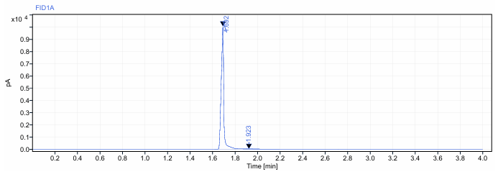

Figure 2: Analytical HPLC analysis of the radiofluorinated intermediate (2) using a Synergi Hydro-RP C18 analytical column (250 × 4.6 mm, 4 μm) with an isocratic mobile phase of a 30:70 (v/v) mixture of water and acetonitrile at a flow rate of 1 mL/min, and UV (254 nm) and radioactive detection. a) HPLC chromatogram of ¹⁸F-intermediate (Rt ~ 10 min) in MeCN after radiofluorination at 85ºC for 1 min b) HPLC chromatogram of ¹⁸F-intermediate after addition of water and holding at 20ºC for 10 min showing the emergence of the degradant peak at ~ 6 min.

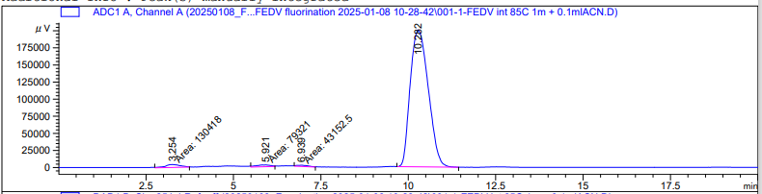
a)
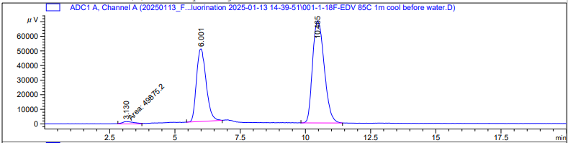
b)

Figure 3: Semi-preparative RP-HPLC chromatogram showing the purification of crude [¹⁸F]FEDV on the Trasis AiO radiosynthesizer, using a Synergi Hydro-RP C18 column (Phenomenex, 10 μm, 250 × 10 mm, 80 Å) under an isocratic flow of 65:35 acetate buffer (0.2 M acetic acid/0.05 M sodium acetate)/EtOH at 3.5 mL/min with UV-visible (254 nm) and radioactive detection. The pure product elutes at ~ 14 min without any discernable chemical impurities as seen in the 254 nm UV window. Peak collected for 2-2.5 minutes.
