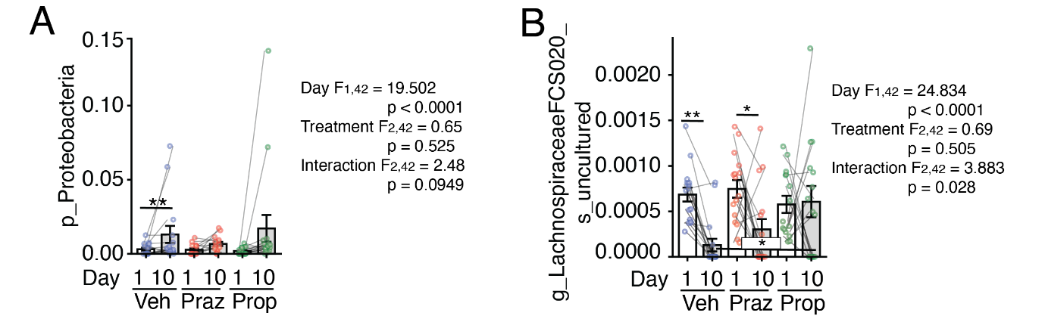

Supplementary Figure 1. Effects of propranolol on proteobacteria and Lachnospiraceae FCS020. Relative abundance of A) the proteobacteria phylum and B) an uncultured species in the Lachnospiraceae FCS020 genus in the Butyricoccus genus in vehicle-, prazosin-, and propranolol-treated mice on Day 1 or Day 10 of CSDS. ART-ANOVA was used to identify overall effects of 10 days of CSDS (Day), treatment (Treatment), and their interaction. The end of each line represents groups in post-hoc comparison distance (n = 15/group, *p < 0.05, **p < 0.01). Lines connecting two data points indicate values from the same mouse. p_ indicates representation of a phylum, g_ indicates representation of a genus, and s_ indicates representation of a species.

