Graphical Abstract

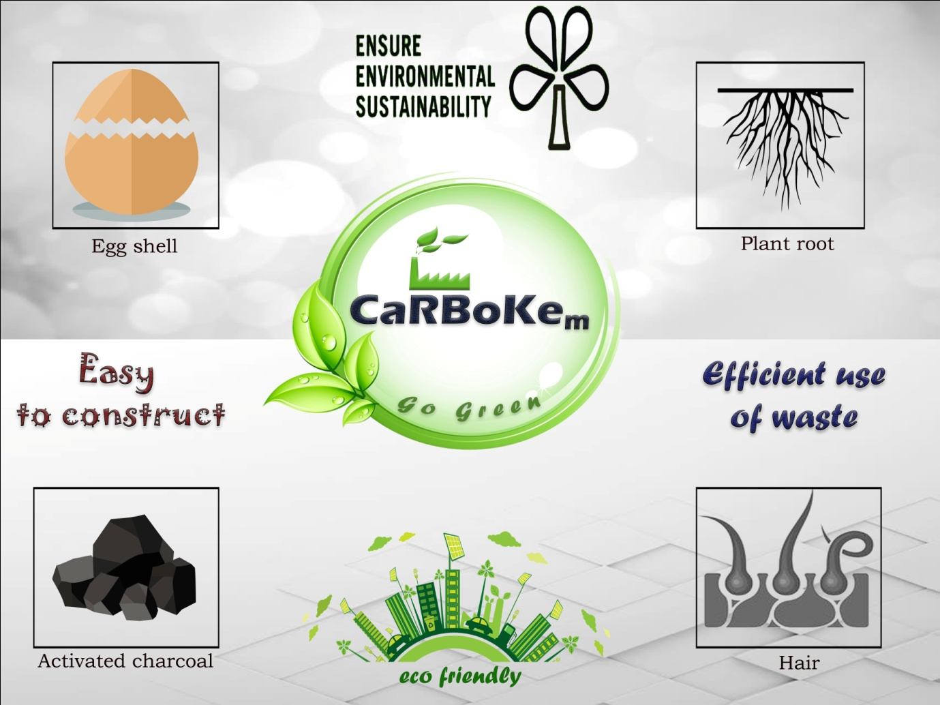
The paper deals with the making of a biofilter with household waste products such as Mustard plant roots, human hair and some common house hold waste products such as, egg shell, and coconut shell. Then the biofilter made for the efficiency test. In that several samples were taken from different industries and the water was made to filter through them. Then AAS test was performed inorder to check the efficiency. The elimination of heavy metals Cu, Pb and Chr₃⁺ using mustard plant roots, eggshell, human hair and activated carbon as adsorbents was carried out by various parameters such as contact time and pH values. The taken as a whole best conditions were at pH value 7 and contact time of 90 mins. As the size of adsorbent was small the competence of adsorption was increased; also these household wastes are economical and the manufacture process is very sustainable. Mover over this will not cause any damage to the future of environment and it is very safe to use. At the primary stage itself the filtration was achieved and it was found that all these adsorbents were finest for adsorption of heavy metals from waste water. In future most likely by modifying the element size to the nanaoscale to attain superior efficiency. Also element modifications may be done on the household waste to amplify the absorbance capability.

.
Metal | pH | Absorbance | Contact time | Unfiltered | Filtered
Cu | 4 | 0.2493 | 60 mins | 37.92ppm | 8.50ppm
Cu | 5 | 0.3283 | 60 mins | 37.92ppm | 8.50ppm
Cu | 6 | 0.034 | 90 mins | 37.92ppm | 8.50ppm
Cu | 7 | 0.0901 | 90 mins | 37.92ppm | 8.50ppm
Pb | 4 | 0.2204 | 60 mins | 12.01ppm | 3.86ppm
Pb | 5 | 0.006 | 60 mins | 12.01ppm | 3.86ppm
Pb | 6 | 0.1908 | 90 mins | 12.01ppm | 3.86ppm
Pb | 7 | 0.0184 | 90 mins | 12.01ppm | 3.86ppm
Chr3⁺ | 4 | 0.1881 | 60 mins | 6.77ppm | 1.82ppm
Chr3⁺ | 5 | 0.0908 | 60 mins | 6.77ppm | 1.82ppm
Chr3⁺ | 6 | 0.1432 | 90 mins | 6.77ppm | 1.82ppm
Chr3⁺ | 7 | 0.2007 | 90 mins | 6.77ppm | 1.82ppm
Table 1: Table of heavy metals with parameter

