Graphical Abstract
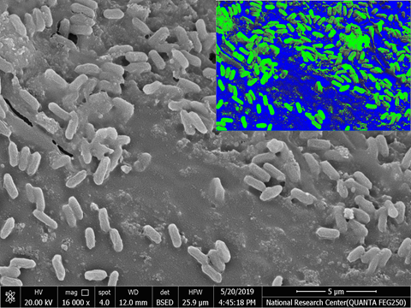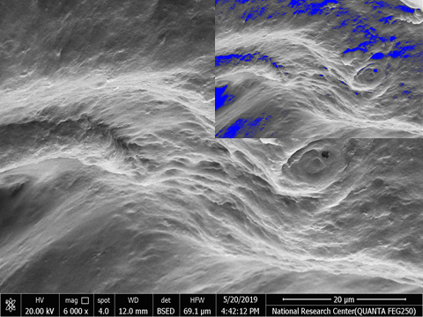
G. xylinum Immobilized onto SCB
G. xylinum immobilized onto Ca-alginate

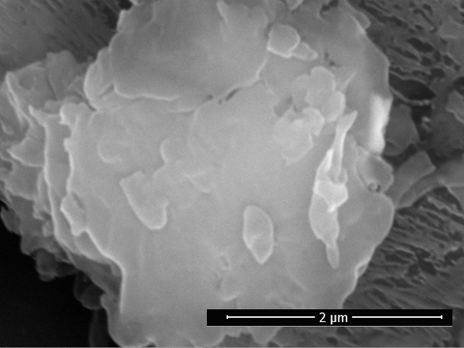
Bacterial Cellulose
Bacterial Cellulose

Repeated batch fermentation

