Online Resource 1
Supplementary methods and results

One boundary in two traces: concept vocabulary and cited references in base-of-the-pyramid, social enterprise and social entrepreneurship research, 2000 to 2025
Faria Zahan Sarna
Lecturer, School of Business and Economics, Metropolitan University, Sylhet, Bangladesh
Email: faria.sarna@metrouni.edu.bd
ORCID: https://orcid.org/0009-0009-6514-4754

Section 1 Search protocol, label assignment and screening

1.1 Sources and retrieval
Records were retrieved from Crossref, Scopus and Google Scholar. Each source was queried for the four label phrases and their common variants, restricted to documents published from 2000 onward. Retrieval operated under source-specific result ceilings, which is why the corpus is described as a large sample of the indexed journal literature rather than a census of it.

1.2 Screening chain
Table S1 Screening chain from retrieval to labelled corpus
Stage | Records | Basis
Retrieved | 1,400 | Raw returns under per-source ceilings: Crossref 1,000, Google Scholar 200, Scopus 200
Unique | 739 | Deduplication on normalised title and on DOI. By contributing source: Crossref 380, Google Scholar 186
OpenAlex-matched | 614 | DOI match, required for reference and concept data
Screened journal articles | 554 | Non-journal document types removed
Labelled | 461 | At least one label matched in title or abstract
Contextual (unlabelled) | 93 | Retained, excluded from all label comparisons
Note. Three source-level counts appear above and are not interchangeable. The ceilings describe raw returns (1,000 / 200 / 200). The 739 unique records decompose as 380 / 186 / 173 by contributing source. The final 554 journal articles decompose as Crossref 324, Scopus 170 and Google Scholar 60. Figure 1 of the manuscript displays the raw returns; the 324 / 170 / 60 split describes the final corpus and is not a retrieval figure.

1.2.1 Detail not recoverable from the archived logs
The archived retrieval logs record the source, the phrase variants, the ceilings and the per-source record counts at each screening stage, which is what is reported above. They do not preserve the verbatim query strings as submitted to each interface, nor the retrieval date for each source. These are stated as missing rather than reconstructed, because a reconstructed query string could not be verified against what was actually run. A reader can reproduce the screening chain and every derived statistic from the deposited identifiers and code in Online Resource 2, but cannot reproduce the original retrieval from this document alone. This is a reproducibility limitation of the study and is stated as such in the manuscript’s limitations.

1.3 Label expressions
A paper receives a label when the expression matches its title or abstract, case-insensitively. Labels are not mutually exclusive and no label is forced.
Table S2 Label expressions as originally described
Label | Regular expression
Base of the pyramid | b(?:ase|ottom)[\s-]of[\s-]the[\s-]pyramid | \bBoP\b | \bBOP\b
Social enterprise | social[\s-]enterprises?
Social entrepreneurship | social[\s-]entrepreneurs(?:hip)?
Inclusive business | inclusive[\s-]business(?:es)? | inclusive[\s-]business[\s-]models?
Note. These expressions are superseded by the patterns as executed, reported in Table S4 (Section 1.6a).

1.4 Label counts
Table S3 Papers carrying each label
Label | Papers with label | Single-label only
Social enterprise | 105 | 56
Social entrepreneurship | 121 | 77
Base of the pyramid | 297 | 259
Inclusive business | 10 | 4
Note. A further 65 papers carry two or more labels, of which 33 span different sides of the division analysed in the paper. Label counts therefore exceed the labelled total.

1.5 Precision audit and the absence of a recall estimate
A random sample of label assignments was coded by hand against the title and abstract. Agreement with the automated assignment was 96 per cent. Recall was not estimated. Doing so would require hand-coding a sample of unlabelled records, which was not undertaken. The paper therefore scopes all conclusions to the retrieved, screened, OpenAlex-matched journal corpus and makes no claim about the literature as a whole.

1.6 Abstract availability
Abstracts are available for 418 of 554 articles (75.5 per cent). The labelling rate is 86.1 per cent among records with an abstract and 74.3 per cent among those without, a gap of 11.8 percentage points. Because the gap is not evenly distributed across labels, the paper repeats its core tests under a title-only labelling rule, reported in Section 2 of this document.

1.6a Label expressions as executed
These are the literal patterns in snbe_common.py. H denotes the hyphen class admitting a space, an ASCII hyphen and four Unicode dash forms. An earlier version of the appendix paraphrased these and differed in three respects, which is corrected here and in Appendix A of the manuscript.
Table S4 Label expressions as executed
Label | Expression as executed
Social enterprise | social H enterprises?\b
Social entrepreneurship | social H entrepreneur(ship)?s?\b
Inclusive business | inclusive H business(es)?\b
Base of the pyramid | (base|bottom) H of H (the H )?(economic H )?pyramid or \bBOP\b or \bBoP\b
Note. H denotes the hyphen class admitting a space, an ASCII hyphen and four Unicode dash forms. The base-of-the-pyramid expression makes both “the” and “economic” optional. The social entrepreneurship expression matches the agent form as well as the process form, which is why a paper may carry both social enterprise and social entrepreneurship. The inclusive business expression has no separate business-model variant.

1.6b Reproduction from the deposit
Online Resource 2 carries a redistributable reproduction dataset under data/: corpus_labels.csv (554 rows, with labels pre-computed under both the title-abstract and the title-only rule), references.csv (34,307 citing-cited OpenAlex id pairs) and concepts.csv (9,752 concept assignments). Raw titles, abstracts and author strings are not redistributed, because part of the corpus came from a subscription source. Every reported statistic depends on that text only through the label assignment, which is deposited pre-computed, so the absence of the text does not prevent reproduction of any reported value. Running code/reproduce_from_deposit.py recomputes the corpus counts, pool sizes and all twelve pairwise Jaccard values from data/ alone and compares them with the deposited results. Verified from a clean directory on 10 October 2026: 29 of 29 checks pass. For the narrower task of re-deriving labels from raw text, code/reconstruct_corpus.py rebuilds the text layer from the OpenAlex API by id.

1.7 Populations
Table S5 Analysis populations
Population | n | Definition | Used for
A | 614 | OpenAlex-matched before document-type exclusion | Not used for any reported result
B | 554 | Screened journal articles | Corpus profile
C | 461 | Labelled papers | Vocabulary, pooled citation, inference
D | 349 | Single-label papers with references | Network and paper-level analysis
Note. Population discipline is enforced throughout. Population A figures are excluded from the manuscript entirely to prevent a pre-exclusion number being read as a canonical one.

Section 2 Robustness, implementation validation and threshold sensitivity

2.1 Main specification: the definitive run
This is the table reproduced as Table 4 of the manuscript. It comes from a single run of 300,000 draws, seed 42, so the raw and Holm-adjusted p values are products of the same Monte Carlo stream. The Holm family is all six pairs. The three inclusive business comparisons are shown because they enter the correction, and are marked exploratory because the group is too small to support inference.
Table S6 Main specification: pairwise label separation in cited references (300,000 draws, seed 42)
Pair | Status | Observed J | Null mean | Effect size | Draws at or below | p | p (Holm)
SE | SEship | Confirmatory | 0.2329 | 0.2598 | −1.16 | 36,288 | 0.1210 | 0.4839
SE | BoP | Confirmatory | 0.1033 | 0.1498 | −3.92 | 3 | 1.3 × 10⁻⁵ | 6.7 × 10⁻⁵
SE | IB | Exploratoryª | 0.0253 | 0.0302 | −0.59 | 86,343 | 0.2878 | 0.8634
SEship | BoP | Confirmatory | 0.1013 | 0.1422 | −4.07 | 2 | 1.0 × 10⁻⁵ | 6.0 × 10⁻⁵
SEship | IB | Exploratoryª | 0.0336 | 0.0354 | −0.17 | 137,543 | 0.4585 | 0.8634
BoP | IB | Exploratoryª | 0.0308 | 0.0358 | −0.52 | 94,317 | 0.3144 | 0.8634
Note. Reproduced as Table 4 of the manuscript. Holm correction is applied across all six pairs. SE social enterprise, SEship social entrepreneurship, BoP base of the pyramid, IB inclusive business, J Jaccard similarity, SD standard deviation
ª Shown because the comparison enters the Holm family; the inclusive business group is too small to support inference.
Why 300,000 draws. Two earlier 10,000-draw runs of this test returned 1,177 and 1,267 draws at or below the observed value for the social-economy pair, p = .118 and p = .1268. That difference was reported in an earlier version of this supplement as an unresolved discrepancy between analysis streams. It is not a discrepancy: at 300,000 draws the estimate is .1210 with a Monte Carlo standard error of 0.0006, and both earlier values lie within 1.8 standard errors of it. The single larger run supersedes both for all reported inference, and it also lifts the two cross-boundary pairs off the reporting floor, so they now carry point estimates rather than a bound. The robustness specifications in Sections 2.2 to 2.9 retain 10,000 draws, which is adequate for sensitivity checks; near p = .05 their Monte Carlo standard error is about 0.002, which is why the two near-threshold values for the social-economy pair are treated as unresolved rather than as evidence either way.

2.2 Temporal split, 2000 to 2012
Table S7 Temporal split, 2000 to 2012 (n = 156)
Pair | Observed J | p | Effect size (null SD)
SE | SEship | 0.1440 | 0.1040 | −1.24
SE | BoP | 0.0270 | 0.0001 | −5.04
SE | IB | 0.0126 | 0.7390 | 0.54
SEship | BoP | 0.0609 | 0.0001 | −4.54
SEship | IB | 0.0114 | 0.7995 | 0.82
BoP | IB | 0.0193 | 0.9760 | 2.27
Note. Group sizes: SE 28, SEship 54, BoP 57, IB 1. 10,000 draws. SE social enterprise, SEship social entrepreneurship, BoP base of the pyramid, IB inclusive business, J Jaccard similarity, SD standard deviation

2.3 Temporal split, 2013 to 2025
Table S8 Temporal split, 2013 to 2025 (n = 398)
Pair | Observed J | p | Effect size (null SD)
SE | SEship | 0.2584 | 0.1838 | −0.90
SE | BoP | 0.1109 | 0.0006 | −2.98
SE | IB | 0.0242 | 0.1867 | −0.89
SEship | BoP | 0.0981 | 0.0095 | −2.25
SEship | IB | 0.0393 | 0.3458 | −0.46
BoP | IB | 0.0307 | 0.1813 | −0.91
Note. Group sizes: SE 77, SEship 67, BoP 240, IB 9. 10,000 draws. The two halves are disjoint subsets of one corpus and one classification pipeline, so they show temporal stability rather than independent replication. SE social enterprise, SEship social entrepreneurship, BoP base of the pyramid, IB inclusive business, J Jaccard similarity, SD standard deviation

2.4 Minimum 5 references
Table S9 Papers with at least 5 references (n = 465)
Pair | Observed J | p | Effect size (null SD)
SE | SEship | 0.2331 | 0.1572 | −1.02
SE | BoP | 0.1034 | 0.0001 | −4.65
SE | IB | 0.0253 | 0.2108 | −0.83
SEship | BoP | 0.1014 | 0.0001 | −4.95
SEship | IB | 0.0337 | 0.3949 | −0.33
BoP | IB | 0.0308 | 0.2189 | −0.81
Note. Group sizes: SE 90, SEship 110, BoP 241, IB 9. 10,000 draws. SE social enterprise, SEship social entrepreneurship, BoP base of the pyramid, IB inclusive business, J Jaccard similarity, SD standard deviation

2.5 Minimum 10 references
Table S10 Papers with at least 10 references (n = 446)
Pair | Observed J | p | Effect size (null SD)
SE | SEship | 0.2334 | 0.1157 | −1.20
SE | BoP | 0.1035 | 0.0001 | −5.03
SE | IB | 0.0253 | 0.1836 | −0.91
SEship | BoP | 0.1017 | 0.0001 | −5.16
SEship | IB | 0.0337 | 0.3557 | −0.43
BoP | IB | 0.0308 | 0.1637 | −0.98
Note. Group sizes: SE 90, SEship 107, BoP 233, IB 9. 10,000 draws. SE social enterprise, SEship social entrepreneurship, BoP base of the pyramid, IB inclusive business, J Jaccard similarity, SD standard deviation

2.6 Minimum 20 references
Table S11 Papers with at least 20 references (n = 418)
Pair | Observed J | p | Effect size (null SD)
SE | SEship | 0.2332 | 0.2112 | −0.82
SE | BoP | 0.1038 | 0.0001 | −4.90
SE | IB | 0.0244 | 0.3406 | −0.47
SEship | BoP | 0.1019 | 0.0001 | −5.46
SEship | IB | 0.0326 | 0.4970 | −0.12
BoP | IB | 0.0289 | 0.4999 | −0.09
Note. Group sizes: SE 82, SEship 102, BoP 216, IB 7. 10,000 draws. SE social enterprise, SEship social entrepreneurship, BoP base of the pyramid, IB inclusive business, J Jaccard similarity, SD standard deviation

2.7 Outlet jackknife, dropping each of the five largest journals
Table S12 Outlet jackknife: p values after excluding each of the five largest journals
Excluded outlet | SE | SEship | SE | BoP | SEship | BoP
Journal of Business Ethics | 0.1522 | 0.0001 | 0.0001
Journal of Business Research | 0.1324 | 0.0001 | 0.0001
Entrepreneurship Theory and Practice | 0.0514 | 0.0001 | 0.0002
Business Strategy and the Environment | 0.1267 | 0.0001 | 0.0001
Journal of Social Entrepreneurship | 0.1112 | 0.0001 | 0.0001
Note. Cells report p values; 10,000 draws. SE social enterprise, SEship social entrepreneurship, BoP base of the pyramid
The social-economy pair comes closest to the conventional threshold when Entrepreneurship Theory and Practice is excluded, at p = .0514. That value is not qualitatively different from .049 and is reported in the main text for that reason.

2.8 Reference-count-stratified null
Labels are reassigned only within quartiles of reference count, so the null preserves how many references each paper contributes.
Table S13 Reference-count-stratified null
Pair | Effect size (null SD) | p
SE | SEship | −1.53 | .0577
SE | BoP | −6.97 | .0001
SEship | BoP | −8.65 | .0001
Note. Labels reassigned within quartiles of reference count; 10,000 draws. SE social enterprise, SEship social entrepreneurship, BoP base of the pyramid, SD standard deviation

2.9 Title-only labelling replication
Labels are assigned from titles alone, removing any dependence on abstract availability. Group sizes: SE 74, SEship 78, BoP 283, IB 7, giving 413 labelled articles.
Table S14 Title-only labelling replication (413 labelled articles)
Pair | Observed J | p | p (Holm)
SE | SEship | 0.1552 | 0.5720 | 0.8150
SE | BoP | 0.0799 | 0.0004 | 0.0020
SEship | BoP | 0.0591 | 0.0001 | 0.0006
Note. Group sizes: SE 74, SEship 78, BoP 283, IB 7. 10,000 draws. SE social enterprise, SEship social entrepreneurship, BoP base of the pyramid, IB inclusive business, J Jaccard similarity, SD standard deviation

2.10 Coupling threshold sensitivity
Table S15 Sensitivity of the bibliographic coupling network to the edge threshold
Threshold | Edges | Displayed nodes | Density | Q (two-way division)
0.02 | 11,647 | 321 | 0.2268 | 0.2648
0.05 | 5,272 | 296 | 0.1208 | 0.2900
0.10 | 1,283 | 234 | 0.0471 | 0.3058
0.15 | 321 | 149 | 0.0291 | 0.3617
Note. Q modularity. The reported specification uses a threshold of 0.05.
Modularity rises as the threshold rises, while the number of displayed nodes falls. The structure is therefore not created by the threshold, but higher thresholds reach it by discarding papers, which is why the paper reports the lower and more inclusive value of 0.05.

2.11 Modularity implementation validation
An error was found and corrected during the analysis. The modularity function originally accumulated the null term only over connected pairs, whereas the definition requires it over every same-community pair. This inflated every modularity value and produced null means near 0.33 instead of near zero. The corrected implementation was validated against direct evaluation of the definition on seven test graphs covering weighted edges, negative modularity, three communities, disconnected components and isolates. The correction changed the reported magnitudes and did not change the direction of any conclusion. It is disclosed here because readers reproducing the analysis from an earlier draft would otherwise find different numbers.
Table S16 Modularity values before and after the implementation correction
Quantity | Superseded value | Corrected value
Two-way division Q | 0.5662 | 0.2900
Four-label Q | 0.5173 | 0.2573
Co-citation Q | 0.4859 | 0.3448
Degree-stratified null mean | 0.3670 | 0.0049
Two-way division z | 37.53 | 42.62
Note. Q modularity; z standardised distance from the null mean.
All modularity nulls in the paper use 10,000 draws. An earlier inconsistency, in which one script used 2,000 draws and another 10,000 for the same quantity, was resolved by standardising to 10,000; the two now agree at z = 42.62.

2.12 Candidate partitions and identification
Table S17 Modularity of candidate two-way divisions of the four labels
Division | Q | Individually significant
SE+SEship vs BoP+IB | 0.2900 | Yes
BoP vs IB+SE+SEship | 0.2868 | Yes
SEship vs BoP+IB+SE | 0.1761 | Yes
BoP+SE vs IB+SEship | 0.1749 | Yes
SE vs BoP+IB+SEship | 0.0518 | Yes
IB+SE vs BoP+SEship | 0.0498 | Yes
IB vs BoP+SE+SEship | −0.0002 | No (p = .690)
Note. Q modularity. SE social enterprise, SEship social entrepreneurship, BoP base of the pyramid, IB inclusive business
Six of the seven divisions are individually significant at p = .0001, so individual significance does not discriminate between candidate groupings. The paired randomisation test of the two leading divisions gives a difference of 0.00314 with two-sided p = .060, a difference not detected at conventional levels. No equivalence claim is made, because no principled margin exists for what difference in modularity would be substantively negligible. Correcting for having searched seven candidates, the best observed division gives a family-wise p of .0001 against a null whose best-division mean is 0.0064.

Section 3 Co-citation representation of frequently cited works

3.1 Why this is supplementary
The co-citation network derives the side of each cited work from the labels of the papers citing it. It therefore shares the same label input as the bibliographic coupling network in the main text and is a second representation built on the same citation records, not independent corroboration. It is reported here rather than in the main text for that reason.

3.2 Construction
The network covers the 287 works cited ten or more times by papers in the corpus. Two works are joined when they are co-cited, and each work is assigned to the side whose papers cite it most often. A work is treated as ambiguous when no side holds a two-thirds majority of its citations.

3.3 Results
Table S18 Modularity of the co-citation network of frequently cited works
Specification | Works | Q | Null mean | z | p
All frequently cited works | 287 | 0.3448 | −0.0035 | 76.25 | .0001
Decisive majority only | 250 | 0.4152 | −0.0038 | 78.05 | .0001
Note. Q modularity. Works cited ten or more times by papers in the corpus; a decisive majority is a two-thirds share of citations from one side. 10,000 draws.
12.9 per cent of works lack a decisive majority, and they concentrate at the boundary between the two sides. Restricting the network to the 250 works with a decisive majority raises modularity, which is a consequence of removing the ambiguous cases rather than further evidence for the structure. Both specifications are reported so that the effect of that removal is visible.
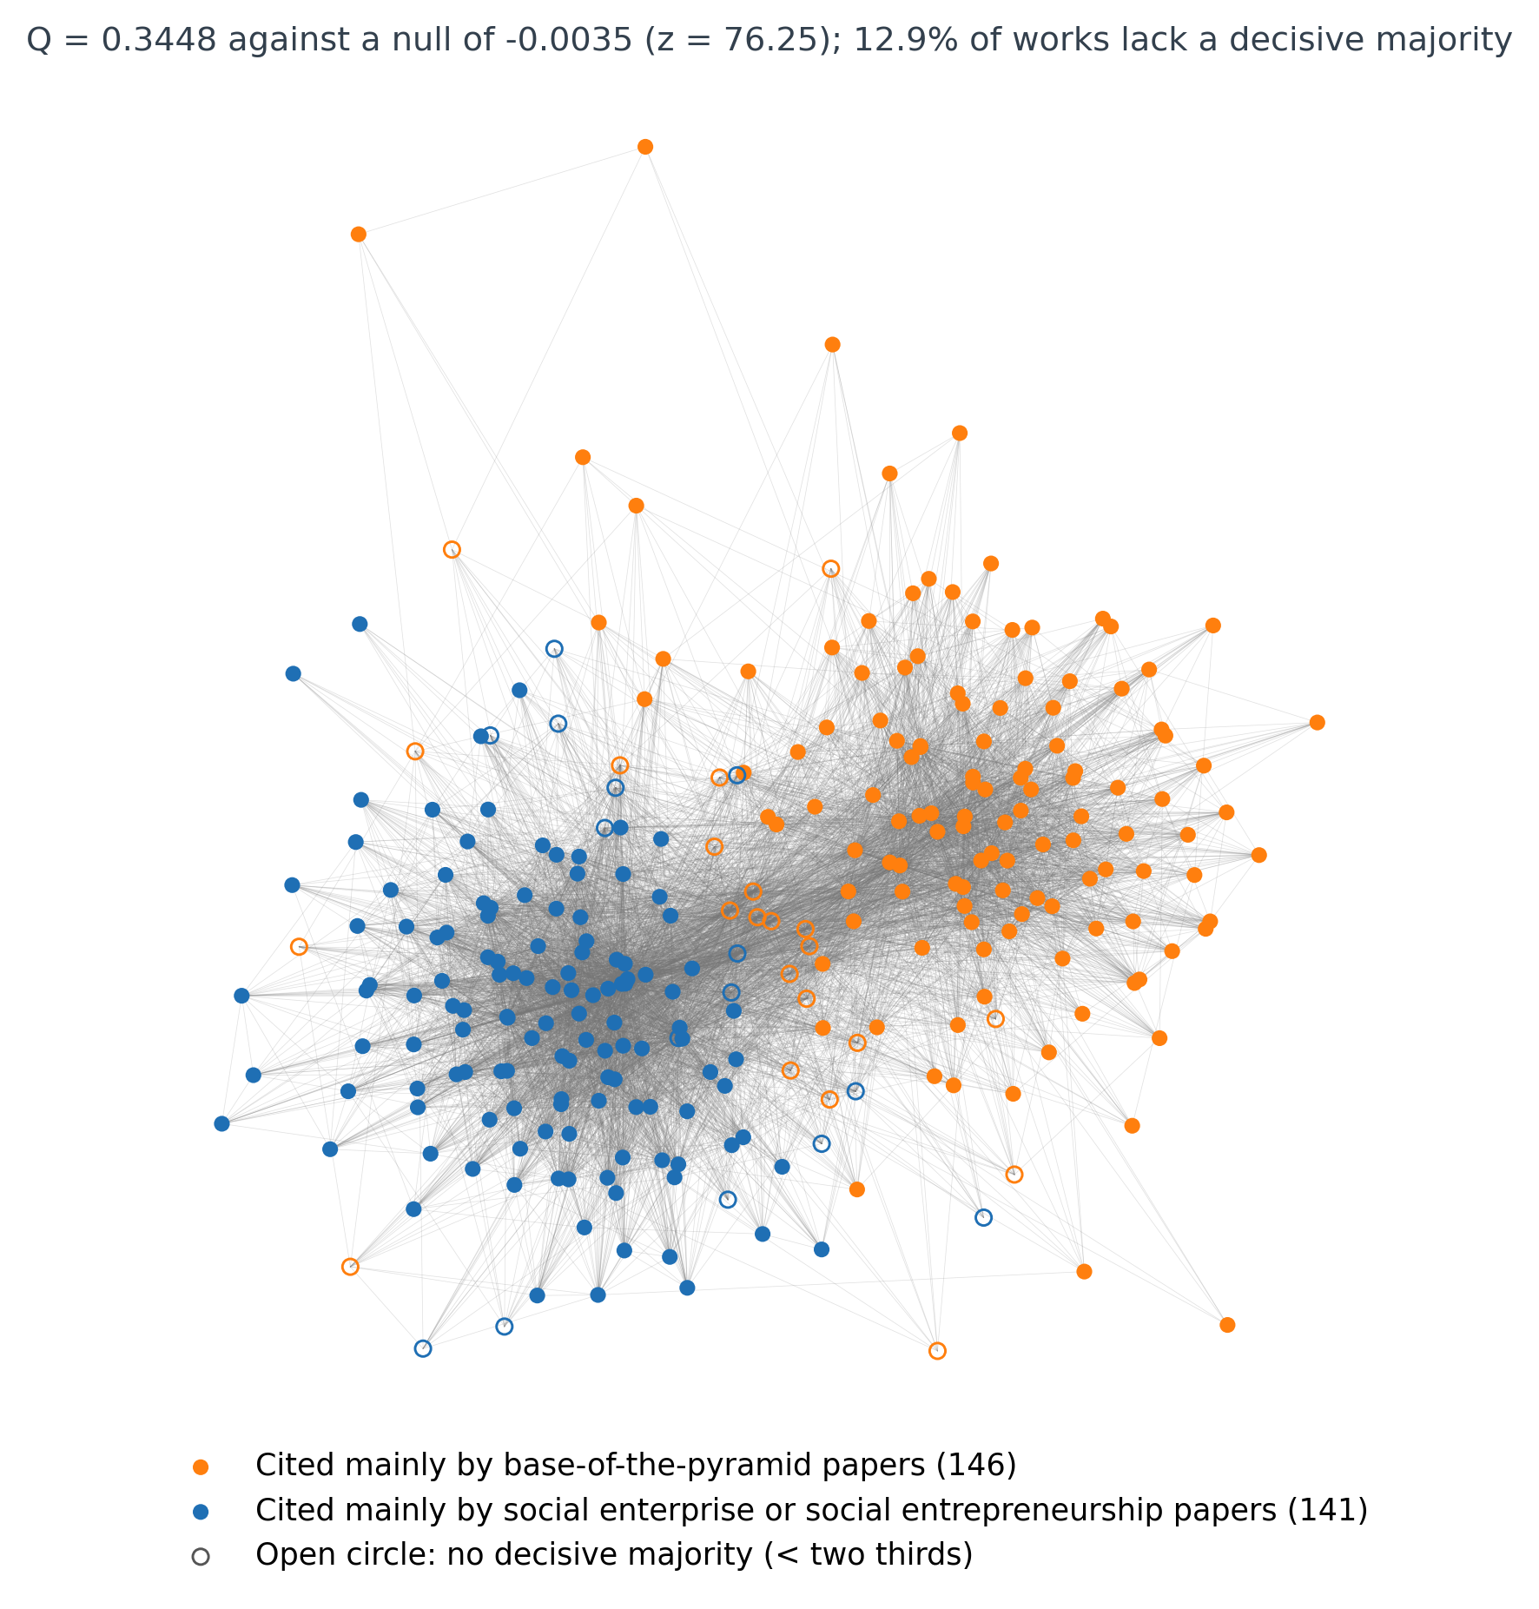
Fig. S1 Co-citation network of the works cited ten or more times, with works coloured by the side whose papers cite them most often and open circles marking the works that lack a decisive two-thirds majority. Orange: cited mainly by base-of-the-pyramid papers (146); blue: cited mainly by social enterprise or social entrepreneurship papers (141). Q = 0.3448 against a null mean of −0.0035 (z = 76.25); 12.9 per cent of works lack a decisive majority

