Semaglutide and Kidney Outcomes in Type 2 Diabetes Patients at Low to Moderate Kidney Risk: A Retrospective Active-Comparator Cohort Study.
Genya Aharon Hananel, MD ^{1,2}, Johannes F. E. Mann, MD ^{3,4}, Alona Aharonovich, PharmD ⁵, Aliza Hammerman Rozenberg ⁶, Ilan Yanuv ⁷, Adir Dagan ⁸, Sivan Gazit, MD ⁹, Efrat Leopold, PhD ⁹, Ori Mayer, MD ⁸, Gil Chernin, MD ^{2,10}
¹ Diabetes Unit, Department of Endocrinology and Metabolism, Hadassah Medical Center, Jerusalem, Israel.
² Faculty of Medicine, Hebrew University of Jerusalem, Jerusalem, Israel.
³ KfH Kidney Centre, München-Schwabing, Germany.
⁴ Department of Medicine, Friedrich-Alexander University, Erlangen, Germany.
⁵ Novo Nordisk, Israel.
⁶ A.I. Statistics, Statistical Consulting, Jerusalem, Israel.
⁷ Independent Statistical Consultant, Modiin, Israel.
⁸ Mayer Analytics and Research, Ramat Gan, Israel.
⁹ KSM Research Institute, Maccabi Healthcare Services, Tel Aviv, Israel.
¹⁰ Kaplan Medical Center, Rehovot, Israel.
Corresponding author: Genya Aharon Hananel, genya.ah@gmail.com

Supplementary methods

S1. Rationale for active comparator selection
DPP4i drugs were selected as the active comparator for several methodological and clinical reasons. DPP4i has demonstrated noninferiority for major cardiovascular outcomes in SAVOR-TIMI 53, EXAMINE, and TECOS [21, 22, 23]. While DPP4is have modest effects on albuminuria—for example, a 14% lower hazard of categorical albuminuria progression in CARMELINA and a pooled reduction in the albumin-to-creatinine ratio of 2.76 mg/g (0.31 mg/mmol) [24, 25]—randomized trials and meta-analyses have not demonstrated an improvement in hard kidney outcomes [24, 26]. These characteristics support their selection as active comparators for evaluating clinically meaningful kidney endpoints.
Second, active comparator designs control for confounding by indication, treatment intensity, and healthcare engagement that systematically bias comparisons with untreated controls.
While DPP4is differ from semaglutide in terms of glycemic efficacy, weight reduction, and cardiorenal benefits, they represent a more methodologically sound comparator than SGLT2is, which have established independent kidney benefits that would obscure the impact of semaglutide. Alternative second-line agents—including sulfonylureas, insulin, and thiazolidinediones—were not suitable comparators because of their opposite effects on weight and declining contemporary use. The study employed robust multivariable adjustment, including baseline HbA1c, BMI, and cardiovascular disease status, to control for differences in treatment indications between semaglutide initiators and DPP4i initiators.
Third, DPP4is remained in widespread clinical use throughout the study period (2019--2024), particularly in primary care settings, providing a contemporaneous and clinically relevant comparison group.

S2. Detailed primary endpoint definition rationale
The composite kidney outcome was designed to capture clinically meaningful kidney deterioration in a population at low to moderate baseline risk for renal complications. In such populations, progression to end-stage kidney disease is uncommon, necessitating the inclusion of earlier markers of kidney function decline to ensure adequate statistical power and clinical relevance.
eGFR decline ≥30%: The FDA and EMA are willing to consider a 30–40% GFR decline as a surrogate endpoint for kidney failure under appropriate conditions [27]. In a meta-analysis of more than 1.7 million participants, a 30% decrease in the eGFR was strongly associated with subsequent ESKD and mortality, with associations preserved among participants with baseline eGFRs ≥60 mL/min/1.73 m² [4].
New-onset or worsening albuminuria: Albuminuria was included, as it frequently represents the first detectable marker of kidney damage in patients with low to moderate KDIGO risk and preserved eGFR. In patients with type 2 diabetes and preserved kidney function, albuminuria is associated with early morphologic kidney damage when the eGFR is still preserved and is superior to the eGFR for predicting early structural glomerular lesions [12]. Albuminuria independently predicts kidney failure, cardiovascular events, and mortality even in patients with eGFRs >60 mL/min/1.73 m² [13, 14, 15].
All-cause death: Due to the retrospective nature of the study and the absence of adjudicated cause-of-death data in the database, all-cause death was included in the composite endpoint instead of cardiovascular death.

S3. Secondary endpoint analysis
For the outcomes related to time to event, Cox proportional hazards models were fitted. Similar to the primary composite outcome, the analysis followed an intention-to-treat principle, and HRs were adjusted for prespecified covariates.
Analysis of transitions across KDIGO categories KDIGO risk categories were determined at each assessment via the eGFR and UACR according to the KDIGO classification [5]. Transitions between KDIGO categories at the end of the follow-up were analyzed. For each participant, the follow-up KDIGO category was defined as the last available measurements of the eGFR and UACR. When the eGFR and UACR were not measured on the same date, values obtained within ±90 days were paired for risk classification. For participants whose final follow-up category represented deterioration or regression, the time to transition was defined as the first date on which that final category was reached. KDIGO categories were treated as ordinal outcomes, such that progression to a given category included all transitions to that category or to a more severe category, as appropriate. Transition rates across KDIGO categories were analyzed via Cox proportional hazards models. Death was included as a component of deterioration outcomes to avoid treating death as noninformative censoring.
Exploratory joint subgroup analysis by baseline HbA1c and diabetes duration
In an exploratory analysis, treatment effects were examined across eight jointly defined strata of baseline HbA1c (<7% vs ≥7%) and diabetes duration (<5, 5–<10, 10–<15, ≥15 years), using a single Cox model including a three-way interaction between treatment assignment, HbA1c category and diabetes duration category. Stratum-specific HRs were derived from this model, and the three-way interaction term was tested to assess whether effect modification by HbA1c differed by diabetes duration.

S4. Statistical power estimation
The feasibility assessment of the MHS database revealed that approximately 30,000 semaglutide initiators and 11,000 DPP4i initiators met the initial inclusion criteria between August 2019 and August 2024. Sample size assumptions are based on a retrospective study from the same database comparing kidney outcomes between SGLT2i and DPP4i cohorts [28]. In the subpopulation without evident renal disease, the cumulative incidence of the composite outcome (eGFR decline ≥40%, kidney failure, and all-cause death) was ~6.0% in the DPP4i group after 5 years.
Our study incorporates an expanded composite outcome including an eGFR decline ≥30%, new-onset or worsening albuminuria, kidney failure, and all-cause death. In a European cohort of screen-detected type 2 diabetes patients, 15% developed new albuminuria over 5.3 years [29]. Adjusting for the assumed shorter follow-up period and accounting for time-to-first-event censoring, where albuminuria progression and 30% eGFR decline often precede the harder outcomes of kidney failure or death, we conservatively estimated a composite event rate of approximately 10–12% in the DPP4i group among patients at low to moderate KDIGO risk.
With this event rate, the required sample sizes per group are as follows:
to detect 15% risk reduction (HR 0.85): approximately 3,200–3,600 participants per group
to detect 20% risk reduction (HR 0.80): approximately 1,800–2,000 participants per group
(80% power, α=0.05, two-sided)
The available sample of ~30,000 semaglutide and >10,000 DPP4i initiators (before being restricted to low to moderate KDIGO risk categories and 1:1 matching) was anticipated to provide adequate power to detect a 15–20% risk reduction in the composite kidney outcome, representing a clinically meaningful difference.

S5. Software statement
Statistical analyses and preparation of tables and figures were performed via R version 4.5.0. The R packages used, with their versions, were car (3.1.3), CBPS (0.23), corrplot (0.0.95), DataExplorer (0.8.4), DT (0.34.0), dtrackr (0.5.0), emmeans (2.0.2), forestploter (1.1.3), ggsurvfit (1.2.0), grid (4.5.0), gt (1.1.0), gtsummary (2.4.0), here (1.0.2), htmltools (0.5.8.1), janitor (2.2.1), kableExtra (1.4.0), knitr (1.50), MatchIt (4.7.2), mice (3.19.0), patchwork (1.3.2), RColorBrewer (1.1.3), renv (1.1.5), rmarkdown (2.30), scales (1.4.0), sessioninfo (1.2.3), SmartEDA (0.3.10), snakecase (0.11.1), survival (3.8.3), survminer (0.5.1), tidycmprsk (1.1.2), tidyselect (1.2.1), tidyverse (2.0.0), validate (1.1.6), withr (3.0.2), and writexl (1.5.4).

Supplementary tables

Table S1. Propensity score model variables

Demographic parameters | Clinical parameters | Comorbidities/medications
Sex  Female/male | eGFR (mL/min/1.73 m²), categorical  45-<60  60-<90  ≥90 | Medications  Metformin  Insulin  Renin-angiotensin system inhibitor  Mineralocorticoid receptor antagonist
Age (years), categorical  18-<35; 35-<45; 45-<55; 55-<65;  65-<75; ≥75 | UACR (mg/g), categorical ª  0; <15; ≥15-<30; 30-<300 | Medical history  Acute Kidney Injury  Retinopathy  Ischemic Heart Disease  Heart Failure
Socioeconomic status, categorical  1-3 (low); 4-5 (medium-low);  6-7 (medium-high); 8-10 (high) | Systolic blood pressure (mm Hg),  categorical  <120; 120-<130; 130-<140  140-<150; ≥150; missing
Diabetes duration (years),
categorical
<1; 1-<5; 5-<10; 10-<15; ≥15
HbA1c (%), categorical ª
<6; 6-<7; 7-<8; 8-<9; ≥9; missing
BMI (kg/m²), categorical
<25; 25-<27; 27-<30; 30-<35; 35-<40;
≥40; missing
ª HbA1c and UACR variables are presented in the units used in the fitted models; corresponding SI values are reported in Tables 1 and S4. SI equivalents: UACR 15/30/300 mg/g = 1.7/3.4/33.9 mg/mmol; HbA1c 6/7/8/9% = 42/53/64/75 mmol/mol. BMI, body mass index; eGFR, estimated glomerular filtration rate; HbA1c, glycated hemoglobin; MHS, Maccabi Healthcare Services; UACR, urine albumin‒creatinine ratio.

Table S2. Variable definitions

Variable | Definition
Demographics
Age | Age at the index date
Sex | Male /female
Socioeconomic status (SES) | Area-level score based on the residential statistical area (1–10; higher scores indicate greater socioeconomic advantage); most recent score recorded within the 365 days before the index date
Measurements
Blood pressure (mm Hg) | Most recent measurement obtained from 365 days before through 30 days after the index date
BMI (kg/m²) | Most recent measurement obtained from 365 days before through 30 days after the index date
Laboratory tests and related parameters
HbA1c (%) ª  LDL cholesterol (mg/dL) ª  HDL cholesterol (mg/dL) ª  Triglycerides (mg/dL) ª  UACR (mg/g) ª | Most recent measurement obtained within the 365 days before the index date
eGFR (mL/min/1.73 m²) | Most recent eGFR value recorded within the 365 days before the index date, calculated using the 2009 CKD-EPI equation
KDIGO kidney risk category | Category assigned using baseline eGFR and UACR
Medical history
Diabetes duration (years) | Time from inclusion in the MHS T2D registry to the index date
Ischemic Heart Disease (IHD) | Confirmed inclusion in the MHS IHD registry before the index date (yes/no)
Heart Failure (HF) | Confirmed inclusion in the MHS HF registry before the index date (yes/no)
Stroke | Confirmed inclusion in the MHS Stroke (Cerebrovascular Accident) registry before the index date (yes/no)
Peripheral Vascular Disease (PVD) | Confirmed inclusion in the MHS PVD registry before the index date (yes/no)
Acute Kidney Injury (AKI) | Confirmed diagnosis recorded in MHS electronic records before the index date: ICD-9 codes 584.5-584.9; yes/no
Atrial Fibrillation | Confirmed diagnosis recorded in MHS electronic records before the index date: ICD-9 code 427.31; yes/no
Chronic Liver Disease | Confirmed diagnosis recorded in MHS electronic records before the index date: ICD-9 codes 571.X; yes/no
Retinopathy | Confirmed diagnosis recorded in MHS electronic records before the index date: ICD-9 codes 362.X; yes/no
Background medications ^{b}
Metformin | Baseline use: purchase of at least three packages from 90 days before through 90 days after the index date. ATC-5 codes: A10BA02, A10BD07, A10BD08, A10BD11, A10BD10, A10BD15, A10BD20
Insulin | Baseline use: purchase of at least one package from 90 days before through 90 days after the index date. ATC-3 code: A10A
Renin-angiotensin system inhibitor | Baseline use: purchase of at least three packages from 90 days before through 90 days after the index date. ATC-5 codes: C09AA01, C09AA02, C09AA03, C09AA05, C09AA06, C09AA07, C09AA08, C09AA09, C09AA13, C09CA01, C09CA03, C09CA04, C09CA06, C09CA08, C09DX02, C09DX04, C09DA01, C09DA03, C09DA04, C09DA06, C09BA05, C09BA08, C09BA09, C09BB02, C09DB01
Mineralocorticoid receptor antagonist | Baseline use: purchase of at least three packages from 90 days before through 90 days after the index date. ATC-5 codes: C03DA01, C03DA04, C03DA05
SGLT2i | Baseline use: purchase of at least 1 package within 180 days before the index date. ATC-5 codes: A10BK03, A10BK01, A10BK04, A10BD15, A10BD20
Beta-blockers | Baseline use: purchase of at least three packages from 90 days before through 90 days after the index date. ATC-3 code: C07A
Antithrombotic agents | Baseline use: purchase of at least three packages from 90 days before through 90 days after the index date. ATC-3 code: B01A
Lipid modifying agents | Baseline use: purchase of at least three packages from 90 days before through 90 days after the index date. ATC-3 codes: C10A, C10B
ª HbA1c, UACR and lipid variables are presented in the units used in the fitted models; corresponding SI values are reported in Tables 1 and S4.^{. b} Exposure windows and package thresholds were tailored to each medication's typical dispensing pattern and daily dosing regimen rather than applying a uniform rule across all drug classes. Because SGLT2 inhibitor status was central to stratification and outcome analyses, a more sensitive single-package/180-day definition was used to minimize misclassification of true users as unexposed; the 3-package/±90-day rule applied to other background medications was tested for SGLT2 inhibitors in a sensitivity analysis, with results essentially unchanged (see Supplementary Table S7). ATC, Anatomical Therapeutic Chemical; BMI, body mass index; eGFR, estimated glomerular filtration rate; HbA1c, glycated hemoglobin; HDL, high-density lipoprotein; ICD, International Classification of Diseases; IHD, ischemic heart disease; LDL, low-density lipoprotein; MHS, Maccabi Healthcare Services; PVD, peripheral vascular disease; SGLT2i, sodium–glucose cotransporter-2 inhibitor; T2D, type 2 diabetes; UACR, urine albumin‒creatinine ratio.

Table S3. Adjustment model variables

Demographic parameters | Clinical parameters | Comorbidities/  medications
Sex  Female/male | Systolic blood pressure (mm Hg),  continuous | Medications  Metformin  Insulin  Renin-angiotensin system inhibitor  Mineralocorticoid receptor antagonist  SGLT2i  Beta blockers  Antithrombotic agents  Lipid modifying agents
Age (years), continuous | Diabetes duration (years),  continuous | Medical history  Ischemic Heart Disease  Heart Failure  Stroke  Peripheral Vascular Disease  Atrial Fibrillation  Chronic Liver Disease
Socioeconomic status,  continuous | HbA1c (%), continuous
 | BMI (kg/m²), continuous
KDIGO kidney risk category
Low/Moderate
LDL cholesterol (mg/dL), continuous
HDL cholesterol (mg/dL), continuous
Triglycerides (mg/dL), continuous

HbA1c and lipid variables are presented in the units used in the fitted models; corresponding SI values are reported in Tables 1 and S4. BMI, body mass index; eGFR, estimated glomerular filtration rate; HbA1c, glycated hemoglobin; HDL, high-density lipoprotein; KDIGO, Kidney Disease: Improving Global Outcomes; LDL, low-density lipoprotein; MHS, Maccabi Healthcare Services; SGLT2i, sodium‒glucose cotransporter-2 inhibitor; UACR, urine albumin‒creatinine ratio.

Table S4. Baseline characteristics before matching

Characteristics | DPP4i N = 8388 | Semaglutide N = 21955 |  | SMD
Sex |  |  |  | 0.01
Male | 4398 (52.4%) | 11574 (52.7%)
Female | 3990 (47.6%) | 10381 (47.3%)
Age, years
Mean (SD) | 63.6 (11.6) | 60.1 (10.5) |  | 0.32
Socioeconomic status category |  |  |  | 0.11
1-3 (low) | 988 (11.8%) | 2257 (10.3%)
4-5 (medium-low) | 2406 (28.7%) | 5666 (25.8%)
6-7 (medium-high) | 2836 (33.8%) | 7440 (33.9%)
8-10 (high) | 2140 (25.5%) | 6551 (29.8%)
Missing | 18 (0.2%) | 41 (0.2%)
Diabetes duration, years
Median (IQR) | 6.5 (2.4-11.5) | 7.3 (2.9-12.9) |  | 0.14
HbA1c, %
Mean (SD) | 7.7 (1.6) | 7.2 (1.5) |  | 0.30
Missing N (%) | 42 (0.5%) | 116 (0.5%)
HbA1c, mmol/mol
Mean (SD) | 60.7 (17.5) | 55.2 (16.4) |  | 0.30
eGFR, mL/min/1.73 m²
Mean (SD) | 86.4 (16.7) | 89.1 (16.2) |  | 0.17
eGFR category, mL/min/1.73 m² |  |  |  | 0.17
45-<60 | 564 (6.7%) | 973 (4.4%)
60-<90 | 3955 (47.2%) | 9107 (41.5%)
≥90 | 3869 (46.1%) | 11875 (54.1%)
Missing N (%) | 0 (0.0%) | 0 (0.0%)
UACR, mg/g
Median (IQR) | 6.1 (0.0-23.1) | 6.6 (0.0-24.9) |  | 0.05
UACR, mg/mmol
Median (IQR) | 0.69 (0.00–2.61) |  | 0.75 (0.00–2.82) | 0.05
UACR category |  |  |  | 0.04
<30 mg/g (<3.4 mg/mmol) | 6738 (80.3%) | 17252 (78.6%)
30–<300 mg/g (3.4–<33.9 mg/mmol) | 1650 (19.7%) | 4703 (21.4%)
Missing N (%) | 0 (0.0%) | 0 (0.0%)
Kidney risk category  (KDIGO classification) |  |  |  | 0.01
Low | 6174 (73.6%) | 16279 (74.1%)
Moderate | 2214 (26.4%) | 5676 (25.9%)
BMI, kg/m²
Mean (SD) | 30.3 (5.4) | 33.8 (5.6) |  | 0.65
Missing N (%) | 1498 (17.9%) | 2198 (10.0%)
Systolic blood pressure, mm Hg
Mean (SD) | 132.9 (15.4) | 132.9 (15.1) |  | <0.01
Missing N (%) | 531 (6.3%) | 1561 (7.1%)
Diastolic blood pressure, mm Hg
Mean (SD) | 78.2 (9.4) | 78.9 (9.3) |  | 0.07
Missing N (%) | 531 (6.3%) | 1561 (7.1%)
HDL cholesterol, mmol/L
Mean (SD) | 1.21 (0.30) | 1.19 (0.29) |  | 0.05
Missing N (%) | 83 (1.0%) | 278 (1.3%)
LDL cholesterol, mmol/L
Mean (SD) | 2.47 (0.95) | 2.42 (0.94) |  | 0.06
Missing N (%) | 163 (1.9%) | 442 (2.0%)
Triglycerides, mmol/L
Median (IQR) | 1.74 (1.25–2.42) | 1.74 (1.28–2.44) |  | 0.01
Missing N (%) | 76 (0.9%) | 262 (1.2%)
Medications
Metformin | 6034 (71.9%) | 14346 (65.3%) |  | 0.14
Insulin | 618 (7.4%) | 2995 (13.6%) |  | 0.21
SGLT2 inhibitor | 1229 (14.7%) | 6967 (31.7%) |  | 0.41
Renin-angiotensin system inhibitor | 4099 (48.9%) | 11814 (53.8%) |  | 0.10
Mineralocorticoid receptor antagonist | 191 (2.3%) | 736 (3.4%) |  | 0.07
Diuretic | 1278 (15.2%) | 3325 (15.1%) |  | <0.01
Lipid modifying agent | 5293 (63.1%) | 13603 (62.0%) |  | 0.02
Antithrombotic agent | 2837 (33.8%) | 7880 (35.9%) |  | 0.04
Comorbidities
Ischemic heart disease | 849 (10.1%) | 3382 (15.4%) |  | 0.16
Stroke | 198 (2.4%) | 445 (2.0%) |  | 0.02
Peripheral vascular disease | 196 (2.3%) | 615 (2.8%) |  | 0.03
Heart failure | 84 (1.0%) | 408 (1.9%) |  | 0.07
Atrial fibrillation | 397 (4.7%) | 1180 (5.4%) |  | 0.03
Retinopathy | 165 (2.0%) | 765 (3.5%) |  | 0.09
Data are presented as n (%) for categorical variables, means (SDs) for normally distributed continuous variables, and medians (IQRs) for nonnormally distributed continuous variables. BMI, body mass index; DPP4i, dipeptidyl peptidase-4 inhibitor; eGFR, estimated glomerular filtration rate; HbA1c, glycated hemoglobin; HDL, high-density lipoprotein; IQR, interquartile range; KDIGO, Kidney Disease: Improving Global Outcomes; LDL, low-density lipoprotein; SD, standard deviation; SGLT2i, sodium‒glucose cotransporter-2 inhibitor; UACR, urine albumin‒creatinine ratio. SMD, standardized mean difference. For variables presented as medians (interquartile ranges), the SMD was calculated using the group means and standard deviations. SMDs are reported as absolute values.

Table S5. Laboratory testing frequency by treatment group

Period | Laboratory test | DPP4i, mean (SD) | Semaglutide, mean (SD)
Baseline | eGFR | 2.26 (1.64) | 2.20 (1.38)
Baseline | UACR | 1.52 (0.74) | 1.53 (0.78)
Follow-up | eGFR | 5.99 (4.32) | 5.32 (3.74)
Follow-up | UACR | 3.67 (1.87) | 3.38 (1.83)
The values are the means (SDs) of the number of laboratory tests per participant. The baseline period was 365 days before treatment initiation; follow-up refers to the study follow-up period of 36 months. DPP4i, dipeptidyl peptidase-4 inhibitor; eGFR, estimated glomerular filtration rate; UACR, urine albumin–creatinine ratio.

Table S6. First occurrence of the primary composite outcome and individual components

 | DPP4i  N = 6705 | Semaglutide  N = 6705 | p value
 | n of events (%)
Primary composite outcome events ª | 844 (12.6%) | 581 (8.7%) | <0.001
eGFR  decline of at least 30% | 191 (2.8%) | 125 (1.9%) | 0.004
New-onset or worsening albuminuria | 545 (8.1%) | 399 (6.0%) | <0.001
ESKD (end-stage kidney disease) | 2 (<0.1%) | 3 (<0.1%) | 0.6
All-cause death | 114 (1.7%) | 61 (0.9%) | <0.001
The event counts and percentages are descriptive and unadjusted. P values were calculated via log-rank tests. Adjusted hazard ratios are reported in the main time‒event analyses. ª For the composite outcome, each participant contributed only once according to the time of first event occurrence. If multiple outcome components occurred on the same day in the same participant, each component was counted in its respective category; therefore, component totals may exceed the number of composite events. DPP4i, dipeptidyl peptidase-4 inhibitor; eGFR, estimated glomerular filtration rate; ESKD, end-stage kidney disease.

Table S7. Sensitivity analysis: 3-month peri-index SGLT2i exposure definition

Primary composite outcome | Adjusted HR
General study cohort | 0.69; 95% CI 0.62–0.78; p<0.001
Participants with SGLT2i at baseline | 0.69; 95% CI 0.53–0.91; p=0.010
Participants without SGLT2i at baseline | 0.69; 95% CI 0.61–0.79; p<0.001
SGLT2i baseline use definition: purchase of at least 3 packages within the period of 90 days before and after the index date.

Supplementary figures

Figure S1. Cumulative cohort entry over time

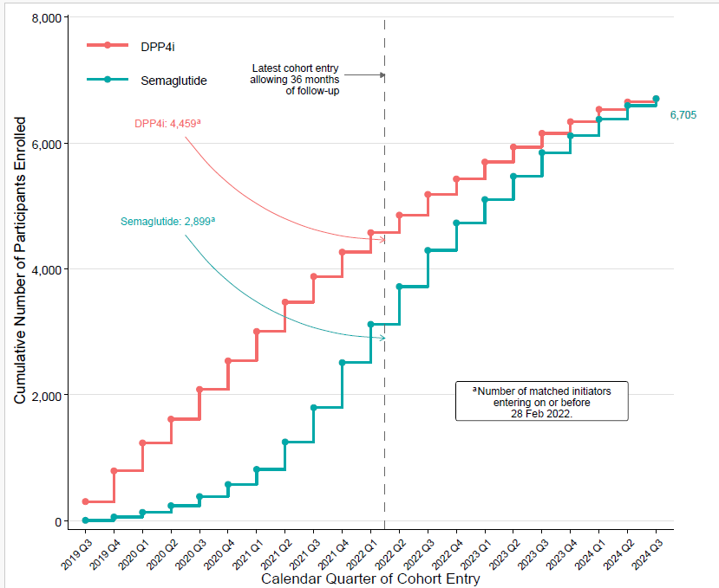
Cumulative numbers of matched DPP4i and semaglutide initiators by calendar quarter of cohort entry. The dashed vertical line marks 28 February 2022, the latest cohort-entry date allowing 36 months of potential follow-up before the end of data availability on 28 February 2025. Participants entering the cohort on or before 28 February 2022 could have up to 36 months of follow-up. DPP4i, dipeptidyl peptidase-4 inhibitor.

Figure S2. Primary composite outcome over up to 5 years of follow-up

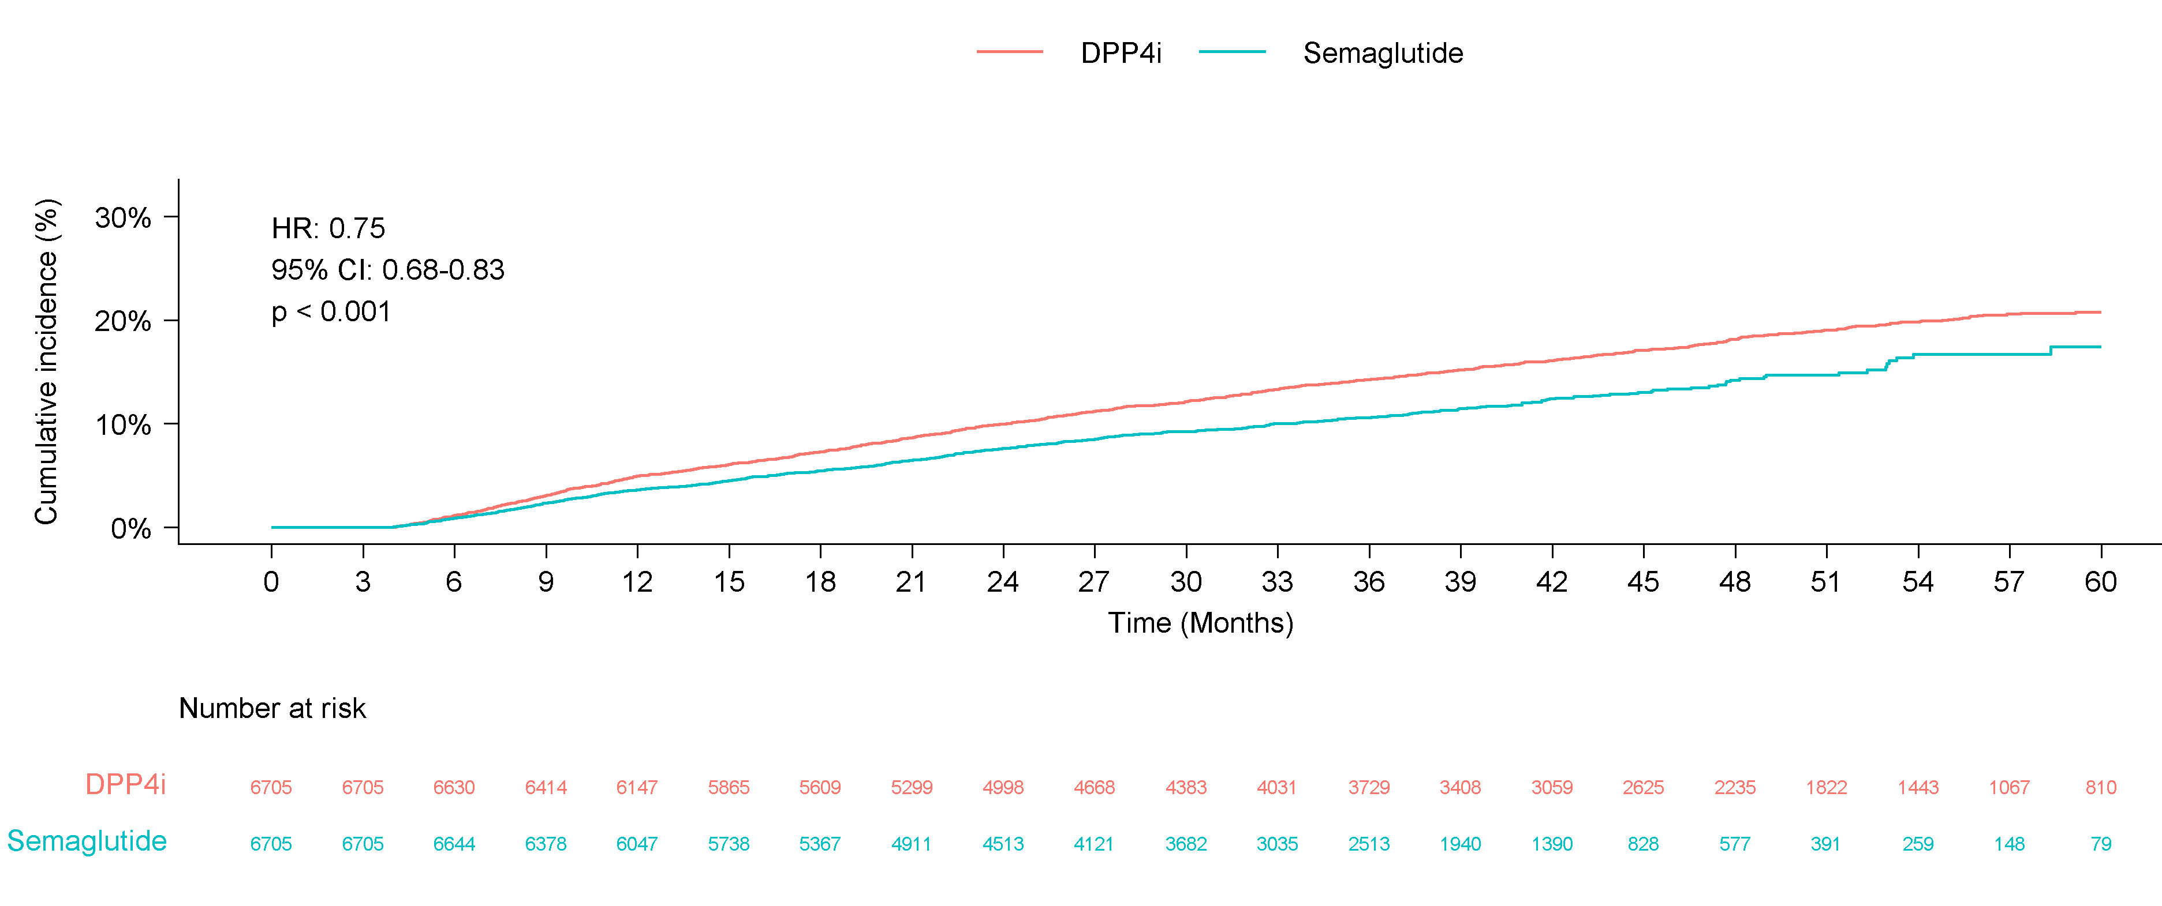
Kaplan–Meier curves for the primary composite outcome over fully available follow-up data, with a maximum of approximately 5 years. The composite outcome comprised confirmed ≥30% eGFR decline, new-onset or worsening albuminuria, ESKD, or all-cause death. Curves and the displayed HR and 95% CI are unadjusted; the adjusted HR is reported in the text. CI, confidence interval; DPP4i, dipeptidyl peptidase-4 inhibitor; eGFR, estimated glomerular filtration rate; ESKD, end-stage kidney disease; HR, hazard ratio.

Figure S3. Composite outcome using a ≥40% eGFR decline threshold
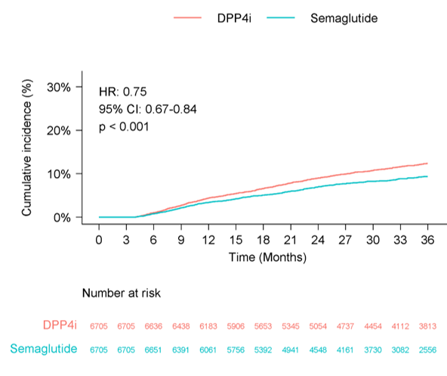
Kaplan‒Meier curves for the composite outcome defined as the first occurrence of confirmed ≥40% eGFR decline, new-onset or worsening albuminuria, ESKD, or all-cause death. Curves and the displayed HR and 95% CI are unadjusted; the adjusted HR is reported in the text. CI, confidence interval; DPP4i, dipeptidyl peptidase-4 inhibitor; eGFR, estimated glomerular filtration rate; ESKD, end-stage kidney disease; HR, hazard ratio.

Figure S4. Composite outcome using a ≥50% eGFR decline threshold

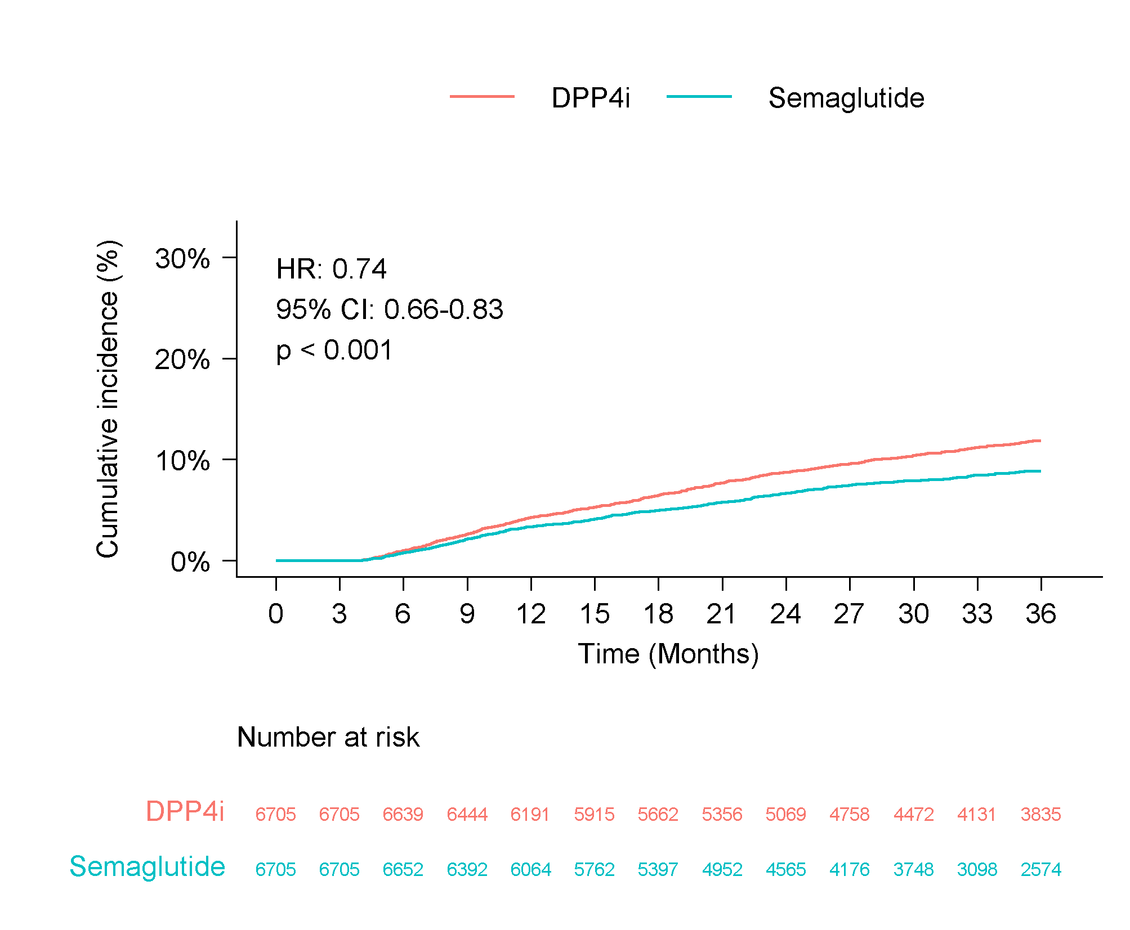
Kaplan‒Meier curves for the composite outcome defined as the first occurrence of confirmed ≥50% eGFR decline, new-onset or worsening albuminuria, ESKD, or all-cause death. Curves and the displayed HR and 95% CI are unadjusted; the adjusted HR is reported in the text. CI, confidence interval; DPP4i, dipeptidyl peptidase-4 inhibitor; eGFR, estimated glomerular filtration rate; ESKD, end-stage kidney disease; HR, hazard ratio

Figure S5. Kidney-specific composite outcome
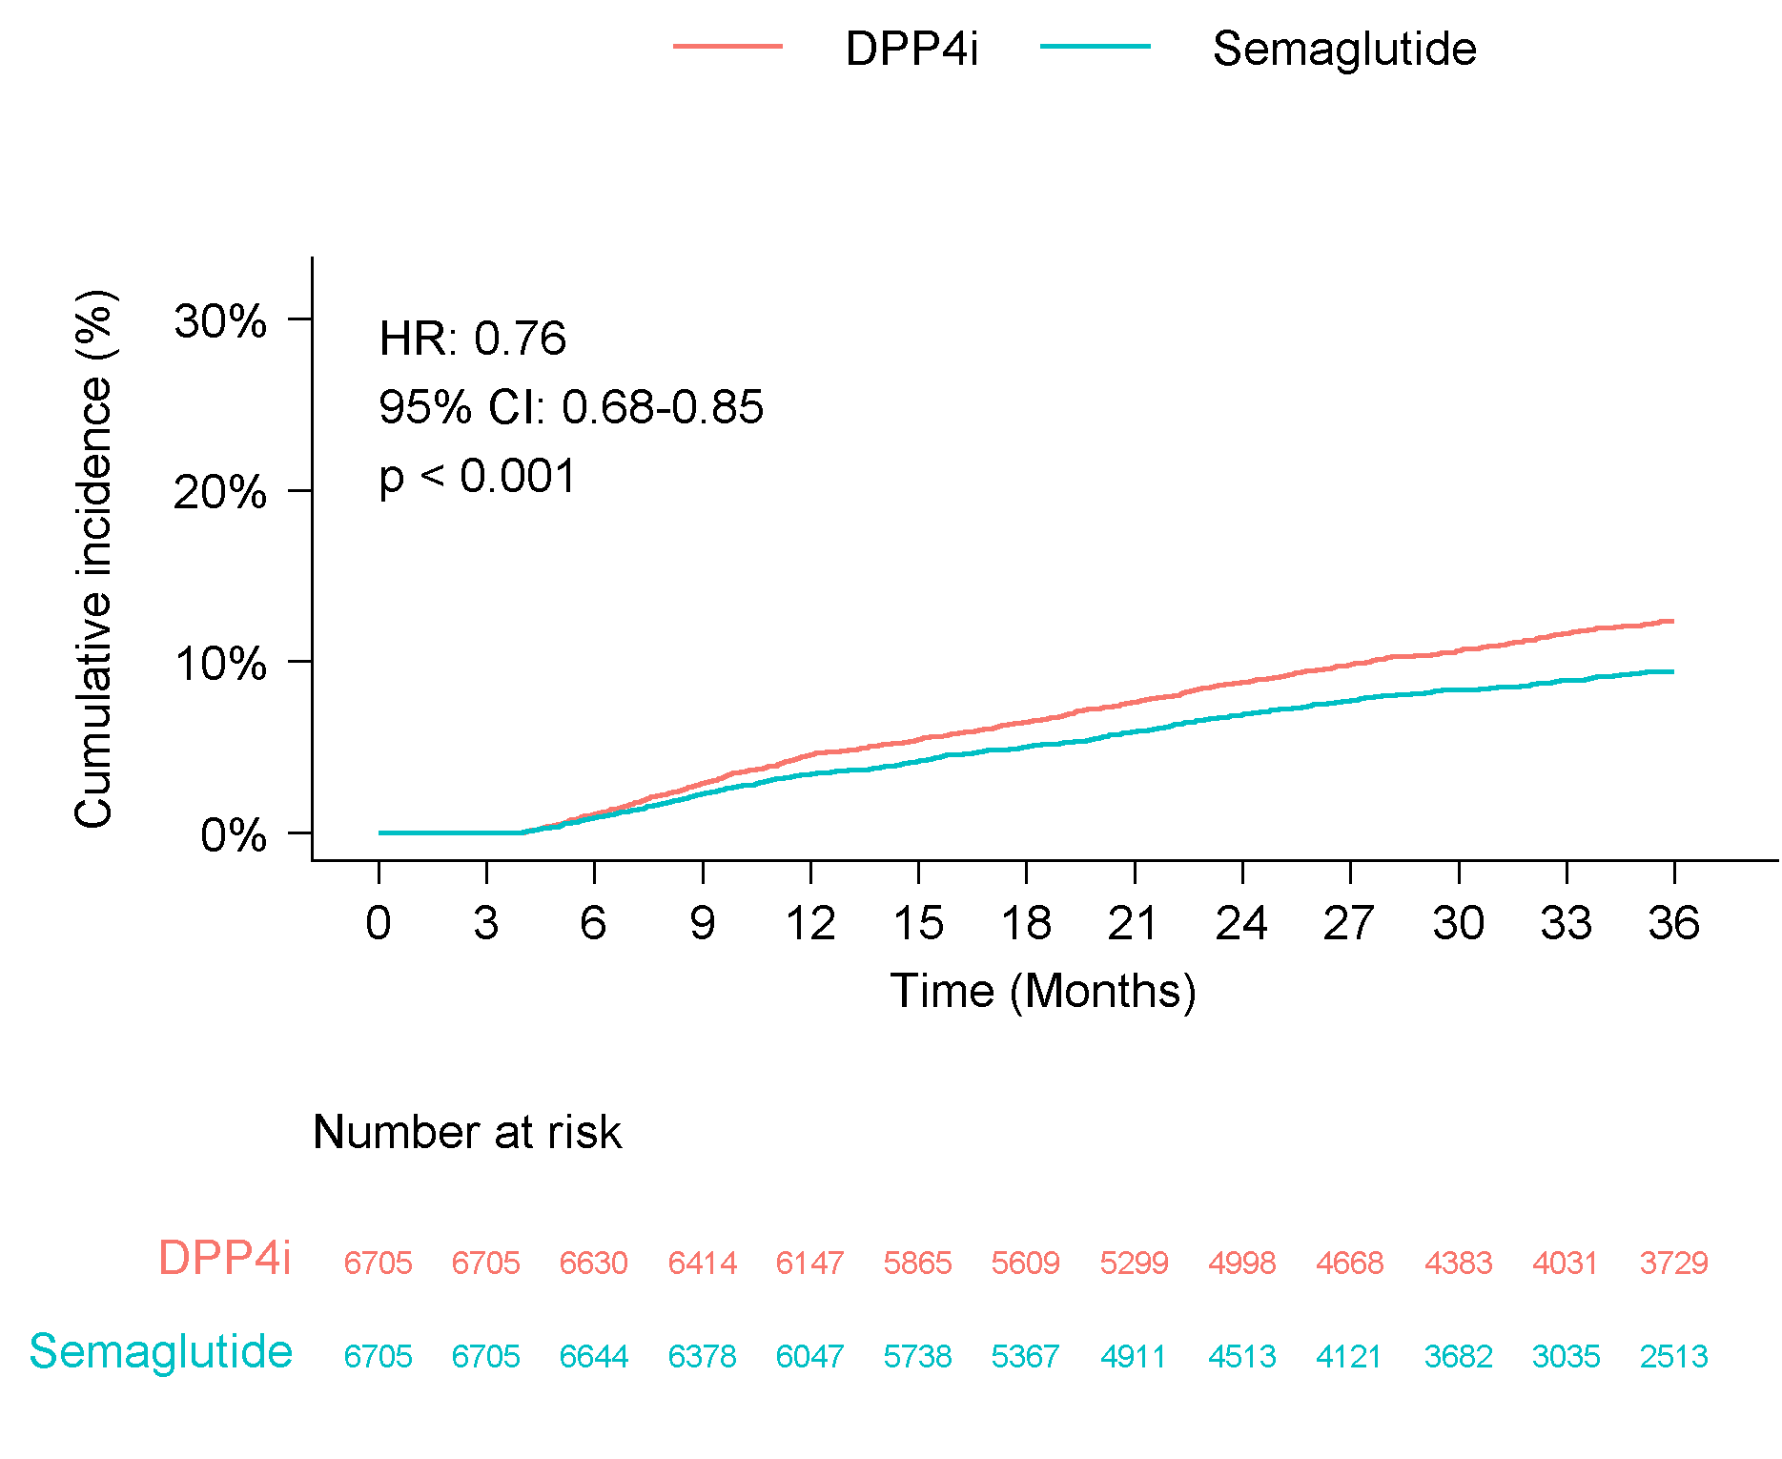

Kaplan‒Meier curves for the first occurrence of the kidney-specific composite outcome, defined as confirmed ≥30% eGFR decline, new-onset or worsening albuminuria, or ESKD. Curves and the displayed HR and 95% CI are unadjusted; the adjusted HR is reported in the text. CI, confidence interval; DPP4i, dipeptidyl peptidase-4 inhibitor; eGFR, estimated glomerular filtration rate; ESKD, end-stage kidney disease; HR, hazard ratio.

Figure S6. Kidney-specific composite outcome with death treated as a competing risk

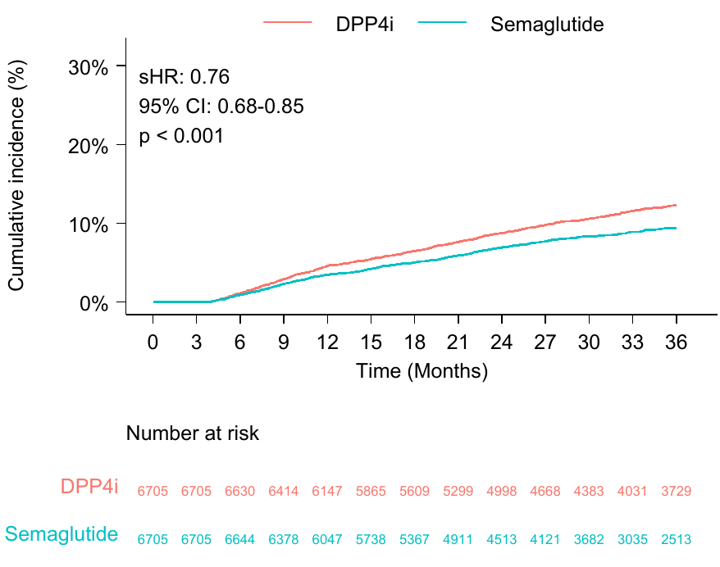
Cumulative incidence curves for the first occurrence of the kidney-specific composite outcome, defined as confirmed ≥30% eGFR decline, new-onset or worsening albuminuria, or ESKD, with all-cause death treated as a competing event. The curves and displayed sHR and 95% CI are unadjusted; the adjusted sHR is reported in the text. CI, confidence interval; DPP4i, dipeptidyl peptidase-4 inhibitor; eGFR, estimated glomerular filtration rate; ESKD, end-stage kidney disease; sHR, subdistribution hazard ratio.

Figure S7. Exploratory joint subgroup analysis by baseline HbA1c and diabetes duration

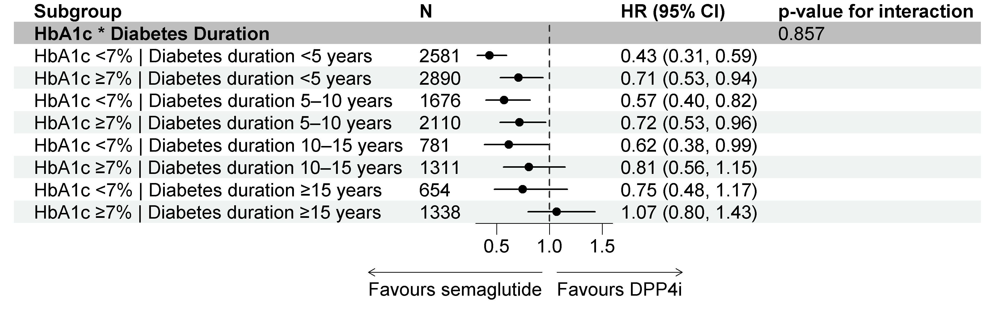
Adjusted HRs and 95% CIs for the primary composite outcome comparing semaglutide with DPP4i across joint strata of baseline HbA1c and diabetes duration. This exploratory analysis was not prespecified and was not adjusted for multiple comparisons. SI equivalent: HbA1c 7% = 53 mmol/mol. CI, confidence interval; DPP4i, dipeptidyl peptidase-4 inhibitor; HbA1c, glycated hemoglobin; HR, hazard ratio.

Figure S8. Transitions in KDIGO risk categories at 36 months of the follow-up

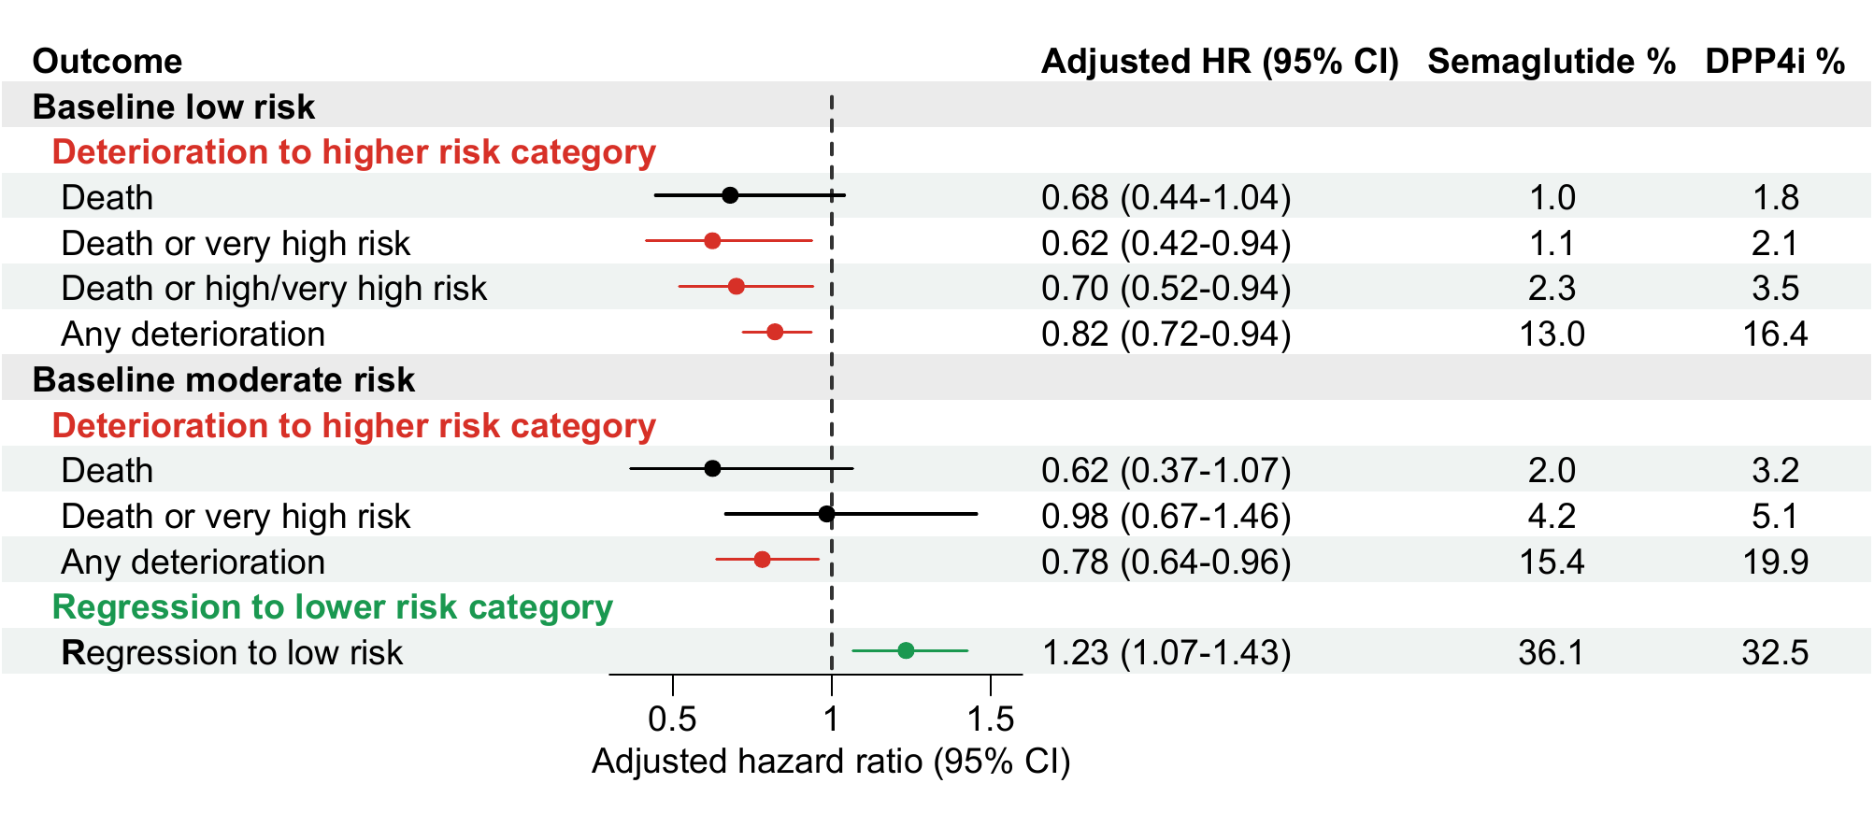
Adjusted HRs and 95% CIs for transitions in KDIGO risk categories during follow-up. Death was included as a component of all deterioration outcomes. For deterioration outcomes, an HR <1 favors semaglutide; for regression to low risk, an HR >1 favors semaglutide. CI, confidence interval; DPP4i, dipeptidyl peptidase-4 inhibitor; HR, hazard ratio; KDIGO, Kidney Disease: Improving Global Outcomes.

Figure S9. Baseline characteristics across semaglutide evidence sources

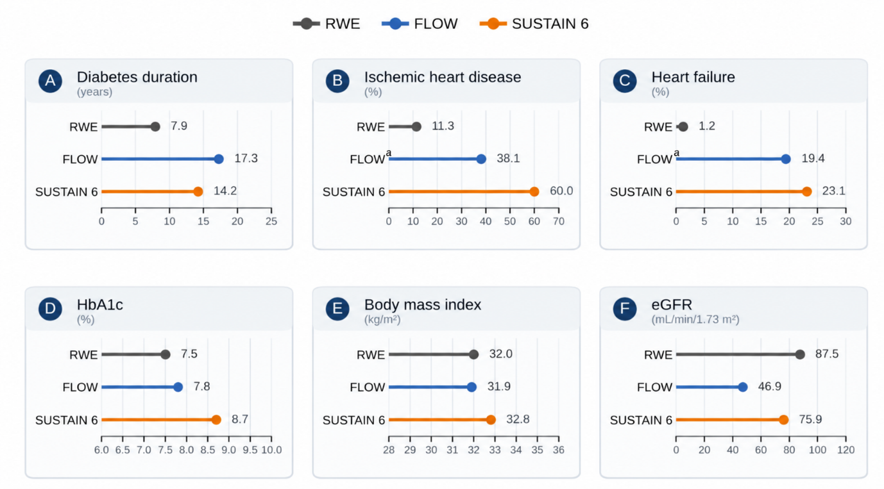
Comparison of baseline characteristics in the matched semaglutide cohort from the current study (RWE; N=6705) and the semaglutide groups in FLOW (N=1767) [6] and SUSTAIN 6 (N=1648) [19, 20]. ª Unpublished data from the FLOW clinical trial report (data on file with Novo Nordisk; used with permission). The values are the means for diabetes duration, HbA1c, BMI, and eGFR and percentages for IHD and HF. The corresponding HbA1c values in the SI units are 58.5, 61.7, and 71.6 mmol/mol for RWE, FLOW, and SUSTAIN 6, respectively. BMI, body mass index; eGFR, estimated glomerular filtration rate; HbA1c, glycated hemoglobin; HF, heart failure; IHD, ischemic heart disease; RWE, real-world evidence.

References:
- American Diabetes Association Professional Practice Committee for Diabetes. Chronic kidney disease and risk management: Standards of Care in Diabetes—2026. Diabetes Care. 2026;49 Suppl 1:S246-S260. doi:10.2337/dc26-S011.
- Chaudhry K, Karalliedde J. Chronic kidney disease in type 2 diabetes: the size of the problem, addressing residual renal risk and what we have learned from the CREDENCE trial. Diabetes Obes Metab. 2024;26 Suppl 5:25-34. doi:10.1111/dom.15765.
- Morales J, Handelsman Y. Cardiovascular outcomes in patients with diabetes and kidney disease: JACC review topic of the week. J Am Coll Cardiol. 2023;82:161-170. doi:10.1016/j.jacc.2023.04.052.
- Coresh J, Turin TC, Matsushita K, Sang Y, Ballew SH, Appel LJ, et al. Decline in estimated glomerular filtration rate and subsequent risk of end-stage renal disease and mortality. JAMA. 2014;311:2518-2531. doi:10.1001/jama.2014.6634.
- Kidney Disease: Improving Global Outcomes (KDIGO) CKD Work Group. KDIGO 2024 Clinical Practice Guideline for the Evaluation and Management of Chronic Kidney Disease. Kidney Int. 2024;105 Suppl 4S:S117-S314. doi:10.1016/j.kint.2023.10.018.
- Perkovic V, Tuttle KR, Rossing P, Mahaffey KW, Mann JFE, Bakris GL, et al. Effects of semaglutide on chronic kidney disease in patients with type 2 diabetes. N Engl J Med. 2024;391:109-121. doi:10.1056/NEJMoa2403347.
- Khunti K, Charbonnel B, Chen H, Cherney DZ, Cooper A, Fenici P, et al.; DISCOVER Investigators. Prevalence and progression of chronic kidney disease among patients with type 2 diabetes: insights from the DISCOVER study. Diabetes Obes Metab. 2021;23:1956-1960. doi:10.1111/dom.14401.
- De Cosmo S, Viazzi F, Pacilli A, Giorda C, Ceriello A, Gentile S, et al.; AMD-Annals Study Group. Predictors of chronic kidney disease in type 2 diabetes: a longitudinal study from the AMD Annals initiative. Medicine (Baltimore). 2016;95:e4007. doi:10.1097/MD.0000000000004007.
- Ortiz A, Arreola Guerra JM, Chan JCN, Jha V, Kramer H, Nicholas SB, et al.; Conference Participants. Preventing chronic kidney disease and maintaining kidney health: conclusions from a Kidney Disease: Improving Global Outcomes (KDIGO) Controversies Conference. Kidney Int. 2025;108:555-571. doi:10.1016/j.kint.2025.04.005.
- Mann JFE, Hansen T, Idorn T, Leiter LA, Marso SP, Rossing P, et al. Effects of once-weekly subcutaneous semaglutide on kidney function and safety in patients with type 2 diabetes: a post-hoc analysis of the SUSTAIN 1–7 randomised controlled trials. Lancet Diabetes Endocrinol. 2020;8:880-893. doi:10.1016/S2213-8587(20)30313-2.
- Levey AS, Stevens LA, Schmid CH, Zhang YL, Castro AF 3rd, Feldman HI, et al.; CKD-EPI (Chronic Kidney Disease Epidemiology Collaboration). A new equation to estimate glomerular filtration rate. Ann Intern Med. 2009;150:604-612. doi:10.7326/0003-4819-150-9-200905050-00006.
- Looker HC, Mauer M, Saulnier PJ, Harder JL, Nair V, Boustany-Kari CM, et al. Changes in albuminuria but not GFR are associated with early changes in kidney structure in type 2 diabetes. J Am Soc Nephrol. 2019;30:1049-1059. doi:10.1681/ASN.2018111166.
- Gansevoort RT, Matsushita K, van der Velde M, Astor BC, Woodward M, Levey AS, et al.; CKD Prognosis Consortium. Lower estimated GFR and higher albuminuria are associated with adverse kidney outcomes in both general and high-risk populations: a collaborative meta-analysis of general and high-risk population cohorts. Kidney Int. 2011;80:93-104. doi:10.1038/ki.2010.531.
- Matsushita K, Coresh J, Sang Y, Chalmers J, Fox C, Guallar E, et al.; CKD Prognosis Consortium. Estimated glomerular filtration rate and albuminuria for prediction of cardiovascular outcomes: a collaborative meta-analysis of individual participant data. Lancet Diabetes Endocrinol. 2015;3:514-525. doi:10.1016/S2213-8587(15)00040-6.
- Matsushita K, van der Velde M, Astor BC, Woodward M, Levey AS, de Jong PE, et al.; CKD Prognosis Consortium. Association of estimated glomerular filtration rate and albuminuria with all-cause and cardiovascular mortality in general population cohorts: a collaborative meta-analysis. Lancet. 2010;375:2073-2081. doi:10.1016/S0140-6736(10)60674-5.
- Ruggenenti P, Porrini E, Motterlini N, Perna A, Parvanova Ilieva A, Iliev IP, et al.; BENEDICT Study Investigators. Measurable urinary albumin predicts cardiovascular risk among normoalbuminuric patients with type 2 diabetes. J Am Soc Nephrol. 2012;23:1717-1724. doi:10.1681/ASN.2012030252.
- Grams ME, Coresh J, Matsushita K, Ballew SH, Sang Y, Surapaneni A, et al.; CKD Prognosis Consortium. Estimated glomerular filtration rate, albuminuria, and adverse outcomes: an individual-participant data meta-analysis. JAMA. 2023;330:1266-1277. doi:10.1001/jama.2023.17002.
- Mann JFE, Buse JB, Idorn T, Leiter LA, Pratley RE, Rasmussen S, et al. Potential kidney protection with liraglutide and semaglutide: exploratory mediation analysis. Diabetes Obes Metab. 2021;23:2058-2066. doi:10.1111/dom.14443.
- Marso SP, Bain SC, Consoli A, Eliaschewitz FG, Jódar E, Leiter LA, et al. Semaglutide and cardiovascular outcomes in patients with type 2 diabetes. N Engl J Med. 2016;375:1834-1844. doi:10.1056/NEJMoa1607141.
- Jódar E, Michelsen M, Polonsky WH, Réa R, Sandberg A, Vilsbøll T, et al. Semaglutide improves health-related quality of life versus placebo when added to standard of care in patients with type 2 diabetes at high cardiovascular risk (SUSTAIN 6). Diabetes Obes Metab. 2020;22:1339-1347. doi:10.1111/dom.14039.
- Scirica BM, Bhatt DL, Braunwald E, Steg PG, Davidson J, Hirshberg B, et al.; SAVOR-TIMI 53 Steering Committee and Investigators. Saxagliptin and cardiovascular outcomes in patients with type 2 diabetes mellitus. N Engl J Med. 2013;369:1317-1326. doi:10.1056/NEJMoa1307684.
- White WB, Cannon CP, Heller SR, Nissen SE, Bergenstal RM, Bakris GL, et al.; EXAMINE Investigators. Alogliptin after acute coronary syndrome in patients with type 2 diabetes. N Engl J Med. 2013;369:1327-1335. doi:10.1056/NEJMoa1305889.
- Green JB, Bethel MA, Armstrong PW, Buse JB, Engel SS, Garg J, et al.; TECOS Study Group. Effect of sitagliptin on cardiovascular outcomes in type 2 diabetes. N Engl J Med. 2015;373:232-242. doi:10.1056/NEJMoa1501352.
- Rosenstock J, Perkovic V, Johansen OE, Cooper ME, Kahn SE, Marx N, et al.; CARMELINA Investigators. Effect of linagliptin vs placebo on major cardiovascular events in adults with type 2 diabetes and high cardiovascular and renal risk: the CARMELINA randomized clinical trial. JAMA. 2019;321:69-79. doi:10.1001/jama.2018.18269.
- Gong Y, Bai X, Zhang D, Yang X, Qin Z, Yang Y, et al. Effect of DPP-4i inhibitors on renal function in patients with type 2 diabetes mellitus: a systematic review and meta-analysis of randomized controlled trials. Lipids Health Dis. 2024;23:157. doi:10.1186/s12944-024-02132-x.
- Bae JH, Kim S, Park EG, Kim SG, Hahn S, Kim NH. Effects of dipeptidyl peptidase-4 inhibitors on renal outcomes in patients with type 2 diabetes: a systematic review and meta-analysis. Endocrinol Metab (Seoul). 2019;34:80-92. doi:10.3803/EnM.2019.34.1.80.
- Levey AS, Gansevoort RT, Coresh J, Inker LA, Heerspink HL, Grams ME, et al. Change in albuminuria and GFR as end points for clinical trials in early stages of CKD: a scientific workshop sponsored by the National Kidney Foundation in collaboration with the US Food and Drug Administration and European Medicines Agency. Am J Kidney Dis. 2020;75:84-104. doi:10.1053/j.ajkd.2019.06.009.
- Melzer Cohen C, Schechter M, Rozenberg A, Yanuv I, Sehtman-Shachar DR, Fishkin A, et al. Long-term, real-world kidney outcomes with SGLT2i versus DPP4i in type 2 diabetes without cardiovascular or kidney disease. Clin J Am Soc Nephrol. 2023;18:1153-1162. doi:10.2215/CJN.0000000000000218.
- Webb DR, Zaccardi F, Davies MJ, Griffin SJ, Wareham NJ, Simmons RK, et al. Cardiovascular risk factors and incident albuminuria in screen-detected type 2 diabetes. Diabetes Metab Res Rev. 2017;33:e2877. doi:10.1002/dmrr.2877.

