Supplementary information

Fig. S1 Four-Dimension Scoring Subflow.
Fig. S2 Overall Scoring Flow.

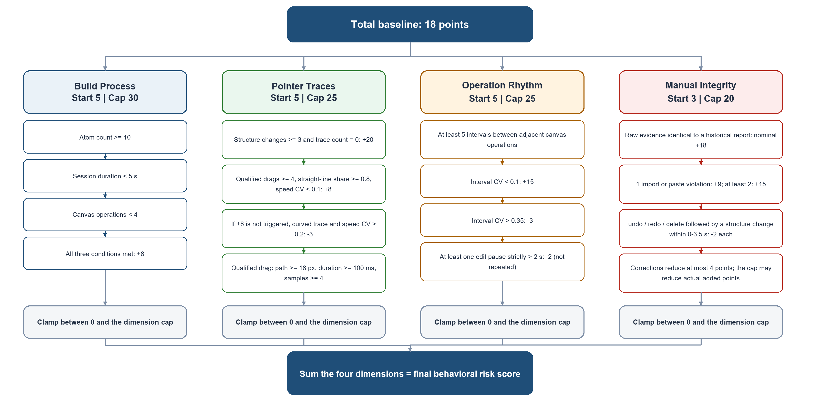Fig. S1 Four-Dimension Scoring Subflow.

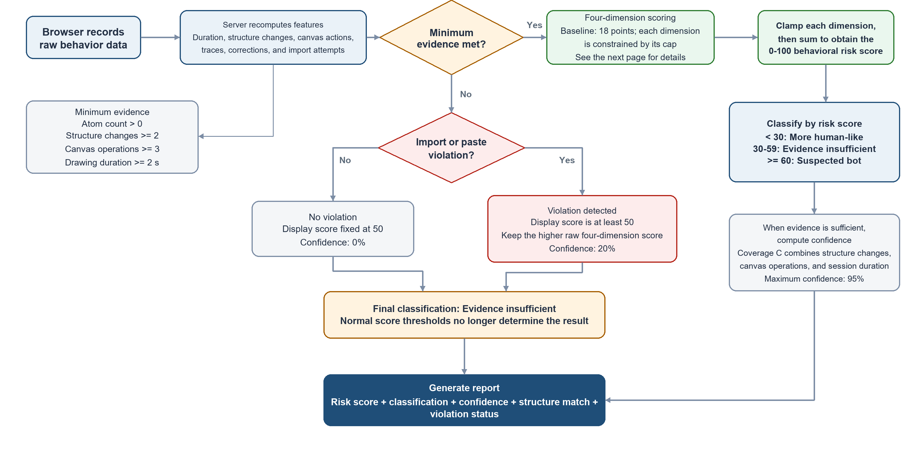
Fig. S2 Overall Scoring Flow.

