Extended data figures and figure legends
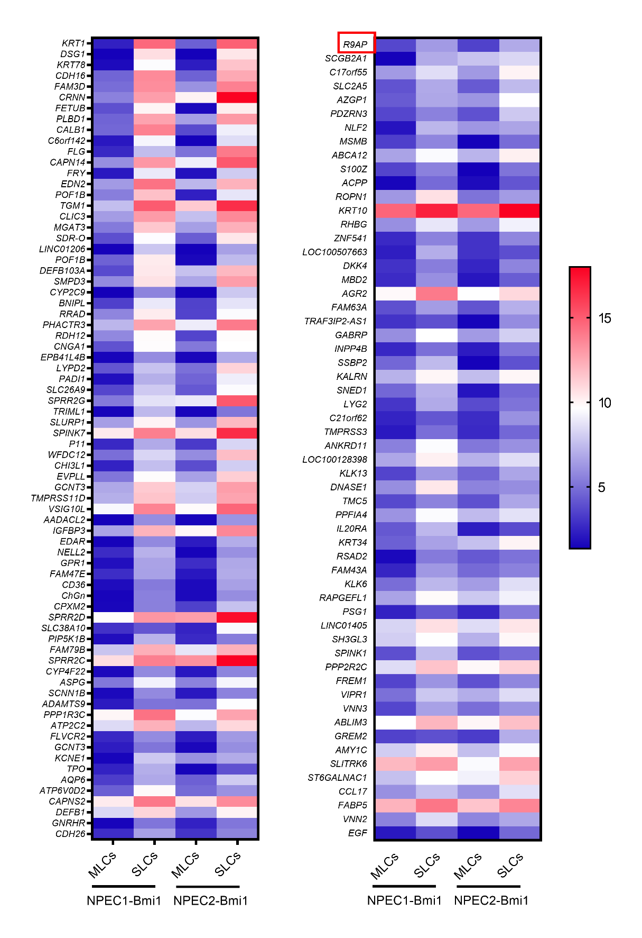

Extended Data Fig. 1｜Heatmap of the normalized expression of upregulated genes in sphere-like cells (SLCs) compared to monolayer cells (MLCs) in NPEC1-Bmi1 and NPEC2-Bmi1 cells.

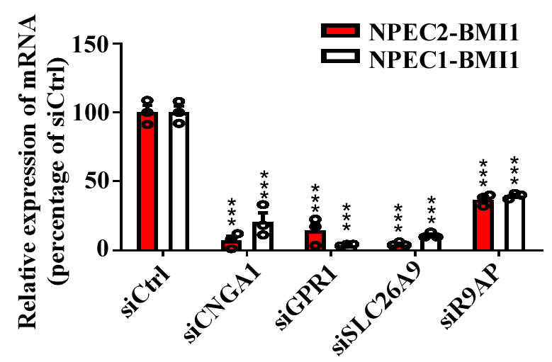

Extended Data Fig. 2｜Knockdown of CNGA1, GPR1, SLC26A9, and R9AP by siRNA pools. NPEC2-Bmi1 and NPEC1-Bmi1 cells were transfected with siRNA pools targeting the indicated genes or control siRNA (siCtrl) and grown as SLCs. RT-qPCR was used to quantify the mRNA level of the respective target gene in SLCs. Results were quantified relative to the expression of the housekeeping gene beta-actin (ACTB) and shown as fold-change of mRNA abundance normalized to siCtrl, which was normalized to 100%. Results are expressed as mean ± s.e.m. from three independent experiments, two-tailed unpaired Student’s t-test (***P < 0.001).

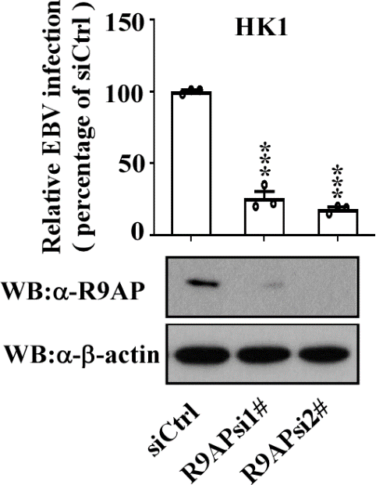

Extended Data Fig. 3｜The R9AP protein level and EBV infection efficiency in siRNAs transfected HK1 cells. HK1 cells were transfected with siCtrl or R9AP siRNAs (R9APsi1#, R9APsi2#), harvested at 36h after transfection and R9AP was analyzed by Western blotting (WB). β-actin was used as loading control. EBV at MOI of ～1000 was added to the cells at 36h after siRNAs transfection and EBV infection efficiency was analyzed by flow cytometry. Bars represent percentage of infection, with infection of siCtrl transfected cells was normalized to 100%.The results are expressed as mean ± s.e.m. from three independent experiments, two-tailed unpaired Student’s t-test (***P < 0.001).

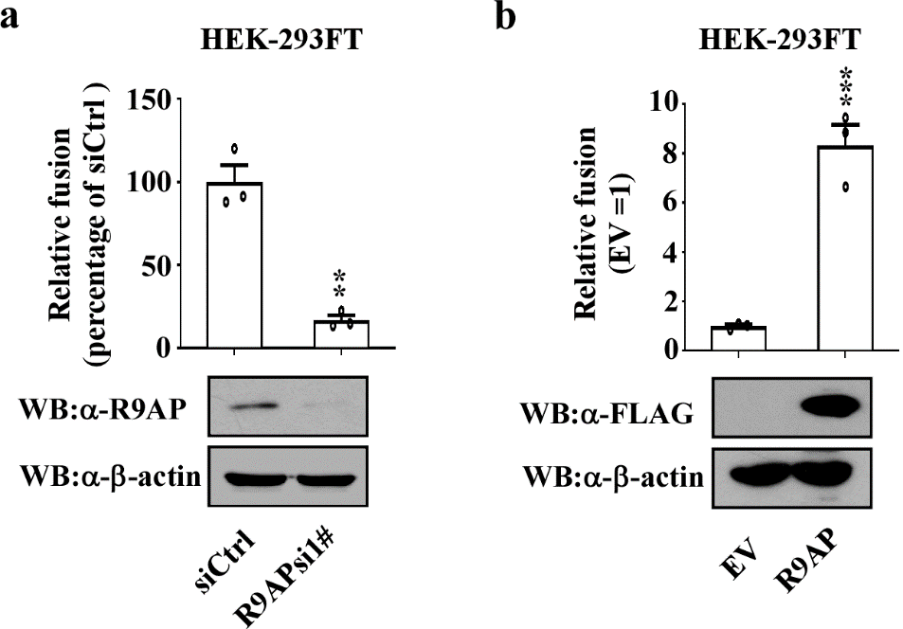
Extended Data Fig. 4｜Relative virus-free EBV fusion after overexpression or knockdown of R9AP.
a, HEK-293T cells were first transfected with R9APsi1# or siCtrl, then transfected with a plasmid expressing T7 polymerase. Cells were then co-cultured with HEK-293T cells transfected with pT7EMCLuc, gB, and gH/gL, and pRL-SV40 expressing Renilla, which was used as control. The relative fusion activity was calculated as the ratio of firefly to Renilla luciferase activity analyzed at 24h after co-culturing. Bars represent percentage of fusion, with fusion of siCtrl transfected cells was normalized to 100%, or EV transfected cells was normalized to 1..The results are expressed as mean ± s.e.m. from three independent experiments, two-tailed unpaired Student’s t-test (**P < 0.01; ***P < 0.001).
b, Same as (a) except that HEK-293T cells were transfected with a plasmid expression T7 polymerase together with a plasmid expressing R9AP or with the empty vector (EV).
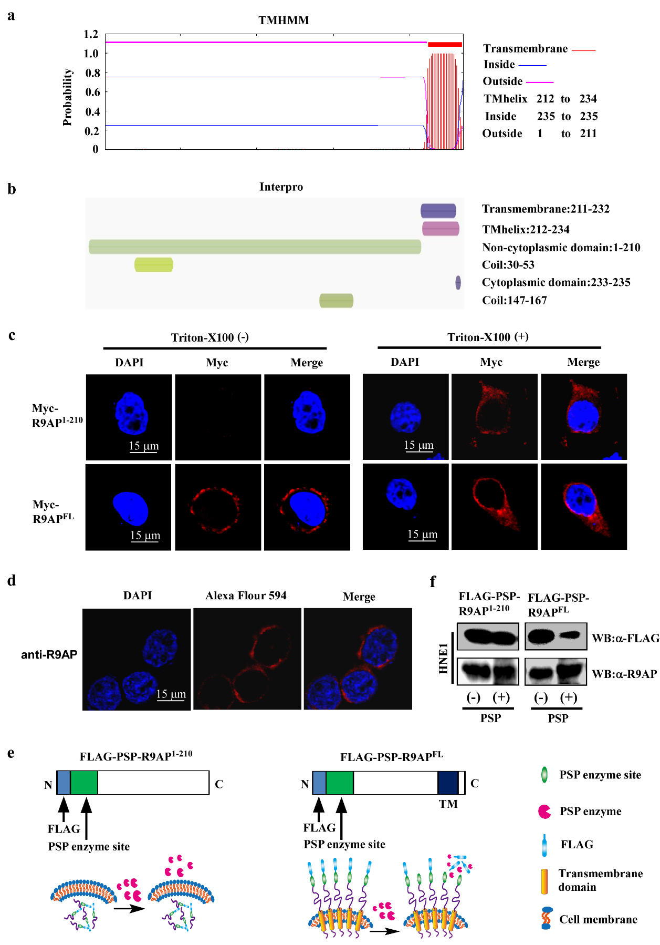
Extended Data Fig. 5｜N-terminus of R9AP locates at cell surface.

a, b, Prediction of R9AP localization by using website software TMHMM (a) or InterPro (b).
c, Confocal microscopy of HNE1 cells transfected with R9AP or R9AP¹⁻²¹⁰. HNE1 cells transfected with Myc-R9AP¹⁻²¹⁰ or Myc-R9AP^{FL} expression plasmid for 24h, fixed and treated with Triton X-100 or left untreated, followed by incubation with antibody specific for Myc tag and Alexa Flour 594-labelled goat antibody (red), nuclei were stained with DAPI (blue).
d, Detection of the endogenous R9AP by confocal microscopy. HK1 cells in a 24–well plate were fixed and then incubated with antibody targeting N-terminal of R9AP and Alexa Flour 594-labelled goat antibody (red), nuclei were stained with DAPI (blue).
e, f, PSP treating of HNE1 cells transfected with R9AP or R9AP¹⁻²¹⁰. One PreScission protease (PSP) enzyme site was inserted between the FLAG tag and the N-terminal end of R9AP¹⁻²¹⁰ (FLAG-psp-R9AP¹⁻²¹⁰) or R9AP^{FL} (FLAG-psp-R9AP^{FL}) expressing plasmid. Cells transfected with indicated plasmid were cultured for 24h followed by PSP treatment to remove FLAG outside of cells. The schematic was used to show that FLAG tag is removed when it located outside the cell by the PSP whereas it is retained when located in the cytoplasm (e). WB was used to detect the R9AP or FLAG tag after adding PSP enzyme (f).
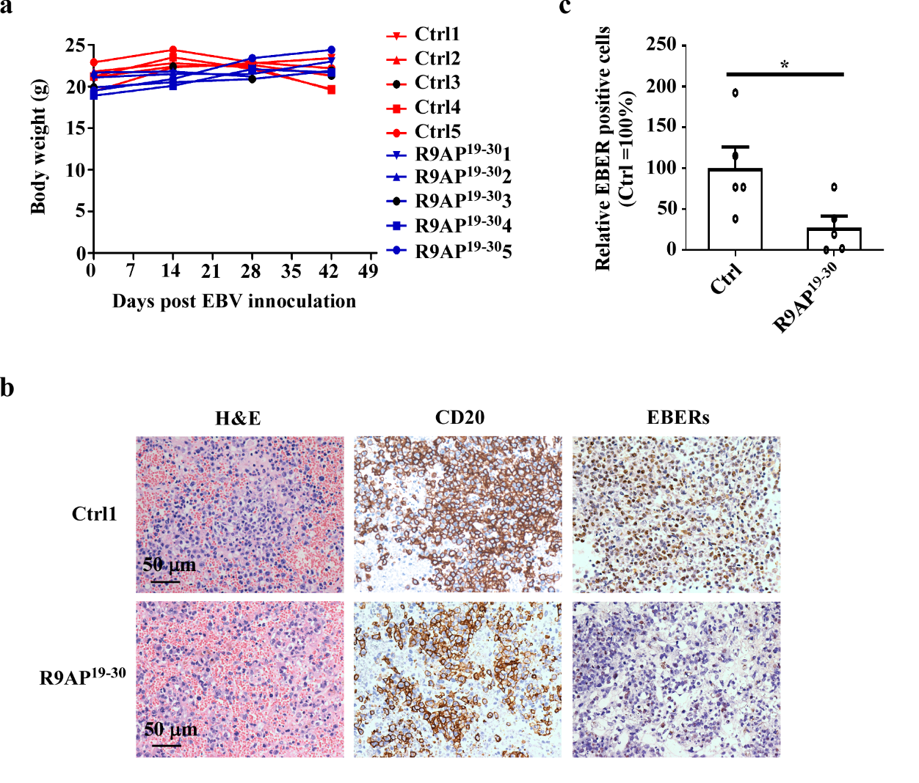

Extended Data Fig. 6｜Characteristics of EBV infected and peptide-treated humanized B-NDG mice.
a, The body weight of humanized B-NDG mice treated with R9AP¹⁹⁻³⁰ peptide or control peptide (Ctrl) at indicated time points. Ctrl, n=5mice; R9AP¹⁹⁻³⁰, n=5mice.

b, Representative images of spleen tissue sections of humanized B-NDG mice infected with EBV and treated with R9AP¹⁹⁻³⁰ or Ctrl peptide stained with hematoxylin-eosin staining (H＆E) or human CD20 or hybridized with EBV EBERs probe. Scale bar=50 μm.
c, The proportion of EBERs-positive cells in spleen of EBV and R9AP¹⁹⁻³⁰ or Ctrl peptide-treated humanized B-NDG mice were independently evaluated by two pathologists. Bars represent proportion of EBERs-positive cells, with the proportion of Ctrl peptide-treated mice was normalized to 100%. Ctrl, n=5mice; R9AP¹⁹⁻³⁰, n=5mice; P value was 0.034, two-tailed unpaired Student’s t-test.
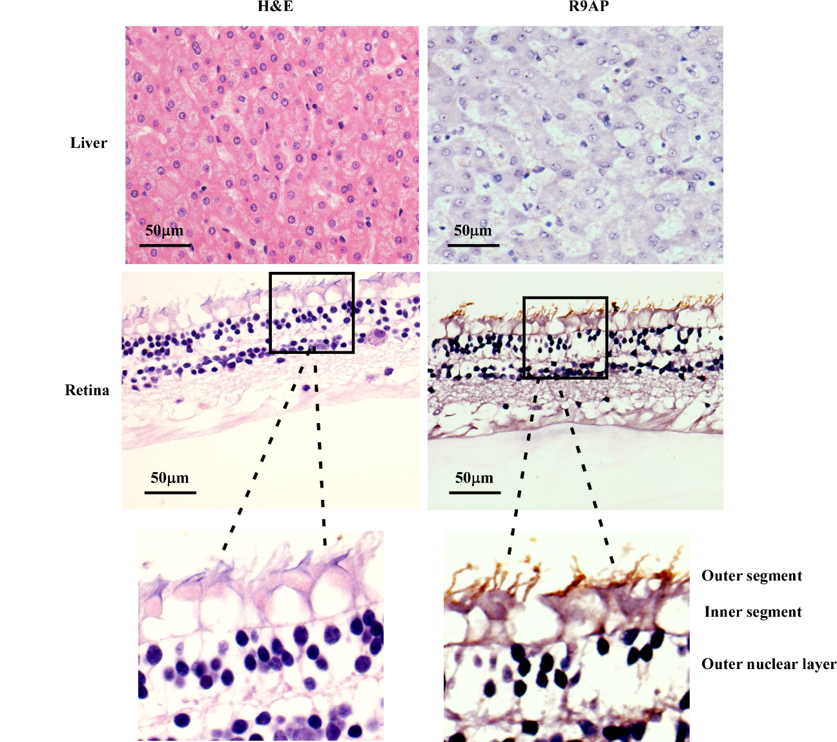

Extended Data Fig. 7｜R9AP expression in human retina and liver tissues. Tissues of human retina and liver tissues were stained with H＆E (top row) and R9AP antibody (middle row). Scale bar=50 μm.

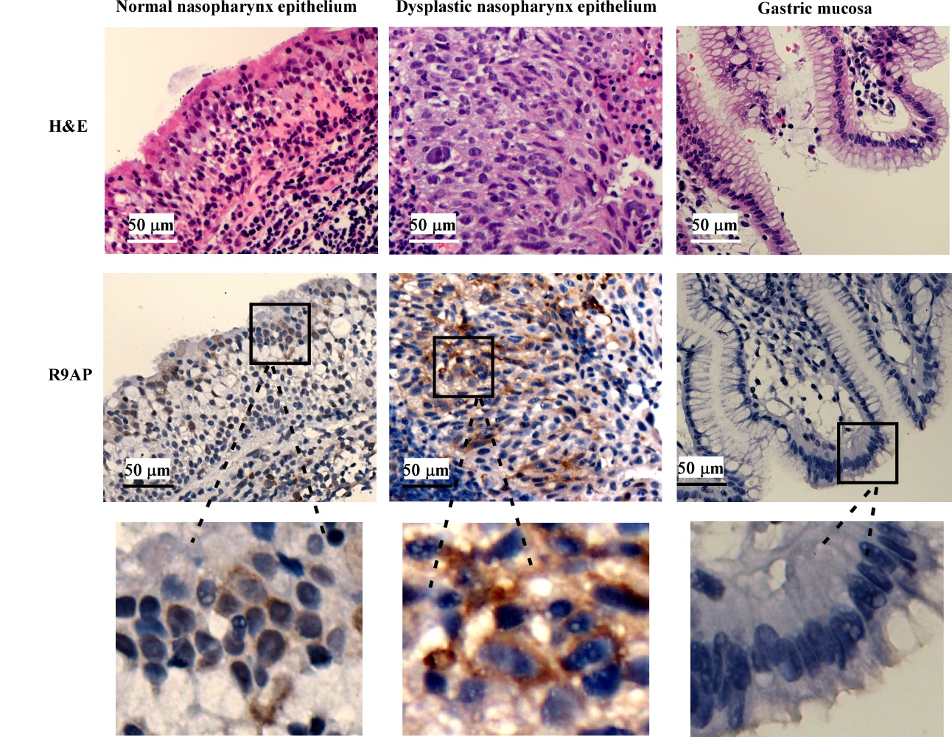

Extended Data Fig. 8｜R9AP expression in human nasopharynx epithelium and gastric mucosa. Tissues of human normal and dysplastic nasopharynx epithelium and normal gastric mucosa were stained with H＆E (top row) and R9AP antibody (middle row). Images of insets were magnified 4 times (bottom row). Scale bar=50 μm.

