Supp fig. 1. Chi3L1 is mainly detected in the inflammatory senescent synoviocytes fibroblasts subtype 2 population (A) UMAP projection of single cell RNA-seq data showing Chi3L1 expression across different human OA synovium cell subpopulations (B) Heatmap of different gene expression across three synovial-fibroblasts subtypes, with Chi3L1 enrichment in SF subtype 2 cell subpopulation.
Supp fig. 2. Metformin treatment presented no detected ameliorative effect on bone structural architecture (A-E) Representative image of lateral and medial subchondral bone (B-F) Quantification of joint subchondral bone microarchitectural parameters: bone volume, bone surface/bone volume (BS/BV) and thickness. Each dot represents a mouse (n=9 per group). (C-G) Representative image of lateral and medial epiphysis (D-H) Quantification of joint subchondral bone microarchitectural parameters: trabecular number, trabecular thickness and bone volume. Each dot represents a mouse (n=9 per group). (I) Histological scoring of joint osteophyte. Each dot represents a mouse (n=9 per group). Data are expressed as means ± SEM. *p < 0,05, **p < 0,01, ***p < 0,001. Two-tailed Man-Whitney test for (B) (D) (F) (H) (I).
Supp fig. 3. Different senescent BM-MSCs model presented common increase of CHI3L1 level (A) Schematic showing BM-MSCs treatment with etoposide (12,5µM) vs DMSO for 24 hours than cultured for ten days (B) Quantification of SA-β-gal staining positive of proliferative BM-MSCs (DMSO) versus senescent (Etoposide). Each dot represents an independent biological replicate (n=6 per group) (C) Relative quantification of Chi3L1 secreted level at day 10 by Elisa. Each dot represents an independent biological replicate (n=6 per group) (D) Schematic showing BM-MSCs transfection with siRNA Control (10mM) vs siRNAs targeting FERMT2, and CBX4 then cultured for one week (E) Representatives images and their relative quantification of SA-β-gal staining positive of proliferative BM-MSCs (siControl) versus senescent-induced (siFERMT2, siCBX4) Each dot represents an independent biological replicate (n=14 per group) (F) Relative quantification of Chi3L1 secreted level at day 7 by Elisa. Each dot represents an independent biological replicate (n=8 per group). Data are expressed as means ± SEM. *p < 0,05, **p < 0,01, ***p < 0,001. Two-tailed Wilcoxon’s matched pair test for (B) (C) and corrected Friedman test for (E) (F).
Supplementary Data
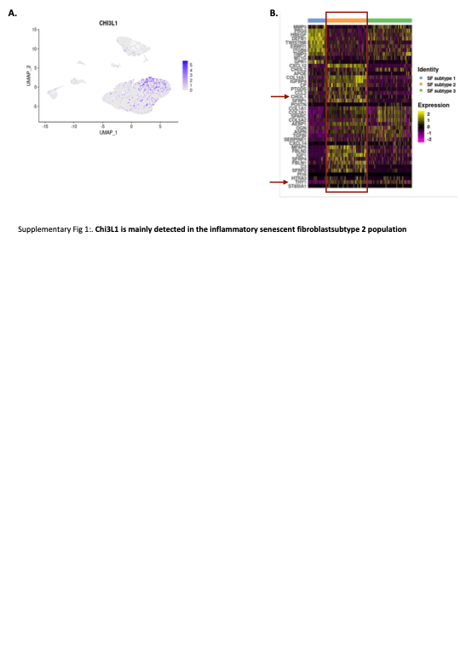
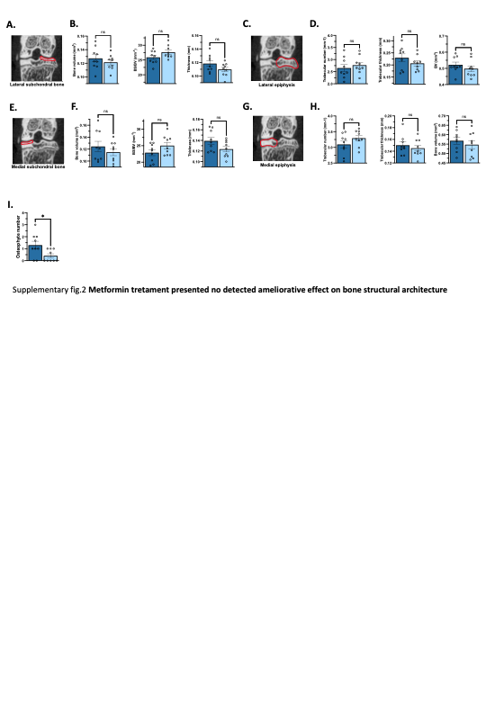

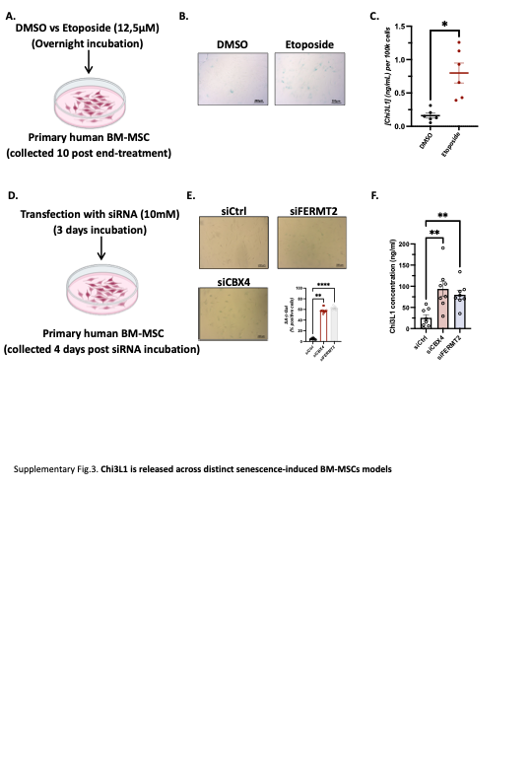

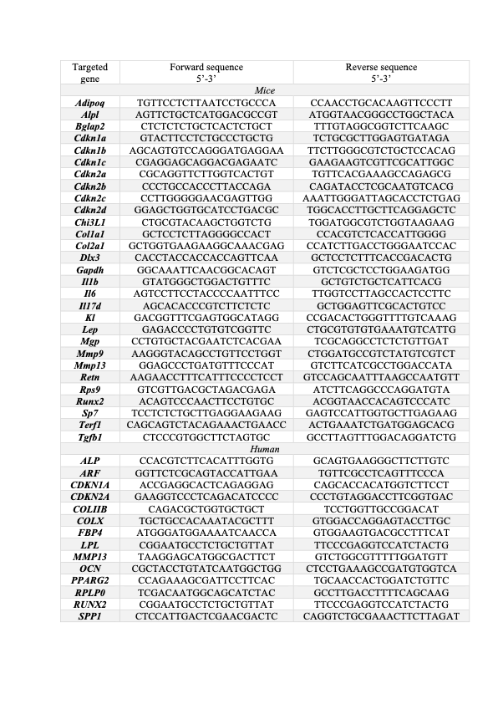
Supplementary table 1. Primer sequences used for gene-specific amplification in transcriptomic analysis

