G-quadruplex binding properties of a potent PARP-1 inhibitor derived from 7-azaindole-1-carboxamide.

Sabrina Dallavalle¹, Loana Musso¹, Roberto Artali², Anna Aviñó³, Leonardo Scaglioni¹, Ramon Eritja³, Raimundo Gargallo⁴, Stefania Mazzini^{1*}

¹Department of Food, Environmental and Nutritional Sciences (DEFENS), University of Milan (Università degli Studi di Milano), Milan, Italy.
²Scientia Advice di Roberto Artali, 20832 Desio, MB, Italy
³Institute for Advanced Chemistry of Catalonia (IQAC), CSIC, Networking Center on Bioengineering, Biomaterials and Nanomedicine (CIBER-BBN), Barcelona, Spain.
⁴Department of Chemical Engineering and Analytical Chemistry, University of Barcelona, Barcelona, Spain.

Contents:
Figure S1 | Aromatic and anomeric protons region of the 1D NMR titration spectra of d(AAGAATTCTT)₂ with 1 at 15 °C in H₂O/D₂0 (9:1), 0.1 M NaCl and 10 mM sodium phosphate buffer, pH = 7.0, at different R = [drug]/[DNA] ratios.
Figure S2 | Aromatic and anomeric protons region of the 1D NMR titration spectra of d(CGTACG)₂ with 1 at 15 °C in H₂O/D₂0 (9:1), 0.1 M NaCl and 10 mM sodium phosphate buffer, pH = 7.0, at different R = [drug]/[DNA] ratios.
Figure S3 | Imino proton region of 1D NMR titration spectra of Pu22T14T23 with ABT888 at 25 °C at different R = [drug]/[DNA] ratios.
Figure S4 | Determination of melting temperature of Pu2T14T23 in 25 mM phosphate buffer and 70 mM KCl.
Figure S5 | Titrations of ligand 1 with Pu22T14T23 (a) and d(TTAGGGT)₄ (b) monitored with molecular fluorescence spectroscopy. Numbers in inset indicate the ratio ligand:DNA. In both cases, the initial concentration of ligand was 3 micromolar, 25 mM phosphate buffer and 70 mM KCl, 20ºC.
Figure S6 | Titrations of ligand 1 with Pu22T14T23 (a) and d(TTAGGGT)₄ (b) in PBS monitored with molecular fluorescence spectroscopy. Numbers in inset indicate the ratio ligand:DNA. In both cases, the initial concentration of ligand was 3 micromolar, PBS buffer 20ºC.
Table S1 | Selected ¹ H chemical shift values for the complex of 1 with d(AAGAATTCTT)₂ and d(CGTACG)₂
Table S2 | Selected ¹ H chemical shift values for the complex of 1 with d(TTAGGGT)₄
Table S3 | Selected ¹ H chemical shift values for the complex of 1 with Pu22T14T23.
Table S4 | Inter-residue NOE interactions of Pu22T14T23 in the complex with 1

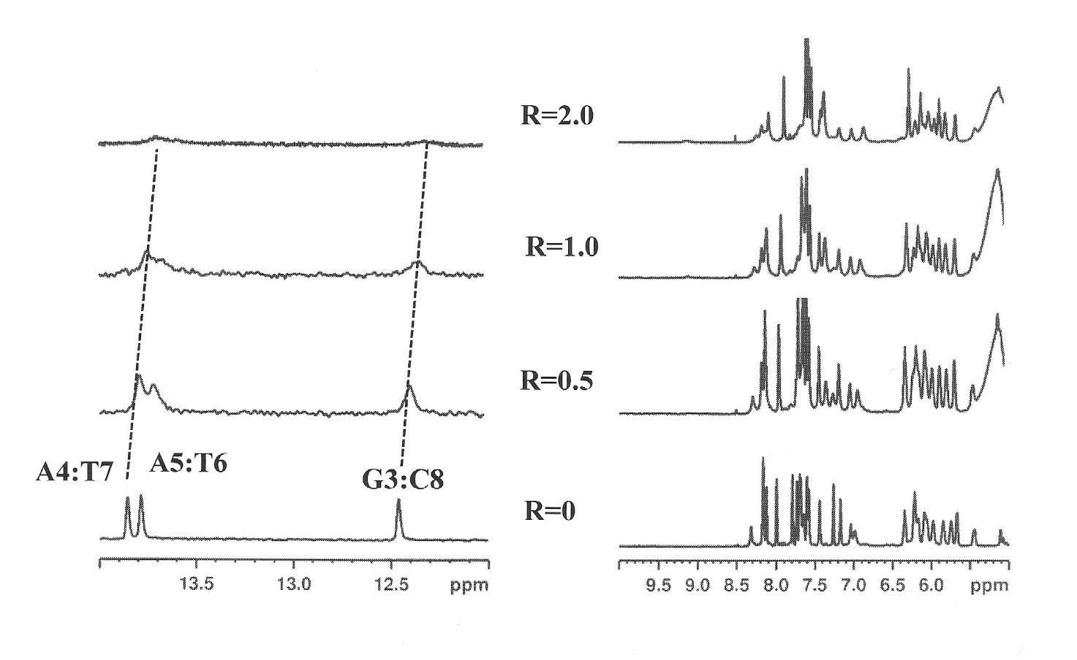

Figure S1. Aromatic and anomeric protons region of the 1D NMR titration spectra of d(AAGAATTCTT)₂ with 1 at 15 °C in H₂O/D₂0 (9:1), 0.1 M NaCl and 10 mM sodium phosphate buffer, pH = 7.0, at different R = [drug]/[DNA] ratios.

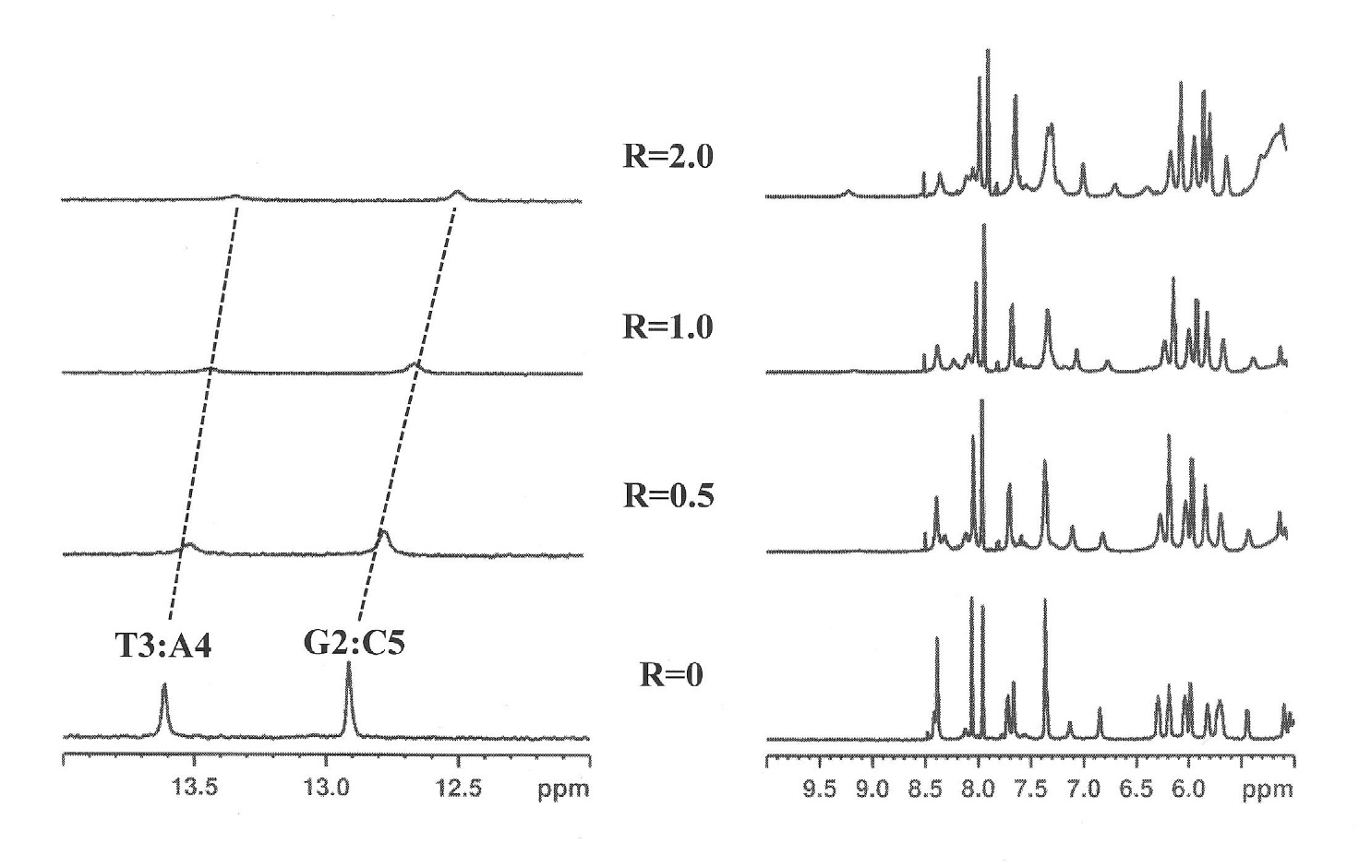

FigureS2. Aromatic and anomeric protons region of the 1D NMR titration spectra of d(CGTACG)₂ with 1 at 15 °C in H₂O/D₂0 (9:1), 0.1 M NaCl and 10 mM sodium phosphate buffer, pH = 7.0, at different R = [drug]/[DNA] ratios.

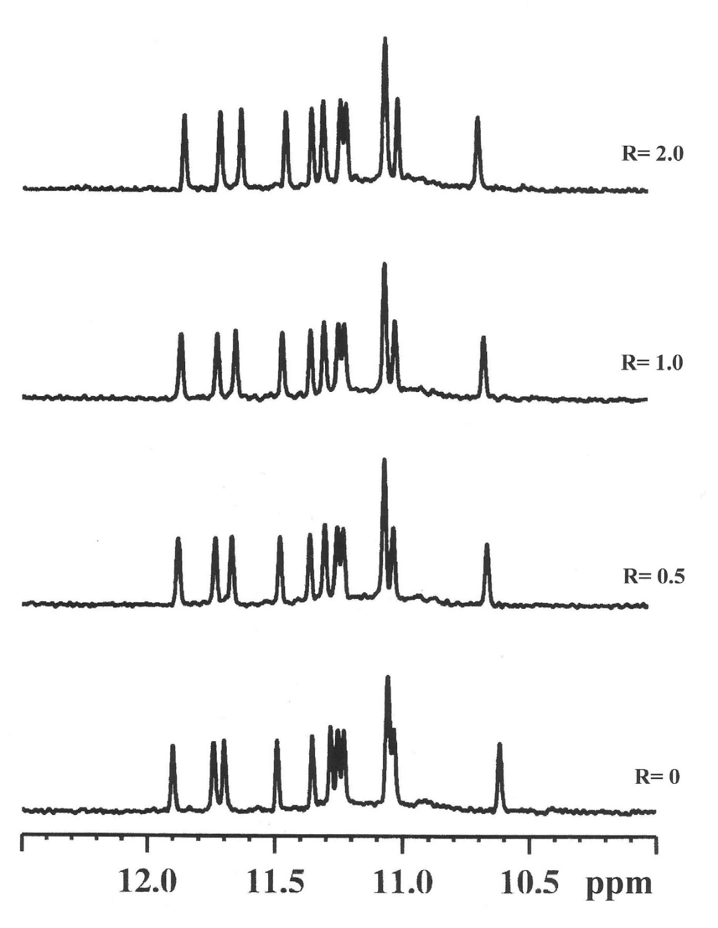
Figure S3. Imino proton region of 1D NMR titration spectra of Pu22T14T23 with ABT888 at 25 °C at different R = [drug]/[DNA] ratios.

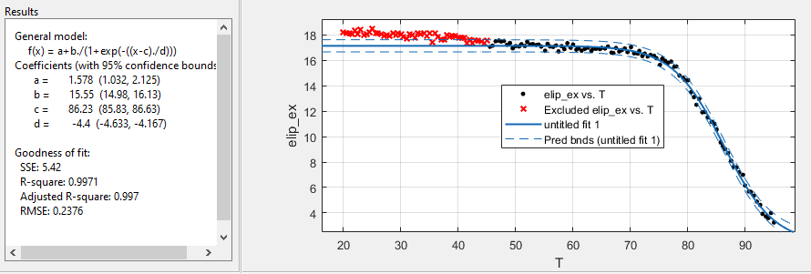

Figure S4. Determination of melting temperature of Pu2T14T23 in 25 mM phosphate buffer and 70 mM KCl.

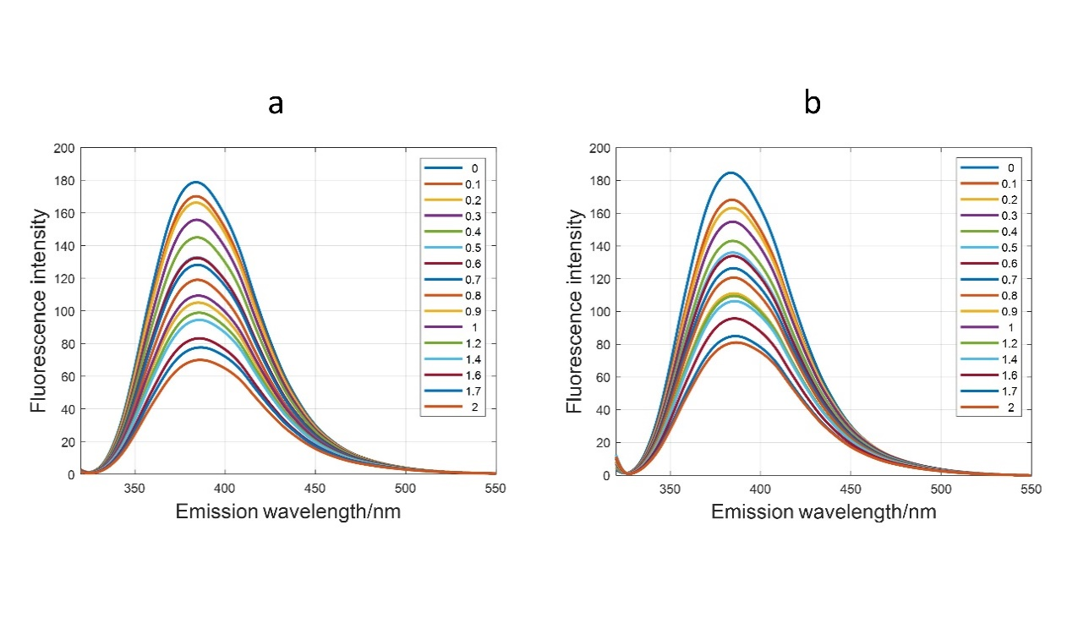
Figure S5. Titrations of ligand 1 with Pu22T14T23 (a) and d(TTAGGGT)₄ (b) monitored with molecular fluorescence spectroscopy. Numbers in inset indicate the ratio ligand:DNA. In both cases, the initial concentration of ligand was 3 micromolar, 25 mM phosphate buffer and 70 mM KCl, 20ºC.

- (b)
Figure S6. Titrations of ligand 1 with Pu22T14T23 (a) and d(TTAGGG)₄ (b) in PBS monitored with molecular fluorescence spectroscopy. Numbers in inset indicate the ratio ligand:DNA. In both cases, the initial concentration of ligand was 3 micromolar, PBS buffer 20ºC.

Table S1. Selected ¹ H chemical shift values for the complex of 1 with d(AAGAATTCTT)₂ and d(CGTACG)2ª
“AATT” | H2/H5/CH₃ | Δδ^{b} | H6/H8 | Δδ^{b} | H1’ | Δδ^{b}
A1 | n.d. | - | 7.88 | -0.13 | 5.83 | -0.02
A2 | n.d. | - | 8.14 | -0.03 | 5.98 | -0.09
G3 | - | - | 7.65 | -0.09 | 5.78 | +0.03
A4 | n.d. | - | 8.06 | -0.08 | 5.78 | -0.28
A5 | n.d. | - | 8.14 | -0.03 | 6.18 | -0.05
T6 | 1.26 | -0.04 | 7.13 | -0.07 | 5.91 | -0.11
T7 | 1.55 | -0.03 | 7.39 | -0.05 | 6.10 | -0.11
C8 | 5.63 | -0.05 | 7.59 | -0.07 | 6.03 | -0.08
T9 | 1.70 | -0.10 | 7.51 | -0.08 | 6.19 | -0.04
T10 | 1.78 | -0.03 | 7.50 | -0.13 | 6.24 | +0.02
 | NH
A4T7 | 13.79^{c} | -0.08
A5T6 | n.d.^{c} | --
G3C8 | 12.39^{c} | -0.07
“CG” | H2/H5/CH₃ | Δδ^{b} | H6/H8 | Δδ^{b} | H1’ | Δδ^{b}
C1 | 5.80 | -0.19 | 7.60 | -0.12 | 5.73 | -0.09
G2 | - | - | 7.95 | -0.12 | 5.90 | -0.13
T3 | 1.42 | -0.17 | 7.29 | -0.07 | 5.89 | +0.19
A4 | 7.60 | -0.07 | 8.33 | -0.06 | 6.12 | -0.18
C5 | 5.25 | -0.19 | 7.25 | -0.11 | 5.60 | -0.10
G6 | - | - | 7.87 | -0.09 | 6.02 | -0.17
 | NH
C1G6 | n.d. | -
G2C5 | 12.64 | -0.36
T3A4 | 13.43 | -0.19

ª Measured at 15°C in ppm (δ) from external DSS. Solvent H₂O-D₂O (90:10 v/v), of 0.1 M NaCl and 10 mM sodium phosphate buffer solution, pH = 7.0; R = 2.0. ^{b}Δδ = δ_{bound} – δ_{free}; ^{c} Very broad signal.

Table S2. Selected ¹ H chemical shift values for the complex of 1 with d(TTAGGGT)₄ª

 | H1/H2/Me | Δδ^{b} | H6/H8 | Δδ
T2 | 1.80 | + 0.04 | 7.30 | -0.02
A3 | n.d. | - | 8.39 | 0.00
G4 | 11.44 | - 0.16 | 7.80 | - 0.12
G5 | 11.10 | - 0.11 | 7.62 | - 0.15
G6 | 10.72 | - 0.30 | 7.69 | + 0.01
T7 | 1.70 | +0.10 | 7.48 | +0.14

ª Measured at 25 °C in ppm (δ) from external DSS. Solvent: H₂O-D₂O (90:10 v/v), 25 mM K-phosphate buffer, 150 mM KCl, 1 mM EDTA, pH 6.7. T1 signals are not detected. The ribose protons showing significant shift variations are: T2H1’ Δδ= -0.25. ^{b} Δδ = δ_{bound} – δ_{free}.

Table S3 . Selected ¹ H chemical shift values for the complex of 1 with Pu22T14T23.ª

 | H1/H2/Me | Δδ^{b} | H6/H8 | Δδ
T4 | 1.55-1.75 |  | 7.33 | +0.12
G5 | n.d. | - | 8.09 | +0.09
A6 | 7.95 | +0.15 | n.d.
G7 | 11.40 | - 0.36 | 7.86 | -0.16
G8 | 11.01 | - 0.21 | 7.60 | -0.12
G9 | 10.70 | +0.10 | 7.71 | -0.04
T10 | n.d. | - | n.d.
G11 | 11.28 | -0.43 | 7.83 | 0.04
G12 | 11.34 | -0.16 | 7.86 | -0.06
G13 | 10.89 | -0.16 | 7.68 | -0.18
T14 | 1.77 | -0.15 | 7.65 | 0
A15 | 8.35 | -0.03 | 8.54 | +0.01
G16 | 11.65 | - 0.35 | 8.15 | +0.04
G17 | 11.05 | - 0.20 | 7.69 | - 0.11
G18 | 10.60 | - 0.42 | 7.68 | - 0.11
T19 | 2.00 | 0.01 | 7.87 | +0.01
G20 | 10.98 | -0.30 | 7.84 | - 0.05
G21 | 11.13 | -0.24 | 7.69 | -0.22
G22 | 10.68 | -0.36 | 7.68 | 0.07
T23 | 1.20 | -0.28 | 7.03 | -0.11
A24 | 7.25 | +0.15 | 7.38 | -0.38
A25 | 7.53 | +0.14 | 7.18 | -0.32

ª Measured at 25°C in ppm (δ) from external DSS. Solvent H₂O-D₂O (90:10 v/v), 25 mM K-phosphate buffer, 70 mM KCl, pH 6.9, R = 2.0.
^{b} Δδ = δ_{bound} – δ_{free}

Table S4. Inter-residue NOE interactions of Pu22T14T23 in the complex with 1ª

NOEs in the tetrads
G-tetrad I | G-tetrad II | Tetrad III | Other NOEs
G7H1-G11H8 | G8H1-G12H8 | G9H1-G13H8 | G13H1-G17H8
G11H1-G16H8 | G12H1-G17H8 | G13H1-G18H8
G16H1-G20H8 | G17H1-G21H8 | G18H1-G22H8
G20H1-G7H8 | G21H1-G8H8 | G22H1-G9H8

ª Acquired at 25°C in H₂O-D₂O (90:10 v/v), 25 mM K-phosphate buffer, 70 mM KCl, pH 6.9; R=2.0

