Supporting information to
Multiyear characterization of Volatile Organic Compounds in Zurich: evidence of urban solvent-related sources
Dufresne et al.,
Corresponding author: Marvin Dufresne, marvin.dufresne@imt-nord-europe.fr
List of figures
List of tables

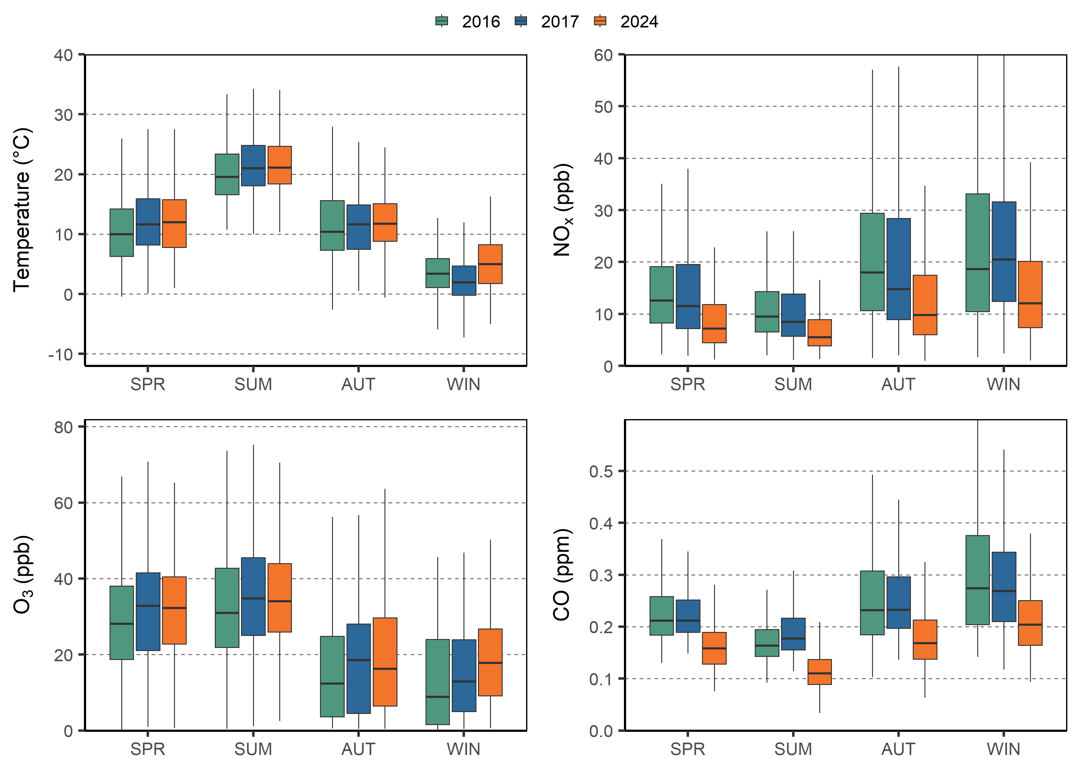
Figure S1. Seasonal variations of ambient temperature, NO_{x}, O₃ and CO measured at the Zurich station in 2016, 2017 and 2024.
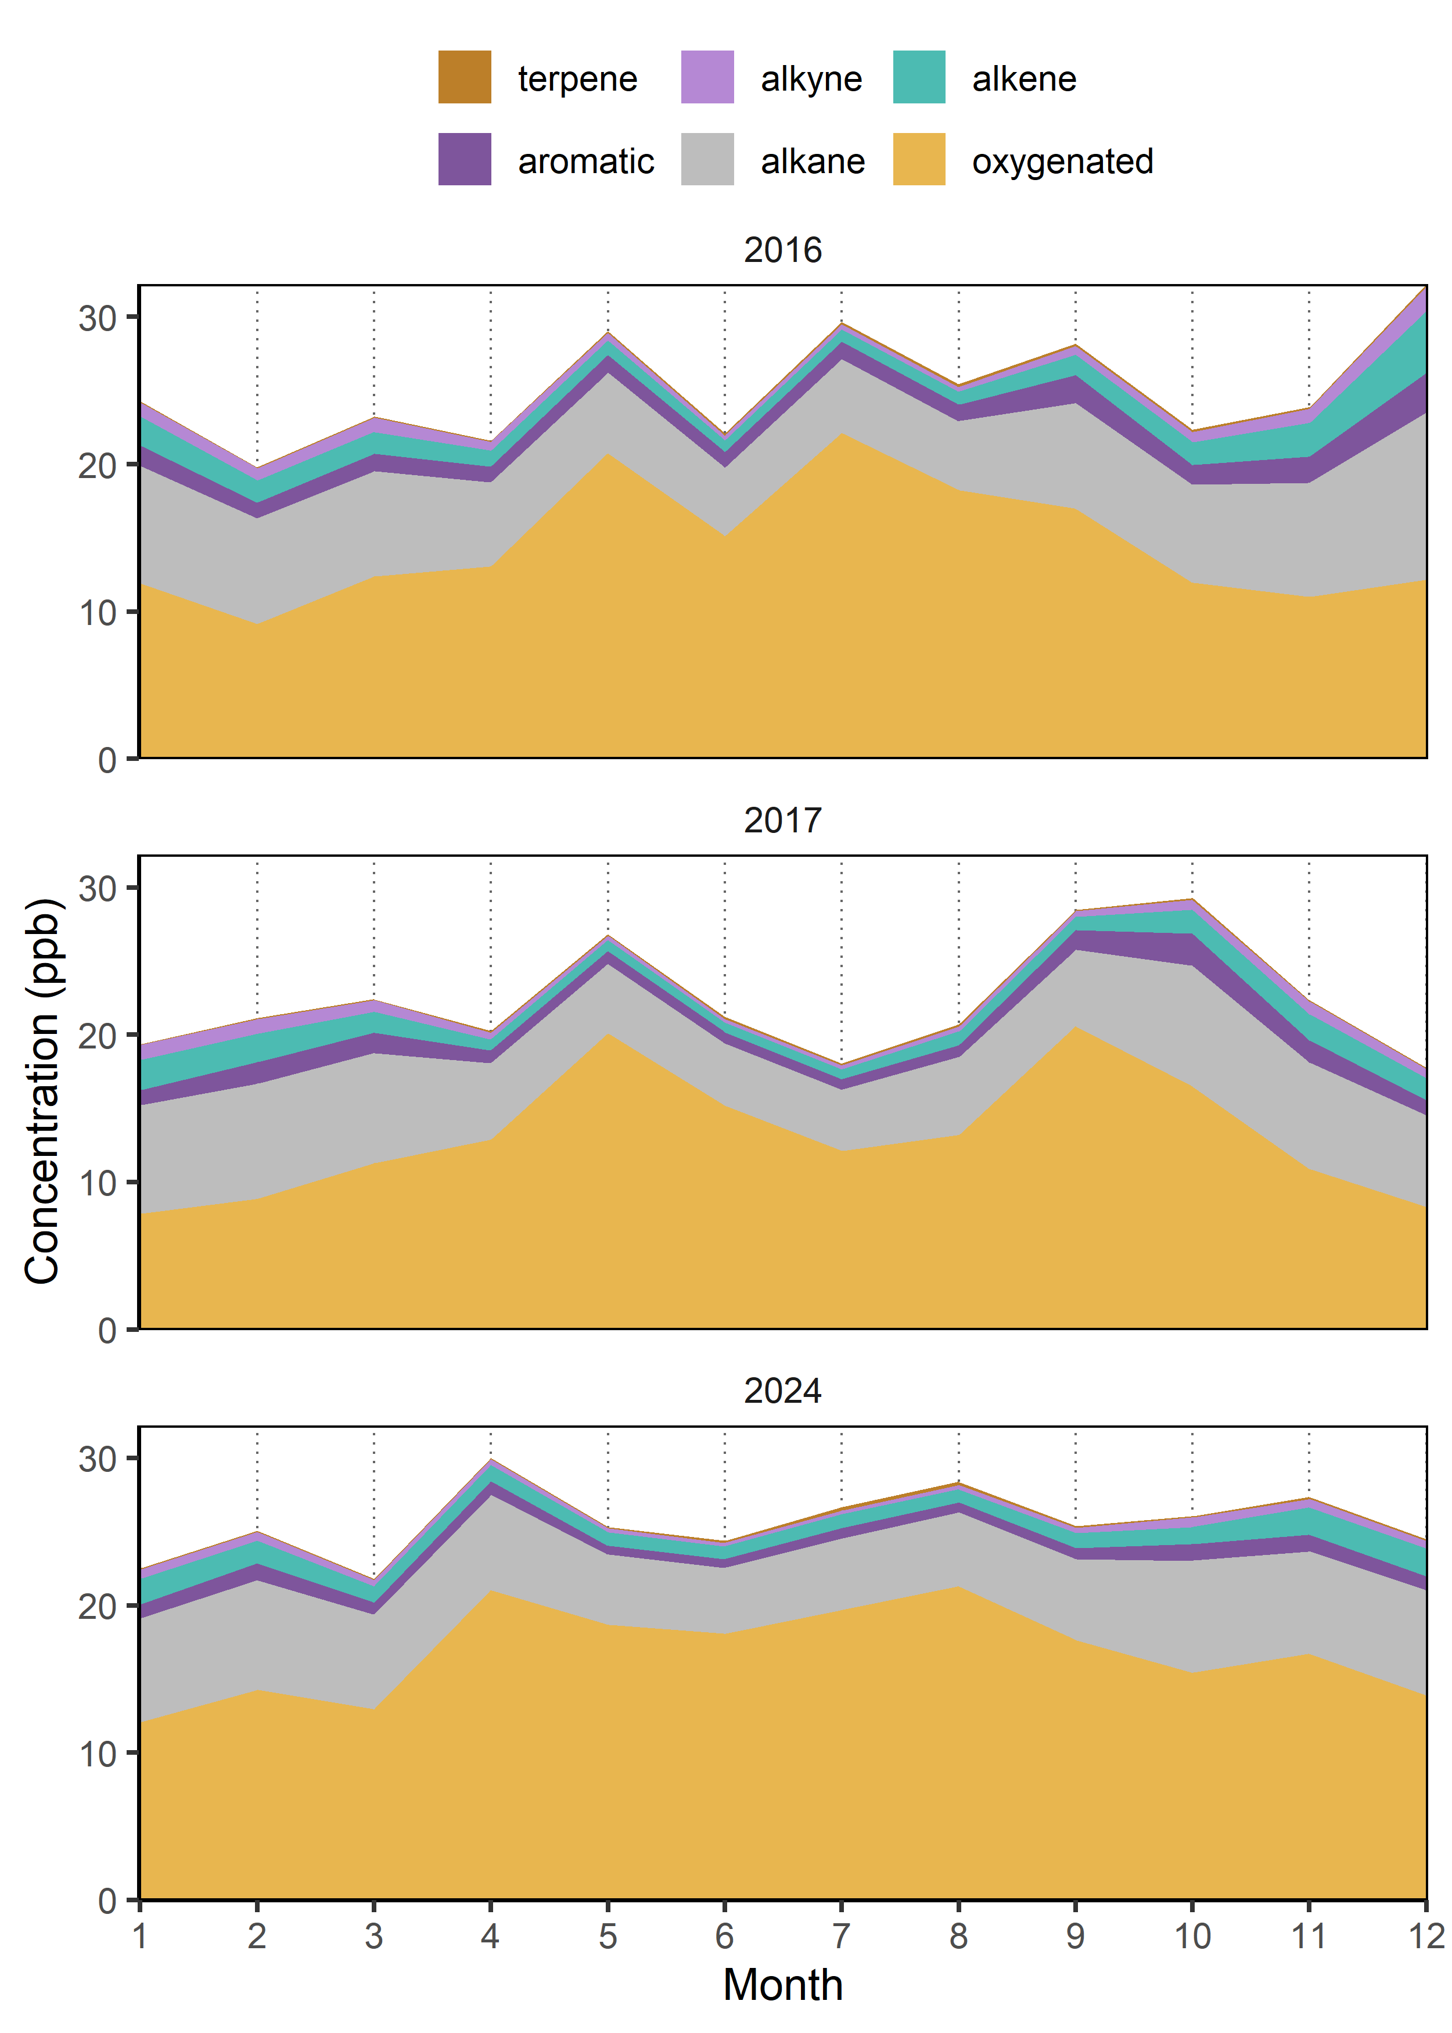
Figure S2. Monthly average of the different VOC classes in Zurich in 2016, 2017 and 2024.

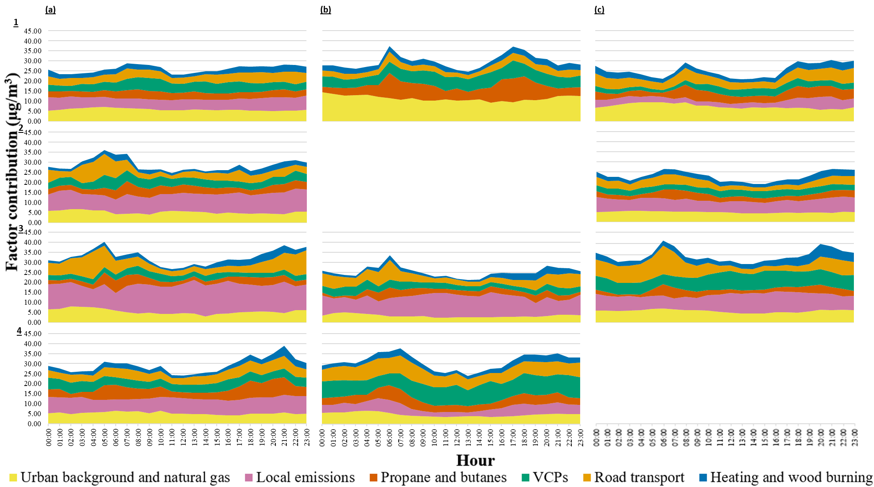
Figure S3. Diurnal profile of each factor for (1) winter, (2) spring, (3) summer and (4) autumn in (a) 2016, (b) 2017 and (c) 2024.

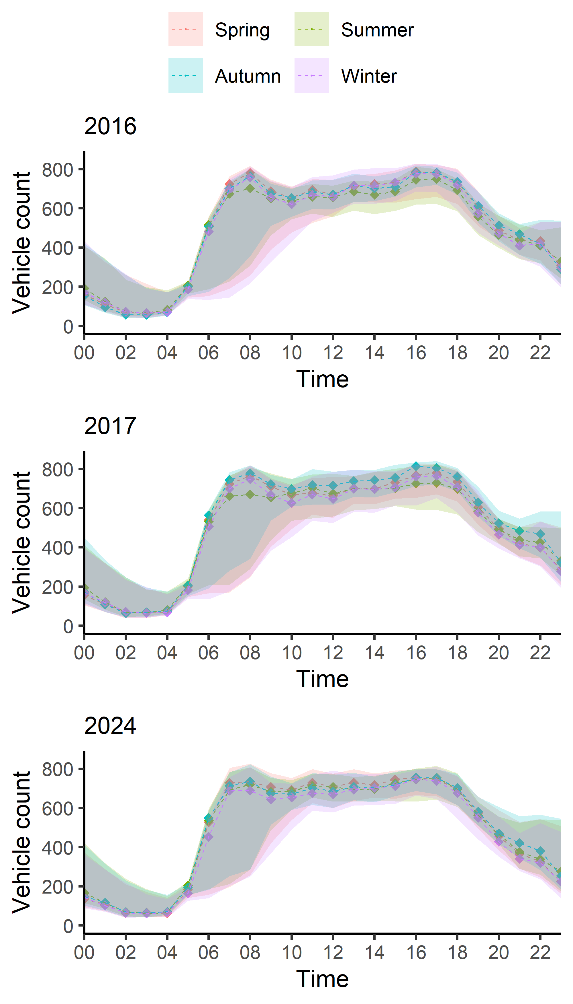
Figure S4. Diurnal vehicles count in 2016, 2017 and 2024 for the different seasons at Gessnerallee, located 400 m away from the monitoring station in Zurich. The shaded areas indicate the 95 % confidence interval. Data accessed on 17.09.2025 at https://data.stadt-zuerich.ch/dataset/sid_dav_verkehrszaehlung_miv_od2031.

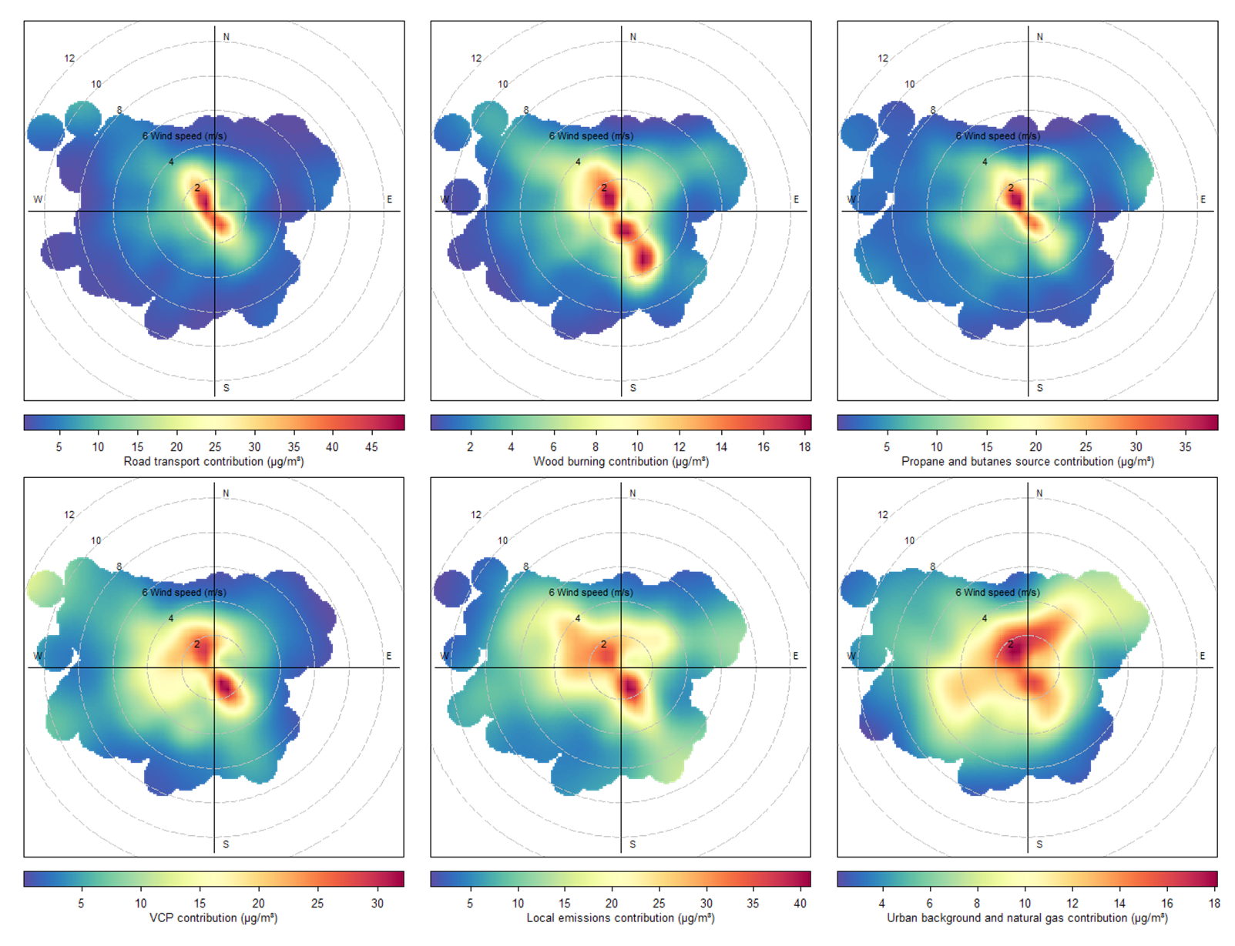
Figure S5. Polar plot of max source contributions considering the entire dataset (2016 - 2024)

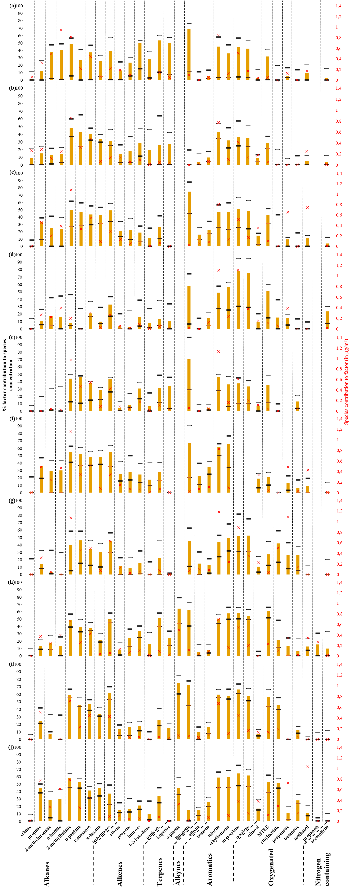
Figure S6. Fingerprint of road transport in (a) winter, (b) spring, (c) summer and (d) autumn 2016, (e) winter, (f) summer and (g) autumn 2017 and (h) winter, (i) spring and (j) summer 2024. The colored bars are the contribution of the identified source to the species (in %), the red crosses are the contribution of the species to the identified source (in µg/m³) and the lower and upper black lines are the 5th and 95th percentiles of the bootstrap runs results.
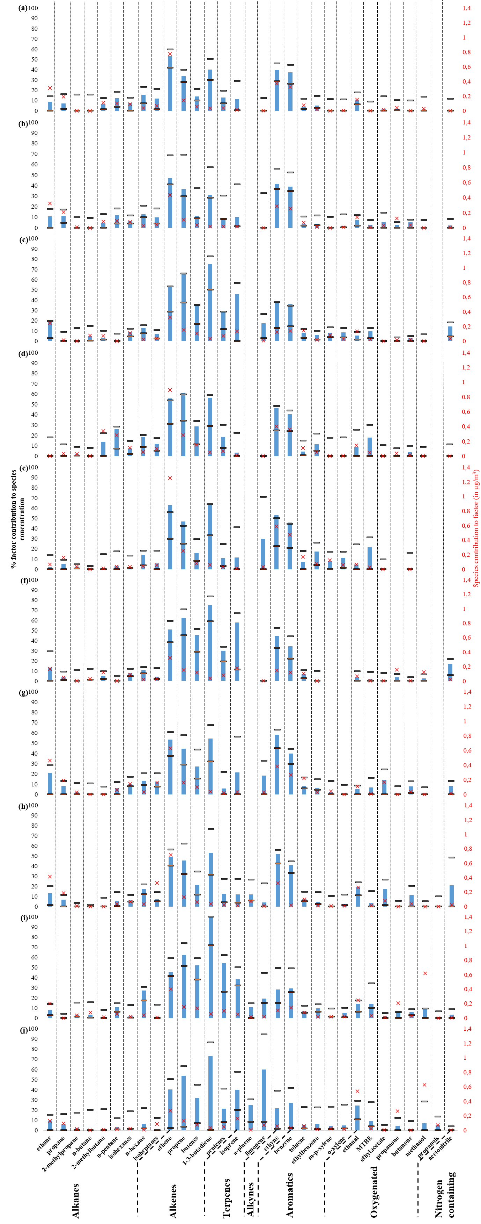
Figure S7. Fingerprint of heating and wood burning in (a) winter, (b) spring, (c) summer and (d) autumn 2016, (e) winter, (f) summer and (g) autumn 2017 and (h) winter, (i) spring and (j) summer 2024. The colored bars are the contribution of the identified source to the species (in %), the red crosses are the contribution of the species to the identified source (in µg/m³) and the lower and upper black lines are the 5th and 95th percentiles of the bootstrap runs results.
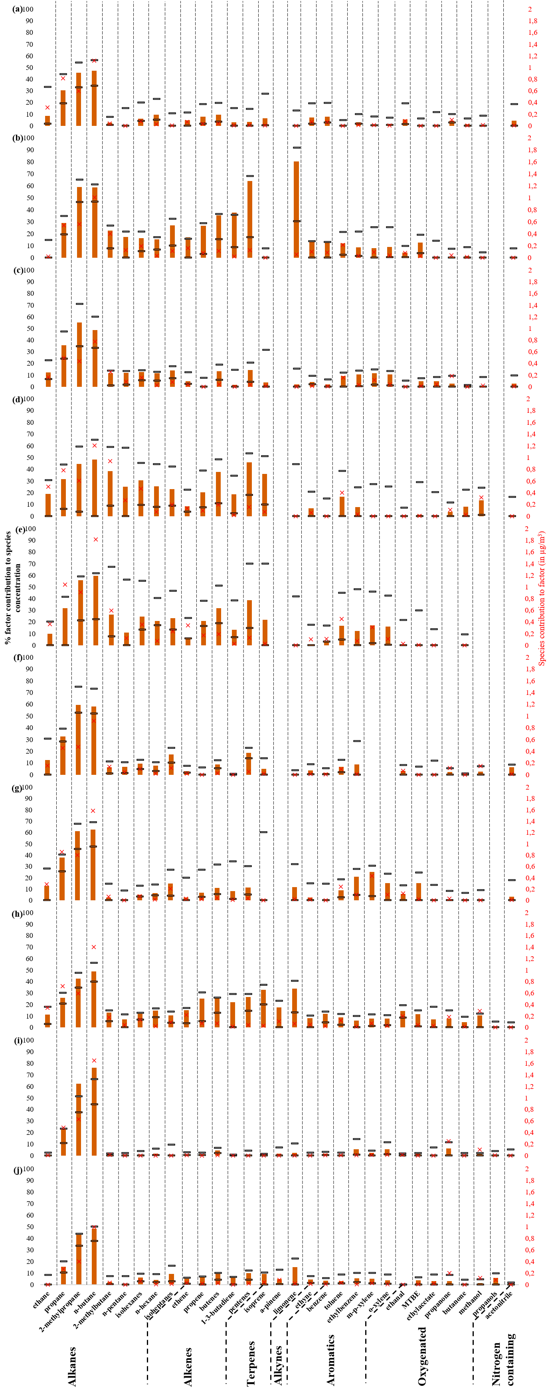
Figure S8. Fingerprint of the source of propane and butanes in (a) winter, (b) spring, (c) summer and (d) autumn 2016, (e) winter, (f) summer and (g) autumn 2017 and (h) winter, (i) spring and (j) summer 2024. The colored bars are the contribution of the identified source to the species (in %), the red crosses are the contribution of the species to the identified source (in µg/m³) and the lower and upper black lines are the 5th and 95th percentiles of the bootstrap runs results.
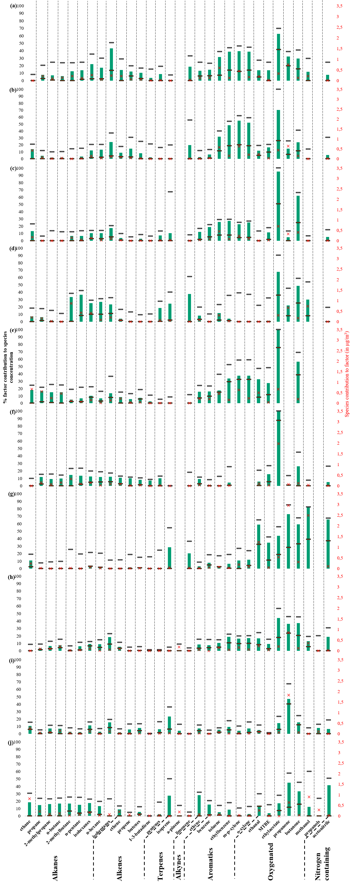
Figure S9. Fingerprint of VCPs in (a) winter, (b) spring, (c) summer and (d) autumn 2016, (e) winter, (f) summer and (g) autumn 2017 and (h) winter, (i) spring and (j) summer 2024. The colored bars are the contribution of the identified source to the species (in %), the red crosses are the contribution of the species to the identified source (in µg/m³) and the lower and upper black lines are the 5th and 95th percentiles of the bootstrap runs results.
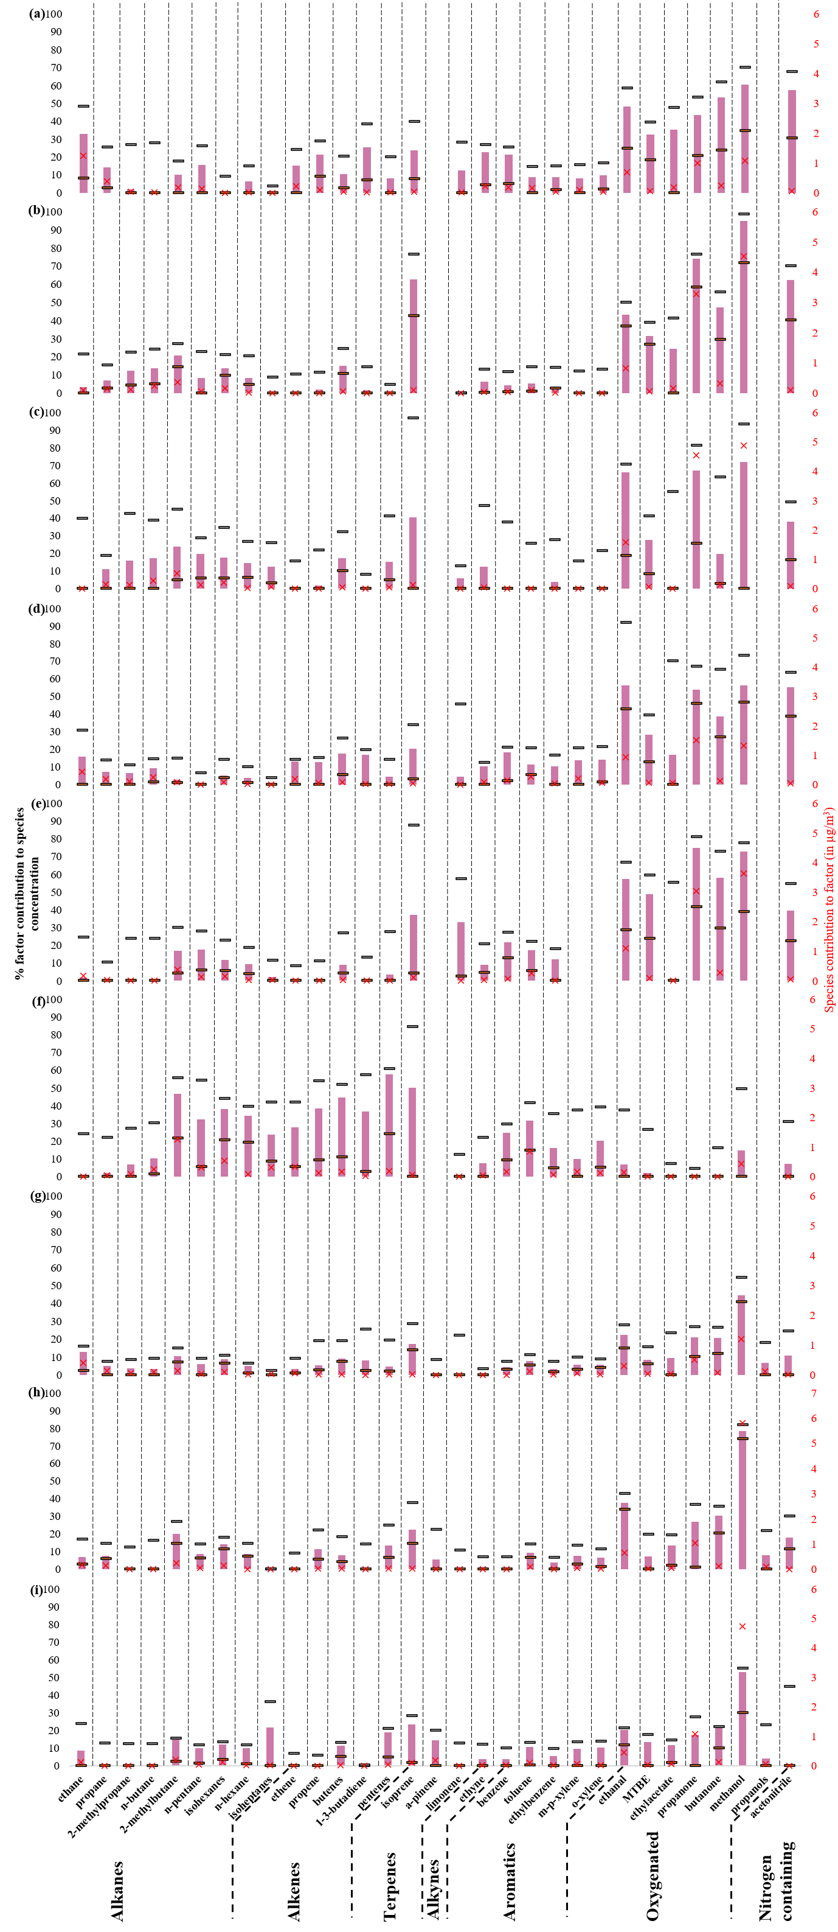
Figure S10. Fingerprint of local emissions in (a) winter, (b) spring, (c) summer and (d) autumn 2016, (e) summer and (f) autumn 2017 and (g) winter, (h) spring and (i) summer 2024. The colored bars are the contribution of the identified source to the species (in %), the red crosses are the contribution of the species to the identified source (in µg/m³) and the lower and upper black lines are the 5th and 95th percentiles of the bootstrap runs results.
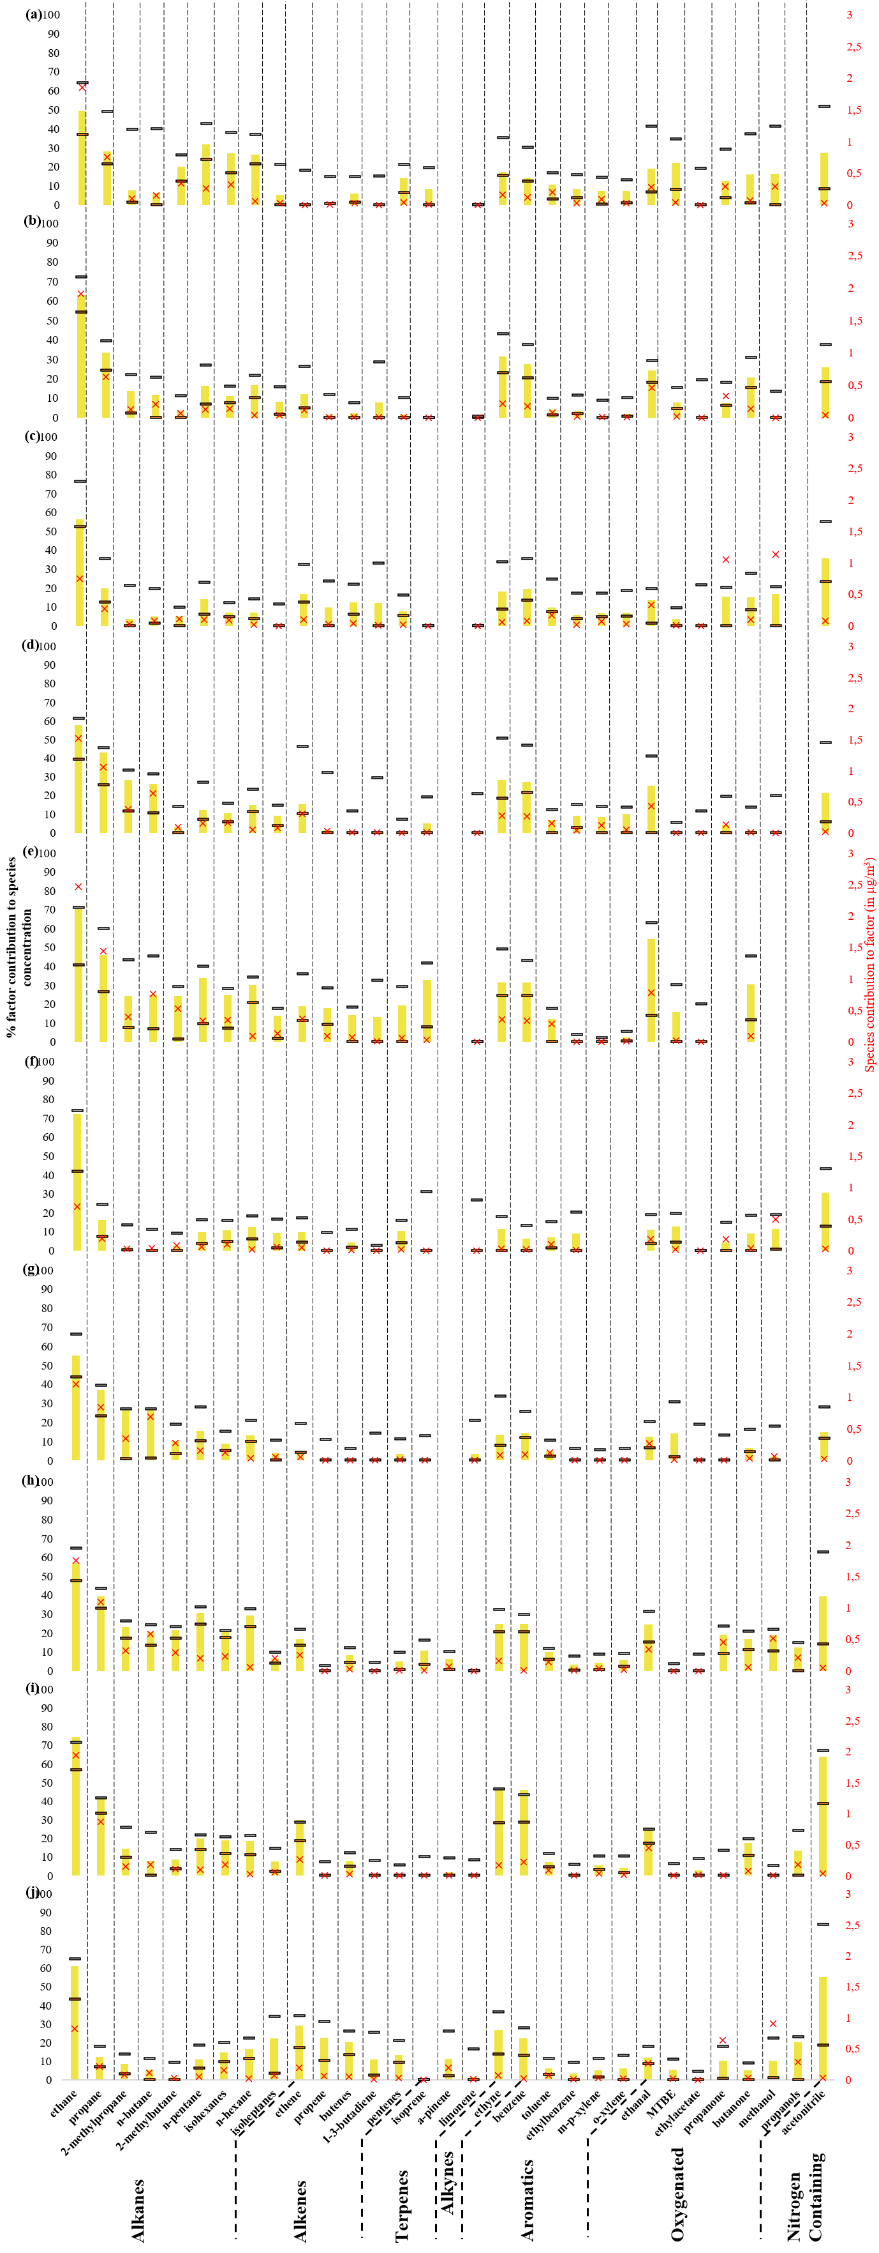
Figure S11. Fingerprint of urban background and natural gas in (a) winter, (b) spring, (c) summer and (d) autumn 2016, (e) winter, (f) summer and (g) autumn 2017 and (h) winter, (i) spring and (j) summer 2024. The colored bars are the contribution of the identified source to the species (in %), the red crosses are the contribution of the species to the identified source (in µg/m³) and the lower and upper black lines are the 5th and 95th percentiles of the bootstrap runs results.
Table S1. Yearly average and their corresponding standard deviation (sd) of the VOCs compounds quantified by the GC-FID at the Zurich station in 2016, 2017 and 2024. Pentanes, pentenes and acetaldehyde were removed as they were not quantified every year.
Compound | VOC Class | 2016 | 2017 | 2024
Compound | VOC Class | mean ± sd (ppt) | mean ± sd (ppt) | mean ± sd (ppt)
ethanol | oxygenated | 7592.7 ± 1389.9 | 6932.4 ± 2053.5 | 8777.6 ± 1030.3
methanol | oxygenated | 3082 ± 1730.8 | 2826.1 ± 1831 | 4374.2 ± 2105.4
Propanone | oxygenated | 1869.9 ± 880.1 | 1524.4 ± 740.6 | 1745.1 ± 619.8
Ethanal | oxygenated | 1101 ± 234.8 | 1057.3 ± 191.4 | 983.8 ± 158.8
Propanols | oxygenated | 574.1 ± 118.6 | 544.4 ± 258.2 | 657.6 ± 148.8
ethylacetate | oxygenated | 197.7 ± 54.9 | 288.6 ± 95.7 | 167.7 ± 36.5
Butanone | oxygenated | 190 ± 52.9 | 151.9 ± 48.8 | 156.9 ± 36.2
acetonitrile | oxygenated | 102.2 ± 49.5 | 69.2 ± 27.6 | 53.5 ± 79.1
methyl-tert-butyl-ether (MTBE) | oxygenated | 63.7 ± 19.1 | 41.7 ± 9.2 | 76.8 ± 19.9
ethane | alkane | 2156.5 ± 800 | 1934.1 ± 745.8 | 1886 ± 558.3
propane | alkane | 1308.2 ± 423.9 | 1192.9 ± 332.2 | 1393.4 ± 266.2
n-butane | alkane | 943.7 ± 335.1 | 873.7 ± 255.9 | 1031.6 ± 254.2
2-methylbutane | alkane | 805.1 ± 259.6 | 730.4 ± 220.6 | 501 ± 115.6
2-methylpropane | alkane | 509.2 ± 186.5 | 460.2 ± 140.1 | 489.8 ± 121.7
isohexanes | alkane | 407.2 ± 105.2 | 336 ± 78.2 | 324.3 ± 46.1
n-pentane | alkane | 332.2 ± 98.2 | 284.2 ± 69.7 | 211.7 ± 48.9
isoheptanes | alkane | 186.9 ± 89.9 | 217.2 ± 91.4 | 259.4 ± 82.5
n-hexane | alkane | 75.6 ± 25.7 | 62.2 ± 13 | 44 ± 8.5
ethene | alkene | 1124.4 ± 721.9 | 890.6 ± 423.5 | 874.5 ± 324.5
propene | alkene | 236.4 ± 123.5 | 181.3 ± 62.5 | 167.1 ± 50.6
Butenes | alkene | 188.3 ± 87 | 139.1 ± 41.8 | 117 ± 25.9
Pentenes | alkene | 99.6 ± 91.4 | 84.0 ± 78.6 | 67.4 ± 67.4
isoprene | alkene | 92.2 ± 43.6 | 71.9 ± 36.7 | 72.9 ± 48.9
1-3-butadiene | alkene | 34.3 ± 17.9 | 26.4 ± 9.2 | 25 ± 9.5
ethyne | alkyne | 722.1 ± 381.2 | 582.5 ± 286 | 433.5 ± 153.4
toluene | aromatic | 633.2 ± 209.9 | 537.6 ± 181.9 | 366.8 ± 92.9
m-p-xylene | aromatic | 330.9 ± 119.8 | 261.7 ± 123.5 | 195.4 ± 56.9
benzene | aromatic | 238.7 ± 109.9 | 190.5 ± 78.2 | 174.2 ± 65.6
o-xylene | aromatic | 115.5 ± 42.4 | 97.2 ± 50.8 | 72.9 ± 19.1
ethylbenzene | aromatic | 94.8 ± 33.8 | 76.3 ± 31.4 | 55 ± 14.3
limonene | terpene | 18.7 ± 12.3 | 19.4 ± 15.8 | 24 ± 11
a-pinene | terpene | 15.1 ± 5.7 | 5.7 ± 2.4 | 24.1 ± 5.9

Table S2. List of PMF parameters and quality indicators
 | Winter 2016 | Spring 2016 | Summer 2016 | Autumn 2016 | Winter 2017 | Summer 2017 | Autumn 2017 | Winter 2024 | Spring 2024 | Summer 2024
n (sample) | 1438 | 2204 | 2160 | 2105 | 2142 | 2216 | 2195 | 1251 | 1922 | 1921
m (species, excluding those defined as bad) | 29 | 29 | 29 | 29 | 26 | 27 | 29 | 31 | 31 | 31
k (factor) | 6 | 6 | 6 | 6 | 5 | 6 | 6 | 7 | 7 | 7
Q_{robust}/Q_{expected} | 6.22 | 6.72 | 5.40 | 9.02 | 7.34 | 9.43 | 10.66 | 8.40 | 12.08 | 10.39
r² model vs measurement | 0.992 | 0.848 | 0.862 | 0.835 | 0.850 | 0.817 | 0.880 | 0.948 | 0.943 | 0.919
Nb species with r²>0.75 for model vs measurement | 25 | 21 | 19 | 20 | 20 | 15 | 18 | 22 | 18 | 20
FPeak | none | -0.5 | -1 | -1 | -1 | -1 | -0.5 | -0.5 | 1 | -0.5
FPeak %dQ | / | 0.01 | 0.03 | 0.04 | 0.02 | 0.02 | 0.01 | 0.02 | 0.01 | 0.01
BS mapping | Natural gas swapped with road transport in 24% of the cases. All other factors recovered in more than 80% of the runs.  0 unmapped* factor | All factors recovered in more than 80% of the runs.  Solvent use factor unmapped* 3 times | Solvent use swapped with local emissions in 19% of the cases. All other factors recovered in more than 80% of the runs.  0 unmapped* factor | All factors recovered in more than 80% of the runs  0 unmapped* factor | All factors recovered in more than 80% of the runs  0 unmapped* factor | All factors recovered in more than 80% of the runs  0 unmapped* factor | All factors recovered in more than 80% of the runs  0 unmapped* factor | All factors recovered in more than 80% of the runs  0 unmapped* factor | All factors recovered in more than 80% of the runs  0 unmapped* factor | Local emissions swapped with solvent use in 43% of the cases. All other factors recovered in more than 80% of the runs.  0 unmapped* factor
*: In BS run a factor is considered unmapped if its r² is below 0.6 with every factor of the base run solutio
 | Propane and butanes source | Local emissions | Urban background and natural gas | VCPs | Road transport | Residential heating and wood burning | Modelized VOCs | modelized VOCs to total VOCs (%)
Winter 2016 | 3.77 | 6.45 | 5.67 | 5.44 | 6.99 | 2.98 | 31.30 | 103
Spring 2016 | 4.24 | 11.53 | 5.08 | 4.80 | 5.50 | 2.49 | 33.64 | 104
Summer 2016 | 3.84 | 14.75 | 6.13 | 3.30 | 7.91 | 2.26 | 34.69 | 103
Autumn 2016 | 7.66 | 8.20 | 5.84 | 5.40 | 6.61 | 3.31 | 37.02 | 101
Mean 2016 | 4.93 | 10.23 | 5.68 | 4.74 | 6.75 | 2.76 | 34.16 | 103
Winter 2017 | 8.59 | - | 11.14 | 8.20 | 6.23 | 4.05 | 38.21 | 119
Summer 2017 | 3.16 | 10.32 | 3.45 | 4.54 | 7.13 | 2.13 | 30.73 | 117
Autumn 2017 | 6.52 | 6.19 | 4.83 | 9.65 | 9.25 | 3.43 | 39.87 | 107
Mean 2017 | 6.09 | 8.26 | 6.47 | 7.46 | 7.54 | 3.20 | 36.27 | 114
Winter 2024 | 6.10 | 4.40 | 7.96 | 3.61 | 7.19 | 3.10 | 32.36 | 103
Spring 2024 | 4.06 | 9.06 | 4.80 | 3.39 | 4.64 | 3.40 | 29.36 | 88
Summer 2024 | 3.14 | 8.07 | 5.24 | 6.91 | 8.28 | 3.61 | 35.25 | 98
Mean 2024 | 4.43 | 7.18 | 6.00 | 4.64 | 6.70 | 3.37 | 32.33 | 96
Table S3. Mean contribution of each factor to VOC concentration for each season (in µg m⁻³)

Table S4. R Pearson correlation coefficient of identified factors with ancillary data in 2016. *** means a p-value below 5 % and * means a p-value above 5%
 | NO_{x} | CO | CH₄ | PM_{2.5} | PM₁₀ | O₃ | Temperature | Ethanol
Road transport | 0.54*** | 0.51*** | 0.43*** | 0.24*** | 0.30*** | -0.31*** | 0.00* | 0.46***
Wood burning | 0.62*** | 0.71*** | 0.63*** | 0.55*** | 0.53*** | -0.44*** | -0.30*** | 0.16***
Propane and butanes source | 0.66*** | 0.60*** | 0.54*** | 0.32*** | 0.37*** | -0.41*** | -0.22*** | 0.19***
Solvent use | 0.61*** | 0.53*** | 0.49*** | 0.31*** | 0.36*** | -0.38*** | -0.23*** | 0.26***
Local emissions | -0.03*** | -0.03*** | -0.11*** | 0.01* | 0.11*** | 0.31*** | 0.56*** | 0.33***
Urban background and natural gas | 0.20*** | 0.28*** | 0.41*** | 0.26*** | 0.20*** | -0.31*** | -0.33*** | 0.03*

Table S5. R Pearson correlation coefficient of identified factors with ancillary data in 2017. *** means a p-value below 5 % and * means a p-value above 5%
 | NO_{x} | CO | CH₄ | PM_{2.5} | PM₁₀ | O₃ | Temperature | Ethanol
Road transport | 0.36*** | 0.24*** | 0.30*** | -0.02* | 0.07*** | -0.28*** | 0.15*** | 0.50***
Wood burning | 0.31*** | 0.30*** | 0.22*** | 0.14*** | 0.16*** | -0.28*** | -0.14*** | 0.16***
Propane and butanes source | 0.56*** | 0.41*** | 0.45*** | 0.21*** | 0.28*** | -0.43*** | -0.22*** | 0.24***
Solvent use | 0.24*** | 026*** | 0.23*** | 0.09*** | 0.13*** | -0.26*** | -0.06*** | 0.24***
Local emissions | 0.22*** | 0.23*** | 0.12*** | 0.22*** | 0.30*** | 0.16*** | 0.39*** | 0.15***
Urban background and natural gas | 0.24*** | 0.37*** | 0.45*** | 0.43*** | 0.34*** | -0.44*** | -0.73*** | -0.08***

Table S6. R Pearson correlation coefficient of identified factors with ancillary data in 2024. *** means a p-value below 5 % and * means a p-value above 5%
 | NO_{x} | CO | CH₄ | PM_{2.5} | PM₁₀ | O₃ | Temperature | Ethanol
Road transport | 0.58*** | 0.40*** | 0.53*** | 0.20*** | 0.21*** | -0.46*** | 0.04* | 0.40***
Wood burning | 0.20*** | 0.40*** | 0.13*** | 0.67*** | 0.55*** | -0.04*** | 0.09*** | 0.39***
Propane and butanes source | 0.45*** | 0.36*** | 0.29*** | 0.12*** | 0.14*** | -0.29*** | -0.12*** | 0.16***
Solvent use | 0.01* | -0.10*** | -0.04*** | 0.15*** | 0.20*** | 0.32*** | 0.58*** | 0.05***
Local emissions | 0.03*** | 0.03*** | 0.01* | 0.16*** | 0.28*** | 0.21*** | 0.42*** | 0.26***
Urban background and natural gas | 0.11*** | 0.28*** | 0.26*** | 0.11*** | -0.03*** | -0.36*** | -0.52*** | -0.02***

