Improved Water/Polar Liquid Separation Performance of Graphene Oxide Membranes by Increasing the Starting Dispersion Concentration

Mikhail V. Matveev¹, Alexander V. Kaplin¹, Alexander A. Gulin¹, Tatiana S. Yankova^{1*}, аnd Natalia A. Chumakova¹

¹ N. N. Semenov Federal Research Center for Chemical Physics, Russian Academy of Science, Kosygin St. 4, Moscow, 119991, Russia

Supporting information
SI1. Starting graphene oxide dispersions microscopy
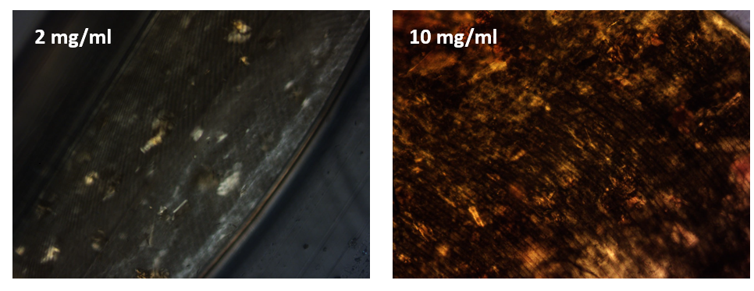
Figure SI1.1. Optical micrographs of the graphene oxide dispersions observed under crossed polarizers: isotropic dispersion (2 mg mL⁻¹) and liquid crystalline dispersion (10 mg mL⁻¹).

SI2. Measurements of GOM permeance to polar liquids
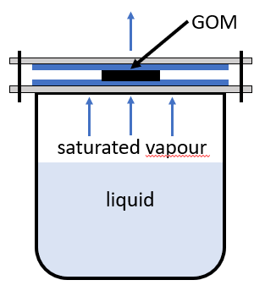
Figure S2.1. Scheme of vapour permeance measurements setup.

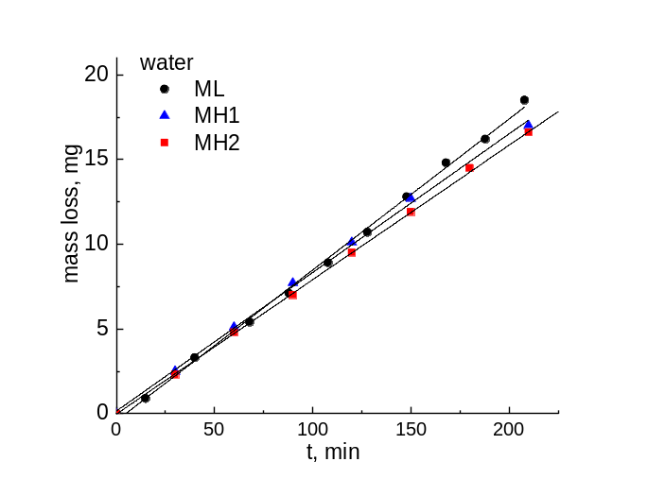
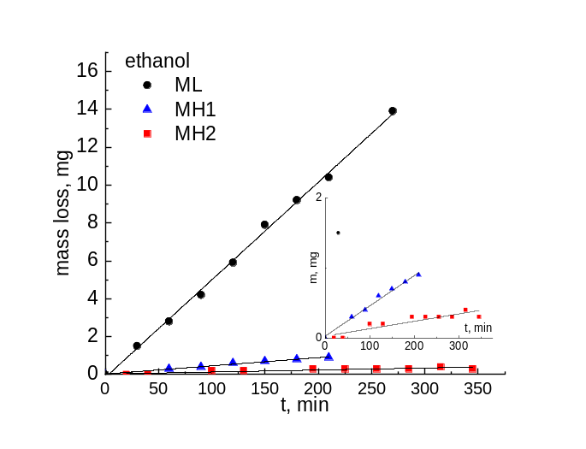
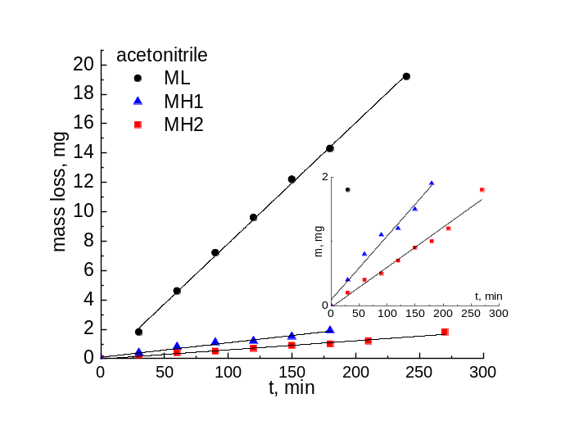
Figure S2.2. Graphs of mass loss of water, ethanol, and acetonitrile through GOMs MH (black circles), MH1 (blue triangles), and MH2 (red squares) at 25°C and linear approximations of the data.

Table S2.1. Coefficients of the Antoine equation [1].
Temperature  interval | T_{min} | T_{max} | A | B | C
Water
№1 | 1 | 100 | 8.07131 | 1730.63 | 233.426
№2 | 99 | 374 | 8.14019 | 1810.94 | 244.485
Ethanol
№1 | -57 | 80 | 8.20417 | 1642.89 | 230.3
№2 | 77 | 243 | 7.68117 | 1332.04 | 199.2
Acetonitrile
№1 | -27 | 82 | 7.33986 | 1482.29 | 250.523
№2 | 76 | 261 | 7.5305 | 1609.86 | 264.7

SI3. EPR spectra of GO dispersions, containing H2 spin probes.

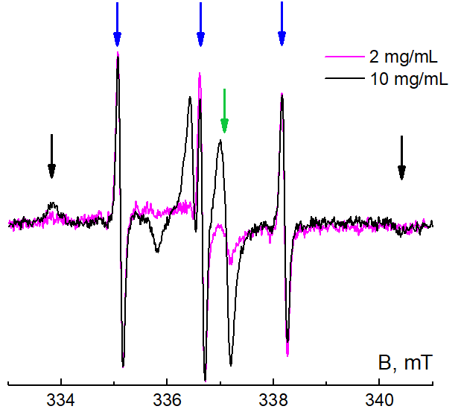
Figure S3.1. EPR spectra of probe H2 in a graphene oxide dispersion with a concentration of 2 mg mL⁻¹ (magenta line) and 10 mg mL⁻¹ (black line). Colored arrows indicate the positions of the following components: triplet of rapidly rotating H2 in bulk water (blue), structureless singlet of the intrinsic graphene oxide signal (green), and components of strongly immobilized H2 near the surface of GO sheets (black).

As signal of sorbed nitroxides present in the dispersions’ samples, we can conclude that H2 spin probe equilibrium distribution is shifted towards sorption on GO flakes.

SI4. SEM images processing

Table S4.1. SEM images processing results

Original image | For analysis | Mask + activated | Activated mask | Distribution
ML

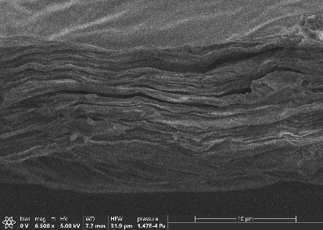  86 | 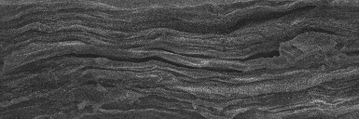  31.88 × 10.58 µm | 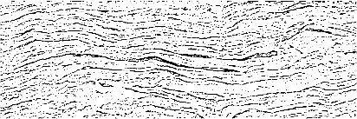  binarization threshold 0.69  Gaussian blur 7 | 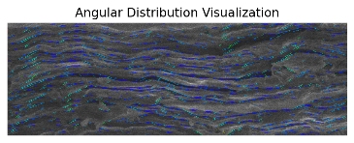  filter 25; threshold 0.70 | 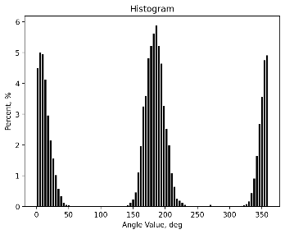  T2_0.873 T4_0.586
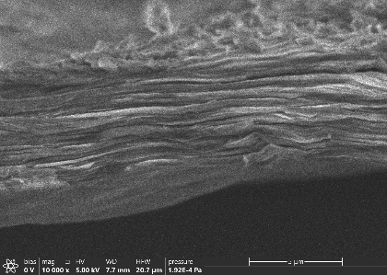  04 | 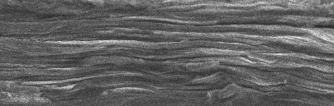  20.15 × 6.42 µm | 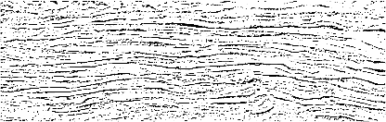  binarization threshold 0.68  Gaussian blur 7 | 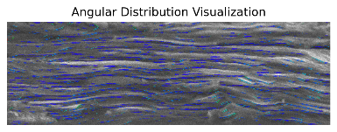  filter 25; threshold 0.70 | 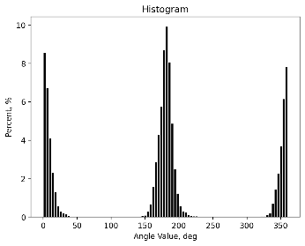  T2_0.937 T4_0.781
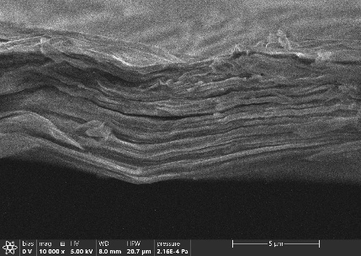  49 | 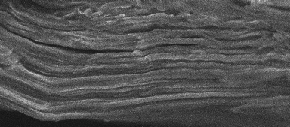  15.07 × 6.62 µm | 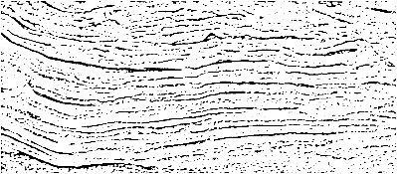  binarization threshold 0.69  Gaussian blur 7 | 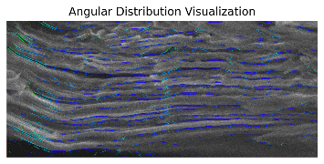  filter 25; threshold 0.70 | 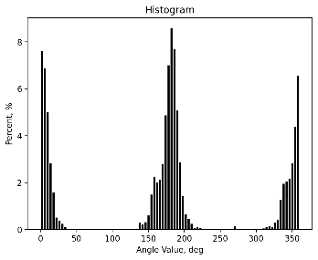  T2_0.895 T4_0.677
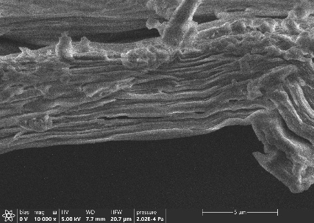  53 | 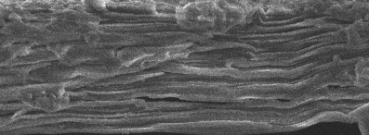  16.75 × 6.18 µm | 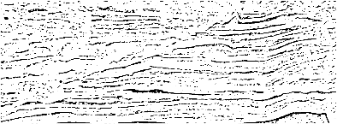  binarization threshold 0.69  Gaussian blur 7 | 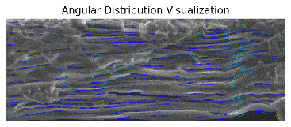  filter 25; threshold 0.70 | 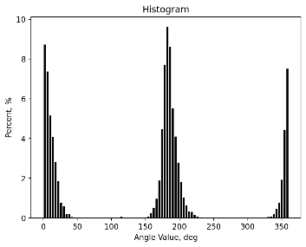  T2_0.920 T4_0.760
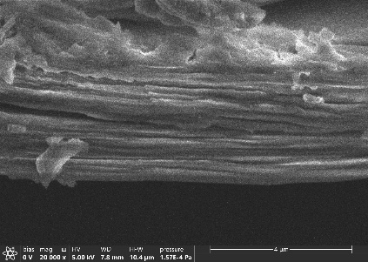  72 | 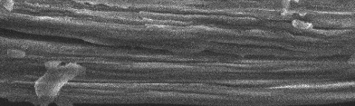  10.36 × 3.10 µm | 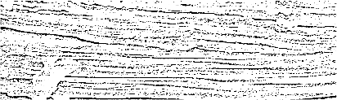  binarization threshold 0.68  Gaussian blur 7 | 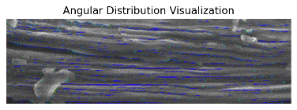  filter 25; threshold 0.70 | 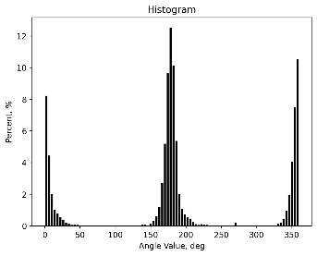  T2_0.926 T4_0.799
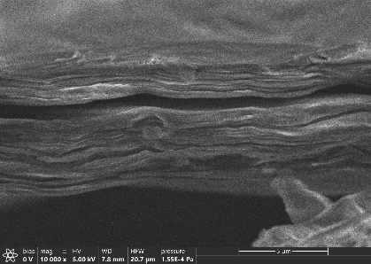  75 | 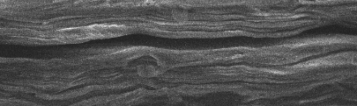  20.72 × 6.18 µm | 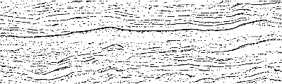  binarization threshold 0.69  Gaussian blur 7 | 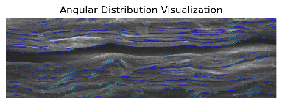  filter 25; threshold 0.70 | 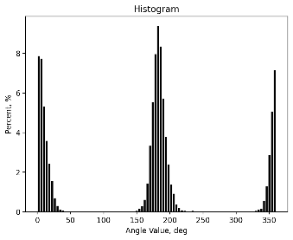  T2_0.936 T4_0.799
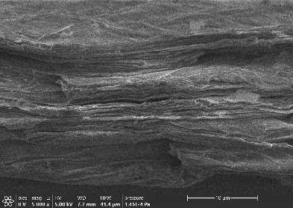  88 | 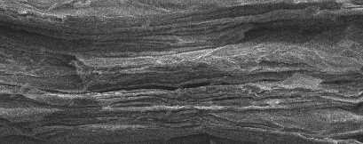  41.44 × 16.40 µm | 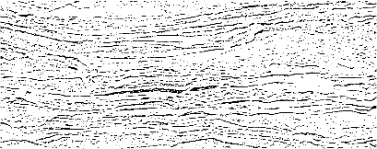  binarization threshold 0.69  Gaussian blur 7 | 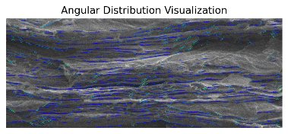  filter 25; threshold 0.70 | 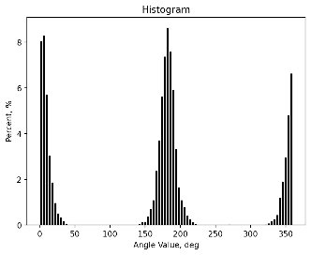  T2_0.927 T4_0.756
MH2

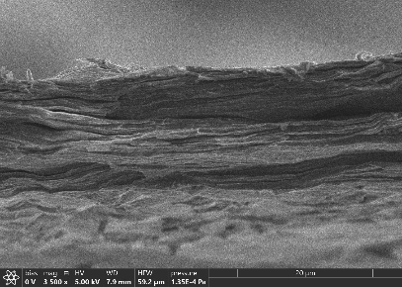  96 | 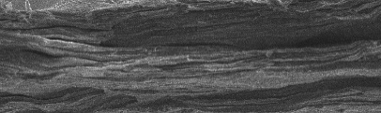  59.20 × 17.73 µm | 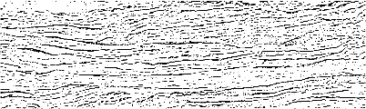  binarization threshold 0.69  Gaussian blur 7 | 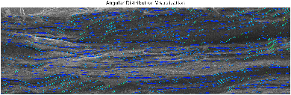  filter 25; threshold 0.70 | 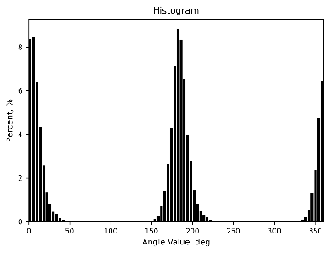  T2_0.933 T4_0.772
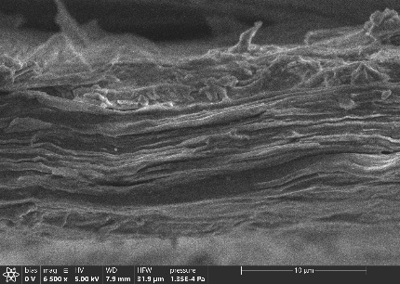  97 | 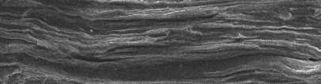  30.98 × 8.11 µm | 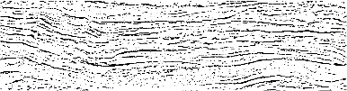  binarization threshold 0.69  Gaussian blur 7 | 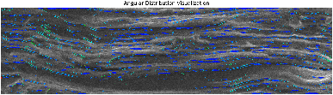  filter 25; threshold 0.70 | 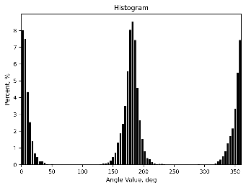  T2_0.915 T4_0.721
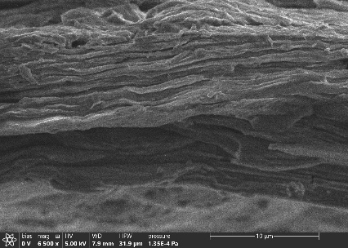  98 | 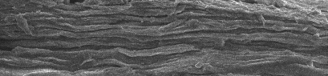  30.78 × 7.12 µm | 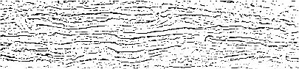  binarization threshold 0.69  Gaussian blur 7 | 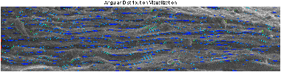  filter 25; threshold 0.70 | 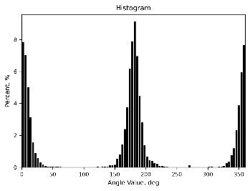  T2_0.921 T4_0.748
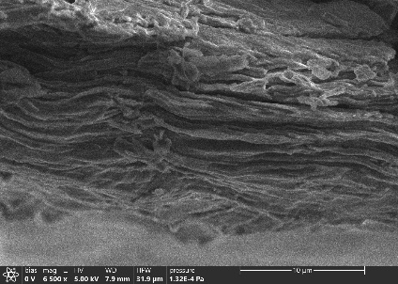  101 | 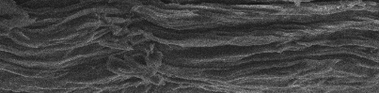  30.88 × 7.55 µm | 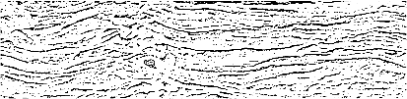  binarization threshold 0.69  Gaussian blur 7 | 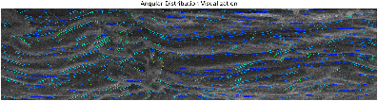  filter 25; threshold 0.70 | 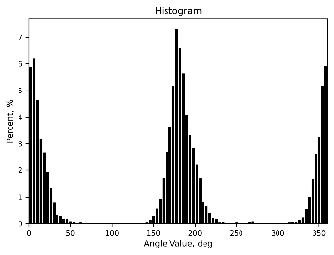  T2_0.880 T4_0.633
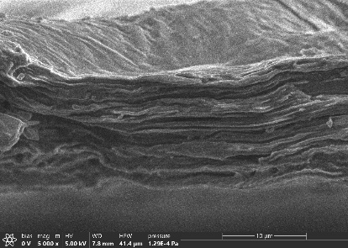  109 | 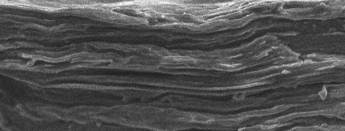  29.27 × 11.16 µm | 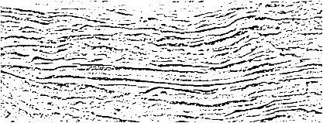  binarization threshold 0.69  Gaussian blur 7 | 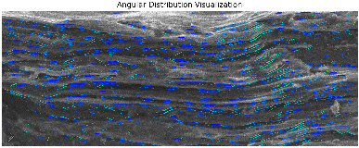  filter 25; threshold 0.70 | 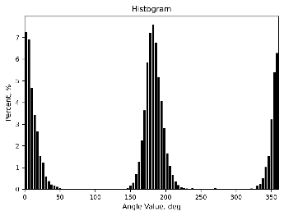  T2_0.910 T4_0.708
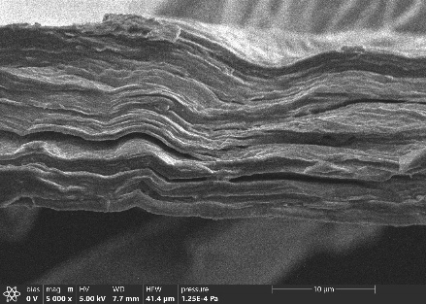  119 | 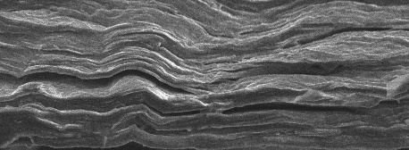  40.85 × 15.00 µm | 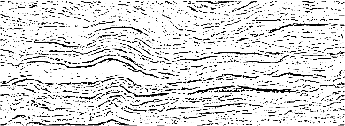  binarization threshold 0.69  Gaussian blur 7 | 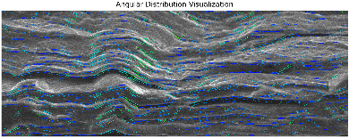  filter 25; threshold 0.70 | 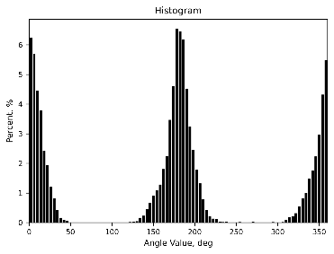  T2_0.866 T4_0.585
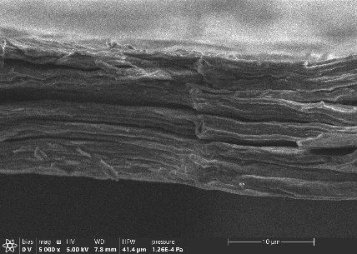  120 | 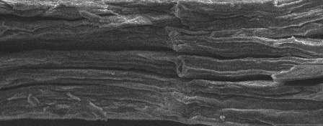  40.23 × 15.84 µm | 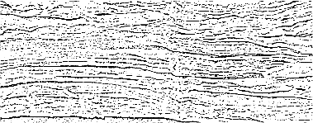  binarization threshold 0.69  Gaussian blur 7 | 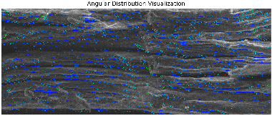  filter 25; threshold 0.70 | 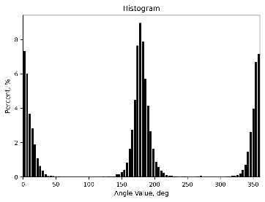  T2_0.915 T4_0.730
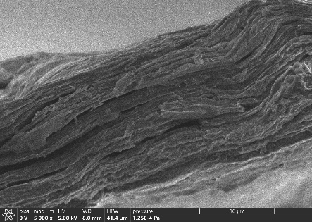  126 | 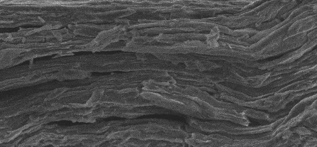  31.48 × 14.60 µm | 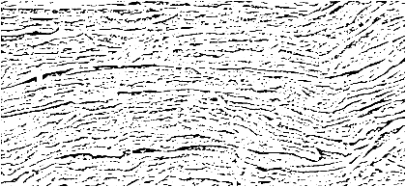  binarization threshold 0.69  Gaussian blur 7 | 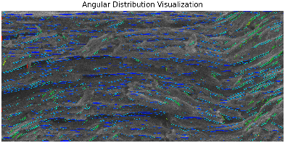  filter 25; threshold 0.70 | 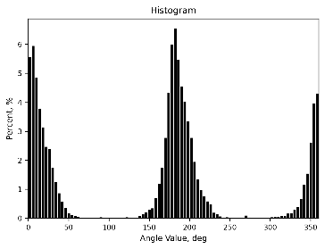  T2_0.849 T4_0.555
MH1

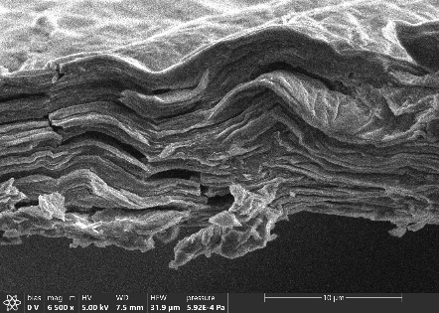  004 | 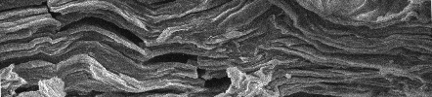  31.88 × 7.18 µm | 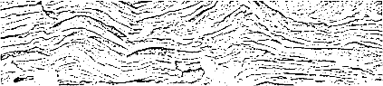  binarization threshold 0.69  Gaussian blur 7 | 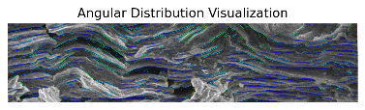  filter 25; threshold 0.70 | 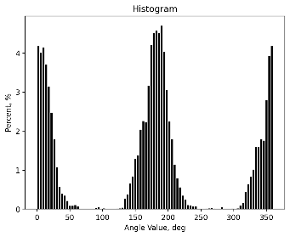  T2_0.785 T4_0.414
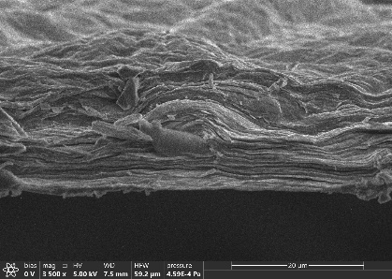  013 | 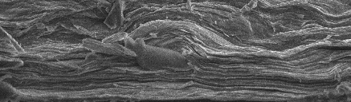  59.20 × 17.34 µm | 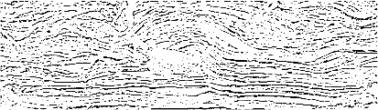  binarization threshold 0.69  Gaussian blur 7 | 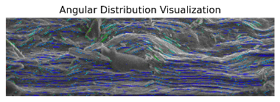  filter 25; threshold 0.70 | 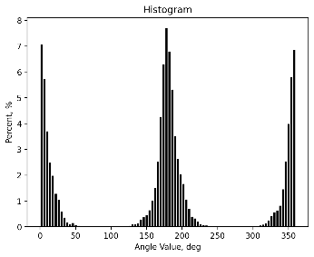  T2_0.876 T4_0.632
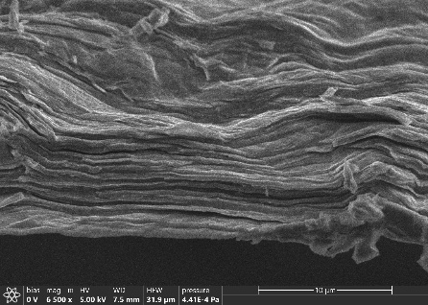  015 | 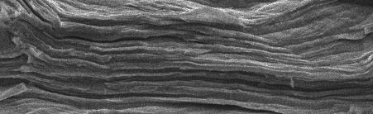  25.36 × 7.76 µm | 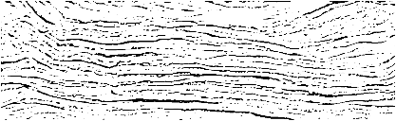  binarization threshold 0.70  Gaussian blur 7 | 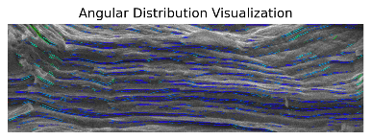  filter 25; threshold 0.70 | 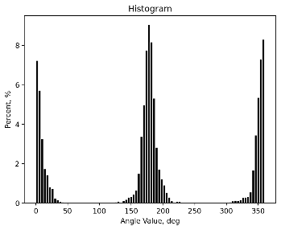  T2_0.920 T4_0.739
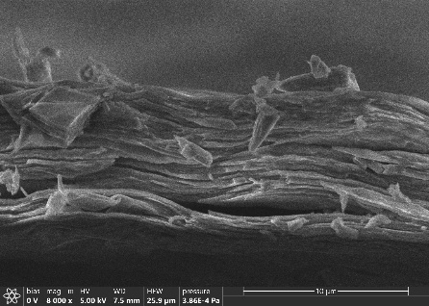  020 | 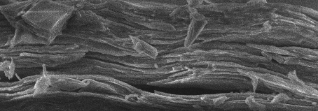  25.90 × 9.11 µm | 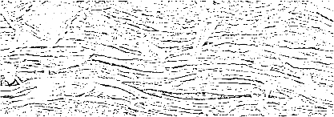  binarization threshold 0.70  Gaussian blur 7 | 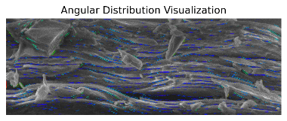  filter 25; threshold 0.70 | 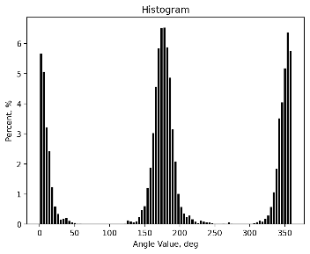  T2_0.885 T4_0.659
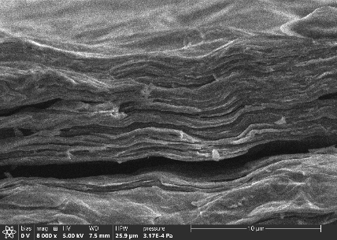  023 | 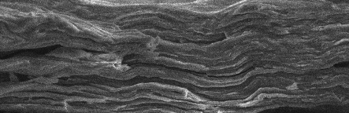  25.29 × 8.25 µm | 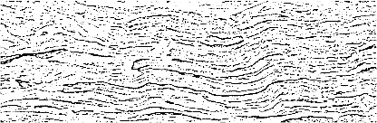  binarization threshold 0.69  Gaussian blur 7 | 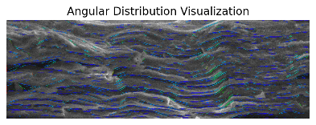  filter 25; threshold 0.70 | 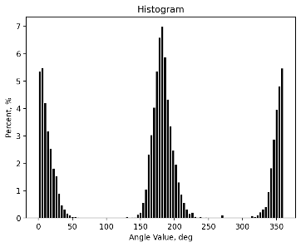  T2_0.879 T4_0.623
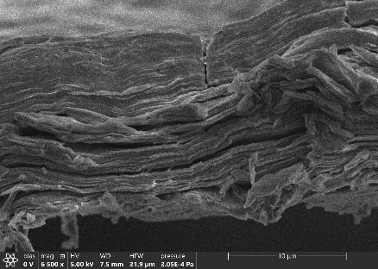  026 | 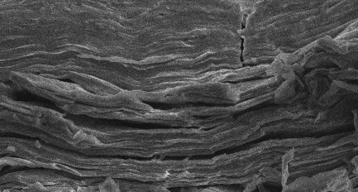  25.26 × 13.55 µm | 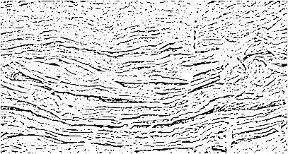  binarization threshold 0.69  Gaussian blur 7 | 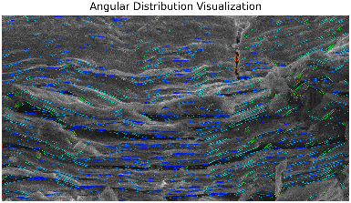  filter 25; threshold 0.70 | 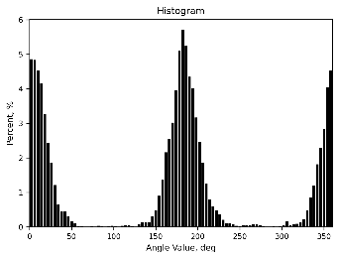  T2_0.830 T4_0.525
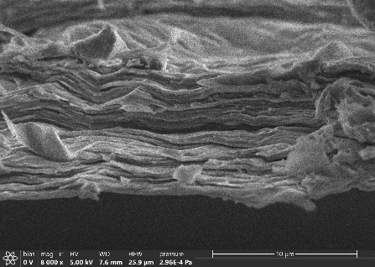  028 | 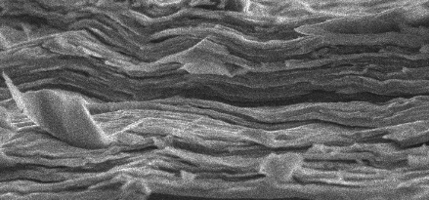  19.76 × 9.24 µm | 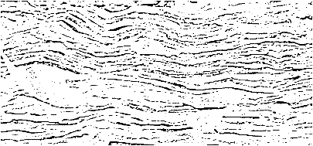  binarization threshold 0.69  Gaussian blur 7 | 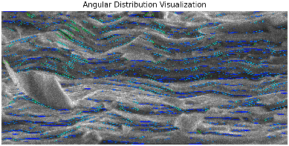  filter 25; threshold 0.70 | 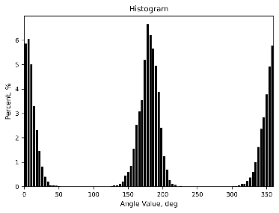  T2_0.891 T4_0.642
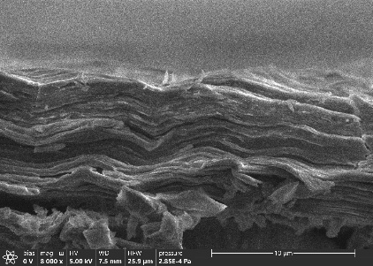  030 | 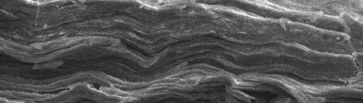  25.90 × 7.39 µm | 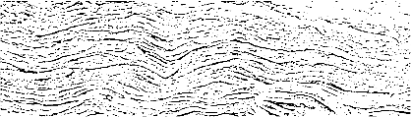  binarization threshold 0.69  Gaussian blur 7 | 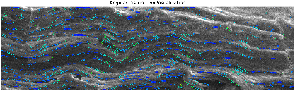  filter 25; threshold 0.70 | 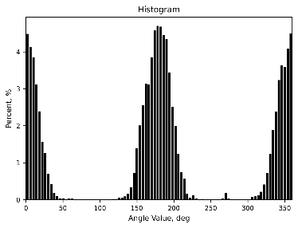  T2_0.837 T4_0.500
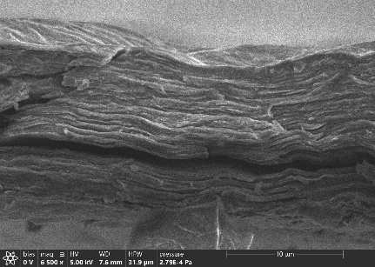  031 | 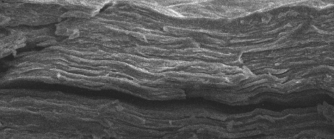  31.88 × 13.28 µm | 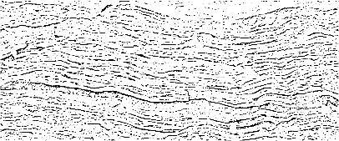  binarization threshold 0.69  Gaussian blur 7 | 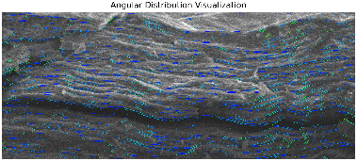  filter 25; threshold 0.70 | 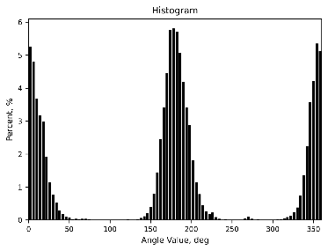  T2_0.860 T4_0.575
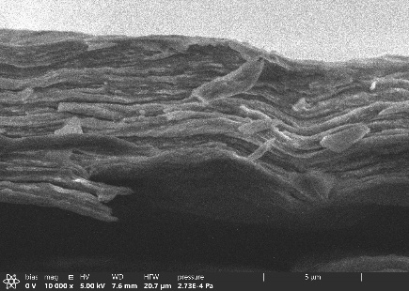  033 | 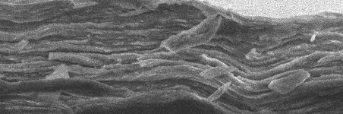  20.72 × 6.88 µm | 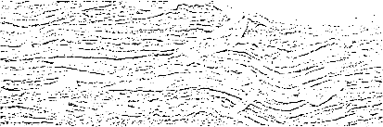  binarization threshold 0.69  Gaussian blur 7 | 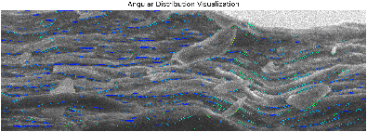  filter 25; threshold 0.70 | 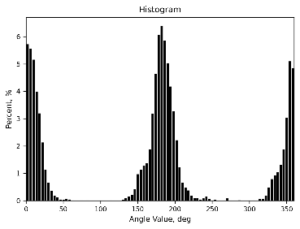  T2_0.869 T4_0.560
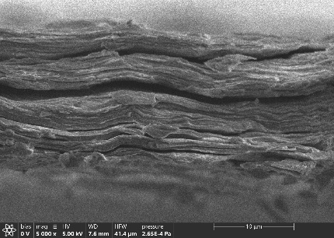  035 | 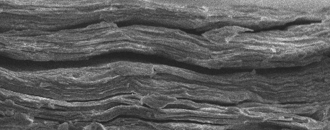  41.44 × 16.40 µm | 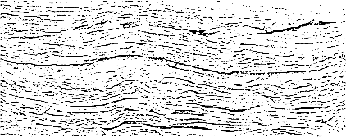  binarization threshold 0.69  Gaussian blur 7 | 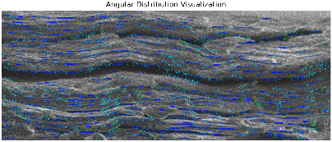  filter 25; threshold 0.70 | 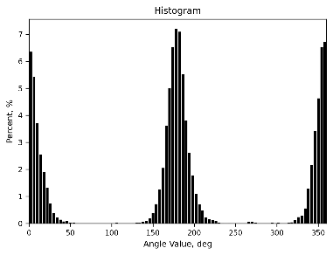  T2_0.903 T4_0.688
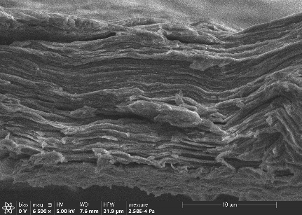  038 | 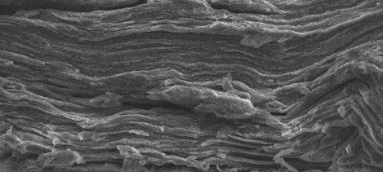  31.88 × 14.36 µm | 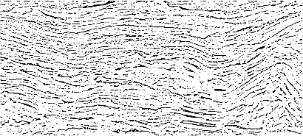  binarization threshold 0.69  Gaussian blur 7 | 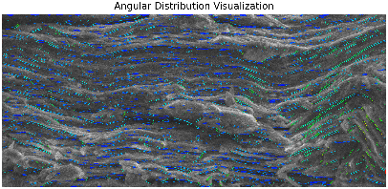  filter 25; threshold 0.70 | 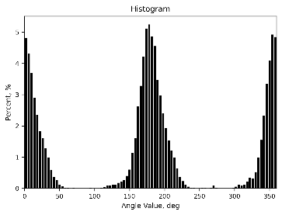  T2_0.816 T4_0.477
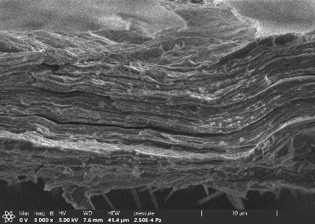  040 | 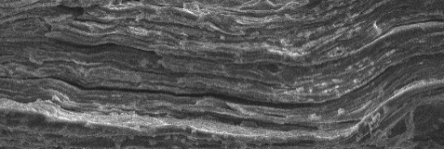  41.44 × 14.03 µm | 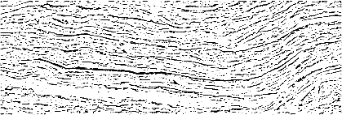  binarization threshold 0.69  Gaussian blur 7 | 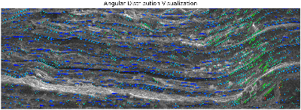  filter 25; threshold 0.70 | 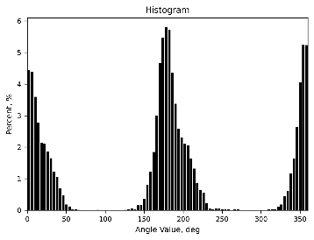  T2_0.804 T4_0.461
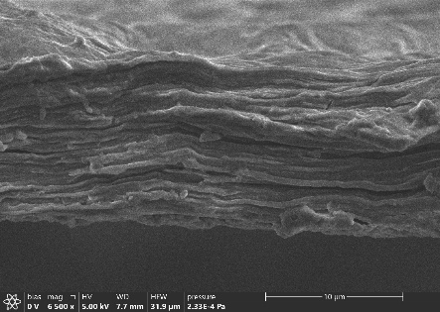  045 | 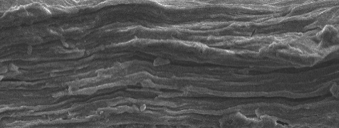  31.38 × 11.89 µm | 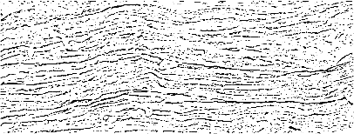  binarization threshold 0.69  Gaussian blur 7 | 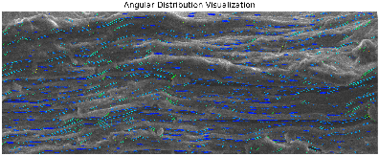  filter 25; threshold 0.70 | 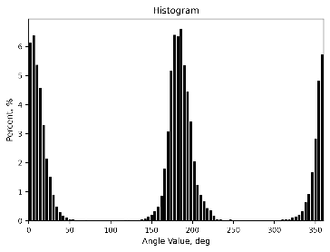  T2_0.893 T4_0.662

SI5. EPR spectra simulations.
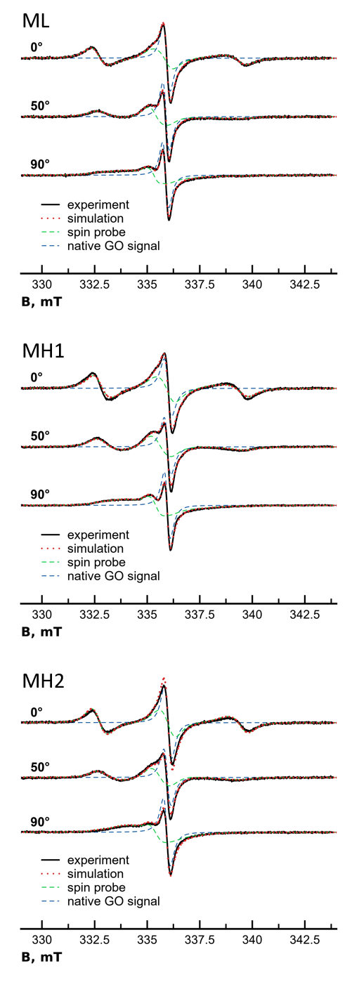
Figure S5.1. The simulation results of spectra deconvolution into nitroxide and GO components.

References:
- “Dortmund Data Bank,” http://ddbonline.ddbst.com/AntoineCalculation/AntoineCalculationCGI.exe

