Supporting Information for
Eco-Friendly In_{x}Ga_{1-x}N Colloidal Quantum Dots for Light Emitting Diodes

By Yangpil Jang¹, Yo-Han Suh², and Jongnam Park^{1,2,*}

Fig. S1 (a) shows inductively coupled plasma mass spectrometry (ICP-MS) results of In_{x}Ga_{1-x}N CQDs, (x=0.25, 0.5, and 0.75), which shows the difference between theoretical and real metal composition of each In_{x}Ga_{1-x}N CQDs. The x-axis shows each sample condition and y-axis shows Ga and In metal ratio of each state. At all In_{x}Ga_{1-x}N CQDs composition, Ga fraction at real metal composition is slightly higher than that of reactants. However, these ICP-MS results show that In-rich In_{x}Ga_{1-x}N CQDs were well synthesized via simple wet-chemical process.
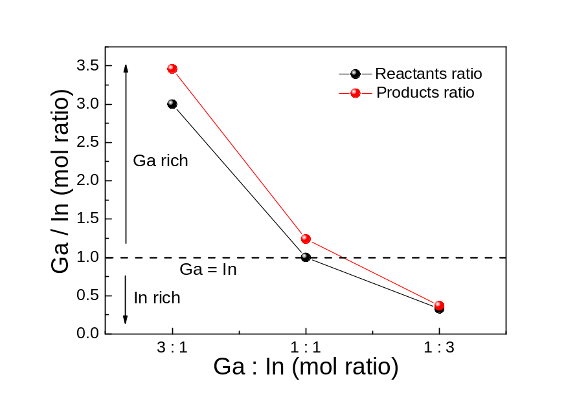
Fig. S1 (a) Metal composition of In_{x}Ga_{1-x}N CQDs : ICP-MS results show that Ga and In metal ratio was well controlled in In_{x}Ga_{1-x}N CQDs, (x = 0.25, 0.5, and 0.75), synthesized by wet-chemical process.
Fig. S1 (b) shows the binding energy shift of In3d_{3/2} and In3d_{5/2} according to metal fraction variation. The In3d spectra of all In_{x}Ga_{1-x}N CQDs had InN binding positions^{1,2}. Both binding states (In3d_{5/2} and In3d_{3/2}) were shifted to lower energy state with increasing In metal fraction. These peaks shift of InN binding states denoted that our colloidal synthetic route can make formation of In, Ga, and N bindings to generate various In_{x}Ga_{1-x}N CQDs.
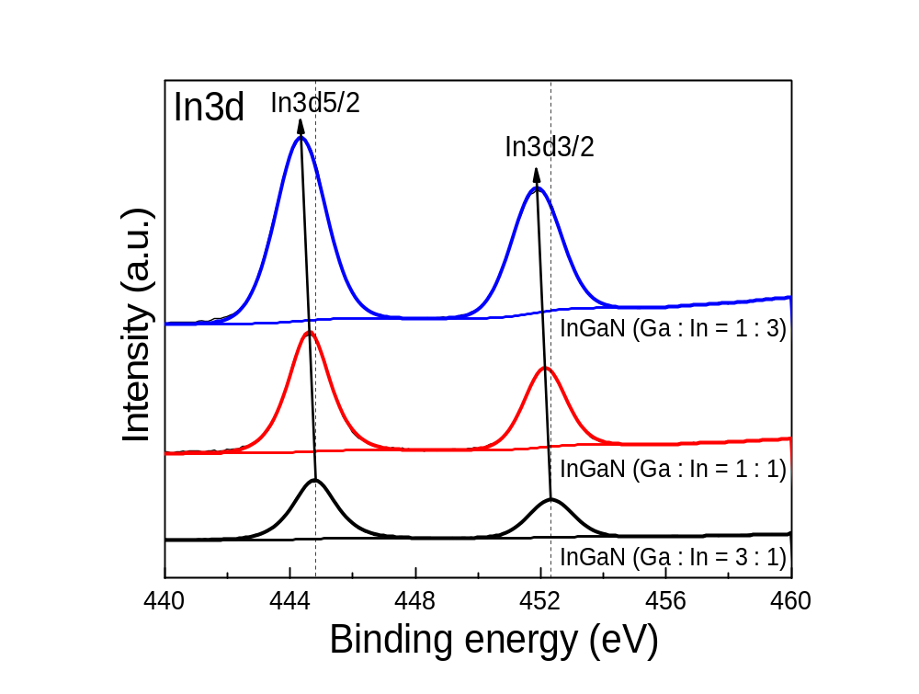
Fig. S1 (b) XPS spectra of In_{x}Ga_{1-x}N CQDs : Binding energy of In_{x}Ga_{1-x}N CQDs of various metal compositions (x = 0.25, 0.5, and 0.75).

Fig. S2 shows relative PL-QY of In_{x}Ga_{1-x}N CQDs according to metal fraction variation. With increasing In fraction, PL-QY decreased from 34% to 3 %, which was well matched with PL intensity change shown in Fig. 2 (b). This PL-QY change in In fraction variation was directly related with unique properties of In_{x}Ga_{1-x}N CQDs. The radiative recombination of GaN or Ga-rich state was relatively less influenced by lattice defects, but, that of In_{x}Ga_{1-x}N in In-rich state was more influenced by lattice defects.³
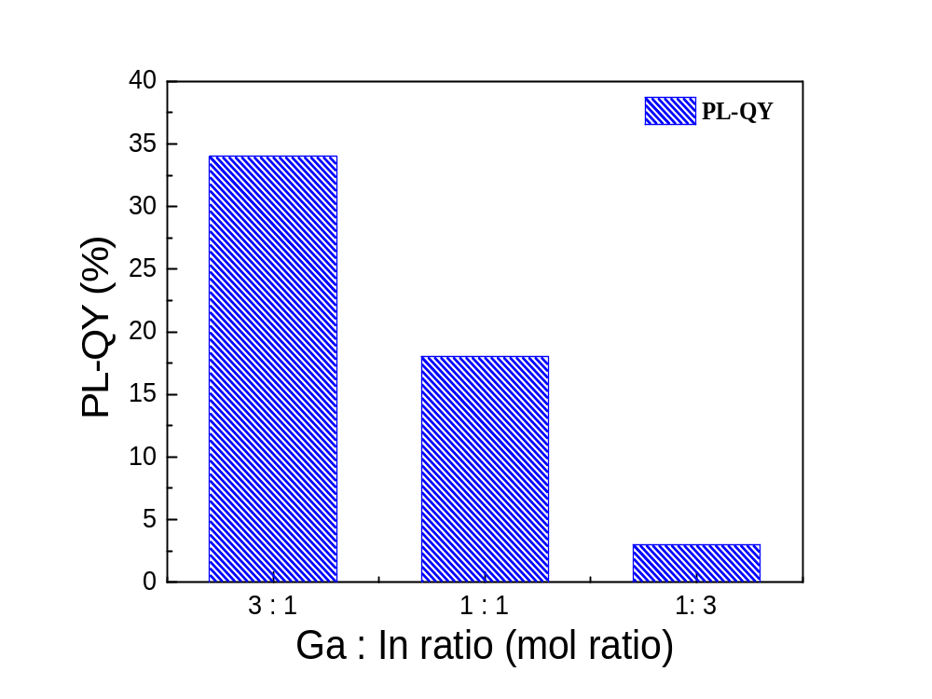
Fig. S2 Relative PL quantum efficiency of In_{x}Ga_{1-x}N CQDs : PL-QY of In_{x}Ga_{1-x}N CQDs of various metal compositions (x = 0.25, 0.5, and 0.75).

Fig. S3 (a) and (b) shows UV-vis absorption and PL spectra of In_{0.75}Ga_{0.25}N CQDs of different size. The Ga and In metal fraction was fixed to 0.25 and 0.75 (In_{0.75}Ga_{0.25}N), because it showed highest PL-QY. For size control of In_{x}Ga_{1-x}N CQDs, the concentration of O.A.(oleic acid) changed from 0.6 mmol to 2.2 mmol. The 1st excitonic peaks as well as PL spectra were blue-shifted with a decrease of particle size (increase of O.A. concentration). These results demonstrated that band gap of In_{x}Ga_{1-x}N CQDs was well controlled by quantum confinement effect.
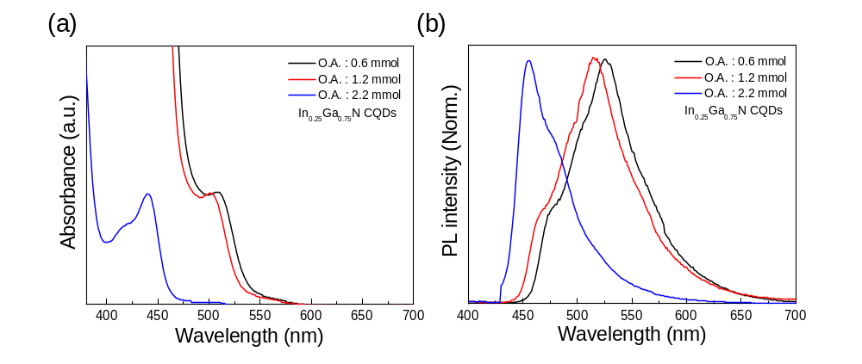
Fig. S3 Band gap tuning of In_{x}Ga_{1-x}N CQDs by quantum confinement effect : (a) UV-vis absorption and (b) PL spectra of size controlled In_{0.25}Ga_{0.75}N CQDs through O.A. concentration (O.A. = 0.6, 1.2, and 2.2 mmol).

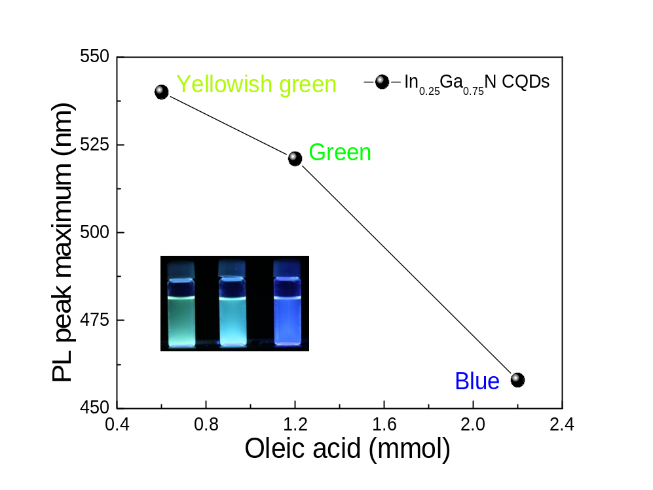
Fig. S4 Band gap tuning of In_{x}Ga_{1-x}N CQDs by quantum confinement effect : Maximum PL peak shift and fluorescence images of In_{0.25}Ga_{0.75}N CQDs of different particle size through O.A. control in solution.

To ascertain that optical property variation of In_{0.25}Ga_{0.75}N CQDs due to quantum confinement effect, transmission electron microscopy (TEM) of In_{0.25}Ga_{0.75}N CQDs with different O.A. concentration was conducted (Fig S5 (a) and (b)). The In_{0.25}Ga_{0.75}N CQDs showed the spherical shape and well distributed states. The average sizes of In_{0.25}Ga_{0.75}N CQDs were 4 nm (1.2 mmol of O.A, Fig. S5 (a)) and 2.5 ~ 3 nm (2.2 mmol of O.A, Fig. S5 (b)), respectively. These TEM results clearly show that optical properties of In_{x}Ga_{1-x}N CQDs are well controlled by particle size variation and our hot-injection routes effectively control the particle size of CQDs via surfactant concentration control. For comparison, TEM images of GaN (3.5 nm) and InN (5 nm) CQDs, synthesized under same synthetic route and condition (1.2 mmol of O.A.), were also shown in Fig. S5 (c) and Fig. S5 (d).
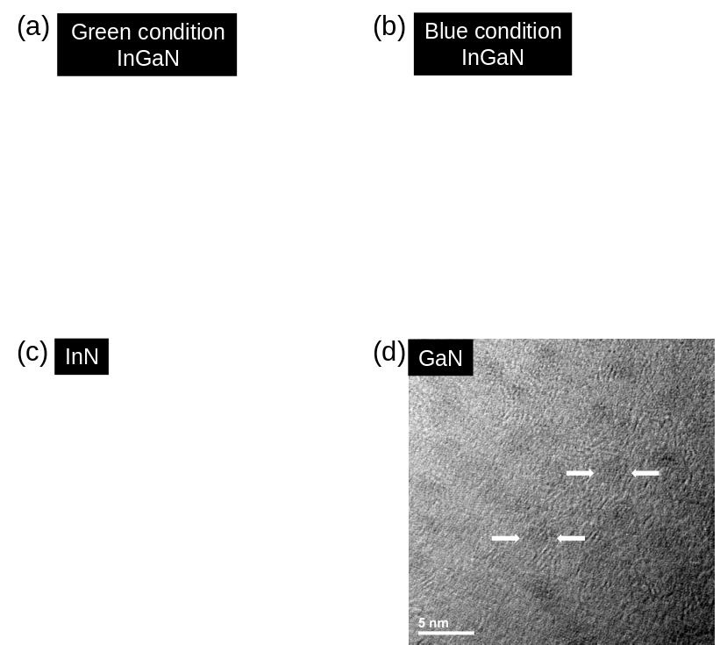
Fig. S5 TEM images of In_{x}Ga_{1-x}N CQDs. (a) green emissive In_{0.25}Ga_{0.75}N CQDs (O.A. = 1.2 mmol, average size : 4 nm), (b) blue emissive In_{0.25}Ga_{0.75}N CQDs (O.A. = 2.2 mmol, average size : 2.5 ~ 3 nm ), (c) InN and (d) GaN CQDs (O.A = 1.2 mmol, average size : 3.5 ~ 5 nm).

The power-dependent experiments (Fig. S6) were conducted to investigate energy state (band structure) and defect condition of In_{x}Ga_{1-x}N CQDs of different metal fraction. The experiment conditions were same for temperature-dependent PL measurement. Fig. S6 (a) shows power-dependent PL spectra of GaN CQDs, which consist of two peaks at ~460 and ~520 nm. No PL spectra shift and PL intensity change at ~460 and 520 nm were observed with excitation power variation. It means that emissive states at ~460 and ~520 nm consist of band like structure and exciton density at each state for PL emission is similar. From this result, it is confirmed that PL of GaN CQDs originates from band-edge recombination.
Fig. S6 (b) shows power-dependent PL spectra of In_{0.25}Ga_{0.75}N CQDs (low concentration of In). With increasing excitation power, PL intensity at ~520 nm more rapidly increased than that of ~560 nm. This result suggested that emissive states at ~560 nm more quickly saturated by high power laser excitation than those at ~520 nm. It can be interpreted by two possibilities. First, number of In-mediated energy states (~520 nm) may be less than that of Ga-metal mediated energy states due to low In fraction in In_{0.25}Ga_{0.75}N CQDs. Second, the emissive states at ~520 nm exhibit a higher degree of crystalline order and a lower density of localized mid-gap defects compared to those at ~560 nm.
Fig. S6 (c) shows power-dependent PL spectra of In_{0.5}Ga_{0.5}N CQDs (same concentration of Ga and In). Similar to temperature-dependent PL results (Fig. 3 (c)), PL intensities at ~560 and ~580 nm, originating from In-alloy mediated states, significantly increased compared to those of In_{x}Ga_{1-x}N CQDs of low In fraction. In addition, PL intensity at ~520 nm more quickly increased than that of ~560 nm with the increase of excitation laser power. These result demonstrates that GaN mediated state had a large number of energy states for exciton generation than that of In-mediated state under equal metal fraction of Ga and In.
Fig. S6 (d) shows power-dependent PL spectra of In_{0.75}Ga_{0.25}N CQDs (high concentration of In). With increasing excitation power, PL intensities at ~460 and ~490 nm more rapidly increased than those at ~520, 560, and 580 nm. This result indicates that the GaN-mediated states possess a more highly ordered band structure than the In-alloy-mediated states, even in the In-rich regime.
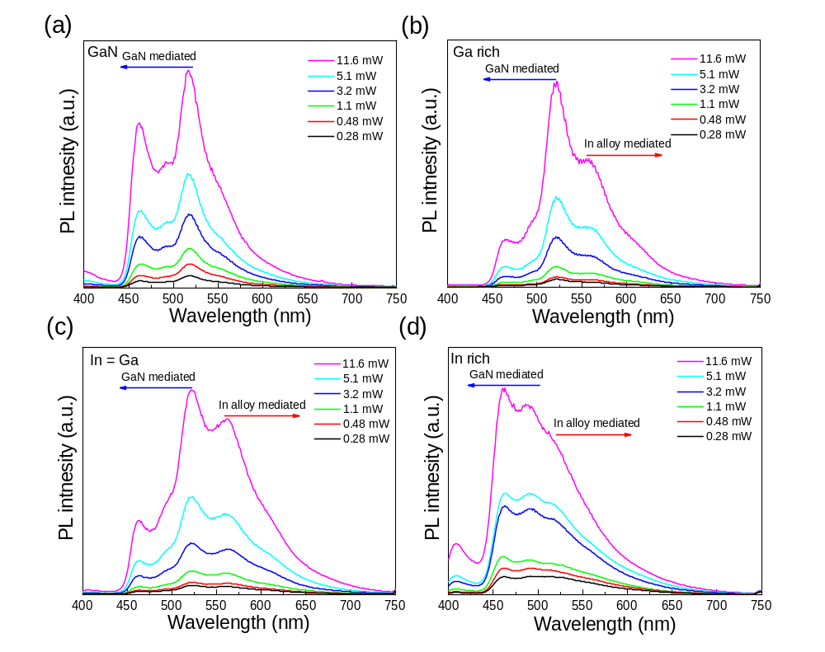
Fig. S6 Power-dependent PL spectra of In_{x}Ga_{1-x}N CQDs (x = 0, 0.25, 0.5 and 0.75). (a) GaN, (b) In_{0.25}Ga_{0.75}N, (c) In_{0.5}Ga_{0.5}N, and (d) In_{0.75}Ga_{0.25}N CQDs. The fs tunable Ti:sapphire laser (Mira900, Coherent) was used as an excitation source at 20K (λ_{exc} = 375 nm).

The time resolved single photon counting (TCSPC) experiments (Fig. S7) were conducted to investigate exciton dynamics of In_{x}Ga_{1-x}N CQDs of different metal fraction. The PL decay profiles were measured at 520 nm (GaN mediated state) and 560 nm (In mediated state). The decay profiles were fitted using bi-exponential fitting, which indicated that PL decay occurred through two relaxation pathways. Table S1 summarized PL lifetimes and fractional intensities of In_{x}Ga_{1-x}N CQDs of different metal fraction. With increasing In fraction, PL lifetime decreased and fraction with short lifetime increased in both wavelength (520 and 560 nm). Fig. S7 (c) showed the change of intensity-weighted average lifetime (τ_{ave}) of In_{x}Ga_{1-x}N CQDs according to In fraction variation. The average lifetime (τ_{ave}) of In_{x}Ga_{1-x}N CQDs at 520 nm decreased and saturated with increasing In fraction. It means that GaN mediated emissive states were strongly affected by defects, which induced by In alloy, even in low In concentration. However, they are not much affected at high In concentration. The intensity-weighted average lifetime (τ_{ave}) of In_{x}Ga_{1-x}N CQDs at 560 nm proportionally decreased with In fraction variation. It indicated that In-mediated emissive states were continually and more affected by defects than Ga-mediated emissive states. From TSCPC results, it is well explained that PL intensity decrease (Fig. 2 (b)) with increasing In fraction resulted from enhancement of non-radiative recombination (quenching) in In_{x}Ga_{1-x}N CQDs.

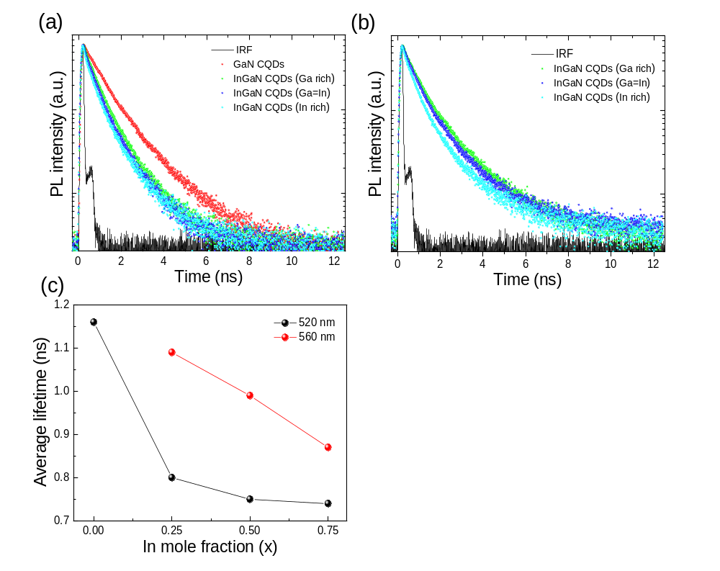
Fig. S7 TCSPC results of In_{x}Ga_{1-x}N CQDs of different metal fraction. (a) PL decay profiles of In_{x}Ga_{1-x}N CQDs, (x = 0, 0.25, 0.5 and 0.75), at 520 nm. (b) PL decay profiles of In_{x}Ga_{1-x}N CQDs, (x = 0.25, 0.5, and 0.75), at 560 nm. (c) Intensity-weighted average lifetime (τ_{ave}) of In_{x}Ga_{1-x}N CQDs according to In fraction variation.

Table 1. PL lifetime of In_{x}Ga_{1-x}N CQDs of different metal fraction in filmª
Metal fraction | Wavelength | τ₁(f₁)/ns | τ₂(f₂)/ns | τ_{ave}/ns^{b} | χ^{2c}
GaN | 520 nm | 0.65 (0.46) | 1.59 (0.54) | 1.16 | 1.194
Ga rich | 520 nm | 0.41 (0.45) | 1.11 (0.55) | 0.80 | 1.202
Ga=In | 520 nm | 0.39 (0.50) | 1.11 (0.50) | 0.75 | 1.267
In rich | 520 nm | 0.32 (0.46) | 1.09 (0.54) | 0.74 | 1.368
Ga rich | 560 nm | 0.50 (0.42) | 1.51 (0.58) | 1.09 | 1.337
Ga=In | 560 nm | 0.47 (0.47) | 1.45 (0.53) | 0.99 | 1.249
In rich | 560 nm | 0.38 (0.50) | 1.35 (0.50) | 0.87 | 1.266
ª Monitored wavelength was 520 and 560 nm. The PL decay curves were fitted by a bi-exponential function to calculate the lifetime of In_{x}Ga_{1-x}N CQDs. ^{b} The intensity-weighted average lifetime (τ_{ave}) was f₁τ₁ + f₂τ₂, where f₁ and f₂ are fractional intensities and τ₁ and τ₂ are lifetimes. ^{c}χ² is the reduced chi-square value.

The XANES results (Fig. S8 (a)) show that white line absorption decreased with increasing In fraction. In addition, atomic position of neighbor inter-atomic distances and bond angle of In components changed with In fraction variation. Fig. S8 (b) shows XAFS results of In_{x}Ga_{1-x}N CQDs (x = 0.25, 0.5, 0.75, and 1). It is observed that high crystalline InN CQDs had fine split In (core) with N or In coordination binding peak. And also, enhancement of peak intensity of coordination binding with peak splitting was observed with increasing In fraction. This phenomenon was related to crystallinity of each In_{x}Ga_{1-x}N CQDs as shown in XRD (Fig. 1(a)).
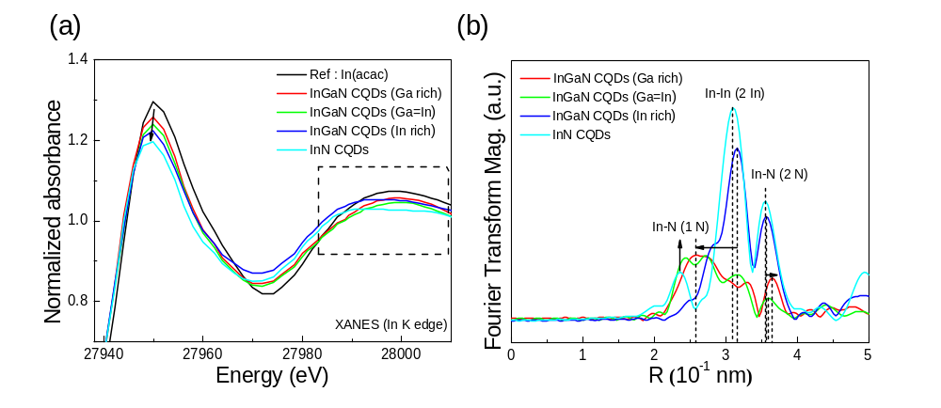
Fig. S8 XAS characterization of In_{x}Ga_{1-x}N CQDs. (a) XANES and (b) XAFS spectra of In_{x}Ga_{1-x}N CQDs (x = 0.25, 0.5, 0.75, and 1).

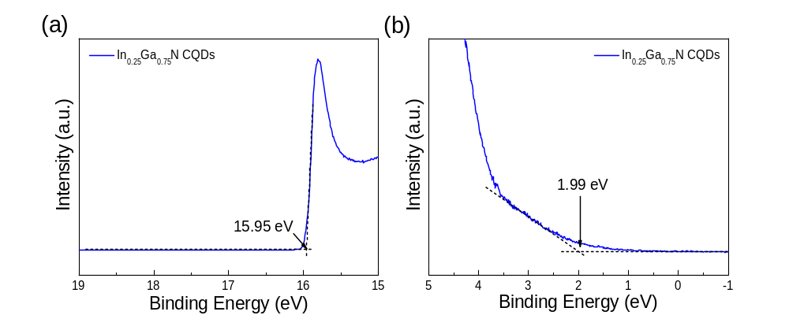
Fig. S9 Ultraviolet photoemission spectroscopy (UPS) spectra of In_{0.25}Ga_{0.75}N CQDs. (a) High binding energy cut-off region and (b) valence band (HOMO) region of In_{0.25}Ga_{0.75}N CQDs at UPS. The valence band (HOMO) level was determined to be 7.24 eV and detail information of valence band (HOMO) energy level calculation was described in experimental method.

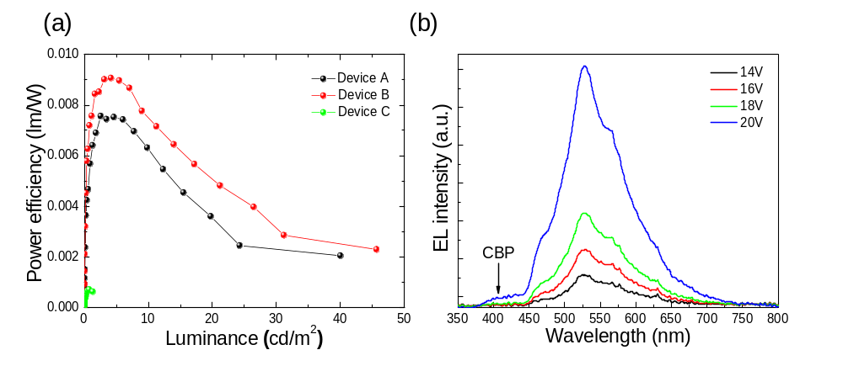
Fig. S10 QD-LEDs characterization. (a) Power efficiency vs. luminance characteristics of QD-LEDs with different HTLs. (b) EL spectra of QD-LED (Device B) according to applied voltage.

Experimental Methods.
Synthesis of ZnO nanoparticles: ZnO nanoparticles were synthesized via a modified Pacholski method.⁴ The 13 mmol of zinc acetate dihydrate and 120 mL of methanol were mixed in a three-neck round-bottom flask and then heated to 60 °C. When the temperature reached at 60 °C, 27 mmol of potassium hydroxide and 60 mL of the methanol solution were injected drop-wise into a zinc acetate solution with strong agitation. The solution was kept at 60 °C for 135 min. When the reaction was terminated, the ZnO nanoparticle solution appeared as a milky solution. After being precipitated by centrifugation at 4000 rpm, the product was washed with methanol to remove the residual reactants. Finally, the ZnO product was precipitated by centrifugation and then re-dispersed in 5 mL of butanol (10 mg/mL).
Relative photoluminescence quantum yield measurements: The relative PL-QY were measured by comparing the fluorescence intensities of In_{x}Ga_{1-x}N CQDs with the intensity of a primary standard dye solution (coumarin 545, PL-QY: 95 % in ethanol, rhodamine 6G, PL-QY: 95 % in ethanol) under different excitation conditions (440 nm and 500 nm). The PL intensity measurements of In_{x}Ga_{1-x}N CQDs were conducted using dilute solutions with absorbance below 0.07 at the excitation wavelength to minimize re-absorption between the CQDs.
The PL QY was calculated using the following equation:⁵
PL QY = $0.95×\frac{I(QD)}{I(dye)}×\frac{A(dye)}{A(QD)}×\frac{{n(hexane)}^{2}}{{n(ethanol)}^{2}}$ (1)
In this equation, I is the integrated area of each PL spectrum, A is the absorbance of a solution at the excitation condition, and n is the refractive index of the solvent used.

References
1 Parala, H. et al. Investigations on InN whiskers grown by chemical vapour deposition. J. Cryst. Growth 231, 68-74 (2001).
2 Bu, Y., Ma, L. & Lin, M. C. Laser‐assisted chemical vapor deposition of InN on Si(100). J. Vac. Sci. Techno. A 11, 2931-2937 (1993).
3 Reshchikov, M. A. & Morkoç, H. Luminescence properties of defects in GaN. J. Appl. Phys. 97, 061301 (2005).
4 Pacholski, C., Kornowski, A. & Weller, H. Self-Assembly of ZnO: From nanodots to nanorods. Angew. Chem. Int. Ed. 41, 1188-1191 (2002).
5 Crosby, G. A. & Demas, J. N. Measurement of photoluminescence quantum yields. Review. J. Phys. Chem. 75, 991-1024 (1971).

