Table S1 Summary of high-quality bacterial 16S rRNA reads obtained per sample after quality filtering across stand types and niches.
Stand types | Niches | 16S rRNA reads after filtering
P | R | 66,622±1,841
P | RS | 60,280±2,592
P | NRS | 59,586±2,742
PC | R | 64,012±2,579
PC | RS | 62,909±2,637
PC | NRS | 58,771±4,254
PS | R | 64,138±3,279
PS | RS | 62,429±1,534
PS | NRS | 61,078±1,617
PZ | R | 62,069±4,089
PZ | RS | 61,186±2,392
PZ | NRS | 59,450±3,700
Average |  | 61,878±3,643

Table S2 Two-way ANOVA results for the effects of niche and stand type on bacterial α diversity indices.
 | Niche |  | Stand type |  | Niche × Stand type
 | F | p | F | p | F | p
Chao1 | 788.696 | 1.9355×10⁻³⁴ | 3.165 | 0.033 | 2.059 | 0.076
Shannon | 271.561 | 6.7536×10⁻²⁷ | 1.621 | 0.197 | 1.769 | 0.126

Table S3 Environmental drivers of bacterial community composition identified by redundancy analysis (RDA), showing vector orientations (RDA1 and RDA2), explained variance (r²), and statistical significance (p values) of individual soil variables.
 | RDA1 | RDA2 | r² | p value
pH | 0.281 | 0.966 | 0.100 | 0.048
SWC | 0.790 | -0.614 | 0.815 | 0.0005
SOM | -0.366 | -0.931 | 0.594 | 0.0005
TP | -0.985 | 0.173 | 0.714 | 0.0005
AP | -0.851 | 0.525 | 0.569 | 0.0005
TK | -0.922 | 0.388 | 0.372 | 0.0005
AK | -0.940 | -0.341 | 0.631 | 0.0005

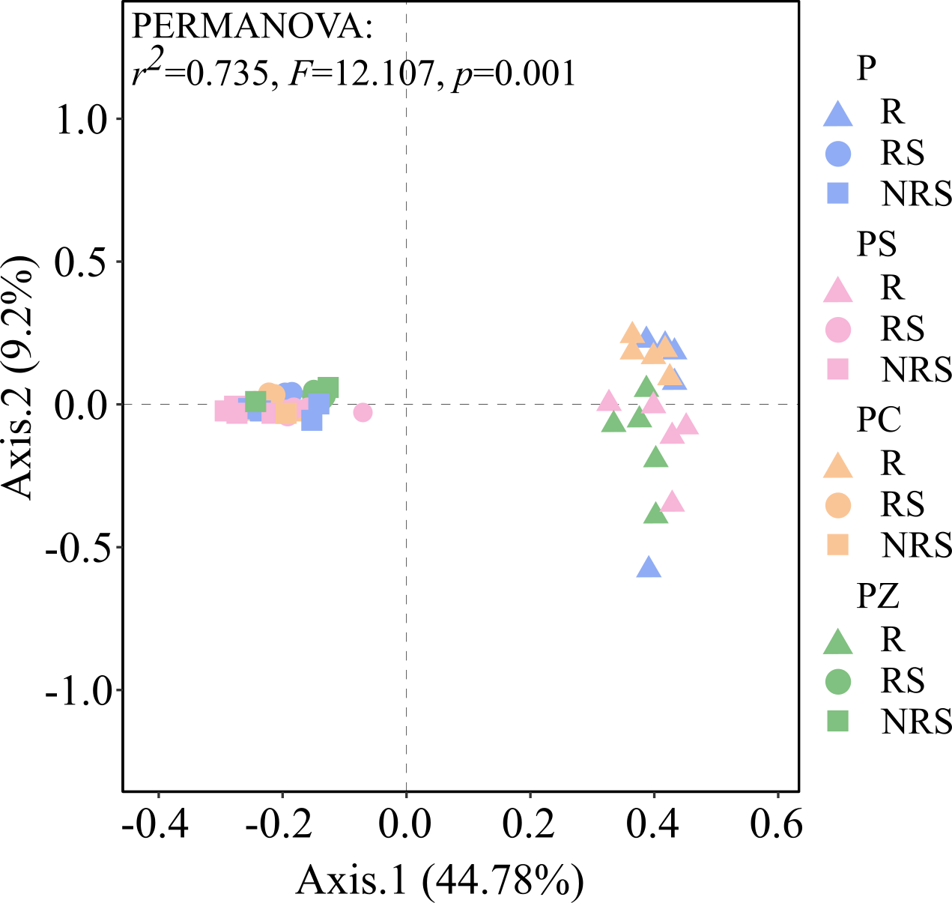
Fig. S1 PCoA ordination (Axis 1: 44.78%; Axis 2: 9.20%) of bacterial communities based on Bray-Curtis dissimilarities. Colors denote stand types (P, PS, PC, PZ), and symbols represent ecological niches (R, RS, NRS).

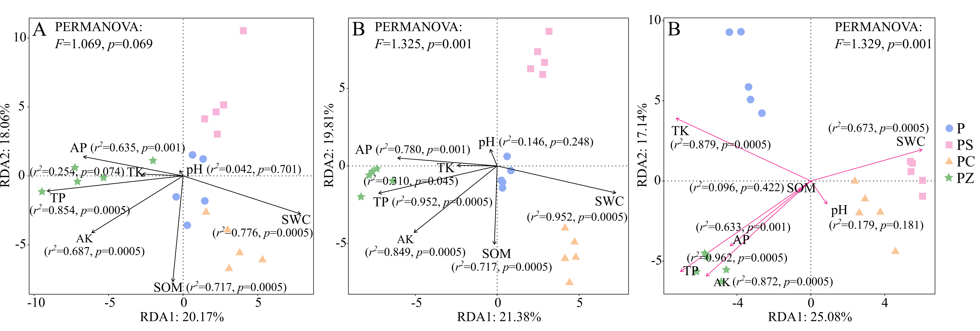
Fig. S2 Redundancy analysis (RDA) showing the relationships between bacterial community composition and environmental variables across niches and stand types. (A) R, (B) RS, and (C) NRS. P, PS, PC, and PZ represent different stand types. Arrows indicate environmental variables, and their lengths reflect the strength of their influence on bacterial community structure.

