Supplementary Material
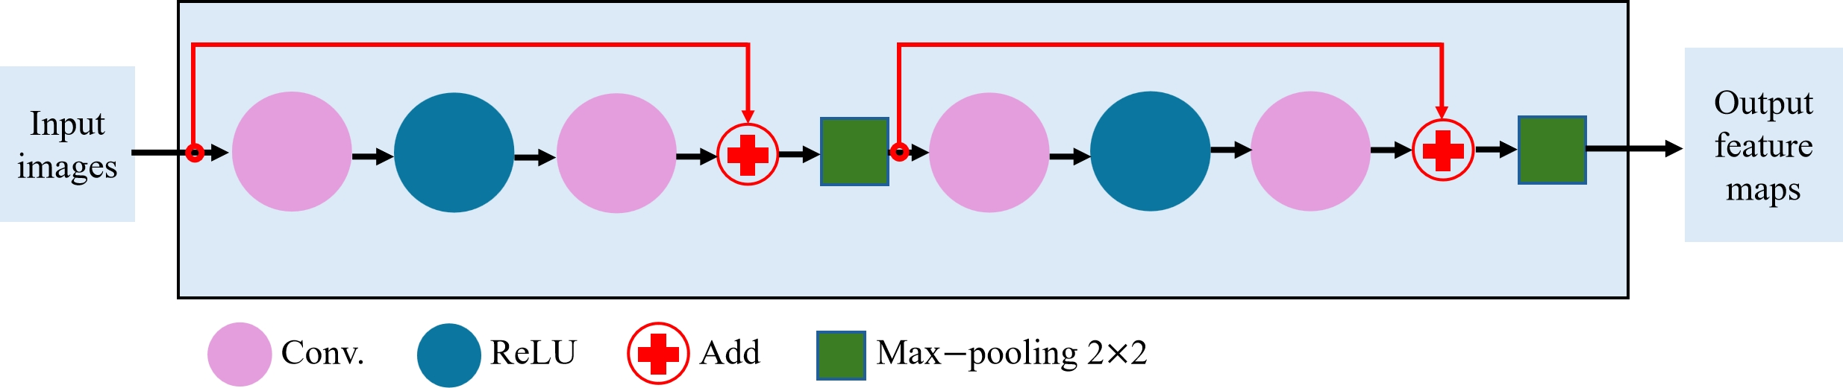
Supplementary Figure S1. Residual block.
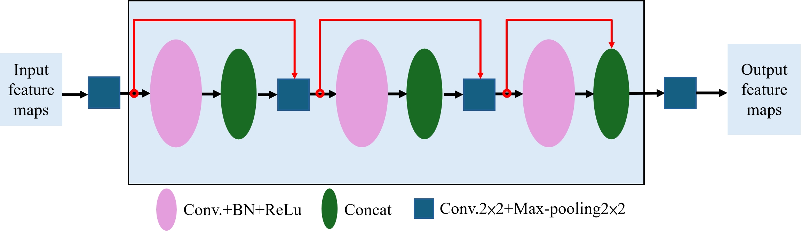
Supplementary Figure S2. Dense block.
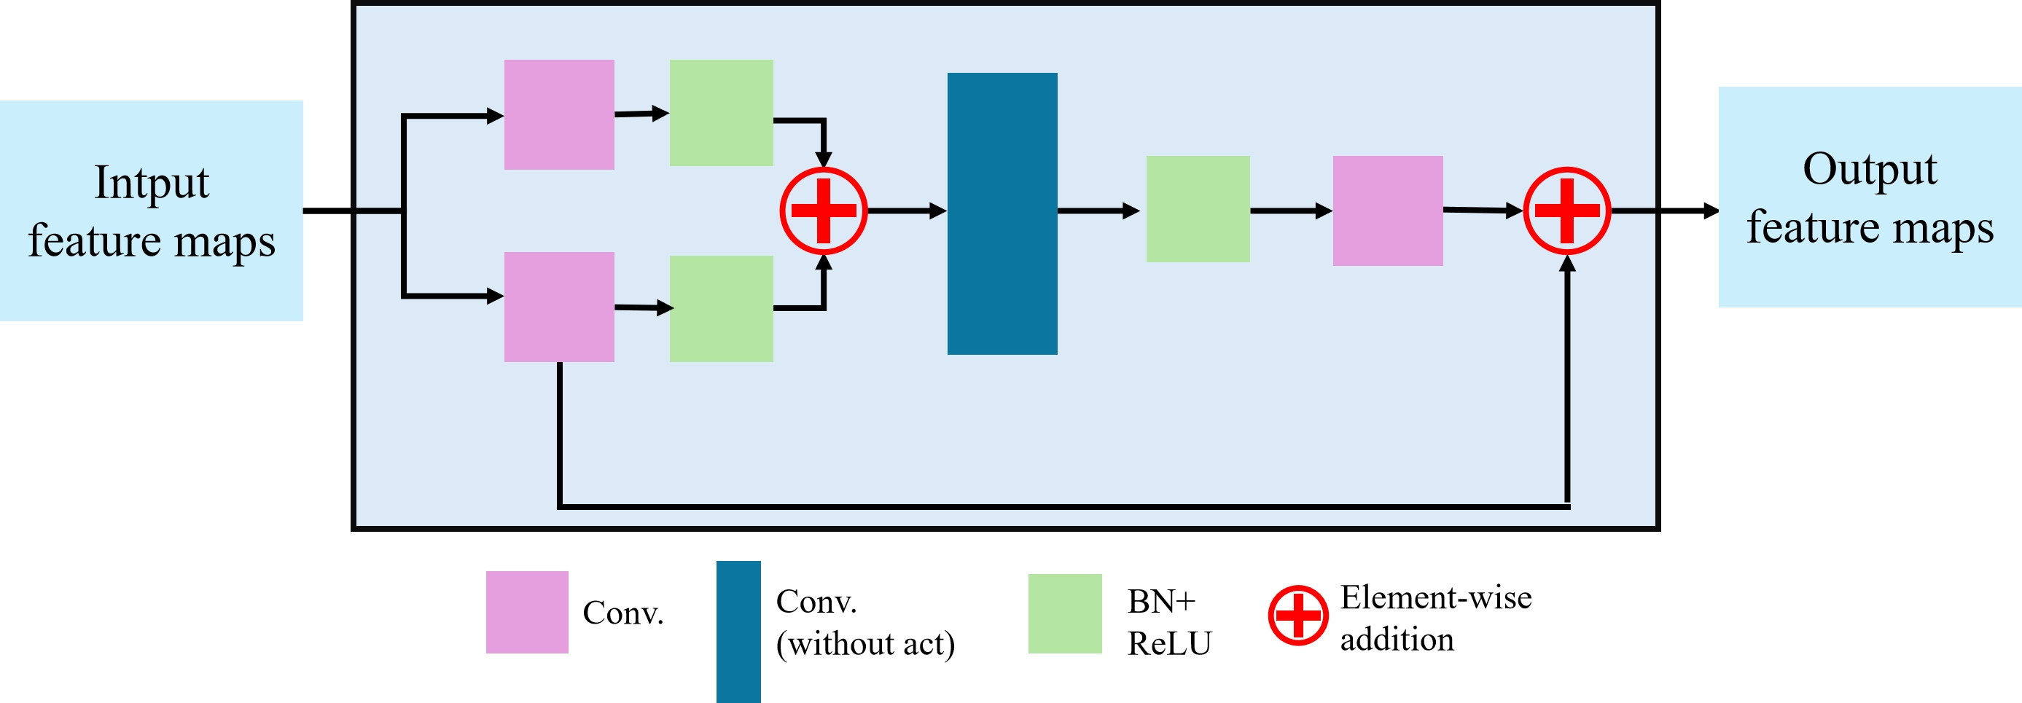
Supplementary Figure S3. Morphology-aware block (MAB).
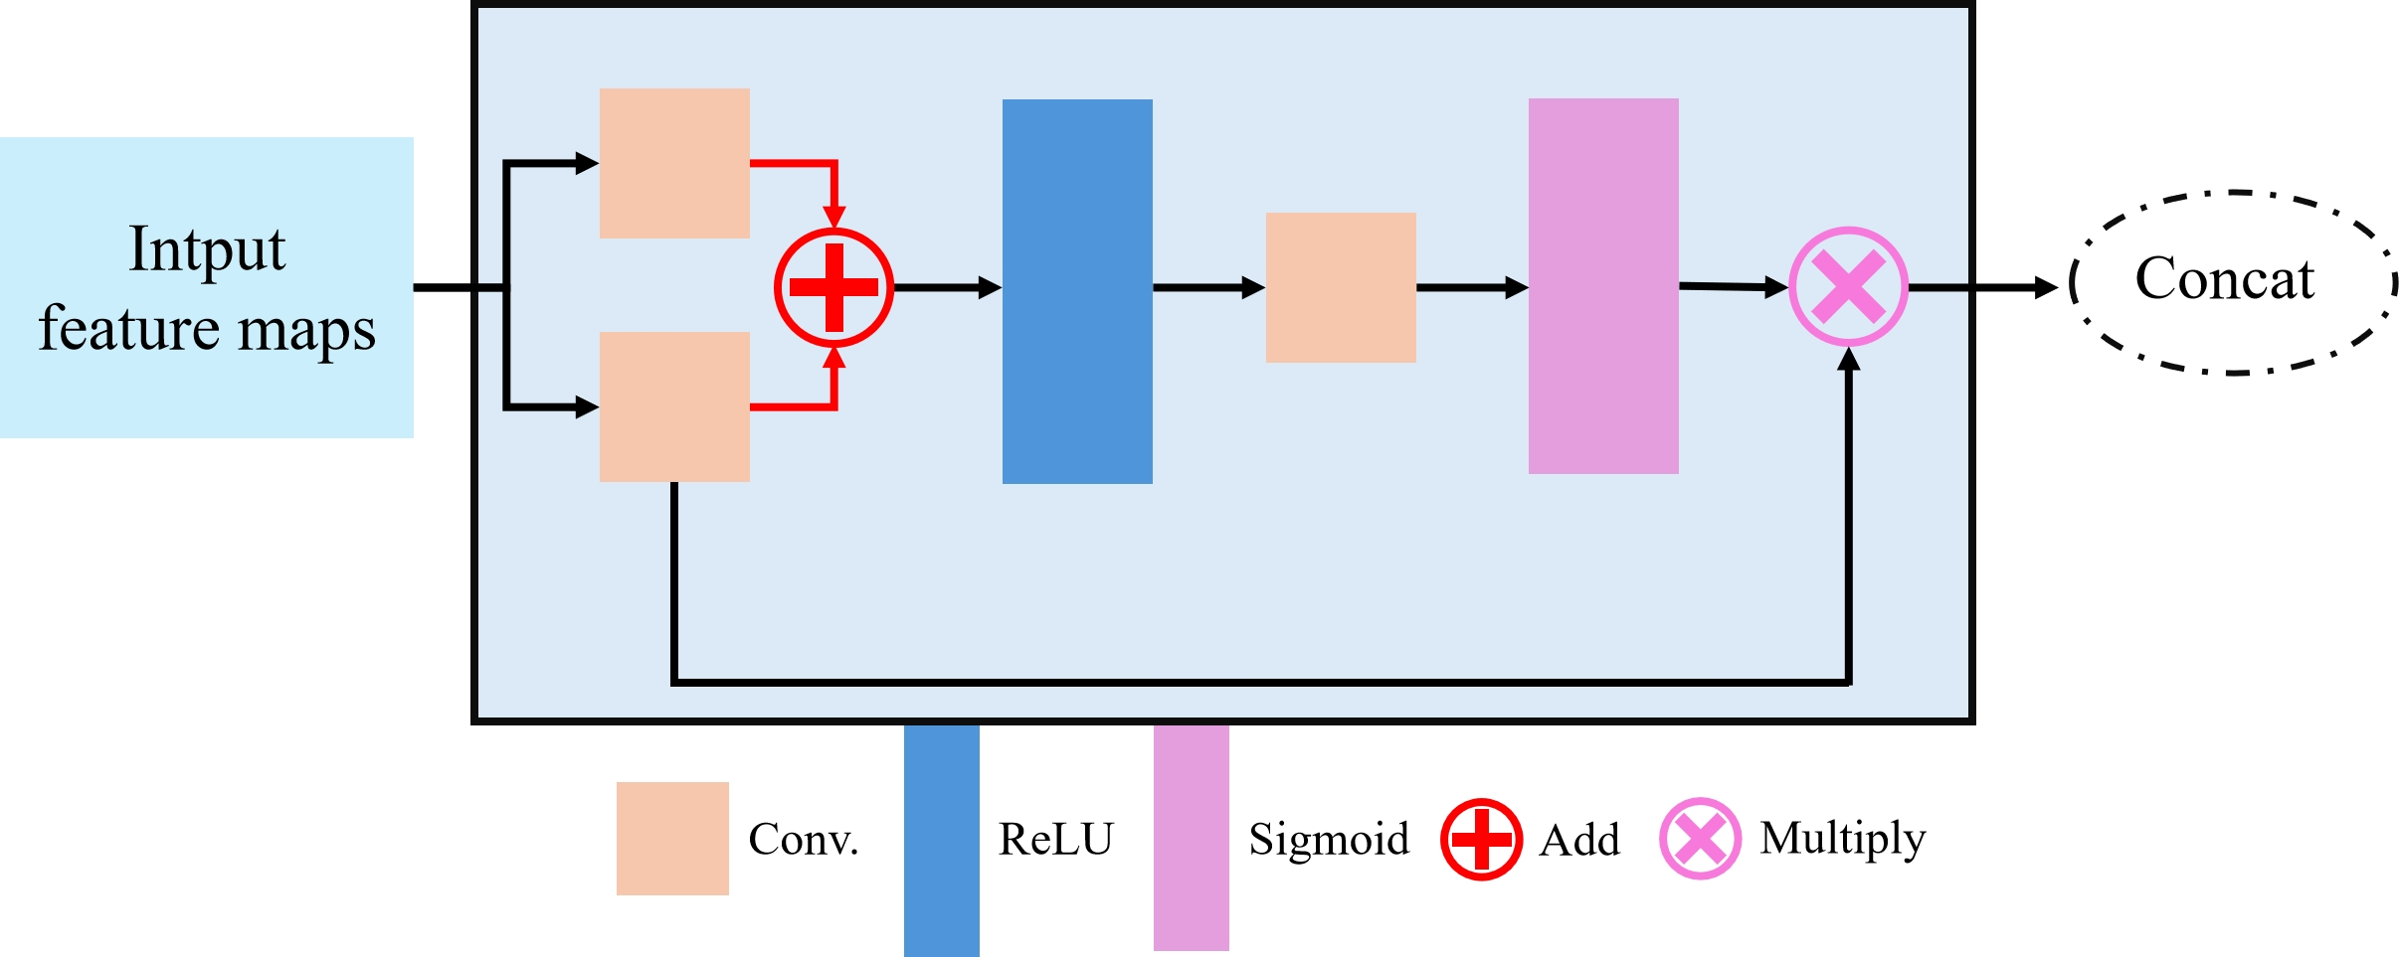
Supplementary Figure S4. Attention gate.

