Supplemental Appendix

Supplemental Methods

Complete eligibility criteria
Inclusion criteria
Inclusion criteria for the study included:
- Males and females aged 18–70 years (inclusive);
- Type 2 diabetes (T2DM) for at least 12 weeks before screening based on the disease diagnostic criteria Guideline for the Prevention and Treatment of Type 2 Diabetes Mellitus in China (2020 Edition)¹. Eligible participants must satisfy one of the following:
- Treatment with diet and exercise only, without any prior use of glucose-lowering agents. No prior use of hypoglycemic agents is defined as meeting any one of the following criteria: (1) no history of any hypoglycemic agent use before screening; (2) continuous use of any hypoglycemic agent(s) for no more than 1 week within the 12 weeks before screening and no use within the 4 weeks before screening; or (3) use of only one oral hypoglycemic agent within the 12 weeks before screening and no use within the 4 weeks before screening.
- Treatment limited to metformin, α-glucosidase inhibitors, or SGLT-2 inhibitors within 12 weeks before screening, either as monotherapy or in a stable dual-agent regimen (≤ 2 drug classes) with consistent types and doses;
- HbA1c ≥ 7.0% and ≤ 11.0% measured at screening by the study site laboratory;
- Fasting plasma glucose (FPG) < 15 mmol/L at screening;
- Body mass index (BMI) ≥ 20 kg/m²;
- Weight stability is defined as < 5% change [(maximum − minimum) / maximum × 100%] over at least 12 weeks prior to screening.

Exclusion criteria
Exclusion criteria included:
- Other forms of diabetes mellitus, such as type 1 diabetes.
- Known severe diabetes-related complications, including proliferative diabetic retinopathy or maculopathy, severe diabetic neuropathy (e.g., urinary retention, incontinence, painful peripheral neuropathy, resting tachycardia, orthostatic hypotension), intermittent claudication, or diabetic foot; or more than two episodes of diabetic ketoacidosis, lactic acidosis, or hyperosmolar hyperglycemic state requiring hospitalization within the 24 weeks prior to screening.
- History of severe hypoglycemia (grade 3) within 12 months before screening; or three or more episodes of documented hypoglycemia (grade 2, venous or peripheral glucose < 3.0 mmol/L) or hypoglycemia-related symptoms within the 3 months prior to screening.
- History of major trauma, serious infection, or surgery likely to impact glycemic control within 6 weeks before screening.
- History of blood transfusion or blood loss/donation ≥ 400 mL within 12 weeks prior to screening; blood loss/donation ≥ 200 mL within 4 weeks prior to screening; or known hemoglobinopathy (e.g., thalassemia, hemolytic anemia, sickle cell disease).
- History of any digestive system disorder or surgery that may compromise safety assessments, including but not limited to:
- Acute or chronic pancreatitis; presence of high-risk factors for pancreatitis at screening (e.g., cholelithiasis or choledocholithiasis < 10 mm in diameter); or history of symptomatic gallbladder or biliary tract disease. Subjects may be enrolled if biliary calculi have been resolved post-treatment or if cholecystectomy was performed without sequelae.
- Gastrointestinal disorders that may affect gastric emptying; severe chronic gastrointestinal diseases (e.g., active ulcer or intestinal tuberculosis within 6 months prior to screening); or chronic use of medications with direct effects on gastrointestinal motility.
- Previous metabolic/bariatric surgery involving resection or reconstruction of the gastrointestinal tract, or prior use of minimally invasive/endoscopic weight-loss devices. Appendectomy, simple herniorrhaphy, or removal of a reversible weight-loss device more than 12 months prior to screening are permitted.
- History of recurrent nausea, vomiting, or irregular gastrointestinal motility due to any cause, such as chronic diarrhea, constipation, inflammatory bowel disease, or irritable bowel syndrome.
- Known personal or family history of medullary thyroid carcinoma or multiple endocrine neoplasia type 2 (MEN2).
- Any suicidal behavior in the past 2 years, or suicidal ideation corresponding to Categories 4 or 5 on the Columbia-Suicide Severity Rating Scale (C-SSRS) within 3 months prior to or during screening.
- History of moderate to severe depression, or a Patient Health Questionnaire-9 (PHQ-9) score ≥ 15 at screening.
- History of malignancy within 5 years prior to screening (except adequately treated basal cell carcinoma or carcinoma in situ).
- History of major cardiovascular or cerebrovascular events within 24 weeks prior to screening, including myocardial infarction, coronary angioplasty or bypass grafting, valvular heart disease or repair, clinically significant unstable arrhythmia, unstable angina, New York Heart Association (NYHA) Class III or IV heart failure, transient ischemic attack, or stroke.
- Known significant electrocardiogram (ECG) abnormalities or findings at screening that pose a safety risk or require intervention, including but not limited to: uncontrolled or medication-requiring arrhythmias (e.g., sustained ventricular tachycardia, second- or third-degree atrioventricular block); QTcF > 450 ms; family history of long QT syndrome or Brugada syndrome; or heart rate < 50 or > 100 beats/minute at screening.
- Systolic blood pressure ≥ 160 mmHg or diastolic blood pressure ≥ 100 mmHg during screening (confirmed by repeat measurement after 10 minutes); or initiation, change, or dose adjustment of antihypertensive therapy within 4 weeks prior to screening.
- Clinically significant laboratory abnormalities during screening, including:
- Positive serology for hepatitis B surface antigen (HBsAg), hepatitis C virus antibody, human immunodeficiency virus (HIV) antibody, or treponema pallidum antibody.
- Haemoglobin < 100 g/L.
- Abnormal thyroid-stimulating hormone (TSH) with concurrent abnormality in triiodothyronine (T3; total or free) or thyroxine (T4; total or free).
- Serum calcitonin > 50 ng/L.
- Serum amylase or lipase > 1.5 × upper limit of normal (ULN) (amylase alone may be used if lipase is unavailable at the site).
- Triglycerides (TG) > 5.7 mmol/L.
- Alanine aminotransferase (ALT) or aspartate aminotransferase (AST) ≥ 2.5 × ULN, or total bilirubin ≥ 1.5 × ULN.
- Estimated glomerular filtration rate (eGFR) < 60 mL/min/1.73 m² (calculated using the CKD-EPI equation based on serum creatinine; see Appendix 5) or urine albumin-to-creatinine ratio (UACR) ≥ 300 mg/g.
- Use of immunosuppressants (e.g., cyclosporine, tacrolimus, mycophenolate) or systemic glucocorticoids (intravenous, oral, intra-articular) within 12 weeks prior to screening.
- Use of any medication or product that may affect body weight stability within 12 weeks prior to screening, including:
- Any approved or investigational weight-loss agents, herbal preparations, supplements, or meal replacements.
- Any glucagon-like peptide-1 receptor agonist (GLP-1RA), GLP-1-based multi-target agonist (e.g., dual GLP-1/GIP, GLP-1/glucagon receptor agonists, or triple agonists), or combination products containing a GLP-1RA.
- Growth hormone, antipsychotics, or antiepileptics (e.g., tricyclic antidepressants, selective serotonin reuptake inhibitors, atypical antipsychotics, valproate, lithium, bupropion).
- Previous surgical or device-based intervention for weight loss, or planned such intervention during the study (acupuncture, liposuction, or abdominoplasty performed >1 year prior to screening is allowed).
- Known allergy to multiple drugs or foods; specific hypersensitivity to paracetamol (applicable to Group B-1 only, if relevant), RAY1225, GLP-1 receptor agonists, or related compounds; history of severe drug reaction (e.g., erythema multiforme, toxic epidermal necrolysis, anaphylaxis, angioedema); or significant atopic disease requiring regular treatment (e.g., asthma, severe allergic rhinitis, severe eczema).
- Conditions contraindicating subcutaneous injections (e.g., local trauma, skin lesions), intolerance to venepuncture, or significant needle or blood phobia.
- History of substance abuse or dependence.
- Average daily alcohol intake > 25 g (men) or > 15 g (women) within 12 weeks prior to screening (equivalent to approximately 580 mL beer, 250 mL wine, or 75 mL spirits for men; 350 mL beer, 150 mL wine, or 45 mL spirits for women).
- Female subjects who are pregnant, breastfeeding, or have a positive pregnancy test.
- Participation in another investigational drug trial within 12 weeks or 5 half-lives (whichever is longer) prior to screening.
- Any other medical or psychiatric condition that, in the investigator’s judgment, could compromise trial completion, data integrity, or subject safety, or otherwise render the subject unsuitable for participation.

Diagnostic Criteria for Type 2 Diabetes Mellitus
Diagnostic Criteria for Diabetes Mellitus
Diagnostic criteria | Venous plasma glucose or HbA1C level
Typical symptoms of diabetes
And random blood glucose | ≥ 11.1 mmol/L
Or fasting blood glucose | ≥ 7.0 mmol/L
Or OGTT 2h blood glucose | ≥ 11.1 mmol/L
Or HbA1C | ≥ 6.5%
If there is no typical symptoms of diabetes, the diagnosis needs to be rechecked another day
Note: OGTT refers to oral glucose tolerance test; HbA1c refers to glycosylated hemoglobin. Typical symptoms of diabetes include polydipsia, polyuria, polyphagia, and unexplained weight loss; random blood glucose refers to blood glucose at any time of the day, regardless of the time of the last meal, and cannot be used to diagnose impaired fasting glucose or impaired glucose tolerance; fasting condition refers to no calorie intake for at least 8 h.

Hypoglycemia definitions
According to the Guideline for the Prevention and Treatment of Type 2 Diabetes Mellitus in China (2020 Edition)¹, the diagnostic criterion for hypoglycemia in non-diabetic individuals is a blood glucose level < 2.8 mmol/L, whereas for diabetic patients receiving pharmacotherapy, hypoglycemia is defined as a blood glucose level < 3.9 mmol/L.
Hypoglycemia Grading:
- Grade 1 Hypoglycemia: Blood glucose < 3.9 mmol/L and ≥ 3.0 mmol/L;
- Grade 2 Hypoglycemia: Blood glucose < 3.0 mmol/L;
- Grade 3 Hypoglycemia: A severe event characterized by altered mental and/or physical status requiring external assistance, with no specific blood glucose threshold.
The clinical manifestations of hypoglycemia are related to both the absolute blood glucose level and the rate of its decline, and may include sympathetic activation symptoms (such as palpitations, anxiety, sweating, dizziness, tremors, and hunger) and neuroglycopenic symptoms (such as altered mental status, cognitive impairment, seizures, and coma).

References
- Chinese Diabetes Society, Chinese Medical Association. Guideline for the Prevention and Treatment of Type 2 Diabetes Mellitus in China (2020 Edition) [J]. Chinese Journal of Diabetes Mellitus, 2021, 13(4): 315-409.

Supplementary Results

Supplementary Table 1. Change from baseline at week 24 (sensitivity analysis)
 | Bilpatide 3mg | Bilpatide 6mg | Bilpatide 9mg | Bilpatide 12mg | Bilpatide 15mg | Placebo
 | (N=41) | (N=39) | (N=40) | (N=41) | (N=8) | (N=62)
Sensitivity analyses 1 (ANCOVA + LOCF)
Change from baseline at week 24 | -1.63 (-1.89,-1.38) | -2.04 (-2.30,-1.77) | -2.06 (-2.32,-1.80) | -2.35 (-2.61,-2.08) | -2.72 (-3.29,-2.14) | -0.26 (-0.46,-0.05)
Difference vs placebo | -1.38 (-1.71,-1.05) | -1.78 (-2.11,-1.45) | -1.80 (-2.13,-1.47) | -2.09 (-2.42,-1.76) | -2.46 (-3.07,-1.85) | -
P-value vs. placebo | <0.0001 | <0.0001 | <0.0001 | <0.0001 | <0.0001 | -
Sensitivity analyses 2 (ANCOVA + MI 1)
Change from baseline at week 24 | -1.65 (-1.91,-1.40) | -2.04 (-2.30,-1.78) | -2.13 (-2.39,-1.87) | -2.34 (-2.60,-2.09) | -2.78 (-3.37,-2.20) | -0.24 (-0.45,-0.03)
Difference vs placebo | -1.42 (-1.74,-1.09) | -1.80 (-2.13,-1.47) | -1.89 (-2.22,-1.57) | -2.10 (-2.43,-1.78) | -2.54 (-3.17,-1.92) | -
P-value vs. placebo | <0.0001 | <0.0001 | <0.0001 | <0.0001 | <0.0001 | -
Sensitivity analyses 3 (ANCOVA + J2R)
Change from baseline at week 24 | -0.25 (-0.46,-0.03) | -2.03 (-2.29,-1.76) | -2.05 (-2.32,-1.78) | -2.34 (-2.61,-2.08) | -2.67 (-3.26,-2.08) | -0.25 (-0.46,-0.03)
Difference vs placebo | -1.39 (-1.73,-1.05) | -1.78 (-2.12,-1.44) | -1.80 (-2.14,-1.46) | -2.10 (-2.43,-1.76) | -2.42 (-3.06,-1.79) | -
P-value vs. placebo | <0.0001 | <0.0001 | <0.0001 | <0.0001 | <0.0001 | -
Sensitivity analyses 4 (ANCOVA + MI )ª
Change from baseline at week 24 | -1.65 (-1.91,-1.39) | -2.05 (-2.31,-1.79) | -2.17 (-2.43,-1.91) | -2.37 (-2.63,-2.11) | -2.81 (-3.38,-2.23) | -0.22 (-0.44,-0.00)
Difference vs placebo | -1.43 (-1.76,-1.09) | -1.83 (-2.17,-1.49) | -1.95 (-2.29,-1.61) | -2.15 (-2.49,-1.82) | -2.58 (-3.20,-1.97) | -
P-value vs. placebo | <0.0001 | <0.0001 | <0.0001 | <0.0001 | <0.0001 | -
Sensitivity analyses 5 (MMRM)^{b}
Change from baseline at week 24 | -1.66 (-1.88,-1.45) | -2.05 (-2.27,-1.83) | -2.17 (-2.39,-1.95) | -2.38 (-2.60,-2.16) | -2.81 (-3.33,-2.29) | -0.23 (-0.41,-0.05)
Difference vs placebo | -1.43 (-1.71,-1.15) | -1.82 (-2.10,-1.54) | -1.94 (-2.22,-1.66) | -2.15 (-2.43,-1.87) | -2.58(-3.13,-2.03) | -
P-value vs. placebo | <.0001 | <.0001 | <.0001 | <.0001 | <.0001 | -
Data are least-squares means (LSMeans) (95% CI), unless otherwise indicated. LSMean (95% CI) for estimated treatment difference versus placebo, predicated from ANCOVA or MMRM analysis. ANCOVA, analysis of covariance; LOCF, last observation carried forward; MI, multiple imputation; J2R, jump-to-reference; MMRM, mixed model for repeated measures. All analyses used FAS. a. Data after intercurrent events were set to missing and analyzed using MI+ANCOVA. b. Data after intercurrent events were set to missing and analyzed using the primary MMRM approach.

Supplementary Table 2. Vitals, ECG findings at week 24
 | Bilpatide 3mg | Bilpatide 6mg | Bilpatide 9mg | Bilpatide 12mg | Bilpatide 15mg | Placebo
 | (N=41) | (N=39) | (N=40) | (N=41) | (N=8) | (N=62)
Systolic blood pressure, mmHg
Baseline | 127.2 (10.98) | 120.5 (11.00) | 122.6 (12.94) | 129.0 (10.87) | 122.0 (9.55) | 121.8 (11.89)
Week 24 | 120.3 (12.54) | 115.6 (10.93) | 117.1 (14.94) | 117.5 (11.62) | 102.5 (7.93) | 121.4 (10.38)
Change from baseline at week 24 | -5.69(-8.80,-2.58) | -6.43(-9.61,-3.24) | -6.24(-9.47,-3.01) | -9.51(-12.66,-6.35) | -22.21(-29.48,-14.93) | -1.32(-3.87,1.23)
p-value vs. placebo | 0.0331 | 0.0136 | 0.0186 | <0.0001 | <0.0001 | -
Diastolic blood pressure, mmHg
Baseline | 84.5 (7.14) | 81.0 (6.25) | 82.1 (7.75) | 85.8 (8.05) | 82.7 (6.77) | 82.2 (7.46)
Week 24 | 82.3 (7.66) | 78.3 (7.35) | 78.0 (8.97) | 79.6 (9.13) | 72.8 (6.78) | 79.7 (8.54)
Change from baseline at week 24 | -1.92(-4.06,0.23) | -3.49(-5.69,-1.30) | -4.27(-6.50,-2.04) | -5.27(-7.44,-3.10) | -11.55(-16.57,-6.53) | -2.80(-4.56,-1.05)
p-value vs. placebo | 0.5298 | 0.6261 | 0.3069 | 0.0811 | 0.0013 | -
Pulse rate, bpm
Baseline | 76.9 (11.64) | 78.5 (10.97) | 77.0 (9.67) | 80.9 (9.56) | 80.0 (9.97) | 79.3 (8.36)
Week 24 | 78.1 (10.63) | 80.1 (8.92) | 82.6 (8.14) | 83.6 (8.86) | 92.4 (9.47) | 79.1 (9.03)
Change from baseline at week 24 | 1.1 (8.60) | 1.2 (9.17) | 5.8 (9.42) | 2.6 (8.19) | 14.0 (10.95) | -0.2 (9.51)
PR interval, msec
Baseline | 163.2 (20.11) | 162.4 (21.30) | 159.5 (20.10) | 156.6 (18.21) | 174.4 (21.45) | 155.4 (19.57)
Week 24 | 164.8 (21.25) | 163.9 (22.40) | 166.0 (25.03) | 159.8 (20.63) | 189.4 (68.65) | 157.2 (16.30)
Change from baseline at week 24 | 2.1 (9.74) | 1.4 (11.54) | 5.1 (13.25) | 3.1 (10.94) | 13.7 (52.74) | 1.8 (13.24)
Data are mean (SD) or least-squares mean (LSMean) (95% CI). LSMean (95% CI) for estimated treatment difference versus placebo, predicated from MMRM analysis, with multiple variables as fixed effects. N, number of patients who were randomized and received at least one dose of study drug. Bpm, beats per minute. Missing data at Week 24. Systolic and diastolic blood pressure data were missing for 8 participants (placebo 4; 3 mg 1; 6 mg 1; 9 mg 4; 12 mg 1; 15 mg 1), and pulse rate, and PR interval data were missing for 14 participants (placebo 4; 3 mg 1; 6 mg 2; 9 mg 4; 12 mg 2; 15 mg 1).

Supplementary Table 3. Change from baseline in lipids profile at week 12 and week 24
 | Bilpatide 3mg | Bilpatide 6mg | Bilpatide 9mg | Bilpatide 12mg | Bilpatide 15mg | Placebo
 | (N=41) | (N=39) | (N=40) | (N=41) | (N=8) | (N=62)
Triglycerides, mmol/L
Week 12 | -0.10(-0.75,0.54) | -0.32(-0.98,0.33) | -0.40(-1.06,0.26) | -0.60(-1.24,0.03) | -0.61(-2.05,0.83) | 0.32(-0.20,0.84)
p-values vs. placebo | 0.3159 | 0.1330 | 0.0946 | 0.0276 | 0.2321 | -
Week 24 | -0.39(-0.90,0.13) | -0.69(-1.22,-0.17) | -0.77(-1.31,-0.24) | -0.88(-1.39,-0.36) | -0.53(-1.74,0.68) | 0.39(-0.03,0.81)
p-values vs. placebo | 0.0221 | 0.0017 | 0.0009 | 0.0002 | 0.1574 | -
Total cholesterol, mmol/L
Week 12 | -0.59(-0.81,-0.37) | -0.76(-0.99,-0.54) | -0.26(-0.49,-0.03) | -0.54(-0.76,-0.32) | -0.46(-0.96,0.04) | -0.24(-0.42,-0.06)
p-values vs. placebo | 0.0171 | 0.0004 | 0.8894 | 0.0394 | 0.4158 | -
Week 24 | -0.36(-0.60,-0.13) | -0.61(-0.84,-0.37) | -0.50(-0.74,-0.26) | -0.71(-0.94,-0.47) | -0.80(-1.34,-0.26) | -0.29(-0.48,-0.10)
p-values vs. placebo | 0.6353 | 0.0427 | 0.1870 | 0.0068 | 0.0834 | -
LDL cholesterol, mmol/L
Week 12 | -0.43(-0.60,-0.26) | -0.58(-0.76,-0.41) | -0.16(-0.34,0.01) | -0.36(-0.53,-0.19) | -0.16(-0.54,0.22) | -0.31(-0.45,-0.17)
p-values vs. placebo | 0.2861 | 0.0157 | 0.1859 | 0.6697 | 0.4497 | -
Week 24 | -0.22(-0.40,-0.04) | -0.44(-0.62,-0.25) | -0.41(-0.59,-0.22) | -0.40(-0.58,-0.21) | -0.49(-0.90,-0.07) | -0.40(-0.55,-0.26)
p-values vs. placebo | 0.1290 | 0.7742 | 0.9703 | 0.9504 | 0.7099 | -
HDL cholesterol, mmol/L
Week 12 | -0.08(-0.13,-0.03) | -0.12(-0.17,-0.07) | 0.03(-0.02,0.07) | -0.11(-0.16,-0.06) | -0.06(-0.17,0.05) | -0.00(-0.04,0.03)
p-values vs. placebo | 0.0157 | 0.0002 | 0.3583 | 0.0005 | 0.3258
Week 24 | -0.02(-0.07,0.04) | -0.02(-0.07,0.04) | 0.06(0.00,0.11) | -0.10(-0.15,-0.05) | -0.04(-0.16,0.08) | 0.04(0.00,0.09)
p-values vs. placebo | 0.0772 | 0.0775 | 0.7477 | <0.0001 | 0.2095 | -
nonHDL cholesterol, mmol/L
Week 12 | -0.52(-0.74,-0.30) | -0.64(-0.87,-0.42) | -0.29(-0.51,-0.06) | -0.44(-0.66,-0.22) | -0.35(-0.85,0.14) | -0.24(-0.42,-0.06)
p-values vs. placebo | -0.28(-0.56,0.00) | -0.41(-0.69,-0.12) | -0.05(-0.34,0.24) | -0.20(-0.48,0.08) | -0.12(-0.64,0.41) | -
Week 24 | -0.36(-0.57,-0.14) | -0.59(-0.81,-0.36) | -0.56(-0.79,-0.33) | -0.61(-0.83,-0.39) | -0.72(-1.23,-0.21) | -0.34(-0.51,-0.16)
p-values vs. placebo | 0.8886 | 0.0854 | 0.1229 | 0.0578 | 0.1640 | -
Free fatty acid, mmol/L
Week 12 | -0.10(-0.20,0.01) | -0.17(-0.28,-0.07) | -0.08(-0.17,0.01) | -0.14(-0.24,-0.04) | -0.20(-0.36,-0.03) | -0.02(-0.10,0.06)
p-values vs. placebo | 0.2620 | 0.0238 | 0.3167 | 0.0545 | 0.0556 | -
Week 24 | -0.17(-0.26,-0.08) | -0.15(-0.24,-0.07) | -0.18(-0.25,-0.10) | -0.18(-0.27,-0.10) | -0.11(-0.26,0.04) | -0.02(-0.08,0.05)
p-values vs. placebo | 0.0058 | 0.0126 | 0.0017 | 0.0023 | 0.2694 | -
Data are mean (SD) or least-squares mean (LSMean) (95% CI). LSMean (95% CI) for estimated treatment difference versus placebo, predicated from MMRM analysis, with multiple variables as fixed effects. N, number of patients who were randomized and received at least one dose of study drug. LDL, low-density lipoprotein. HDL, high-density lipoprotein.

Supplementary Table 4. Change from baseline in ALT, AST, GGT, uric acid, UACR, and eGFR at week 12 and week 24
 | Bilpatide 3mg | Bilpatide 6mg | Bilpatide 9mg | Bilpatide 12mg | Bilpatide 15mg | Placebo
 | (N=41) | (N=39) | (N=40) | (N=41) | (N=8) | (N=62)
ALT, U/L
Week 12 | -6.32(-9.76,-2.88) | -7.23(-10.71,-3.74) | -9.36(-12.93,-5.80) | -10.20(-13.92,-6.48) | -8.85(-16.49,-1.22) | -4.21(-7.05,-1.37)
p-values vs. placebo | 0.3464 | 0.1810 | 0.0249 | 0.0111 | 0.2601 | -
Week 24 | -3.50(-8.91,1.91) | -10.27(-15.77,-4.77) | -12.29(-17.94,-6.64) | -16.03(-21.66,-10.40) | -14.42(-27.52,-1.31) | -1.82(-6.27,2.64)
p-values vs. placebo | 0.6343 | 0.0188 | 0.0043 | 0.0001 | 0.0737 | -
AST, U/L
Week 12 | -3.48(-5.38,-1.59) | -2.81(-4.74,-0.88) | -5.53(-7.51,-3.56) | -5.19(-7.10,-3.27) | -4.16(-8.39,0.07) | -1.95(-3.49,-0.41)
p-values vs. placebo | 0.2139 | 0.4903 | 0.0050 | 0.0095 | 0.3326 | -
Week 24 | -2.91(-5.85,0.02) | -3.62(-6.62,-0.63) | -5.36(-8.43,-2.29) | -6.76(-9.75,-3.77) | -6.74(-14.11,0.62) | -0.87(-3.28,1.53)
p-values vs. placebo | 0.2885 | 0.1586 | 0.0242 | 0.0027 | 0.1362 | -
GGT, U/L
Week 12 | -7.59(-12.24,-2.95) | -7.64(-12.35,-2.92) | -10.86(-15.63,-6.10) | -12.89(-17.52,-8.25) | -8.28(-18.67,2.10) | -1.03(-4.78,2.72)
p-values vs. placebo | 0.0308 | 0.0313 | 0.0015 | 0.0001 | 0.1963 | -
Week 24 | -5.29(-10.78,0.20) | -11.71(-17.30,-6.12) | -14.10(-19.82,-8.38) | -17.30(-22.88,-11.73) | -18.22(-31.80,-4.65) | -0.76(-5.25,3.73)
p-values vs. placebo | 0.2088 | 0.0028 | 0.0003 | <0.0001 | 0.0168 | -
Uric acid, umol/L
Week 12 | 16.37(-3.72,36.46) | 17.40(-2.98,37.77) | -4.87(-25.51,15.78) | 11.09(-8.88,31.07) | 19.30(-25.41,64.01) | 6.47(-9.71,22.66)
p-values vs. placebo | 0.4493 | 0.4077 | 0.3934 | 0.7216 | 0.5953 | -
Week 24 | 4.06(-14.99,23.12) | 2.36(-16.97,21.68) | -29.53(-49.24,-9.81) | -7.99(-27.20,11.21) | -16.63(-62.29,29.03) | 2.73(-12.74,18.21)
p-values vs. placebo | 0.9149 | 0.9760 | 0.0116 | 0.3884 | 0.4290 | -
UACR, mg/g
Week 12 | -15.87(-26.19,-5.55) | -12.64(-23.15,-2.12) | -11.21(-22.41,0.00) | -22.35(-32.75,-11.95) | -15.67(-38.74,7.40) | -3.81(-12.39,4.76)
p-values vs. placebo | 0.0773 | 0.2003 | 0.3013 | 0.0069 | 0.3428 | -
Week 24 | -12.00(-22.82,-1.19) | -11.77(-22.79,-0.75) | -20.22(-32.05,-8.38) | -26.61(-37.65,-15.58) | -19.64(-45.79,6.50) | 1.80(-7.26,10.86)
p-values vs. placebo | 0.0546 | 0.0615 | 0.0038 | 0.0001 | 0.1276 | -
eGFR, mL/min/1.73 m²
Week 12 | -5.12(-7.92,-2.32) | -5.23(-8.09,-2.38) | -2.54(-5.43,0.35) | -5.14(-7.93,-2.34) | -3.42(-9.68,2.84) | -0.49(-2.76,1.78)
p-values vs. placebo | 0.0120 | 0.0110 | 0.2718 | 0.0112 | 0.3858 | -
Week 24 | -3.42(-5.76,-1.07) | -2.61(-5.00,-0.22) | -2.55(-5.00,-0.10) | -5.34(-7.73,-2.95) | -5.76(-11.55,0.02) | 1.20(-0.72,3.12)
p-values vs. placebo | 0.0030 | 0.0150 | 0.0182 | <0.0001 | 0.0252 | -
Data are least-squares mean (LSMean) (95% CI). ALT, alanine aminotransferase. AST, aspartate aminotransferase. GGT, gamma-glutamyl transferase. UACR, urinary albumin-to-creatinine ratio. eGFR, estimated glomerular filtration rate.

Supplementary Table 5. Lipase and amylase values
 | Bilpatide 3mg | Bilpatide 6mg | Bilpatide 9mg | Bilpatide 12mg | Bilpatide 15mg | Placebo
 | (N=41) | (N=40) | (N=40) | (N=41) | (N=8) | (N=63)
Serum lipase, U/L
Baseline | 49.52 (61.48) | 40.07(21.41) | 40.85 (26.06) | 38.10 (25.067) | 24.61 (4.24) | 34.26 (23.91)
Week 12 | 93.29 (176.87) | 62.51 (53.45) | 63.80 (65.43) | 63.10 (65.44) | 32.04 (7.68) | 34.75 (18.27)
Week 24 | 76.41 (80.99) | 64.73 (42.76) | 59.10 (53.15) | 66.23 (62.247) | 29.35 (5.16) | 36.75 (20.03)
Serum amylase, U/L
Baseline | 51.93 (17.18) | 53.04 (15.13) | 51.61 (19.27) | 55.25 (17.09) | 46.75 (11.25) | 47.80 (16.83)
Week 12 | 61.05 (25.26) | 61.77 (29.10) | 67.86 (34.98) | 72.71 (39.75) | 56.25 (4.98) | 48.42 (18.33)
Week 24 | 63.75 (23.25) | 67.27 (26.68) | 62.17 (18.13) | 70.73 (32.39) | 57.00 (11.85) | 50.30 (20.26)
Data are mean (SD). The mean baseline value is defined as the last non-missing observation before the first administration of the investigational drug. Lipase data were missing at week 12 for 24 participants (placebo 7; 3 mg 6; 6 mg 8; 9 mg 3; 12 mg 0; 15 mg 0) and at week 24 for 29 participants (placebo 8; 3 mg 6; 6 mg 8; 9 mg 4; 12 mg 1; 15 mg 2). Amylase data were missing at week 12 for 8 participants (placebo 2; 3 mg 1; 6 mg 2; 9 mg 3; 12 mg 0; 15 mg 0) and at week 24 for 15 participants (placebo 4; 3 mg 1; 6 mg 2; 9 mg 4; 12 mg 2; 15 mg 2).

Supplementary Table 6. Other safety parameters
 | Bilpatide 3mg | Bilpatide 6mg | Bilpatide 9mg | Bilpatide 12mg | Bilpatide 15mg | Placebo
 | (N=41) | (N=39) | (N=40) | (N=41) | (N=8) | (N=62)
Participants with ADA, n (%)
At baseline | 5 (12.2%) | 3 (7.7%) | 5 (12.5%) | 3 (7.3%) | 0 | 4 (6.5%)
Post-treatment | 9 (22.0%) | 6 (15.4%) | 10 (25.0%) | 7 (17.1%) | 0 | 6 (9.7%)
Treatment-emergent | 6 (14.6%) | 4 (10.3%) | 6 (15.0%) | 5 (12.2%) | 0 | 3 (4.8%)
Enhanced | 2 (4.9%) | 1 (2.6%) | 1 (2.5%) | 0 | 0 | 0
Induced | 4 (9.8%) | 3 (7.7%) | 5 (12.5%) | 5 (12.2%) | 0 | 3 (4.8%)
Seroreversion | 1 (2.4%) | 1 (2.6%) | 1 (2.5%) | 0 | 0 | 1 (1.6%)
All percentages are relative to the total number of treatment-emergent ADA evaluable participants in each treatment group. ADA, anti-drug antibodies. Treatment-enhanced ADA, pre-existing antibodies present at baseline with a post-dose ADA titer increase of at least 4-fold compared to baseline. Treatment-induced ADA, no pre-existing ADA at baseline, with at least one positive ADA result after dosing.

Supplementary Figure 1. Study design
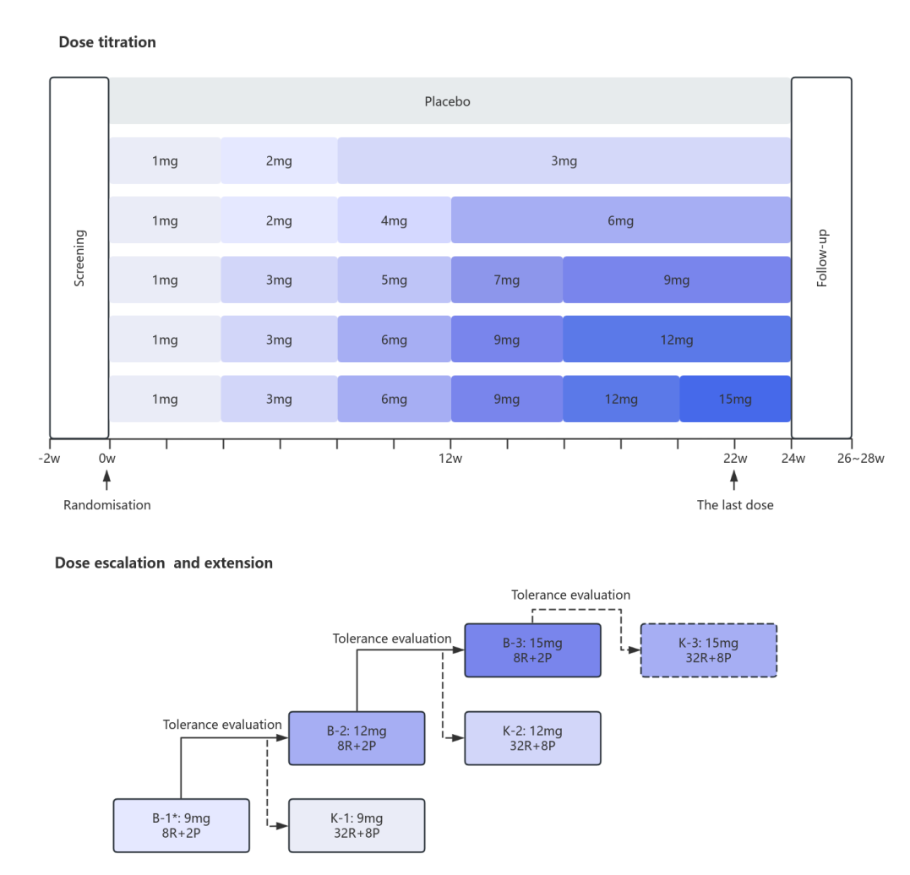
SHINING-1 trial design for Part A: Parallel study (A), Part B: Dose escalation study (B), and Extension study (K). R: RAY1225 (Bilpatide), P: placebo. * Studies on the effects of gastric emptying.

Supplementary Figure 2. Subgroup analysis
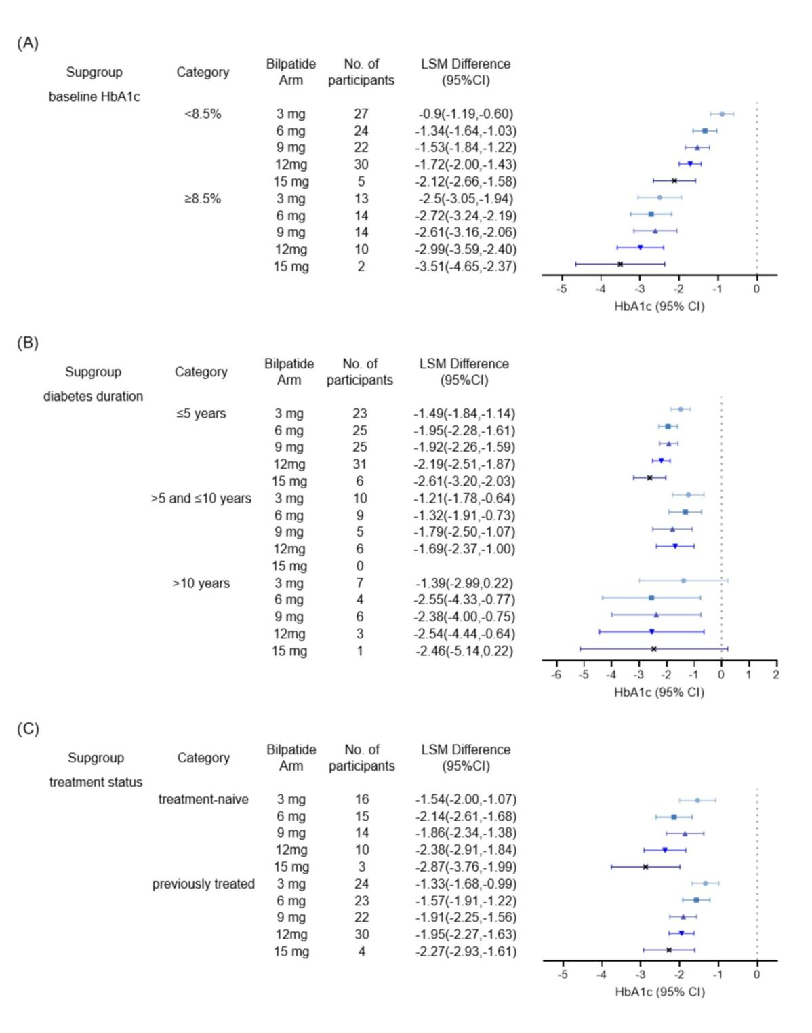
Subgroup analysis of change in HbA1c from baseline to week 24 according to (A) baseline HbA1c, (B) diabetes duration , or (C) prior diabetes treatment status. Data are least-squares mean (LSM). Error bar indicates 95% CI.

Supplementary Figure 3. Prevalence and severity of (A) diarrhoea, (B) nausea, (C) abdominal distension, and (D) vomiting
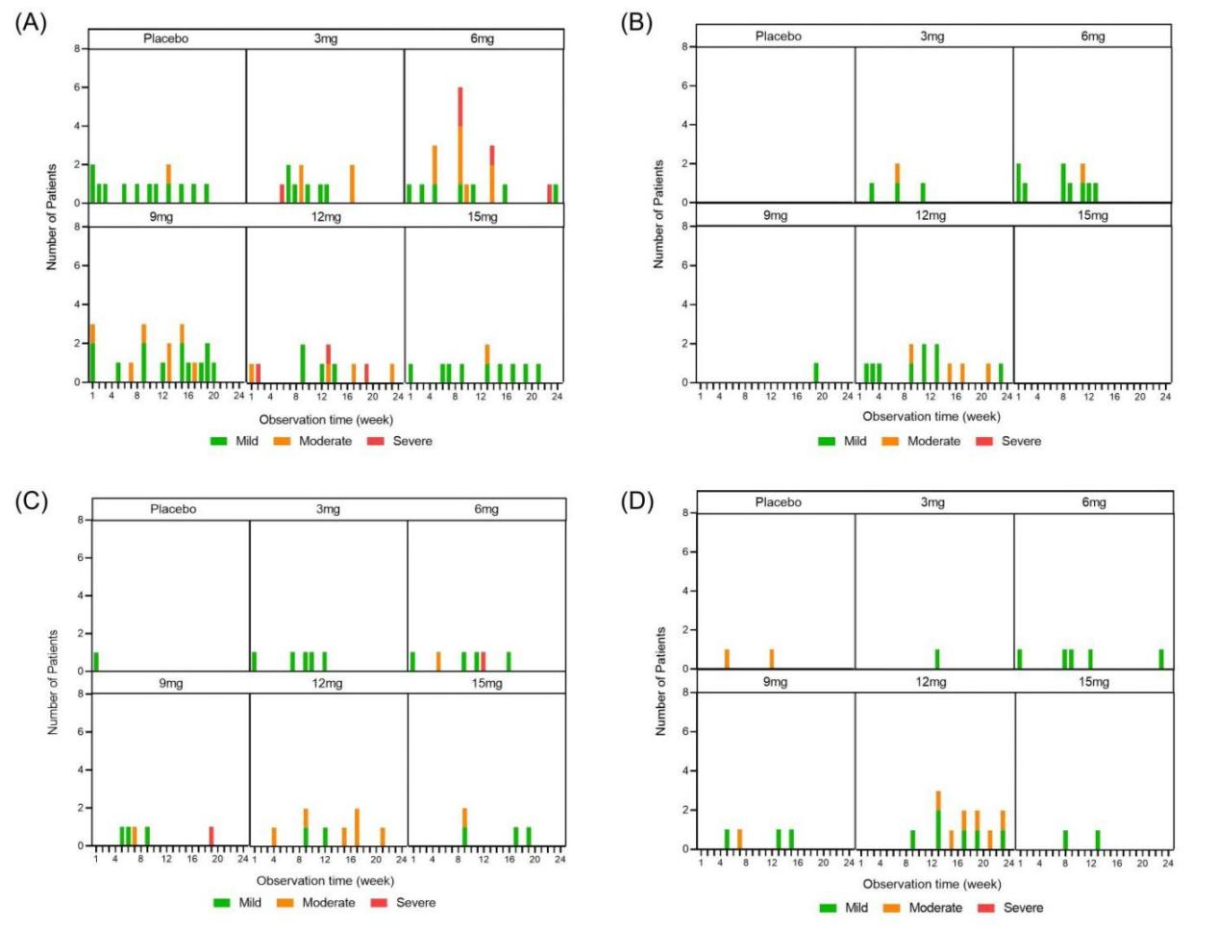
Severity is indicated by color: green (mild); orange (moderate); red (severe).

