Supplementary Information
Additional file 1
Table S1: Diversity and abundance of mosquito collection by location (indoor/outdoor)
District | Indoor |  |  |  |  |  | Outdoor
District | An. gambiae s.l. | An. funestus group | An. pretoriensis | An. maculipalpis | Culicine | Total | An. gambiae s.l. | An. funestus group | An. pretoriensis | An. maculipalpis | Culicine | Total
Masvingo | 5 | 3 | 5 | 0 | 2 | 15 | 1 | 4 | 1 | 0 | 13 | 19
Chegutu | 2 | 0 | 0 | 0 | 43 | 45 | 0 | 0 | 0 | 0 | 31 | 31
Gokwe South | 6 | 0 | 2 | 0 | 17 | 25 | 16 | 0 | 0 | 1 | 29 | 46
Total | 13 | 3 | 7 | 0 | 62 | 85 | 17 | 4 | 1 | 1 | 73 | 96

Additional file 2
Table S2: Diversity and abundance of indoor mosquitoes by time of collection
District | Mosquito species | Indoor collection time (hours) |  |  |  |  |  |  |  |  |  |  |  | Total
District | Mosquito species | 18:00-  19:00 | 19:00-  20:00 | 20:00-  21:00 | 21:00-  22:00 | 22:00-  23:00 | 23:00-  00:00 | 00:00-  01:00 | 01:00-  02:00 | 02:00-  03:00 | 03:00-  04:00 | 04:00-  05:00 | 05:00-  06:00 | Total
Masvingo | An. gambiae s.l. | 0 | 1 | 1 | 1 | 2 | 0 | 0 | 0 | 0 | 0 | 0 | 0 | 5
 | An. funestus group | 0 | 0 | 1 | 1 | 0 | 0 | 0 | 0 | 0 | 1 | 0 | 0 | 3
 | An. pretoriensis | 0 | 0 | 1 | 0 | 0 | 0 | 0 | 1 | 0 | 2 | 0 | 1 | 5
 | An. maculipalpis | 0 | 0 | 0 | 0 | 0 | 0 | 0 | 0 | 0 | 0 | 0 | 0 | 0
 | Culicine | 0 | 0 | 0 | 0 | 1 | 0 | 0 | 0 | 0 | 1 | 0 | 0 | 2
Total |  | 0 | 1 | 3 | 2 | 3 | 0 | 0 | 1 | 0 | 4 | 0 | 1 | 15
Chegutu | An. gambiae s.l. | 0 | 0 | 0 | 0 | 0 | 2 | 0 | 0 | 0 | 0 | 0 | 0 | 2
 | An. funestus group | 0 | 0 | 0 | 0 | 0 | 0 | 0 | 0 | 0 | 0 | 0 | 0 | 0
 | An. pretoriensis | 0 | 0 | 0 | 0 | 0 | 0 | 0 | 0 | 0 | 0 | 0 | 0 | 0
 | An. maculipalpis | 0 | 0 | 0 | 0 | 0 | 0 | 0 | 0 | 0 | 0 | 0 | 0 | 0
 | Culicine | 3 | 1 | 2 | 3 | 6 | 3 | 12 | 6 | 2 | 2 | 3 | 0 | 43
Total |  | 3 | 1 | 2 | 3 | 6 | 5 | 12 | 6 | 2 | 2 | 3 | 0 | 45
Gokwe South | An. gambiae s.l. | 0 | 2 | 0 | 3 | 0 | 0 | 0 | 0 | 0 | 1 | 0 | 0 | 6
 | An. funestus group | 0 | 0 | 0 | 0 | 0 | 0 | 0 | 0 | 0 | 0 | 0 | 0 | 0
 | An. pretoriensis | 0 | 1 | 0 | 0 | 0 | 0 | 0 | 0 | 0 | 1 | 0 | 0 | 2
 | An. maculipalpis | 0 | 0 | 0 | 0 | 0 | 0 | 0 | 0 | 0 | 0 | 0 | 0 | 0
 | Culicine | 0 | 0 | 2 | 3 | 1 | 2 | 0 | 1 | 0 | 5 | 3 | 0 | 17
Total |  | 0 | 3 | 2 | 6 | 1 | 2 | 0 | 1 | 0 | 7 | 3 | 0 | 25
Grand total |  | 3 | 5 | 7 | 11 | 10 | 7 | 12 | 8 | 2 | 13 | 6 | 1 | 85

Additional file 3
Table S3: Diversity and abundance of outdoor mosquitoes by time of collection
District | Mosquito species | Outdoor collection time (hours) |  |  |  |  |  |  |  |  |  |  |  | Total
District | Mosquito species | 18:00-  19:00 | 19:00-  20:00 | 20:00-  21:00 | 21:00-  22:00 | 22:00-  23:00 | 23:00-  00:00 | 00:00-  01:00 | 01:00-  02:00 | 02:00-  03:00 | 03:00-  04:00 | 04:00-  05:00 | 05:00-  06:00 | Total
Masvingo | An. gambiae s.l. | 0 | 0 | 0 | 0 | 0 | 1 | 0 | 0 | 0 | 0 | 0 | 0 | 1
 | An. funestus group | 0 | 0 | 1 | 0 | 0 | 0 | 0 | 0 | 0 | 2 | 1 | 0 | 4
 | An. pretoriensis | 0 | 0 | 1 | 0 | 0 | 0 | 0 | 0 | 0 | 0 | 0 | 0 | 1
 | An. maculipalpis | 0 | 0 | 0 | 0 | 0 | 0 | 0 | 0 | 0 | 0 | 0 | 0 | 0
 | Culicine | 0 | 1 | 2 | 1 | 5 | 1 | 0 | 0 | 0 | 2 | 1 | 0 | 13
Total |  | 0 | 1 | 4 | 1 | 5 | 2 | 0 | 0 | 0 | 4 | 2 | 0 | 19
Chegutu | An. gambiae s.l. | 0 | 0 | 0 | 0 | 0 | 0 | 0 | 0 | 0 | 0 | 0 | 0 | 0
 | An. funestus group | 0 | 0 | 0 | 0 | 0 | 0 | 0 | 0 | 0 | 0 | 0 | 0 | 0
 | An. pretoriensis | 0 | 0 | 0 | 0 | 0 | 0 | 0 | 0 | 0 | 0 | 0 | 0 | 0
 | An. maculipalpis | 0 | 0 | 0 | 0 | 0 | 0 | 0 | 0 | 0 | 0 | 0 | 0 | 0
 | Culicine | 1 | 4 | 0 | 1 | 0 | 2 | 1 | 2 | 8 | 4 | 8 | 0 | 31
Total |  | 1 | 4 | 0 | 1 | 0 | 2 | 1 | 2 | 8 | 4 | 8 | 0 | 31
Gokwe South | An. gambiae s.l. | 0 | 1 | 4 | 2 | 1 | 0 | 0 | 0 | 2 | 1 | 5 | 0 | 16
 | An. funestus group | 0 | 0 | 0 | 0 | 0 | 0 | 0 | 0 | 0 | 0 | 0 | 0 | 0
 | An. pretoriensis | 0 | 0 | 0 | 0 | 0 | 0 | 0 | 0 | 0 | 0 | 0 | 0 | 0
 | An. maculipalpis | 0 | 0 | 0 | 0 | 1 | 0 | 0 | 0 | 0 | 0 | 0 | 0 | 1
 | Culicine | 0 | 2 | 4 | 2 | 6 | 1 | 1 | 0 | 0 | 9 | 4 | 0 | 29
Total |  | 0 | 3 | 8 | 4 | 8 | 1 | 1 | 0 | 2 | 10 | 9 | 0 | 46
Grand total |  | 1 | 8 | 12 | 6 | 13 | 5 | 2 | 2 | 10 | 18 | 19 | 0 | 96

Additional file 4
Figure S1: Temperature and humidity fluctuations in the study districts, 2016–2020
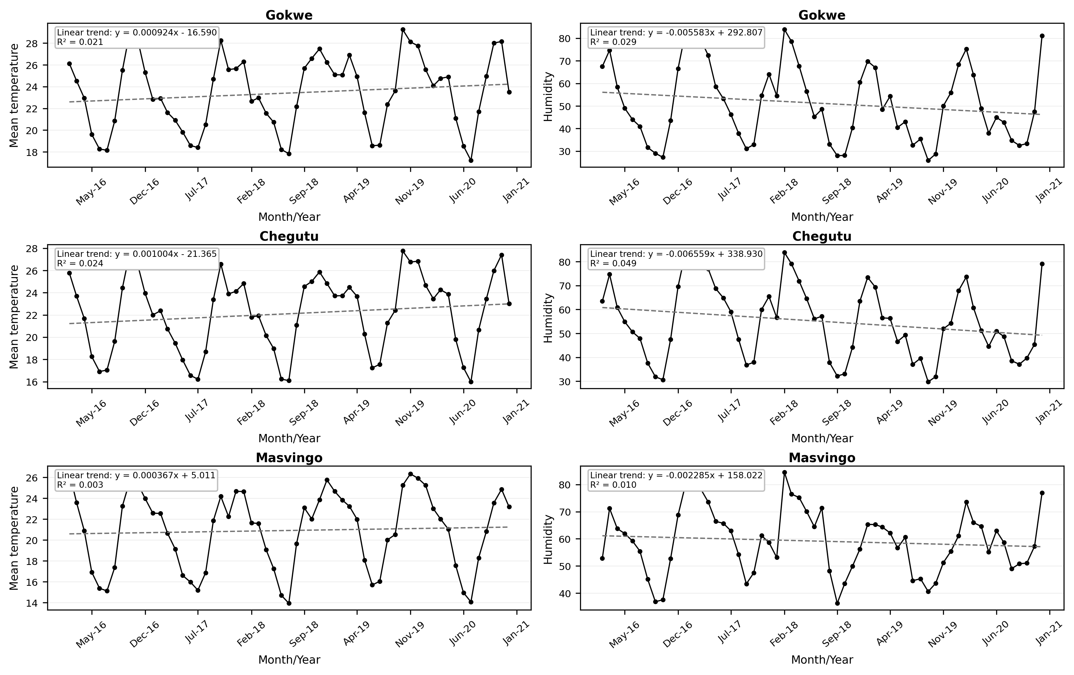

Additional file 5
Figure S2: Precipitation fluctuations in the study districts, 2016–2020
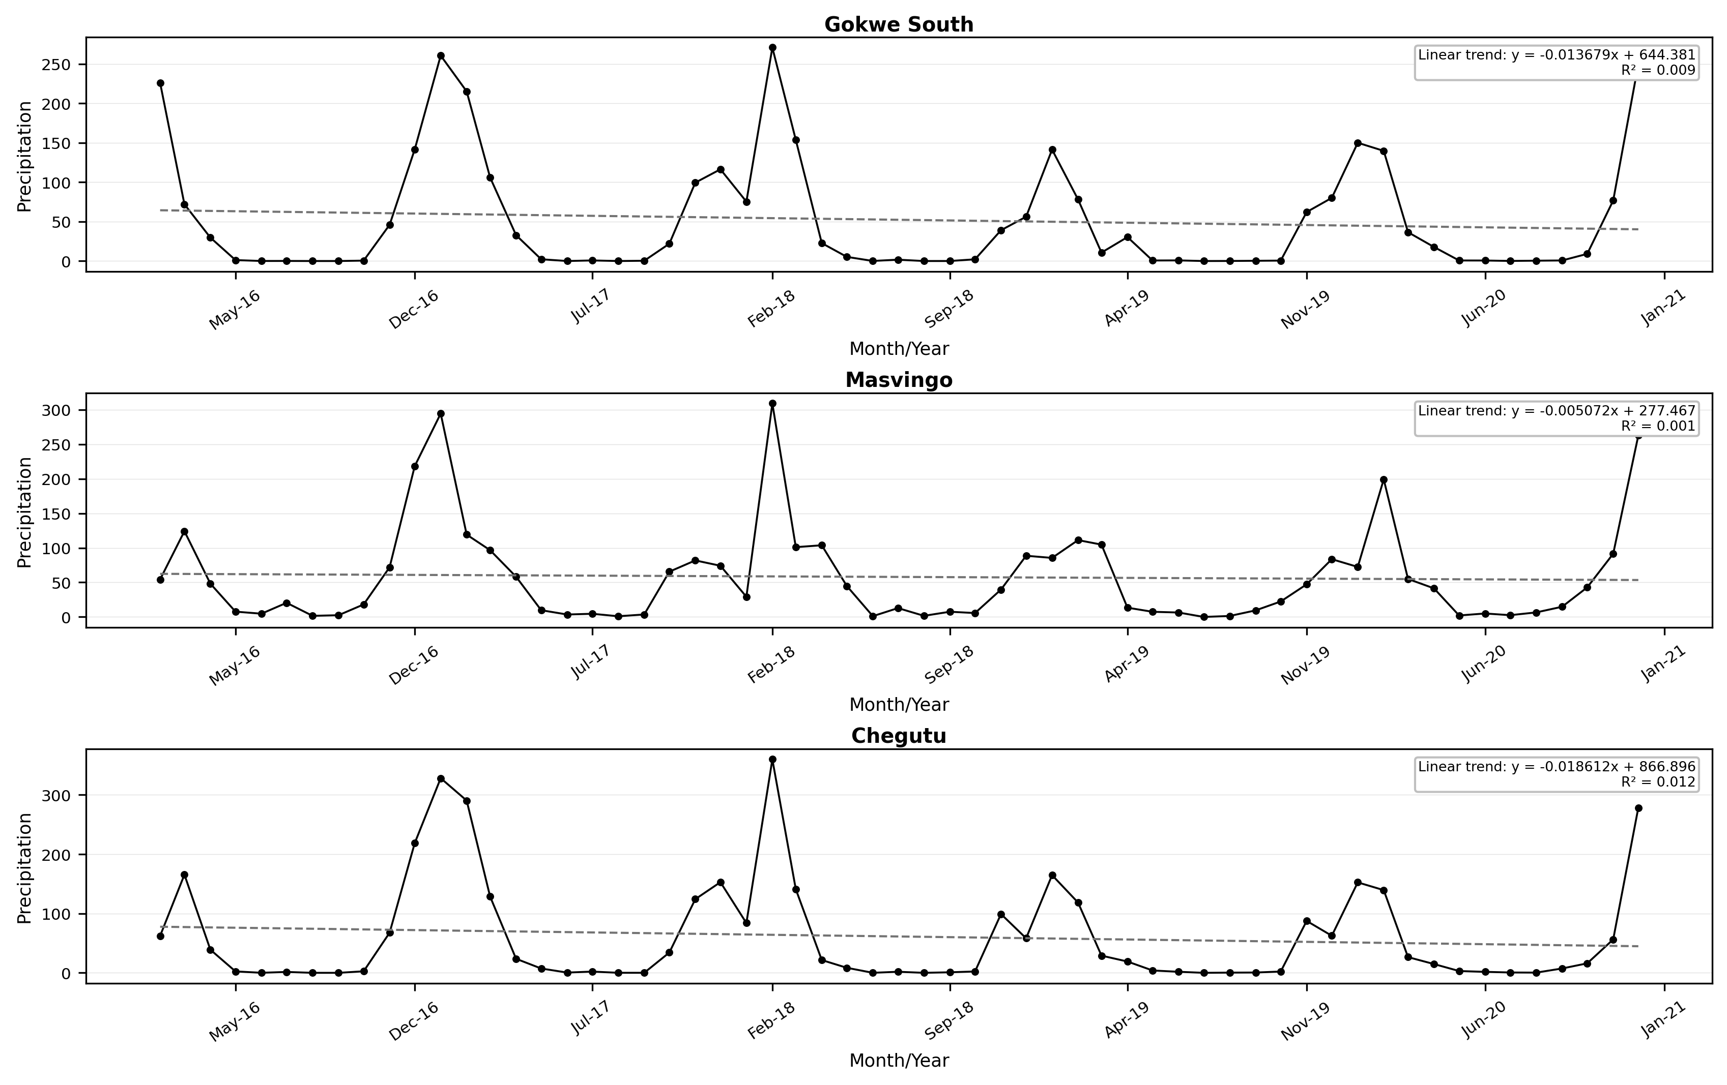

Additional file 6
Table S4: Mann–Kendall trend test results for precipitation, temperature and humidity
Variable | District | Sen slope | Kendall tau | p-value | α | Test interpretation
Rainfall | Gokwe South | 0.034 | 0.043 | 0.823 | 0.05 | Accept Ho
Rainfall | Masvingo | 0.27 | -0.028 | 0.94 | 0.05 | Accept Ho
Rainfall | Chegutu | 0.27 | -0.111 | 0.492 | 0.05 | Accept Ho
Temperature | Gokwe South | 0.431 | 0.278 | 0.176 | 0.05 | Accept Ho
Temperature | Masvingo | 0.298 | 0.222 | 0.321 | 0.05 | Accept Ho
Temperature | Chegutu | 0.561 | 0.25 | 0.315 | 0.05 | Accept Ho
Humidity | Gokwe South | -1.406 | -0.238 | 0.351 | 0.05 | Accept Ho
Humidity | Masvingo | 0.049 | -0.111 | 0.492 | 0.05 | Accept Ho
Humidity | Chegutu | -3.029 | -0.222 | 0.406 | 0.05 | Accept Ho

