Supplementary Materials for
Loading path controls the seismic potential of strongly cemented healing faults

Changliang Wu^{a, †}, Yiwen Ju^{b, †}, Ali Raza^{c}, Yanjun Luª, Yu Qiª, Jianchao Cai^{e, *}, Hongjian Zhu^{a, *}
ªSchool of Vehicle and Energy, Yanshan University, Qinhuangdao, 066000, China
^{b}State Key Laboratory of Earth System Numerical Modeling and Application, College of Earth and Planetary Sciences, University of Chinese Academy of Sciences, Beijing 101408, China
^{c}Department of Earth and Atmospheric Sciences, University of Houston, Houston, TX, 77204, USA
^{d}State Key Laboratory of Petroleum Resources and Engineering, China University of Petroleum, Beijing 102249, China
* Corresponding author.
E-mail addresses: caijc@cup.edu.cn (Jianchao Cai), zhj8641@163.com (Hongjian Zhu).
† Changliang Wu and Yiwen Ju contributed equally to this paper.

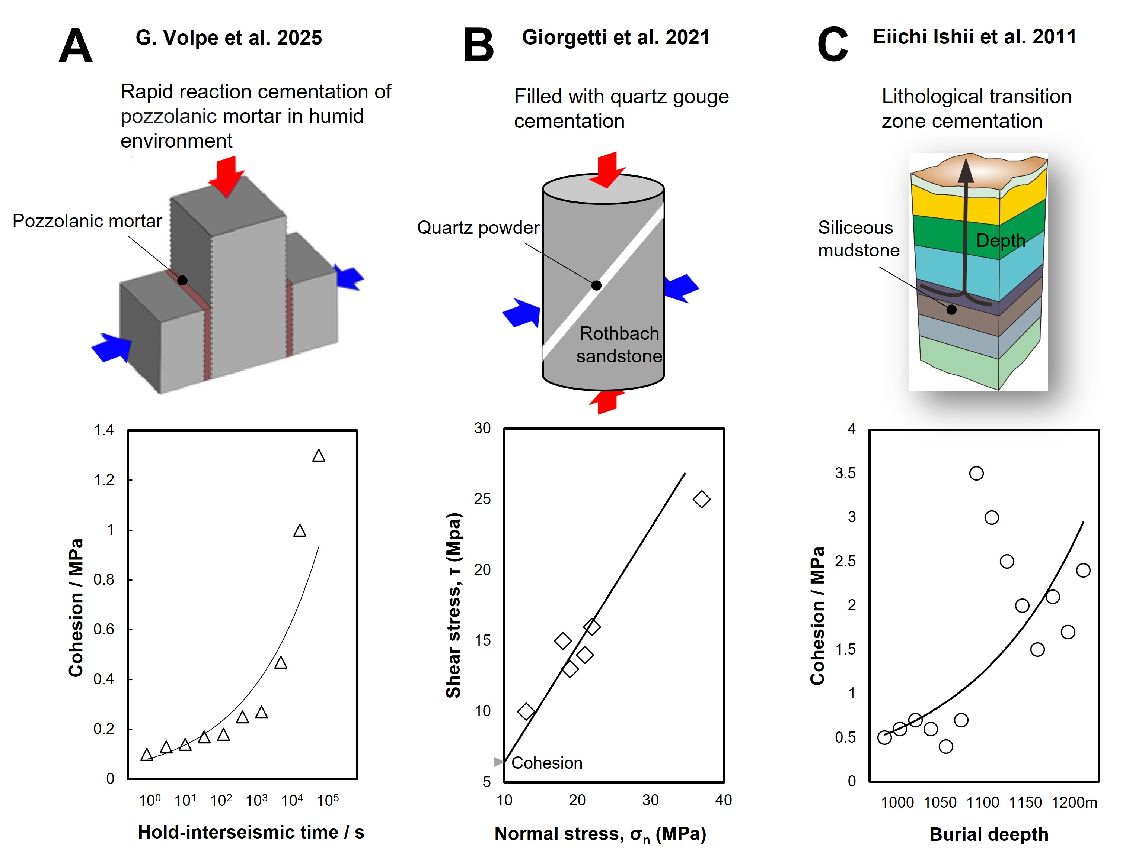
Fig. S1. Current research primarily focuses on the frictional reactivation of uncemented or weakly cemented faults. A: Fault gouge filled with rapidly hydrated, cemented volcanic ash. B: Fault gouge filled with quartz powder. C: A natural lithological transition zone in mudstone.

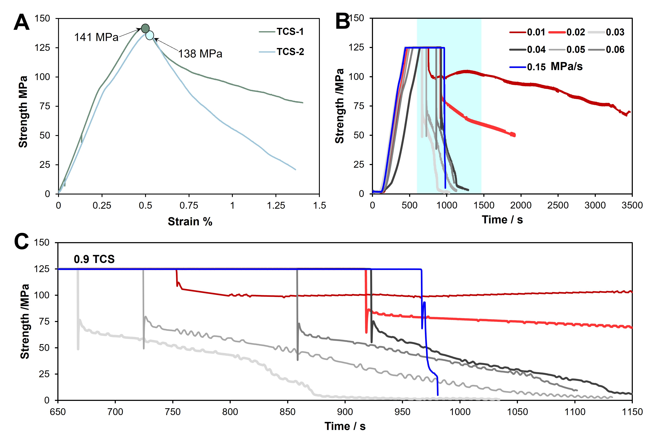
Fig. S2: Stress-time curves of strongly cemented fault reactivation under different unloading rates along the LWP. At low unloading rates (≤0.02 MPa/s), the fault deforms via stable creep with gradual energy release, leaving the sample intact. Intermediate rates (0.03–0.06 MPa/s) trigger instability within 200–300 s, accompanied by intermittent stick-slip oscillations in slip rate. At the highest rate (0.15 MPa/s), the fault collapses instantaneously.

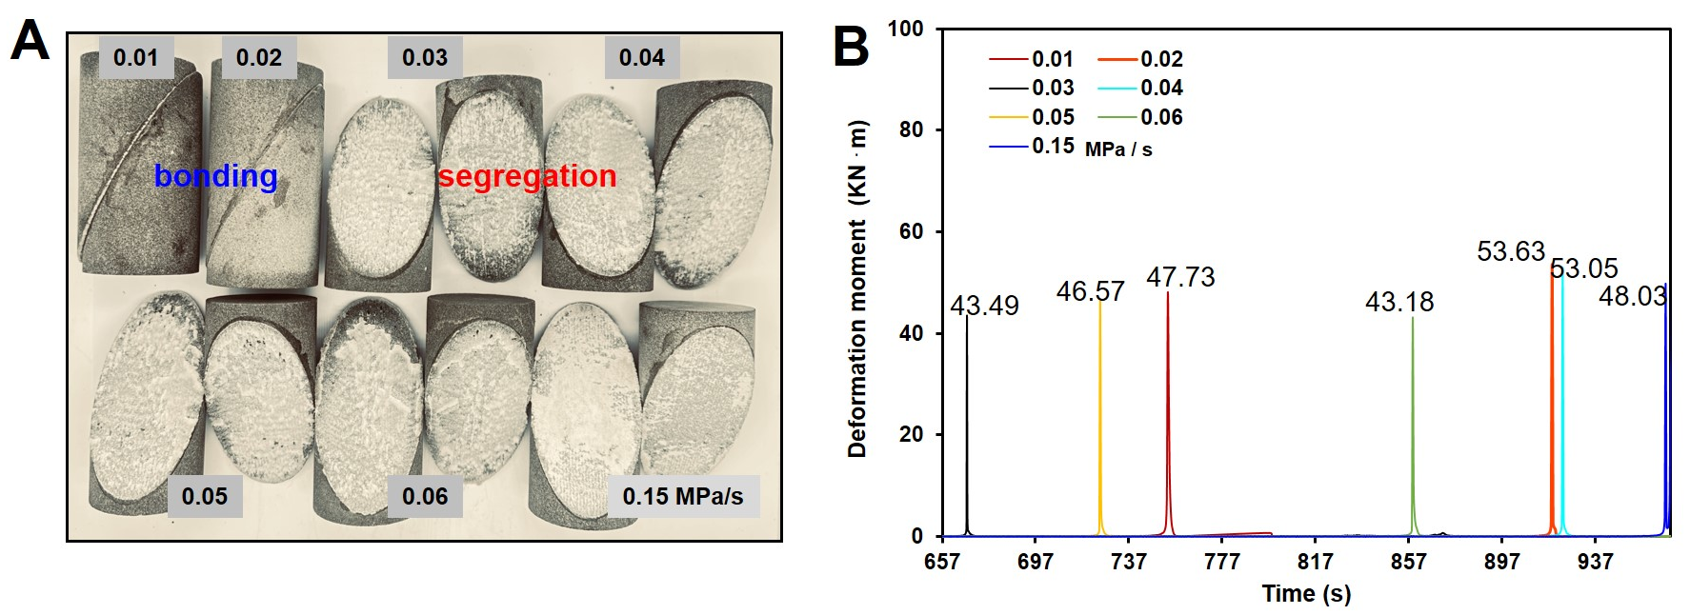
Fig. S3. A: Post failure states of strongly cemented faults under different unloading rates along the LWP. B: Distribution of deformation moment. At low unloading rates, the fault remains in stable sliding after failure, whereas at high unloading rates, the cement breaks rapidly upon failure.

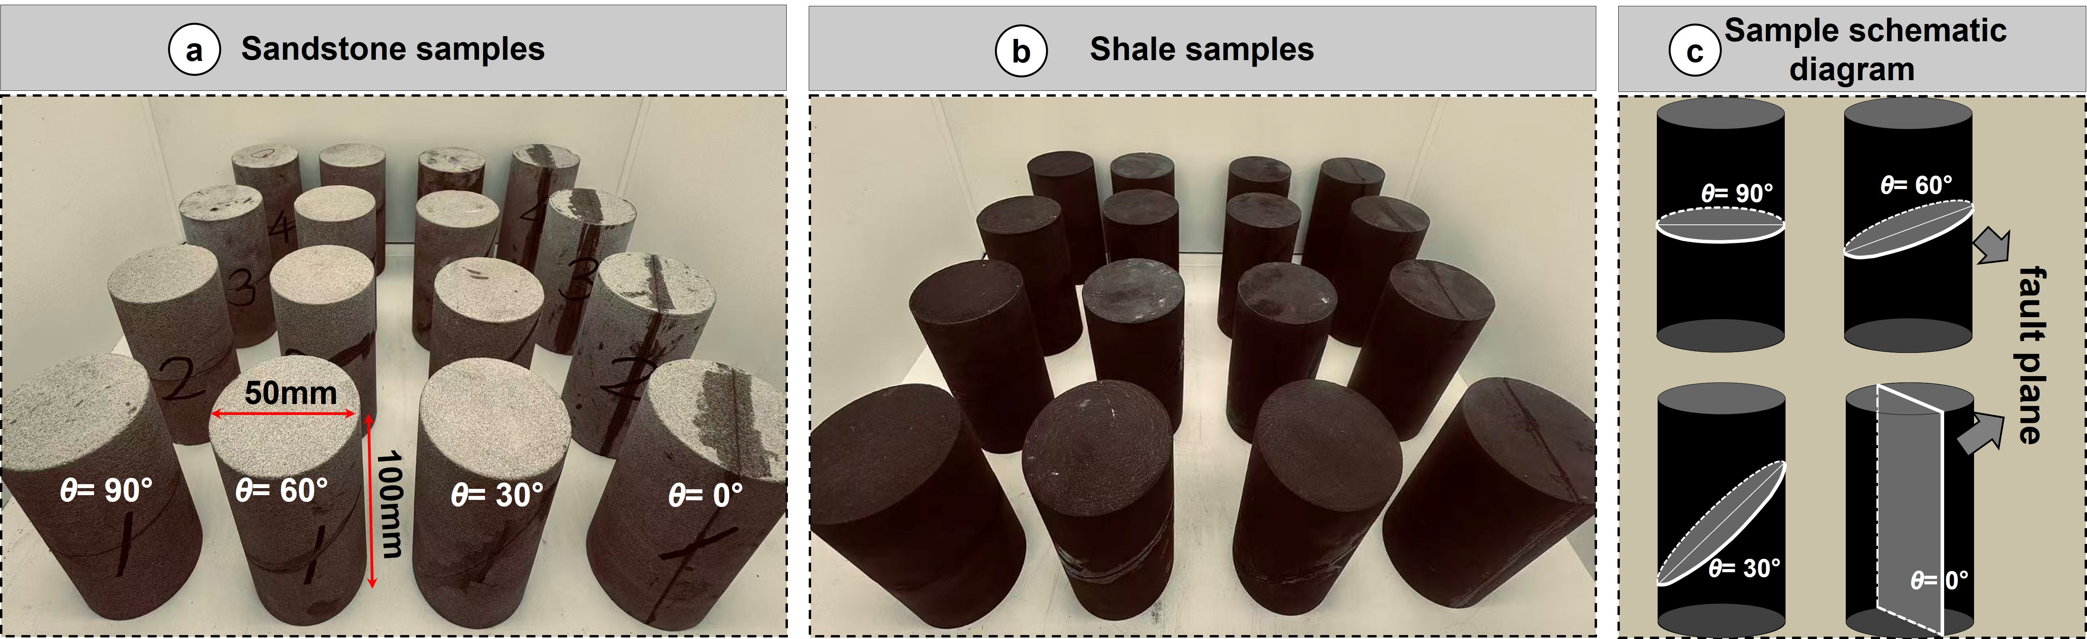
Fig. S4. Fabrication of sandstone and shale fault samples with varying dip angles. The fault surfaces are strongly cemented with epoxy resin to simulate quartz- and calcite-vein-cemented basement faults under static or quasi-static slip conditions. A: Prefabricated sandstone fault. B: Prefabricated shale fault. C: Schematic of cutting for different dip angles.

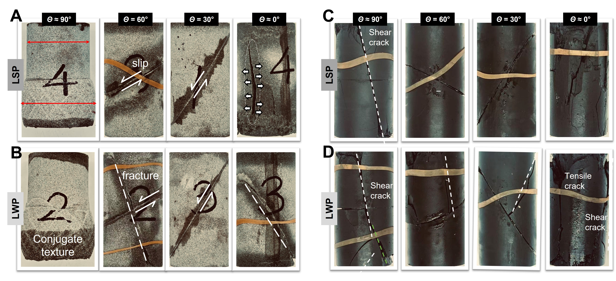
Fig. S5. Failure modes of prefabricated sandstone and shale fault samples with different dip angles under distinct stress-path histories. A: Instability mode of a prefabricated sandstone fault under the LSP. B: Instability mode of a prefabricated sandstone fault under the LWP. C: Instability mode of a prefabricated shale fault under the LSP. D: Instability mode of a prefabricated shale fault under the LWP. LSP, load-strengthening path; LWP, load-weakening path.
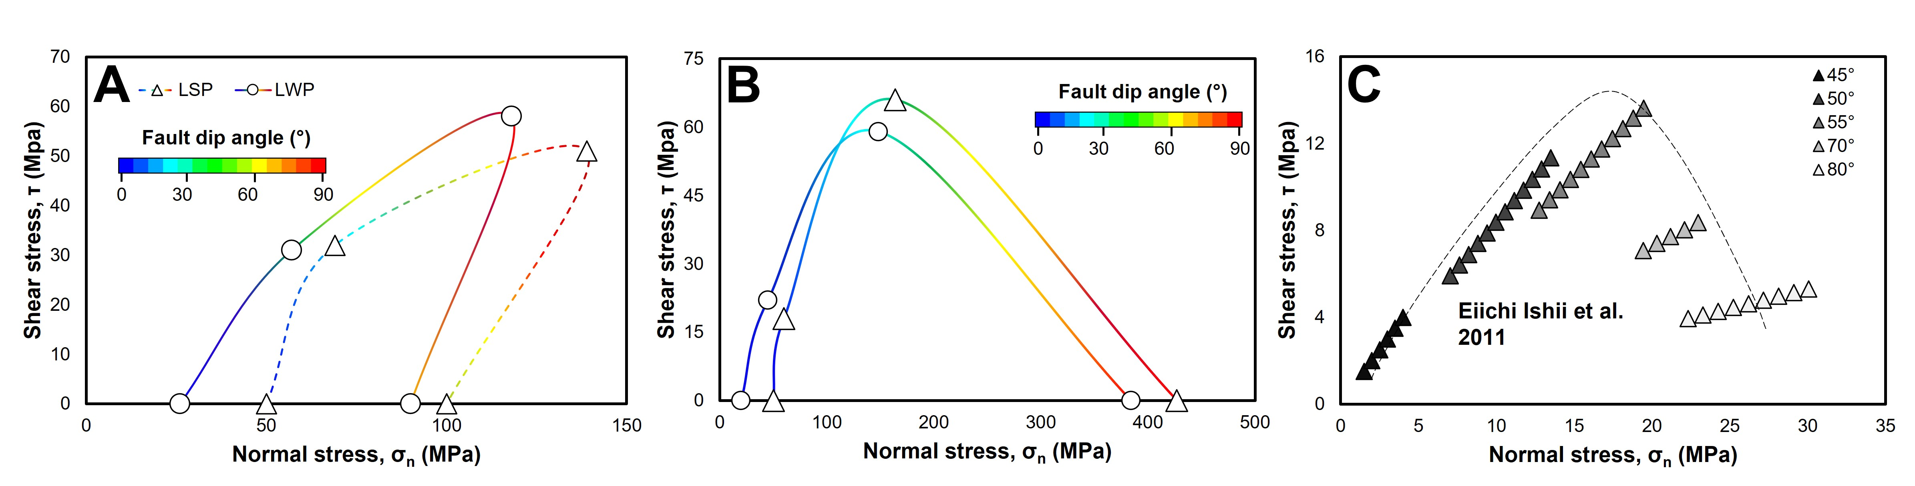
Fig. S6. Coulomb stress distribution within the fault zones of prefabricated sandstone and shale samples with different dip angles under distinct stress-path histories. A: Sandstone sample. B: Shale sample. C: Natural mudstone lithologic transition zone. The normal stress on high-angle faults increases continuously, whereas the shear stress exhibits a critical peak. This indicates that an increase in fault dip leads to an imbalance in the normal-to-shear stress ratio, which significantly influences the mechanical behavior of the cemented fault core and the cohesive strength of the fault system.

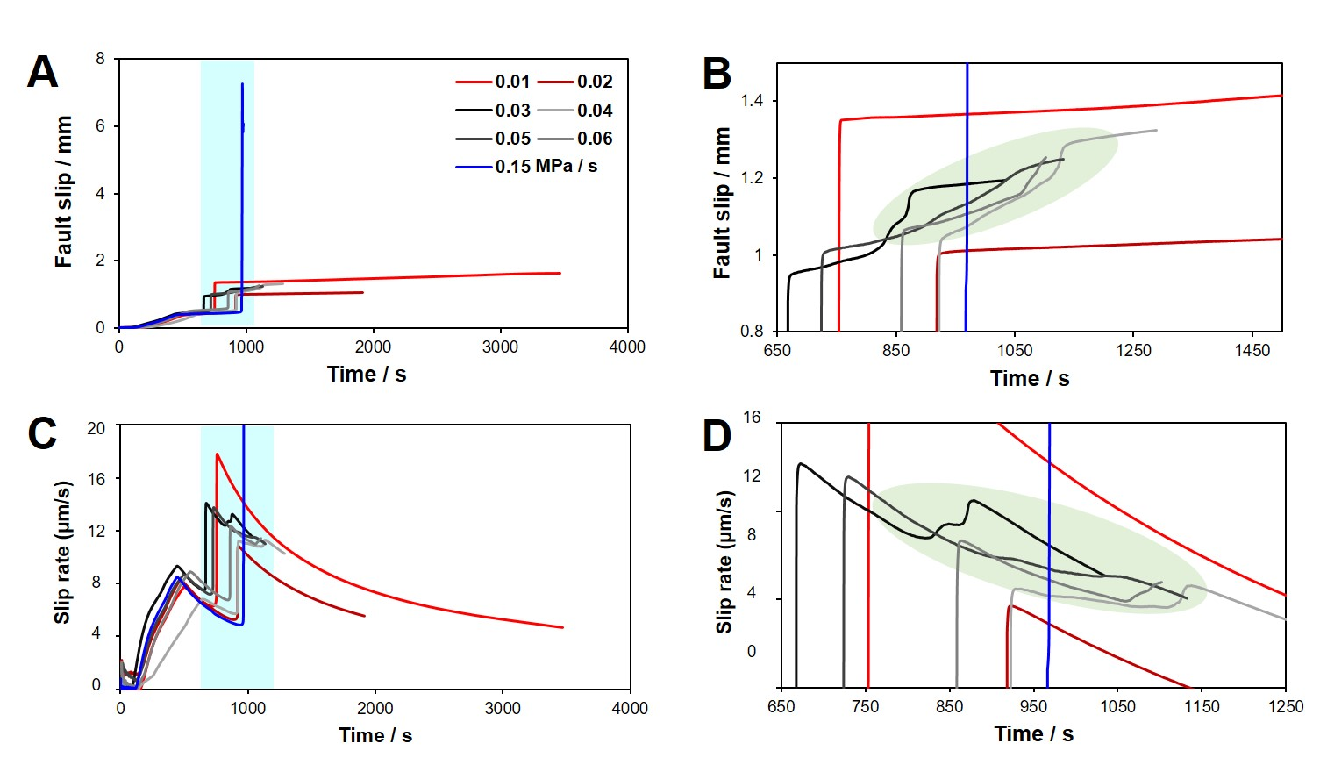
Fig. S7. Fault slip displacement and slip rate curves under different unloading rates. A: Fault slip displacement; B: enlarged view of slip displacement; C: fault slip rate; D: enlarged view of slip rate.
At low unloading rates, the fault enters a stable sliding state (creep) immediately after initial activation. At intermediate rates, the fault exhibits cyclic accelerating-decelerating slip (stick-slip) following initial activation. At high rates, the fault undergoes instantaneous instability (brittle failure) upon activation.
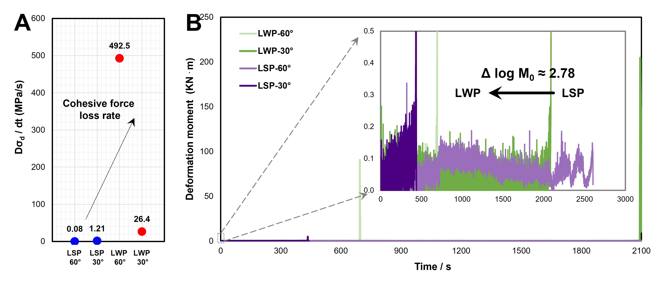
Fig. S8. Statistics of cohesion‑loss rate and deformation moment for prefabricated shale fault cores with different dip angles under distinct stress‑path histories. A: Post‑peak stress‑drop rate. B: Temporal evolution of deformation moment.

