Supplement to:

Role of Selectin-dependent Organ Invasion and Prognostic Impact
of Loss of CD2 in Systemic Mastocytosis*

Peter Valent^{1,2}, Emir Hadzijusufovic^{1,2}, Nina Nehmann³, Hanna Maar⁴, Gerit-Holger Schernthaner⁵, Daniela Berger^{1,2}, Irena Angelova-Fischer⁶, Alex Stefan⁷, Isma Ishaq-Parveen^{1,2}, Johannes Woltsche⁸, Karoline V. Gleixner^{1,2}, Martin Bilban⁹, Wolfgang R. Sperr^{1,2}, Hans-Peter Horny¹⁰, Udo Schumacher*⁴, Daniel Wicklein^{4,11}

¹Department of Internal Medicine I, Division of Hematology and Hemostaseology, Medical University of Vienna, Vienna, Austria; ²Ludwig Boltzmann Institute for Hematology and Oncology, Medical University of Vienna, Vienna, Austria; ³Institute for Anatomy and Experimental Morphology, University Cancer Center Hamburg, University Medical Center Hamburg Eppendorf, Hamburg, Germany; ⁴Institute of Pathology, University of Lübeck and University Medical Center Schleswig-Holstein, Campus Lübeck, Lübeck, Germany; ⁵Department of Internal Medicine II, Division of Angiology, Medical University of Vienna, Vienna, Austria; ⁶Department of Dermatology and Venerology, Kepler University Hospital, Johannes Kepler University Linz, Linz, Austria; ⁷Department of Internal Medicine III - Hematology and Oncology, Kepler Medical University Linz, Linz, Austria; ⁸Department of Dermatology and Venereology, Medical University of Graz, Graz, Austria; ⁹Department of Laboratory Medicine & Core Facilities, Medical University of Vienna, Vienna, Austria; ¹⁰Institute of Pathology, Ludwig Maximilian University Munich, Munich, Germany; ¹¹MSH Medical School Hamburg, University of Applied Sciences and Medical University,
Institute for Molecular Medicine, Hamburg, Germany

Running head: Adhesion molecules and mast cell disease evolution

Key words: mastocytosis, mast cell leukemia, adhesion receptors, selectins, LFA-2, CD44

Correspondence:
Peter Valent, M.D.
Department of Medicine I
Division of Hematology & Hemostaseology and
Ludwig Boltzmann Institute for Hematology and Oncology
Medical University of Vienna
Währinger Gürtel 18-20, A-1090 Vienna, Austria

Phone: +43 1 40400 -60850, -54880
E-mail: peter.valent@meduniwien.ac.at

*We dedicate this publication to our good friend, Udo Schumacher, who contributed essentially in this project for many years but unfortunately passed away before we finalized the article.

Supplemental Methods

Immunocytochemistry (ICC) staining of HMC-1.2 cells
ICC was performed on cytospin preparations from parental HMC-1.2 cells as well as from CD2+ and CD2− subclones according to published techniques.³⁶ In particular, HMC-1.2 cells (on cytospin slides) were fixed in acetone and blocked with 10% fetal bovine serum (FBS) in tris-buffered saline (TBS). Cytospin slides were incubated with primary antibodies diluted in TBS with 10% fetal calf serum (FCS) for 16 hours at room temperature (RT). The antibodies applied are shown in Supplemental Table S2. After incubation, slides were washed and incubated with biotinylated goat-anti-rabbit IgG (#GR602H, Biocare Medical, Pacheco, CA, USA) or biotinylated goat-anti-mouse IgG (#GM601H, Biocare Medical) for 30 minutes at RT followed by incubation with strepavidin-alkaline-phosphatase-complex (#AP605H, Biocare, Walnut Creek, CA) for another 30 minutes. Antibody-reactivity was made visible by Neofuchsin (#415161F; Histofine, Nichirei Bioscience Inc., Tokyo, Japan). Slides were mounted with aquatex (#1.08562.0050; Merck, Darmstadt, Germany).

RNA isolation and quantitative PCR (qPCR)
RNA was isolated from parental HMC-1.2 cells and CD2+ and CD2− subclones using RNeasy Mini Kit (Qiagen, Hilden, Germany) according to the manufacturer’s protocol.
Reverse transcription of RNA to cDNA was performed with Moloney murine leukemia virus reverse transcriptase (Promega, Madison, WI, USA), random primers, first strand buffer (Invitrogen, Carlsbad, CA, USA), dNTPs (Thermo Fisher Scientific, Vilnius, Lithuania) and RNAse Inhibitor (Applied Biosystems) according to the manufacturer´s instructions. The primers used for qPCR studies are shown in Table S3. Beta-glucuronidase (GUSB) was employed as housekeeping gene. mRNA levels were quantified on a 7500 Fast Real-Time PCR System (Thermo Fisher Scientific). Results were expressed as percent of GUSB mRNA level.

Laminar flow assay
To analyze dynamic adhesion of CD2+ and CD2− HMC-1.2 cells to vascular endothelial cells under physiological flow conditions, human cultured umbilical vein endothelial cells (HUVEC; Promocell, Heidelberg, Germany) were seeded into ibidi® µ-slides (ibidi Gräfelfing, Germany) at a concentration of 1.5 x 10⁵ cells/mL in 30 µL Endothelial Cell Medium (Carlsbad, CA, USA) overnight. Adhesion of HMC-1.2 cells was analyzed after activation of HUVEC with 1 ng/mL recombinant human interleukin-1-alpha (IL-1A) (Peprotech, Hamburg, Germany) at a shear stress of 0.25 dyne/cm² for 4 hours. The laminar flow adhesion behavior of HMC-1.2 cells on HUVEC was filmed by video microscopy (100 x magnification) in a Zeiss Axiovert 200 microscope (Zeiss, Jena, Germany) in 3 pre-defined regions of interest (ROI) in each experiment. The numbers of firm (flow-resistant) adhesions per minute and ROI were determined with CapImage software (Dr. Zeintl Ingenieurbüro, Dreieich, Germany) in 3 independent experiments.

Immunohistochemistry (IHC) staining of mouse tissues for CD44 expression
Organ specimens were cut and embedded in 4% agar (Agar Noble, Difco Laboratories, Detroit, MI, USA). Agar blocks were routinely processed for wax histology and were serially sectioned. Lung metastases were examined using quantitative assessment in hematoxylin-eosin-stained sections according to a standard protocol.³¹ For IHC stains, the following mAb were used: mouse anti-human CD2 antibody (LFA-2, Novocastra Laboratories Ltd, Newcastle upon Tyne, UK) diluted 1:200 in TRIS-buffered saline (TBS), HABP-biotin (Calbiochem, Merck KGaA, Darmstadt, Germany) diluted 1:75 in TBS, mouse anti-human CD44 mAb G44–26 (BD Pharmingen, Franklin Lakes, N.J., USA) diluted 1:25 in antibody diluent (DAKO, Glostrup, Denmark), mouse anti-human CD15s antibody (sLex, BD Pharmingen, Franklin Lakes, N.J., USA) diluted 1:200 in TBS, and mouse antihuman CA-19-9 antibody (sLea, Novus Biologicals, Cambirdge, UK) diluted 1:200 in TBS. Sections were dewaxed and pre-treated in different ways. Staining with anti-CD2 was performed after treatment with 0.1% trypsin or microwave treatment in citrate buffer (pH 6.0), slides incubated with HABP-biotin were treated with Dako retrieval solution (DAKO, Glostrup, Denmark) at 60°C overnight, and IHC with anti-CD44 antibody was performed after microwave pre-treatment in citrate buffer (pH 6.0). After washing, sections stained with CD44 mAb were incubated with 20% acetic acid in methanol for 3 minutes, in order to inhibit endogenous alkaline phosphatase. Staining with anti-CD15s mAb was performed after treatment with 0.1% trypsin or microwave treatment in citrate buffer (pH 6.0) and CA19-9 antibody was used without pre-treatment. Following pre-treatment, all sections were washed and nonspecific binding was blocked by incubating the sections in 10% normal rabbit serum (DAKO, Hamburg, Germany) for 30 minutes. Sections were then incubated for with primary antibody at 4°C for 24-48 hours, rinsed and then incubated with secondary biotinylated antibodies (DAKO, Hamburg, Germany) diluted 1:200 for 30 minutes at RT. Subsequently, sections were rinsed and incubated with a horseradish-peroxidase-conjugated avidin-biotin complex (Vector Laboratories, Burlingame, Calif, USA; anti-mitochondria) or with a streptavidin-alkaline phosphate kit for another 30 minutes. Enzyme reactivity of the alkaline phosphate complex was visualized using naphtol-AS-BI phosphate as a substrate and hexatozised new fuchsin for simultaneous coupling. Enzyme reactivity of the peroxidase complex was visualized by means of the nickel-glucose oxidase technique using 0.5 mg/ml diaminobenzidine (Sigma, St. Louis, Mo., USA), 0.4 mg/ml ammonium chloride (Sigma A-4514), 600 µl 0.05 M nickel sulfate, 600 µl 10% beta-D-glucose (Merck, Darmstadt, Germany) and 100 µl of 1.2 mg/ml glucose oxidase in 30 ml destilled water for 20 minutes. Sections were counterstained with Mayer’s Hemalun. Stained sections were examined and photographed under a Zeiss Axioplan photomicroscope (Zeiss Jena, Germany). Negative controls were treated the same way without the incubation step with the IgG control and the primary antibody, and showed no immunoreactivity.

Supplemental (S) Tables

Supplemental Table S1

Characterization of monoclonal antibodies used in flow cytometry studies to define the cell surface phenotype of HMC-1 subclones
--------------------------------------------------------------------------------------------------------
Reactive Fluoro-
CD Antigen Clone Isotype chrome Company
--------------------------------------------------------------------------------------------------------
CD2 LFA-2 RPA-2.10 mIgG1 PE BD-Pharmingen
CD9 BA2 ALB 6 mIgG1 FITC Immunotech
CD25 IL-2RA 2A3 mIgG1 PE BD-Pharmingen
CD31 PECAM1 AC128 mIgG1 APC Miltenyi Biotec
CD44 HERMES 515 mIgG1 PE BD-Pharmingen
CD54 ICAM-1 84H10 mIgG1 FITC Immunotech
CD58 LFA-3 AICD58 mIgG2a FITC Immunotech
CD62E E-Selectin 68-5H11 mIgG1 PE BD-Pharmingen
CD62L L-Selectin Dreg 56 mIgG1 PE BD-Pharmingen
CD62P P-Selectin AK-4 mIgG1 PE BD-Pharmingen
CD63 LAMP-3 CLB-gran12 mIgG1 PE Immunotech
CD117 KIT 104D2 mIgG1 PE BD-Pharmingen
CD162 P-Selectin- KPL-1 mIgG1 PE BD-Pharmingen
Ligand
- Isotype MOPC-21 mIgG1 FITC BD-Pharmingen
- Isotype MOPC-21 mIgG1 PE BD-Pharmingen
- Isotype X39 mIgG2a FITC BD-Pharmingen
- Isotype X40 mIgG1 APC BD-Pharmingen
--------------------------------------------------------------------------------------------------------
Abbreviations: LFA, leukocyte function antigen; mIgG, mouse immunoglobulin; IL-2RA, interleukin-2 receptor alpha; ICAM-1, intercellular adhesion molecule-1; LAMP-3, lysosome-associated membrane glycoprotein 3; PE, phycoerythrin; FITC, fluorescein isothiocyanate; APC, alophycocyanin; BD, Becton Dickinson.
Company location: BD-Pharmingen, San Diego, CA, USA; Immunotech, Marseille, France; Miltenyi Biotec, Bergisch Gladbach, Germany.

Supplemental Table S2

Characterization of antibodies used in immunocytochemistry (ICC) studies to define
the phenotype of HMC-1 subclones
--------------------------------------------------------------------------------------------------------
Animal
Antigen (CD) Clone Ig class source Dilution Company
--------------------------------------------------------------------------------------------------------
LFA-2 (CD2) 6F10.3 mouse 1:25 Beckman Coulter
LFA-2 (CD2) polyclonal IgG rabbit 1:100 Atlas Antibody
KIT (CD117) polyclonal IgG rabbit 1:500 Dako
HDC polyclonal IgG rabbit 1:1000 Progen
HO-1 polyclonal IgG rabbit 1:50 Enzo Life Sciences
Tryptase G3 IgG1 mouse 1:100 Cell Marque
Tryptase G3 IgG1 mouse 1:100 Sigma-Aldrich
Tryptase AA1 IgG1 mouse 1:500 Progen
VEGF C-1 IgG1 mouse 1:50 Santa Cruz Biotech
VEGF polyclonal - - 1:50 Santa Cruz Biotech
--------------------------------------------------------------------------------------------------------
Abbreviations: CD, cluster of differentiation; Ig, immunoglobulin; LFA-2, leukocyte function antigen 2; HDC, histidine decarboxylase; HO-1, heme oxygenase-1; VEGF, vascular endothelial growth factor. Before applied in ICC experiments, antibodies were diluted in Tris-buffered saline (TBS) with 10% fetal calf serum (FCS).
Company location: Beckman Coulter, Brea, CA, USA; Atlas Antibodies, Stockholm, Sweden; Dako, Glostrup, Denmark; Progen, Heidelberg, Germany; Enzo Life Sciences, Farmingdale, NY, USA; Cell Marque, Rocklin, CA, USA; Sigma-Aldrich, St. Louis, MO, USA; Santa Cruz Biotech, Dallas, TX, USA.

Supplemental Table S3A

Sequences of primers used to perform qPCR experiments
-----------------------------------------------------------------------------------------------------------------
Gene Sequence
-----------------------------------------------------------------------------------------------------------------
LFA-2 (CD2) 5' AAT CCA GTG TCG AGC CTG TC 3' (forward)
5' AAG ACC ATC AAG AGG CTG CC 3' (reverse)

TSPAN29 (CD9) 5' ACA TCA TCG GCG CAG TGG 3' (forward) 5' GGT TCC TGC GGA TAG CAC AG 3' (reverse)

IL-2RA (CD25) 5' GGA CTG CTC ACG TTC ATC ATG G 3' (forward)
5' GCT TTG AAT GTG GCG TGT GG 3' (reverse)

PECAM-1 (CD31) 5' TGC AGA GTA CCA GGT GTT GG 3' (forward) 5' ACA GTT GAC CCT CAC GAT CC 3' (reverse)

CD44 5' CGG ACA CCA TGG ACA AGT TT 3' (forward) 5' GCA AAG CGG CAG GTT ATA TT 3' (reverse)

ICAM-1 (CD54) 5' TGA TGG GCA GTC AAC AGC TA 3' (forward)
5' AGT TCC ACC CGT TCT GGA GT 3' (reverse)

LFA-3 (CD58) 5' AGA TGA GTA TGA AAT GGA ATC GC 3' (forward)
5' GTG TGG GAG ATG GAA GAG ACT 3' (reverse)

E-Selectin (CD62E) 5' AGT GTG ACC CTG GCT TCA GT 3' (forward)
5' CCA GGG CTG TAC AGT TCA CA 3' (reverse)

TSPAN30 (CD63) 5' ACA CTG CTT CGA TCC TGG AC 3' (forward)
5' TCG ACA TGG AAG GGA TTT TC 3' (reverse)

KIT (CD117) 5' GCG TTC TGC TCC TAC TGC TTC G 3' (forward) 5' CCC TGG ACT CAC AGA TGG TTG A 3' (reverse)

PSGL-1 (CD162) 5' AAC AGG AAG ATG GCA GTG GG 3' (forward) 5' AAC AGG AGG AGT TGC AGA GG 3' (reverse)

CCL18 5' CTT GTC CTC GTC TGC ACC AT 3' (forward) 5' GGA GGT ATA GAC GAG GCA GC 3' (reverse)

CDH11 5' AGC GCC AAG TTA GTG TAC AGT 3' (forward) 5' TGT TGG GTA GGG CTG TTC TG 3' (reverse)

CERCAM 5' GTC TTC GCC TAT GCC TGC C 3' (forward) 5' TGG GAT TTC ACC GGC ACA TT 3' (reverse)

COL5A1 5' CGA AGG GGC CAG AAT CAC TT 3' (forward)
5' AGC AGT TTC CCA CGC TTG AA 3' (reverse)

GUSB 5' GGG CTT CGA GGA GCA GTG G 3' (forward)
5' GCT GGA GGG AAC TGG CAT GT 3' (reverse)

LGALS3 5' AAG TGC CAC CGG AGC CTA 3' (forward)
5' CAA AGG CAG GTT ATA AGG CAC AA 3' (reverse)

NRCAM 5' GAG CGA AGG GAA AGC TGA GA 3' (forward)
5' ACA ATG GTG ATC TGG ATG GGC 3' (reverse)

TUBA1A 5' GAC CTC GTG TTG GAC CGA AT 3' (forward)
5' AAC CAG TTC CCC CAC CAA AG 3' (reverse)
-----------------------------------------------------------------------------------------------------------------
Abbreviations: RT-PCR, real time polymerase chain reaction; CD, cluster of differentiation; TSPAN29; tetraspanin-29; IL-2Rα, interleukin-2 receptor alpha chain; PECAM-1, platelet endothelial cell adhesion molecule-1; ICAM-1, intercellular adhesion molecule-1; LFA-3, lymphocyte function-associated antigen 3; E-Selectin, endothelial-selectin; P-Selectin, platelet-selectin; TSPAN30, tetraspanin 30; CCL18, CC motif chemokine ligand 18; CDH11, cadherin-11; CERCAM, cerebral endothelial cell adhesion molecule; COL5A1, collagen type V alpha 1; GUSB, beta-glucuronidase (reference gene); LGALS3, galectin-3; NRCAM, neuronal cell adhesion molecule; TUBA1A, tubulin alpha-1A.

Supplemental Table S3B
Expression of mRNA specific for CD antigens in HMC-1.2 cells determined by qPCR
-------------------------------------------------------------------------------------------------------- mRNA expression in HMC-1.2 cells
---------------------------------------------------------------------------
Gene Parental +1rH3 -2rE6 -3rD2
--------------------------------------------------------------------------------------------------------
LFA-2 (CD2) + +++ +/- +/-
TSPAN26 (CD9) +++ +++ +++ +++
IL-2RA (CD25) +/- +/- +/- +/-
PECAM-1 (CD31) +/- +/- +/- +/-
Hermes (CD44) +++ +++ +++ +++
ICAM-1 (CD54) + + ++ ++
LFA-3 (CD58) + ++ + ++
E-Selectin (CD62E) +/- +/- +/- +/-
P-Selectin (CD62P) +/- +/- +/- +/-
TSPAN30 (CD63) +++ +++ +++ +++
KIT (CD117) +++ +++ +++ +++
CCL18 + + +/- +
CDH11 +/- +/- +/- +/-
CERCAM + ++ ++ ++
COL5A1 +/- +/- +/- +/-
LGALS3 +/- + + ++
NRCAM + + ++ ++
TUBA1A +++ +++ +++ +++
--------------------------------------------------------------------------------------------------------
mRNA expression levels were quantified by qPCR using an established protocol. GUSB served as a reference gene. Transcript levels were categorized based on their abundance relative to GUSB mRNA as follows: +++, high expression (>100%); ++, moderate expression (50-100%); +, low expression (10-50%); +/-, trace expression (≤10%).
Abbreviations: LFA-2, lymphocyte function-associated antigen-2; TSPAN29; Tetraspanin-29; IL-2RA, interleukin-2 receptor alpha chain; PECAM-1, platelet endothelial cell adhesion molecule-1; ICAM-1, intercellular adhesion molecule-1; LFA-3, lymphocyte function-associated antigen 3; E-Selectin, endothelial-selectin; P-Selectin, platelet-selectin; TSPAN30, tetraspanin 30; CCL18, CC motif chemokine ligand 18; CDH11, cadherin-11; CERCAM, cerebral endothelial cell adhesion molecule; COL5A1, collagen type V alpha 1; LGALS3, galectin-3; NRCAM, neuronal cell adhesion molecule; TUBA1A, tubulin alpha-1A chain; GUSB, beta-glucuronidase; qPCR, quantitative real-time PCR.

Supplemental Table S4

Relative expression of gene products (mRNA) involved in adhesion or extracellular matrix organization
in CD2+ HMC-1 cells compared to CD2− HMC-1.2 cells as determined by whole transcriptome studies
Affymetrix Probe Set ID | Gene Symbol | Fold Change CD2+/CD2- | Gene Title/Name | Known biological Function(s)
208949_s_at | LGALS3 | 29.57 | lectin, galactoside-binding, soluble, 3 | extracellular matrix organization
209118_s_at | TUBA1A | 24.37 | tubulin, alpha 1a | microtubule-based movement
205831_at | CD2 | 16.39 | CD2 molecule | cell adhesion
201590_x_at | ANXA2 | 6.29 | annexin A2 | collagen fibril organization
221748_s_at | TNS1 | 5.92 | tensin 1 | cell-substrate junction assembly
210427_x_at | ANXA2 | 5.83 | annexin A2 | collagen fibril organization
213503_x_at | ANXA2 | 5.76 | annexin A2 | collagen fibril organization
221747_at | TNS1 | 5.46 | tensin 1 | cell-substrate junction assembly
207173_x_at | CDH11 | 4.46 | cadherin 11, type 2, OB-cadherin (osteoblast) | cell adhesion
212488_at | COL5A1 | 4.20 | collagen, type V, alpha 1 | cell adhesion
203325_s_at | COL5A1 | 4.01 | collagen, type V, alpha 1 | cell adhesion
208816_x_at | ANXA2P2 | 3.85 | annexin A2 pseudogene 2 | collagen fibril organization
32128_at | CCL18 | 3.81 | chemokine (C-C motif) ligand 18 | chemotaxis
225293_at | COL27A1 | 2.76 | collagen, type XXVII, alpha 1 | cell adhesion
224794_s_at | CERCAM | 2.52 | cerebral endothelial cell adhesion molecule | cell adhesion
204105_s_at | NRCAM | 2.46 | neuronal cell adhesion molecule | cell adhesion
233317_at | CD9 | 1.33 | CD9 molecule | cell adhesion
201005_at | CD9 | 1.07 | CD9 molecule | cell adhesion
206341_at | IL2RA | 0.91 | IL2RA, CD25 | immune responses
211269_s_at | IL2RA | 0.75 | IL2RA, CD25 | cell adhesion
208982_at | PECAM1 | 1.12 | platelet/endothelial cell adhesion molecule | cell adhesion
1559921_at | PECAM1 | 1.00 | platelet/endothelial cell adhesion molecule | cell adhesion
208981_at | PECAM1 | 0.97 | platelet/endothelial cell adhesion molecule | cell adhesion
208983_s_at | PECAM1 | 0.90 | platelet/endothelial cell adhesion molecule | cell adhesion
212063_at | CD44 | 1.03 | CD44 molecule (Indian blood group) | cell adhesion
216056_at | CD44 | 1.00 | CD44 molecule (Indian blood group) | cell adhesion
204489_s_at | CD44 | 0.92 | CD44 molecule (Indian blood group) | cell adhesion
217523_at | CD44 | 0.91 | CD44 molecule (Indian blood group) | cell adhesion
234418_x_at | CD44 | 0.90 | CD44 molecule (Indian blood group) | cell adhesion
234411_x_at | CD44 | 0.86 | CD44 molecule (Indian blood group) | cell adhesion
1565868_at | CD44 | 0.82 | CD44 molecule (Indian blood group) | cell adhesion
210916_s_at | CD44 | 0.79 | CD44 molecule (Indian blood group) | cell adhesion
229221_at | CD44 | 0.79 | CD44 molecule (Indian blood group) | cell adhesion
209835_x_at | CD44 | 0.76 | CD44 molecule (Indian blood group) | cell adhesion
1557905_s_at | CD44 | 0.75 | CD44 molecule (Indian blood group) | cell adhesion
212014_x_at | CD44 | 0.75 | CD44 molecule (Indian blood group) | cell adhesion
204490_s_at | CD44 | 0.71 | CD44 molecule (Indian blood group) | cell adhesion
215485_s_at | ICAM1 | 0.84 | intercellular adhesion molecule 1 (CD54) | cell adhesion
202637_s_at | ICAM1 | 0.69 | intercellular adhesion molecule 1 | cell adhesion
202638_s_at | ICAM1 | 0.46 | intercellular adhesion molecule 1 | cell adhesion
216942_s_at | CD58 | 1.35 | CD58 molecule | cell adhesion
211744_s_at | CD58 | 1.27 | CD58 molecule | cell adhesion
205173_x_at | CD58 | 1.26 | CD58 molecule | cell adhesion
222061_at | CD58 | 1.16 | CD58 molecule | cell adhesion
216322_at | CD58 | 1.00 | CD58 molecule | cell adhesion
209893_s_at | FUT4 | 1.21 | CD15 | protein amino acid glycosylation
209892_at | FUT4 | 1.44 | CD15 | protein amino acid glycosylation
216981_x_at | SPN | 1.10 | CD43, sialophorin | chemotaxis
206057_x_at | SPN | 1.09 | CD43, sialophorin | chemotaxis
206056_x_at | SPN | 1.02 | CD43, sialophorin | chemotaxis
216980_s_at | SPN | 1.00 | CD43, sialophorin | chemotaxis
1568964_x_at | SPN | 1.60 | CD43, sialophorin | chemotaxis
202351_at | ITGAV | 1.92 | CD51, integrin, alpha V | cell adhesion
216261_at | ITGB3 | 1.09 | CD61, integrin, beta 3 | cell adhesion
211579_at | ITGB3 | 1.08 | CD61, integrin, beta 3 | cell adhesion
204625_s_at | ITGB3 | 1.00 | CD61, integrin, beta 3 | cell adhesion
204627_s_at | ITGB3 | 1.00 | CD61, integrin, beta 3 | cell adhesion
215240_at | ITGB3 | 1.00 | CD61, integrin, beta 3 | cell adhesion
204628_s_at | ITGB3 | 0.90 | CD61, integrin, beta 3 | cell adhesion
204626_s_at | ITGB3 | 0.86 | CD61, integrin, beta 3 | cell adhesion
206211_at | SELE | 1.00 | CD62E, selectin E | cell adhesion
204563_at | SELL | 0.60 | CD62L, selectin L | cell adhesion
206049_at | SELP | 0.85 | CD62P, selectin P | cell adhesion
200663_at | CD63 | 1.15 | CD63 molecule | positive regulation of endocytosis
205051_s_at | KIT | 1.03 | CD117, KIT | protein amino acid phosphorylation
208677_s_at | BSG | 1.41 | CD147, basigin | signal transduction
209880_s_at | SELPLG | 1.37 | selectin P ligand | cell adhesion
209879_at | SELPLG | 1.49 | selectin P ligand | cell adhesion
Whole transcriptome profiling studies were performed on CD2+ and CD2− HMC-1.2 cells as described
in the text. The top upregulated (overexpressed) genes identified in CD2+ HMC-1.2 cells compared to
CD2− HMC- 1.2 cells are shown together with the gene symbols (abbreviations) and the excess (fold-
change) in mRNA expression. The complete data set results is provided in Gene Expression Omnibus
under: http://www.ncbi.nlm.nih.gov/geo/query/acc.cgi?acc=GSE33504.

Table S5

Infiltration grade and local tumor formation of CD2+ and CD2− HMC-1.2 cells in the lungs of pfp/rag2 mice and scid select mice and comparison to survival
-----------------------------------------------------------------------------------------------------------------
HMC-1.2 mouse Animal Lung infiltration Survival Weight of i.p.
subset strain number grade (day) tumor (gram)
-----------------------------------------------------------------------------------------------------------------
CD2+ pfp/rag2 1 +++ 69 2.1
CD2+ pfp/rag2 2 + 69 1.6
CD2+ pfp/rag2 3 n.d. 71 0.9
CD2+ pfp/rag2 4 + 85 5.0
CD2+ pfp/rag2 5 ++ + 85 4.6
CD2+ pfp/rag2 6 + 85 3.5
CD2+ pfp/rag2 7 +++ 91 1.0
CD2+ pfp/rag2 8 +++ 91 4.4
CD2+ pfp/rag2 9 ++++ 91 5.1

CD2− pfp/rag2 10 +++ 63 3.5
CD2− pfp/rag2 11 n.d. 63 1.3
CD2− pfp/rag2 12 +++ 65 5.4
CD2− pfp/rag2 13 + 65 1.4
CD2− pfp/rag2 14 - 65 6.2
CD2− pfp/rag2 15 +++ 65 4.6
CD2− pfp/rag2 16 +++ 65 4.9
CD2− pfp/rag2 17 +++ 83 5.7
CD2+ pfp/rag2 18 - 85 5.2
-----------------------------------------------------------------------------------------------------------------
CD2+ and CD2− HMC-1.2 cells (1 x 10⁶ cells per mouse in 200 µl medium) were injected intraperitoneally (i.p.) into pfp/rag2 mice. Animals were sacrificed when their overall condition became poor (in-house scoring system). Survival was defined as time between injection and sacrification. Lung tissue sections were fixed in 4% buffered formaldehyde and stained with an antibody against human CD44 to define the infiltration grade of HMC-1.2 cells. Based on staining results, the following grading was established: no CD44+ cells present: -; very few CD44+ cells detected: +; low to moderate numbers of CD44+ cells detected, ++; partially confluent layers of CD44+ cells present, +++, confluent layers of CD44+ cells in most of the lung tissue found: ++++. Additionally, the combined weight of the total mastocytoma load in the respective animal’s peritoneum was determined. Abbreviations: n.d., not done (lung tissue lost during preparation); i.p., intraperitoneal.
Supplemental (S) Figures

Figure S1

Parental HMC-1.2 cells:
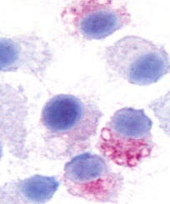
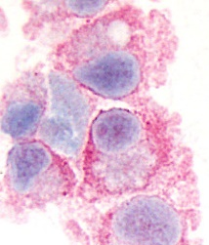
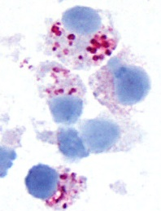
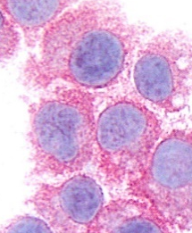
LFA-2/CD2 HDC Tryptase KIT/CD117 HO-1
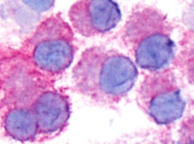

CD2-negatice HMC-1.2 subclone:
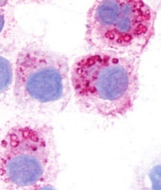
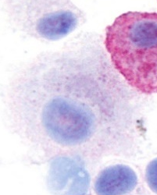
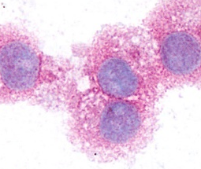
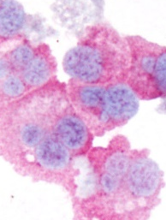
LFA-2/CD2 HDC Tryptase KIT/CD117 HO-1
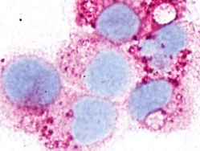

-3D2 -2rE6 -3rD2 -3rD2 -3rD2
CD2-positive HMC-1.2 subclone:
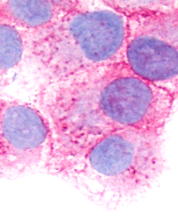
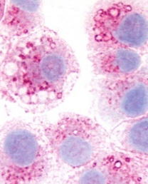
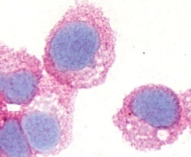
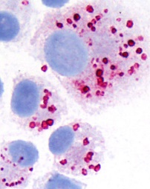
LFA-2/CD2 HDC Tryptase KIT/CD117 HO-1
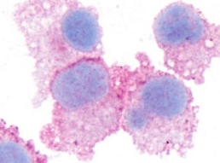

+1rH3 +1rH3 +1rH3 +1rH3 +1rH3

Figure S1

Expression of mast cell-related antigens in HMC-1.2 cells and HMC-1.2 subclones as determined by immunocytochemistry (ICC)
Parental HMC-1.2 cells (upper panels), the CD2-negative HMC-1.2 subclones -3D2 and
-2rE6 (middle panels) and the CD2-positive HMC-1.2 subclone 1rH3 (lower panels) were spun on cytospin slides and stained with antibodies against LFA-2 (CD2), histidine decarboxylase (HDC), tryptase, KIT (CD117), and heme-oxygenase-1 (HO-1) by ICC. Details about the staining techniques applied are provided in the section methods of this supplement.

Figure S2

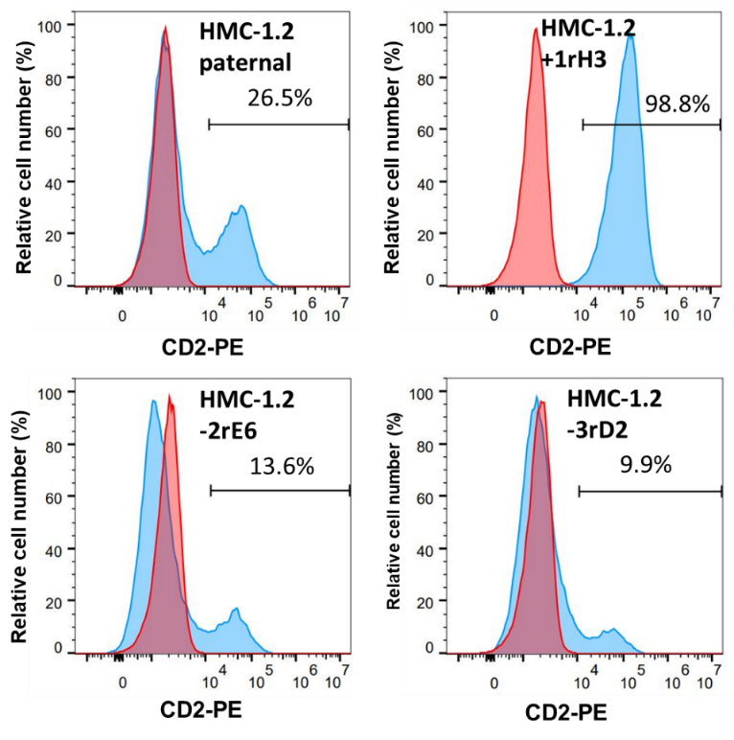

Figure S2

Expression of CD2 on paternal HMC-1.2 cells and HMC-1.2 subclones
HMC-1.2 cells were stained with a phycoerythrin (PE) labeled CD2 antibody (blue histograms) and an isotype-matched (IgG1) control antibody (red histograms) and analyzed by flow cytometry as described in the text. Expression levels of CD2 in paternal HMC-1.2 cells (upper left image) and HMC-1.2 subclones are expressed as percentage (%) of all HMC-1.2 cells analyzed (% values are depicted in each image).

Figure S3
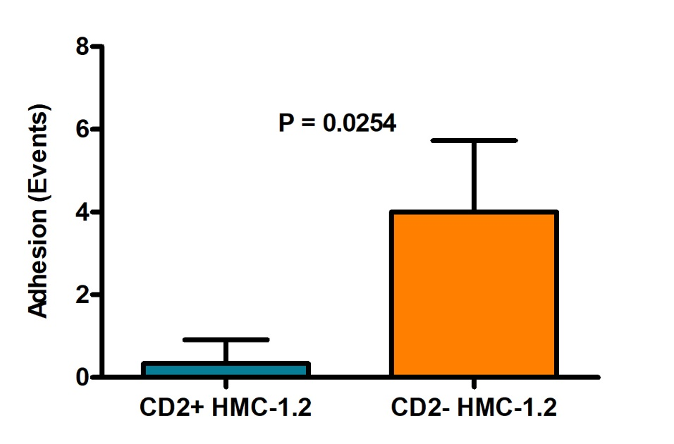

Figure S3

Endothelial-adhesion capacity of CD2+ and CD2− HMC-1.2 cells
Purified (sorted) CD2+ HMC-1.2 cells (left blue column) and CD2− HMC-1.2 cells (right orange column) were seeded in ibidi® µ-slides at a concentration of 1.5 x 10⁵ cells/mL in 30 µL endothelial cell medium overnight. Adhesion of HMC-1.2 cells was analyzed after activation of HUVEC with 1 ng/mL recombinant IL-1A at a shear stress of 0.25 dyne/cm2 for 4 hours. The laminar flow adhesion behavior of HMC-1.2 cells on HUVEC was filmed by video microscopy (Zeiss Axiovert 200) in 3 pre-defined regions of interest (ROI). Results are expressed as adhesion-events per minute (per ROI) and represent the mean±S.D. of 3 independent experiments.
Figure S4
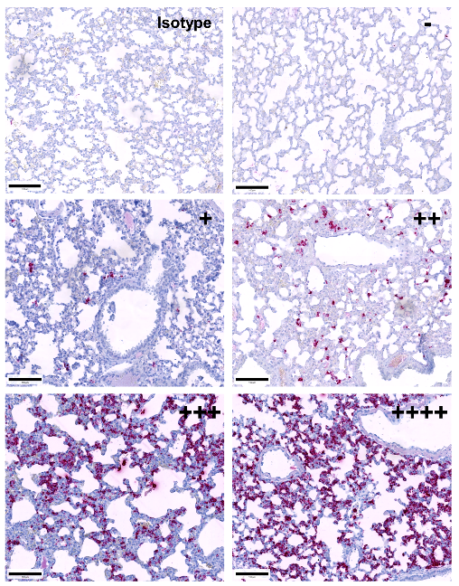

Figure S4

Detection of lung infiltrates of HMC-1.2 cells in pfp/rag2 after intraperitoneal injection
HMC-1.2 cells (CD2+ or CD2−) were suspended in serum-free medium and injected intraperitoneally into pfp/rag2 mice. Animals were sacrificed when tumors started to ulcerate or when the tumor weight exceeded 20% of the initial mouse body weight. Afterwards, lungs were extracted and prepared for immunohistochemical examination. HMC-1.2 infiltrates in the connective tissue of the lungs of pfp/rag2 mice were visualized by staining with anti-CD44 monoclonal antibody. Based on staining results, the following grading was established: no CD44+ cells present, -; very few CD44+ cells detected: +; low to moderate numbers of CD44+ cells detected, ++; partially confluent layers of CD44+ cells present, +++, confluent layers of CD44+ cells in most of the lung tissue found. The presence of more than a few solid mastocytoma nodules in the alveolar septae were confined to CD2+ HMC-1.2 cells. Bars: 100 µm.

Figure S5

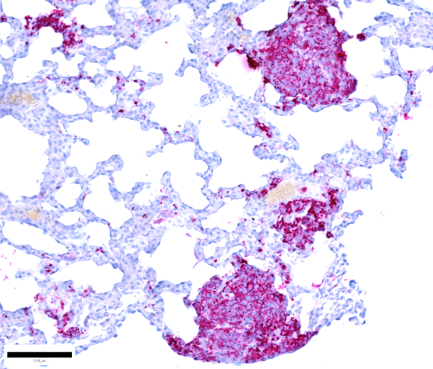
A

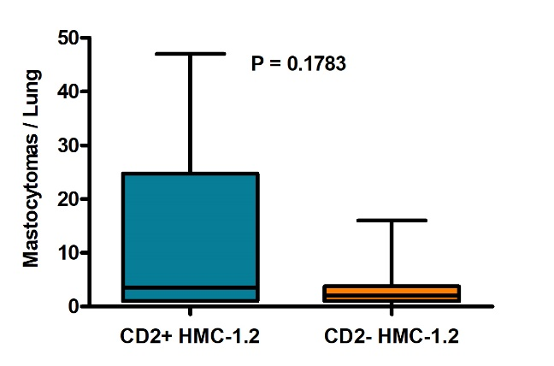
B

Figure S5

Detection of lung infiltrates of HMC-1.2 cells in pfp/rag2 after intraperitoneal injection
CD2+ HMC-1.2 cells (CD2+) and CD2− HMC-1.2 cells (CD2-) (each 10 mice) were injected intraperitoneally into pfp/rag2 mice. Animals were sacrificed when tumors started to ulcerate or when the tumor weight exceeded 20% of the initial mouse body weight. Afterwards, lungs were extracted and prepared for immunohistochemical examination using anti-CD44 monoclonal antibody. A: a typical example of dense multifocal infiltrates of CD44+/CD2+ HMC-1.2 cells in the lung of a pfp/rag2 mouse. Bar: 50 µm. B: Quantification of CD44+ HMC-1.2 infiltrates in the two groups of mice. Results show the numbers of mastocytoma lesions per lung and are expressed as mean±S.D. of all lungs in all mice examined. As visible, mice injected with CD2+ HMC-1.2 cells (blue bar) developed dense multifocal infiltrates in the lungs more frequently than mice injected with CD2− HMC-1.2 cells (yellow bars). However, based on a highly variable number of MC nodules in mice injected with CD2+ cells and variability in infiltration grade, this difference did not reach statistical significance (p=0.1783 by unpaired t-test).

