Posterior cortical gray matter heterogeneity between hyposmia- and RBD-defined prodromal phenotypes in Parkinson's disease: a PPMI voxel-based morphometry study
Authors: Lingzhuo Chen; Shengqiang Chen; Kejia Hu; Hua He
Affiliations 1: Department of Neurosurgery, The Third Affiliated Hospital of Naval Medical University (Second Military Medical University), Shanghai 200438, China
Affiliations 2: Department of Hepatic Surgery VI, Eastern Hepatobiliary Surgery Hospital, The Third Affiliated Hospital of Naval Medical University, Shanghai, China
Affiliation 3: Department of Neurosurgery, Center for Functional Neurosurgery, Ruijin Hospital, Shanghai Jiao Tong University School of Medicine, Shanghai, China
Affiliation 4: Emergency & Critical Care Medicine Center, Ruijin Hospital, Shanghai Jiao Tong University School of Medicine, Shanghai, China
Affiliation 5: Shanghai Institute of Aviation Medicine, Ruijin Hospital, Shanghai Jiao Tong University School of Medicine, Shanghai, China
Correspondence: Hua He (hehual624@smmu.edu.cn); Kejia Hu (hukejia@shsmu.edu.cn)
Supplementary Tables S1–S9 and Supplementary Figures S1–S2 report scanner composition, whole-brain VBM sensitivity and disease-context findings, MRI quality control, matched-pair results, clinical scales and timing, exploratory atlas ROI effects, MRI-proximal RBDSQ associations, and PALM inference with directional and spatial audits.
Table S1. Scanner-family distribution across analysis cohorts.
Panel A. Primary phenotype cohort and all-3T disease-context cohort
Scanner family | Hyposmia-only, n (%) | RBD-only, n (%) | PD, n (%)
GE_ARCHITECT | 15 (3.2%) | 28 (18.8%) | 18 (5.7%)
GE_MR750 | 15 (3.2%) | 9 (6.0%) | 14 (4.4%)
OTHER | 2 (0.4%) | 11 (7.4%) | 12 (3.8%)
SIEMENS_PRISMA | 208 (44.7%) | 79 (53.0%) | 171 (54.1%)
SIEMENS_SKYRA | 54 (11.6%) | 19 (12.8%) | 53 (16.8%)
SIEMENS_VERIO | 155 (33.3%) | 2 (1.3%) | 40 (12.7%)
SIEMENS_VIDA | 16 (3.4%) | 1 (0.7%) | 8 (2.5%)
Total | 465 (100.0%) | 149 (100.0%) | 316 (100.0%)
Note: Hyposmia-only/RBD-only columns correspond to the primary phenotype cohort (N=614); adding PD gives the all-3T disease-context cohort (N=930).
Panel B. Scanner common-support cohorts
Scanner family | Hyposmia-only, n (%) | RBD-only, n (%) | PD, n (%)
GE_ARCHITECT | 15 (5.1%) | 28 (20.7%) | 18 (7.0%)
GE_MR750 | 15 (5.1%) | 9 (6.7%) | 14 (5.5%)
SIEMENS_PRISMA | 208 (71.2%) | 79 (58.5%) | 171 (66.8%)
SIEMENS_SKYRA | 54 (18.5%) | 19 (14.1%) | 53 (20.7%)
Total | 292 (100.0%) | 135 (100.0%) | 256 (100.0%)
Note: Hyposmia-only/RBD-only subset N=427; adding PD gives N=683.
Panel C. Siemens PRISMA/SKYRA-restricted cohorts
Scanner family | Hyposmia-only, n (%) | RBD-only, n (%) | PD, n (%)
SIEMENS_PRISMA | 208 (79.4%) | 79 (80.6%) | 171 (76.3%)
SIEMENS_SKYRA | 54 (20.6%) | 19 (19.4%) | 53 (23.7%)
Total | 262 (100.0%) | 98 (100.0%) | 224 (100.0%)
Note: Hyposmia-only/RBD-only subset N=360; adding PD gives N=584.
Panel D. Siemens PRISMA-only phenotype sensitivity
Scanner family | Hyposmia-only, n (%) | RBD-only, n (%) | PD, n (%)
SIEMENS_PRISMA | 208 (100.0%) | 79 (100.0%) | —
Total | 208 (100.0%) | 79 (100.0%) | —
Note: PRISMA-only phenotype sensitivity included 208 Hyposmia-only and 79 RBD-only participants (N=287); no PRISMA-only disease-context model was used in the manuscript. In the primary phenotype cohort, scanner-family distribution differed between phenotypes (chi-square=117.16, df=6, p=6.42 x 10^-23, Cramer's V=0.437).
Table S2. Cluster-level VBM results for primary, sensitivity, and disease-context analyses.
Panel A. Primary phenotype comparison and prespecified sensitivity analyses
Analysis / restriction | N | Contrast | k | Cluster pFWE | Peak statistic | Peak MNI [x,y,z] | Inference
Primary, GM mask 0.05 | 614 | Phenotype difference (F) | 4499 | 4.15 x 10^-7 | F=25.81 | [0, -91.5, 22.5] | FWE significant
Primary, GM mask 0.05 | 614 | Hyposmia > RBD | 5947 | 1.33 x 10^-7 | T=5.08 | [0, -91.5, 22.5] | FWE significant
Sensitivity, GM mask 0.10 | 614 | Phenotype difference (F) | 3830 | 3.46 x 10^-6 | F=25.83 | [0, -91.5, 22.5] | FWE significant
Sensitivity, GM mask 0.10 | 614 | Hyposmia > RBD | 5169 | 1.03 x 10^-6 | T=5.08 | [0, -91.5, 22.5] | FWE significant
Scanner common support | 427 | Phenotype difference (F) | 3127 | 1.97 x 10^-5 | F=22.30 | [0, -91.5, 24] | FWE significant
Scanner common support | 427 | Hyposmia > RBD | 4178 | 7.21 x 10^-6 | T=4.72 | [0, -91.5, 24] | FWE significant
Siemens PRISMA/SKYRA | 360 | Phenotype difference (F) | 1547 | 0.0027 | F=20.08 | [-1.5, -87, 27] | FWE significant
Siemens PRISMA/SKYRA | 360 | Hyposmia > RBD | 2265 | 7.94 x 10^-4 | T=4.48 | [-1.5, -87, 27] | FWE significant
Siemens PRISMA only | 287 | Phenotype difference (F) | 381 | 0.273 | F=16.06 | [0, -88.5, 25.5] | Not FWE significant
Siemens PRISMA only | 287 | Hyposmia > RBD | 564 | 0.156 | T=4.01 | [0, -88.5, 25.5] | Not FWE significant
Note: Whole-brain maps used voxel p<0.001 uncorrected with cluster-level FWE p<0.05. PRISMA-only rows report the largest spatially concordant posterior clusters despite lack of FWE significance. No RBD-only > Hyposmia-only cluster survived cluster-level FWE correction in the phenotype analyses.
Panel B. Prespecified disease-context F contrasts
Restriction | N | Contrast | k | Cluster pFWE | Bonferroni-adjusted p | Peak F | Peak MNI [x,y,z] | Inference
All 3 T | 930 | Hyposmia vs PD (F) | 3907 | 1.47 x 10^-6 | 2.94 x 10^-6 | F=25.64 | [1.5, -79.5, 10.5] | Significant
All 3 T | 930 | RBD vs PD (F) | 368 | 0.28 | 0.56 | F=17.04 | [-24, -7.5, 0] | Not significant
Scanner common support | 683 | Hyposmia vs PD (F) | 3283 | 1.11 x 10^-5 | 2.22 x 10^-5 | F=21.18 | [0, -90, 12] | Significant
Scanner common support | 683 | RBD vs PD (F) | 1344 | 0.0047 | 0.0094 | F=20.44 | [-24, -7.5, 0] | Significant
Siemens PRISMA/SKYRA | 584 | Hyposmia vs PD (F) | 1954 | 5.66 x 10^-4 | 0.0011 | F=17.83 | [0, -87, 12] | Significant
Siemens PRISMA/SKYRA | 584 | RBD vs PD (F) | 626 | 0.088 | 0.176 | F=21.31 | [15, 6, 55.5] | Not significant
Note: The disease-context inferential family comprised Hyposmia-only vs PD and RBD-only vs PD F contrasts. Bonferroni adjustment was applied across these two contrasts; Bonferroni-adjusted p<0.05 (equivalently, raw cluster p_FWE<0.025) was treated as significant. For nonsignificant contrasts, the row shows the cluster with the smallest cluster-level pFWE to document attenuation rather than imply absence of any suprathreshold voxels.
Table S3. Structural MRI quality-control criteria and cohort flow.
Panel A. Cohort flow
Stage | N | Source
Candidate baseline T1 examinations | 1236 | Frozen manuscript flow
Matched to clinical analysis table | 1230 | Frozen manuscript flow
CAT12 quality criterion failures | 17 | BL_review_list / frozen audit
Tissue-volume QC exclusions | 46 | BL_review_list / frozen audit
Overlap: CAT12 + tissue-volume | 9 | BL_review_list / frozen audit
Unique QC exclusions | 54 | BL_review_list / frozen audit
Final QC-passed source cohort | 1176 | Frozen manuscript flow
Panel B. QC criteria
QC component | Criterion | Purpose / interpretation
CAT12 image quality | IQR < 80% or unavailable quality information | Exclude low-quality or unavailable CAT12 quality assessments.
Raw tissue volumes | TIV, GM, WM, CSF | Screen global tissue-volume plausibility.
Ratio metrics | GM/TIV, WM/TIV, CSF/TIV, GM/WM | Detect disproportionate tissue segmentation or normalization patterns.
Global z-score flag | absolute z > 3 for each volume and ratio | Identify extreme cohort-level values.
MAD modified-z flag | absolute modified z > 3.5 for each volume and ratio | Provide a robust outlier screen less sensitive to extreme observations.
IQR flag | outside Q1 - 3*IQR or Q3 + 3*IQR | Identify extreme values using a conservative 3 x IQR rule.
Sex-specific z-score flag | absolute z > 3 within sex for TIV, GM, WM, CSF | Detect extreme tissue volumes relative to sex-specific distributions.
Final decision | Automatically flagged cases were reviewed; 46 were excluded by tissue-volume QC | Flags generated candidates for review; they were not automatic exclusion decisions.
Note: Tissue-volume screening evaluated TIV, GM, WM, CSF and GM/TIV, WM/TIV, CSF/TIV, and GM/WM ratios. The QC audit yielded 17 CAT12 quality failures, 46 tissue-volume exclusions, and 9 overlapping cases, corresponding to 54 unique exclusions and a final QC-passed source cohort of 1,176. Flagged tissue-volume cases were reviewed; the automated screen generated review candidates rather than automatic exclusions.

Table S4. Post hoc sex- and scanner-family-matched whole-brain VBM sensitivity (123 pairs).
Test | N (pairs) | k (voxels) | Cluster pFWE | Peak statistic | MNI [x,y,z] | Inference
Direction-independent phenotype F | 246 (123) | 304 | 0.37954 | F=18.06 | [3, −85.5, −6] | Not FWE-significant
Hyposmia > RBD T | 246 (123) | 996 | 0.02660 | T=4.18 | [−28.5, −103.5, 12] | FWE-significant
RBD > Hyposmia T | 246 (123) | — | 0.98960 (minimum) | — | — | Not FWE-significant
The matched F contrast was primary; each row reports the lowest cluster-FWE P for its map, not a common F/T mask. Exact sex/scanner-family matching gave mean absolute age difference 0.626 y (maximum 10). SPM25 model: phenotype + pair fixed effects + age + TIV; 246 observations, 127 columns, rank 126, residual df 120. A single dependent column does not in itself invalidate the phenotype contrast; its estimability was checked in STEP11. Voxel P<0.001 uncorrected; cluster FWE P<0.05; GM mask 0.05. The matched sample overlaps the primary cohort and is not independent replication.

Table S5. Clinical scale comparisons and month-precision MRI timing audit.
Panel A. Visit-filtered clinical questionnaire results
Cohort / Scale | H n, mean ± SD | RBD n, mean ± SD | Adjusted H−RBD difference (95% CI) | FDR q
N=614 / UPSIT-SC | 465; 22.30 ± 7.39 | 146; 24.47 ± 8.39 | −4.00 (−5.64, −2.35) | 2.32×10⁻⁶
N=614 / RBDSQ-BL | 465; 4.54 ± 3.73 | 148; 9.76 ± 2.47 | −4.58 (−5.26, −3.91) | 1.29×10⁻³⁵
123 pairs / UPSIT-SC | 121 complete pairs | 121 complete pairs | −4.93 (−6.63, −3.22) | 7.84×10⁻⁸
123 pairs / RBDSQ-BL | 122 complete pairs | 122 complete pairs | −4.28 (−5.09, −3.47) | 2.54×10⁻¹⁸
Primary models adjusted for age, sex, and scanner family (HC3 SE); matched models used paired differences and age adjustment. BH-FDR covered two scales separately by cohort. Paired counts differed by scale; scores describe enrollment phenotypes, not independent validation.
Panel B. MRI ±90-day timing classification from month-year INFODT
Phenotype / scale (required visit) | With visit + date | Certainly within 90 d | Indeterminate | Certainly outside
H / UPSIT-SC | 465 | 19 | 20 | 426
RBD / UPSIT-SC | 146 | 109 | 12 | 25
H / RBDSQ-BL | 465 | 462 | 1 | 2
RBD / RBDSQ-BL | 148 | 144 | 1 | 3
The entire possible clinical measurement month had to lie within ±90 days of the MRI acquisition date for "certainly within" classification. Day 1 in a month/year source field was not considered an observed day. For the matched 123 pairs, 7 pairs had both UPSIT assessments certainly within ±90 days, versus 117 pairs for RBDSQ.
Panel C. Exploratory within-phenotype UPSIT–RBDSQ associations
Phenotype | n | Partial Spearman ρ | Approximate 95% CI | FDR q
Hyposmia-only | 465 | −0.120 | −0.209 to −0.029 | 0.0205
RBD-only | 145 | −0.108 | −0.271 to +0.061 | 0.209
Rank-residualized scores adjusted for age, sex, and scanner family. A significant correlation in one subgroup and nonsignificant correlation in the other does not establish a between-group difference in correlation strength.

Table S6. Exploratory atlas-integrated GM contrasts in parent and matched cohorts.
ROI | Cohort | Adjusted H−RBD mL (95% CI) | Approx. standardized effect | FDR q
Bilateral cuneus | Primary N=614 | +0.211 (+0.095, +0.327) | 0.420 | 0.000742
Bilateral calcarine | Primary N=614 | +0.165 (+0.068, +0.262) | 0.388 | 0.000907
Bilateral cuneus | Matched 123 pairs | +0.187 (+0.041, +0.333) | 0.201 | 0.0253
Bilateral calcarine | Matched 123 pairs | +0.110 (−0.022, +0.242) | 0.160 | 0.101
SPM Neuromorphometrics atlas: bilateral calcarine labels 108+109; bilateral cuneus labels 114+115. Atlas-integrated smoothed modulated GM signal (nominal mL) is not native-space tissue volume. Full-cohort adjusted effects were scaled by residual SD for standardization, whereas the paired exploratory descriptive standardized effect used the unadjusted SD of paired ROI differences; those standardized numbers are not directly interchangeable. Analyses use HC3 robust SE and separate two-ROI BH-FDR families. Matched sample is nested in the parent cohort; ROI selection follows whole-brain posterior findings.

Table S7. Exploratory MRI-proximal RBDSQ–regional GMV associations.
ROI | Test | N | Estimated slope/difference (95% CI), mL/point | FDR q
Cuneus | Pooled RBDSQ slope | 606 | −0.00338 (−0.01558, +0.00882) | 0.586
Calcarine | Pooled RBDSQ slope | 606 | −0.00743 (−0.01823, +0.00336) | 0.353
Cuneus | Phenotype × RBDSQ | 606 | +0.01102 (−0.02468, +0.04672) | 0.724
Calcarine | Phenotype × RBDSQ | 606 | +0.00564 (−0.02566, +0.03693) | 0.724
Only RBDSQ-BL assessments certainly within ±90 days of MRI were used in the primary association analyses (H n=462; RBD n=144). Models adjusted for phenotype, age, sex, TIV, and scanner family, with HC3 robust SE. Additional within-phenotype slopes (four tests) and an all-dated-BL timing sensitivity (n=613) were also nonsignificant after FDR correction. These null results neither prove equivalence nor identify biological mechanisms; RBD recruitment criteria may have restricted symptom-score variation.

Table S8. Nonparametric whole-brain PALM inference in the original N=614 phenotype cohort.
PALM corrected method | Minimum FWE P | Significant voxels | Minimum-P MNI [x, y, z] | Interpretation
TFCE (primary) | 0.0027 | 8,967 | [1.5, −90, 21] | Whole-brain significant
Voxel maximum statistic | 0.0277 | 50 | [0, −91.5, 24] | Whole-brain significant
Cluster extent | 0.0021 | 3,562 | [9, −88.5, −12] | Whole-brain significant
Note: PALM reused the frozen 614-person SPM images, design, contrast, and mask. Two-sided 10,000-sign-flip inference used Freedman–Lane nuisance adjustment and phenotype-specific variance groups. TFCE was primary; voxel maximum and cluster extent (forming z=3.2905) were secondary. FWER P maps were encoded as −log10(P). Counts denote significant voxels across a map, not single-cluster extents. Two-sided P maps do not themselves show effect direction; this was evaluated separately against the signed original SPM contrast image (Table S9). Sign flipping presumes independent, approximately symmetric residual errors.

Table S9. Post hoc direction and spatial correspondence of PALM-significant voxels with the original parametric SPM contrast.
Corrected PALM map | H>RBD / RBD>H in original SPM contrast | PALM voxels also positive at SPM T voxel P<0.001, n (%) | Distance to parent SPM peak, mm
TFCE-FWE (primary) | 8,967 / 0 | 6,382 (71.2%) | 2.60
Voxel maximum-statistic FWE | 50 / 0 | 50 (100%) | 1.50
Cluster-extent FWE | 3,562 / 0 | 3,562 (100%) | 35.78
Note: STEP16B made no new permutations or subject-level analyses. PALM significance was based on two-sided whole-brain FWER P<0.05. Effect direction was determined from the ORIGINAL signed SPM Hyposmia-minus-RBD contrast on the identical spatial grid: positive means Hyposmia-only > RBD-only. The overlap column counts PALM FWER-significant voxels also exceeding the positive SPM T voxel threshold of P<0.001 uncorrected; these are NOT overlaps between two FWER-corrected masks and should not be presented as independent replication. Distances refer to the PALM minimum-P coordinate and the original SPM H>RBD maximum [0, −91.5, 22.5] mm. FWE-significant voxel totals are not cluster extents.

Supplementary Figure S1
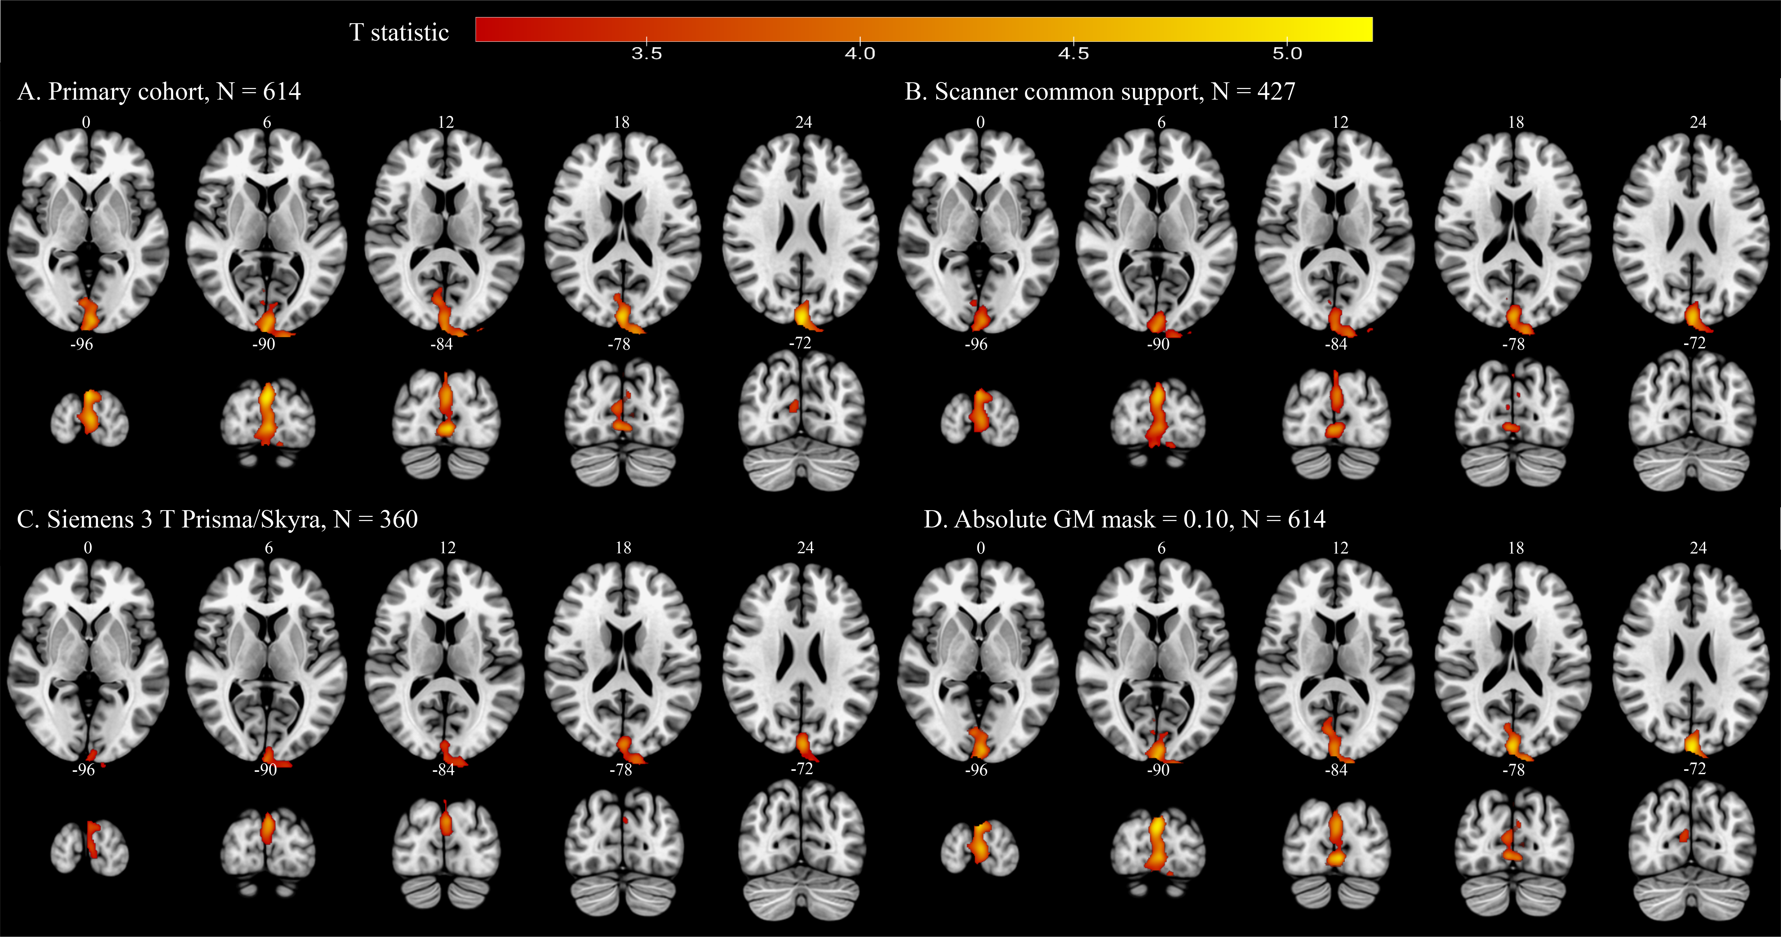
Supplementary Figure S1. Scanner-family and gray-matter mask sensitivity of the posterior phenotype contrast. Directional Hyposmia-only > RBD-only T-statistic maps are shown for (A) the primary phenotype cohort (N = 614; absolute GM mask 0.05), (B) the scanner common-support cohort (N = 427), (C) the Siemens PRISMA/SKYRA-restricted cohort (N = 360), and (D) the primary cohort with an absolute GM mask of 0.10 (N = 614). All panels reproduce the original maps; these sensitivity analyses are not independent cohorts. Displayed suprathreshold regions should be interpreted together with their exact cluster-level FWE results in Supplementary Table S2.

Supplementary Figure S2
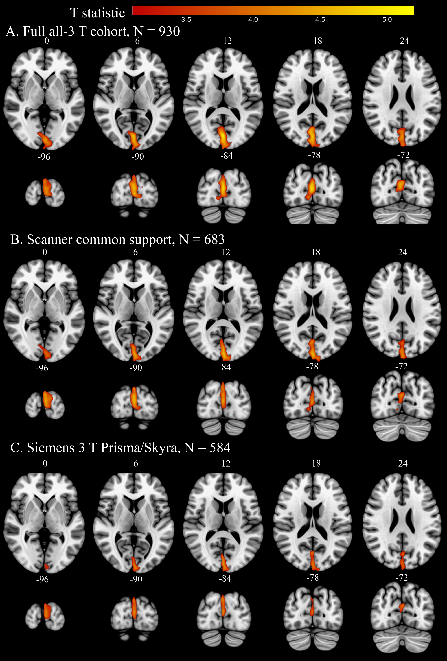
Supplementary Figure S2. Disease-context voxel-based morphometry analyses involving manifest Parkinson disease (PD). Hyposmia-only versus PD showed posterior cortical differences in the full all-3T post-2020 sample (N = 930) and scanner-restricted subsets. RBD-only versus PD results were less stable across scanner restrictions: a corrected left striatal-region finding was observed in the scanner common-support subset (N = 683), but not in the full N = 930 comparison. Refer to Supplementary Tables S1 and S2 for cohort composition, cluster statistics, and multiplicity adjustment. These disease-context analyses are secondary and do not establish a progression trajectory.

