C. albicans incorporates methaemoglobin into surface attached and aggregate biofilms that exhibit increased virulence and antifungal resistance.

Deshmukh-Reeves, E¹. Provatas, A². Bragg, J¹. Binder B. J²., Gourlay C. W.^{1*}

Supplementary Data:

Supplementary Table 1: Strains and isolates.
Organism | Strain | Genotype/Parent
Candida albicans | SC5314 | Common wild-type. Originally isolated from bloodstream infection.
Candida albicans | SN250  (Noble KO library reference strain) | Δura3::imm434/URA3 Δiro1::imm434/IRO1 Δhis1::hisG/Δhis1::hisG Δleu2::CmLEU2/Δleu2::CdHIS1 arg4/arg4
Candida albicans | SN152  (Homann TFKO reference strain) | URA3/Δura3::imm434 IRO1/Δiro1::imm434 Δhis1::hisG/Δhis1::hisG LEU2/LEU2 ARG4/ARG4
Candida albicans | fRS29 x fRS32  (Diploid Shaprio Adhesin KO wild-type) | MATa/α his4Δ/his4Δ ura3::HIS4/ura3::imm434 gal1::URA3/+
Candida albicans | TFKO library | SN152
Candida albicans | Noble KO library | SN250
Candida albicans | Adhesin KO library | fRS29 x fRS32
Candida albicans | KVP-001 | Isolate from failed voice prosthesis – provided by East Kent Hospital University Foundation Trust
Candida albicans | KVP-002 | Isolate from failed voice prosthesis – provided by East Kent Hospital University Foundation Trust
Candida albicans | KVP-003 | Isolate from failed voice prosthesis – provided by East Kent Hospital University Foundation Trust

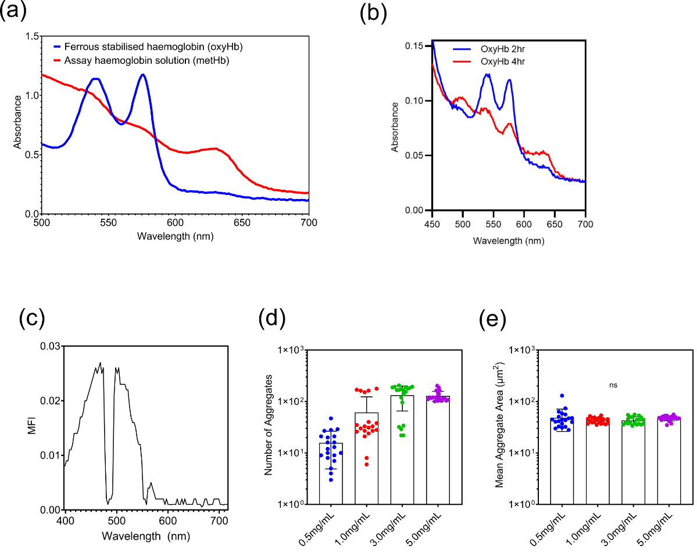
Supplementary Figure 1: Cell free haemoglobin analysis. (a) Absorbance spectroscopy of standard 0.3 % haemoglobin solutions and ferrous stabilised solutions in RPMI-1640 to confirm redox state. (b) Ferrous stabilised (oxyHb) solutions incubated in RPMI-1640 for 2 and 4 hours with oxidation to metHb demonstrated at 4 hours, 37 °C, 180RPM. (c) MetHb solutions analysed by lambda scanning with an excitation of 561 nm. (d, e) Increasing concentrations of cell free metHb solutions incubated for 4 hours at 37 °C, 180RPM and quantified by image analysis. (d) Number of aggregates per field of view. (e) Mean area of aggregates formed in cell free preparations. Data points depict technical replicates.

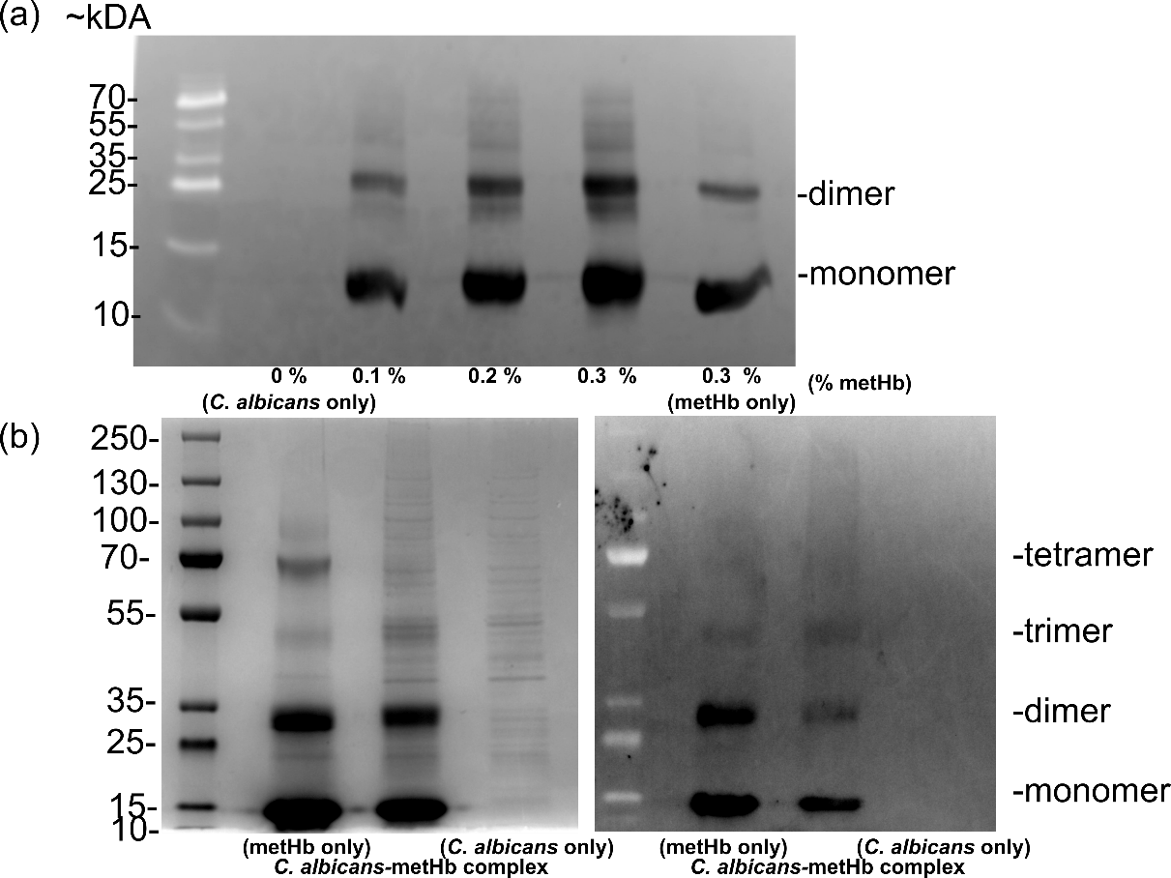
Supplementary Figure 2: Protein analysis of MetHb aggregates and C. albicans-MetHb complexes. Western blots of protein extracts were probed using anti-haemoglobin-FITC (a) Total protein extracts from C. albicans-metHb complexes formed in increasing concentrations of metHb bands at ~15kDA and 30 correspond to haemoglobin subunit monomers and dimers. (b) MetHb (cell free) or C. albicans incubated in 0.3 % MetHb for 4 hours at 37 °C 180 RPM. Aggregates were then isolated by centrifugation and total protein extracted for analysis by SDS-PAGE. (left) Coomassie stain and (right) western blot, of metHb aggregates (cell free) and C. albicans-MetHb complexes. The monomer, dimer and trimers of the haemoglobin subunits are visible on both Coomassie and western blot with the tetramer form only visible by Coomassie in the metHb only (cell free) condition.

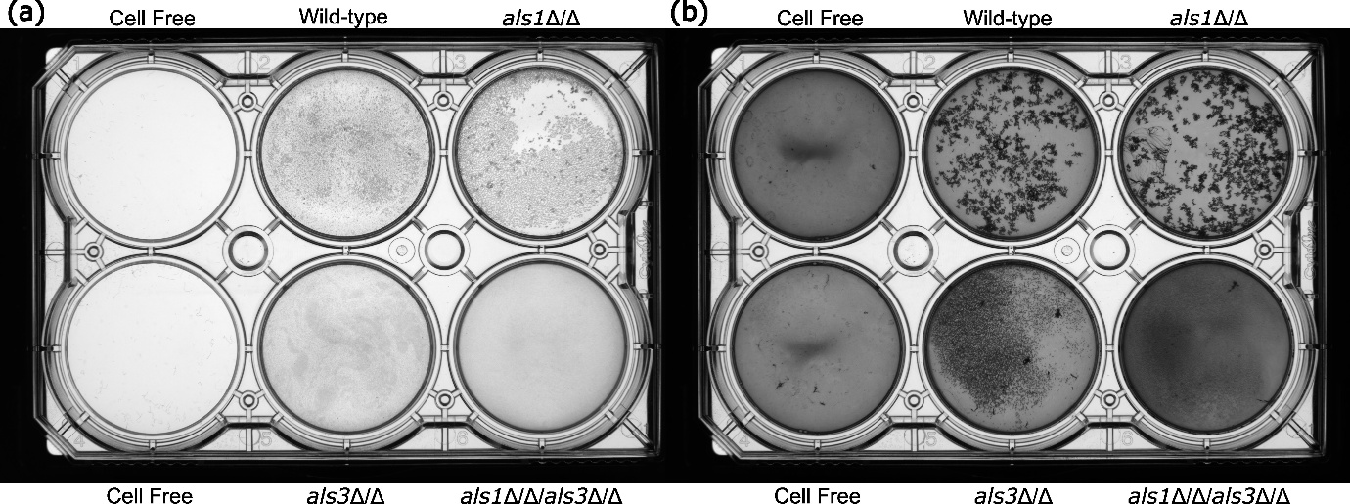
Supplementary Figure 3: Whole well imaging of C. albicans-MetHb complexes and adhesin deletion strains. C. albicans strains were grown for 4 hours in RPMI-1640 ± 0.3 % metHb in 6 well plates. Plates were imaged using a ColonyCam Silhouette (Singer) system. Equivalent imaging parameters and brightness/contrast were used for all conditions. (a) C. albicans strains in RPMI-1640. (b) C. albicans strains in RPMI-1640 + 0.3 % metHb.

