Supplementary Materials to: Development and in vivo characterization of the first peptide-based ^{99m}Tc-Nitrido-radiopharmaceuticals for FAP-targeted SPECT imaging
J. Kleynhans^{1,2}*, N. Salvarese³, C. Gobbi³, C.M. Deroose⁴, F. Cleeren¹ C. Bolzati³*
¹Laboratory for Radiopharmaceutical Research, Catholic University of Leuven, Leuven, Belgium
²Department of Nuclear Chemistry, Faculty of Nuclear Sciences and Physical Engineering, Czech Technical University in Prague, Prague, Czech Republic
³Institute of Condensed Matter Chemistry and Energy Technologies, Padova, Italy
⁴Division of Nuclear Medicine, University Hospital Leuven, Leuven, Belgium
Co-corresponding authors: J Kleynhans: kleynjan@cvut.cz; C. Bolzati: cristina.bolzati@cnr.it
SUPPLEMENTARY MATERIALS
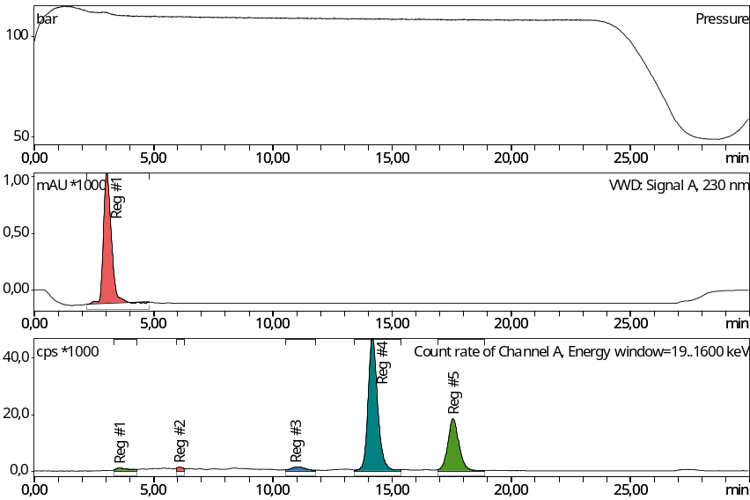
Supplement A1: Representative radio-HPLC chromatograms crude [^{99m}Tc][Tc(N]PNP3]-cysFAP (region 4: 63.59%, region 5: 29.77%).
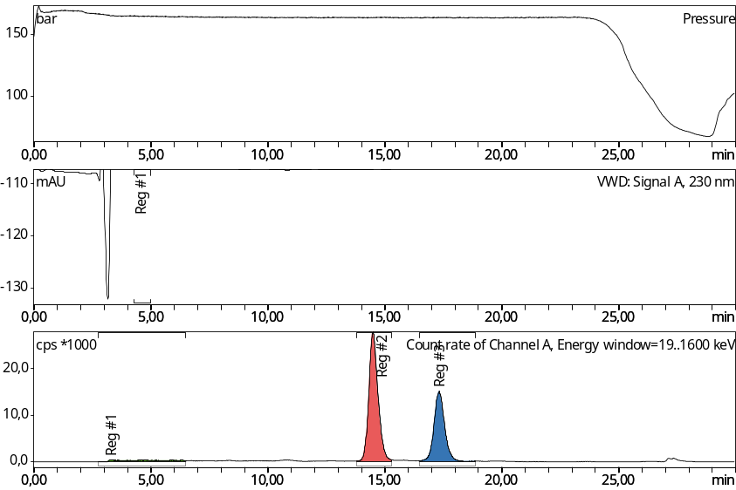
Supplement A2: Representative radio-HPLC chromatograms Purified [^{99m}Tc][Tc(N]PNP3]-cysFAP (region 2: 58.92%, region 3: 36.88%).
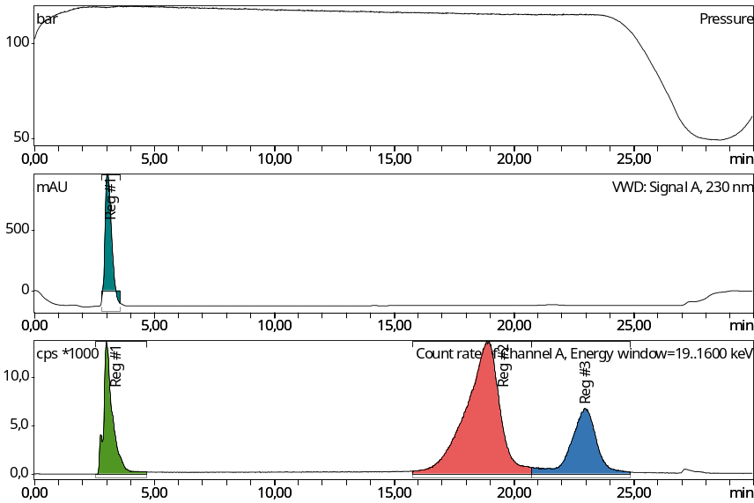
Supplement A3: Representative radio-HPLC chromatograms crude [^{99m}Tc][Tc(N]PNP3OH]-cysFAP (region 2: 60.94%, region 3: 23.03%).
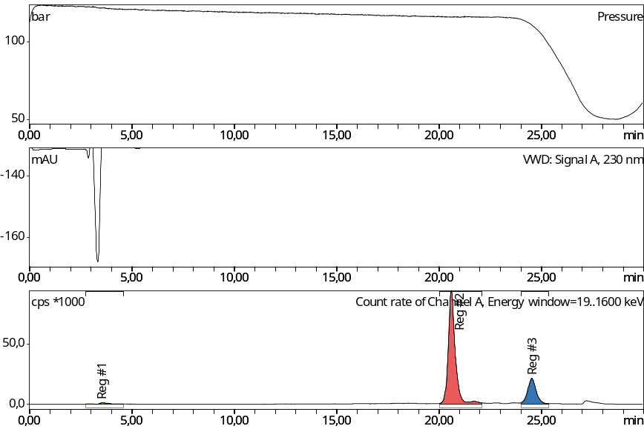
Supplement A4: Representative radio-HPLC chromatograms Purified [^{99m}Tc][Tc(N)]PNP3OH]-cysFAP (region 2: 76.87%, region 3: 21.57%).
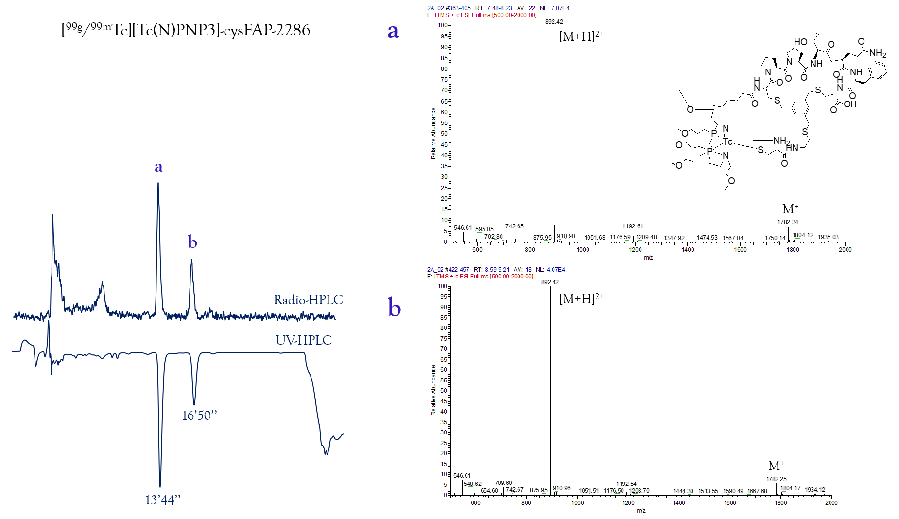
Figure Supplement B1: [^{99g/99m}Tc][Tc(N]PNP3]-cysFAP, dual UV/radiometric HPLC profiling showed co-eluting peaks
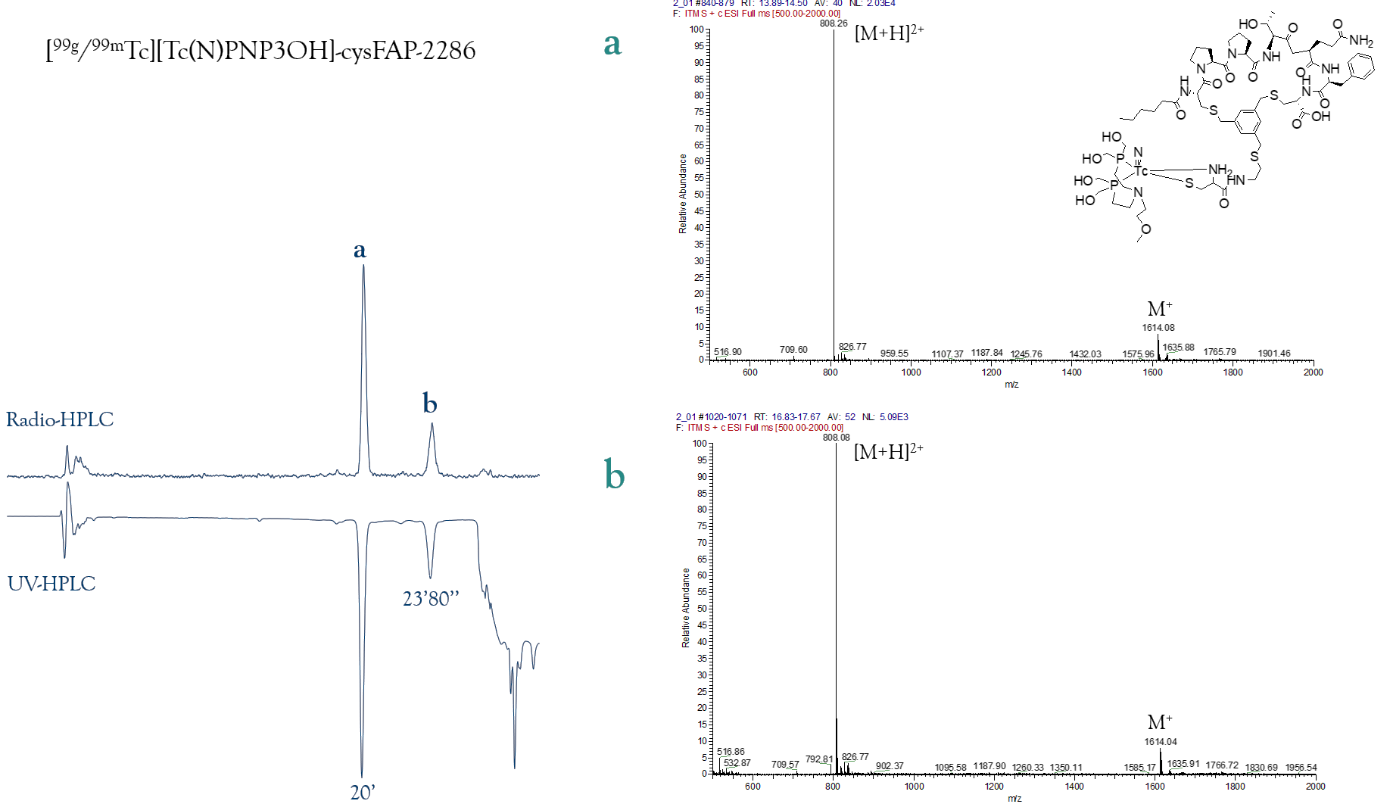
Figure Supplement B2: [^{99g/99m}Tc][Tc(N]PNP3OH]-cysFAP, dual UV/radiometric HPLC profiling showed co-eluting peaks
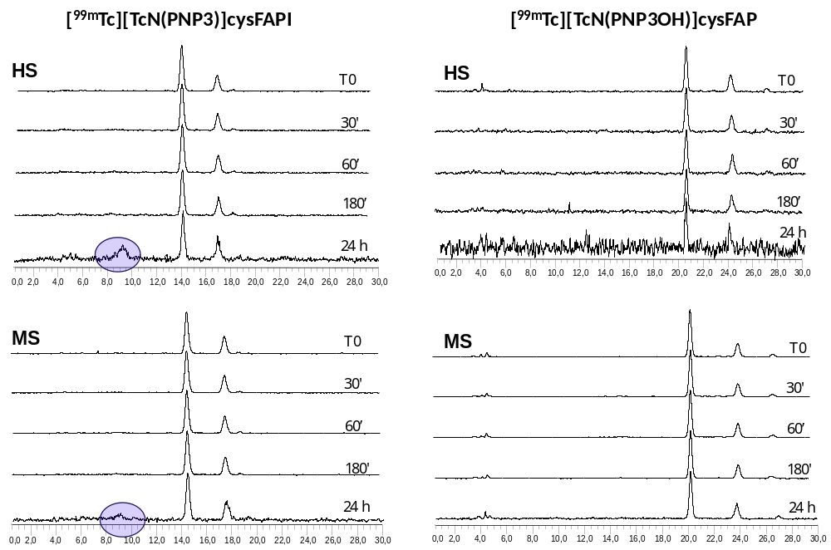
Supplement C1: Radio-HPLC chromatograms of [^{99m}Tc][Tc(N]PNP3]-cysFAP and [^{99m}Tc][Tc(N]PNP3OH]-cysFAP after inbation in human serum (HS) and mouse serum (MS).
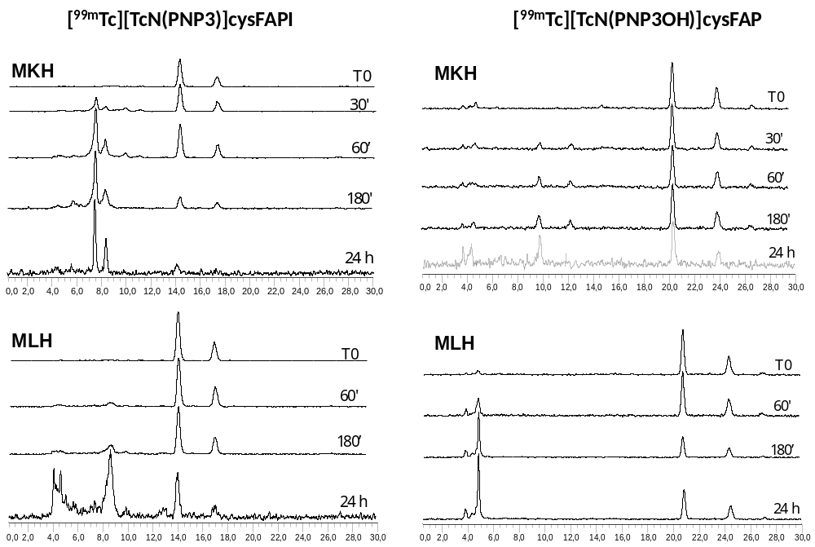
Supplement C2: Radio-HPLC chromatograms of [^{99m}Tc][Tc(N]PNP3]-cysFAP and [^{99m}Tc][Tc(N]PNP3OH]-cysFAP after incubation in muose kidney (MKH) and liver (MLH) homogenate .
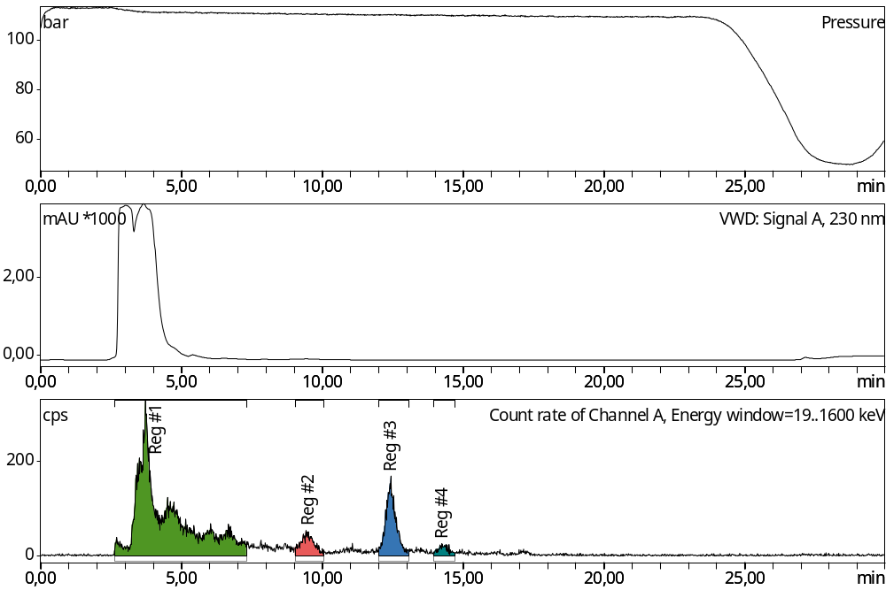
Supplement C3: Representative radio-HPLC chromatograms urinary sample [^{99m}Tc][Tc(N]PNP3]-cysFAP

Supplement C4: Representative radio-HPLC chromatograms serum sample [^{99m}Tc][Tc(N]PNP3]-cysFAP

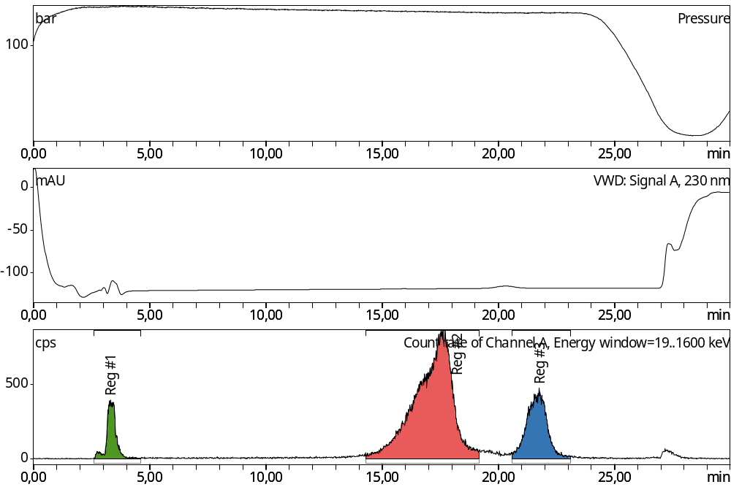
Supplement C5: Representative radio-HPLC chromatograms urinary sample [^{99m}Tc][Tc(N]PNP3OH]-cysFAP

Supplement C6: Representative radio-HPLC chromatograms serum sample [^{99m}Tc][Tc(N]PNP3OH]-cysFAP

