Supplementary Information

S1. Chemicals and Materials
Poly(vinylidene fluoride) (PVDF; Mw 275 kDa, Mn 107 kDa), polyvinylpyrrolidone K30 (PVP-K30; Mw 40 kDa), cobalt(II) acetate tetrahydrate (Co(CH₃COO)₂·4H₂O, 99%), tetrabutyl titanate (Ti(OC₄H₉)₄, 97%), tetraisopropyl titanate (Ti(OC₃H₇)₄, 99%), ethylene glycol (EG), tetracycline hydrochloride (99%), N,N-dimethylacetamide (DMAc, ≥99%), humic acid (technical grade), sodium hydroxide (NaOH), and hydrochloric acid (HCl, 36.5%) were purchased from Sigma-Aldrich (Germany). Graphene powder was obtained from Alfa Aesar (UK). Absolute ethanol (99.95%) was used as received. All chemicals were of analytical grade and used without further purification.
S1. Synthesis of holey graphene (HGN)
In a typical synthesis procedure, 1.0 g graphene (GN) (Alfa Aesar, UK) was placed into alumina crucible and heated in a muffle furnace at 400ºC with a heating ramp of 5°C min⁻¹ for 3 h under the atmospheric air environment (Scheme S1). Holey GN (HGN) black powder was obtained upon cooling to RT and stored in an air-tight vessel. SEM, TEM, TGA, and Raman analysis was performed to characterized GN and HGN.
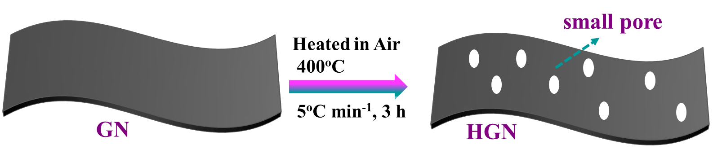
Scheme S1. Schematic illustration for synthesis of HGN from GN via a controlled air oxidation.
S2. Characterization of CoTiO₃, CoTiO₃/TiO₂ and HGN-CoTiO₃/TiO₂ nanocomposites
The surface textures of CoTiO₃, CoTiO₃/TiO₂, and HGN-CoTiO₃/TiO₂ were characterized using a field emission scanning electron microscope (Nano SEM 650, FEI Co., USA). SEM images were acquired at different magnifications and acceleration voltage. The elemental composition of calcined CoTiO₃ was determined using an energy-dispersive X-ray (EDX) spectrometer connected to NovaNano SEM 650. Thermogravimetric analysis (TGA) was conducted on a Netzsch STA 449F5 instrument over the temperature range of 50 to 800ºC at a 10ºC min⁻¹ heating rate in a zero-air atmosphere. X-ray diffraction analysis was done in the range of 5 to 80º with 0.1º step increments using an X-ray diffractometer (Empyrean, PANalytical) with Cu K_{α} radiation source (λ = 1.54 Å) at 40 kV and 45 mA. The zeta potentiometer (ZetaSizer Nano-ZS, Malvern Co., UK) was applied to determine the particle size and zeta potential of 0.2 mg mL⁻¹ suspension for each sample in water. The N₂ adsorption-desorption analysis was conducted on a BET Nova 800 instrument. The degassing of samples was carried out at 150ºC for 3 h, and subsequently, N₂ adsorption-desorption isotherms were recorded at 77 K. The surface area and the pore volume were calculated by the Brunauer-Emmett-Teller (BET) model and the Barrett-Joyner-Halenda (BJH) method. Raman analysis was conducted on a confocal Raman spectroscope with a 532 nm laser of 52 mW single-mode output power (Witec Alpha 300R). Raman spectra were acquired in the range of 100 to 3000 cm⁻¹ for 100 scans with 1.0 sec scanning time. The UV-Vis diffuse reflectance spectroscopy (UV-DRS) spectra were recorded over a wide range from 200 to 700 nm using a UV-Vis spectrophotometer (PerkinElmer Lambda 950). Transmission electron microscopy (TEM) images were scanned using a Tecnai transmission electron microscope at 200 kV. The well-dispersed suspension of each sample with 0.2 mg mL⁻¹ was dropped on a 300-mesh carbon-coated Cu grid and dried in a vacuum oven for 5 min at 40ºC. The chemical compositions and elements valence states were analysed by X-ray photoelectron spectroscopy measurements on a Thermo Scientific Escalab Xi⁺ X-ray photoelectron spectrometer linked to a monochromatic Al Kα radiation source of 1486.6 eV.
S3. Synthesis HGN–CoTiO₃/TiO₂ Nanocomposites
Perovskite CoTiO₃ was synthesized through a sol–gel using Co(CH₃COO)₂·4H₂O and Ti(OC₄H₉)₄ in ethylene glycol (EG) as a structure-directing solvent^{S1,S2}. Briefly, 10 mmol Co(CH₃COO)₂·4H₂O was dissolved in 60 mL EG under stirring (300 rpm). Subsequently, 10 mmol Ti(OC₄H₉)₄ was added dropwise to form a homogeneous pink solution. The mixture was stirred for 24 h at room temperature (RT), resulting in a light pink precipitate. The precipitate was collected by vacuum filtration, washed alternately with ethanol via centrifugation–redispersion cycles, and dried at 70°C for 12 h (Fig. S1a). The dried powder was ground and calcined in air at a heating rate of 5°C min⁻¹ for 3 h within the temperature range 400-800°C. After cooling to RT, green CoTiO₃ powder was stored in airtight vessel (Fig. S1b). Calcined CoTiO₃ (CoTiO₃-700) was used to prepare CoTiO₃/TiO₂ via hydrothermal treatment. TiO₂ was first generated by adding 10 mmol Ti(OC₃H₇)₄ dropwise into 40 mL DI water under vigorous stirring (500 rpm), forming a white suspension within 30 min. Subsequently, 10 wt.% CoTiO₃-700 (relative to TiO₂ mass) was dispersed into the suspension and stirred for 1 h. The mixture was transferred into a 200 mL Teflon-lined stainless-steel autoclave and heated at 180°C for 14 h^{S3}. The resulting product was centrifuged three times with ethanol and dried overnight at 80°C to obtain CoTiO₃/TiO₂ powder (Fig. S1c).
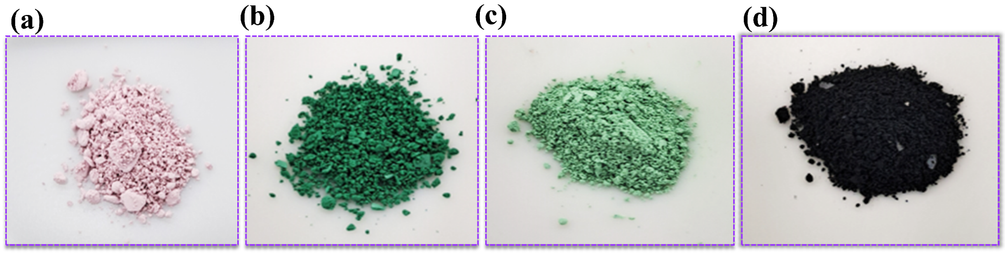Fig. S1. Digital pictures of: (a) CoTiO₃; (b) calcinated CoTiO₃; (c) CoTiO₃/TiO₂ and (d) HGN-CoTiO₃/TiO₂-30 nanocomposite.
Ternary nanocomposites were prepared by integrating HGN with CoTiO₃/TiO₂ at different weight ratios (10, 20, and 30 wt.% HGN). The respective amounts of HGN and CoTiO₃/TiO₂ were ultrasonicated in ethanol for 1 h to ensure homogeneous dispersion. The suspensions were transferred into autoclaves and treated at 180°C for 12 h. The products were recovered by centrifugation, washed with ethanol, and dried to yield HGN–CoTiO₃/TiO₂-10, 20, or 30 (Fig. S1d). Detailed characterization procedures for the nanocomposite are provided in Section S2.
S4. Photocatalytic Performance Evaluation
Photocatalytic degradation experiments were conducted using a 150 W UV-LED system (Bettsens Industrial Co., Ltd., China). For each test, 100 mg of HGN–CoTiO₃/TiO₂ nanocomposites was dispersed in 200 mL of 50 ppm antibiotic solution (TCL or CFL) in a glass reactor under magnetic stirring. Prior to irradiation, suspensions were stirred in the dark for 60 min to establish adsorption–desorption equilibrium. UV irradiation was then applied at 25°C (temperature maintained using a water recirculation system). At 10 min intervals, 4 mL aliquots were withdrawn, filtered through 0.22 μm nylon syringe filters, and analyzed using a UV–Vis spectrophotometer (Shimadzu, Japan) at 357 nm (TCL) and 275 nm (CFL)^{S4,S5}. Reusability tests were performed for the optimal HGN–CoTiO₃/TiO₂-30 sample. After each cycle, the catalyst was recovered via vacuum filtration, washed alternately with ethanol and water, dried at 60°C, and reused. Photocatalytic performance was further evaluated in antibiotic-spiked hospital wastewater (HWW) from hospitals in Abu Dhabi, UAE. The wastewater was prefiltered using a Stericup® vacuum filtration system. TCL or CFL (25 ppm) was spiked into pretreated HWW and ultrasonicated for 1 h. The photocatalyst was added, and the suspension was irradiated under UV for 2 h with continuous stirring (200 rpm). Removal efficiency (R_{A}) was calculated using Eq. S1:
$$R_{A }\left(\%\right)=\frac{C_{o}-C_{t}}{C_{o}} ×100 (S1)$$
C₀​ and C_{t}​ are the initial and final concentration of antibiotic^{S6}.

S5. Fabrication of Hybrid Membranes
Hybrid membranes were fabricated via the non-solvent induced phase separation (NIPS) method^{S7-10}. HGN–CoTiO₃/TiO₂-30 nanocomposite was first dispersed in DMAc via ultrasonication (40 kHz, 1 h). PVDF (16 wt.%) and PVP-K30 (2 wt.%) were subsequently dissolved at 70°C under stirring for 6 h. The casting solution was stirred for an additional 24 h at RT and degassed under vacuum for 3 h. The homogeneous solution was cast onto a PET-PBT support (Novatexx 2483, Freudenberg, Germany) using an automatic film applicator (Elcometer 4340, UK) with a 300 μm gap. The cast film was immediately immersed in a DI water coagulation bath for 30 min, the resulting membranes were washed and stored in fresh water for 24 h to remove residual solvent. The wet membranes were finally dried in air at RT. Membranes with 0.5–2 wt.% of HGN–CoTiO₃/TiO₂-30 were fabricated similarly, which were labeled as MTG05, MTG1, and MTG2. Pristine PVDF membrane, MTG0 was also fabricated without integration of HGN–CoTiO₃/TiO₂-30 nanocomposite. The compositions of blend solutions are provided in Table S1. Unsupported membranes were prepared for TGA and mechanical testing.
S6. Membranes characterization
The porosity was measured by a gravimetric method using the weight of dried and wet membranes according to the Eq. (S1)^{S7,S10}:
$${ ε}_{m }=\frac{W_{w}-W_{d}}{S × d × ρ_{water}} ×100 (S1)$$
W_{w} is the weight of the wet membrane (g), W_{d} is the weight of the dry membrane (g), S is the membrane area (cm²), d is the average membrane thickness (cm), and ρ_{water} is the density of water (g cm⁻ ³).

Table S1. The composition of the blend solutions for hybrid membranes fabrication and their digital images.
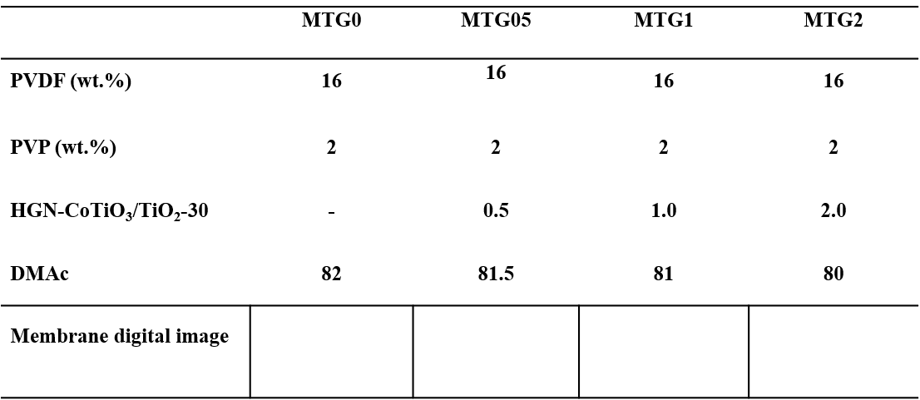
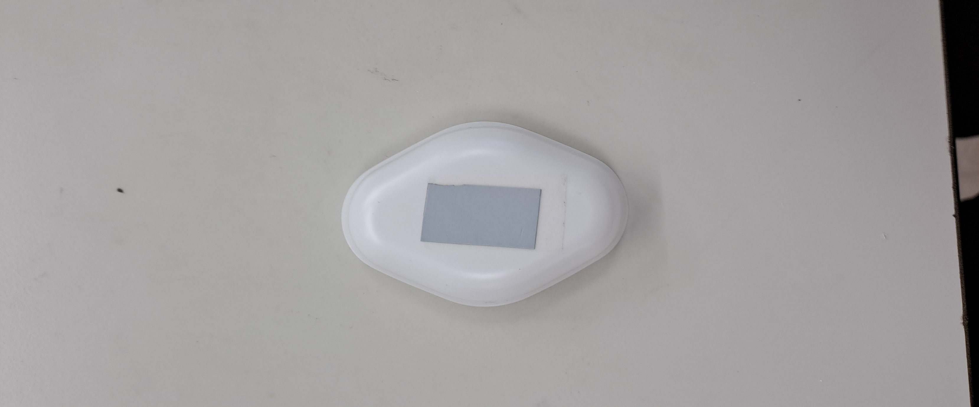
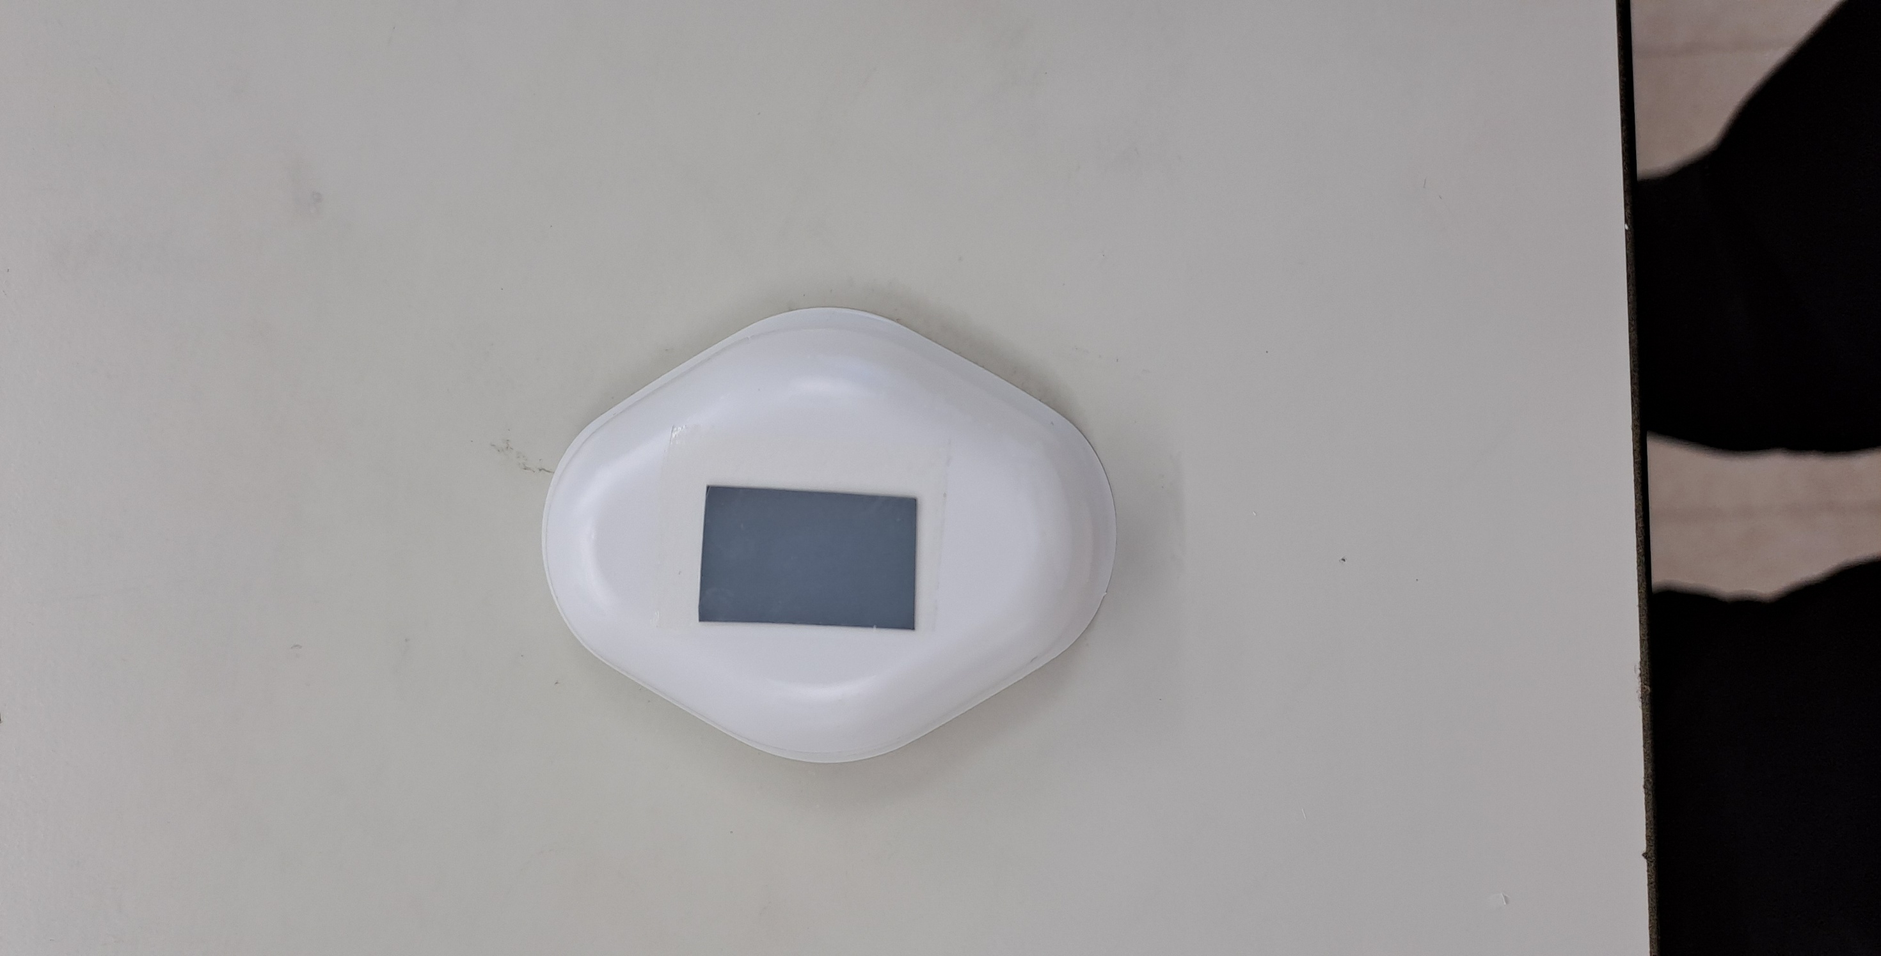
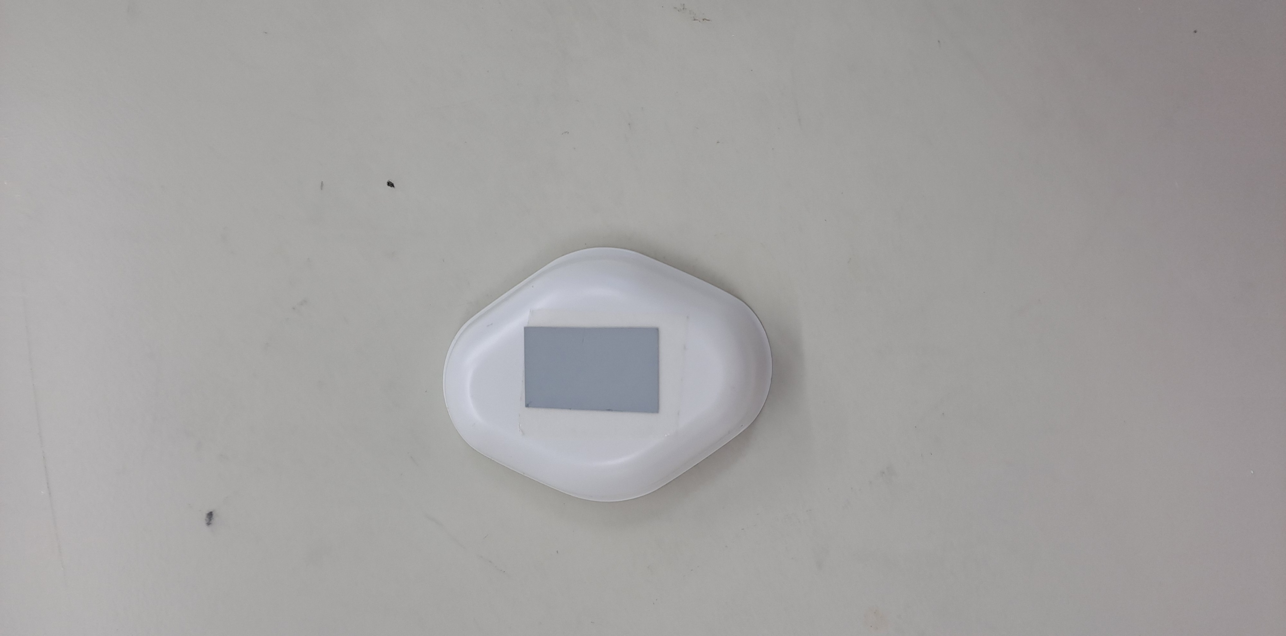
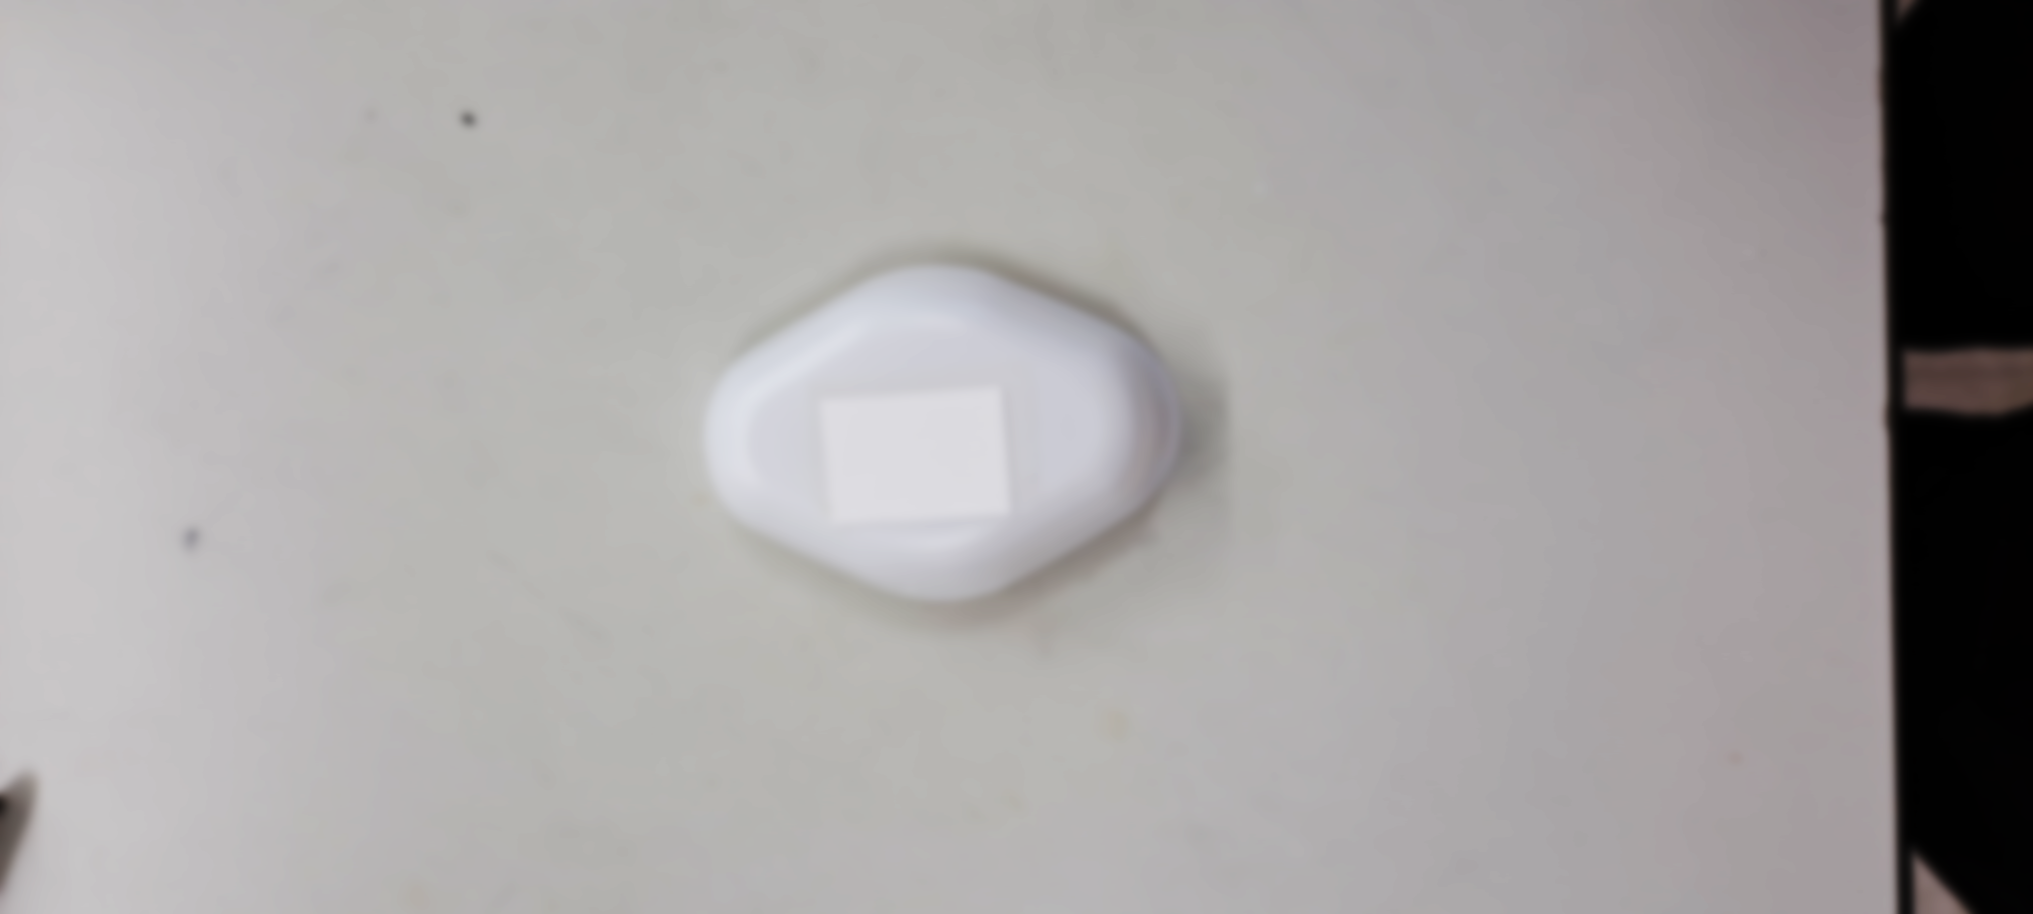

The surface morphology of membranes was examined using a scanning electron microscope (Nova Nano SEM 650, FEI Co., USA). A multistep solvent-exchange was performed to prevent membrane pore collapse upon drying at RT^{S11}. All membrane coupons mounted on SEM stubs were coated with a 10 nm Au-Pd ultrathin layer in a vacuum using a sputtering machine. The surface SEM images were acquired at an accelerating voltage of 5.0 kV and scanning scales of 1.0 and 5.0 µm. An electrokinetic analyser (SurPASS, Anton Paar, Austria) was utilized to measure the surface zeta potential (ζ; mV) of each membrane at pH 7.0. The thermal stability and loading content of HGN-CoTiO₃/TiO₂-30 within the membranes were assessed by TGA in the range of 50 to 650ºC on a Netzsch STA 449F5 Jupiter instrument at a 10ºC min⁻¹ heating rate under zero-air atmosphere. The mechanical strength was determined using a tensile strength testing machine (5960 series, Instron, USA). The membrane surface water wettability was measured using a contact angle analyser (Krüss, Germany). Water contact angle (WCA) measurements were conducted at least five locations on each membrane surface, and the average WCA values were reported. The surface free energy (-ΔG_{SL}, mJ m⁻²) was determined from WCA values using the Young-Dupre Eqn. (S2)^{S10,S12}:
$$-G_{SL}=\left(1+cos\right){}_{L }^{T }(S2)$$
where θ is the water CA (deg.) and ${}_{L}^{T}$is the surface tension of water (72.8 mJ m⁻²).

S7. Pure Water Flux, HA Rejection, Antifouling, Self-Cleaning, and Antibiotic Removal efficiency of the membranes
Pure water flux was measured using a dead-end ultrafiltration (UF) system (UHP 4370, Sterlitech Co., USA). Circular wet membrane coupons (44 mm diameter) were mounted in the UF cell connected to a 5 L stainless-steel feed reservoir and pressurized using N₂ gas. Prior to measurement, membranes were pre-compacted at 2.0 bar for 1 h. Subsequently, pure water filtration was conducted at a constant feed pressure of 1.0 bar for 1 h, and the permeate was collected. The mass of permeate was recorded using a digital analytical weighing balance (Ohaus, UK). The pure water flux (J_{w}; L m⁻² h⁻¹ bar⁻¹) was calculated according to Eq. S2^{S10,S13}:
$$J_{w }= \frac{∆m}{ρ_{w}× A_{m}× ∆t × ∆P } (S2)$$
Δm is the mass of permeated water (g), ρ_{w} is the density of water (g cm⁻³), A_{m} is the effective membrane area (m²), Δt is the filtration time (h), and ΔP is the applied pressure (bar).
HA rejection performance was evaluated by filtering a 10 ppm HA aqueous solution at 1 bar for 24 h. To minimize concentration polarization effects, the feed solution was stirred at 400 rpm throughout filtration. The permeate flux during HA filtration (J_{HA}) was recorded. The HA concentration in feed and permeate was determined by measuring absorbance at 254 nm wavelength using a UV–Vis spectrophotometer. The rejection efficiency (R_{HA}; %) was calculated using Eq. S3^{S9,S10}:
$$R_{HA }\left(\%\right)= \frac{\left(C_{f}^{o}-C_{permeate}^{t}\right)}{C_{f}^{o}} ×100 (3)$$
where $C_{f}^{0}$ and $C_{permeate}^{t}$ represent the concentrations of HA in the feed and permeate.
UV-assisted self-cleaning properties were investigated using sequential filtration of DI water and HA solution. Initially, DI water was filtered for 1 h at 1.0 bar to J_{w}. Subsequently, 10 ppm HA solution was filtered for 24 h under identical feed pressure, and the fouled membrane flux (J_{HA}) was recorded. Following fouling, membranes were rinsed inside the filtration cell with DI water for 30 min at 300 rpm stirring. The post-cleaning water flux (J_{w,pc}) was measured during 1 h water filtration at 1.0 bar. DI water cleaned membranes were removed and consequently irradiated under UV light for 30 min to assess photocatalytic self-cleaning. The water flux after UV treatment (J_{w, UV}) was then measured, while the flux recovery ratio (FRR), reversible fouling ratio (R_{r}), irreversible fouling ratio (R_{ir}), and total fouling ratio (R_{t}) were calculated using Eqs. S4–S7^{S9,S10,S13,S14}:
$$FRR \left(\%\right)= \frac{J_{w, UV}}{J_{w}} ×100 (S4)$$
$$R_{r} \left(\%\right)= \frac{J_{w, UV}-J_{HA}}{J_{w}} (S5)$$
$$R_{ir }\left(\%\right)= \frac{J_{w}-J_{w, UV}}{J_{w}} \left(S6\right)$$
$$R_{t}\left(\%\right)= R_{r}+R_{ir } (S7)$$
Furthermore, the photocatalytic degradation of TCL using hybrid membranes was evaluated under UV irradiation. A membrane coupon (MTG2; effective area 30 cm²) was fixed at the bottom of a reactor, and 200 mL of 20 ppm TCL solution was then added. The system was kept inside the dark for 30 min to reach adsorption–desorption equilibrium. The reactor was then exposed to UV light at 25°C for 180 min. At every 20 min interval, 3 mL aliquot was withdrawn, and absorbance was recorded at 357 nm using UV–Vis spectrophotometer to determine the concentration of TCL in feed and UV exposed TCL solution. Identical experimental conditions were maintained in the case of other membrane samples for comparison purpose.

S8. Characterization of CoTiO₃, CoTiO₃/TiO₂, and HGN–CoTiO₃/TiO₂

The thermal evolution of uncalcined CoTiO₃ precursor is shown in Fig. S2a. A first-stage mass loss of 11.8% occurred below 200°C, followed by two major weight-loss steps at 203–250°C and 268–376°C, giving an overall mass loss of 51.2%. These losses are attributed to combustion of residual organic species and intermediate formation (e.g., carbonate and Ti-complex species) during conversion toward the perovskite phase. A final stage between 376 and 667°C corresponds to the formation of ilmenite CoTiO₃^{S1}. No substantial mass change beyond 700°C indicates completion of crystallization and supports 700°C as an optimal calcination temperature. Consistent with this, DSC exhibited endothermic/exothermic events at ~230°C and 363°C, assigned to organic decomposition and CoTiO₃ crystallization, respectively^{S1}. The SEM image (Fig. S2b) shows that CoTiO₃-700 forms a porous rod-like morphology. SEM-EDX confirms the presence of Co (40.3 wt.%), Ti (33.9 wt.%), and O (24 wt.%) (Fig. S2c), consistent with CoTiO₃ formation. To identify a suitable temperature to transform graphene (GN) into holey graphene (HGN), TGA was performed under zero-air (Fig. S2d). GN began degrading above 300°C, and ~10 wt.% loss occurred at 400°C, supporting controlled oxidation at 400°C to generate porosity while preserving the carbon framework. Thermal stability and composition trends of CoTiO₃/TiO₂ and HGN–CoTiO₃/TiO₂ composites were also examined (Fig. S2d). HGN–CoTiO₃/TiO₂ exhibited two-stage weight-loss behaviour, while the char residue at 800°C increased with increasing CoTiO₃/TiO₂ content, indicating improved thermal stability and successful integration of HGN with CoTiO₃/TiO₂ via hydrothermal treatment at 180°C
Fig. S2. (a) TGA/DSC profiles of uncalcined CoTiO₃ precursor. (b) SEM image and (c) EDX spectrum of CoTiO₃-700. (d) TGA profiles of GN, CoTiO₃/TiO₂, and HGN–CoTiO₃/TiO₂ composites, (e) Zeta potential (ζ) at pH 7 and (f) particle-size distributions (DLS) of HGN, CoTiO₃/TiO₂, and HGN–CoTiO₃/TiO₂-30.
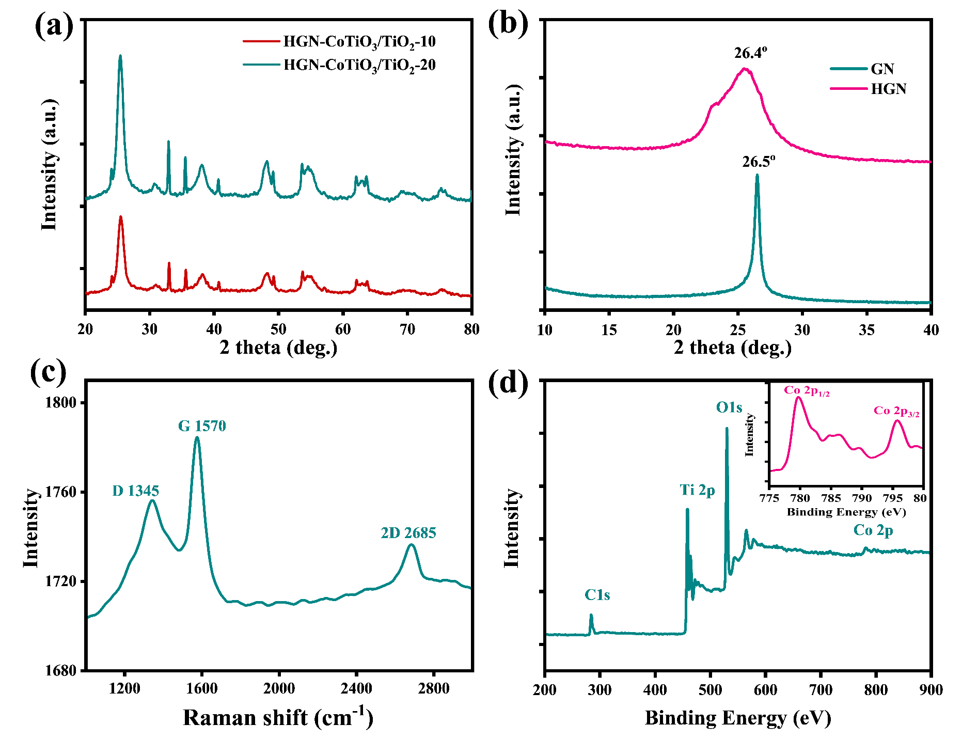
Fig. S3. (a) XRD patterns of HGN-CoTiO₃/TiO₂-10 and HGN-CoTiO₃/TiO₂-20; (b) XRD patterns of GN and HGN; (c) Raman spectrum of HGN and (d) XPS survey scan of CoTiO₃/TiO₂ nanocomposite.

Fig. S4. Raman spectrum of CoTiO₃/TiO₂ nanocomposite.
.

Fig. S5. (a) TGA; (b) the tensile strength versus tensile strain profiles of membranes with different wt.% HGN-CoTiO₃/TiO₂-30 and (c) UV-Vis spectra of 20 ppm TCL and 180 min UV irradiation.
Fig. S6. (a–d) UV–Vis spectra and adsorption behavior of TCL and CFL during dark equilibration using HGN–CoTiO₃/TiO₂-30. (e) Antibiotic removal efficiency (R_{A}, %) of CoTiO₃, CoTiO₃/TiO₂, and HGN–CoTiO₃/TiO₂ composites during 60 min dark adsorption followed by UV irradiation (50 ppm TCL or CFL). (f) Effect of HGN loading (10–30 wt.%) on photocatalytic removal efficiency.
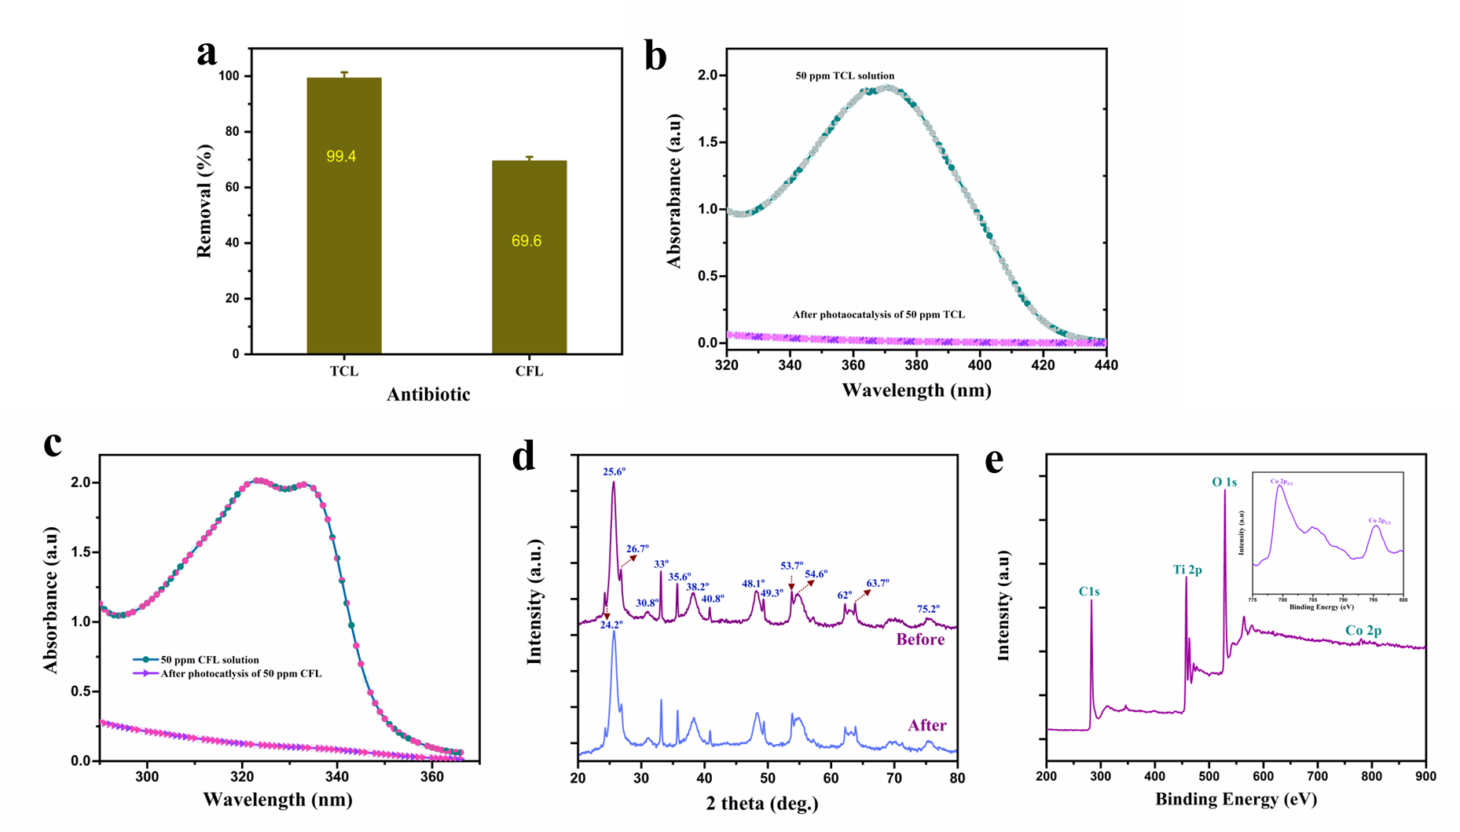
Fig. S7. (a) Removal efficiency of HGN (%) for 50 ppm TCL or CFL solution; (b) UV-Vis spectra of 50 ppm TCL solution and after adsorption-photocatalysis; (c) UV-Vis spectra of 50 ppm CFL and after adsorption-photocatalysis using HGN-CoTiO₃/TiO₂-30; (d) XRD patterns of fresh and used HGN-CoTiO₃/TiO₂-30 and (e) XPS survey spectrum of HGN-CoTiO₃/TiO₂-30 nanocomposite after use in photocatalysis.

Table S2. The comparative performance the hybrid membrane developed in this work with other reported self-cleaning hybrid membranes^{S15-S21}. 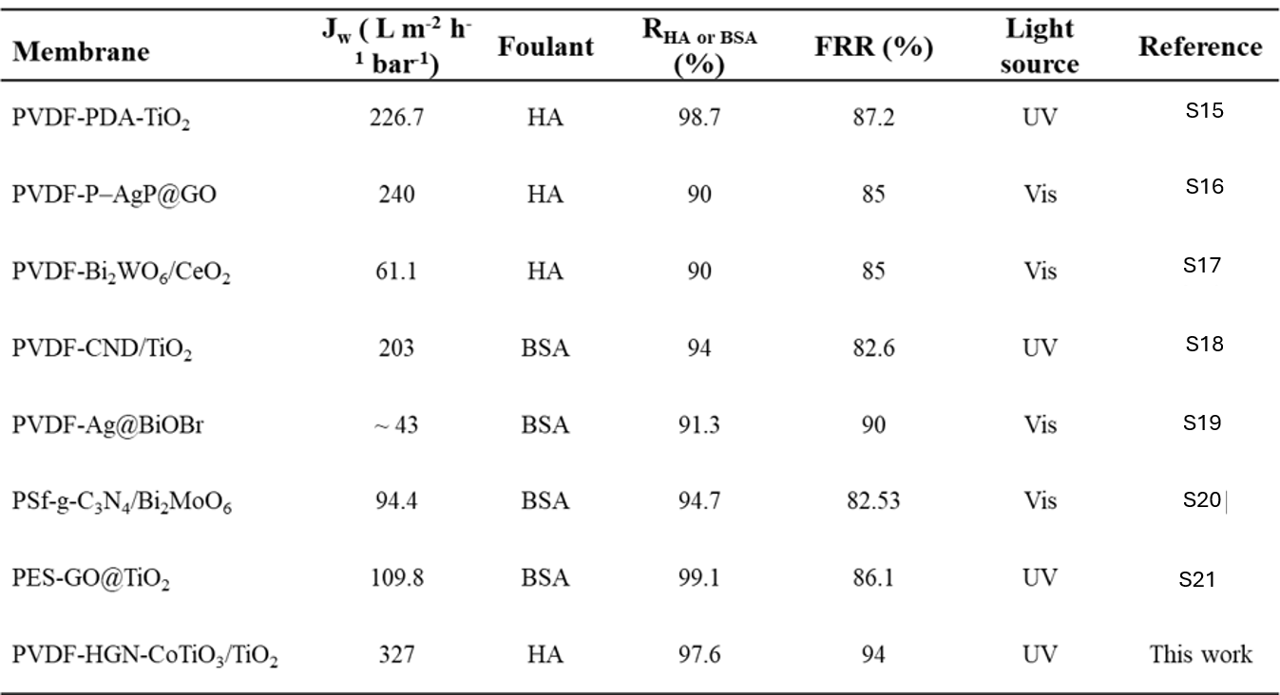

References
S1 Qu, Y., Zhou, W. & Fu, H. Porous Cobalt Titanate Nanorod: A New Candidate for Visible Light-Driven Photocatalytic Water Oxidation. ChemCatChem 6, 265-270, doi:https://doi.org/10.1002/cctc.201300718 (2014).
S2 Wei, S. et al. Enhanced Hydrogen Storage Properties of LiAlH4 by Excellent Catalytic Activity of XTiO3@h-BN (X = Co, Ni). Advanced Functional Materials 32, 2110180, doi:https://doi.org/10.1002/adfm.202110180 (2022).
S3 Han, X. et al. Scalable holey graphene synthesis and dense electrode fabrication toward high-performance ultracapacitors. ACS Nano 8, 8255-8265, doi:10.1021/nn502635y (2014).
S4 Ma, Y., He, D., Liu, Q., Le, S. & Wang, X. A S-type 2D/2D heterojunction via intercalating ultrathin g-C3N4 into NH4V4O10 nanosheets and the boosted removal of ciprofloxacin. Applied Catalysis B: Environment and Energy 344, 123642, doi:https://doi.org/10.1016/j.apcatb.2023.123642 (2024).
S5 Sun, M. et al. Amorphous Titanium Dioxide-Based Heterojunction with Locally Enhanced Electron Transport Multipathways for High-Efficient Photodegradation of Tetracycline. Langmuir 40, 19560-19574, doi:10.1021/acs.langmuir.4c02082 (2024).
S6 Jing, S. et al. Efficient photocatalytic production of H2O2 and photodegradation of tetracycline by CdS/square tubular g-C3N4 S-scheme heterojunction photocatalyst. Chemical Engineering Journal 479, 147150, doi:https://doi.org/10.1016/j.cej.2023.147150 (2024).
S7 Yang, C. et al. Ultrathin g-C3N4 composite Bi2WO6 embedded in PVDF UF membrane with enhanced permeability, anti-fouling performance and durability for efficient removal of atrazine. Journal of Hazardous Materials 451, 131154, doi:https://doi.org/10.1016/j.jhazmat.2023.131154 (2023).
S8 Zhou, P. et al. Construction of PES mixed matrix membranes incorporating ZnFe2O4 @MXene composites with high permeability and antifouling performance. Journal of Environmental Chemical Engineering 11, 110252, doi:https://doi.org/10.1016/j.jece.2023.110252 (2023).
S9 Xu, J.-F. et al. Ag@SnS/PVDF membranes with self-cleaning ability driven by photocatalysis process. Journal of Membrane Science 707, 123015, doi:https://doi.org/10.1016/j.memsci.2024.123015 (2024).
S10 Kumar, M. et al. Polydopamine-coated graphene oxide nanosheets embedded in sulfonated poly(ether sulfone) hybrid UF membranes with superior antifouling properties for water treatment. Chemical Engineering Journal 433, 133526, doi:https://doi.org/10.1016/j.cej.2021.133526 (2022).
S11 Zhang, L., Chen, B., Ghaffar, A. & Zhu, X. Nanocomposite Membrane with Polyethylenimine-Grafted Graphene Oxide as a Novel Additive to Enhance Pollutant Filtration Performance. Environmental Science & Technology 52, 5920-5930, doi:10.1021/acs.est.8b00524 (2018).
S12 Mi, Y.-F. et al. Constructing zwitterionic surface of nanofiltration membrane for high flux and antifouling performance. Journal of Membrane Science 541, 29-38, doi:https://doi.org/10.1016/j.memsci.2017.06.091 (2017).
S13 Hu, Z. et al. Development of conductive two-dimensional metal-organic frameworks self-cleaning membrane for enhanced antibiotics rejection and sustainable fouling mitigation. Journal of Membrane Science 709, 123108, doi:https://doi.org/10.1016/j.memsci.2024.123108 (2024).
S14 Zhou, C. et al. Explication of polydopamine modified g-C3N4 as effective additive in PVDF nanocomposite membrane fabrication for enhanced ultrafiltration and self-cleaning performance. Journal of Environmental Chemical Engineering 11, 110577, doi:https://doi.org/10.1016/j.jece.2023.110577 (2023).
S15 Shi, Y. et al. Enhance organic pollutants removal of wastewater by a PVDF/PDA-TiO2 composite membrane with photocatalytic property. Journal of Environmental Chemical Engineering 11, 110389, doi:https://doi.org/10.1016/j.jece.2023.110389 (2023).
S16 Fan, G. et al. Enhancing the antifouling and rejection properties of PVDF membrane by Ag3PO4-GO modification. Science of The Total Environment 801, 149611, doi:https://doi.org/10.1016/j.scitotenv.2021.149611 (2021).
S17 Krishnan, S. A. G., Abinaya, S., Arthanareeswaran, G., Govindaraju, S. & Yun, K. Surface-constructing of visible-light Bi(2)WO(6)/CeO(2) nanophotocatalyst grafted PVDF membrane for degradation of tetracycline and humic acid. J Hazard Mater 421, 126747, doi:10.1016/j.jhazmat.2021.126747 (2022).
S18 Li, Y. et al. Carboxylated Nanodiamond-Enhanced Photocatalytic Membranes with Improved Antifouling and Self-Cleaning Properties. Industrial & Engineering Chemistry Research 59, 3538-3549, doi:10.1021/acs.iecr.9b06389 (2020).
S19 Zhang, J. et al. Ag@BiOBr/PVDF photocatalytic membrane for remarkable BSA anti-fouling performance and insight of mechanism. Journal of Membrane Science 677, 121611, doi:https://doi.org/10.1016/j.memsci.2023.121611 (2023).
S20 Meng, M., Li, B., Zhu, Y., Yan, Y. & Feng, Y. A novel mixed matrix polysulfone membrane for enhanced ultrafiltration and photocatalytic self-cleaning performance. Journal of Colloid and Interface Science 599, 178-189, doi:https://doi.org/10.1016/j.jcis.2021.04.082 (2021).
S21 Ding, C.-K., Qin, X.-C., Tian, Y. & Cheng, B. PES membrane surface modification via layer-by-layer self-assembly of GO@TiO2 for improved photocatalytic performance. Journal of Membrane Science (2022).

