Supplementary material for:
A Tropical–Extratropical Coupling Between the Intertropical Convergence Zone and Mediterranean Hydroclimate Variability
Tamar Eshet^{1, *}, Sigalit Berkovic², Assaf Hochman^{1, *}
- Fredy and Nadine Herrmann, Institute of Earth Sciences, The Hebrew University of Jerusalem, Israel.
- Department of Applied Mathematics, IIBR, Ness-Ziona, Israel.
*Correspondence to: tamar.eshet@mail.huji.ac.il; Assaf.Hochman@mail.huji.ac.il

Contents of this file:
Figures S1 – S3

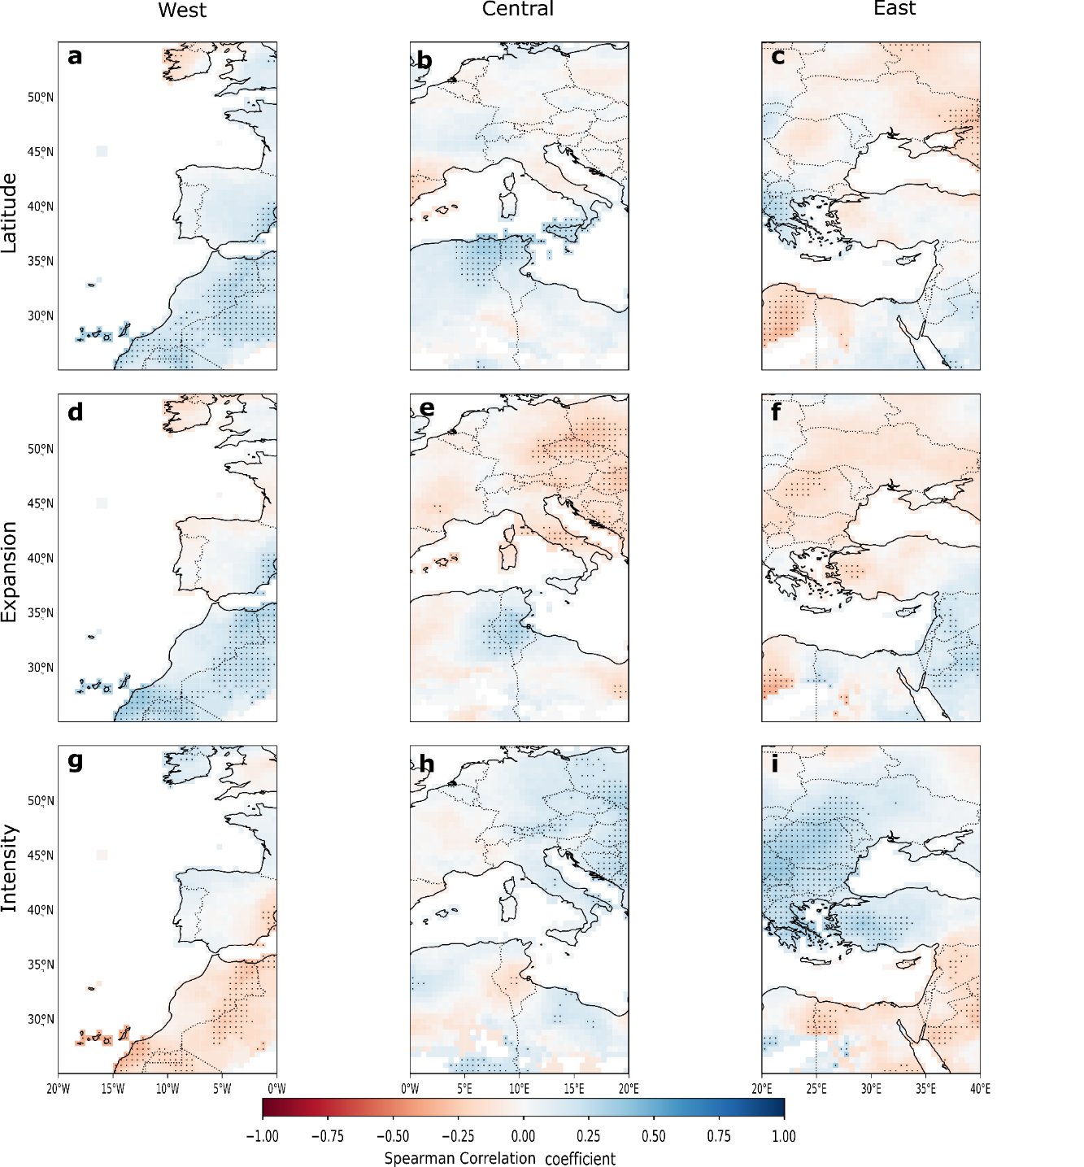
Figure S1 Same as Fig. 1, but the correlations were computed on the CRU dataset.

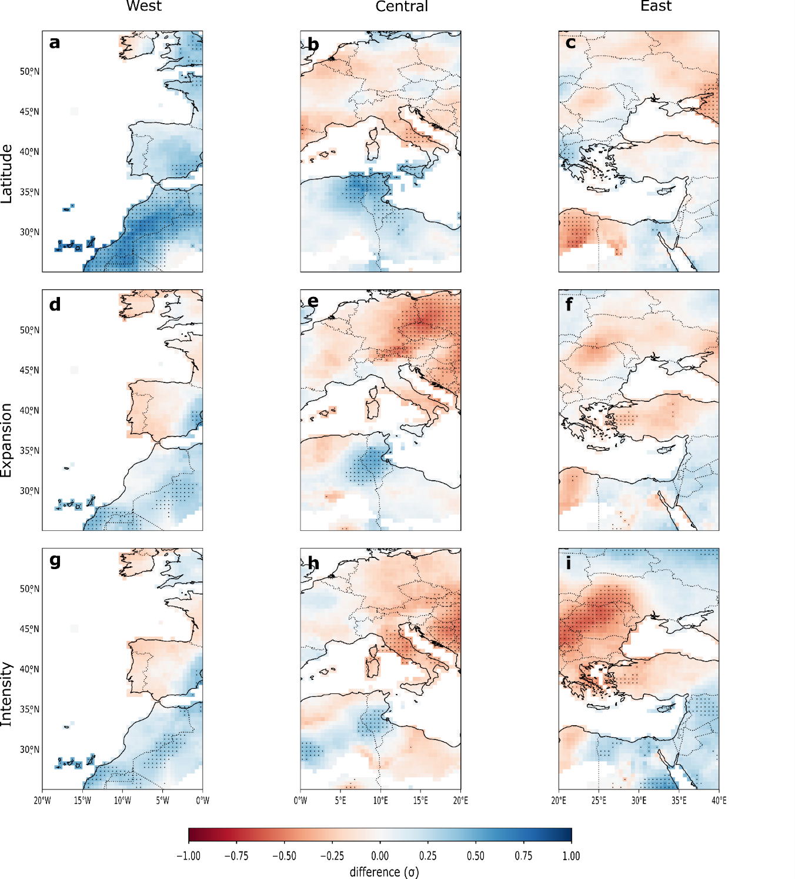
Figure S2 Same as Fig. 3, but the composite mean differences were computed on the CRU dataset.

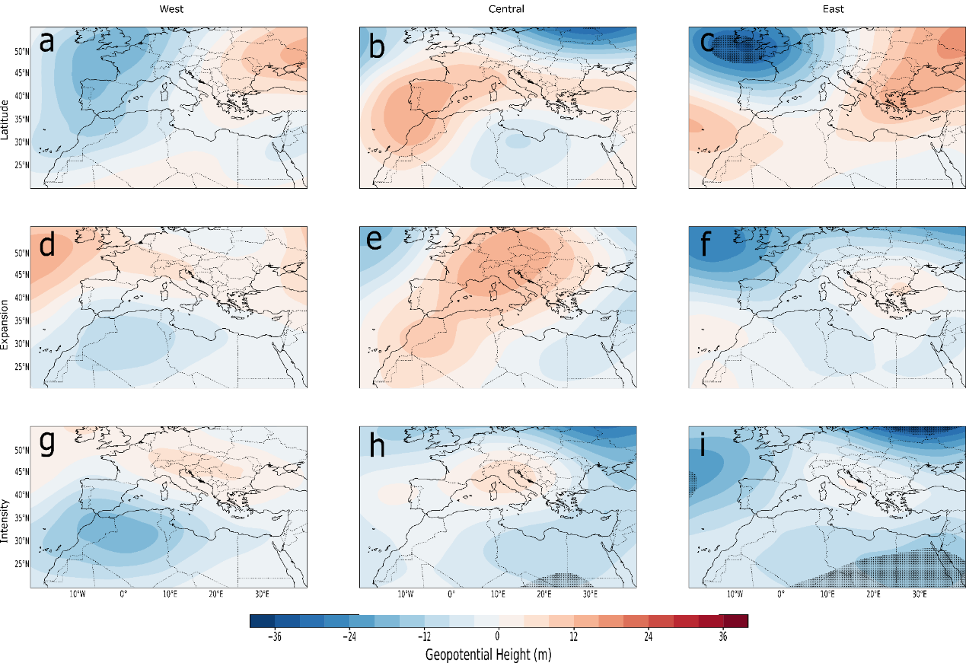
Figure S3 Same as Fig. 4, but for the differences in geopotential height at 500 hPa (Z500).

