Fig. S1 Principal component analysis (PCA) of metabolic profiles in shoot of rice seedling of Xiangyaxiangzhan and Yuxiangyouzhan under control and treatments (A). The Identified total significant different metabolites and up- and down-regulated metabolites (B). The Venn diagram of the significant different metabolites among the treatments (C). KEGG enrichment analyses of the identified significant different metabolites (D) and ranking of the identified significant differential metabolites (E) in Xiangyaxiangzhan and Yuxiangyouzhan under different treatments.
X_A: ZnO NPs 0 + Cd 0 for Xiangyaxiangzhan, X_B: ZnO NPs 0 + Cd 100 for Xiangyaxiangzhan, X_C: ZnO NPs 50+Cd 0 for Xiangyaxiangzhan, X_D: ZnO NPs 50 + Cd 100 for Xiangyaxiangzhan; Y_A: ZnO NPs 0 + Cd 0 for Yuxiangyouzhan, Y_B: ZnO NPs 0 + Cd 100 for Yuxiangyouzhan, Y_C: ZnO NPs 50 + Cd 0 for Yuxiangyouzhan, Y_D: ZnO NPs 50 + Cd 100 for Yuxiangyouzhan. The abscissa indicates that the rich factor, ordinate corresponding to each pathway is the path name, and the color of the point is p-value, the redder the enrichment is more significant. The size of the points represents the number of enriched differential metabolites.

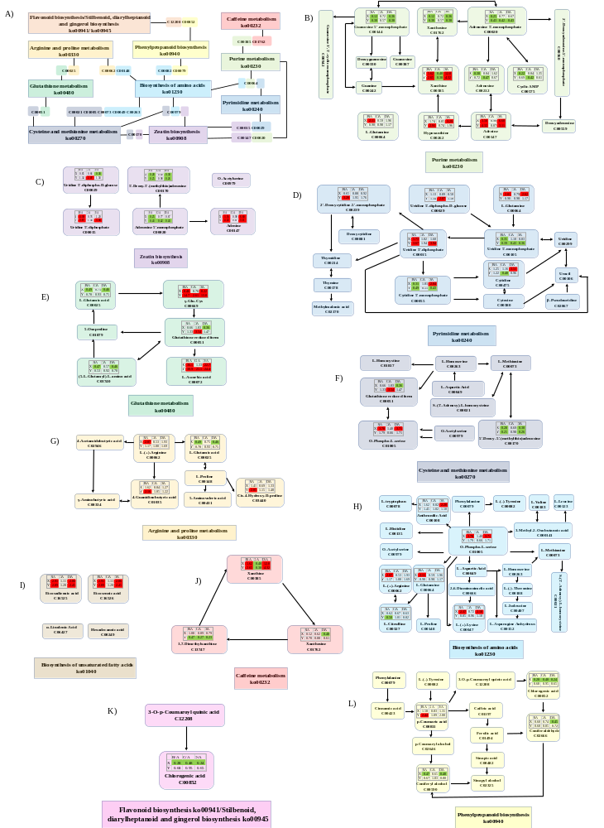
Fig. S2 Metabolic pathways network.
The metabolites with similar color with the pathways mean the linking metabolites between two pathways. A: ZnO NPs 0 + Cd 0, B: ZnO NPs 0 + Cd 100, C: ZnO NPs 50 + Cd 0, D: ZnO NPs 50 + Cd 100. Fold changes of metabolites in red color indicated significant up-regulation (fold change > 2) and in green color showed significant down-regulation (fold change < 0.5), in comparison with normalized metabolite concentrations under treatment and control condition; and in white color indicated no significant changes. Metabolic pathways were constructed on basis of KEGG database (http://www.genome.jp/kegg/).

