Title:

Domestic water mineral exposure increases affective disorders vulnerability by impairing brain structural resilience

Authors: Jinghan Sun^{1,#}, Qian Qian^{1,#}, Shaoying Wang^{1,#}, Nannan Zhang¹, Guoshu Zhao², Shiji Jiao³, Man Chong¹, Xiangrong Chen¹, Fengyu Wang¹, Yiwei Wang¹, Wen Qin¹, Meng Liang², Jiayuan Xu^{1,*}, Quan Zhang^{1,*}

Affiliations:
¹ Department of Radiology and Tianjin Key Lab of Functional Imaging, Tianjin Institute of Radiology, State Key Laboratory of Experimental Hematology, Tianjin Medical University General Hospital, Tianjin 300052, China
² School of Medicine, Nankai University, Tianjin 300071, China
³ School of Medical Imaging and Tianjin Key Laboratory of Functional Imaging, Tianjin Medical University, Tianjin 300203, China
# These authors contributed equally to this work: Jinghan Sun, Qian Qian and Shaoying Wang
* Correspondence to:
Quan Zhang, e-mail: quanzhang@tmu.edu.cn
Jiayuan Xu, e-mail: xujiayuan@tmu.edu.cn

Supplementary Figures
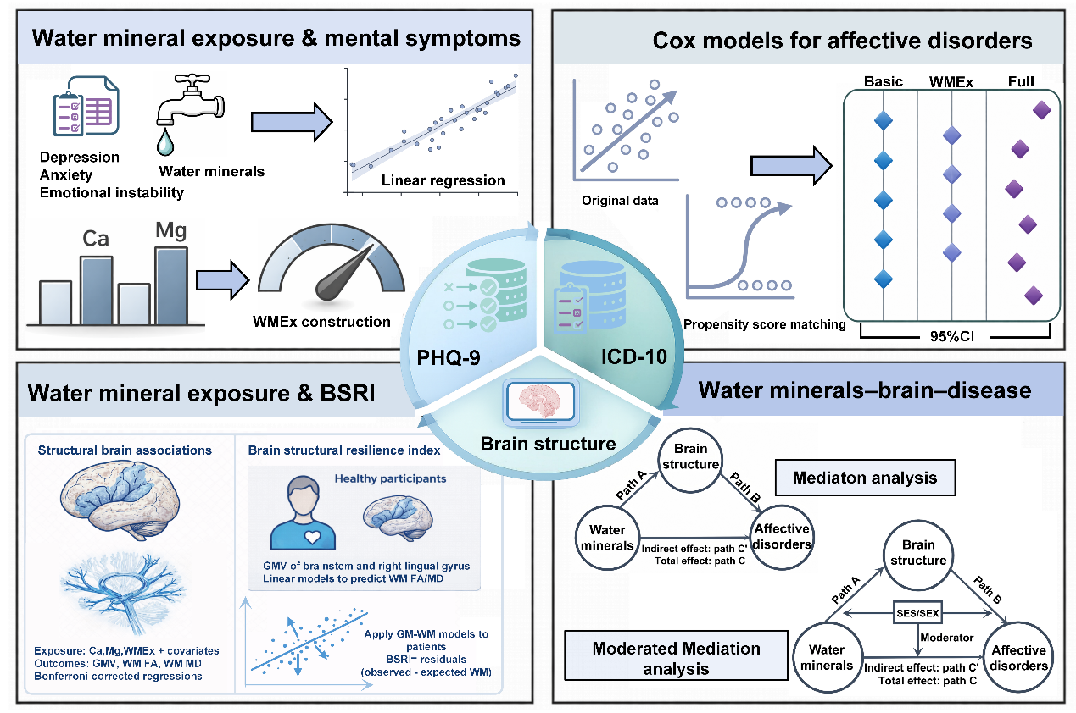
Supplementary Figure 1 | Overview of analyses conducted in this study. In this study, we examined the univariable associations between five domestic water mineral exposure and three mental symptoms (depression, anxiety and emotional instability) in up to 389,984 participants (308,632 for discovery and 81,352 for replication) from the UK Biobank (UKB). After confirming the associations between individual domestic water mineral exposure and mental symptoms, we constructed a domestic water mixture mineral exposure (WMEx) using weighted quantile sum regression analysis and investigated its mixture effect on mental symptoms. Based on the individual and mixture effects of domestic water mineral exposure on mental health, Cox proportional hazards regression analyses were applied to assess the predictive value of water mineral exposure for the onset of affective disorders using longitudinal individual data. To further mitigate bias from imbalances between cases and controls, we employed propensity score matching (PSM) to create well-matched cohorts and re-evaluated these predictive associations. To elucidate the neural mechanisms, we assessed brain gray matter macrostructure and white matter microstructure. Crucially, we further derived a brain structural resilience index (BSRI) using a normative modeling approach, which characterizes the coupling between gray and white matter structures relative to a healthy population norm in 5,846 healthy controls during 15.3 years visit. Using these neuroimaging phenotypes as mediators, causal mediation analyses were conducted to determine the pathways linking domestic water mineral exposure to affective disorders. Finally, we conducted sex-stratified and areal SES-stratified analyses to identify the sex- and SES-specific associations between domestic water mineral exposure, neuroimaging phenotypes and affective disorders using moderated mediation analyses.

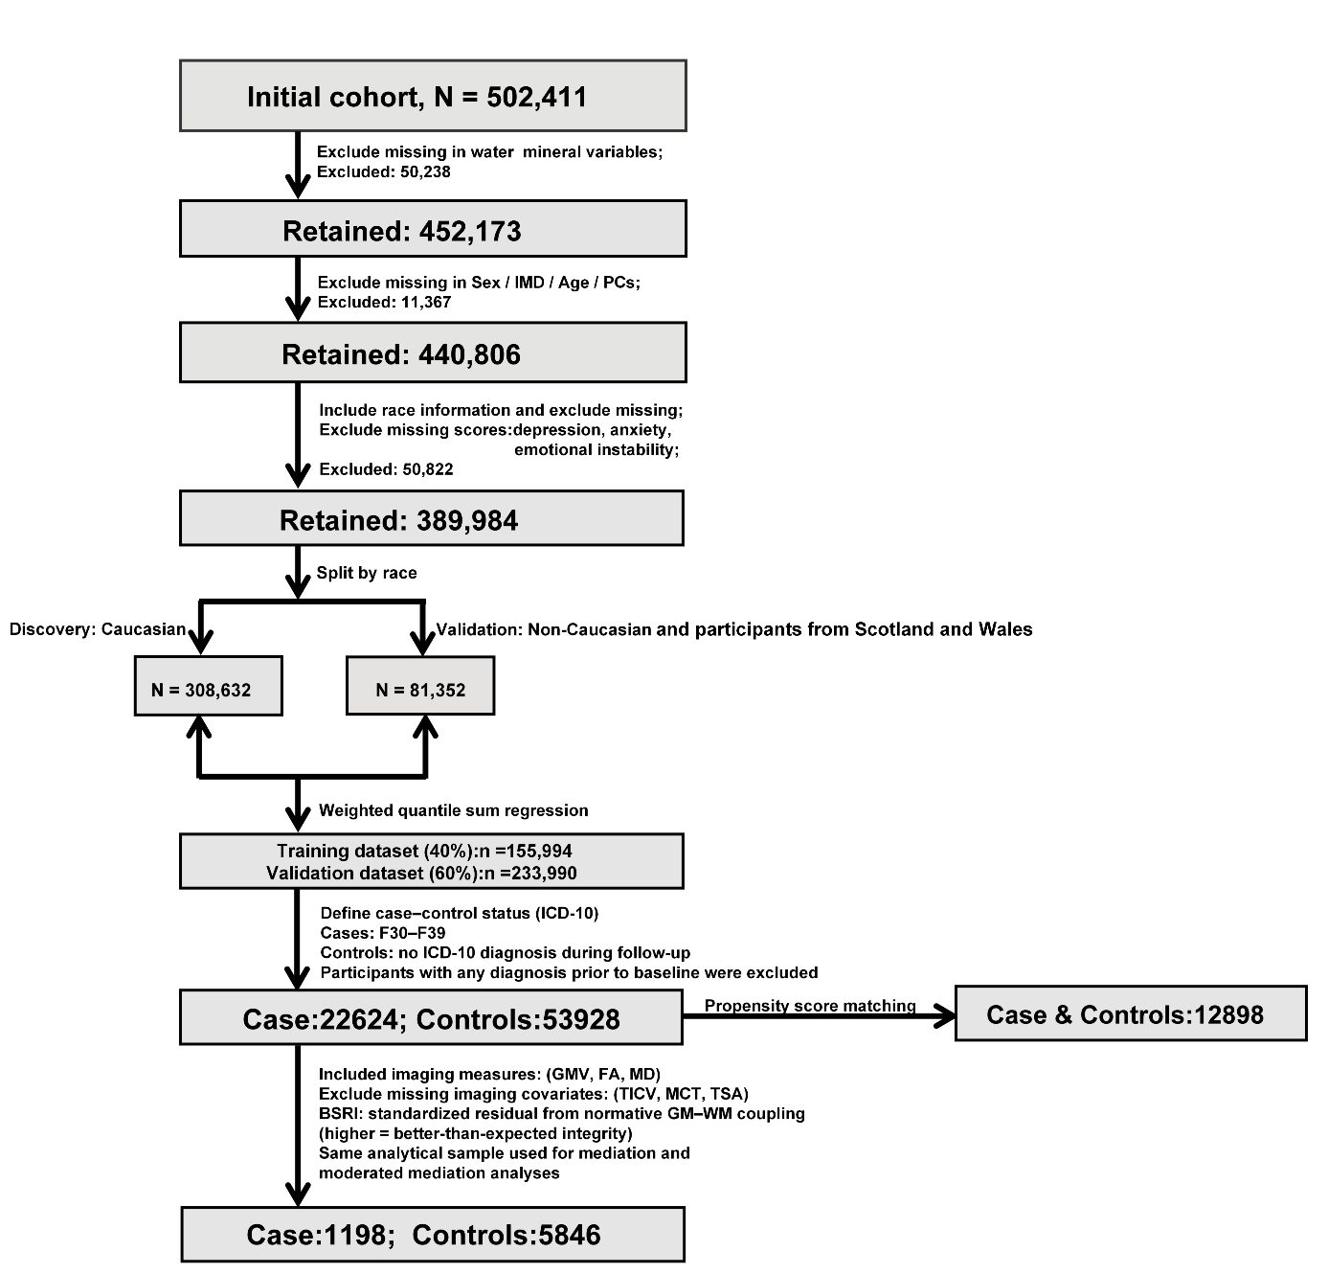
Supplementary Figure 2 | Participant inclusion/exclusion criteria and data-filtering workflow. Participants were drawn from the initial cohort (N = 502,411) and excluded sequentially for missing domestic water mineral exposure variables (n = 50,238), missing key covariates (sex/IMD/age/PCs; n = 11,367), and missing race information or symptom measures (depression, anxiety, emotional instability; n = 50,822), leaving 389,984 participants for the primary analyses. The sample was split into a discovery dataset (Caucasian; n = 308,632) and a validation dataset (non-Caucasian and participants from Scotland and Wales; n = 81,352). For WQS regression, the discovery sample was further divided into a training set (40%; n = 155,994) and an internal validation set (60%; n = 233,990). Case-control status was defined using ICD-10 diagnoses (cases: F30–F39; controls: no ICD-10 diagnosis during follow-up), and participants with any diagnosis prior to baseline were excluded. PSM produced a matched sample (n = 25,796). A neuroimaging subset with available structural and diffusion measures (GMV, FA, MD) and complete imaging covariates (TICV, MCT, TSA) was used for mediation and moderated mediation analyses (final imaging sample: n = 7,044: 1,198 cases and 5,846 controls). The BSRI was defined as the standardized residual from a normative gray-white matter coupling model (n = 5,846) (higher BSRI values indicate greater brain structural resilience). Abbreviations: IMD, Index of Multiple Deprivation; PCs, principal components; WQS, weighted quantile sum; ICD-10, International Classification of Diseases, 10th Revision; PSM, propensity score matching; GMV, gray matter volume; FA, fractional anisotropy; MD, mean diffusivity; TICV, total intracranial volume; MCT, mean cortical thickness; TSA, total surface area; BSRI, brain structural resilience index.

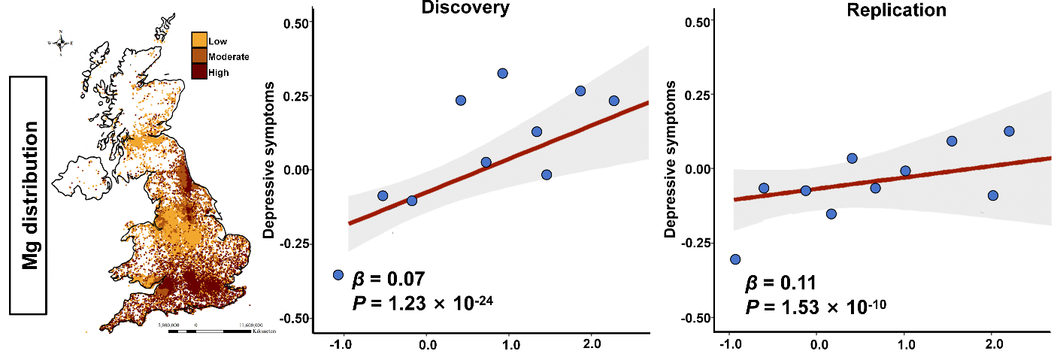
Supplementary Figure 3 | Spatial distribution of water mineral exposures and covariate-adjusted associations with depressive symptoms. Panels(left) show the spatial distribution of Mg concentration across the United Kingdom. Panels (middle–right) display the associations between Mg concentration and depressive symptoms in the discovery (middle) and replication (right) samples. Points represent bin-averaged depressive symptoms (mean Y) within 0.25-wide bins of exposure (mean X; Mg) to reduce overplotting; the solid line indicates the fitted linear association estimated from the full sample using multivariable regression models adjusted for covariates, with the shaded band denoting the 95% confidence interval. Reported β coefficients and P values correspond to the covariate-adjusted models.

