Supplementary Tables
Table 1. Division of the available NSQIP Clavien Dindo Postoperative Complications into their respective grades
Clavien-Dindo Complications
Grade I
Prolonged NPO
Delirium

Grade II (treated by pharmacological treatment)
UTI
DVT
AKI
Pneumonia
Clostridium Difficile
Surgical Site Infection
Wound Dehiscence
Sepsis
Transfusion
Lymphocele
Ureteral Obstruction
Anastomotic Leak with no reoperation

Grade III (treated by reoperation)
Lymphocele
Ureteral Obstruction
Anastomotic Leak
Rectal Injury

Grade IV (Life threatening complications)
Septic Shock
Intubation
Ventilator Use
Renal Failure
Cerebrovascular accident
Myocardial Infarction
Cardiac Arrest

Grade V
Death

Table 2. FTR by complication type
Complication | No Death | Death | Failure to rescue rate (%)
Lymphocele | 264 | 4 | 1.49
Ureteral Obstruction | 180 | 2 | 1.10
Anastomotic Leak | 185 | 16 | 7.96
Rectal Injury | 129 | 7 | 5.14
Myocardial Infarction | 133 | 18 | 11.92
Cardiac Arrest | 22 | 53 | 70.67
Renal Failure | 64 | 4 | 5.88
CVA | 36 | 7 | 16.28
Septic Shock | 136 | 4 | 2.86
Ventilator >48hrs | 80 | 30 | 27.27
Intubation | 105 | 76 | 41.99

Table 3. Clavien–Dindo complication severity stratified by 30-day survival status after radical cystectomy (n=5,864 patients with ≥1 complication). Values are number of patients (column percentage). Survivors and non-survivors had markedly different profiles of complication severity (p<0.001).
Clavien–Dindo Grade | Survived (n=5,720) | Died (n=144)
I (minor complication) | 625 (10.9%) | 2 (1.4%)
II (moderate complication) | 4,039 (70.6%) | 31 (21.5%)
III (requires intervention) | 594 (10.4%) | 5 (3.5%)
IV (life-threatening complication) | 462 (8.1%) | 106 (73.6%)
Patients who had no complications are excluded from this table. “Grade V” (death) is the outcome.. Among the 152 total deaths, 144 had at least one complication (shown above). Percentages reflect the distribution within survivor vs. death groups

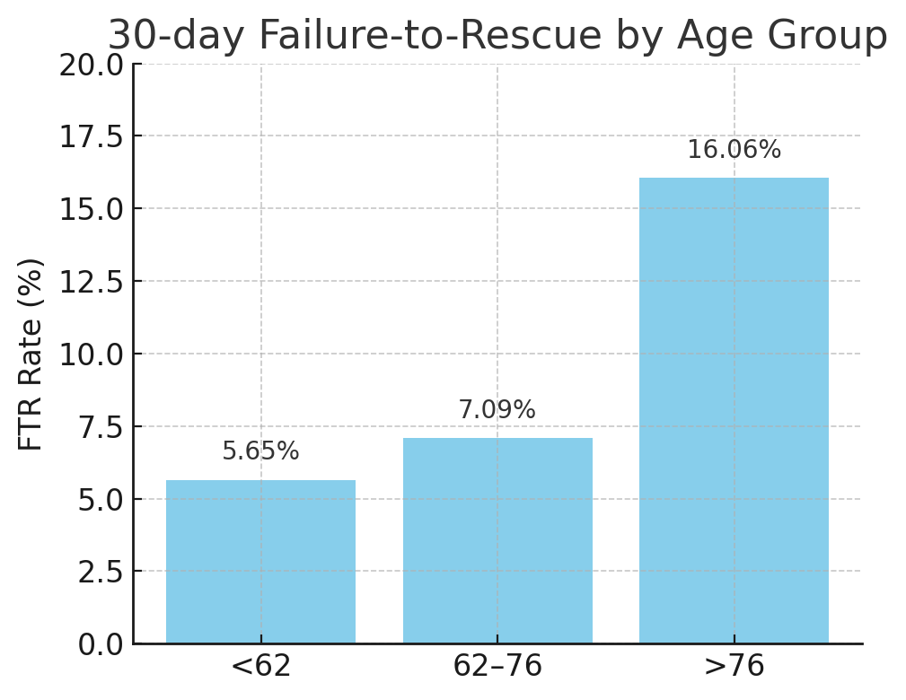
Figure 1. 30-day Failure-to-Rescue rates by age group after radical cystectomy. Patients >76 years experienced significantly higher FTR (16.1%) compared to those aged 62–76 (7.1%) and <62 (5.7%). Younger and middle-aged groups had comparable FTR rates.

