Supplementary Figure S1. Original exploratory metabolite heatmap
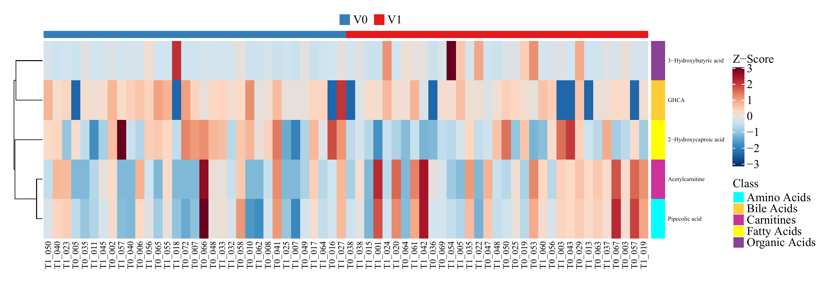
Figure legend: Original sample-level standardized heatmap of the five candidate metabolites; colors represent the Z-scores of each metabolite across samples, and the top color bar indicates the V0 and V1 groups.
Figure results: All five candidate metabolites show marked intersample heterogeneity, and the heatmap itself does not provide effect sizes, multiple-testing corrections, or independent validation results.
This figure is used only to show how β-HB was initially included among the candidates, cannot replace the audited reanalysis of the 65 samples, and does not serve as primary statistical evidence.

Supplementary Figure S2. Original OPLS-DA permutation output
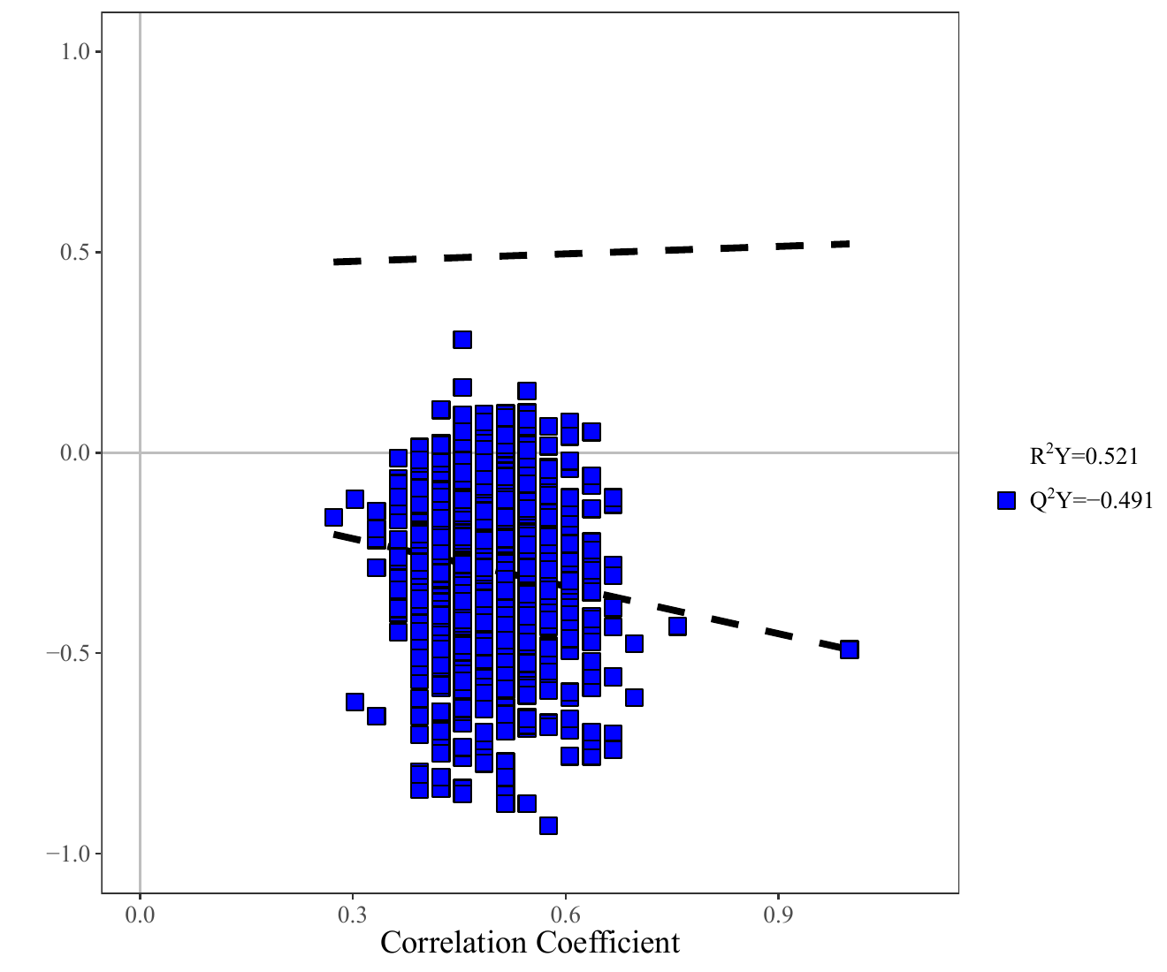
Figure legend: Original OPLS-DA permutation test; the horizontal axis represents the permuted correlation coefficients, and the vertical axis shows the R²Y and Q² statistics and their regression trends.
Figure results: The Q² intercept is negative (−0.491), and the results do not provide support for stable prediction or reliable between-group discrimination.
This figure limits claims of “clear metabolomic group separation” or “stable classification performance,” consistent with the main text’s characterization of β-HB as a single exploratory signal rather than a global metabolic classifier.

Supplementary Figure S3. Original ketone-body pathway diagram
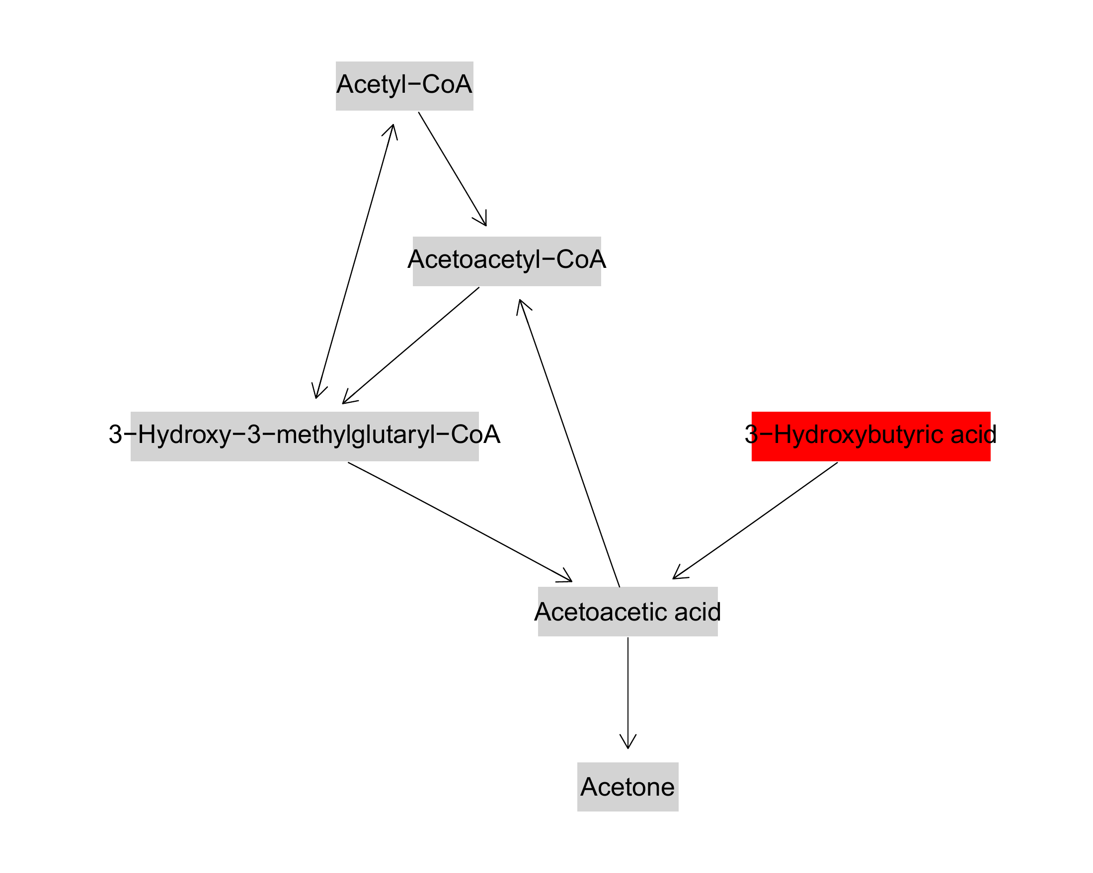
Figure legend: Original pathway diagram of ketone-body synthesis and degradation; the red node marks the detected signal annotated as β-HB by untargeted metabolomics.
Figure results: The figure only confirms that β-HB was mapped to the ketone-body pathway; upstream synthesis, downstream utilization, reaction direction, and metabolic flux were not measured.
Role in the overall argument: This figure supports the pathway assignment of β-HB but cannot support “activation of ketone-body metabolism” or “enhanced β-HB utilization,” and highlights the need for subsequent targeted quantification and isotope tracing.

Supplementary Figure S4. Original butyrate metabolism pathway diagram
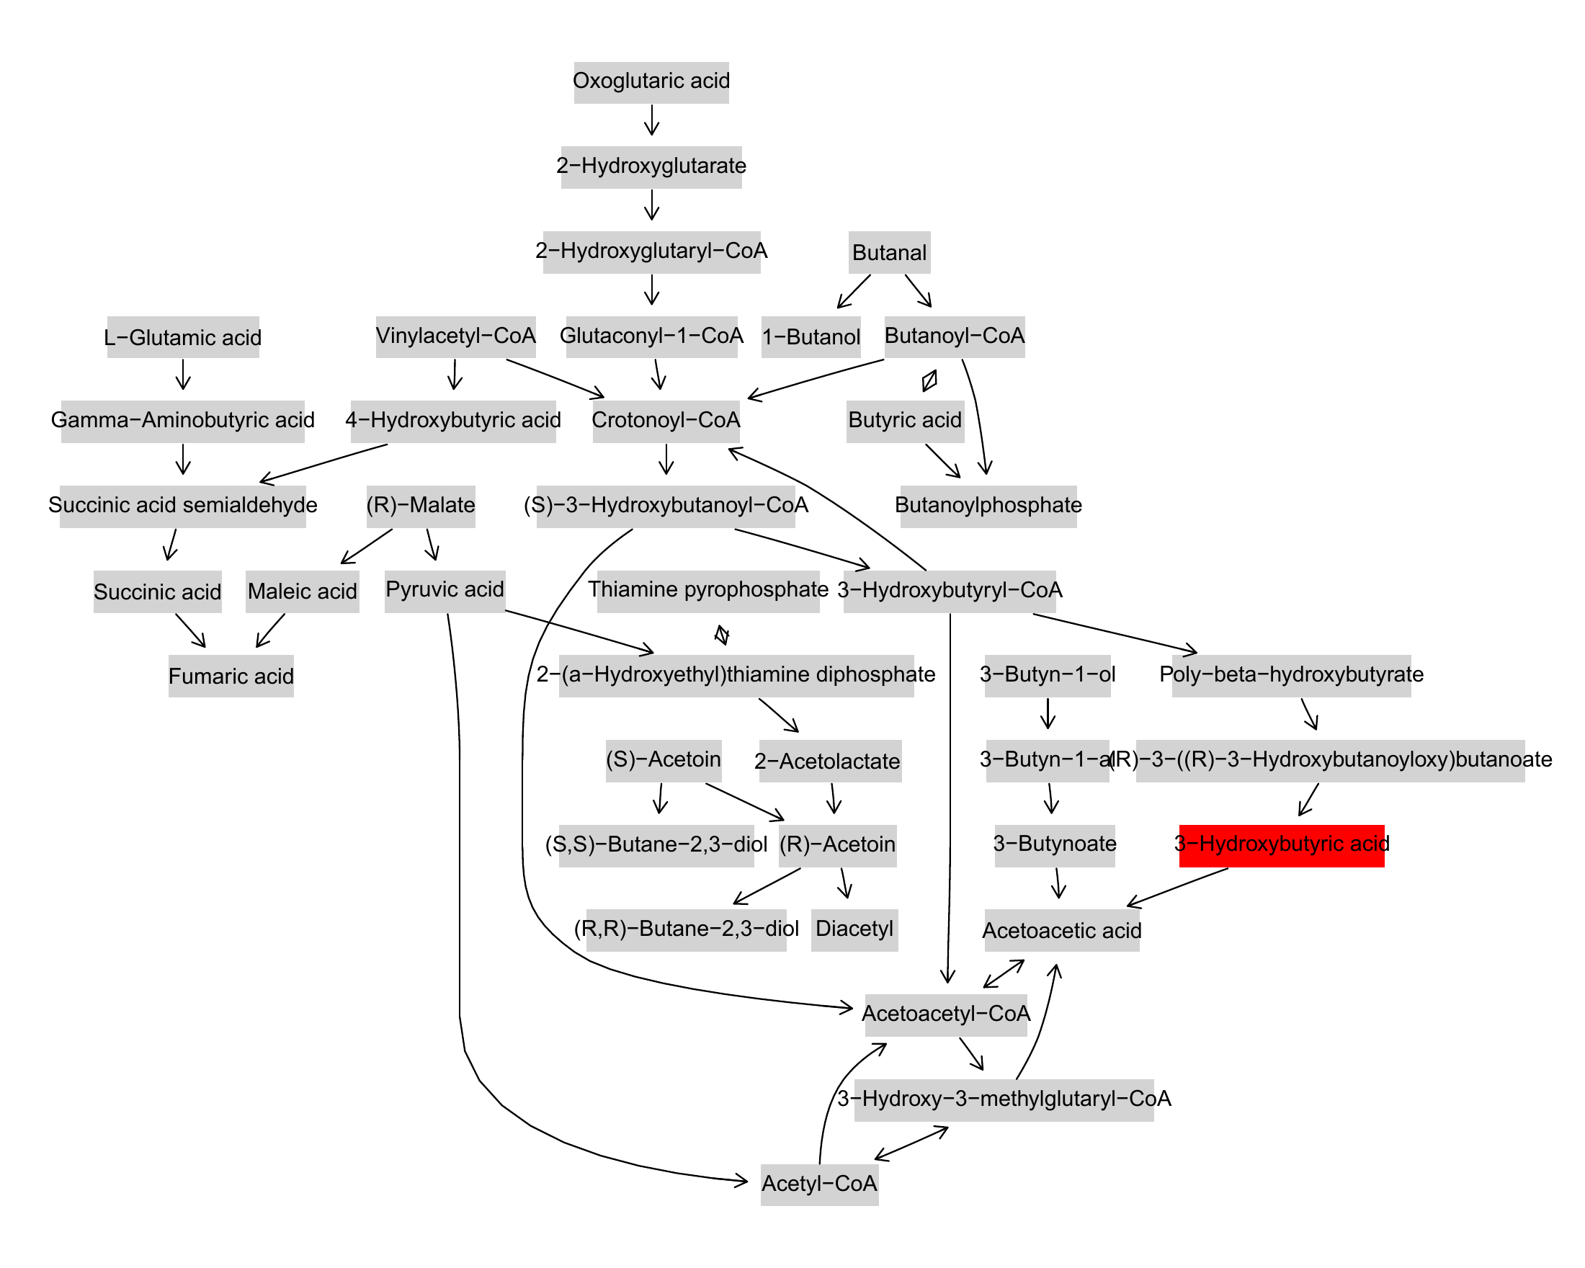
Figure legend: Original butyrate metabolism pathway diagram; the red β-HB node represents the same metabolite signal as the detected feature in Supplementary Figure S4.
Figure results: The figure contains no second independent metabolite hit in butyrate metabolism, and neither butyrate metabolic flux nor the direction of flow between β-HB and the butyrate pathway was directly measured.
Role in the overall argument: This figure limits the strength of evidence for the “β-HB–butyrate metabolism” link, provides only a starting point for hypothesis generation at the level of database annotation, and cannot serve as independent validation of β-HB-mediated invasion or LVI.

Supplementary Figure S6. Lymph node status sensitivity analysis in GSE246963
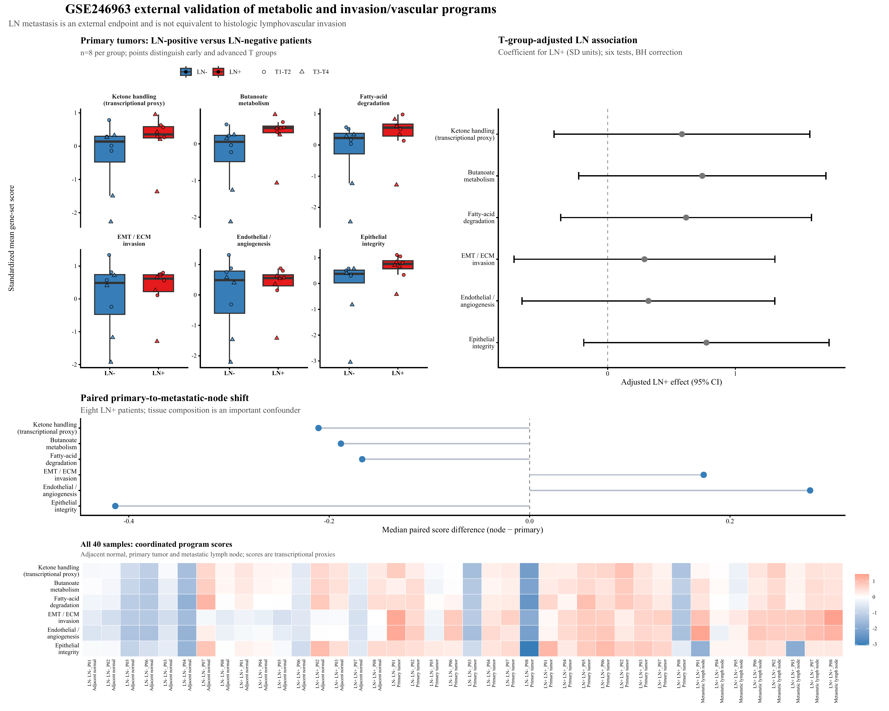
Figure legend: The figure shows scores for six programs in 8 lymph node-positive and 8 lymph node-negative primary gastric cancers, adjusted associations with lymph node status, paired analyses of primary tumors and lymph node metastases, and a sample-centered program heatmap.
Figure results: The directions of effect for all three metabolic programs are upward, with butyrate metabolism showing the strongest nominal result (Cliff’s δ effect size = 0.625, P = 0.0406, q = 0.1217).
This figure provides only directional sensitivity information for a surrogate endpoint.
In GSE237876, the median metastasis-minus-primary changes in all six programs across 14 patients were in the direction of the working hypothesis. Fatty acid degradation showed the largest metabolic change (median Δ = 0.221, P = 0.064, q = 0.384). The composite metabolic change was negatively coordinated with the composite invasion/vascular change (ρ = −0.354, P = 0.215). Heterogeneity in metastatic routes and organs allows this dataset to serve as an LVI validation cohort (Supplementary Figure S7).

Supplementary Figure S7. Within-patient paired analysis of multisite metastases in GSE237876
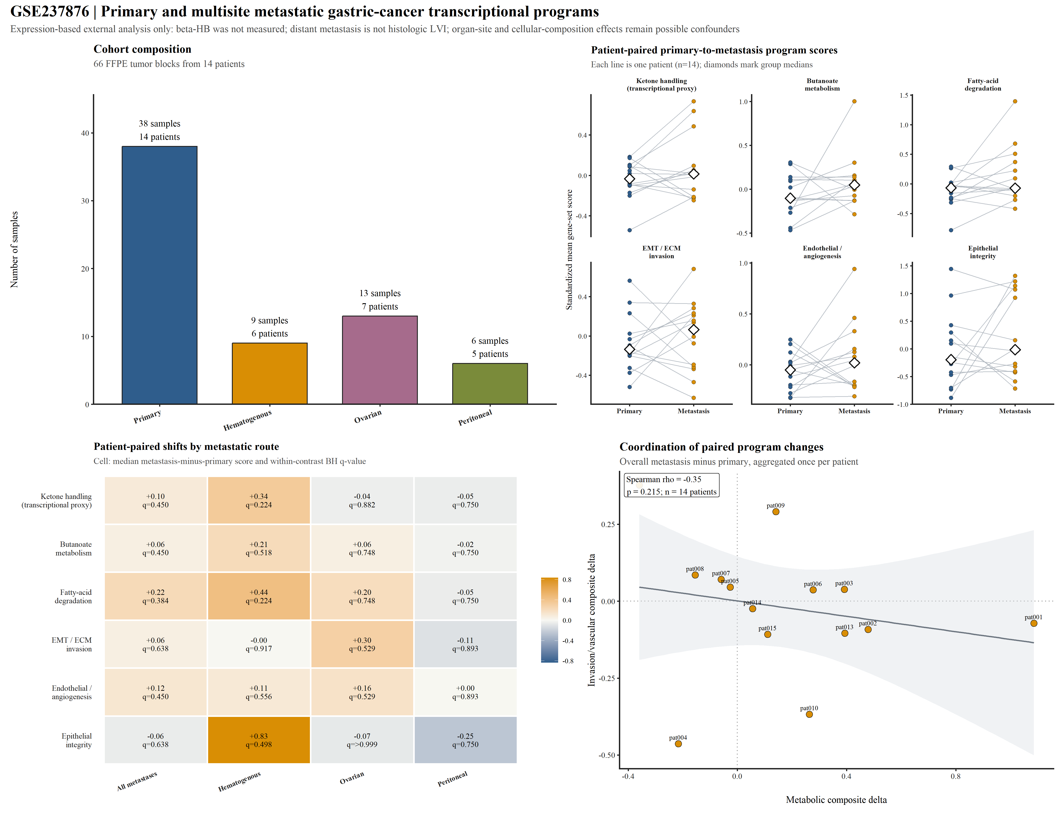
Figure legend: The figure shows the composition of primary tumors and multisite metastases from 14 patients, within-patient paired changes in the six programs, a heatmap of changes for individual patients, and a correlation analysis between composite metabolic changes and composite invasion/vascular changes.
Figure results: The directions of median changes in the six programs are generally consistent with the working hypothesis; fatty acid degradation shows the largest median change (Δ = 0.221, P = 0.064, q = 0.384), and composite metabolic changes are negatively correlated with composite invasion/vascular changes (ρ = −0.354, P = 0.215).

Supplementary Figure S8. Single-cell pseudobulk feasibility analysis in GSE163558
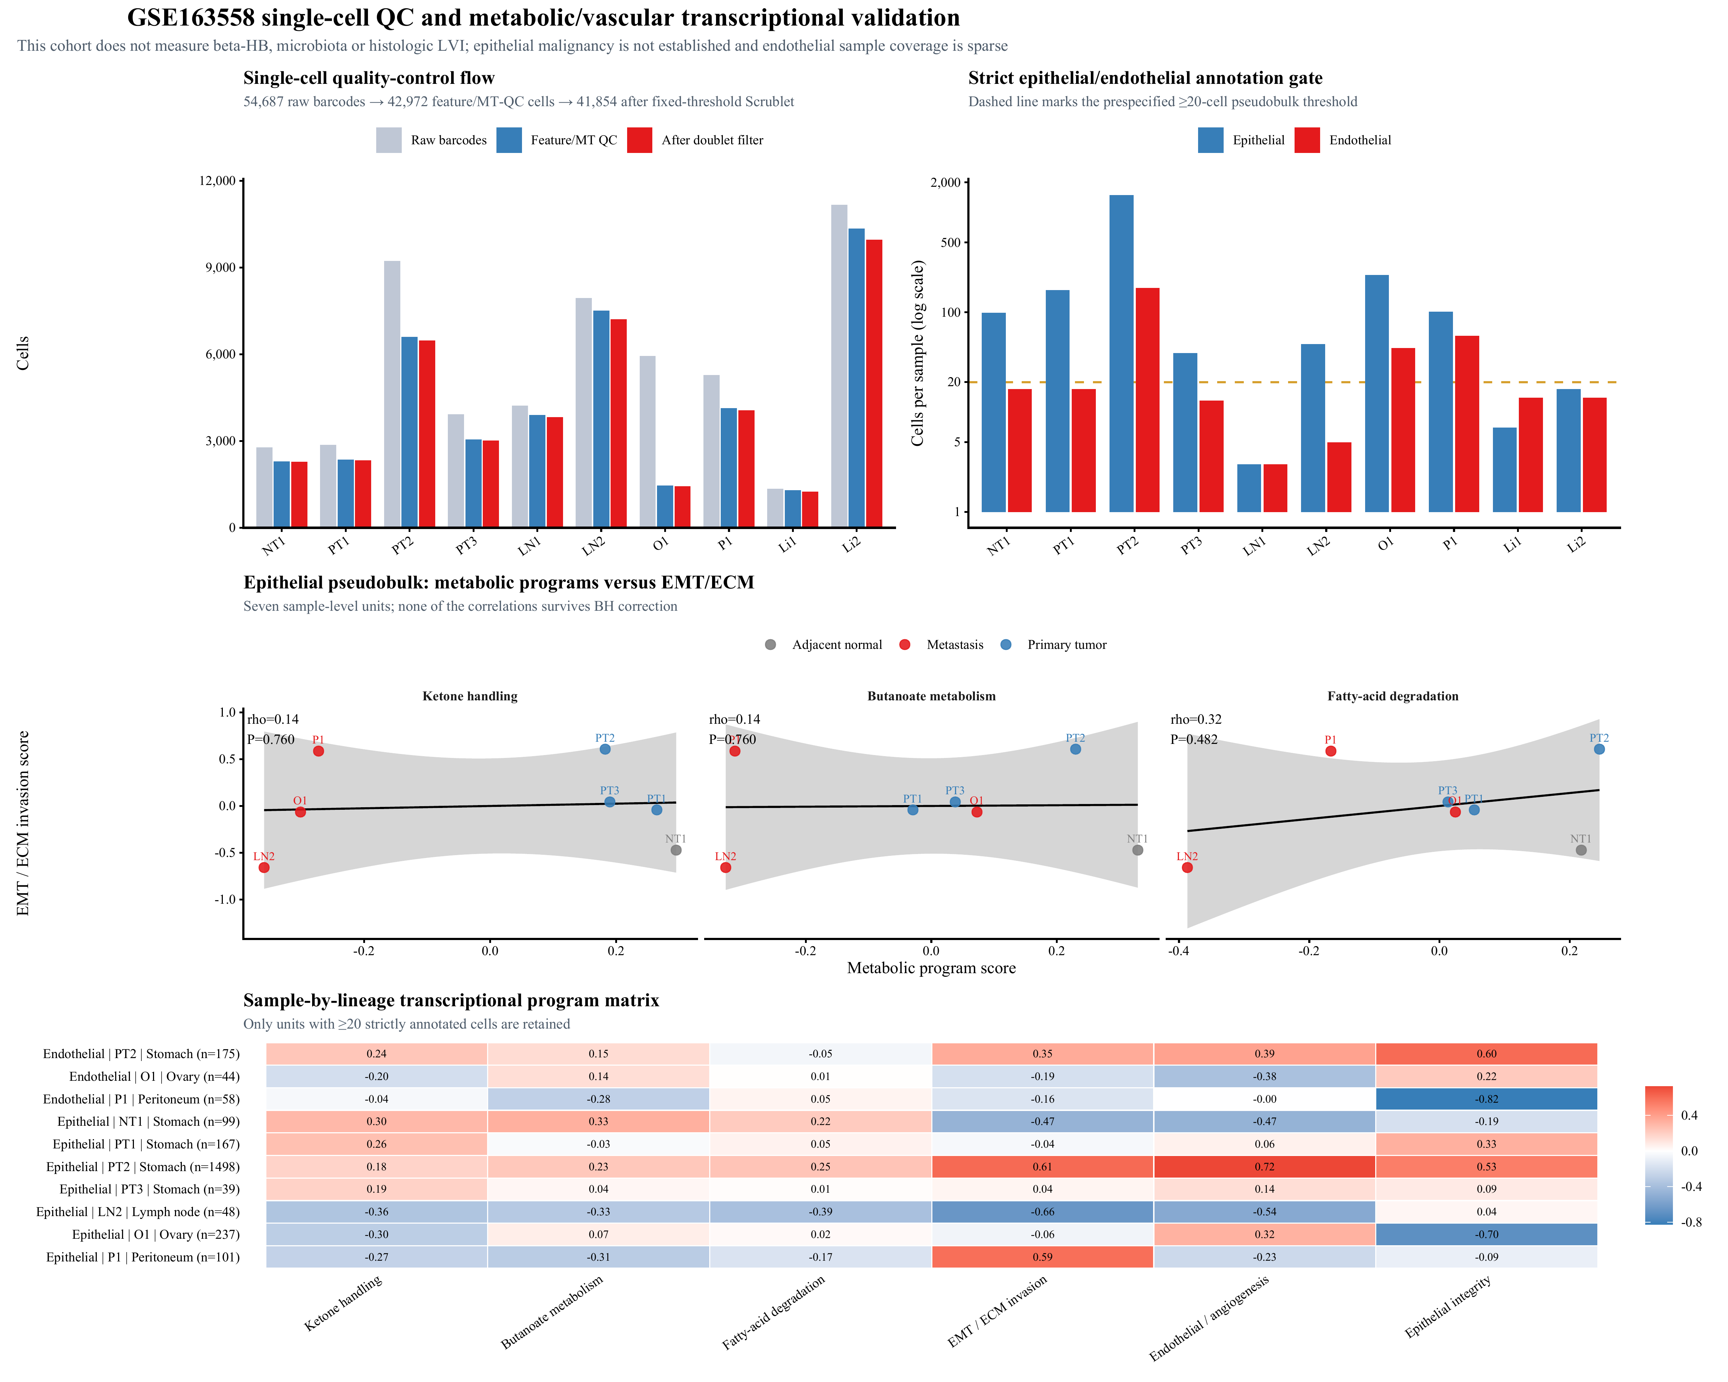
Figure legend: The figure shows single-cell quality control, the composition of major non-immune cell types, coverage under stringent epithelial and endothelial annotation, sample-level pseudobulk program correlations, and the sample–lineage correlation matrix.
Figure results: A total of 41,854 cells passed quality control, but only 7 and 3 sample units were available for the epithelial and endothelial pseudobulk analyses, respectively.
This figure validates metabolic–invasive or metabolic–vascular coupling; because measurements of β-HB, the microbiome, and LVI are lacking, it can only serve as an analysis of feasibility and the limits of the evidence.
GSE239676 provided paired primary tumor–metastasis comparisons of epithelial-like cells from 11 patients. The median changes in ketone-body handling (−0.476, q = 0.103), butyrate metabolism (−0.361, q = 0.103), and fatty acid degradation (−0.512, q = 0.103) were all negative, showing the hypothesized decreases. Changes in butyrate metabolism and fatty acid degradation were correlated (ρ = 0.764, q = 0.0374), suggesting internal co-regulation. Given that this cohort lacks direct measurements of β-HB, the microbiome, or LVI, lacks CNV-confirmed malignant cell identity, and contains only four endothelial pairs, it constitutes a boundary analysis rather than positive validation (Supplementary Figure S9).

Supplementary Figure S9. Local within-patient paired single-cell sensitivity analysis in GSE239676
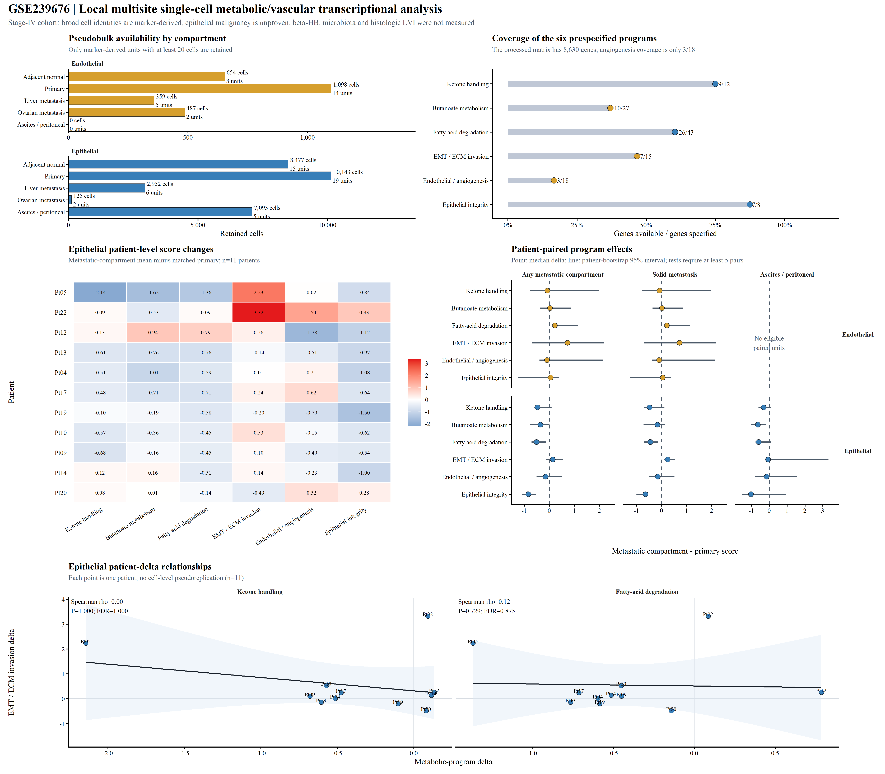
Figure legend: The figure shows the availability of patient pairs for epithelial-like and endothelial cells, gene coverage of the predefined programs, paired primary tumor–metastasis changes, an epithelial program correlation matrix, and patient-level relationships between metabolic changes and EMT changes.
Results: In the paired epithelial-like cell analysis of 11 patients, the median changes in all three metabolic programs were negative, with q = 0.103 for each; changes in butyrate metabolism and fatty acid degradation were correlated (ρ = 0.764, q = 0.0374).
This figure supports internal co-regulation of the butyrate and fatty acid transcriptional programs.

Supplementary Figure S10. DepMap/LINCS in silico perturbation prioritization
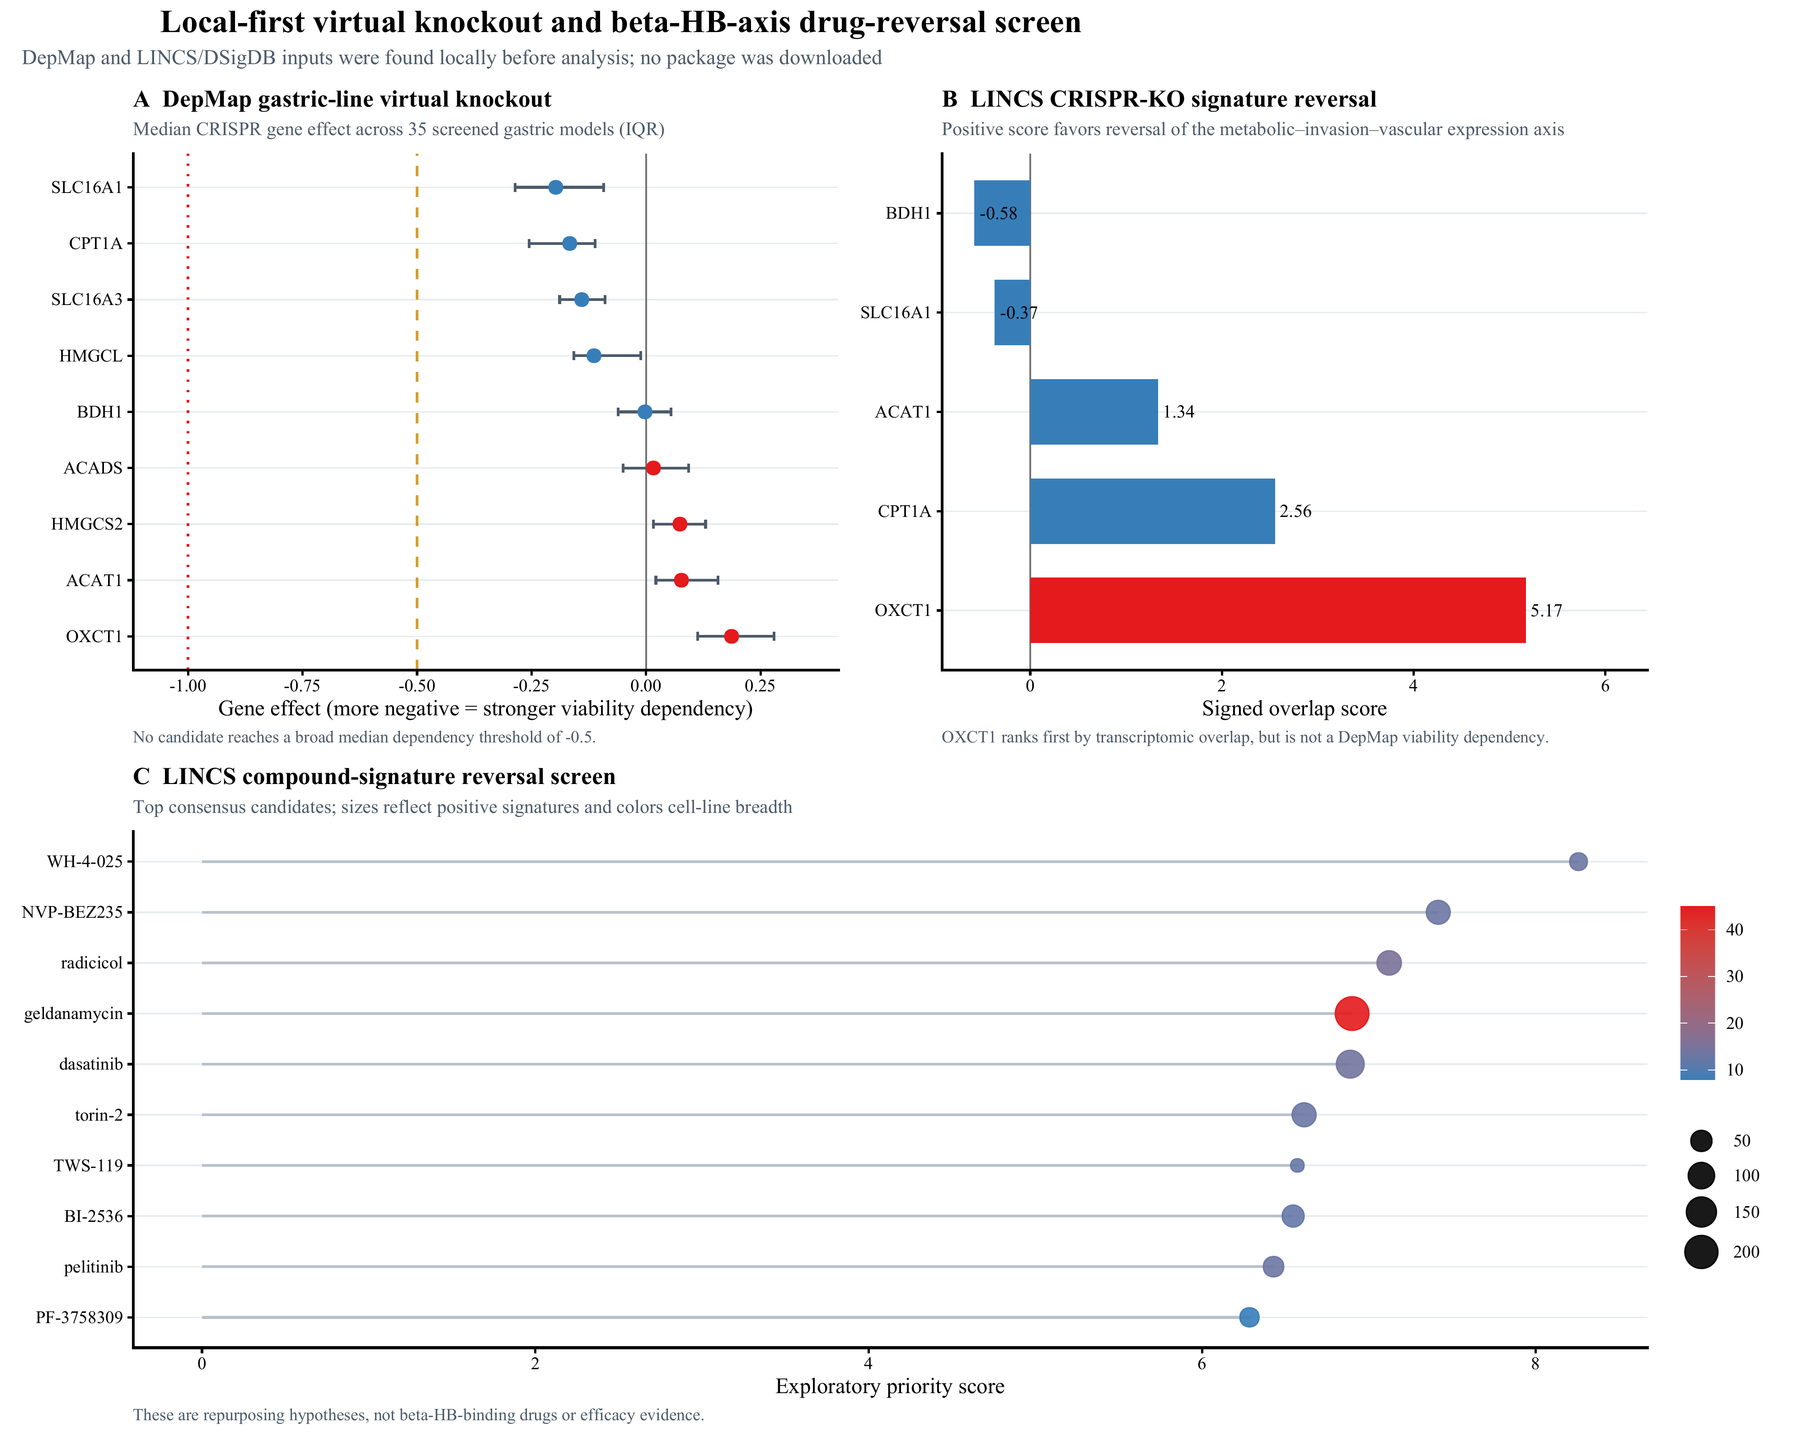
Figure legend: The figure shows candidate gene dependencies in stomach-derived DepMap models, LINCS CRISPR knockout signature-reversal rankings, and compound signature-reversal priorities; the dashed line indicates a commonly used dependency threshold.
Figure results: SLC16A1 has the strongest median dependency among the candidate genes, but its median gene effect is only −0.197; OXCT1 knockout has the highest LINCS reversal overlap score (5.17), and none of the top-ranked compounds has direct evidence of targeting the proposed metabolic axis.
This figure limits in silico knockout and drug screening to tools for prioritizing experiments; it cannot demonstrate target binding, β-HB blockade, invasion rescue, or therapeutic efficacy against LVI, and only provides candidates for subsequent controlled perturbation experiments.

