Supplementary Figures:
Females:
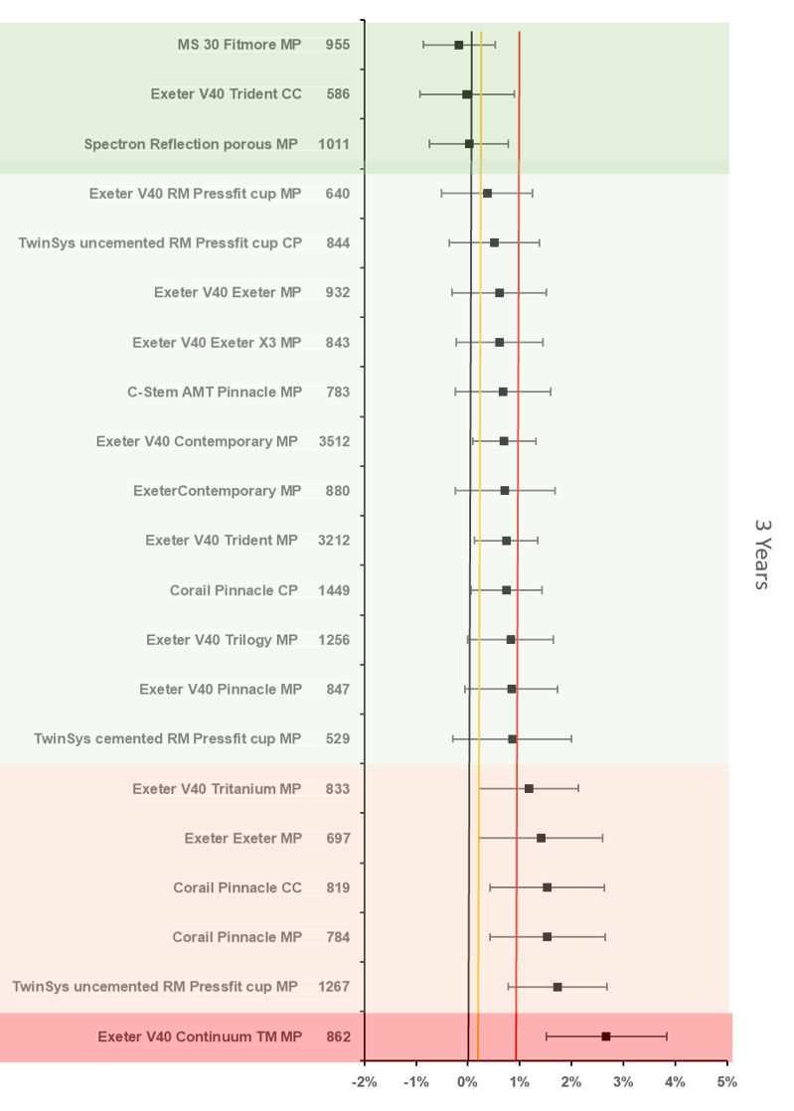
Figure 7. Difference in failure of implanted constructs compared with a contemporary reference (Spectron Reflection cemented MP (1.00%, 95% CI 0.54 - 1.46) at 3 years, using all stem-cup combinations with >500 procedures remaining at risk. CC, ceramic-on-ceramic; CP, ceramic-on-polyethylene; MP, metal-on-polyethylene.

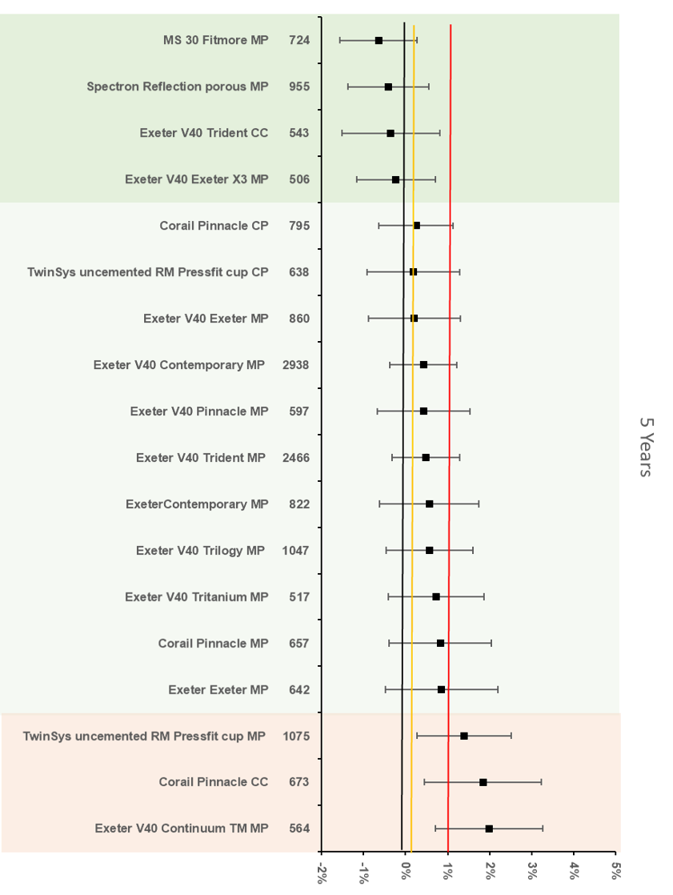
Figure 8 Difference in failure of implanted constructs compared with a contemporary reference (MS 30 Fitmore MP (1.16%, 95% CI 0.64 - 1.67) at 5 years, using all stem-cup combinations with >500 procedures remaining at risk. CC, ceramic-on-ceramic; CP, ceramic-on-polyethylene; MP, metal-on-polyethylene.

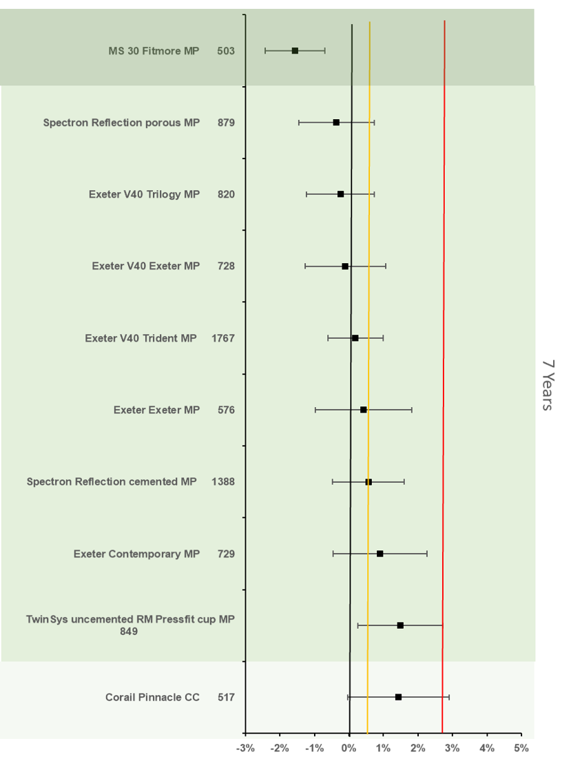
Figure 9. Difference in failure of implanted constructs compared with a contemporary reference (Exeter V40 Contemporary MP (2.76%, 95% CI 2.22 - 3.30)) at 7 years, using all stem-cup combinations with >500 procedures remaining at risk. CC, ceramic-on-ceramic; CP, ceramic-on-polyethylene; MP, metal-on-polyethylene.

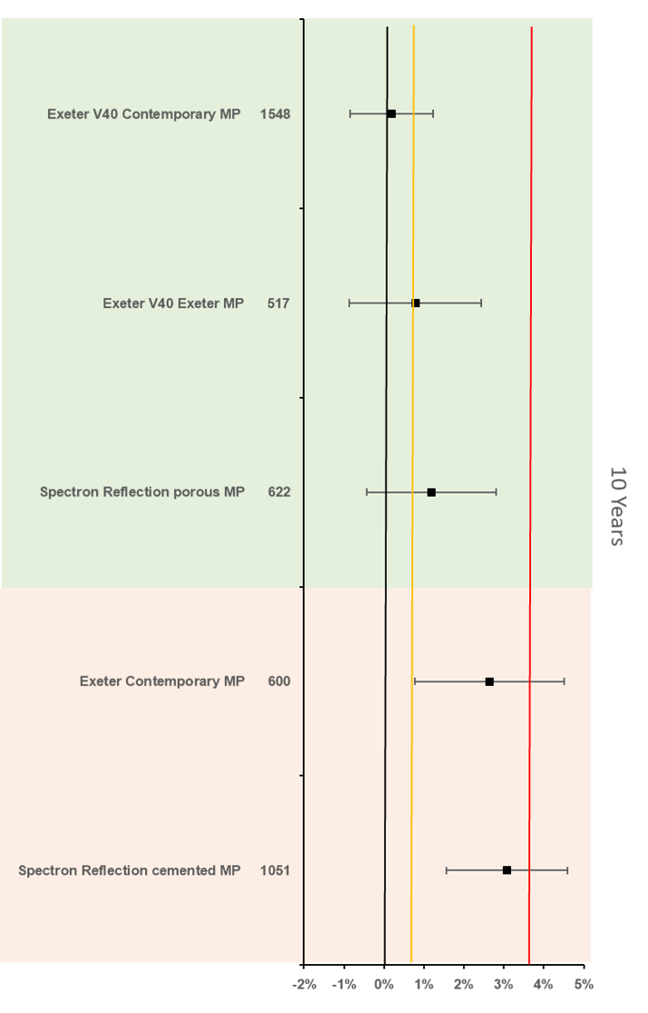
Figure 10. Difference in failure of implanted constructs compared with a contemporary reference (ExeterV40/Trident MP (3.76%, 95% CI 3.02 - 4.50)) at 10 years, using all stem-cup combinations with >500 procedures remaining at risk. CC, ceramic-on-ceramic; CP, ceramic-on-polyethylene; MP, metal-on-polyethylene.

Males:
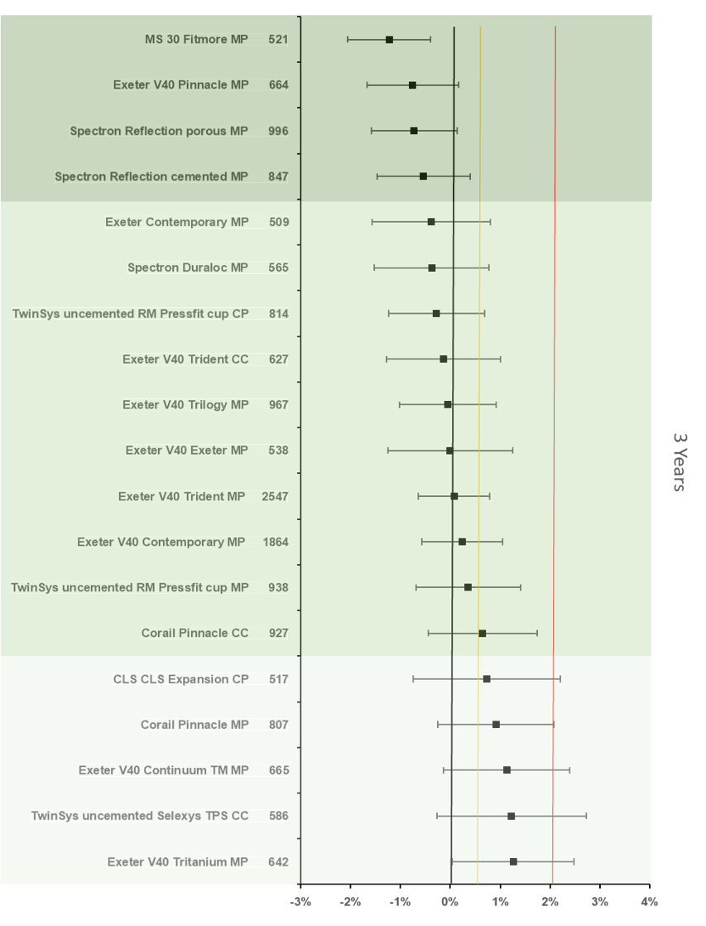
Figure 11. Difference in failure of implanted constructs compared with a contemporary reference (Corail Pinnacle CP (2.04%, 95% CI 1.53 - 2.55)) at 3 years, using all stem-cup combinations with >500 procedures remaining at risk. CC, ceramic-on-ceramic; CP, ceramic-on-polyethylene; MP, metal-on-polyethylene.
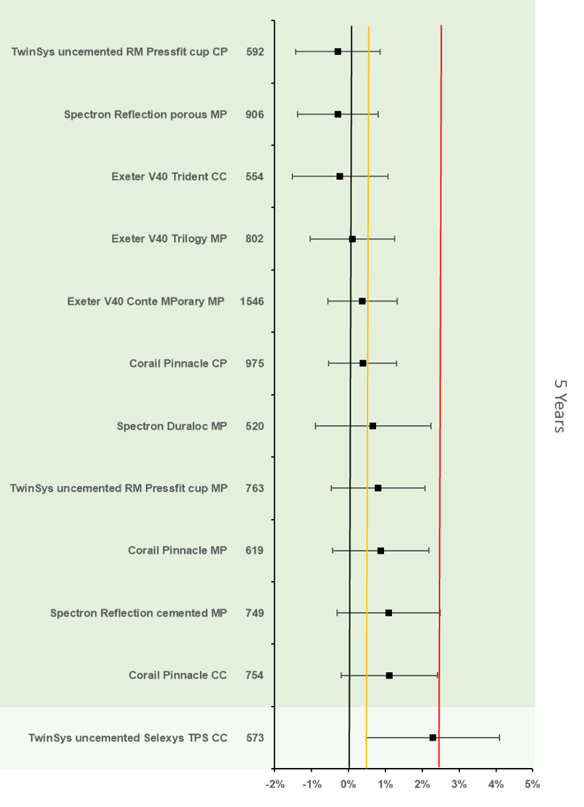
Figure 12. Difference in failure of implanted constructs compared with a contemporary reference (ExeterV40/Trident MP (2.64%, 95% CI 2.06 - 3.21)) at 5 years, using all stem-cup combinations with >500 procedures remaining at risk. CC, ceramic-on-ceramic; CP, ceramic-on-polyethylene; MP, metal-on-polyethylene.

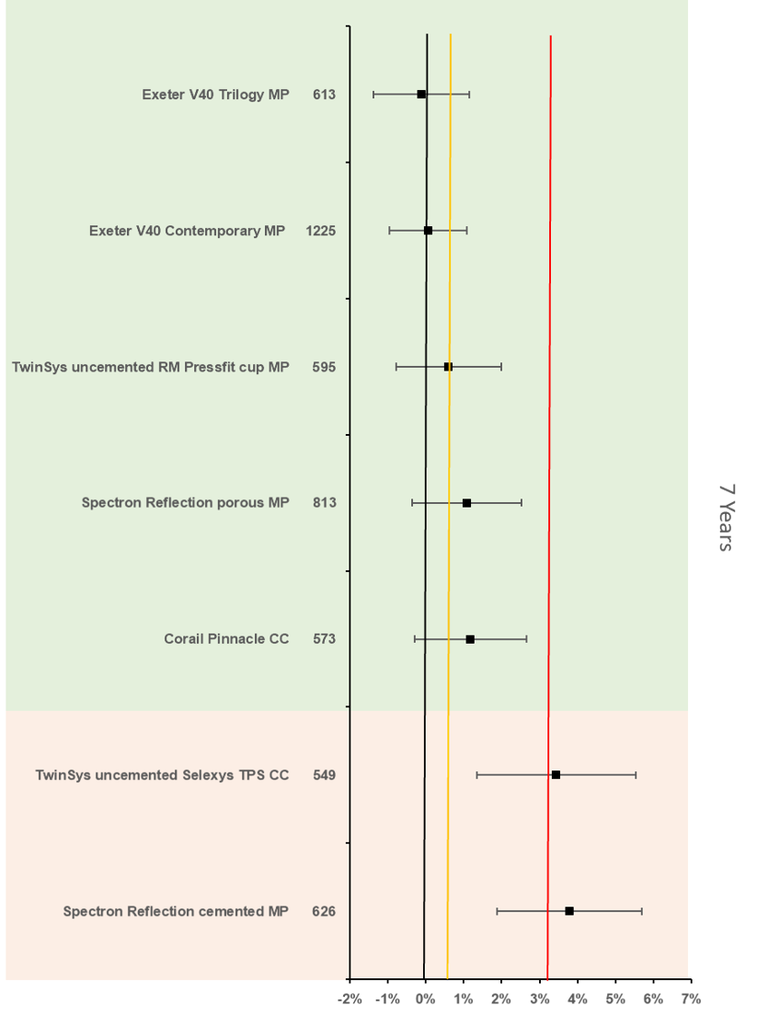
Figure 13. Difference in failure of implanted constructs compared with a contemporary reference (Exeter V40 Trident MP (3.16%, 95% CI 2.49 - 3.82)) at 7 years, using all stem-cup combinations with >500 procedures remaining at risk. CC, ceramic-on-ceramic; CP, ceramic-on-polyethylene; MP, metal-on-polyethylene.

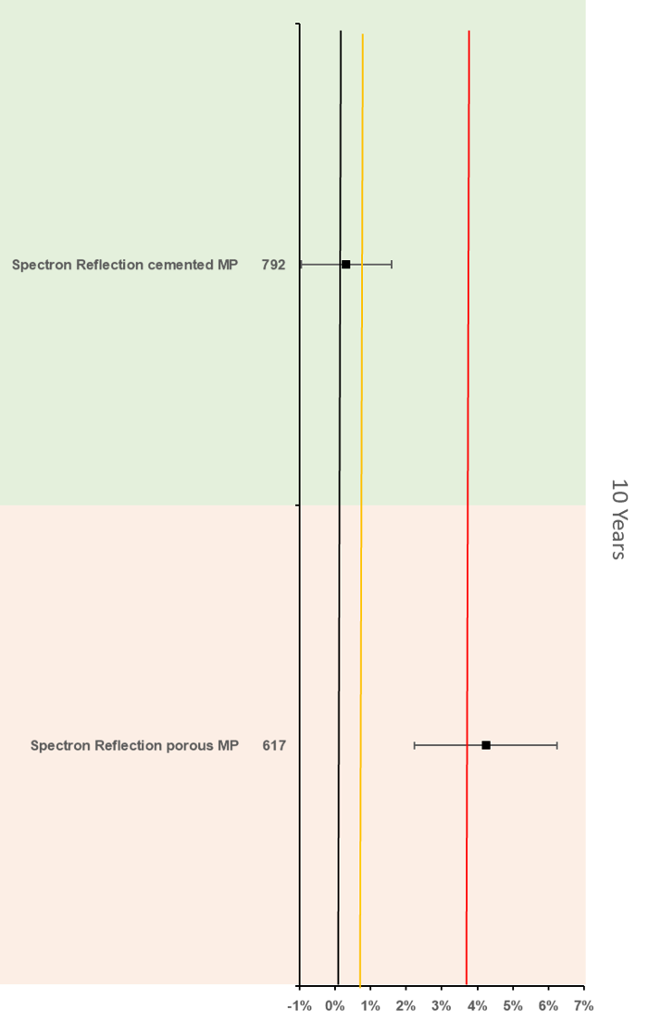
Figure 14. Difference in failure of implanted constructs compared with a contemporary reference (ExeterV40/Trident MP (3.84%, 95% CI 3.03 - 4.66)) at 10 years, using all stem-cup combinations with >500 procedures remaining at risk. CC, ceramic-on-ceramic; CP, ceramic-on-polyethylene; MP, metal-on-polyethylene.

