Table of Contents
Bridging the QC–QA Cognitive Handoff: An Agentic Verification Harness for Error Detection, Specification Cross-Checking and Quality Documentation Assembly in Pharmaceutical Quality Assurance 1
Abstract 1
1. Introduction 1
2. Background 1
2.1 Quality assurance, quality control and the role of documentation 1
2.2 The conventional QC–QA documentation workflow 1
2.3 Challenges of conventional QA review 1
2.4 Artificial intelligence in pharmaceutical sciences 1
2.5 Applications in pharmaceutical quality 1
2.6 Artificial intelligence in GxP and regulated environments 1
3. Literature review, research gap, aim and scope 1
3.1 Literature review 1
3.2 The core research gap 1
3.3 Aim and specific objectives 1
3.4 Scope and context of use 1
4. Methodology 1
4.0 Methodology — introduction 1
4.1 Study design 1
4.2 The ACTD product-quality structure as the documentary frame 1
4.3 Baseline establishment and adjudication of pre-existing anomalies 1
4.4 Controlled error injection 1
4.5 Ground-truth development and expert validation 1
4.6 Architecture of the verification harness: the three-role separation principle 1
4.6.1 What makes the architecture agentic 1
4.6.2 The pinned model pool and the cardinal arithmetic invariant 1
4.6.3 The three-role separation principle 1
4.6.4 Which component performs which methodological step 1
4.6.5 Stage 1 — Extract: ingestion, extraction sub-agents, normalisation and the grounding gate 1
4.6.6 Stage 2 — Build the source-of-truth tree 1
4.6.7 Stage 3 — Identify: deterministic rails and relational invariants 1
4.6.8 Stage 4 — Fix: correction directives and the boundary of automated correction 1
4.6.9 Stage 5 — Consolidate and compile 1
4.6.10 Orchestration: the zero-privilege finite-state harness 1
4.6.11 Context management: hierarchical dynamic context slicing 1
4.6.12 Evidence: the audit ledger and two-hop provenance 1
4.6.13 The self-improvement boundary 1
4.7 Experimental evaluation protocol 1
4.8 Performance metrics 1
4.9 Analysis of false positives and false negatives 1
4.10 Human-in-the-loop verification 1
4.11 Repeatability assessment 1
4.12 Statistical analysis 1
4.13 Ethical and data-integrity considerations 1
5. Results 1
5.1 Composition of the controlled reference dataset 1
5.2 Detection on the controlled reference dataset 1
5.3 The 17 interventions not detected 1
5.4 Endpoints not reported 1
6. Worked demonstration: one case package traced end to end 1
6.1 Status and construction of the package 1
6.2 Ingestion, extraction, grounding and consolidation 1
6.3 Deterministic verification findings 1
6.4 Sub-agent reconciliation and provenance 1
6.5 Assembly, computational profile and human review 1
6.6 What the demonstration does and does not establish 1
7. Discussion 1
7.1 Reading the detection result 1
7.2 The seventeen not detected 1
7.3 Where accuracy comes from at this interface 1
7.4 Repetitive manual workload, and what the timing does and does not show 1
7.5 Compilation of quality documentation, and where authority sits 1
7.6 Relation to existing applications of artificial intelligence in pharmaceutical quality 1
7.7 Novelty and practical significance of addressing the QC–QA cognitive handoff 1
7.8 Critical appraisal 1
7.9 What deployment would require 1
7.10 Overall assessment 1
8. Limitations 1
9. Conclusion 1
10. Limitations of existing approaches 1
References 1
Declarations 1
Appendix A — Literature search protocol 1
Appendix B — The controlled reference dataset 1
B.1 Record inventory 1
B.2 De-identification token map 1
B.3 What was preserved 1
B.4 Known limitations of the conversion 1
Appendix C — Outstanding reporting items 1
Appendix D — Orchestration transition function and tool registry 1
D.1 The transition function δ 1
D.2 Tool registry enumeration 1
Appendix E — Completeness, manifest and chronology specifications 1
E.1 Required-element schema (class D5) 1
E.2 Package manifest (class D9) 1
E.3 Chronology tolerances (class D6) 1
E.4 Staged compendial criteria (class D2, dissolution and content uniformity) 1
E.5 Impurity threshold hierarchy (classes D8 and D2) 1
Appendix F — Reporting checklist for the completed evaluation 1
Appendix G — Discrepancy class, ACTD site and mechanism map 1
Appendix H — ACTD Part II sections represented in the reference dataset 1
Supplementary Material 1
Algorithms 1

Bridging the QC–QA Cognitive Handoff: An Agentic Verification Harness for Error Detection, Specification Cross-Checking and Quality Documentation Assembly in Pharmaceutical Quality Assurance

Abstract
Background. Pharmaceutical quality control (QC) generates analytical data inside validated, audit-trailed instrumentation. The step that follows — moving each result into the quality assurance (QA) documentation where it will be assessed, checking it against its own acceptance criterion, reconciling it with every parallel record that reports the same batch, and assembling it into the submission structure — remains manual. Manual cross-checking of this kind fails in predictable ways: transposed values, carried-over units, comparison against the wrong specification, divergent batch identifiers, contradictory dates and omitted results. Published applications of artificial intelligence in pharmaceutical quality concentrate on the data-generation side and largely bypass this review step.
Objective. To develop an agentic verification harness for the QC-to-QA documentation handoff; to specify a controlled experimental protocol that evaluates it against a ground truth the system never receives, using a reference dataset built from de-identified authentic pharmaceutical quality records; and to report the first blinded detection result obtained under that protocol.
Methods. The harness is constructed on a three-role separation principle: probabilistic components propose, deterministic software rails dispose, and a qualified human decides. Layout-preserving visual-spatial ingestion reconstructs table grids with character-level coordinate offsets. Every proposed entity must cross a token grounding gate that tests joint lexical and spatial coverage against the immutable source token stream before it enters the verification stream. All recomputable statistics — ordinary least-squares linearity, relative standard deviation, percentage recovery, limits of detection and quantitation, and dissolution similarity — are computed by pinned deterministic microkernels; the language models are structurally forbidden from performing arithmetic. Extracted facts are consolidated into a typed, coordinate-grounded canonical quality knowledge graph in which each quantity is held once with its complete occurrence list retained, disagreements between printings are preserved as conflicts rather than averaged, deterministic relational invariants are asserted over the consolidated store, and conflicts between documents are resolved by a five-level Tree-of-Truth precedence lattice in which raw instrumental records strictly dominate downstream summaries. Orchestration runs as a deterministic finite-state automaton restricted to a four-tool immutable verification contract, with no shell, no arbitrary code execution and an append-only cryptographically chained ALCOA+ event ledger.
Results. The controlled reference dataset carried 112 interventions across 13 records de-identified from an authentic ACTD Part II submission, representing all nine discrepancy classes and concentrated in P.8.3 stability data, P.5.3 analytical method validation, P.5.4 batch analysis and P.3.5 process validation. Applied to the complete dataset under the blinded protocol, the harness detected 95 of the 112 interventions: an observed detection rate of 84.8 % (95 % Wilson CI 77.0–90.3); against the 107 interventions reachable by a verification rail, under a stratification fixed at injection time, the rate is 88.8 % (81.4–93.5). Detection occurred in all nine classes; per-class figures are exploratory, since with 6 to 18 interventions per class the intervals overlap almost completely. The figure is reported as a detection rate rather than a sensitivity because the true-negative and false-positive cells are not established for this corpus. Four mechanisms account for the findings: deterministic recomputation recovered a calibration slope of 9,800.4 against a reported 10,020, a recovery of 97.20 % against 101.40 % and a repeatability %RSD of 1.48 % against 0.85 %; specification binding identified a declared reporting threshold of 0.05 % that a method with a validated quantitation limit of 0.08 % cannot support; cross-document reconciliation resolved batch-identifier and method-revision conflicts toward the primary record; and evidence grounding admitted 123 of 124 candidate facts (mean score 0.982 ± 0.015) while blocking an unsupported working range at 0.081. Every assembled value resolved to a source page region, and the automated pipeline completed in 144.0 s.
Conclusion. The study contributes a controlled reference-standard evaluation framework for verification at the QC-to-QA handoff and an initial blinded assessment of an agentic harness against it. The architecture confines probabilistic models to proposing transcriptions and excludes them from arithmetic, acceptance decisions and unsupervised document assembly. It does not establish specificity, precision, F1-score, false-alarm rate, extraction accuracy, assembly completeness, repeatability or superiority to human review — all contingent on expert adjudication of the defects the authentic source records already carried, and none to be inferred from the detection result. The contribution is therefore a reproducible architecture and an experimental protocol for blinded evaluation rather than a claim of production readiness, with the corpus becoming a reusable benchmark once its expert validation is complete. In practice the system is best positioned as an AI-assisted verification and documentation-support layer that improves the accuracy and consistency of QC-to-QA information transfer, supports faster and more traceable documentation workflows, and supports rather than replaces qualified human QA review and final decision-making.
Keywords: pharmaceutical quality assurance; quality control; agentic artificial intelligence; data integrity; ALCOA+; 21 CFR Part 11; GAMP 5; regulatory dossier assembly; document verification; ground-truth evaluation

1. Introduction
Pharmaceutical quality is a patient-safety function before it is a documentation function. Every marketed drug product must be safe, effective and manufactured consistently to its registered specification, and the evidence that it is rests on two interlocking systems. Quality control (QC) performs the testing — chemical, physical and microbiological — that produces objective results on raw materials, in-process samples and finished product. Quality assurance (QA) governs the system that surrounds that testing, confirming that procedures, records and documentation satisfy regulatory and organisational requirements before a batch is released or a dossier is filed.
The interface between them is the subject of this paper. QC data generation is already automated and already governed: chromatographic assays, dissolution testing and stability monitoring execute inside qualified software with audit trails, and laboratory information management systems capture the results under controlled access. What happens next is neither automated nor instrumented. Before a result can support a marketing authorisation, a qualified professional must move it from the record where it was generated into the documentation where it will be assessed — the finished-product specification, the analytical validation report, the batch analysis summary, the certificate of analysis and the stability tabulation. That movement is manual. A reviewer reads a value from one document, compares it against an acceptance criterion held in another, recalculates the value where the criterion requires recalculation, confirms that batch identifiers and dates agree across every document that mentions them, and assembles the verified result into the submission structure.
Each individual check is elementary. None of it is exotic mathematics: a linear regression across five calibration points, a relative standard deviation across six replicate injections, a percentage recovery from a spiked and recovered weight, a comparison of a result against a compendial limit, a character-by-character comparison of two batch identifiers. What makes the work burdensome is volume and repetition. A single analytical method validation package can carry a dozen validation characteristics across multiple analytes. A stability package can carry results at eight or more pull points across three storage conditions for several batches and several packaging configurations. A process validation summary can cite critical quality attribute results across three performance qualification batches. A reviewer who has verified the first forty values correctly is, by the nature of sustained repetitive checking, not equally reliable on the four-hundredth — and a second reviewer checking the same package is prone to the same fatigue pattern rather than an independent one.
The consequences of failure at this step are asymmetric. A defect introduced here is individually small, individually invisible within a dense multi-page document, and individually capable of reaching a regulatory dossier, where it surfaces as a deficiency letter, an approval delay or a data-integrity observation. Where an out-of-specification result is recorded as compliant because it was compared against the wrong acceptance criterion, the defect carries direct product-quality risk.
Artificial intelligence has been applied extensively to the laboratory that feeds this review desk and very little to the desk itself. Published work concentrates on the generation side: process analytical technology, real-time release testing, sensor-driven process modelling and quality-by-digital-design. Where artificial intelligence has reached pharmaceutical documentation at all, it has been applied to translating regulatory text, surveying commercial document-management platforms or interpreting guidance — not to verifying reported data against its own specification and against parallel records.
Unconstrained language models cannot simply be inserted into the gap. They are non-deterministic; they produce fluent output that cannot be distinguished from verified output without independently checking it; and they provide no traceable link between a stated finding and the source supporting it. A quality assurance function operating under 21 CFR Part 11 and ALCOA+ obligations cannot accept a finding it cannot trace to a source, and cannot validate a system whose output varies between runs on identical input. Any system proposed for this interface must therefore be architecturally constrained rather than merely prompted, and must be measurable against something.
Two problems consequently remain open, and this study addresses them together. The first is architectural: whether an agentic system constrained by deterministic verification and explicit evidence anchoring can detect the discrepancy classes that arise in QC-to-QA transfer, at a sensitivity high enough to be useful and a false-positive burden low enough to be tolerated in routine review. The second is prior to the first and more fundamental: no reference standard exists against which any such system could be measured. No published corpus of pharmaceutical quality documents carries known, expert-validated discrepancies at known locations. Until such a corpus exists, every claim about automated verification performance in this domain — including any claim this paper might make — is unfalsifiable.
This paper therefore does two things. It specifies an agentic verification harness in which the probabilistic, deterministic and human roles are separated by architecture rather than by policy, and it specifies a controlled, ground-truth-based protocol for constructing the reference standard and evaluating the harness against it. A single case package, constructed under that protocol, is traced end-to-end to demonstrate that the architecture executes as specified. That demonstration is explicitly not the evaluation, and is not reported as evidence of performance.

2. Background

2.1 Quality assurance, quality control and the role of documentation
Quality assurance and quality control are complementary rather than interchangeable. QC is the testing function: it produces objective, reliable results on product quality through laboratory analysis. QA is the systems function: it reviews and verifies those results, confirming accuracy, completeness and compliance with standard operating procedures before a batch is approved for release or a dossier section is authorised.
Underlying both is documentation. Every test result, every observation and every decision must be recorded in a manner that supports traceability, accountability and regulatory compliance. Documentation is not an administrative residue of the quality system; it is the quality system’s evidentiary substance. A result that cannot be traced to the record in which it was generated has, for regulatory purposes, not been generated.
In the practice from which the present framework is drawn, QA is a pharmacist-staffed review function that does not itself perform manufacturing or testing. It receives raw analytical, stability and process-validation data from QC and is responsible for verifying that data before drafting the dossier sections it supports. The verification work is concrete and enumerable: recomputing linearity regressions from calibration points; confirming a reported percentage recovery against its spike-and-recovery raw data; recalculating relative standard deviation across replicate injections; checking that a stability result at a given pull point is consistent with the protocol schedule and with adjacent time points; and confirming that batch, lot and material-specification identifiers match identically across every source document feeding a single dossier table.

2.2 The conventional QC–QA documentation workflow
The conventional pharmaceutical quality-documentation workflow is the progressive transfer, verification, evaluation and consolidation of quality information generated during development, manufacturing, quality control and stability activities. Quality information is distributed across multiple records and dossier components and requires sequential review to establish that reported results are accurate, internally consistent, compliant with established specifications and supported by source documentation. In the ACTD product-quality structure, the relevant information includes finished-product specifications, analytical procedures and their validation, batch-analysis results, reference-standard information and stability data.
For the purposes of this study, the conventional workflow is represented as eight sequential stages (Figure 1).
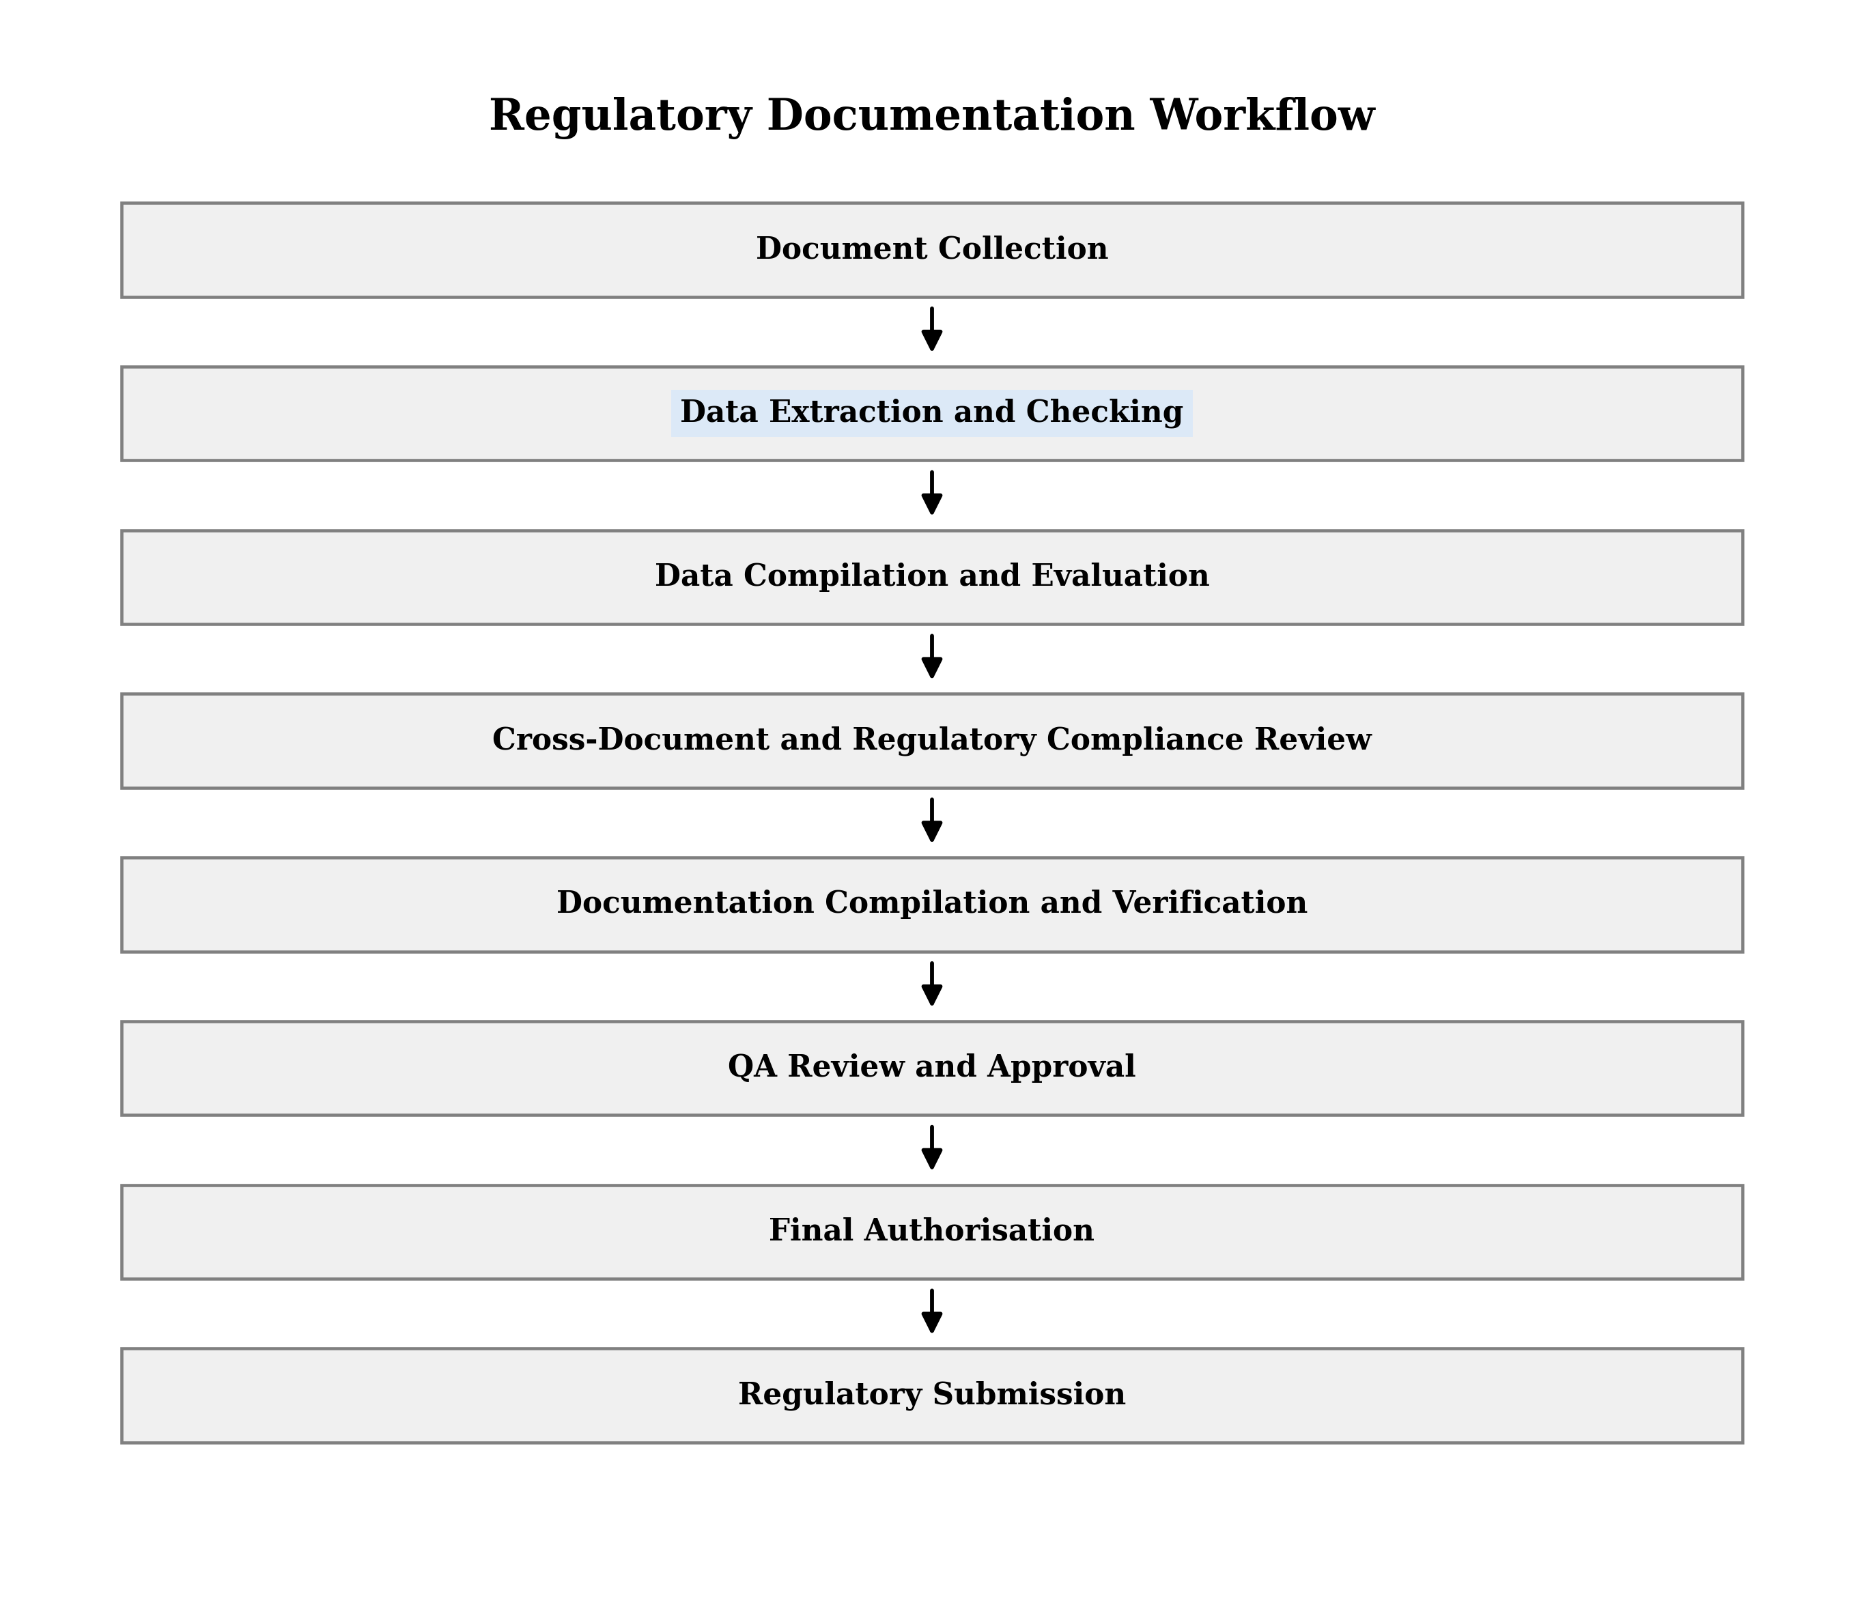
Figure 1. The conventional pharmaceutical QC–QA regulatory documentation workflow, as eight sequential stages from document collection to regulatory submission. Stage 2 is the transcription point: quality control output is moved out of the record in which it was generated, and it is where the nine discrepancy classes examined in this study are introduced. Stages 3, 5 and 7 carry any defect introduced there forward without re-deriving the value from source. Stages 4 and 6 are the two stages nominally positioned to catch such a defect, and both are manual comparison steps whose reliability degrades with volume. Stage 8 is where any surviving defect reaches the dossier.
Two properties of the sequence matter for what follows. First, it is unidirectional: no stage re-derives a value from the source record once that value has been transcribed, so an error introduced at Stage 2 is carried forward unchallenged unless a reviewer independently returns to the original document. Second, verification is concentrated in Stages 4 and 6, both of which are manual comparison tasks performed on documentation that has already been assembled — which means the reviewer is checking a compiled artefact against its sources rather than observing the transcription as it occurs.

2.3 Challenges of conventional QA review
The conventional workflow is sound in design and fragile in execution. Its principal stress points are the following.
- Volume. Increasing production scale and testing requirements generate documentation faster than manual review capacity grows.
- Repetition. Reviewers verify structurally similar data patterns and calculations across many batches, which depresses both efficiency and sustained attention.
- Time. Manual verification of extensive records is inherently time-intensive and can delay batch release and product availability.
- Human error. Prolonged manual review under time pressure increases susceptibility to oversight and judgement error.
- Transcription error. Manual transfer of data between documents introduces risk of inaccurate replication of values, units and identifiers.
- Missing information. Incomplete entries and omitted data points can remain undetected in the absence of a systematic completeness check.
- Inconsistency. Divergences in values, formats or terminology across related documents are difficult to detect by manual comparison.
- Comprehensive comparison. Simultaneous cross-referencing of many interrelated records exceeds practical human working memory, which bounds the thoroughness of verification irrespective of reviewer diligence.
The last of these is the one that automation is best positioned to address, and it is the one this work targets. A reviewer can recompute a regression correctly. What a reviewer cannot reliably do is hold six documents open simultaneously and confirm, for every value in each, that it agrees with every other document that mentions it.

2.4 Artificial intelligence in pharmaceutical sciences
Several classes of computational technique bear on the problem.
- Machine learning. Algorithmic systems that identify predictive patterns and statistical relationships from empirical datasets, applied in pharmaceutical quality to spectral calibration and anomaly classification.
- Natural language processing. Computational techniques for parsing unstructured and semi-structured technical text, enabling automated extraction of entities, test methods and regulatory limits.
- Layout-preserving document intelligence. Conventional optical character recognition flattens visual pages into undifferentiated character streams, destroying table grids and cell relationships. Visual-spatial foundation models instead perform full-page visual patch tokenisation, preserving multi-row spans, table grids, headers and character-level spatial bounding coordinates.
- Large language models and mixture-of-experts architectures. Long-context language architectures capable of structured schema-constrained generation and domain-specific regulatory reasoning.
- Agentic state machines. Goal-directed computational harnesses that coordinate language models through strictly bound, sandboxed software tools, eliminating unbounded code execution and enforcing deterministic state transitions.

2.5 Applications in pharmaceutical quality
Applications of artificial intelligence within pharmaceutical quality operations span several domains:
- QC laboratory analysis — automated chromatographic peak integration, baseline drift correction and system suitability monitoring.
- Process monitoring and PAT — real-time multivariate monitoring of critical process parameters and critical quality attributes via near-infrared and Raman spectroscopy.
- Regulatory document processing — automated parsing of legacy technical reports, certificate-of-analysis digitisation and regulatory guidance querying.
- QA decision support — deviation triage, out-of-specification investigation clustering and historical CAPA root-cause analysis.
- Dossier preparation and assembly — structured compilation of ACTD Part II product-quality sections, and their ICH M4Q Module 3.2.P equivalents, from verified technical data streams.
The distribution is uneven. The first two domains are mature; the last two are, in the published literature, largely aspirational.

2.6 Artificial intelligence in GxP and regulated environments
Deployment within a regulated pharmaceutical environment is governed by constraints that determine architecture rather than merely inform it.
Data integrity and ALCOA+. Every data point processed or emitted by an automated system must satisfy the ALCOA+ criteria: attributable, legible, contemporaneous, original, accurate, complete, consistent, enduring and available. A generative model that produces a plausible but ungrounded laboratory figure violates the requirement for data truth at its foundation, and does so in a form specifically difficult to detect, because the fabrication is fluent.
Computerised systems validation. Under FDA 21 CFR Part 11, EU GMP Annex 11 and ISPE GAMP 5, software used in quality decisions must be validated, predictable and audit-trailed. A purely probabilistic model that produces non-deterministic arithmetic output is not merely difficult to validate; it is unvalidatable in principle, because validation requires that identical input produce identical output.
The necessity of deterministic software rails. These two constraints jointly force a separation of concerns. Artificial intelligence cannot be permitted to perform arithmetic or to make autonomous quality determinations. It may read documents and propose candidate values. Deterministic software must recompute every mathematical figure from raw data. Qualified human professionals must retain exclusive authority over final regulatory decisions. This separation is the organising principle of the system described in Section 4.

3. Literature review, research gap, aim and scope

3.1 Literature review
Published work on artificial intelligence in pharmaceutical quality has grown rapidly and is not evenly distributed across the quality system. Read against the eight-stage workflow of Figure 1, the literature clusters at the two ends and thins in the middle: it is dense where data is generated and dense again where regulatory guidance is interpreted, and sparse across the transcription, comparison and assembly stages that separate them. The following review is organised by that observation, into three streams, and assesses what each establishes and what it leaves unaddressed.
The QC–QA interface presents a verification challenge that none of this published work addresses. The relevant information is distributed across multiple ACTD sections and comprises analytical results, specifications, batch identifiers, units, dates, validation information, stability results and supporting records. Verification therefore requires not only extraction but comparison of related information across sections, assessment against predefined specifications, identification of inconsistencies, and traceable linkage of every finding to its source evidence. Stream one operates before the information reaches a document; stream two operates on documents one at a time; stream three states the constraints under which any such system must operate without specifying how they are met.
Table 1 summarises the studies most relevant to the present investigation and states the specific gap each leaves open.
Table 1. Prior work relevant to AI-assisted pharmaceutical quality verification, and the gap each leaves open.
Study | Focus | Reported finding | Gap relevant to the present study
Vaghela et al. (2024) [1] | AI/ML applications in pharmaceutical QA documentation | Potential for AI-based approaches to support documentation activities and reduce manual processing | Does not establish an integrated verification workflow for controlled detection of discrepancies across multiple quality records
Dobariya et al. (2024) [2] | AI and ML in pharmaceutical quality documentation | Potential of AI to improve documentation and address limitations of manual processes | Addresses documentation automation rather than experimental evaluation of cross-document verification against predefined ground truth
European Journal of Pharmaceutical Sciences review (2024) [3] | Broad AI application across development, manufacturing and QC | Expanding role of AI across pharmaceutical operations | Application-level discussion rather than a dedicated experimental framework for QC-to-QA document verification
Gaikwad & Pawar (2026) [4] | AI-assisted pharmaceutical analysis and quality monitoring | AI/ML applications for analytical and process monitoring | Focuses on analytical and process-level monitoring rather than document-level verification of quality information
Stassen et al. (2025) [5] | AI in biopharmaceutical continued process verification | AI-supported monitoring and prediction within GxP environments | Concentrates on process monitoring rather than verification of information transferred among QC documents, specifications and QA documentation
Nakka et al. (2026) [6] | AI/ML in pharmaceutical manufacturing under GxP | Computer vision, anomaly detection and automated inspection in manufacturing | Does not establish controlled ground-truth evaluation of multi-document extraction, specification checking, discrepancy detection and documentation assembly
The databases, period, search terms, inclusion and exclusion criteria behind this account, and the records it returned, are given in Appendix A. That search returned no dataset of pharmaceutical quality documents annotated with discrepancies of known class at known locations; the absence is reported for the indexed literature searched, not as a claim that no such corpus exists anywhere.

3.2 The core research gap
The central gap addressed by this study is the absence of a controlled, evidence-grounded framework for evaluating agentic artificial intelligence at the QC–QA verification interface.
The literature demonstrates that artificial intelligence can support individual pharmaceutical quality activities. It provides insufficient evidence on whether an agentic system can simultaneously extract relevant quality information, normalise heterogeneous records, cross-check results against specifications, identify inconsistencies between related documents, retrieve supporting evidence and assist in assembling quality documentation while maintaining human QA oversight.
The present study addresses the gap by developing an agentic verification harness and by specifying its evaluation against a controlled pharmaceutical quality-document dataset whose discrepancies are of known class at known locations and whose ground truth is to be expert-validated under the procedure of Section 4.5. The study does not assume that artificial intelligence improves QA performance; it specifies how that proposition is to be tested using predefined error-containing and error-free cases.

3.3 Aim and specific objectives
The study aims to construct and expert-validate a reference dataset of pharmaceutical quality documents, including specifications, batch analyses, certificates of analysis, stability documents and analytical method-validation records, by identifying pre-existing defects, introducing nine predefined discrepancy classes according to a prespecified reachability stratification, and obtaining independent confirmation from qualified QA, QC and regulatory professionals, with disagreements resolved through predefined adjudication and agreement reported using a chance-corrected statistic; develop a modular verification harness that separates probabilistic data extraction from deterministic verification, normalises structured fields and anchors every finding to its source document, page, table and field; evaluate discrepancy-detection performance using sensitivity, specificity, precision and F1-score overall and by discrepancy class; assess specification–result and cross-document verification, including compliance classification, incorrect specifications, unit inconsistencies and insufficient evidence, while reporting field-level extraction accuracy separately; evaluate documentation assembly by measuring section accuracy, completeness, preservation of original values and incorrect insertion rates; characterise false-positive and false-negative failure modes, assess repeatability across repeated runs and obtain QA-professional judgements on evidence sufficiency; and ultimately determine whether the system can support the preparation of an accurate, precise and traceable regulatory dossier while reducing review and assembly time, without replacing qualified human judgement or treating automated outputs as final quality-assurance decisions.

3.4 Scope and context of use
The operational boundaries of the framework are defined explicitly, because a system deployed in a regulated environment is validated against its declared scope and not against its capabilities.
Scope of the system. The system ingests multi-format source documents and decodes complete page layouts with character-level coordinate offsets; extracts candidate quality attributes and maps document hierarchies; enforces a token grounding gate that blocks unanchored proposals; consolidates repeated printings of the same quantity into a single canonical record while retaining every occurrence and every disagreement; recomputes all derivable statistics in deterministic pinned software; compares recomputed figures against protocol and compendial specifications; emits structured discrepancy findings carrying two-hop source evidence; emits reviewer-gated correction directives where a conflict admits one unambiguous resolution; and assembles verified data into the standard regulatory submission structure. Equally, and by construction rather than by policy, it produces no analytical laboratory data of its own; writes no unverified narrative prose, expert summary or regulatory evaluation; reaches no autonomous conclusion regarding batch release or manufacturing disposition; never closes, dismisses or resolves a finding on its own authority; never applies a correction directive without reviewer acceptance; and never judges whether a declared acceptance criterion is scientifically appropriate — a determination reserved exclusively to qualified human specialists.
The system does not draft, revise or compose any part of the dossier narrative. The intended outcome is less time spent on mechanical verification and more consistent detection of the errors that verification exists to catch, with the reviewing pharmacist’s professional judgement and authorship fully preserved.

4. Methodology
Sections 4.1–4.5 define the reference dataset, 4.6 the harness and 4.7–4.13 the evaluation; the reference standard was fixed before, and independently of, the harness.

4.0 Methodology — introduction
This study employed a controlled experimental methodology to develop and assess an agentic AI-based verification harness designed to support the pharmaceutical QC-to-QA documentation workflow. The methodology was structured to evaluate the system under controlled and reproducible conditions using de-identified pharmaceutical quality records containing predefined, deliberately introduced discrepancies while retaining corresponding error-free source records as the reference standard. The proposed workflow integrated document ingestion and data extraction, structured data normalization, specification and cross-document verification, deterministic analytical calculations, evidence grounding, discrepancy identification, provenance tracking, and automated quality-document compilation, followed by qualified human QA review and final approval. The experimental design therefore focused on determining whether the AI-assisted workflow could reliably process pharmaceutical quality information, identify predefined inconsistencies, reduce repetitive manual verification activities, and facilitate preparation of traceable quality documentation while maintaining human oversight for the final quality decision.

4.1 Study design
This controlled experimental study evaluated an agentic verification harness for pharmaceutical quality control (QC)/quality assurance (QA) documentation. Discrepancies of predefined class, magnitude and location were injected, unmodified records served as negative controls, and findings on error detection, specification/cross-document verification and documentation assembly were scored against a ground truth withheld from the harness.
The corpus is not synthetic: 13 records converted to markdown from an authentic ASEAN Common Technical Dossier (ACTD) Part II (Quality) submission for a small-molecule immediate-release oral solid, de-identified by a fixed token map (Section 4.13; Appendix B), with all analytical content and original wording preserved and page delimiters retained. Authentic records give external validity but carry pre-existing defects, so complete discrepancy knowledge holds only for injected interventions and specificity awaits the baseline census (Sections 4.3, 5.11).
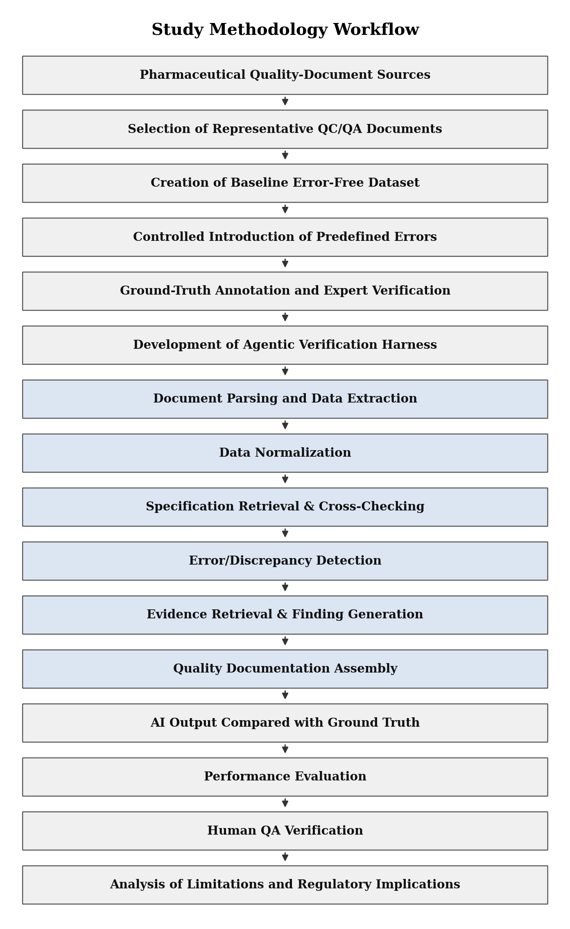
Figure 2. Sixteen-step workflow: corpus and ground truth (steps 1–5) precede harness development (step 6); the harness pipeline (steps 7–12) runs blind; evaluation (steps 13–16) is performed on the sealed ledger by a process the harness cannot invoke.

4.2 The ACTD product-quality structure as the documentary frame
Sources (QC laboratory, manufacturing, QA, specification, stability and procedural records) were logged in a document inventory (identifier, type, system, version, approval status, effective date, confidentiality, permitted use). Every field and discrepancy is addressed by ACTD Part II section, the point at which QC results become regulatory evidence; this defines the assembly target and maps directly to ICH M4Q Module 3.2.P. Included sections form four functional groups (Table 2).
Table 2. ACTD Part II sections included in the reference dataset.
Group | ACTD section | Title | QC content received | Role in the evaluation
1. Testing and release | P.2.3.3 | Physicochemical and biological properties | Finished-product test results | Batch agreement with P.5.4 and P.8.3
 | P.2.6 | Microbiological attributes | Microbial limit test results | Specification assertion
 | P.5.1 | Specification | Results checked against acceptance limits | Result and criterion on one page (D2, D8)
 | P.5.4 | Batch analyses | Assay and release data for representative batches | Main QC output entering the dossier
 | P.5.5 | Characterisation of impurities | Impurity identification and quantification | Specification assertion
2. Method and validation | P.3.4 | Control of critical steps and intermediates | In-process control data | Cross-section consistency
 | P.3.5 | Process validation and evaluation | Validation batch data | Batch and manufacture-date reference
 | P.4.1 / P.4.2 | Excipient specifications and analytical procedures | Excipient specifications and results | Specification and unit checks
 | P.5.2 | Analytical procedures | Method performance data | Method revision parity with P.5.3
 | P.5.3 | Validation of analytical procedures | Accuracy, precision, linearity, range, LOD, LOQ | Main site of recomputable statistics (D1); LOQ bounds P.5.1 reporting threshold
3. Stability | P.8.3 | Stability data | Results across conditions, time points and packs | Only longitudinal section; chronology and trend invariants
4. Reference and comparative data | P.6 | Reference standard | Reference-standard CoA data | Identity must remain constant across documents
 | P.9.2 | Comparative dissolution profile study | Paired dissolution profile data | f₂ recomputation
Excluded | P.1, P.2.1, P.2.2, P.3.1–P.3.3, P.7 | Narrative, descriptive or process sections | No reported QC results | No deterministic invariant can be asserted
Cross-section constraints. Each included section is constrained by at least one other: results must meet P.5.1 criteria; batch results must agree across P.5.4, P.8.3 and P.2.3.3; the method revision declared in P.5.2 must match that validated in P.5.3; and batch and date attribution must be consistent across the package. Every evaluation case therefore spans more than one section.

4.3 Baseline establishment and adjudication of pre-existing anomalies
Before injection, a baseline census records pre-existing anomalies by document, page, field and class: (i) arithmetic non-reproduction (mean, SD, %RSD, recovery, row sum, f₂); (ii) specification excursion; (iii) transcription/typographical artefact. The panel (Section 4.5) classes each as a genuine defect (added to the ground truth) or a conversion artefact (corrected). Until then, unmatched findings are uninterpretable, so specificity, precision and false-positive burden are not reported, and uninjected negative controls are valid only post-census.

4.4 Controlled error injection
Nine classes of documented QC-to-QA transfer failure were injected into baseline copies at the ACTD sites where they arise, so detection requires cross-section comparison (Table 3).
Pre-specified stratification by rail reachability. At injection, each intervention was recorded as rail-reachable if it (a) enters a recomputed statistic, (b) is bound to a criterion elsewhere, (c) is restated elsewhere, or (d) removes a required element/record; otherwise it is a blind control. The primary endpoint is detection against all interventions; the reachable stratum is a pre-specified secondary subgroup. Reachability is corpus-specific and supports no claim about other reviewers (no human arm).
Table 3. Discrepancy classes.
# | Class (definition) | Injection site | Contradicting evidence | Detection mechanism
D1 | Numerical transcription (transposed/misread value) | P.5.3, P.5.4, P.2.3.3 | Raw data annex (L1) | Microkernel recomputation; root precedence
D2 | Specification violation | P.5.4, P.8.3, P.2.6, P.5.5 | P.5.1 limits; monograph | Criterion bound assertion
D3 | Unit mismatch | P.5.4, P.8.3, P.4.2 | P.5.1 declared unit | Typed normalisation; dimensional comparison
D4 | Batch mismatch | P.8.3, P.5.4 | P.5.4, P.3.5, P.6 | Scoped cardinality; edit-distance adjudication
D5 | Missing value | P.5.4, P.2.3.3, P.8.3 | P.5.1 test panel; pull schedule | Required-element completeness
D6 | Date inconsistency (conflict or causal-order violation) | P.8.3, P.5.4 | P.3.5 manufacture record; adjacent pulls | Chronology invariant
D7 | Cross-document contradiction (result or method revision) | P.5.4 vs P.8.3; P.5.3 vs P.5.2 | All sections citing the pair/method | Relational comparison
D8 | Incorrect specification (altered or unsupportable by method) | P.5.1, P.4.1 | Monograph; P.5.3 capability | Monograph binding; capability assertion
D9 | Missing supporting document | Manifest (P.5.3, P.6 or P.9.2 withheld) | Citing sections | Manifest completeness

4.5 Ground-truth development and expert validation
A separately held master record lists per case the identifier, document, class, field, correct/altered values, supporting document and expected classification. At least two experienced QA/QC/regulatory reviewers independently verify each case, including the cleanliness of negative controls; agreement is reported as raw agreement and Cohen’s/Fleiss’ κ (CI), with consensus or third-reviewer adjudication, and reviewer details, blinding, adjudications and exclusions are reported. Status: not yet executed; Section 5.1 uses the unconfirmed injection register, so the corpus is a controlled reference dataset, not expert-validated.

4.6 Architecture of the verification harness: the three-role separation principle

4.6.1 What makes the architecture agentic
A controlling agent invokes single-responsibility sub-agents in a fixed order: adaptive within, deterministic between. The enumerable control flow is GAMP 5-validatable; sub-agent output is untrusted until grounded, recomputed and invariant-checked.

4.6.2 The pinned model pool and the cardinal arithmetic invariant
Sub-agents draw, by task demand, on a version-pinned pool (Gemini 3.4 Flash Lite, Mistral Large 3), chosen as the cheapest models meeting the hardest task (a cost/deployability decision, not a benchmark claim). On-premise execution is required (EU GMP Annex 11), but no air-gap is claimed. Serving mode, weights/provider details, retention terms, hardware and date are required per run (Appendix C) and are incomplete for the reported run, making Section 7.8 conditional; self-hosted open-weight models preserve all guarantees.
Cardinal invariant: no model performs arithmetic. This is enforced by the tool contract (Table 4; no arithmetic tool, recompute_statistic calls compiled kernels, no eval/exec) and qualified by registry enumeration.

4.6.3 The three-role separation principle
The probabilistic layer proposes; the deterministic layer disposes (no model numeral is accepted as truth); the qualified human decides. Five layers (source corpus, ingestion, sandboxed proposal, deterministic verification, human decision with 21 CFR Part 11 sign-off) have their load-bearing boundary between Layers 4 and 5; nothing above it closes findings, authors text, derives statistics or accepts results (page-read values excepted).
[Figure suggestion: five stacked layers with a bold Layer 4/5 boundary, annotated with key constraints (L3 no arithmetic tool; L4 G ≥ 0.50, four-tool registry, C/NumPy kernels; L5 QA pharmacist disposition, audit-trail lock).]

4.6.4 Which component performs which methodological step
Five fixed stages (Extract, Source of truth, Identify, Fix, Compile; 4.6.5–4.6.9) are supported by orchestration, model selection, context slicing, audit and the learning boundary (4.6.2, 4.6.10–4.6.13), with final disposition by the QA pharmacist. Each step has one owner, and boundaries are enforced by construction (no model arithmetic, no orchestrator shell, no sub-agent spawning, immutable gate/kernels/criteria). The full component-to-step mapping is given in Supplementary Table S1.
[Figure suggestion: swim-lane flowchart of Stages 1–5 with their components, a band for cross-cutting functions, and the QA pharmacist as terminal node.]

4.6.5 Stage 1 — Extract: ingestion, extraction sub-agents, normalisation and the grounding gate
Why layout preservation is necessary
Pipelined OCR flattens row spans, interleaves borderless columns and discards traceability coordinates.
Visual-spatial ingestion
PaddleOCR-VL (vision transformer, pages ≤ 1536 × 1536, explicit rowspan/colspan) runs per file, on-premise on a single GPU, storing each span as (document ID, page, byte span, normalised bounding box).
Deterministic structural normalisation
Merged cells are expanded with provenance; values (e.g., 100.2 %, 100.2% w/w, 1.002 × 10²) become typed, dimensioned decimals, enabling D3 detection.
The extraction sub-agent layer
Harness-scheduled domain sub-agents (method validation, ICH Q2(R2); stability, ICH Q1A(R2); process validation, PPQ; monograph/specification binding, USP/Ph. Eur.; entity resolution, feeding Stage 2) post typed candidates to an immutable blackboard.
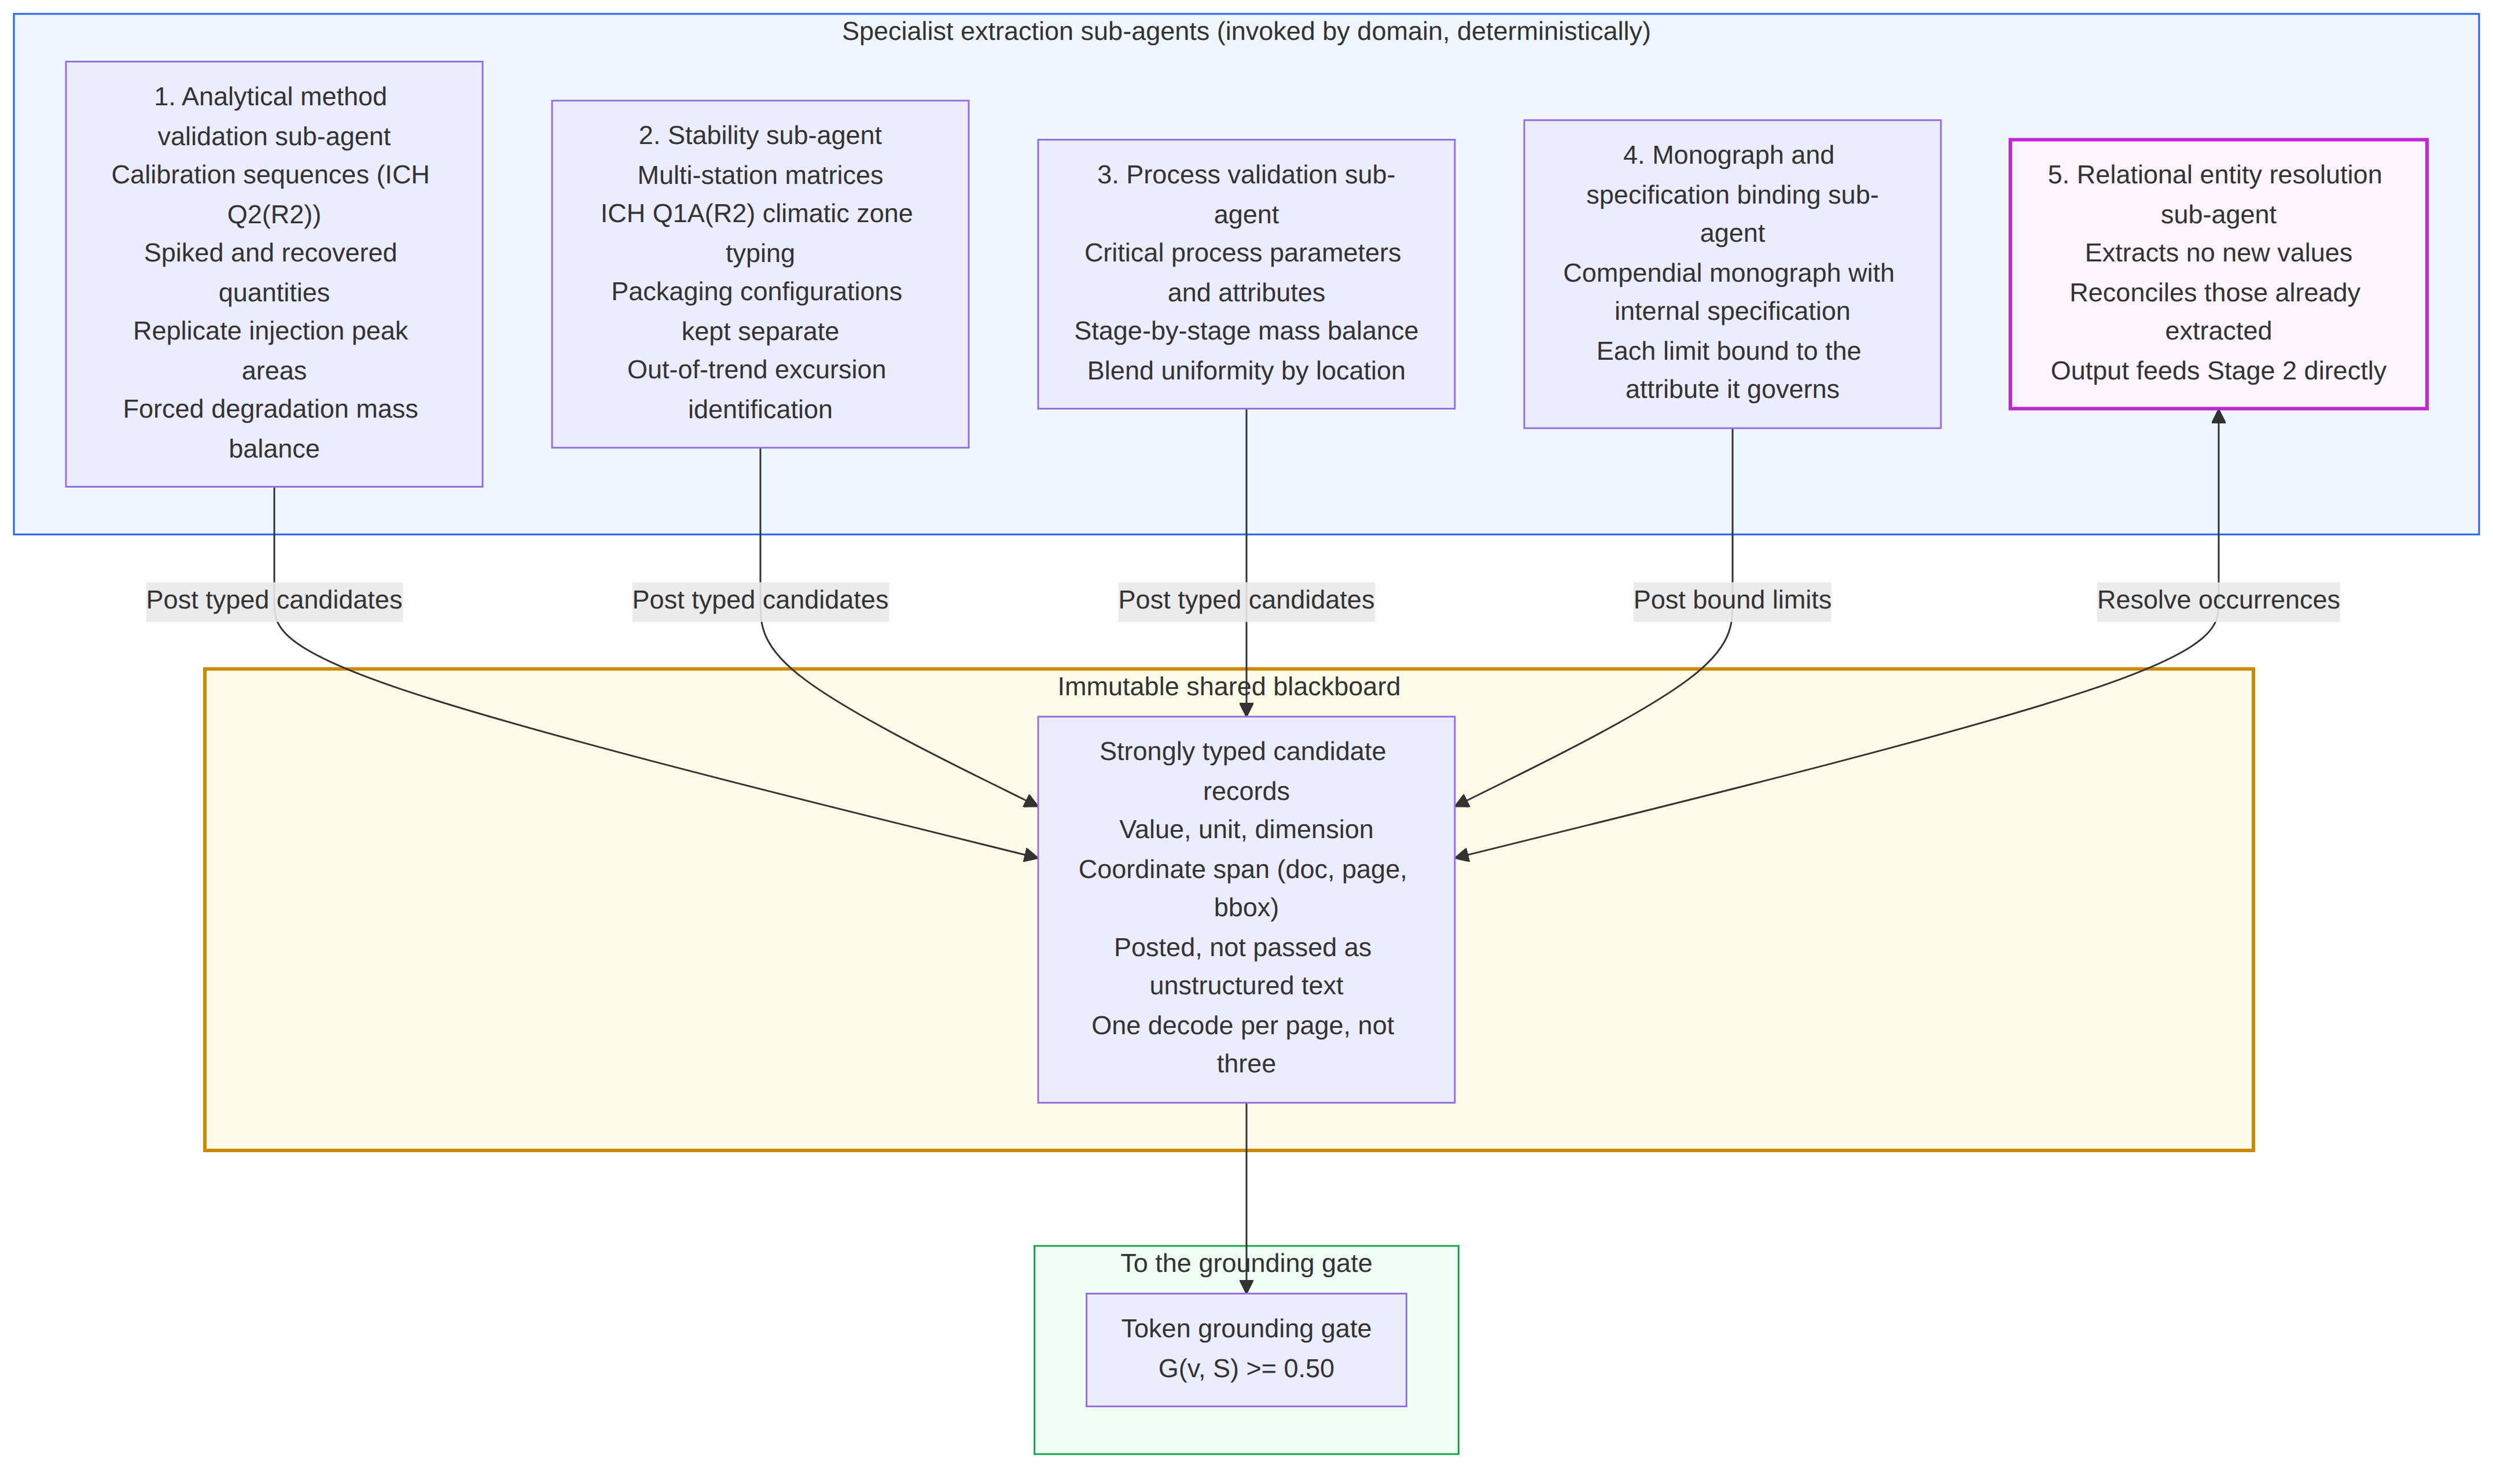
Figure 3. Extraction sub-agents over a shared immutable blackboard.
The grounding gate
G(v, S) = [ |T(v) ∩ T(S)_p(v)| / |T(v)| ] × I( B_v ⊆ B_page(v) )
T(v) are candidate subword tokens, T(S)_p(v) the attributed page’s token stream and I page containment (G = 0 if |T(v)| = 0). Candidates with G < 0.50 (hardcoded) are quarantined and logged. The gate blocks fabrication, not misassignment (wrong-cell values score 1.0; page attribution is model-supplied); this risk is unmeasured (Sections 4.8, 5.11), and a cell-level term I(B_v ⊆ B_row(v) ∩ B_col(v)) is specified but not implemented. The threshold is provisional (genuine ≥ 0.941 vs one fabrication at 0.081 on one package); a corpus-wide sweep is outstanding.
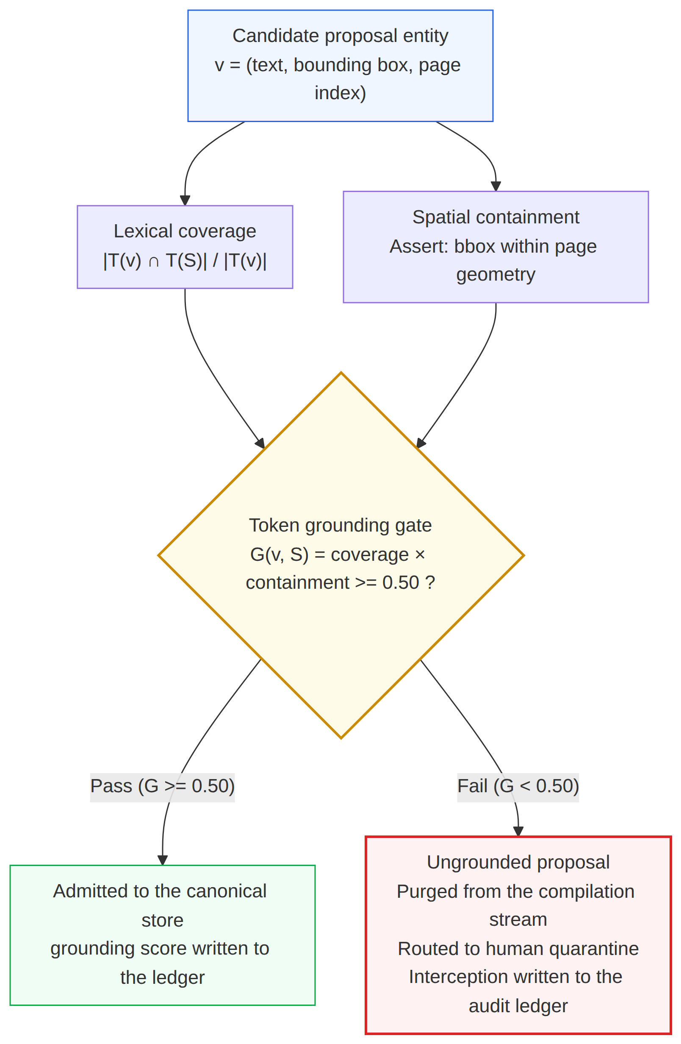
Figure 4. The token grounding gate (Algorithm S1 in Supplementary Material).

4.6.6 Stage 2 — Build the source-of-truth tree
Recurring facts are merged by canonical key (batch, test, time point, attribute) into one entity pointing to all occurrences, with naming variants unified and disagreements kept as conflicts, never averaged (Algorithm S2, Supplementary Material). Vector retrieval was rejected: it splits headers from cells, cannot separate 99.8 % from 89.8 % or B-24-0117 from B-24-01l7, and cannot traverse documents. Facts are held in the canonical quality knowledge graph (CQ-KG), 𝒢 = (𝒱, ℰ, Φ, Ψ): with typed entities 𝒱, relations ℰ, GxP typing Φ and an immutable source-span map Ψ (DocUUID, page, box, hash). Seven node types (schema in Supplementary Table S2) form domain subgraphs sharing a nexus core (Product, Batch, AnalyticalMethod, MonographLimit) where identity conflicts surface.
Establishing precedence: the Tree-of-Truth
To prevent summary deference: L1 raw signals ≻ L2 run logs ≻ L3 executed reports ≻ L4 CQ-KG ≻ L5 ACTD tables. Canonical value: Π_root(v_k) = arg min_{l ≤ k} { v ∈ 𝒱_l : (v, v_k) ∈ ℰ_provenance }. Design Invariant 1: for i < j, conflicts are corrected toward L_i only (an imposed invariant under 21 CFR 211.194, verifiable by inspection).
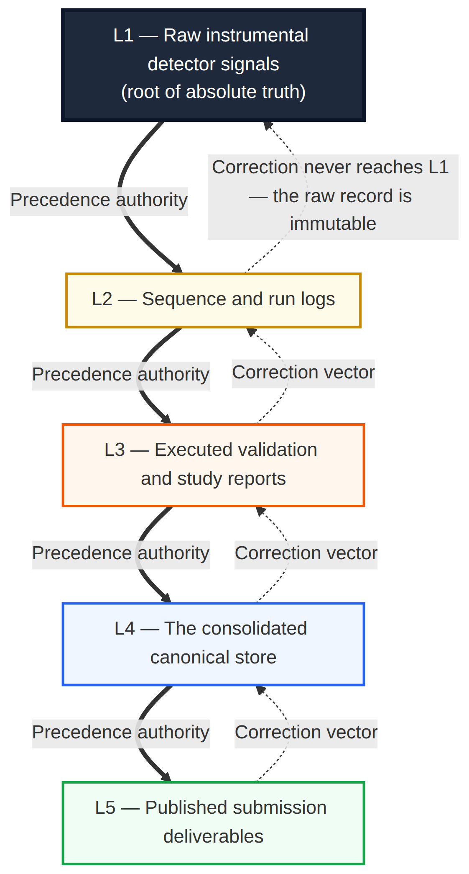
Figure 5. Tree-of-Truth precedence lattice; correction runs opposite to authority.

4.6.7 Stage 3 — Identify: deterministic rails and relational invariants
The rail is selected by entity type, not by model judgement.
Deterministic recomputation
Frozen exact-decimal kernels (GAMP 5 Category 4) recompute statistics from raw values. Δ_rel = |V_calc − V_rep|/|V_calc| × 100; Δ_abs = |V_calc − V_rep|, expressed in percentage points (pp) for percentages.
- 𝒦_OLS: m = [nΣxy − ΣxΣy]/[nΣx² − (Σx)²]; c = [Σy − mΣx]/n; r² = [nΣxy − ΣxΣy]²/{[nΣx² − (Σx)²][nΣy² − (Σy)²]}; slope Δ_rel ≤ 0.10 %.
- 𝒦_RSD (n ≥ 6): s = √[Σ(x − x̄)²/(n − 1)]; %RSD = s/x̄ × 100; Δ_abs ≤ 0.01 pp.
- 𝒦_REC: % recovery = A_recovered/A_spiked × 100; mean recovery and per-level %RSD at Δ_abs ≤ 0.05 pp.
- 𝒦_LOQ: LOD = 3.2σ/S; LOQ = 10σ/S. Asserted: “not detected” bound to an established LOD; LOQ ≤ each impurity result; LOD ≤ LOQ ≤ reporting ≤ identification ≤ qualification threshold (ICH Q3B(R2)/Q3A(R2)), violations reported per level. F-04 (Section 6.6) arises from reporting threshold ≥ LOQ; its LOD statement is reported separately.
- 𝒦_F2: f₂ = 50 · log₁₀{[1 + (1/n)Σ(R_t − T_t)²]^−0.5 × 100}; Δ_abs ≤ 0.1.
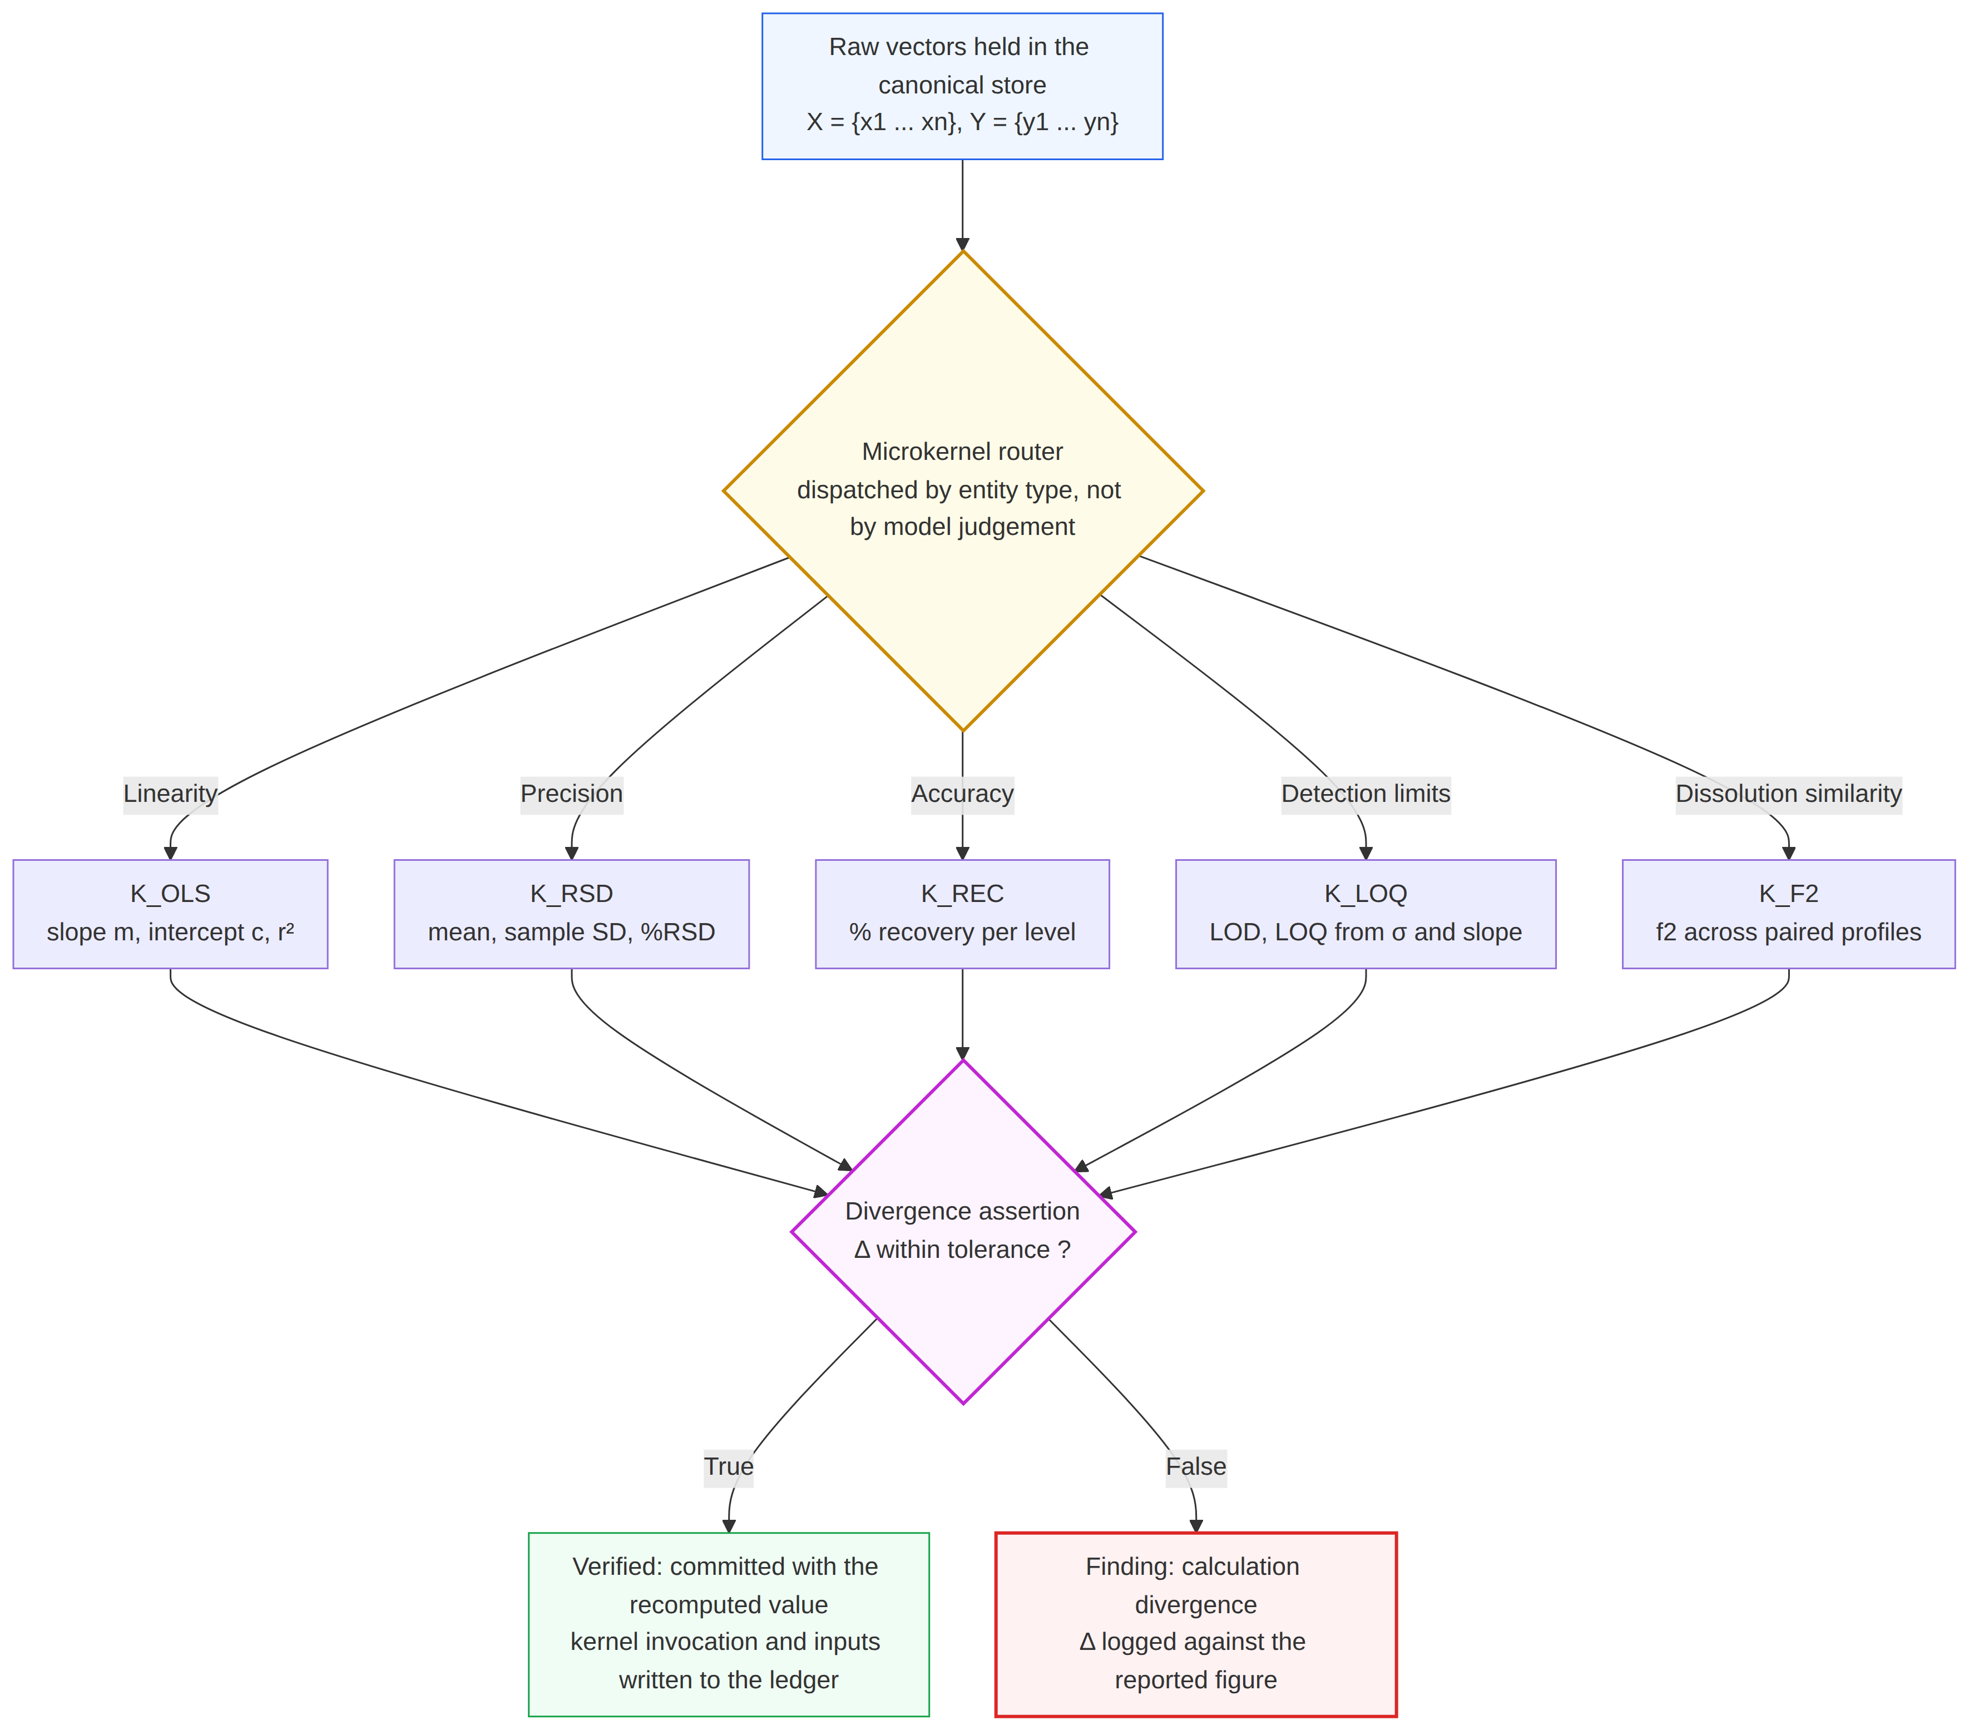
Figure 6. Deterministic verification rails (Algorithm S3 in Supplementary Material).
Relational invariants
Declarative CQ-KG queries; arithmetic is delegated to kernels.
Identity cardinality (D4). With B_decl fixed beforehand (manifest ≻ PPQ approval table ≻ specification/stability batch lists), for each scope key s = ⟨section, batch⟩: |BatchIDs(s)| = 1 and BatchIDs(s) ⊆ B_decl; violations are undeclared-batch or D4 conflict findings. A Levenshtein distance-1 difference is a candidate transcription slip only for confusion pairs {1,l,I}, {0,O,o}, {5,S}, {8,B}, {2,Z}, {6,G} or identifiers outside B_decl; increments between declared batches are scope questions. Nothing is auto-corrected; false-positive rate is uncharacterised.
Method revision parity (D7): cited revisions vs raw sequence-log headers.
Chronology (D6). T_manufacture ≤ T_sampling ≤ T_testing ≤ T_pull (same day allowed). Pull windows follow the protocol, else ICH Q1A(R2) (±3 d ≤ 3 mo; ±1 wk 6–12 mo; ±2 wk > 12 mo; substitution recorded); undeclared test lag > 30 d is a query. Pull before manufacture, test before pull and interval inversion are violations.
Trend. Out of trend means outside the pre-declared prediction interval of a regression on ≥ 4 prior pulls (same batch, station, pack), width bounded by validated repeatability %RSD; otherwise insufficient evidence to determine. Raw-record disagreements remain D1/D7 findings; false-alarm rates are uncharacterised.
Compendial bound assertion (D2, D8). Scalar: L_lower ≤ v ≤ L_upper, bounds matched to the monograph. Staged criteria are criterion objects: USP ⟨711⟩ S1 (6 units, each ≥ Q + 5 %), S2 (12; mean ≥ Q, none < Q − 15 %), S3 (24; mean ≥ Q, ≤ 2 < Q − 15 %, none < Q − 25 %); USP ⟨905⟩ acceptance value on 10 (L1) and 30 (L2) units. Outputs: PASS, FAIL, ADVANCE_TO_NEXT_STAGE; undeclared n/statistic gives insufficient evidence plus a documentation finding. A lone dissolution value < Q is a candidate non-conformance requiring QA verification; confirmed OOS requires investigation (21 CFR 211.192).
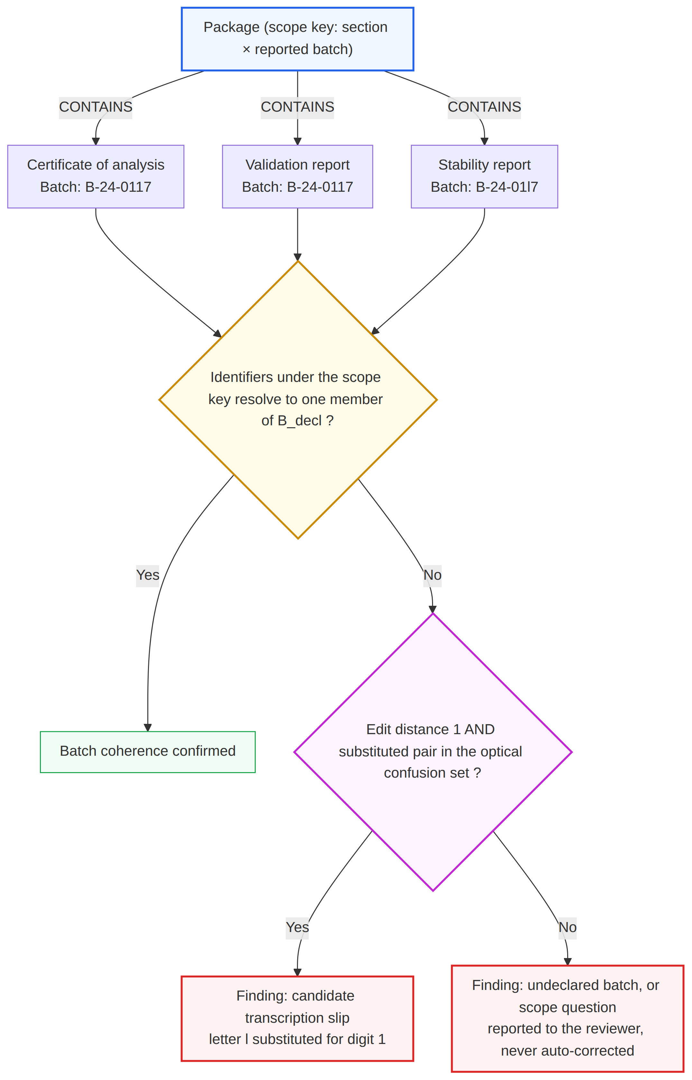
(a) Identity cardinality
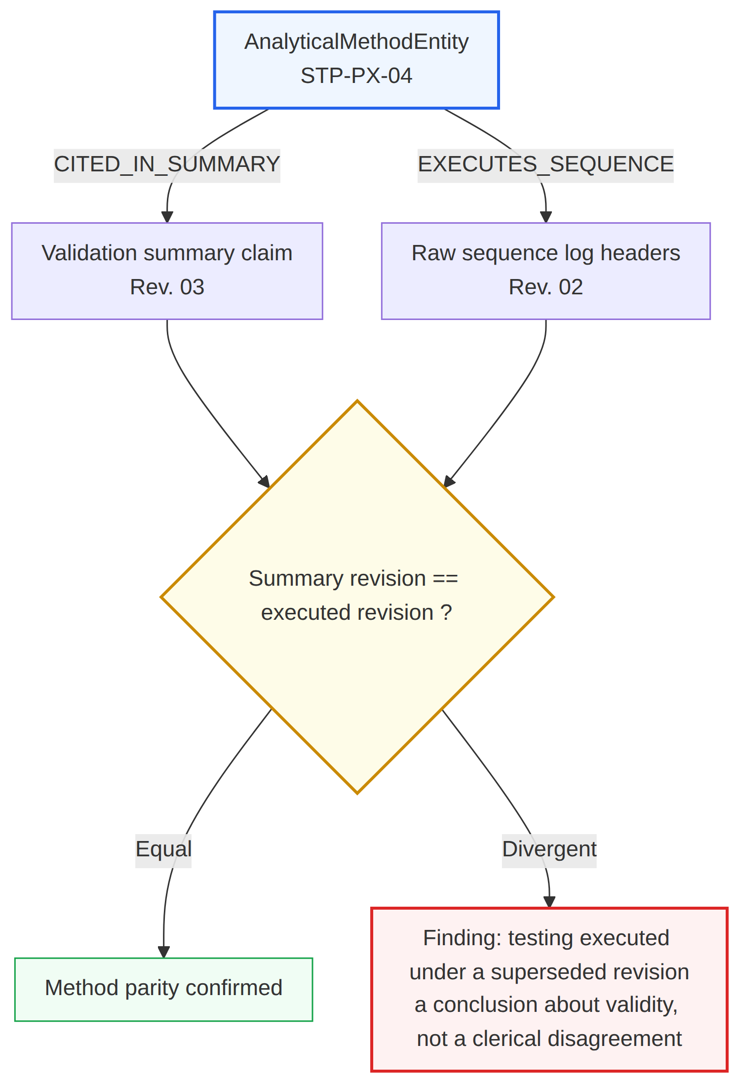
(b) Method revision parity
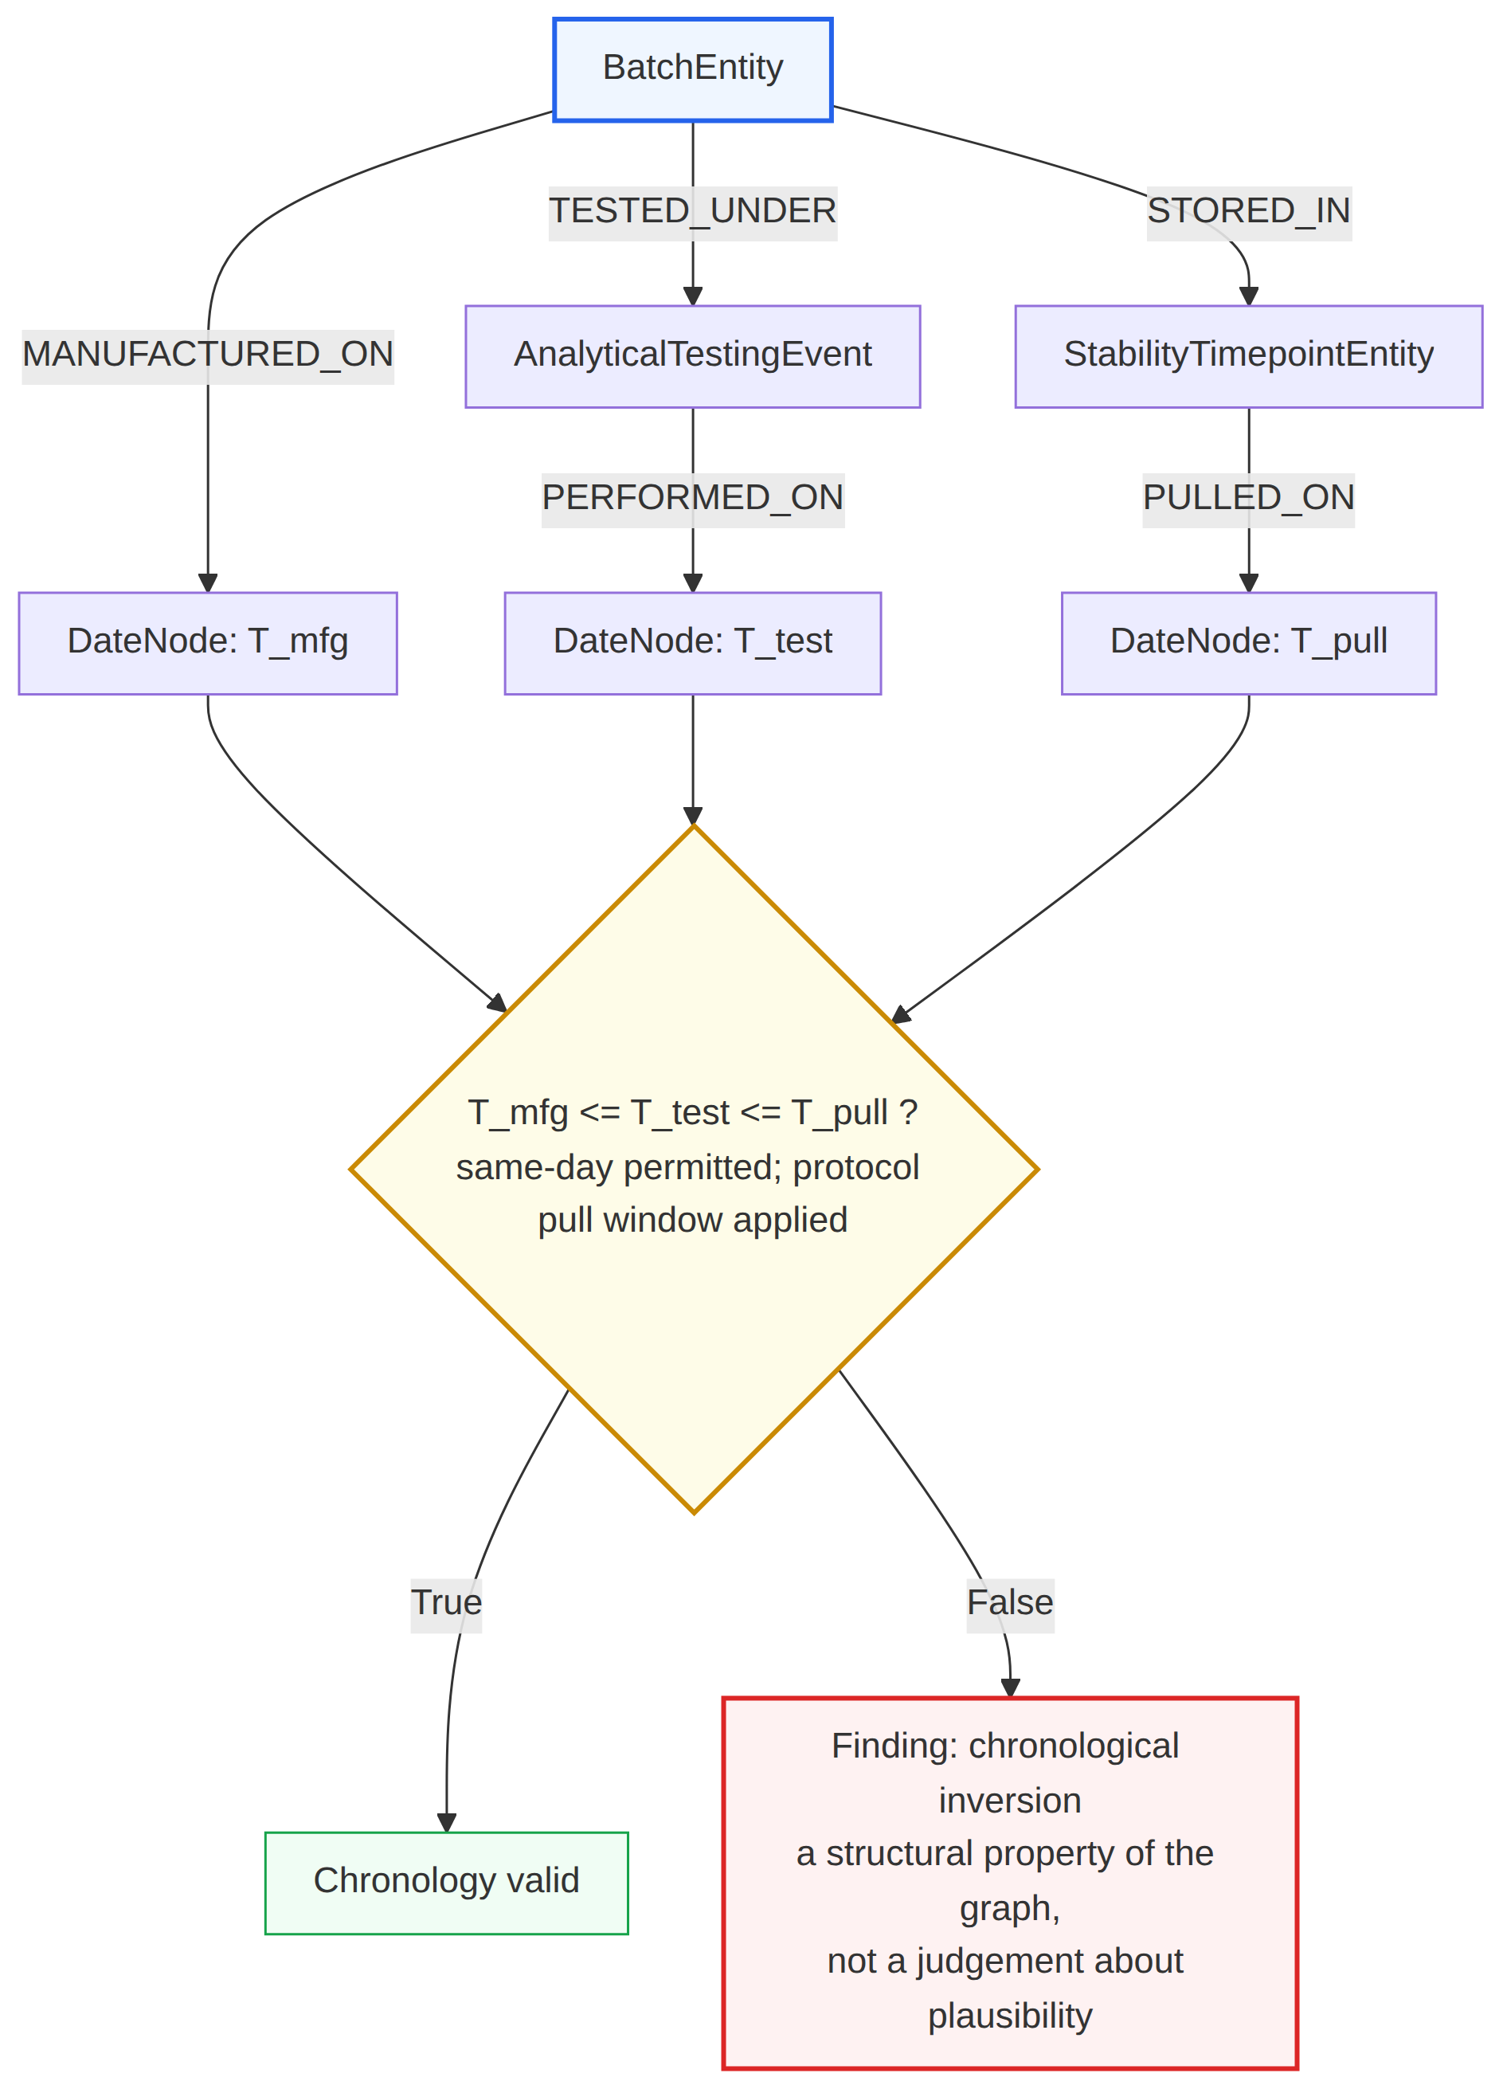
(c) Chronology
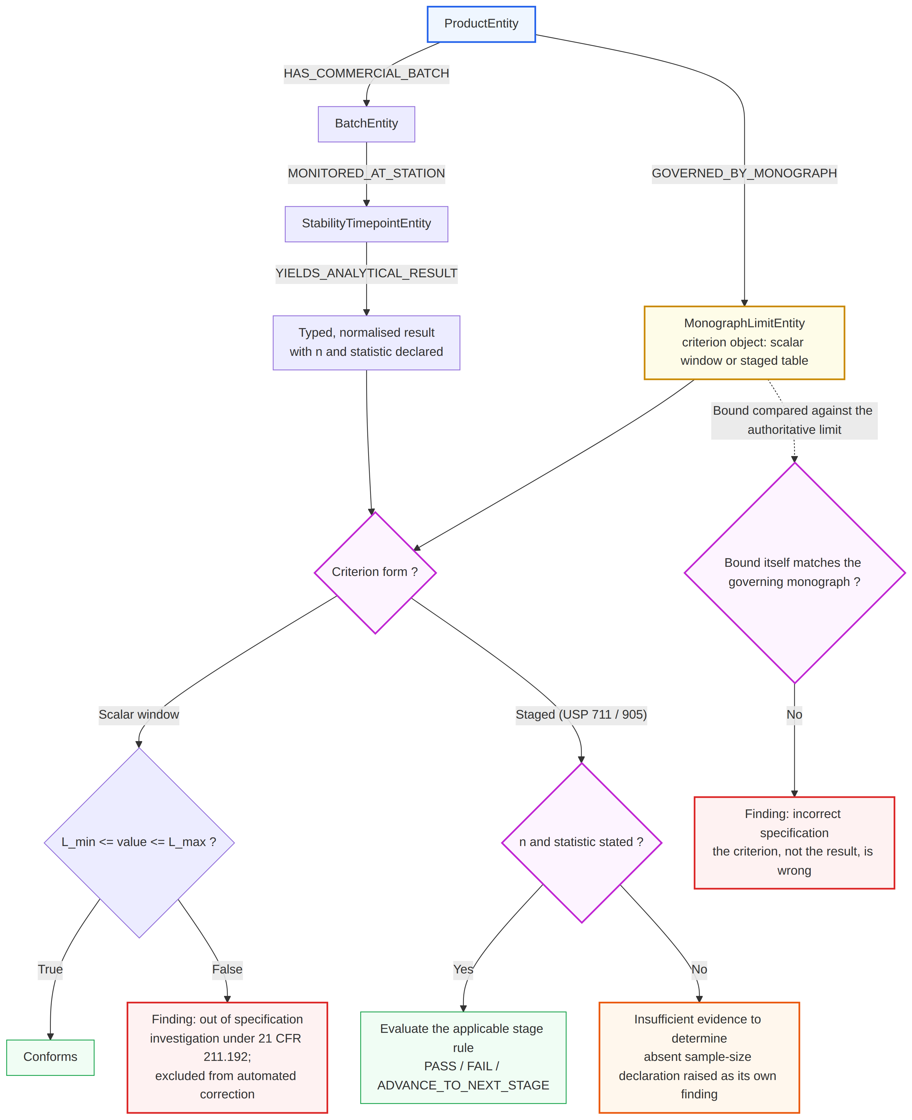
(d) Specification assertion
Figure 7. Invariant traversals: (a) identity cardinality; (b) method revision parity; (c) chronology; (d) specification assertion.

4.6.8 Stage 4 — Fix: correction directives and the boundary of automated correction
Where a higher stratum gives one unambiguous resolution (e.g., non-reproducible slope, one-character batch slip, L5–L1 disagreement), a correction directive (current and corrected value, source stratum, evidence span) is emitted via Algorithm S4 (Π_root; Supplementary Material); it takes effect only on reviewer acceptance, and no source record is written. OOS results, missing values and equal-stratum conflicts are never auto-corrected. Outcomes: error detected, no error detected, requires QA verification, insufficient evidence to determine.

4.6.9 Stage 5 — Consolidate and compile
Verified records are projected unaltered into the target section’s required-element schema (D5/D9 asserted here); accepted directives insert corrected values, open ones attach findings. No narrative is authored.

4.6.10 Orchestration: the zero-privilege finite-state harness
General-purpose frameworks (unbounded tools; recursive state graphs) fail 21 CFR Part 11, so orchestration uses DeepSeek Agent as a deterministic finite automaton ℳ = ⟨Q, Σ, δ, q₀, F, Γ⟩:
- Q = {q_idle, q_ingest, q_ground, q_consolidate, q_dispatch, q_assert, q_commit, q_quarantine, q_halt};
- Σ = {σ_doc, σ_pass, σ_fail, σ_call, σ_return, σ_complete};
- δ is deterministic; q₀ = q_idle; F = {q_commit, q_halt}; Γ is the ledger.
Out-of-contract calls fault; each (state, event) pair appears once in δ, independent of model output.
Table 4. The four-tool immutable verification contract (Ω_tools).
Tool | Inputs | Pre-condition | Engine | Post-condition
bind_anchor | entity_id, doc_uuid, page_idx, bbox | DocUUID registered; bbox in page | Coordinate registry | Hashed anchored span
recompute_statistic | stat_type, X, Y, tolerance | Valid non-empty vectors | Pinned kernel | Immutable value; no model arithmetic
cross_match_entity | entity_key, scope_package_id, invariant_type | ≥ 2 occurrences | Relational rail | Parity confirmed; slips flagged
assert_specification | test_result_value, monograph_ref, attribute | Limits [L_min, L_max] bound | Compendial evaluator | PASS or OUT_OF_SPECIFICATION
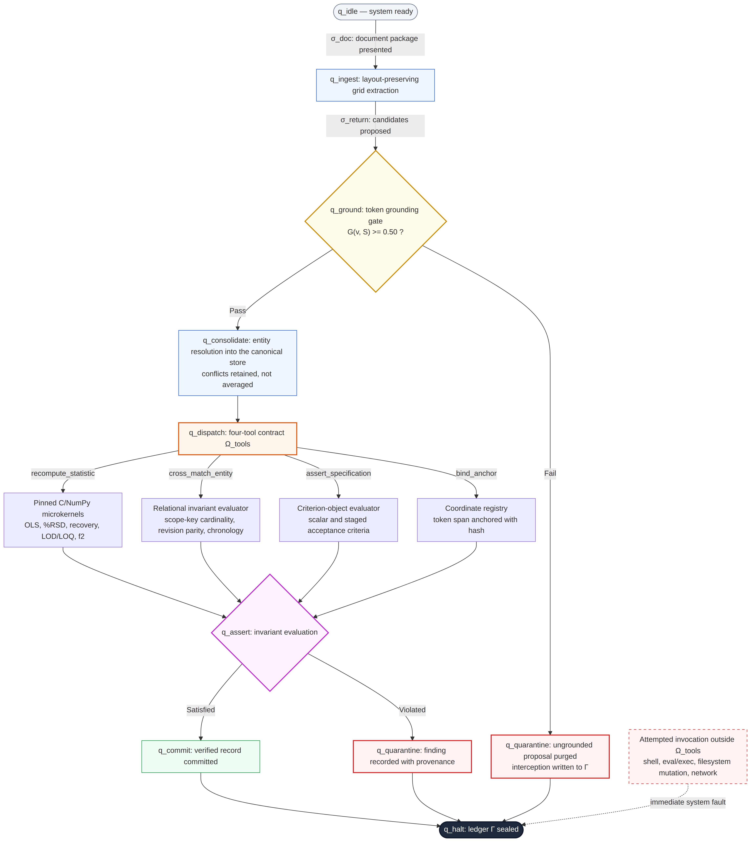
Figure 8. Finite-state automaton with halt branch (Algorithm S5 in Supplementary Material).

4.6.11 Context management: hierarchical dynamic context slicing
HDCS limits each sub-agent’s context to the target section’s entity types, the nexus core and one-hop relations: 𝒢_scoped(𝒮_target) = (𝒱_target ∪ 𝒱_nexus, ℰ_target), where 𝒱_target = {v : Φ(v) ∈ σ_scope(𝒮_target)} and σ_scope : 𝒮_target → 𝒫(𝒯_entities) × ℕ_hop. Cross-section checks bind only the queried node and provenance leaf, pruned after commit.
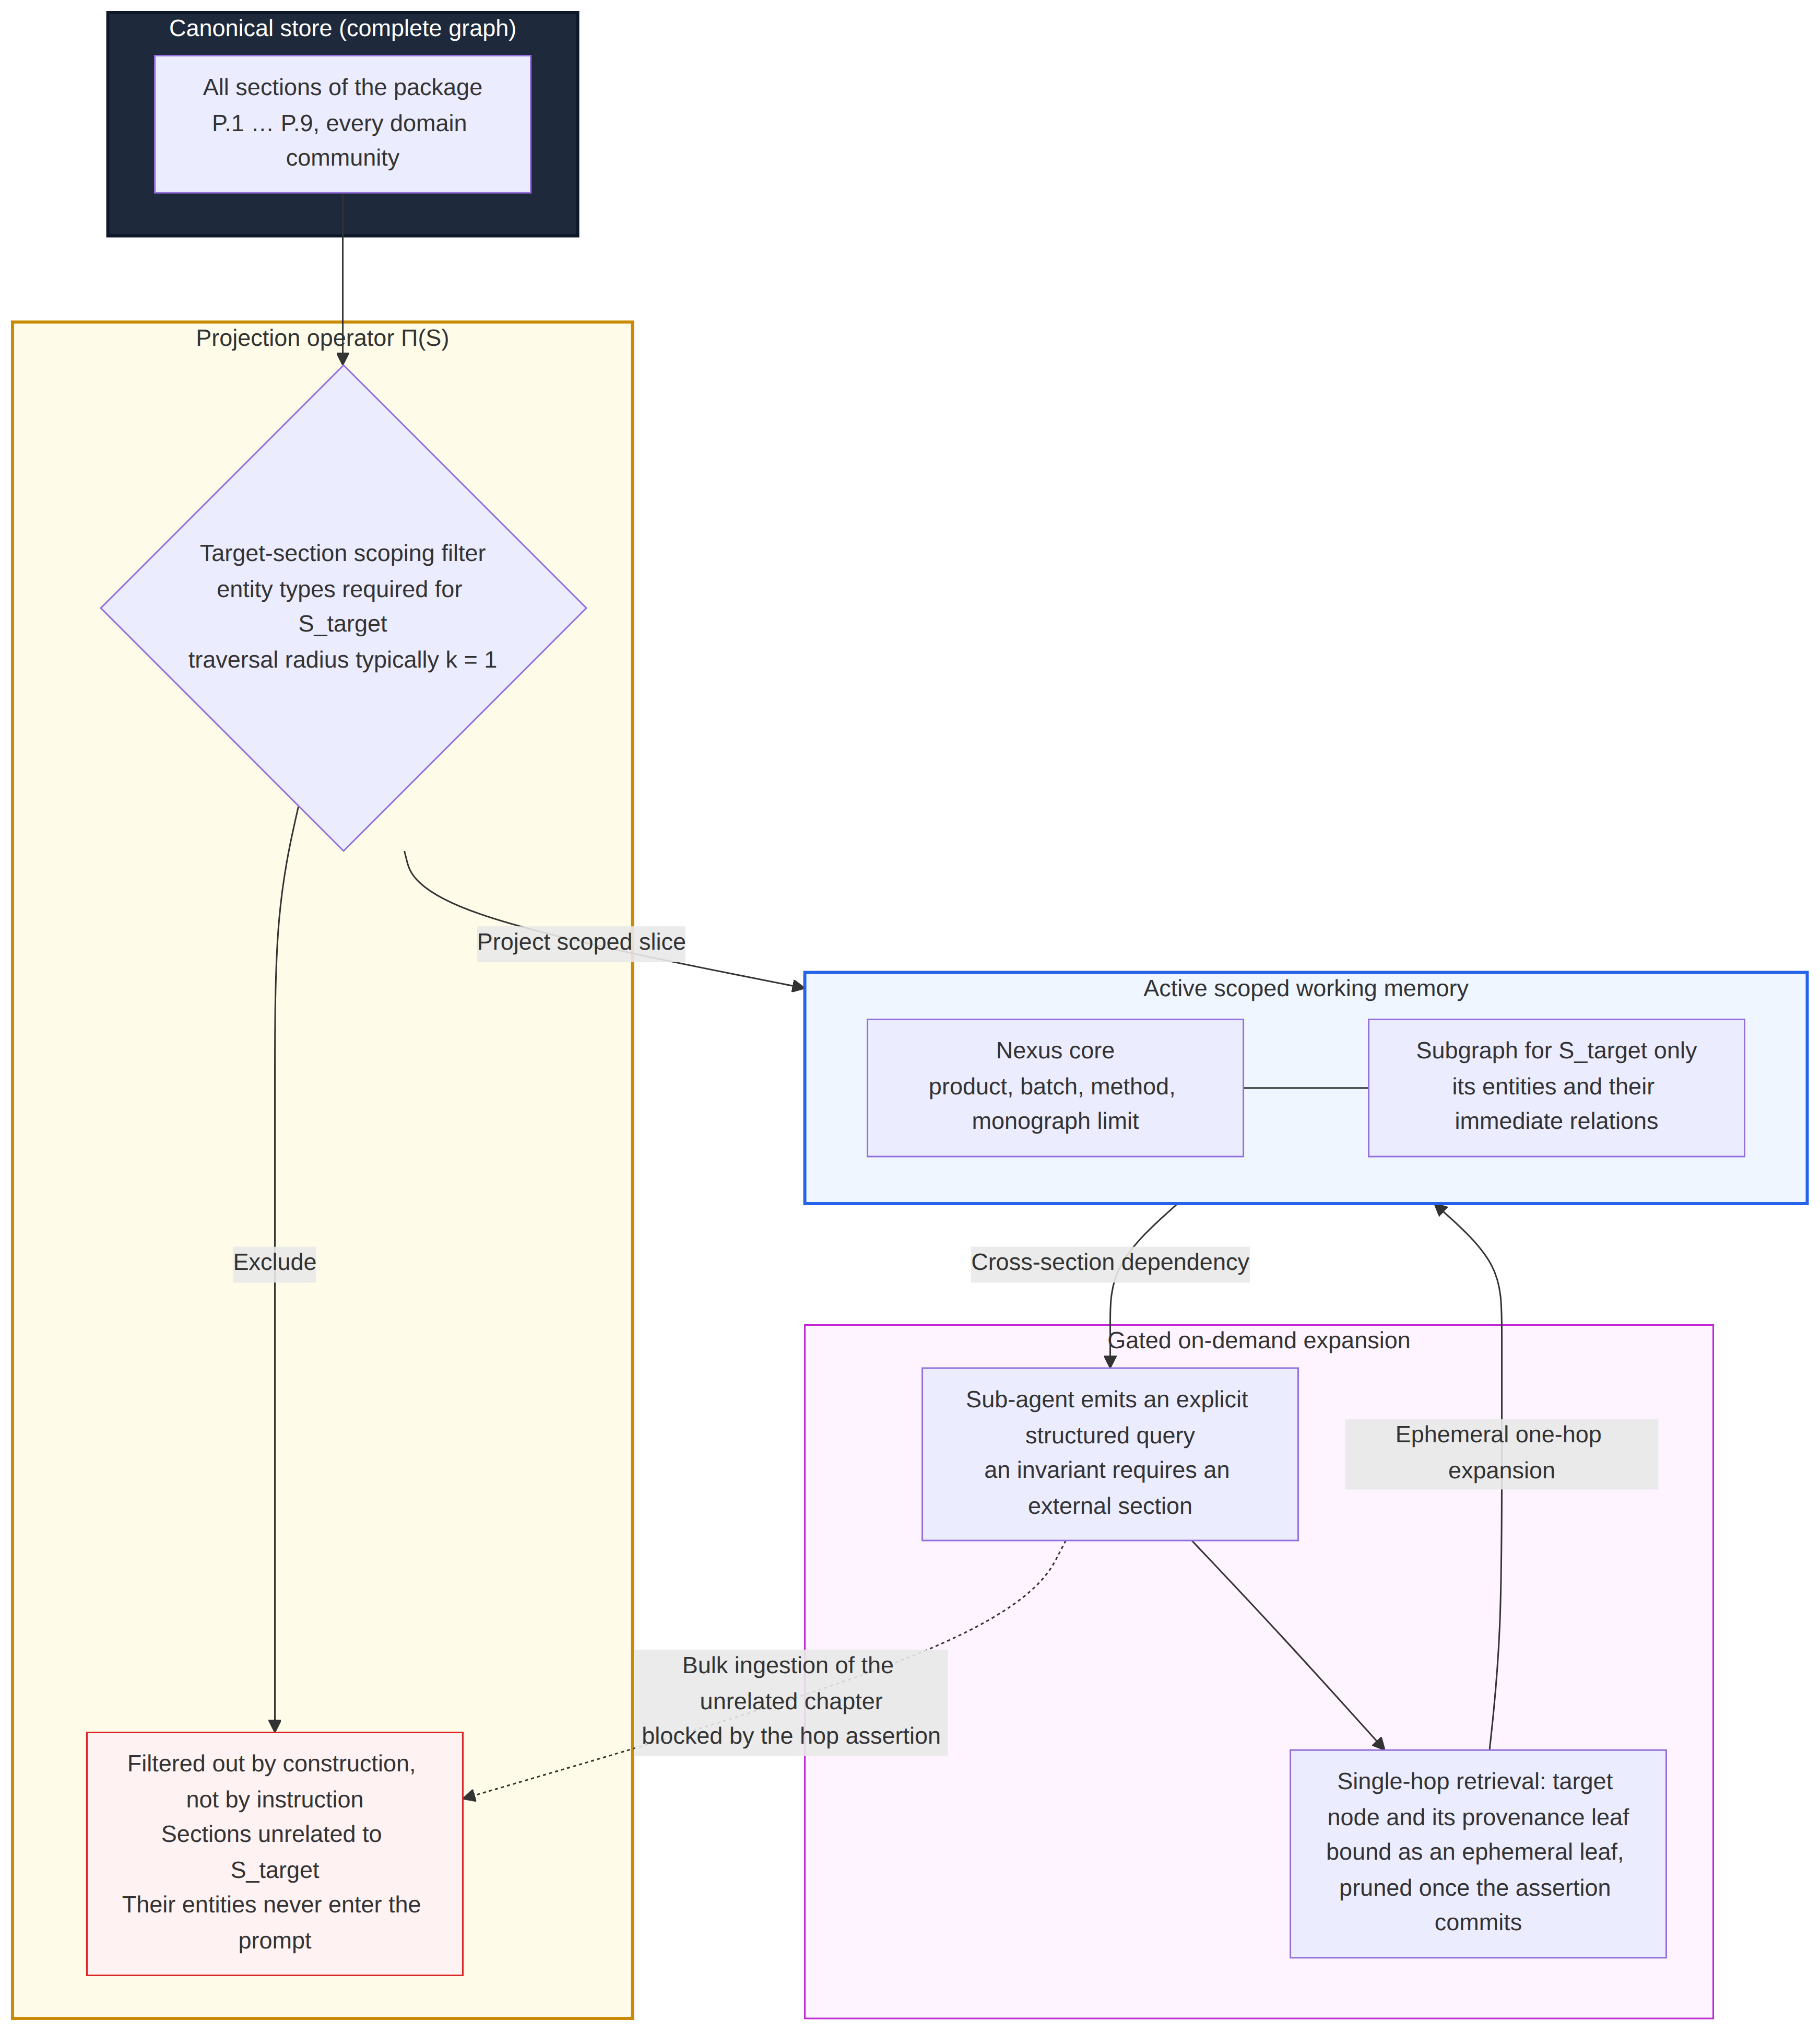
Figure 9. HDCS with gated single-hop expansion.

4.6.12 Evidence: the audit ledger and two-hop provenance
All events are written to an append-only ledger (21 CFR Part 11; Annex 11): ℒ_t = ⟨t, EventUUID, AgentID, ToolSignature, PayloadHash, Verdict, ℋ(ℒ_t−1)⟩, where ℋ is SHA-256. Sealed at q_halt, it is the evaluation artefact. A two-hop join (value → entity → Ψ → coordinates) returns all occurrences for click-to-source review, classing values as line-verified, derived, ambiguous or blocked.
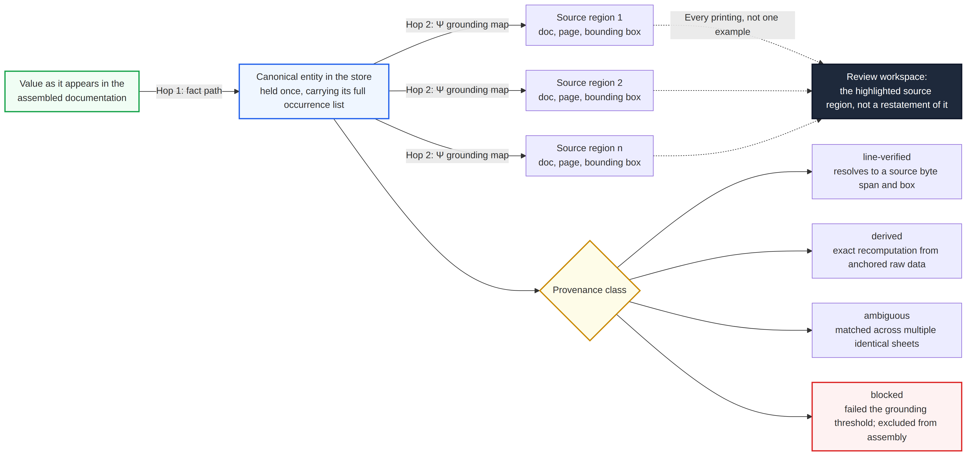
Figure 10. Two-hop provenance resolution.

4.6.13 The self-improvement boundary
Only declarative YAML/JSON navigation skills learn from reviewer layout corrections; kernels, criteria, grounding threshold, invocation order and model weights are frozen inside the GAMP 5 Category 4 boundary (gains measured in Section 6.5).
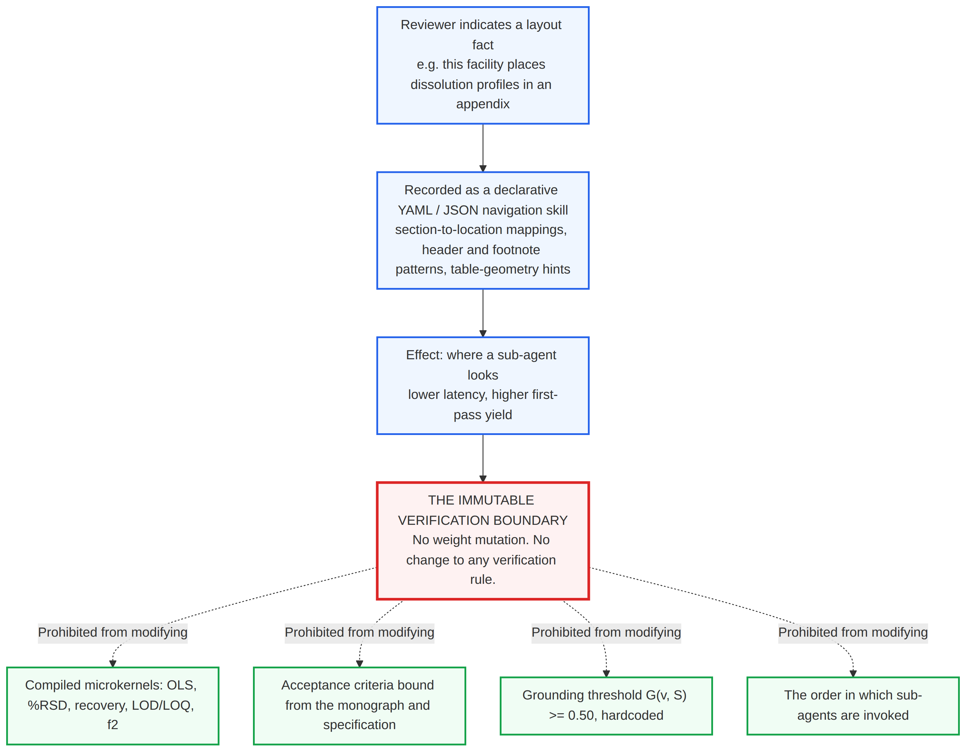
Figure 11. Adaptive navigation skills versus the immutable verification core.

4.7 Experimental evaluation protocol
The harness received case packages only; blinding was architectural (no filesystem, network or shell access). Cases ran independently with rebuilt stores, and sealed ledgers were scored afterwards by a separate process. TP required the correct discrepancy and location; wrong-reason findings, requires QA verification and insufficient evidence were tallied separately from TP, TN, FP and FN.

4.8 Performance metrics
Detection: sensitivity = TP/(TP+FN); specificity = TN/(TN+FP); precision = TP/(TP+FP); F1 = 2PR/(P+R), reported overall and by class. Specification checking: the proportion of result–specification pairs correctly classified as compliant, non-compliant, incorrect specification, unit inconsistency or insufficiently supported. Extraction (separate from detection): field-level accuracy (batch, test, result, unit, specification), table-cell accuracy, cell-misassignment count and their G distribution. Assembly: placement, completeness, value preservation, consistency and, separately, incorrect insertion rate. Provenance integrity: complete two-hop joins by class. Telemetry (schema adherence, consolidation agreement, CER, tokens, latency) is labelled and never used as accuracy.

4.9 Analysis of false positives and false negatives
Each FP/FN is attributed to extraction, normalisation, consolidation, specification retrieval, comparison or formatting failure, separating inherent from correctable limitations.

4.10 Human-in-the-loop verification
QA professionals review the same cases, recording detections, misses, unnecessary flags, evidence adequacy and directive acceptance; no claim of replacing QA staff is made.

4.11 Repeatability assessment
Triplicate runs assess agreement in finding identity, evidence citation and classification, reported with decoding parameters (temperature, top-p, seed), batch-invariant inference, hardware, serving stack and comparison definitions, because non-determinism is the key GxP barrier. Not yet executed (Section 5.4).

4.12 Statistical analysis
All metrics in Section 4.8, plus FP/FN rates, are reported descriptively with CIs where sample size permits. No inferential tests are used, and between-class comparisons are exploratory.

4.13 Ethical and data-integrity considerations
The dataset is derived from real records. The token map replaced product, strength, comparator and manufacturer names; active substance and formula; standards; four specified impurities; applicant, site and contact details; all individuals; coded batch and document numbers. Stable role tokens preserve signatory consistency; categories are in Appendix B and the key is withheld. Before release, three items are required (outstanding, Appendix C): submission-holder permission and a licence; independent confirmation that no commercially sensitive content is recoverable; and confirmation that retained dates and batch sequence numbers are not jointly identifying. The corpus is not released with this paper. No identifiable personal data were processed. The corpus, harness and findings are for research only, not regulatory submission, batch release or quality disposition. Run-level reproducibility items are listed in Appendix C; all outputs are candidate observations requiring verification.

5. Results
This section and Section 6 report two separate bodies of evidence. Section 5 reports the controlled reference dataset: 13 de-identified ACTD Part II records carrying 112 interventions across nine discrepancy classes, processed blind under the protocol of Section 4.7. Section 6 reports the demonstrated execution: one 48-page case package with nine seeded items, traced end to end and run non-blinded. No statement in this paper claims that the system detected all 112 interventions, and no measurement from the 48-page package is offered as evidence about the 112-intervention dataset.

5.1 Composition of the controlled reference dataset
The corpus comprised 13 records de-identified from an authentic ACTD Part II submission for a small-molecule immediate-release film-coated tablet. Interventions were concentrated where reportable results and cross-section constraints are densest: P.8.3 stability data, P.5.3 analytical method validation, P.5.4 batch analysis and P.3.5 process validation. Each intervention used values drawn from the record itself, so the altered value stays plausible in context. Each was logged at injection with its document, field, original and altered value, class and reachability stratum (Table 5).

5.2 Detection on the controlled reference dataset
The harness received the manipulated records with no indication of which records contained interventions, how many there were, or where they sat.
The harness detected 95 of the 112 interventions, an observed detection rate of 84.8 % (95 % Wilson CI 77.0–90.3). Against the 107 rail-reachable interventions, the rate was 88.8 % (81.4–93.5). We report an observed detection rate, not a sensitivity. Sensitivity needs true-negative and false-positive cells, and this corpus does not yet establish them (Section 5.4).

Table 5. Composition and detection by discrepancy class. Blind = blind controls with no detection route. Class rates use the rail-reachable stratum as denominator, with 95 % Wilson confidence intervals. Per-class figures are exploratory: the intervals span 20–45 percentage points and overlap almost completely, so the table does not rank classes.
# | Discrepancy class | Injected | Blind | Reachable | Detected | Missed | Rate, % (95 % CI) | Principal rail
D1 | Numerical transcription error | 18 | 5 | 13 | 12 | 1 | 92.3 (66.7–98.6) | recompute_statistic; cross_match_entity
D2 | Specification violation | 13 | 0 | 13 | 13 | 0 | 100.0 (77.2–100.0) | assert_specification (criterion object)
D3 | Unit mismatch | 13 | 0 | 13 | 11 | 2 | 84.6 (57.8–95.7) | cross_match_entity after dimensional typing
D4 | Batch mismatch | 11 | 0 | 11 | 11 | 0 | 100.0 (74.1–100.0) | Scope-key identity cardinality
D5 | Missing value | 13 | 0 | 13 | 11 | 2 | 84.6 (57.8–95.7) | Required-element completeness
D6 | Date inconsistency | 13 | 0 | 13 | 12 | 1 | 92.3 (66.7–98.6) | Chronology invariant
D7 | Cross-document contradiction | 13 | 0 | 13 | 10 | 3 | 76.9 (49.7–91.8) | cross_match_entity over the canonical store
D8 | Incorrect specification | 12 | 0 | 12 | 10 | 2 | 83.3 (55.2–95.3) | Threshold-hierarchy and monograph binding
D9 | Missing supporting document | 6 | 0 | 6 | 5 | 1 | 83.3 (43.6–97.0) | Package manifest completeness
Total | Against reachable (95/107) | 112 | 5 | 107 | 95 | 12 | 88.8 (81.4–93.5)
Total | Against all introduced (95/112) | 112 | — | — | 95 | 17 | 84.8 (77.0–90.3) | Primary endpoint

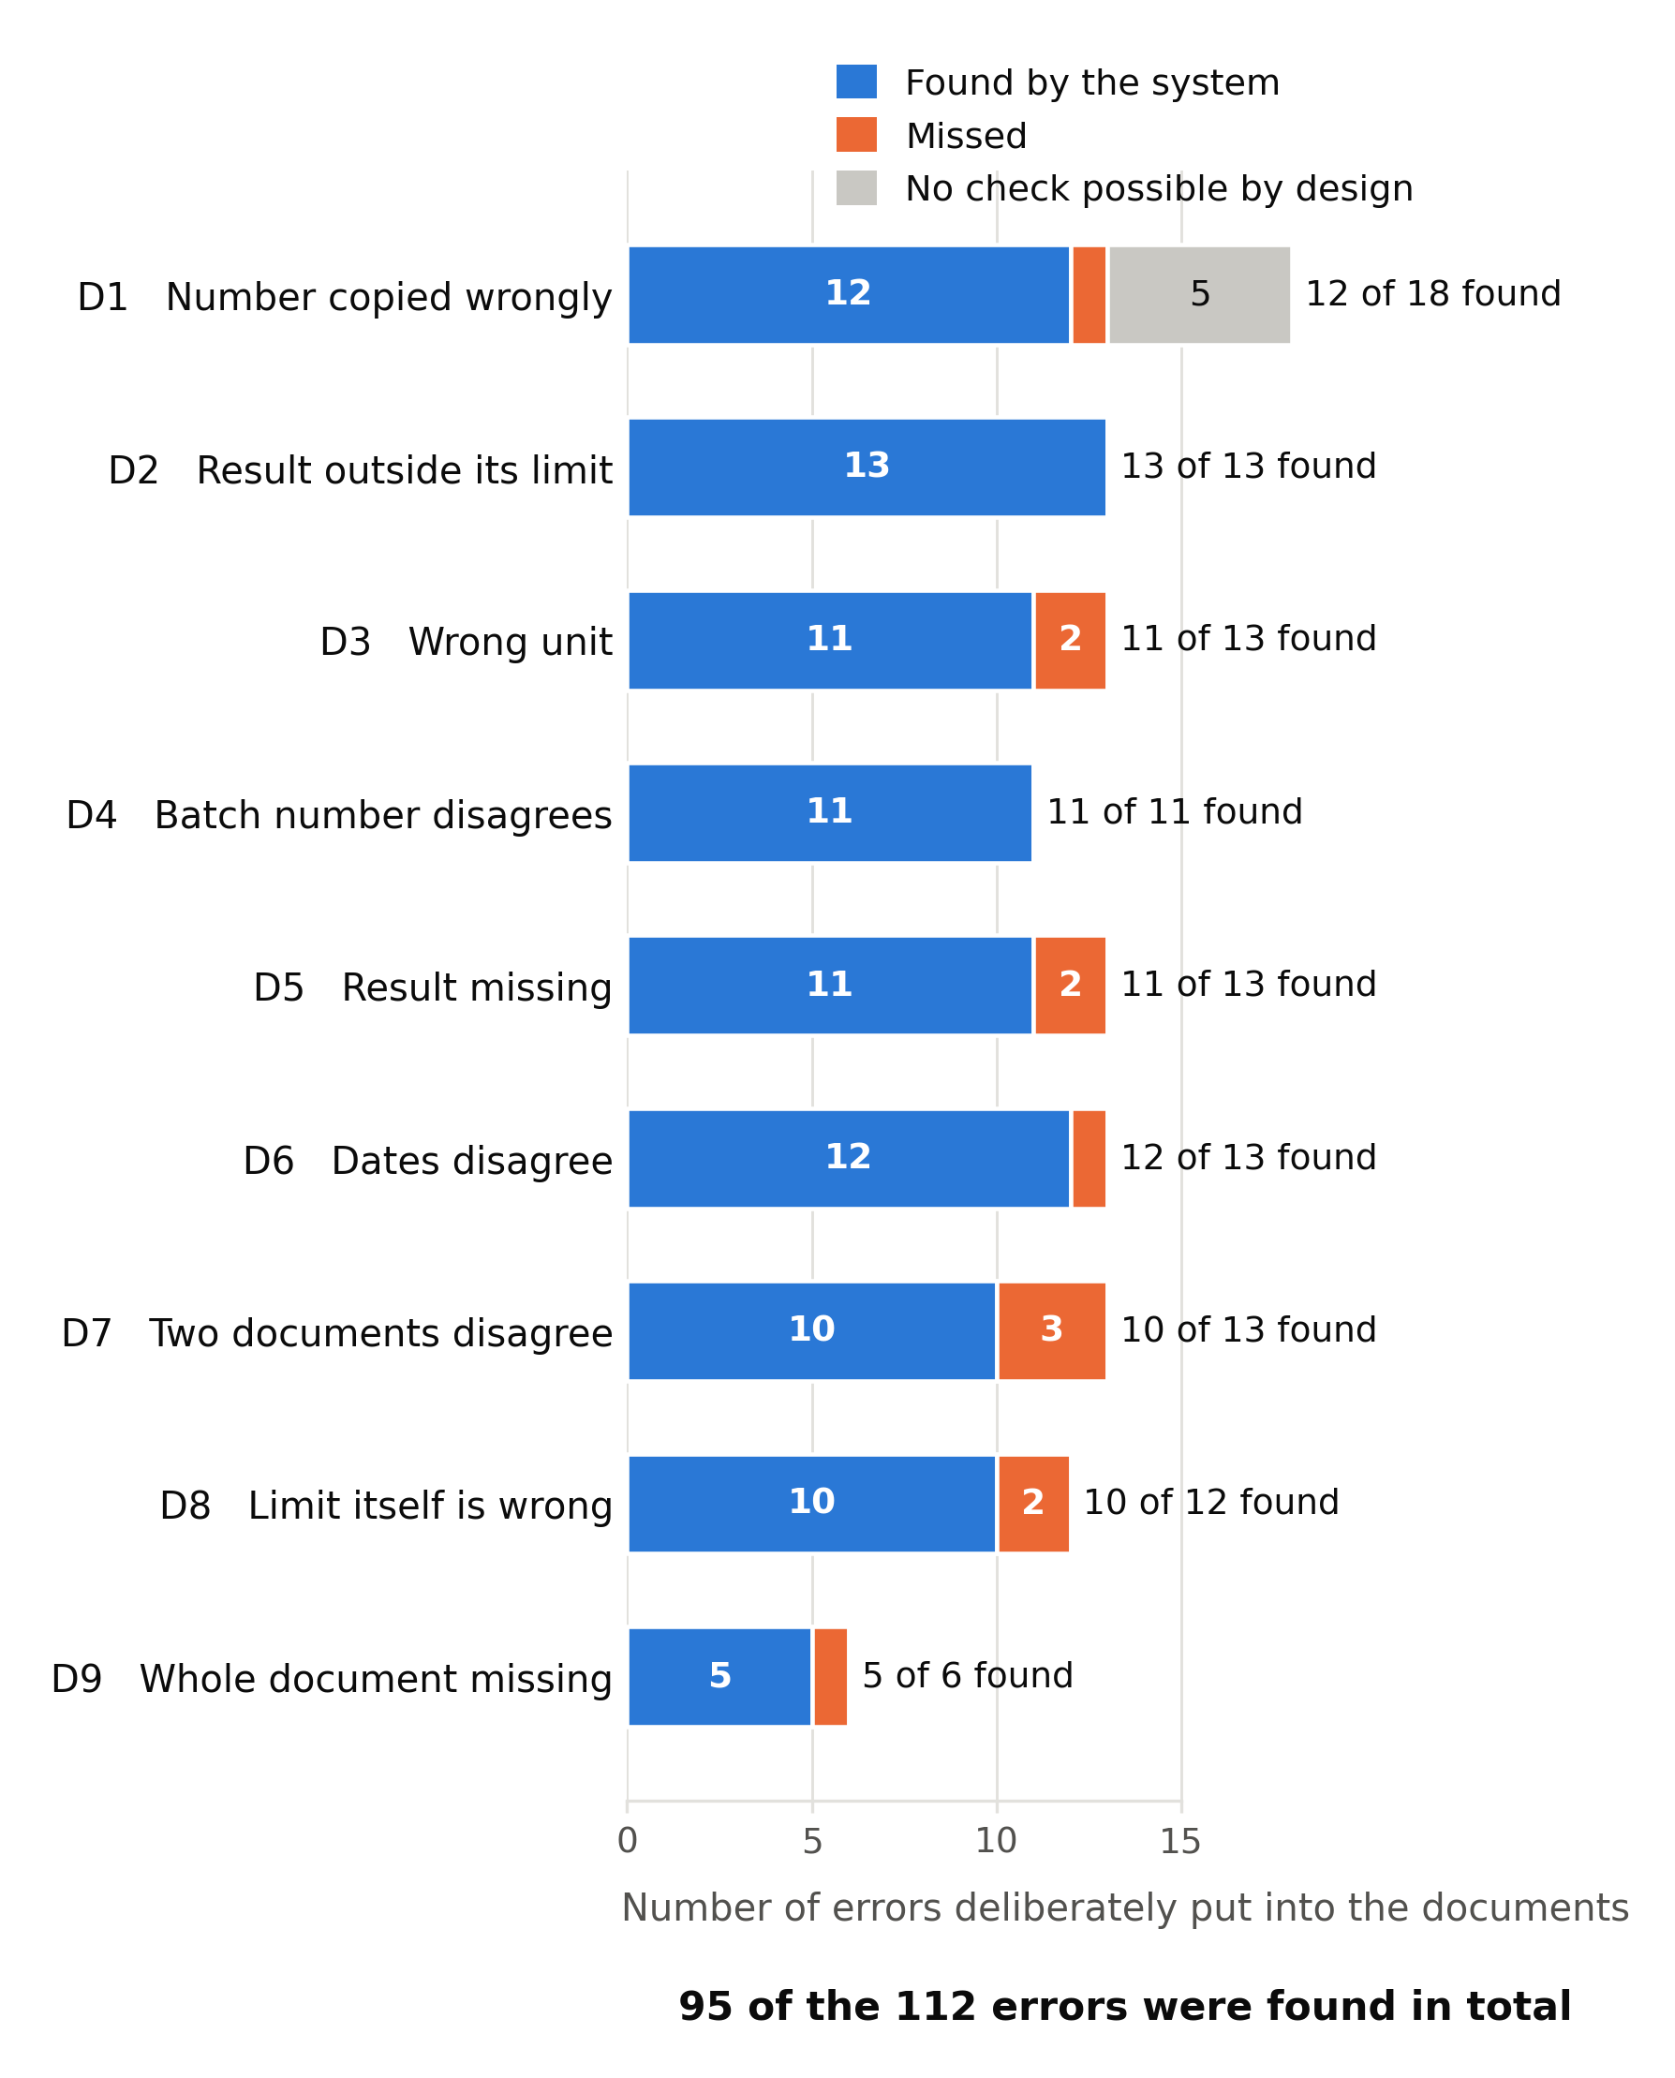
Figure 12. Introduced errors by discrepancy class: found by the harness (blue), missed although a check could reach them (orange), and unreachable by design (grey; D1 only, see Section 5.3). Across all classes, 95 of 112 errors were found. Bars are counts, not a ranking; Table 5 gives the rates with their confidence intervals. Formal class definitions are in Table 3.
Detection occurred in all nine classes. This is the substantive composition finding: no class in the taxonomy proved wholly unreachable by the architecture. The apparent ranking between classes is not a finding. With 6 to 18 interventions per class, the study cannot distinguish classes, and we performed no between-class test.

5.3 The 17 interventions not detected
Five had no detection route. They were assigned to the blind-control stratum at injection, under the rule of Section 4.4. In each, the altered value stays within its acceptance criterion, appears in no other record and feeds no reported statistic. The document therefore stays consistent, arithmetically correct and compliant, and no invariant — recomputation, limit assertion, identity cardinality, chronology or completeness — has anything to test. All five are numerical transcription errors, the only class that need not disturb a relationship the document exposes.
Twelve were reachable and were missed: D1 (1), D3 (2), D5 (2), D6 (1), D7 (3), D8 (2) and D9 (1). These twelve, not the blind controls, bear on system performance. The cause classification of Section 4.9 has not been performed, so we offer no explanation for these misses, and none should be read into their class distribution.

5.4 Endpoints not reported
The protocol of Sections 4.7–4.12 commits the study to more endpoints than the detection rate. Table 6 states the status of each, so that no gap has to be inferred from silence. No claim in this paper rests on an unreported endpoint, and no reported figure stands in for one.
Table 6. Status of the pre-specified endpoints.
Endpoint | Specified in | Status | Reason
Detection rate, overall | 4.8 | Reported | 84.8 % (95 % CI 77.0–90.3)
Detection rate, per class | 4.8 | Reported as exploratory | Denominators of 6–18 give intervals of 20–45 pp
Specificity; precision; F1; true-negative and false-positive counts; false-positive burden | 4.7–4.9 | Not obtained | All need the baseline census (Section 4.3). Until pre-existing anomalies in the source records are adjudicated, a finding outside the injection register cannot be classed as a false positive
Correct case, wrong reason; counts of the two non-binary outcomes | 4.6.8, 4.7 | Not obtained | Not extracted from the run ledger
Specification-checking accuracy | 4.8 | Not obtained | Needs per-pair classification against ground truth across five categories
Field-level extraction accuracy, including cell misassignment | 4.8 | Not obtained | This measure bounds the residual risk the grounding gate leaves (Section 4.6.5)
Assembly completeness; incorrect insertion rate; corpus-wide provenance integrity | 4.8 | Not obtained | Required-element schema not applied across the corpus; provenance reported for the demonstration only (Section 6.4)
Failure-mode classification | 4.9 | Not obtained | The twelve reachable misses are unclassified
Triplicate repeatability | 4.11 | Not obtained | Protocol not executed; a single run is no substitute
Human-in-the-loop arm; matched manual-review time | 4.10 | Not obtained | One pharmacist adjudicated the demonstration only; no time-and-motion comparison was run
Grounding threshold sweep | 4.6.5 | Not obtained | 0.50 is a provisional setting with no characterised operating point
Expert validation of the ground truth | 4.5 | Not executed | The ground truth is the unconfirmed injection register
Deployment and reproducibility record | 4.13 | Incomplete | Model identifiers, serving configuration, decoding parameters and run date outstanding (Appendix C)
Three consequences follow. They constrain what the paper claims, so we state them here rather than among the limitations.
The corpus is not yet the reference standard this paper proposes. It is a controlled reference dataset with a known injection register. It becomes the reference standard of Sections 3.3 and 7.7 only after the baseline census is adjudicated and the expert validation of Section 4.5 is executed and reported.
The detection figure is a first result, not a completed evaluation. It shows that the harness, run blind, found 95 of 112 introduced interventions. It does not show how the system behaves on documents that contain no intervention — the other half of any verification claim.
Usability in routine review remains open. A verification aid with an 84.8 % detection rate and an unknown false-alarm rate cannot be judged for routine use: at a high false-positive rate it would add reviewer work while still missing about one defect in seven. The question stays open until specificity and precision are measured.

6. Worked demonstration: one case package traced end to end

6.1 Status and construction of the package
This section traces one case package, built under the injection protocol of Section 4.4, through every stage of the harness. It shows that the architecture runs as specified and that each mechanism fires on the defect class it targets.
The run was not blinded, and it is not the evaluation. Operators had the injection register, so they could instrument each stage and watch each mechanism act on its target defect. A 9-of-9 outcome obtained with the answer key available carries no evidential weight about detection, and one package with nine seeded items cannot yield sensitivity, specificity or precision. Every figure in this section is engineering telemetry from a single run, reported to demonstrate mechanism, not performance.
The package represents a hypothetical 100 mg immediate-release film-coated tablet (Product X). It holds 48 pages in six documents: a standard test procedure and finished-product specification (STP-PX-04; P.5.1, P.5.2); a 16-page analytical method validation report (PX-AMV-2024-01; P.5.3); its raw chromatographic sequence and integration annex (PX-RAW-HPLC-01; Tree-of-Truth L1); a process performance qualification report on three commercial-scale batches (PX-PV-PPQ-02; P.3.4, P.3.5); an 8-page multi-station stability report (PX-STAB-2024-R1; P.8.3); and a certificate of analysis (PX-COA-B240117; P.5.4).
The governing criteria were: assay 90.0–110.0 %; dissolution Q ≥ 85 % at 45 min; specified related compounds A–D ≤ 0.20 % each; repeatability %RSD ≤ 1.0 %; and a related-substances reporting threshold of ≤ 0.05 %. Stability covered accelerated (40 °C / 75 % RH) and long-term (30 °C / 75 % RH; ICH Q1A(R2) zone IVb) stations in aluminium–aluminium and PVC/PVDC blisters.
Nine items were seeded: eight document defects across five discrepancy classes, plus one unanchored value as a system-integrity control. The control is not a member of the taxonomy — the value exists in no source record — so it is counted separately throughout. The package carries eight defects and one control, not nine defects.

6.2 Ingestion, extraction, grounding and consolidation
Ingestion. The layout-preserving model decoded all 48 pages in 86.4 s (1.80 s per page; 124,815 characters) and rebuilt all 14 analytical tables with row spans, column spans and token-level coordinates for every numerical entry. The key case was an ICH Q6A degradation table in which the label “specified degradation products” spans five rows across related compounds A–D. The model kept the exact row span. Pipelined OCR flattens this construction and silently turns four governed limits into four unbounded values. The reported character error rate (< 0.15 %) is an estimate whose sampling method and size were not recorded (Appendix C); it is not an extraction-accuracy figure and does not bound cell misassignment.
Extraction and grounding. The extraction sub-agents produced 124 candidate facts in 28.2 s (138 tokens s⁻¹; 2.8 GB GPU memory). The grounding gate runs before consolidation (Algorithm S5, lines 5–9) and admitted 123 of them. Genuine candidates scored G(v, S) = 0.941–1.000 (mean 0.982 ± 0.015); the only departures from 1.0 came from punctuation normalisation during ingestion. One candidate scored G = 0.081: the seeded working range of 50.0–150.0 %, whose lower bound appears in no source document. The gate blocked it, purged it from the compilation stream and raised F-09. On inspection, the reviewer confirmed that a 50 % lower bound had never been validated. The fabricated value lies about 60 SD below the genuine mean ((0.982 − 0.081) / 0.015 ≈ 60), so a fixed threshold worked on this package without tuning. This is a system-integrity result, not a discrepancy class: the harness could not be induced to place a value that exists in no source record. It rests on one fabricated instance and does not by itself justify the 0.50 threshold. The gate also does not exclude a value read from the wrong cell of the correct table (Section 4.6.5).
Consolidation. The entity resolution sub-agent (24.5 s; 4.1 GB) established 42 relational entities — batch numbers, test dates and storage conditions — and resolved 122 of the 123 admitted candidates to single canonical records (99.2 %). This step separates the architecture from plain extraction: one assay value can appear in the certificate of analysis, the batch analysis, the initial stability time point and the process validation table. The one divergence, an analyst footnote on baseline correction, was kept as a conflict and shown to the reviewer, not averaged away (Section 4.6.6), because disagreement between two printings of a value is itself a discrepancy class. The 99.2 % is an agreement rate between repeated printings — telemetry, not accuracy, and not a consensus rate between models.

6.3 Deterministic verification findings
Under the four-tool contract, the harness dispatched 25 tool calls with zero faults and no attempted call outside the contract. Of the 25 invariants evaluated, eight raised findings, one per seeded defect. The grounding block (F-09) accounts for the ninth item (Table 7).

Table 7. Findings on the demonstration package, with the ACTD section carrying each defect, the verification outcome, the mechanism and the discrepancy class.
Finding | ACTD section | Seeded defect | Verification outcome | Mechanism | Class | Severity
F-01 | P.5.3 | Calibration slope reported as 10,020 | Recomputed from five raw points (20–100 µg/mL): slope 9,800.4, r² > 0.9999; Δ_rel 2.24 % against a ≤ 0.10 % tolerance | recompute_statistic (OLS); Tree-of-Truth precedence | D1 | Major
F-02 | P.5.3 | Recovery reported as 101.40 % (100 % level) | 48.60 mg recovered / 50.00 mg spiked = 97.20 %; Δ_abs 4.20 pp against ≤ 0.05 pp | recompute_statistic (REC) | D1 | Critical
F-03 | P.5.3 | Repeatability %RSD reported as 0.85 % | Six replicate areas give 1.48 % (Δ_abs 0.63 pp against ≤ 0.01 pp), which also exceeds the ≤ 1.0 % limit | recompute_statistic (RSD); assert_specification | D1 (secondary D2) | Critical
F-04 | P.5.1 vs P.5.3 | Reporting threshold declared as ≤ 0.05 % | Threshold lies below the validated LOQ of 0.08 % (0.05 ≥ 0.08 is false), so it is unsupportable under ICH Q3B(R2) whatever the dose table permits | assert_specification (method capability) | D8 | Major
F-04b | P.5.3 | Impurity C “not detected” (arises from the F-04 defect) | “Not detected” is an LOD statement; reviewer must confirm that the validation established an LOD and bound the statement to it | assert_specification (LOD binding) | D8 (secondary) | Minor
F-05 | P.8.3 | 12-month assay 99.8 % (9-month 96.2 %) | Reported value does not reproduce from its raw integration record; resolved toward L1. The +3.6 pp rise alone is not a finding: it lies within analytical variability, and with three prior pulls (< 4) the trend rail returned insufficient evidence to determine | Tree-of-Truth reconciliation (not the trend rail) | D1 | Major
F-06 | P.8.3 vs P.5.4 | Batch identifier B-24-01l7 on stability report p. 1 | Two identifiers under one scope key; B-24-01l7 is outside the declared batch set; edit distance 1 with the {1, l} confusion pair, so reported as a candidate slip for B-24-0117. The three PPQ batches raise nothing because the check runs per scope key | cross_match_entity (identity cardinality) | D4 | Critical
F-07 | P.5.3 vs P.5.2 | Summary cites STP-PX-04 Rev. 03 | Raw sequence-log headers record Rev. 02: testing used the superseded revision | cross_match_entity (revision parity) | D7 | Major
F-08 | P.8.3 vs P.5.1 | PVC/PVDC 12-month dissolution 82.0 % against Q ≥ 85 % | Not an OOS determination. The record omits n and the statistic, so the USP ⟨711⟩ stages cannot be evaluated; the criterion object returned insufficient evidence to determine and raised the excursion and the missing sample-size declaration. Alu–Alu gave 89.2 %, localising the excursion to the pack | assert_specification (staged ⟨711⟩ criterion) | D2 | Major; needs QA verification
F-09 | P.5.3 | Working range 50.0–150.0 % (integrity control) | Lower bound absent from all sources; G = 0.081 against the 0.50 threshold | Token grounding gate | System integrity | Major

Two mechanisms produced these findings. Recomputation in pinned compiled kernels, not in a language model, caught the three validation statistics (F-01 to F-03) and the non-reproducing assay (F-05) — the checks that manual review handles least reliably. Specification assertion caught two defects in which no single value is wrong: F-04 exists only in the relationship between the specification and the validation report, and F-08 stays a candidate non-conformance because the staged rule cannot be evaluated from the record.
Coverage. Each finding counts once, under its primary class, so the tally sums to the eight defects: D1 (F-01, F-02, F-03, F-05), D2 (F-08), D4 (F-06), D7 (F-07) and D8 (F-04). D3, D5, D6 and D9 are absent from this package. Their mechanisms (Sections 4.6.5, 4.6.7, 4.6.9) are exercised elsewhere in the corpus but not demonstrated here, and no inference about them should be drawn from this section. The package exercises P.5.1–P.5.4 and P.8.3, plus P.3.4 and P.3.5 without seeded defects. These sections were chosen for their density of recomputable statistics and cross-section constraints; they are not a representative sample of the dossier, and the demonstration says nothing about microbiological limits, impurity characterisation, excipient control or comparative dissolution.

6.4 Sub-agent reconciliation and provenance
The method validation sub-agent extracted the five calibration points, nine accuracy determinations and six precision replicates. The stability sub-agent separated the 0–12-month results by pack and found that dissolution at 12 months held at 89.2 % in aluminium–aluminium blister but fell to 82.0 % in PVC/PVDC. The process validation sub-agent confirmed stage yields (granulation 99.2 %, compression 98.8 %, coating 98.4 %; limit ≥ 97.0 %) and blend uniformity at ten locations (mean 99.6 %, %RSD 1.12 %; limit ≤ 5.0 %). It raised no finding, as expected: the report carried no seeded defect and served as an internal negative control. The monograph binding sub-agent bound the criteria listed in Section 6.1. The entity resolution sub-agent mapped “Product X”, “PX Tab 100 mg Film-Coated” and “PX-100-FC” to one product record, detected the divergences behind F-06 and F-07, and confirmed that the calibration peak areas followed the vial sequence without inversion (clean).
Root-directed precedence. Two findings required the Tree-of-Truth to decide between strata rather than just detect a divergence. For F-01, the L1 raw integration signals overrode the L3 summary figure. The correction directive points toward the summary, never toward the raw record, and it took effect only when the reviewer accepted it (Section 4.6.8). For F-07, the L1 sequence header (Rev. 02) overrode the L3 claim (Rev. 03). The finding is therefore not a typing error: the validation ran under a revision other than the one claimed. Only applying precedence yields this conclusion; noting that two documents disagree does not.
Provenance. Of the 124 candidates, one was blocked and 123 were assembled. Of these, 113 (91.9 %) were line-verified directly to a source byte span and image bounding box, 10 (8.1 %) were derived by kernel recomputation from anchored raw data, and none was ambiguous. No assembled value lacked provenance, and selecting any value opened its source region in under 120 ms. The distinction matters for audit: a line-verified value is one the system read, and a derived value is one it computed from values it read. The ledger records every kernel call and its inputs, so a health authority can re-execute each derived value.

6.5 Assembly, computational profile and human review
Assembly. The harness projected canonical records into the required-element schema of the target ACTD sections instead of re-reading the sources. Each placed value is therefore the verified record, with its occurrence list and coordinates. Accepted directives inserted the corrected value with the directive recorded; open directives left the original value with the finding attached. Rendering into the submission structure took 2.1 s. The harness authored nothing: no narrative, no expert summary and no regulatory evaluation.

Table 8. Execution profile for the 48-page package on one workstation (NVIDIA A10G 24 GB GPU; AMD EPYC 7763 host).
Stage | Component | Hardware | Latency | Peak memory | Output
1 | Layout-preserving ingestion | GPU (FP8) | 86.4 s | 8.2 GB VRAM | 48 pages decoded; 14 tables structured
2 | Proposal extraction | GPU (BF16) | 28.2 s | 2.8 GB VRAM | 124 candidate facts
3 | Consolidation into the source-of-truth tree | GPU (BF16) | 24.5 s | 4.1 GB VRAM | 122 of 123 resolved (99.2 %); 42 relational entities
4 | Token grounding gate | CPU | 0.8 s | < 150 MB | 1 blocked; 123 admitted
5 | Agentic orchestration | CPU (FSM) | 1.8 s | < 40 MB | 25 tool calls; 0 faults
6 | Deterministic microkernels | CPU | 0.2 s | < 25 MB | 25 invariants; 8 findings
7 | Documentation assembly and render | CPU | 2.1 s | < 85 MB | Assembled sections with provenance
1–7 | Total automated pipeline | Single workstation | 144.0 s | 10.4 GB VRAM; ≤ 165 W | 9 findings
8 | Human review and disposition | Reviewer workspace | 18.5 min | — | 9 findings adjudicated; documentation signed

Cost sits in reading. The deterministic layer — grounding gate, orchestration loop and all kernel calls — took 2.8 s of the 144.0 s total; ingestion and proposal generation took almost all of the rest. Stages 2 and 3 draw on the pooled models as needed, and neither is tied to a named model. The workload fits one GPU at below 165 W, so hardware does not restrict on-premise deployment to large manufacturers. The run record does not show whether any inference call reached a remote endpoint. Appendix C lists the missing deployment details, which EU GMP Annex 11 confidentiality obligations require for any run offered as a compliant deployment.
Auxiliary mechanisms. Scoped subgraph projection cut the active context for one sectional task from 148,200 to 14,600 tokens (−90.1 %) and sectional verification latency from 48.2 s to 12.7 s. Cross-section misattribution (for example, commercial batch quantities confused with development batch quantities) occurred in 4.2 % of attributed values under full-package loading and was not observed under scoped projection. Both denominators are unrecorded (Appendix C), so the 0 % bounds nothing. After the sequence-log layout was recorded as a declarative navigation skill, extraction latency on the remaining annexes fell by 38 %, with no change to model weights, thresholds, criteria or kernels (Section 4.6.13). These figures describe efficiency, not correctness.
Human review. A qualified QA pharmacist received all nine findings with their evidence, adjudicated them and signed the documentation in 18.5 min. The system closed no finding, applied no directive without acceptance and wrote to no source record. Every finding carried the source page region, so the reviewer judged against the original document. No matched manual review was performed, so neither the 144.0 s nor the 18.5 min is evidence of time saved.

6.6 What the demonstration does and does not establish
Established. The pipeline ran end to end on a realistic multi-document package without manual intervention. Each mechanism fired on its target defect class under non-blinded conditions. The grounding gate rejected a fabricated value by a wide margin. Every assembled value resolved to a source span, and orchestration stayed within its four-tool contract. No language model computed a derived statistic or authored an acceptance decision or narrative sentence. Models still transcribed the 113 line-verified values and the raw inputs the kernels consumed. The architecture removes models from computation, assertion and authorship, not from reading, and the guarantee holds only at that boundary.
Not established. The accuracy of transcribed values, including cell misassignment that passes the gate at high G (Section 5.4); specificity, precision and F1, which need the negative-control adjudication of Section 4.3; behaviour on D3, D5, D6 and D9; false-positive burden, which a package built to contain defects cannot measure and which decides whether the aid is usable in routine review; repeatability (Section 4.11); and generalisation, because the corpus and this package come from one submission and share its layout, house style and terminology.

8. Limitations
Most of the pre-specified evaluation has not been performed. This is the principal limitation and it is not a qualification of the results but a statement about their extent. The observed detection rate is reported; sensitivity proper, specificity, precision, F1, specification-checking accuracy, field-level extraction accuracy, assembly completeness, incorrect insertion rate, failure-mode distribution, repeatability and the human-comparison arm are not. Section 5.4 states each one’s status and reason. A reader should treat this paper as reporting an architecture, a protocol and a first detection result.
The corpus is authentic, and therefore its baseline is not clean. The thirteen records are de-identified from a real ACTD Part II submission and retain the source submission’s own defects — typographical artefacts, statistics that do not reproduce from their listed inputs, results outside their stated limits. This buys external validity and costs the clean baseline a synthetic corpus would have supplied. Until the baseline census of Section 4.3 is adjudicated, a finding outside the injection register cannot be classified, so specificity, precision and false-positive burden are unmeasurable rather than merely unmeasured.
Single product, single submission, single dosage form. All thirteen records derive from one submission for one small-molecule immediate-release solid oral product. Layout conventions, house style, terminology and document structure are therefore shared across the entire corpus, which is the condition least like production use and which inflates any extraction measure obtained on it. Nothing here establishes transfer to a second submission, let alone a second manufacturer.
The case count is small and the study is not powered for class comparison. The corpus carries 112 interventions across 13 records, between 6 and 18 per class. This supports descriptive reporting with confidence intervals and does not support inferential comparison between discrepancy classes; the per-class intervals span 20 to 45 percentage points and overlap almost entirely. No between-class test is performed and none should be inferred from Table 5.
Transcription accuracy is unmeasured, and it bounds everything else. The grounding gate excludes fabricated values; it does not exclude a value read from the wrong cell of the correct table on the correct page, which scores G = 1.0. Every recomputation the microkernels perform consumes model-transcribed inputs. The size of this residual is not established here, and until it is, the architecture’s guarantees should be read as applying to computation, assertion and authorship, not to reading.
The grounding threshold is provisional. 0.50 is hardcoded, which fixes it against drift, and is justified by a separation observed against a single fabricated candidate in a single package. No threshold sweep, no ROC analysis and no false-quarantine characterisation on legitimate content has been performed.
The confidentiality posture of the reported run is unestablished. Model identifiers, serving configuration and whether any inference call left the local network are not recorded for this execution (Appendix C). The Annex 11 argument of Section 7.8 is conditional on them.
Single-discrepancy construction. Constructing most cases with a single seeded defect permits unambiguous attribution of a detection failure, at the cost of not characterising behaviour when defects interact — for instance where an incorrect specification masks a specification violation, or where a batch mismatch prevents a cross-document comparison from being attempted at all. Concurrent-defect cases are included but are too few to characterise this behaviour.
The ground truth is not yet expert-validated. The detection result is scored against the injection register compiled at the time of injection. The independent review, agreement statistic and adjudication procedure specified in Section 4.5 have not been executed, so the corpus is described throughout as a controlled reference dataset and not as an expert-validated one. When that procedure is performed, two independent reviewers with third-reviewer adjudication will remain a defensible minimum and weaker than a larger panel, and the agreement statistic is reported so that the strength of the standard can be assessed rather than assumed.
The demonstration package is a non-blinded demonstration. Section 6 traces one package, with the injection register available to the operators, and instantiates five of nine discrepancy classes. It supports no performance claim, and the internal measurements it reports — throughput, context reduction, latency, skill-learning effect — were obtained on one execution on one package on one hardware configuration.
Component figures are not independently benchmarked. The named implementation components were selected on architectural grounds — layout preservation with coordinate output, long-context schema-constrained generation, and a prunable deterministic tool registry. Comparative benchmark figures asserting the superiority of these components over alternatives are not reported, because independent published verification of the specific figures available to the authors could not be established. Component substitution is expected to change throughput and extraction accuracy; it should not change any regulatory guarantee, since every such guarantee is enforced below the probabilistic layer.
No comparison against manual review, and no human arm at all. The human-in-the-loop protocol of Section 4.10 asks reviewers to work the same case set; it has not been executed. One pharmacist adjudicated the demonstration package, and no reviewer detection profile, evidence-adequacy rating or directive-acceptance rate was collected. Even when executed, that protocol is not a controlled trial of reviewer performance with and without the system, and no time-saving or accuracy-improvement claim is made or supportable. It follows that no statement in this paper about what a human reviewer would or would not catch rests on measurement.
Generalisation across dosage forms and modalities is untested. The document categories and validation characteristics represented are those of small-molecule solid oral dosage forms. Biologics, sterile products and combination products carry different document structures, different validation characteristics and different invariants, and nothing here establishes transfer to them.

9. Conclusion
This work presents a controlled reference-standard evaluation framework for automated verification at the pharmaceutical QC-to-QA documentation handoff and provides an initial blinded assessment of an agentic verification harness using de-identified material from an authentic ACTD Part II submission. Under the prespecified blinded protocol, the harness detected 95 of 112 seeded discrepancies, corresponding to an observed detection rate of 84.8% (95% Wilson CI, 77.0–90.3), while a detection rate of 88.8% (81.4–93.5) was observed for the 107 interventions reachable by the verification rails under the injection-time stratification. The architecture is deliberately designed so that probabilistic models propose transcriptions but do not perform arithmetic, acceptance decisions, or unsupervised document assembly: extracted values are constrained by token-level evidence grounding, recomputable statistics are generated by deterministic microkernels, and cross-document relationships are evaluated through a typed canonical knowledge graph with preserved conflicts and explicit source precedence. The end-to-end demonstration further illustrates how deterministic recomputation, specification binding, cross-document reconciliation, and evidence grounding can identify distinct classes of documentation defects while maintaining traceability to source evidence.
These findings provide initial evidence that an agentic verification architecture can detect a substantial proportion of deliberately introduced QC-to-QA documentation discrepancies while preventing probabilistic components from originating derived calculations or acceptance decisions. However, the present study does not establish specificity, precision, F1-score, false-alarm rate, extraction accuracy, assembly completeness, repeatability, or superiority to human review. These endpoints remain contingent on completion of expert adjudication of pre-existing defects in the authentic source records and therefore should not be inferred from the detection-rate result. Accordingly, the principal contribution of this study is not a claim of production readiness, but a reproducible architecture and experimental protocol for blinded evaluation of automated pharmaceutical documentation verification. Once expert validation is complete, the resulting reference corpus can provide a reusable benchmark for comparing verification systems based on different technical approaches. In practical terms, the proposed system is best positioned as an AI-assisted verification and documentation-support layer that can improve the accuracy and consistency of QC-to-QA information transfer, facilitate faster and more efficient documentation workflows, and maintain traceability from assembled information to its source evidence, while supporting rather than replacing qualified human QA review and final decision-making.

10. Limitations of existing approaches
Two limitations run across all three streams reviewed above, and they are of different kinds.
The first is methodological. A gap separates AI-based information processing from evidence-grounded quality verification. Existing approaches do not demonstrate an integrated workflow in which information is extracted from multiple quality documents, normalised into a common representation, systematically compared against specifications and related records, and bound to source-level evidence before human QA review.
The second limitation is evaluative rather than architectural, and it is the more consequential. Many discussions of AI adoption emphasise potential improvements in efficiency or automation without establishing performance against a predefined ground truth containing both correct and intentionally discrepant records. Efficiency claims of this kind are not falsifiable. What is required is a controlled experimental framework that can determine quantitatively whether a system detects known discrepancies while avoiding unnecessary findings in error-free records.

References
Note on completeness. References [1]–[6] are the primary-literature citations carried forward from the source drafts. Author names, year and subject are as recorded; journal title, volume, issue, page range and DOI must be completed from the original library before submission and have deliberately not been reconstructed here, since a plausible but incorrect citation is worse than an incomplete one. References [7]–[9] are the pharmaceutical primary literature identified by the search protocol of Appendix A, each retrieved and verified against the publisher record and carrying complete bibliographic detail. References [10]–[21] are the document-artificial-intelligence, grounding and consistency-benchmark literature: [10]–[19] are cited by author, title, venue and year, and their page ranges and DOIs must be verified against the publisher record before submission, while [20] and [21] were retrieved and verified during the same search. References [22]–[40] are regulatory guidance, standards and compendia, cited by official designation, which require no reconstruction. The numbering is a single continuous sequence; the discontinuous numbering of earlier drafts has been resolved.
Primary literature — pharmaceutical quality, process analytical technology and GxP artificial intelligence
[1] Vaghela, et al. (2024). AI/ML applications in pharmaceutical quality assurance documentation. [Journal, volume, pages and DOI to be completed.]
[2] Dobariya, et al. (2024). Artificial intelligence and machine learning applications in pharmaceutical quality documentation. [Journal, volume, pages and DOI to be completed.]
[3] Review of artificial intelligence across pharmaceutical development, manufacturing and quality control (2024). European Journal of Pharmaceutical Sciences. [Volume, pages and DOI to be completed.]
[4] Gaikwad & Pawar (2026). AI-assisted pharmaceutical analysis and quality monitoring. [Journal, volume, pages and DOI to be completed.]
[5] Stassen, et al. (2025). Artificial intelligence implementation in biopharmaceutical continued process verification. [Journal, volume, pages and DOI to be completed.]
[6] Nakka, et al. (2026). AI and machine learning in pharmaceutical manufacturing under GxP considerations. [Journal, volume, pages and DOI to be completed.]
[7] Nagy B, Galata DL, Farkas A, Nagy ZK. Application of artificial neural networks in the process analytical technology of pharmaceutical manufacturing — a review. The AAPS Journal 2022;24(4):74. doi:10.1208/s12248-022-00706-0
[8] Chen T, Mo H, Wang T, Jiang C, Liu Z, Hou F, Gan J. A lightweight large language model for regulatory affairs translation in pharmaceutical industry. Scientific Reports 2025;15:37992. doi:10.1038/s41598-025-21867-w
[9] Niazi SK. Regulatory perspectives for AI/ML implementation in pharmaceutical GMP environments. Pharmaceuticals 2025;18(6):901. doi:10.3390/ph18060901
Document artificial intelligence, grounding, source attribution and consistency benchmarks
[10] Xu Y, Li M, Cui L, Huang S, Wei F, Zhou M. LayoutLM: pre-training of text and layout for document image understanding. Proceedings of the 26th ACM SIGKDD International Conference on Knowledge Discovery and Data Mining (KDD), 2020.
[11] Xu Y, Xu Y, Lv T, Cui L, Wei F, et al. LayoutLMv2: multi-modal pre-training for visually-rich document understanding. Proceedings of the 59th Annual Meeting of the Association for Computational Linguistics (ACL-IJCNLP), 2021.
[12] Zhong X, ShafieiBavani E, Jimeno Yepes A. Image-based table recognition: data, model, and evaluation. European Conference on Computer Vision (ECCV), 2020. [PubTabNet.]
[13] Smock B, Pesala R, Abraham R. PubTables-1M: towards comprehensive table extraction from unstructured documents. IEEE/CVF Conference on Computer Vision and Pattern Recognition (CVPR), 2022.
[14] Mathew M, Karatzas D, Jawahar CV. DocVQA: a dataset for VQA on document images. IEEE/CVF Winter Conference on Applications of Computer Vision (WACV), 2021.
[15] Lewis P, Perez E, Piktus A, Petroni F, Karpukhin V, et al. Retrieval-augmented generation for knowledge-intensive NLP tasks. Advances in Neural Information Processing Systems (NeurIPS), 2020.
[16] Edge D, Trinh H, Cheng N, Bradley J, Chao A, et al. From local to global: a Graph RAG approach to query-focused summarization. arXiv preprint, 2024. [Verify final publication venue.]
[17] Ji Z, Lee N, Frieske R, Yu T, Su D, et al. Survey of hallucination in natural language generation. ACM Computing Surveys, 2023.
[18] Thorne J, Vlachos A, Christodoulopoulos C, Mittal A. FEVER: a large-scale dataset for fact extraction and verification. Proceedings of NAACL-HLT, 2018.
[19] Es S, James J, Espinosa-Anke L, Schockaert S. RAGAS: automated evaluation of retrieval augmented generation. Proceedings of the 18th Conference of the European Chapter of the Association for Computational Linguistics (EACL), System Demonstrations, 2024.
[20] Ma X, Zhuang S, Koopman B, Zuccon G, Chen W, Lin J. VISA: retrieval augmented generation with visual source attribution. Proceedings of the 63rd Annual Meeting of the Association for Computational Linguistics (ACL), Volume 1: Long Papers, 2025:30154–30169. doi:10.18653/v1/2025.acl-long.1456
[21] Kwon Y, Kim J, Lee G, Bae S, Kyung D, Cha W, Pollard T, Johnson A, Choi E. EHRCon: dataset for checking consistency between unstructured notes and structured tables in electronic health records. Advances in Neural Information Processing Systems 37 (NeurIPS 2024), Datasets and Benchmarks Track, 2024.
Regulatory guidance and standards
[22] International Council for Harmonisation. ICH M4Q(R1): The Common Technical Document for the Registration of Pharmaceuticals for Human Use — Quality. 2002.
[23] International Council for Harmonisation. ICH Q2(R2): Validation of Analytical Procedures. 2023.
[24] International Council for Harmonisation. ICH Q1A(R2): Stability Testing of New Drug Substances and Products. 2003.
[25] International Council for Harmonisation. ICH Q3A(R2): Impurities in New Drug Substances. 2006.
[26] International Council for Harmonisation. ICH Q3B(R2): Impurities in New Drug Products. 2006.
[27] International Council for Harmonisation. ICH Q6A: Specifications — Test Procedures and Acceptance Criteria for New Drug Substances and New Drug Products: Chemical Substances. 1999.
[28] International Council for Harmonisation. ICH Q9(R1): Quality Risk Management. 2023.
[29] International Council for Harmonisation. ICH Q10: Pharmaceutical Quality System. 2008.
[30] International Council for Harmonisation. ICH Q14: Analytical Procedure Development. 2023.
[31] US Food and Drug Administration. 21 CFR Part 11: Electronic Records; Electronic Signatures.
[32] US Food and Drug Administration. 21 CFR 211.192: Production Record Review.
[33] US Food and Drug Administration. 21 CFR 211.194: Laboratory Records.
[34] US Food and Drug Administration. Guidance for Industry: Investigating Out-of-Specification (OOS) Test Results for Pharmaceutical Production. 2022.
[35] European Commission. EudraLex Volume 4, Good Manufacturing Practice, Annex 11: Computerised Systems. 2011.
[36] International Society for Pharmaceutical Engineering. GAMP 5: A Risk-Based Approach to Compliant GxP Computerized Systems, second edition, 2022.
[37] Medicines and Healthcare products Regulatory Agency. GxP Data Integrity Guidance and Definitions, 2018. [ALCOA+ principles.]
[38] ASEAN. ASEAN Common Technical Dossier (ACTD) — Part II: Quality.
Compendia
[39] United States Pharmacopeia–National Formulary, current edition. General Chapters ⟨621⟩ Chromatography; ⟨711⟩ Dissolution; ⟨905⟩ Uniformity of Dosage Units.
[40] European Pharmacopoeia, current edition, for compendial monograph limits and general methods.

Declarations
Data availability. The controlled reference dataset, the injection register, the ground-truth master record and the evaluation scripts are not released with this paper. Release is conditional on the three requirements stated in Section 4.13 — documented permission from the organisation holding the source submission, an independent residual-identifiability review, and confirmation that preserved dates and batch sequence numbers do not in combination identify product or site — and on completion of the baseline census (Section 4.3) and expert validation (Section 4.5). On satisfaction of those conditions the intention is to deposit the corpus, the injection register, the ground-truth master record and the evaluation scripts in a persistent repository with a DOI, under a licence permitting reuse for method evaluation, together with the required-element schema and package manifest of Appendix E. [Repository, DOI, licence and embargo status to be completed before submission.]
Code availability. [To be completed: repository and licence for the orchestration harness, the deterministic microkernels, the grounding gate and the evaluation scripts, or a statement of what is withheld and why.]
Funding. [To be completed.]
Competing interests. [To be completed. The manuscript names specific third-party software components; any commercial relationship, consultancy, shareholding or funding relationship with the vendors or maintainers of those components, or with the organisation holding the source submission, must be disclosed here, and a positive statement of no competing interests must be made if none exists.]
Author contributions. [To be completed in CRediT taxonomy terms: conceptualization; methodology; software; validation; formal analysis; investigation; data curation; writing — original draft; writing — review and editing; visualization; supervision; project administration.]
Ethics approval. No human participants and no personal data were involved. All named individuals in the source records were replaced with role tokens before any processing (Section 4.13). Ethics committee approval was therefore not sought; the permissions that are required are those governing use of the source submission, and their status is recorded above and in Appendix C.
Use of artificial intelligence in preparing this manuscript. [To be completed in accordance with the target journal’s policy.]

