Infection | Online Resource 2
The Many Faces of Salmonella: Atypical Extraintestinal Infections in a Tertiary Care Hospital in Pakistan
Microbiological photographs
Muhammad Shabir^{1,2}, Faiza Zaheer^{1,2}, Faisal Hanif^{1,2}, Ibrar Hussain³, Muhammad
Huzifa⁴, Taimoor Shahzad⁵, Yumna Rubab^{1,2}Amir Afzal khan⁶,Waqar Ahmad⁶
- Armed Forces Institute of Pathology (AFIP), Rawalpindi, Pakistan
- Combined Military Hospital (CMH), Rawalpindi, Pakistan
- Pak Emirates Military Hospital (PEMH), Rawalpindi, Pakistan
- National Institute of Health (NIH), Islamabad, Pakistan
- Bacha Khan Medical Complex, Swabi, Pakistan
- Riphah International university,Rawalpindi
Corresponding author: Muhammad Shabir
Department of Microbiology, Armed Forces Institute of Pathology (AFIP), Rawalpindi, Pakistan
Email: mshabbir034519@gmail.com
Postal address: Tameez-ud-Din Road, CMH Complex, Rawalpindi Cantt, Pakistan
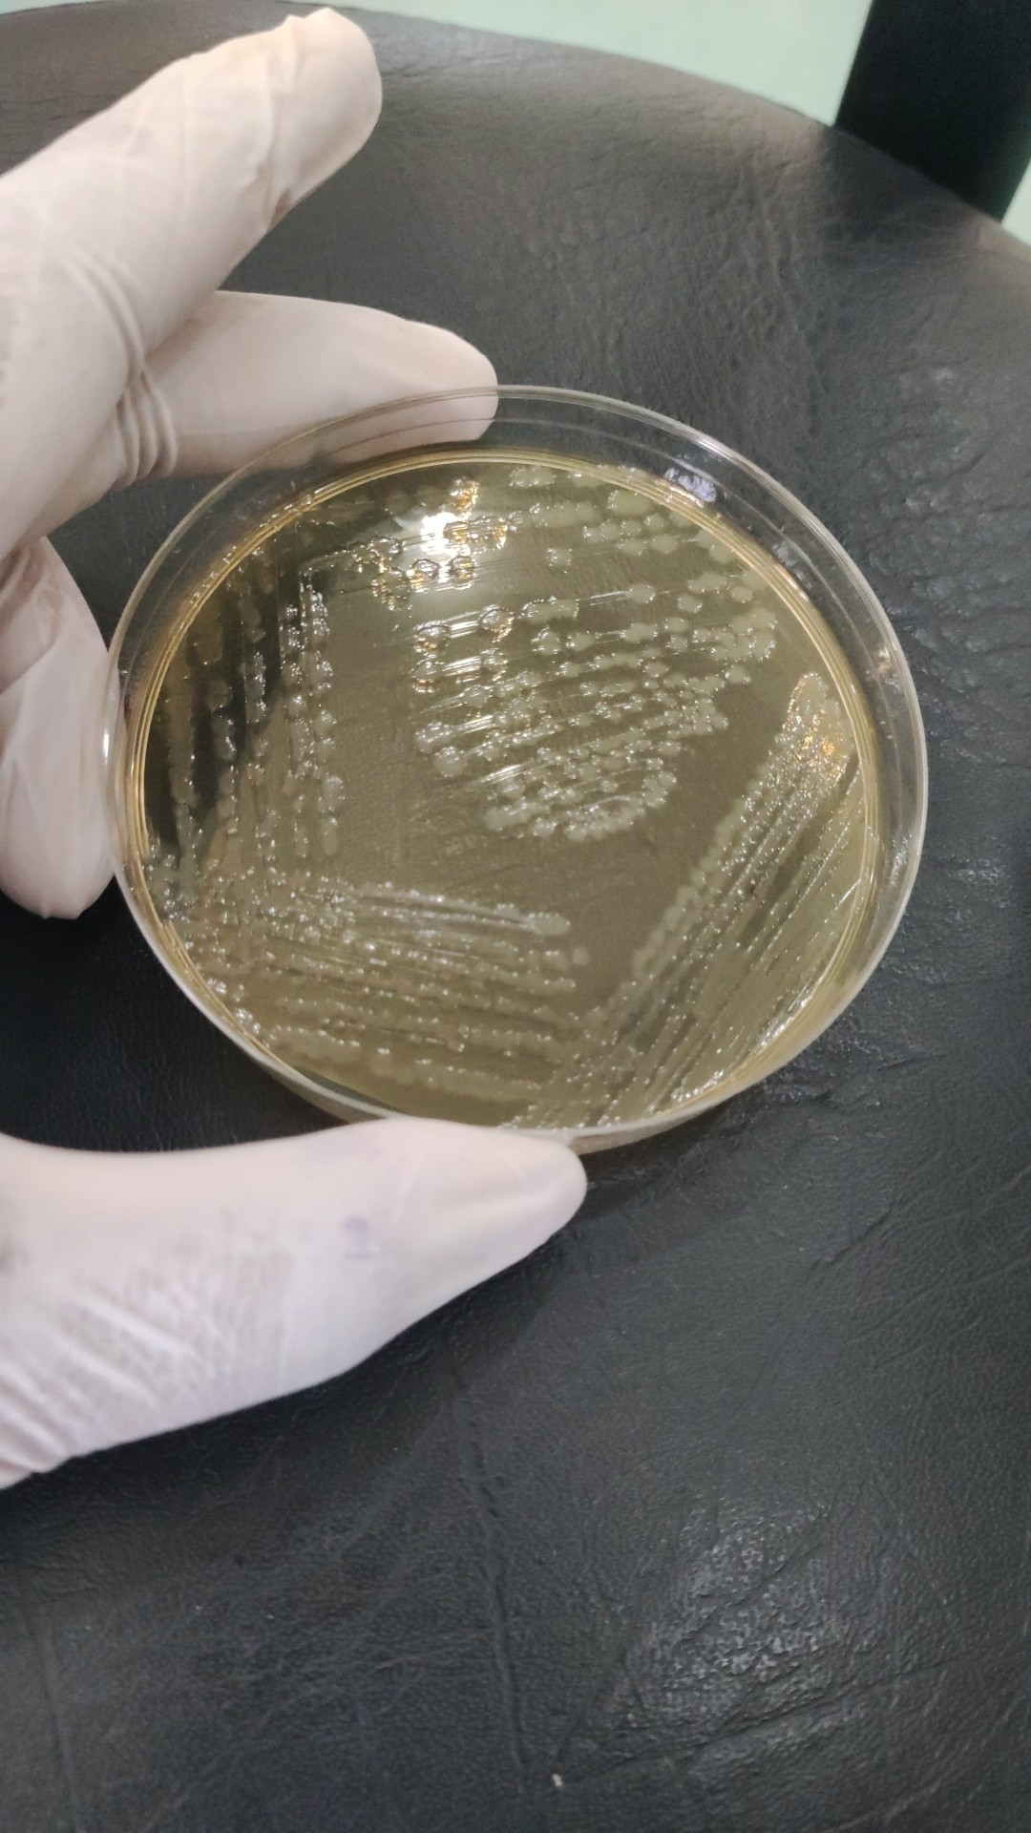
Supplementary Figure 1. Culture photograph from the microbiological workup
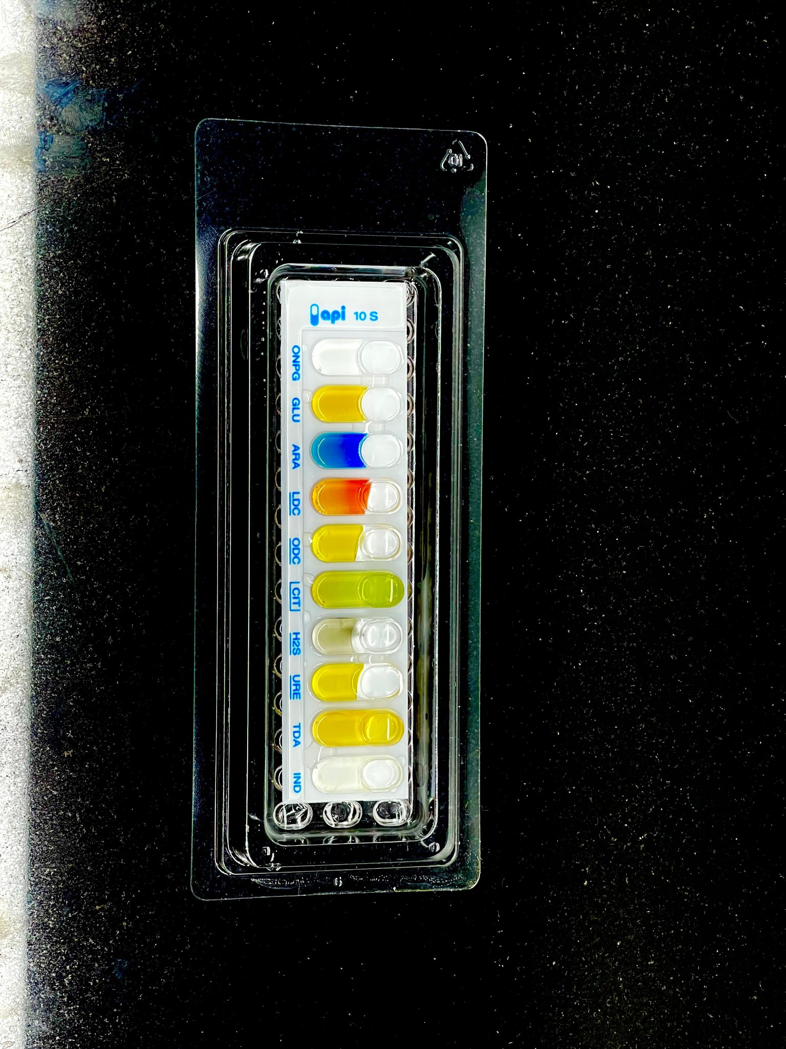
Supplementary Figure 2. API 10 S biochemical identification strip from the microbiological. Serovar confirmation was performed separately using specific antisera.
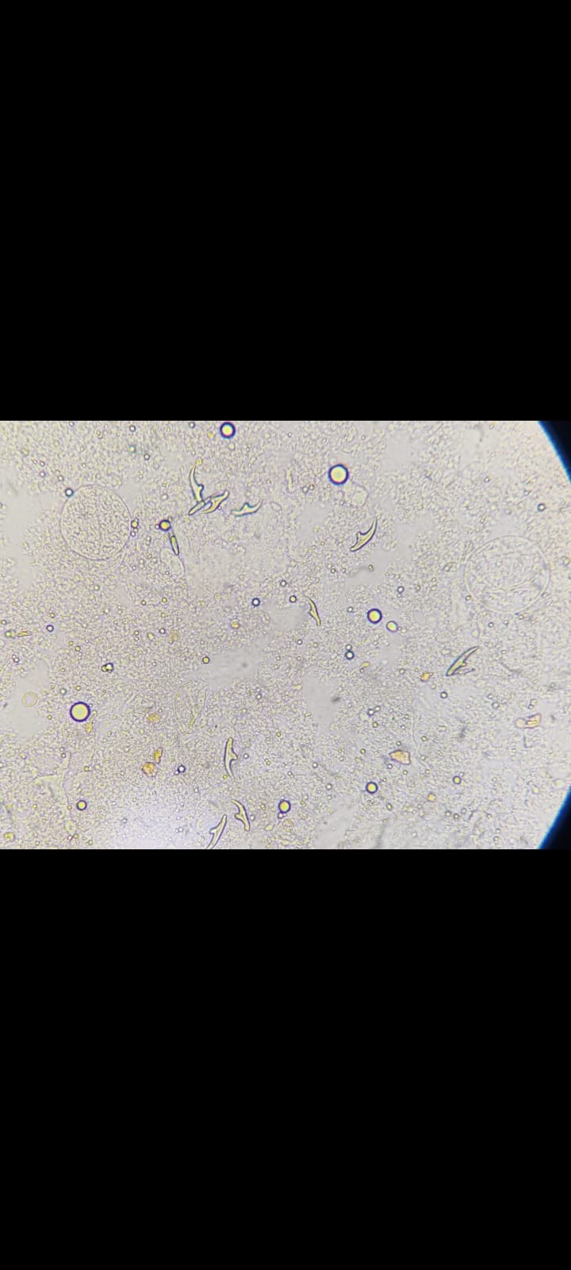
Supplementary Figure 3. Pleural-fluid microscopy from the hydatid case, showing Echinococcus hooklets.

