Supporting Information

Quantum Mechanical Modeling Unveil the Effect of Substitutions on the Activation Barriers of the Diels-Alder reactions of an antiviral compound 7H-Benzo[a]phenalene

Cartesian Coordinates
1a
1 |  | 6 | 1.051097 | -0.000738 | 0.05032
2 |  | 6 | 0.804674 | -1.400793 | 0.080294
3 |  | 6 | -0.573796 | -1.903093 | 0.418473
4 |  | 6 | -0.022157 | 0.943628 | 0.136202
5 |  | 6 | -1.683877 | -0.921428 | 0.147949
6 |  | 6 | -1.419593 | 0.451731 | 0.055255
7 |  | 6 | 2.390015 | 0.462869 | -0.06896
8 |  | 6 | 1.84709 | -2.278968 | -0.093836
9 |  | 6 | 0.284964 | 2.284195 | 0.219754
10 |  | 6 | -2.992942 | -1.385958 | 0.028428
11 |  | 6 | -2.492689 | 1.322415 | -0.177759
12 |  | 6 | 3.438875 | -0.476348 | -0.231931
13 |  | 6 | 2.648713 | 1.855928 | -0.009105
14 |  | 6 | 3.169742 | -1.81839 | -0.262991
15 |  | 6 | 1.618729 | 2.740344 | 0.158442
16 |  | 6 | -4.048667 | -0.511144 | -0.180772
17 |  | 6 | -3.792225 | 0.85316 | -0.285775
18 |  | 1 | -0.771914 | -2.841717 | -0.105547
19 |  | 1 | -0.586909 | -2.144111 | 1.490276
20 |  | 1 | 1.651829 | -3.346414 | -0.078098
21 |  | 1 | -0.502494 | 3.018943 | 0.326442
22 |  | 1 | -3.17992 | -2.452748 | 0.100744
23 |  | 1 | -2.312735 | 2.382777 | -0.298379
24 |  | 1 | 4.454976 | -0.110613 | -0.331359
25 |  | 1 | 3.672995 | 2.203372 | -0.087578
26 |  | 1 | 3.971798 | -2.534339 | -0.398365
27 |  | 1 | 1.817339 | 3.803402 | 0.226253
28 |  | 1 | -5.059806 | -0.889172 | -0.272896
29 |  | 1 | -4.602472 | 1.549494 | -0.465852
2a
1 |  | 6 | 0 | 0.663379 | -1.259058
2 |  | 6 | 0 | -0.663379 | -1.259058
3 |  | 6 | 0 | 1.122906 | 0.16268
4 |  | 8 | 0 | 0 | 0.964206
5 |  | 6 | 0 | -1.122906 | 0.16268
6 |  | 8 | 0 | 2.223846 | 0.598304
7 |  | 8 | 0 | -2.223846 | 0.598304
8 |  | 1 | 0 | 1.35939 | -2.084345
9 |  | 1 | 0 | -1.35939 | -2.084345
3a
1 |  | 6 | 0.972368 | 3.687795 | -0.504823
2 |  | 6 | 1.850763 | 2.703442 | -0.30655
3 |  | 6 | -0.440007 | 3.506421 | -0.185697
4 |  | 6 | -0.952114 | 2.304258 | 0.143483
5 |  | 6 | -0.08306 | 1.12057 | 0.148865
6 |  | 6 | 1.412213 | 1.399214 | 0.310257
7 |  | 6 | -2.412032 | 2.122546 | 0.443951
8 |  | 6 | -2.952575 | 0.757044 | 0.104386
9 |  | 6 | -2.075507 | -0.326451 | -0.025199
10 |  | 6 | -0.615347 | -0.11825 | -0.021393
11 |  | 6 | -4.327095 | 0.550164 | 0.040689
12 |  | 6 | -4.846795 | -0.731748 | -0.099041
13 |  | 6 | -3.985775 | -1.820071 | -0.123654
14 |  | 6 | -2.604534 | -1.633239 | -0.075026
15 |  | 6 | -1.708905 | -2.787208 | 0.043506
16 |  | 6 | 0.250402 | -1.341148 | -0.339412
17 |  | 6 | -0.384396 | -2.661043 | -0.000213
18 |  | 6 | 2.191185 | 0.21181 | -0.215066
19 |  | 6 | 1.617103 | -1.10945 | 0.272393
20 |  | 6 | 2.765928 | -2.050746 | -0.010551
21 |  | 8 | 3.934572 | -1.307258 | 0.076661
22 |  | 6 | 3.653265 | 0.051162 | 0.124165
23 |  | 8 | 4.485468 | 0.855709 | 0.375491
24 |  | 8 | 2.781817 | -3.211777 | -0.245973
25 |  | 1 | 1.295885 | 4.640991 | -0.906716
26 |  | 1 | 2.908709 | 2.825373 | -0.512062
27 |  | 1 | -1.102801 | 4.361967 | -0.264936
28 |  | 1 | 1.603954 | 1.482393 | 1.394605
29 |  | 1 | -2.999839 | 2.905095 | -0.04119
30 |  | 1 | -2.556031 | 2.253883 | 1.526426
31 |  | 1 | -4.995053 | 1.401844 | 0.118327
32 |  | 1 | -5.918257 | -0.882337 | -0.153238
33 |  | 1 | -4.379857 | -2.829518 | -0.167003
34 |  | 1 | -2.166396 | -3.757757 | 0.20555
35 |  | 1 | 0.382966 | -1.35057 | -1.434633
36 |  | 1 | 0.273883 | -3.516434 | 0.102045
37 |  | 1 | 2.143429 | 0.21565 | -1.31434
38 |  | 1 | 1.523125 | -1.072281 | 1.36772
4a
1 |  | 6 | -1.005667 | 3.74842 | 0.138316
2 |  | 6 | -1.877707 | 2.7349 | 0.064654
3 |  | 6 | 0.414946 | 3.532843 | -0.045825
4 |  | 6 | 0.948988 | 2.279525 | -0.10762
5 |  | 6 | 0.074046 | 1.109976 | -0.089397
6 |  | 6 | -1.410933 | 1.367133 | -0.353743
7 |  | 6 | 2.375549 | 2.062613 | -0.049981
8 |  | 6 | 2.912339 | 0.831932 | 0.078667
9 |  | 6 | 2.041259 | -0.332756 | 0.097477
10 |  | 6 | 0.597604 | -0.132303 | 0.107156
11 |  | 6 | 4.399154 | 0.629551 | 0.253114
12 |  | 6 | 4.868742 | -0.754866 | -0.081372
13 |  | 6 | 4.010862 | -1.771461 | -0.205296
14 |  | 6 | 2.569709 | -1.589703 | -0.065148
15 |  | 6 | 1.694361 | -2.741912 | -0.244183
16 |  | 6 | -0.261326 | -1.369074 | 0.370017
17 |  | 6 | 0.370582 | -2.652828 | -0.092051
18 |  | 6 | -2.199374 | 0.220371 | 0.244603
19 |  | 6 | -1.639527 | -1.120987 | -0.208647
20 |  | 6 | -2.784827 | -2.049337 | 0.119473
21 |  | 8 | -3.951982 | -1.306011 | 0.029493
22 |  | 6 | -3.667846 | 0.050049 | -0.068664
23 |  | 8 | -4.503851 | 0.845271 | -0.335497
24 |  | 8 | -2.795853 | -3.202684 | 0.390964
25 |  | 1 | -1.351247 | 4.750457 | 0.365096
26 |  | 1 | -2.942801 | 2.88203 | 0.202553
27 |  | 1 | 1.081312 | 4.388275 | -0.028402
28 |  | 1 | -1.541141 | 1.323934 | -1.450068
29 |  | 1 | 3.018711 | 2.938266 | -0.070171
30 |  | 1 | 4.658604 | 0.826349 | 1.304452
31 |  | 1 | 5.936259 | -0.919823 | -0.176523
32 |  | 1 | 4.3721 | -2.771633 | -0.420682
33 |  | 1 | 2.152409 | -3.685381 | -0.522316
34 |  | 1 | -0.367175 | -1.454504 | 1.46569
35 |  | 1 | -0.2791 | -3.512249 | -0.214632
36 |  | 1 | -2.132964 | 0.272469 | 1.341582
37 |  | 1 | -1.569041 | -1.111556 | -1.306569
38 |  | 1 | 4.949531 | 1.374206 | -0.328627
5a
1 |  | 6 | -1.05421 | 3.761088 | -0.110328
2 |  | 6 | -1.916057 | 2.652268 | 0.029932
3 |  | 6 | 0.303582 | 3.584471 | -0.097189
4 |  | 6 | 0.867081 | 2.292386 | 0.044258
5 |  | 6 | 0.013905 | 1.168114 | 0.193611
6 |  | 6 | -1.400116 | 1.389783 | 0.182561
7 |  | 6 | 2.273966 | 2.100026 | 0.048361
8 |  | 6 | 2.819559 | 0.851413 | 0.108508
9 |  | 6 | 1.962465 | -0.292716 | 0.165278
10 |  | 6 | 0.598744 | -0.140533 | 0.299398
11 |  | 6 | 4.306687 | 0.624585 | 0.212991
12 |  | 6 | 4.764357 | -0.59358 | -0.585919
13 |  | 6 | 3.854953 | -1.764869 | -0.359594
14 |  | 6 | 2.56576 | -1.630767 | -0.00381
15 |  | 6 | 1.667828 | -2.783926 | 0.032143
16 |  | 6 | -0.293921 | -1.35107 | 0.550693
17 |  | 6 | 0.35583 | -2.666375 | 0.233344
18 |  | 6 | -2.253236 | 0.175709 | 0.388174
19 |  | 6 | -1.605131 | -1.084766 | -0.174189
20 |  | 6 | -2.765238 | -2.049437 | -0.114638
21 |  | 8 | -3.922283 | -1.29892 | -0.279371
22 |  | 6 | -3.657794 | 0.05925 | -0.158316
23 |  | 8 | -4.472004 | 0.877418 | -0.421006
24 |  | 8 | -2.801114 | -3.226031 | 0.018495
25 |  | 1 | -1.47621 | 4.751658 | -0.229875
26 |  | 1 | -2.989777 | 2.792352 | 0.011171
27 |  | 1 | 0.972085 | 4.431967 | -0.203411
28 |  | 1 | 2.91791 | 2.973276 | 0.0011
29 |  | 1 | 4.538489 | 0.44847 | 1.270603
30 |  | 1 | 5.792824 | -0.850874 | -0.321525
31 |  | 1 | 4.237748 | -2.759194 | -0.571603
32 |  | 1 | 2.105573 | -3.759202 | -0.156197
33 |  | 1 | -0.534248 | -1.364302 | 1.626664
34 |  | 1 | -0.289948 | -3.537467 | 0.230357
35 |  | 1 | -2.378834 | 0.013429 | 1.471199
36 |  | 1 | -1.400689 | -0.929393 | -1.243071
37 |  | 1 | 4.848665 | 1.521902 | -0.091764
38 |  | 1 | 4.770605 | -0.361405 | -1.659671
6a
1 |  | 8 | -1.822157 | -2.676758 | 1.581943
2 |  | 6 | -0.355266 | 3.422225 | 0.264338
3 |  | 6 | -1.705065 | 3.421602 | -0.000595
4 |  | 6 | 0.390008 | 2.230366 | 0.184943
5 |  | 6 | -0.259669 | 1.020808 | -0.148792
6 |  | 6 | -2.348566 | 2.229883 | -0.362479
7 |  | 6 | -1.643203 | 1.044077 | -0.435562
8 |  | 6 | 1.805971 | 2.230198 | 0.411485
9 |  | 6 | 2.558923 | 1.108744 | 0.301971
10 |  | 6 | 1.926039 | -0.147644 | -0.03961
11 |  | 6 | 0.524757 | -0.194562 | -0.231973
12 |  | 6 | 4.047059 | 1.130764 | 0.551716
13 |  | 6 | 4.766195 | 0.08393 | -0.295528
14 |  | 6 | 4.191935 | -1.294853 | 0.017738
15 |  | 6 | 2.693128 | -1.332531 | -0.169962
16 |  | 6 | 2.054286 | -2.520338 | -0.465636
17 |  | 6 | -0.095321 | -1.430708 | -0.495994
18 |  | 6 | 0.664626 | -2.574725 | -0.613407
19 |  | 6 | -2.346874 | -0.223216 | -0.906337
20 |  | 6 | -1.591938 | -1.508065 | -0.565745
21 |  | 6 | -3.646857 | -0.3981 | -0.136397
22 |  | 6 | -2.225041 | -1.925833 | 0.762475
23 |  | 8 | -3.456448 | -1.312843 | 0.872687
24 |  | 8 | -4.689335 | 0.141989 | -0.302332
25 |  | 1 | 0.154963 | 4.341891 | 0.528892
26 |  | 1 | -2.275359 | 4.340702 | 0.0579
27 |  | 1 | -3.408143 | 2.237576 | -0.591379
28 |  | 1 | 2.27909 | 3.174027 | 0.666402
29 |  | 1 | 4.231714 | 0.912215 | 1.61109
30 |  | 1 | 4.434395 | 2.133904 | 0.360931
31 |  | 1 | 5.839469 | 0.103106 | -0.095082
32 |  | 1 | 4.623297 | 0.309587 | -1.357181
33 |  | 1 | 4.425849 | -1.550359 | 1.058824
34 |  | 1 | 4.652323 | -2.064721 | -0.605979
35 |  | 1 | 2.639059 | -3.427776 | -0.57282
36 |  | 1 | 0.178654 | -3.524548 | -0.809462
37 |  | 1 | -2.58198 | -0.133234 | -1.968426
38 |  | 1 | -1.885782 | -2.297097 | -1.26736
2b
1 |  | 6 | 1.257671 | 0.242541 | 0
2 |  | 6 | -0.000613 | 0.668286 | 0
3 |  | 6 | 1.214957 | -1.244143 | 0
4 |  | 6 | -0.917274 | -0.527175 | 0
5 |  | 8 | -0.115549 | -1.638425 | 0
6 |  | 8 | 2.104745 | -2.023111 | 0
7 |  | 8 | -2.097637 | -0.558667 | 0
8 |  | 1 | 2.179235 | 0.803292 | 0
9 |  | 17 | -0.625787 | 2.242761 | 0
3b
1 |  | 6 | 0.773548 | 3.592192 | -0.164959
2 |  | 6 | -0.620829 | 3.859645 | -0.500931
3 |  | 6 | 1.217597 | 2.35204 | 0.119744
4 |  | 6 | 0.289291 | 1.217252 | 0.055111
5 |  | 6 | -1.552415 | 2.914065 | -0.36582
6 |  | 6 | -1.191205 | 1.56371 | 0.198322
7 |  | 6 | 2.658645 | 2.080553 | 0.444736
8 |  | 6 | 3.134082 | 0.700811 | 0.067566
9 |  | 6 | 2.205114 | -0.328576 | -0.125456
10 |  | 6 | 0.759108 | -0.04033 | -0.14799
11 |  | 6 | 4.497051 | 0.42238 | 0.028659
12 |  | 6 | 4.951552 | -0.878977 | -0.149916
13 |  | 6 | 4.035112 | -1.917311 | -0.241559
14 |  | 6 | 2.665134 | -1.658242 | -0.219389
15 |  | 6 | 1.708185 | -2.767166 | -0.172704
16 |  | 6 | -0.155166 | -1.205911 | -0.540311
17 |  | 6 | 0.394268 | -2.572224 | -0.239588
18 |  | 6 | -2.007809 | 0.446509 | -0.413429
19 |  | 6 | -1.543501 | -0.939749 | -0.003993
20 |  | 6 | -3.499808 | 0.343804 | -0.198997
21 |  | 6 | -2.721899 | -1.782627 | -0.484883
22 |  | 8 | -3.844214 | -0.986663 | -0.426479
23 |  | 8 | -4.308087 | 1.165289 | 0.061344
24 |  | 8 | -2.747664 | -2.906682 | -0.85331
25 |  | 1 | 1.479095 | 4.416035 | -0.193225
26 |  | 1 | -0.888354 | 4.846261 | -0.860783
27 |  | 1 | -2.598397 | 3.10229 | -0.581751
28 |  | 1 | -1.407527 | 1.597712 | 1.27874
29 |  | 1 | 2.782311 | 2.165718 | 1.534237
30 |  | 1 | 3.299261 | 2.846478 | 0.001848
31 |  | 1 | 5.207117 | 1.232746 | 0.157373
32 |  | 1 | 6.014687 | -1.084377 | -0.183268
33 |  | 1 | 4.376799 | -2.943796 | -0.316739
34 |  | 1 | 2.110687 | -3.765783 | -0.038908
35 |  | 1 | -0.257602 | -1.163845 | -1.638656
36 |  | 1 | -0.311064 | -3.392733 | -0.179336
37 |  | 1 | -1.885948 | 0.490963 | -1.506944
38 |  | 17 | -1.571739 | -1.113634 | 1.799009
2c
1 |  | 6 | -0.377537 | -1.230032 | -0.000305
2 |  | 6 | 0.803044 | -0.614444 | 0.000058
3 |  | 6 | -1.448323 | -0.198908 | -0.000177
4 |  | 8 | -0.83641 | 1.045518 | 0.000241
5 |  | 6 | 0.524657 | 0.861607 | 0.000418
6 |  | 8 | -2.626282 | -0.325065 | -0.000377
7 |  | 8 | 1.302984 | 1.756669 | 0.000777
8 |  | 1 | -0.602981 | -2.286357 | -0.000643
9 |  | 6 | 2.197927 | -1.122734 | 0.000115
10 |  | 1 | 2.729845 | -0.746816 | -0.876879
11 |  | 1 | 2.729547 | -0.747471 | 0.877568
12 |  | 1 | 2.221648 | -2.211008 | -0.000283
3c
1 |  | 6 | 0.601059 | 3.553229 | -0.195527
2 |  | 6 | -0.805992 | 3.773019 | -0.511893
3 |  | 6 | 1.083681 | 2.333855 | 0.115799
4 |  | 6 | 0.185471 | 1.173418 | 0.103381
5 |  | 6 | -1.708624 | 2.807555 | -0.328088
6 |  | 6 | -1.302073 | 1.483723 | 0.267648
7 |  | 6 | 2.538304 | 2.1115 | 0.416171
8 |  | 6 | 3.042165 | 0.732559 | 0.074212
9 |  | 6 | 2.137333 | -0.325574 | -0.076497
10 |  | 6 | 0.682174 | -0.078547 | -0.081006
11 |  | 6 | 4.411525 | 0.489564 | 0.023838
12 |  | 6 | 4.899118 | -0.803536 | -0.125382
13 |  | 6 | 4.009613 | -1.867475 | -0.177185
14 |  | 6 | 2.633345 | -1.644457 | -0.142443
15 |  | 6 | 1.708146 | -2.777918 | -0.068011
16 |  | 6 | -0.217664 | -1.273899 | -0.420306
17 |  | 6 | 0.3881 | -2.617364 | -0.123234
18 |  | 6 | -2.094967 | 0.322854 | -0.29069
19 |  | 6 | -1.590763 | -1.036033 | 0.197988
20 |  | 6 | -3.578287 | 0.19818 | -0.053098
21 |  | 6 | -2.740484 | -1.913397 | -0.262815
22 |  | 8 | -3.894558 | -1.14301 | -0.226305
23 |  | 8 | -4.402383 | 1.008472 | 0.207788
24 |  | 8 | -2.766247 | -3.058366 | -0.569686
25 |  | 1 | 1.284289 | 4.393675 | -0.262125
26 |  | 1 | -1.106514 | 4.739615 | -0.899278
27 |  | 1 | -2.762968 | 2.958942 | -0.532168
28 |  | 1 | -1.49901 | 1.553988 | 1.351853
29 |  | 1 | 2.68646 | 2.238838 | 1.498527
30 |  | 1 | 3.147578 | 2.87789 | -0.068405
31 |  | 1 | 5.100723 | 1.322335 | 0.119027
32 |  | 1 | 5.966822 | -0.981625 | -0.168588
33 |  | 1 | 4.377121 | -2.886315 | -0.232848
34 |  | 1 | 2.139847 | -3.765064 | 0.062061
35 |  | 1 | -0.351789 | -1.252868 | -1.514743
36 |  | 1 | -0.289366 | -3.462284 | -0.064198
37 |  | 1 | -1.989312 | 0.335422 | -1.385903
38 |  | 6 | -1.548956 | -1.141857 | 1.733895
39 |  | 1 | -2.494347 | -0.830834 | 2.186783
40 |  | 1 | -1.35193 | -2.1754 | 2.024342
41 |  | 1 | -0.745435 | -0.519472 | 2.130737
TS1a
1 |  | 6 | 0.3644 | 3.536576 | -0.095171
2 |  | 6 | -1.06914 | 3.724288 | -0.268588
3 |  | 6 | 0.928145 | 2.316744 | 0.034804
4 |  | 6 | 0.08414 | 1.120397 | 0.063186
5 |  | 6 | -1.913522 | 2.70135 | -0.127042
6 |  | 6 | -1.404812 | 1.364393 | 0.341047
7 |  | 6 | 2.431499 | 2.179569 | -0.01451
8 |  | 6 | 2.954925 | 0.767488 | -0.021984
9 |  | 6 | 2.081111 | -0.322009 | -0.082369
10 |  | 6 | 0.619385 | -0.116967 | -0.121085
11 |  | 6 | 4.329541 | 0.556116 | 0.050024
12 |  | 6 | 4.852448 | -0.729551 | 0.087979
13 |  | 6 | 3.988932 | -1.816446 | 0.08884
14 |  | 6 | 2.609964 | -1.627568 | 0.016593
15 |  | 6 | 1.710536 | -2.777415 | 0.128449
16 |  | 6 | -0.242472 | -1.353518 | -0.396275
17 |  | 6 | 0.39227 | -2.660219 | -0.008484
18 |  | 6 | -2.197078 | 0.194777 | -0.202058
19 |  | 6 | -1.601411 | -1.132568 | 0.237561
20 |  | 6 | -3.648594 | 0.011205 | 0.174349
21 |  | 6 | -2.747433 | -2.077802 | -0.042776
22 |  | 8 | -3.919498 | -1.348022 | 0.094695
23 |  | 8 | -4.48182 | 0.798331 | 0.472519
24 |  | 8 | -2.758867 | -3.231372 | -0.312755
25 |  | 1 | 1.009145 | 4.406465 | -0.176288
26 |  | 1 | -1.432895 | 4.706849 | -0.54569
27 |  | 1 | -2.983828 | 2.812634 | -0.259238
28 |  | 1 | -1.510934 | 1.363284 | 1.440315
29 |  | 1 | 2.870104 | 2.704143 | 0.841388
30 |  | 1 | 2.802418 | 2.697044 | -0.905209
31 |  | 1 | 4.993513 | 1.414226 | 0.082639
32 |  | 1 | 5.923709 | -0.882273 | 0.138843
33 |  | 1 | 4.378967 | -2.825775 | 0.161485
34 |  | 1 | 2.158348 | -3.74119 | 0.347384
35 |  | 1 | -0.39139 | -1.398486 | -1.488407
36 |  | 1 | -0.265437 | -3.518484 | 0.073304
37 |  | 1 | -2.179852 | 0.232198 | -1.301597
38 |  | 1 | -1.487622 | -1.118621 | 1.331713
TS2a
1 |  | 6 | 1.007526 | 3.736695 | -0.329099
2 |  | 6 | 1.856132 | 2.693992 | -0.308346
3 |  | 6 | -0.375067 | 3.593394 | 0.031732
4 |  | 6 | -0.947248 | 2.338744 | 0.097021
5 |  | 6 | -0.096928 | 1.136631 | 0.03157
6 |  | 6 | 1.389203 | 1.395339 | 0.296868
7 |  | 6 | -2.344263 | 2.134058 | 0.115788
8 |  | 6 | -2.902931 | 0.83543 | 0.065177
9 |  | 6 | -2.039664 | -0.336983 | -0.101977
10 |  | 6 | -0.621209 | -0.117937 | -0.168445
11 |  | 6 | -4.367347 | 0.585801 | 0.011576
12 |  | 6 | -4.852443 | -0.707455 | -0.008361
13 |  | 6 | -3.990973 | -1.800267 | -0.017545
14 |  | 6 | -2.599919 | -1.616992 | -0.052494
15 |  | 6 | -1.710533 | -2.77996 | 0.005094
16 |  | 6 | 0.260802 | -1.34227 | -0.437362
17 |  | 6 | -0.390344 | -2.658195 | -0.115243
18 |  | 6 | 2.195425 | 0.202573 | -0.168058
19 |  | 6 | 1.585002 | -1.11891 | 0.267476
20 |  | 6 | 2.744184 | -2.065806 | 0.055862
21 |  | 8 | 3.90443 | -1.335776 | 0.229074
22 |  | 6 | 3.629281 | 0.031501 | 0.272564
23 |  | 8 | 4.452815 | 0.819485 | 0.587419
24 |  | 8 | 2.76168 | -3.22589 | -0.192394
25 |  | 1 | 1.353391 | 4.706723 | -0.670832
26 |  | 1 | 2.889798 | 2.773715 | -0.621428
27 |  | 1 | -1.018612 | 4.46431 | 0.052026
28 |  | 1 | 1.481227 | 1.475174 | 1.397057
29 |  | 1 | -3.010569 | 2.987319 | 0.185458
30 |  | 1 | -3.336866 | 0.787798 | 1.164221
31 |  | 1 | -5.020595 | 1.447554 | 0.068386
32 |  | 1 | -5.925014 | -0.859702 | -0.019113
33 |  | 1 | -4.389529 | -2.806851 | 0.006581
34 |  | 1 | -2.165427 | -3.749989 | 0.174277
35 |  | 1 | 0.465611 | -1.362883 | -1.519707
36 |  | 1 | 0.262897 | -3.522315 | -0.060902
37 |  | 1 | 2.232621 | 0.213755 | -1.268253
38 |  | 1 | 1.41511 | -1.087391 | 1.353753
TS3a
1 |  | 6 | -1.003236 | 3.74839 | -0.294074
2 |  | 6 | -1.867134 | 2.644307 | -0.073833
3 |  | 6 | 0.351061 | 3.553925 | -0.289675
4 |  | 6 | 0.891613 | 2.262058 | -0.106141
5 |  | 6 | 0.045222 | 1.117701 | 0.052668
6 |  | 6 | -1.37405 | 1.382615 | 0.107427
7 |  | 6 | 2.300724 | 2.062106 | -0.030792
8 |  | 6 | 2.858113 | 0.760174 | 0.174414
9 |  | 6 | 1.998068 | -0.39648 | 0.142232
10 |  | 6 | 0.587139 | -0.179319 | 0.177439
11 |  | 6 | 4.311345 | 0.577957 | 0.497153
12 |  | 6 | 4.845355 | -0.718506 | -0.048735
13 |  | 6 | 4.002417 | -1.751251 | -0.233118
14 |  | 6 | 2.577871 | -1.655758 | -0.026915
15 |  | 6 | 1.680329 | -2.734214 | -0.368631
16 |  | 6 | -0.286719 | -1.414552 | 0.384454
17 |  | 6 | 0.345385 | -2.618762 | -0.277204
18 |  | 6 | -2.215159 | 0.192667 | 0.451781
19 |  | 6 | -1.662486 | -1.08331 | -0.166896
20 |  | 6 | -2.82503 | -2.025633 | 0.018734
21 |  | 8 | -3.982496 | -1.250797 | 0.001605
22 |  | 6 | -3.678873 | 0.097093 | 0.089858
23 |  | 8 | -4.502225 | 0.935234 | -0.068575
24 |  | 8 | -2.869104 | -3.202345 | 0.138562
25 |  | 1 | -1.42026 | 4.736796 | -0.436384
26 |  | 1 | -2.938657 | 2.800678 | -0.032069
27 |  | 1 | 1.031041 | 4.389863 | -0.418293
28 |  | 1 | 2.714712 | 1.399445 | -1.04019
29 |  | 1 | 2.9695 | 2.91636 | 0.031337
30 |  | 1 | 4.358488 | 0.576168 | 1.601084
31 |  | 1 | 5.910293 | -0.811398 | -0.213621
32 |  | 1 | 4.391699 | -2.703425 | -0.581715
33 |  | 1 | 2.113017 | -3.642233 | -0.778535
34 |  | 1 | -0.396695 | -1.60919 | 1.46727
35 |  | 1 | -0.315025 | -3.414581 | -0.600954
36 |  | 1 | -2.196304 | 0.058959 | 1.545519
37 |  | 1 | -1.575875 | -0.930341 | -1.252887
38 |  | 1 | 4.888338 | 1.446492 | 0.169574
TS4a
1 |  | 6 | -1.139683 | 3.731324 | -0.230019
2 |  | 6 | -1.988436 | 2.653148 | 0.024928
3 |  | 6 | 0.230218 | 3.538763 | -0.329876
4 |  | 6 | 0.789211 | 2.266009 | -0.175083
5 |  | 6 | -0.057993 | 1.174088 | 0.068926
6 |  | 6 | -1.447834 | 1.3837 | 0.160964
7 |  | 6 | 2.228879 | 2.044483 | -0.273009
8 |  | 6 | 2.817107 | 0.886206 | 0.047557
9 |  | 6 | 1.992773 | -0.298193 | 0.511472
10 |  | 6 | 0.519225 | -0.172138 | 0.174926
11 |  | 6 | 4.325068 | 0.772848 | 0.053784
12 |  | 6 | 4.90871 | -0.653758 | 0.096701
13 |  | 6 | 3.915003 | -1.748168 | -0.125844
14 |  | 6 | 2.594035 | -1.616591 | 0.051996
15 |  | 6 | 1.695588 | -2.751108 | -0.107494
16 |  | 6 | -0.232706 | -1.280118 | -0.03535
17 |  | 6 | 0.358901 | -2.60662 | -0.111285
18 |  | 6 | -2.219272 | 0.136534 | 0.462116
19 |  | 6 | -1.678946 | -1.028266 | -0.356123
20 |  | 6 | -2.769449 | -2.054744 | -0.159107
21 |  | 8 | -3.951146 | -1.349732 | 0.030944
22 |  | 6 | -3.703781 | 0.000648 | 0.242327
23 |  | 8 | -4.578716 | 0.798215 | 0.264026
24 |  | 8 | -2.751478 | -3.238582 | -0.185438
25 |  | 1 | -1.5559 | 4.724498 | -0.349092
26 |  | 1 | -3.058453 | 2.795707 | 0.112826
27 |  | 1 | 0.884856 | 4.380753 | -0.527944
28 |  | 1 | 2.83978 | 2.888608 | -0.582985
29 |  | 1 | 4.701197 | 1.334868 | 0.914481
30 |  | 1 | 5.380361 | -0.828628 | 1.071771
31 |  | 1 | 4.308091 | -2.728479 | -0.382785
32 |  | 1 | 2.142687 | -3.727914 | -0.260677
33 |  | 1 | 2.05084 | -0.304033 | 1.617387
34 |  | 1 | -0.297469 | -3.458223 | -0.238665
35 |  | 1 | -2.065892 | -0.119099 | 1.523865
36 |  | 1 | -1.758096 | -0.750938 | -1.421588
37 |  | 1 | 4.69958 | 1.293107 | -0.830243
38 |  | 1 | 5.717377 | -0.745157 | -0.632624
TS1b
1 |  | 6 | -0.839033 | -3.07841 | -0.093915
2 |  | 6 | -0.816455 | -1.697475 | 0.126029
3 |  | 6 | -0.23248 | -3.743842 | 1.000092
4 |  | 6 | 0.046725 | -1.522665 | 1.379554
5 |  | 8 | 0.297239 | -2.711656 | 1.900355
6 |  | 8 | -0.056323 | -4.881377 | 1.308512
7 |  | 8 | 0.443613 | -0.481603 | 1.829624
8 |  | 1 | -1.366184 | -3.612302 | -0.867023
9 |  | 17 | -2.596564 | -0.951987 | 0.768977
10 |  | 6 | 1.386508 | 0.85277 | -0.488381
11 |  | 6 | 1.842531 | 1.894027 | 0.351046
12 |  | 6 | 0.847001 | 2.588199 | 1.219142
13 |  | 6 | -0.012844 | 0.599425 | -0.609546
14 |  | 6 | -0.523843 | 2.652499 | 0.628615
15 |  | 6 | -0.945088 | 1.638079 | -0.259394
16 |  | 6 | 2.31574 | 0.056236 | -1.206929
17 |  | 6 | 3.19892 | 2.153608 | 0.43833
18 |  | 6 | -0.456731 | -0.716709 | -1.114694
19 |  | 6 | -1.414697 | 3.653317 | 0.993418
20 |  | 6 | -2.24379 | 1.693526 | -0.805232
21 |  | 6 | 3.671718 | 0.359403 | -1.119314
22 |  | 6 | 1.835384 | -1.056338 | -2.007895
23 |  | 6 | 4.104805 | 1.399789 | -0.308205
24 |  | 6 | 0.555701 | -1.428248 | -1.953563
25 |  | 6 | -2.693533 | 3.68634 | 0.452768
26 |  | 6 | -3.104656 | 2.714204 | -0.460191
27 |  | 1 | 0.769437 | 1.971314 | 2.130534
28 |  | 1 | 1.195698 | 3.577421 | 1.520045
29 |  | 1 | 3.555153 | 2.940441 | 1.09301
30 |  | 1 | -1.403104 | -0.646731 | -1.65081
31 |  | 1 | -1.099818 | 4.417934 | 1.694457
32 |  | 1 | -2.573024 | 0.940889 | -1.50724
33 |  | 1 | 4.386139 | -0.23288 | -1.678611
34 |  | 1 | 2.554304 | -1.609169 | -2.601234
35 |  | 1 | 5.16349 | 1.62374 | -0.245783
36 |  | 1 | 0.208515 | -2.3149 | -2.468557
37 |  | 1 | -3.372422 | 4.483498 | 0.732759
38 |  | 1 | -4.097868 | 2.753454 | -0.88834
TS1c
1 |  | 6 | -1.257327 | 1.440947 | 0.93795
2 |  | 6 | -0.749657 | 3.785406 | 0.738321
3 |  | 6 | 0.657015 | 2.149476 | -0.345587
4 |  | 6 | 2.525262 | 0.558946 | -0.505553
5 |  | 6 | -2.968988 | -0.338172 | -0.703698
6 |  | 6 | 0.348283 | 3.471114 | -0.051238
7 |  | 6 | 1.913769 | 1.800716 | -1.084762
8 |  | 6 | 0.226639 | -0.284762 | -0.158961
9 |  | 6 | 1.642337 | -0.498998 | -0.149662
10 |  | 6 | -0.188222 | 1.1047 | 0.086729
11 |  | 6 | 4.411835 | -0.851997 | 0.022008
12 |  | 6 | 3.88547 | 0.37145 | -0.426532
13 |  | 6 | 3.575392 | -1.90378 | 0.329337
14 |  | 6 | 2.18448 | -1.762147 | 0.214266
15 |  | 6 | 1.295367 | -2.870791 | 0.420599
16 |  | 6 | -0.618188 | -1.488658 | -0.375374
17 |  | 6 | 0.003442 | -2.763473 | 0.070725
18 |  | 6 | -1.530542 | 2.758471 | 1.26082
19 |  | 6 | -2.281249 | -1.432933 | -0.033051
20 |  | 6 | -3.576317 | -0.778648 | -1.896123
21 |  | 6 | -2.819116 | -2.640095 | -0.839223
22 |  | 8 | -3.381793 | -2.222117 | -1.969514
23 |  | 8 | -4.173847 | -0.251526 | -2.791752
24 |  | 8 | -2.735843 | -3.794395 | -0.525367
25 |  | 1 | 0.99569 | 4.258736 | -0.421029
26 |  | 1 | -0.973734 | 4.818779 | 0.973558
27 |  | 1 | -2.358696 | 2.982584 | 1.921615
28 |  | 1 | -1.875507 | 0.671089 | 1.366742
29 |  | 1 | 2.619746 | 2.631776 | -1.06609
30 |  | 1 | 1.678502 | 1.600041 | -2.139823
31 |  | 1 | 4.555257 | 1.171318 | -0.721332
32 |  | 1 | 5.485662 | -0.97336 | 0.103255
33 |  | 1 | 3.98151 | -2.859662 | 0.63887
34 |  | 1 | 1.706999 | -3.81563 | 0.756962
35 |  | 1 | -0.731834 | -1.548575 | -1.469203
36 |  | 1 | -0.638256 | -3.636244 | 0.068703
37 |  | 1 | -2.995391 | 0.704637 | -0.455271
38 |  | 6 | -2.427811 | -1.696534 | 1.47398
39 |  | 1 | -3.432175 | -1.425999 | 1.802164
40 |  | 1 | -2.27527 | -2.761298 | 1.662839
41 |  | 1 | -1.696093 | -1.149237 | 2.068933

Vibrational modes and corresponding frequencies
TS1a
1 | -73.13
2 | 39.35
3 | 59.78
4 | 115.96
5 | 144.21
6 | 153.13
7 | 158.19
8 | 184.54
9 | 214.50
10 | 240.65
11 | 257.18
12 | 287.83
13 | 311.32
14 | 320.11
15 | 380.19
16 | 403.41
17 | 424.62
18 | 453.51
19 | 458.13
20 | 472.76
21 | 486.53
22 | 518.48
23 | 526.32
24 | 560.04
25 | 566.53
26 | 576.91
27 | 586.35
28 | 620.92
29 | 651.00
30 | 654.84
31 | 677.95
32 | 695.16
33 | 718.82
34 | 746.87
35 | 754.60
36 | 761.61
37 | 780.73
38 | 787.31
39 | 804.49
40 | 828.04
41 | 850.88
42 | 892.07
43 | 905.59
44 | 930.50
45 | 939.51
46 | 954.87
47 | 968.62
48 | 985.67
49 | 997.81
50 | 1005.28
51 | 1009.42
52 | 1018.93
53 | 1024.17
54 | 1068.37
55 | 1079.18
56 | 1101.71
57 | 1126.42
58 | 1135.38
59 | 1143.93
60 | 1175.88
61 | 1183.60
62 | 1191.68
63 | 1194.11
64 | 1205.58
65 | 1222.67
66 | 1234.00
67 | 1236.46
68 | 1242.60
69 | 1249.86
70 | 1266.50
71 | 1267.73
72 | 1279.41
73 | 1305.54
74 | 1322.25
75 | 1330.12
76 | 1338.43
77 | 1347.44
78 | 1374.23
79 | 1399.01
80 | 1406.54
81 | 1420.80
82 | 1435.51
83 | 1443.95
84 | 1458.50
85 | 1509.22
86 | 1516.14
87 | 1624.53
88 | 1651.52
89 | 1660.16
90 | 1677.62
91 | 1726.79
92 | 1743.53
93 | 1918.44
94 | 1984.60
95 | 2963.13
96 | 2973.76
97 | 3015.80
98 | 3032.94
99 | 3037.73
100 | 3068.47
101 | 3165.42
102 | 3175.06
103 | 3179.30
104 | 3185.59
105 | 3187.32
106 | 3198.29
107 | 3203.95
108 | 3207.04
TS2a
1 | -1116.8
2 | 42.57
3 | 59.38
4 | 90.68
5 | 119.43
6 | 145.01
7 | 152.07
8 | 179.56
9 | 201.19
10 | 231.62
11 | 237.59
12 | 272.11
13 | 294.36
14 | 317.68
15 | 320.11
16 | 384.65
17 | 410.19
18 | 445.44
19 | 458.09
20 | 472.15
21 | 478.87
22 | 499.48
23 | 516.42
24 | 525.39
25 | 559.12
26 | 562.23
27 | 578.49
28 | 596.07
29 | 624.40
30 | 640.55
31 | 657.76
32 | 673.48
33 | 689.97
34 | 707.88
35 | 711.55
36 | 719.26
37 | 754.61
38 | 756.82
39 | 767.85
40 | 783.55
41 | 796.06
42 | 815.61
43 | 834.59
44 | 865.32
45 | 876.43
46 | 895.40
47 | 913.96
48 | 937.62
49 | 954.87
50 | 981.44
51 | 987.75
52 | 988.66
53 | 1008.13
54 | 1032.07
55 | 1035.91
56 | 1054.85
57 | 1093.35
58 | 1104.40
59 | 1125.39
60 | 1128.38
61 | 1155.78
62 | 1170.86
63 | 1177.43
64 | 1184.52
65 | 1188.78
66 | 1195.05
67 | 1209.75
68 | 1229.44
69 | 1238.86
70 | 1256.31
71 | 1270.91
72 | 1274.78
73 | 1288.40
74 | 1298.73
75 | 1307.49
76 | 1333.49
77 | 1348.43
78 | 1368.64
79 | 1390.17
80 | 1408.14
81 | 1414.43
82 | 1423.09
83 | 1437.12
84 | 1454.35
85 | 1469.28
86 | 1519.98
87 | 1540.69
88 | 1573.89
89 | 1602.91
90 | 1627.47
91 | 1684.46
92 | 1739.82
93 | 1918.57
94 | 1987.82
95 | 2482.88
96 | 2942.73
97 | 2988.10
98 | 3009.37
99 | 3028.34
100 | 3183.02
101 | 3183.97
102 | 3190.10
103 | 3195.35
104 | 3203.03
105 | 3206.39
106 | 3208.26
107 | 3211.04
108 | 3217.81
TS3a
1 | -1022.7
2 | 44.85
3 | 59.30
4 | 88.47
5 | 132.88
6 | 144.41
7 | 147.14
8 | 164.88
9 | 185.78
10 | 235.14
11 | 257.78
12 | 286.10
13 | 307.43
14 | 315.16
15 | 328.05
16 | 384.64
17 | 410.45
18 | 423.77
19 | 456.36
20 | 470.78
21 | 479.33
22 | 482.81
23 | 505.39
24 | 539.14
25 | 550.38
26 | 570.58
27 | 574.88
28 | 589.49
29 | 631.11
30 | 650.35
31 | 658.05
32 | 678.81
33 | 686.08
34 | 698.58
35 | 729.06
36 | 746.30
37 | 764.79
38 | 768.60
39 | 780.42
40 | 790.95
41 | 803.55
42 | 847.73
43 | 884.49
44 | 923.42
45 | 930.68
46 | 961.70
47 | 965.18
48 | 972.00
49 | 983.27
50 | 989.22
51 | 993.02
52 | 998.23
53 | 1005.39
54 | 1013.18
55 | 1058.00
56 | 1068.76
57 | 1101.12
58 | 1117.91
59 | 1143.01
60 | 1155.09
61 | 1179.71
62 | 1185.51
63 | 1189.52
64 | 1199.88
65 | 1210.31
66 | 1213.73
67 | 1221.06
68 | 1234.46
69 | 1240.21
70 | 1263.37
71 | 1279.42
72 | 1289.60
73 | 1307.37
74 | 1333.27
75 | 1342.09
76 | 1363.53
77 | 1370.45
78 | 1391.01
79 | 1401.68
80 | 1404.48
81 | 1412.67
82 | 1429.72
83 | 1448.48
84 | 1460.64
85 | 1476.87
86 | 1502.61
87 | 1522.40
88 | 1583.41
89 | 1603.29
90 | 1657.08
91 | 1687.73
92 | 1700.89
93 | 1914.15
94 | 1979.44
95 | 2073.10
96 | 2930.93
97 | 2954.91
98 | 2998.70
99 | 3031.35
100 | 3094.61
101 | 3171.53
102 | 3173.63
103 | 3175.20
104 | 3184.43
105 | 3198.28
106 | 3204.77
107 | 3216.21
108 | 3228.42
TS4a
1 | -144.01
2 | 52.22
3 | 58.97
4 | 96.89
5 | 114.26
6 | 148.49
7 | 162.67
8 | 175.29
9 | 222.37
10 | 256.04
11 | 258.94
12 | 300.40
13 | 308.07
14 | 334.60
15 | 346.82
16 | 384.86
17 | 402.28
18 | 420.86
19 | 458.68
20 | 482.78
21 | 500.50
22 | 509.06
23 | 513.03
24 | 557.68
25 | 578.74
26 | 589.88
27 | 600.61
28 | 617.96
29 | 645.05
30 | 662.62
31 | 683.17
32 | 685.20
33 | 731.32
34 | 741.21
35 | 767.83
36 | 779.98
37 | 785.45
38 | 800.86
39 | 813.47
40 | 836.84
41 | 864.20
42 | 883.62
43 | 898.44
44 | 911.93
45 | 924.82
46 | 932.79
47 | 953.50
48 | 964.15
49 | 980.60
50 | 1010.56
51 | 1015.41
52 | 1017.51
53 | 1022.70
54 | 1033.79
55 | 1089.18
56 | 1102.52
57 | 1113.26
58 | 1133.90
59 | 1152.13
60 | 1181.09
61 | 1185.14
62 | 1197.56
63 | 1197.96
64 | 1215.41
65 | 1230.37
66 | 1232.81
67 | 1244.86
68 | 1259.01
69 | 1270.21
70 | 1280.49
71 | 1287.01
72 | 1297.62
73 | 1317.35
74 | 1321.18
75 | 1342.13
76 | 1351.13
77 | 1375.47
78 | 1384.96
79 | 1392.99
80 | 1396.37
81 | 1413.09
82 | 1465.18
83 | 1471.03
84 | 1495.11
85 | 1497.96
86 | 1520.00
87 | 1618.58
88 | 1645.53
89 | 1667.83
90 | 1695.94
91 | 1726.62
92 | 1735.43
93 | 1925.57
94 | 1988.03
95 | 2926.20
96 | 2983.19
97 | 3000.91
98 | 3035.46
99 | 3049.41
100 | 3081.43
101 | 3099.88
102 | 3151.01
103 | 3167.09
104 | 3179.28
105 | 3192.44
106 | 3203.95
107 | 3209.51
108 | 3220.22
TS1b
1 | -217.68
2 | 32.37
3 | 46.54
4 | 63.57
5 | 87.10
6 | 96.75
7 | 146.93
8 | 161.60
9 | 173.86
10 | 182.34
11 | 190.90
12 | 216.50
13 | 222.05
14 | 240.18
15 | 258.09
16 | 301.76
17 | 360.22
18 | 377.77
19 | 388.07
20 | 415.92
21 | 434.94
22 | 440.90
23 | 449.14
24 | 495.03
25 | 499.63
26 | 517.45
27 | 531.03
28 | 552.58
29 | 575.88
30 | 588.93
31 | 612.52
32 | 641.73
33 | 653.55
34 | 661.88
35 | 679.73
36 | 710.30
37 | 730.34
38 | 739.61
39 | 761.05
40 | 772.77
41 | 780.40
42 | 791.70
43 | 797.20
44 | 800.21
45 | 822.61
46 | 837.05
47 | 850.69
48 | 879.07
49 | 886.89
50 | 923.88
51 | 943.44
52 | 956.26
53 | 971.81
54 | 992.88
55 | 1005.41
56 | 1011.25
57 | 1021.11
58 | 1024.70
59 | 1059.64
60 | 1079.74
61 | 1085.01
62 | 1097.45
63 | 1118.91
64 | 1153.40
65 | 1167.93
66 | 1189.60
67 | 1197.38
68 | 1208.32
69 | 1209.55
70 | 1224.98
71 | 1244.84
72 | 1265.92
73 | 1289.43
74 | 1297.85
75 | 1310.17
76 | 1335.67
77 | 1349.58
78 | 1361.37
79 | 1392.73
80 | 1394.83
81 | 1418.90
82 | 1424.39
83 | 1429.81
84 | 1437.23
85 | 1464.67
86 | 1507.58
87 | 1526.39
88 | 1538.76
89 | 1621.35
90 | 1640.83
91 | 1669.22
92 | 1680.25
93 | 1723.04
94 | 1843.89
95 | 1912.40
96 | 3007.69
97 | 3112.62
98 | 3119.48
99 | 3181.75
100 | 3186.73
101 | 3189.73
102 | 3194.94
103 | 3195.11
104 | 3207.29
105 | 3207.79
106 | 3212.86
107 | 3233.71
108 | 3272.73
TS1c
1 | -154.02
2 | 39.23
3 | 53.46
4 | 69.86
5 | 77.12
6 | 118.19
7 | 144.29
8 | 156.94
9 | 168.67
10 | 172.96
11 | 197.04
12 | 204.10
13 | 223.41
14 | 269.03
15 | 299.43
16 | 319.41
17 | 342.52
18 | 377.51
19 | 383.06
20 | 402.54
21 | 434.33
22 | 447.91
23 | 463.88
24 | 471.93
25 | 504.89
26 | 507.75
27 | 541.73
28 | 553.02
29 | 568.41
30 | 578.54
31 | 587.86
32 | 616.40
33 | 629.37
34 | 633.27
35 | 666.15
36 | 673.55
37 | 693.92
38 | 750.73
39 | 755.34
40 | 766.66
41 | 770.48
42 | 784.92
43 | 786.17
44 | 795.43
45 | 822.86
46 | 824.12
47 | 834.94
48 | 855.21
49 | 897.52
50 | 916.48
51 | 923.31
52 | 936.37
53 | 961.15
54 | 968.42
55 | 991.48
56 | 1000.79
57 | 1013.52
58 | 1018.97
59 | 1027.42
60 | 1058.83
61 | 1060.76
62 | 1078.94
63 | 1097.09
64 | 1097.89
65 | 1110.99
66 | 1155.86
67 | 1160.62
68 | 1178.19
69 | 1189.11
70 | 1193.02
71 | 1195.83
72 | 1201.84
73 | 1231.56
74 | 1245.98
75 | 1252.57
76 | 1261.09
77 | 1272.60
78 | 1299.61
79 | 1310.76
80 | 1339.03
81 | 1347.93
82 | 1349.90
83 | 1373.25
84 | 1390.48
85 | 1397.41
86 | 1410.58
87 | 1440.28
88 | 1451.77
89 | 1463.92
90 | 1497.83
91 | 1499.87
92 | 1509.46
93 | 1521.68
94 | 1530.09
95 | 1598.07
96 | 1638.98
97 | 1671.96
98 | 1677.32
99 | 1691.28
100 | 1830.86
101 | 1884.16
102 | 3005.71
103 | 3030.11
104 | 3057.18
105 | 3115.08
106 | 3136.63
107 | 3145.19
108 | 3181.67
109 | 3185.53
110 | 3190.60
111 | 3197.32
112 | 3200.78
113 | 3202.88
114 | 3206.45
115 | 3221.25
116 | 3297.55
117 | 3323.13
110 | 3190.60
111 | 3197.32
112 | 3200.78
113 | 3202.88
114 | 3206.45
115 | 3221.25
116 | 3297.55
117 | 3323.13

Table S1: Absolute energies and free energies (in Hartree) of optimized geometries of local minima and transition states for all the reactions as calculated in Gaussian 09W with M06-2X/6311++G(d,p).
 | E (Hartree) | ZPE (Hartree) | G (Hartree)
1a | -654.947264 | 0.236599 | -654.748288
2a | -379.258045 | 0.056400 | -379.230080
TS1a | -1034.190532 | 0.297665 | -1033.935773
3a | -1034.191409 | 0.298029 | -1033.937346
TS2a | -1034.070398 | 0.291624 | -1033.822379
4a | -1034.162371 | 0.297055 | -1033.909515
TS3a | -1034.104456 | 0.292220 | -1033.855751
5a | -1034.227557 | 0.299367 | -1033.971581
TS4a | -1034.190855 | 0.297797 | -1033.936041
6a | -1034.274672 | 0.299505 | -1034.019214
2b | -838.853479 | 0.047271 | -838.837581
TS1b | -1493.739469 | 0.283641 | -1493.502339
3b | -1493.788896 | 0.288266 | -1493.545983
2c | -418.572454 | 0.084234 | -418.519758
TS1c | -1073.407232 | 0.320903 | -1073.132449
3c | -1073.499187 | 0.325948 | -1073.218181

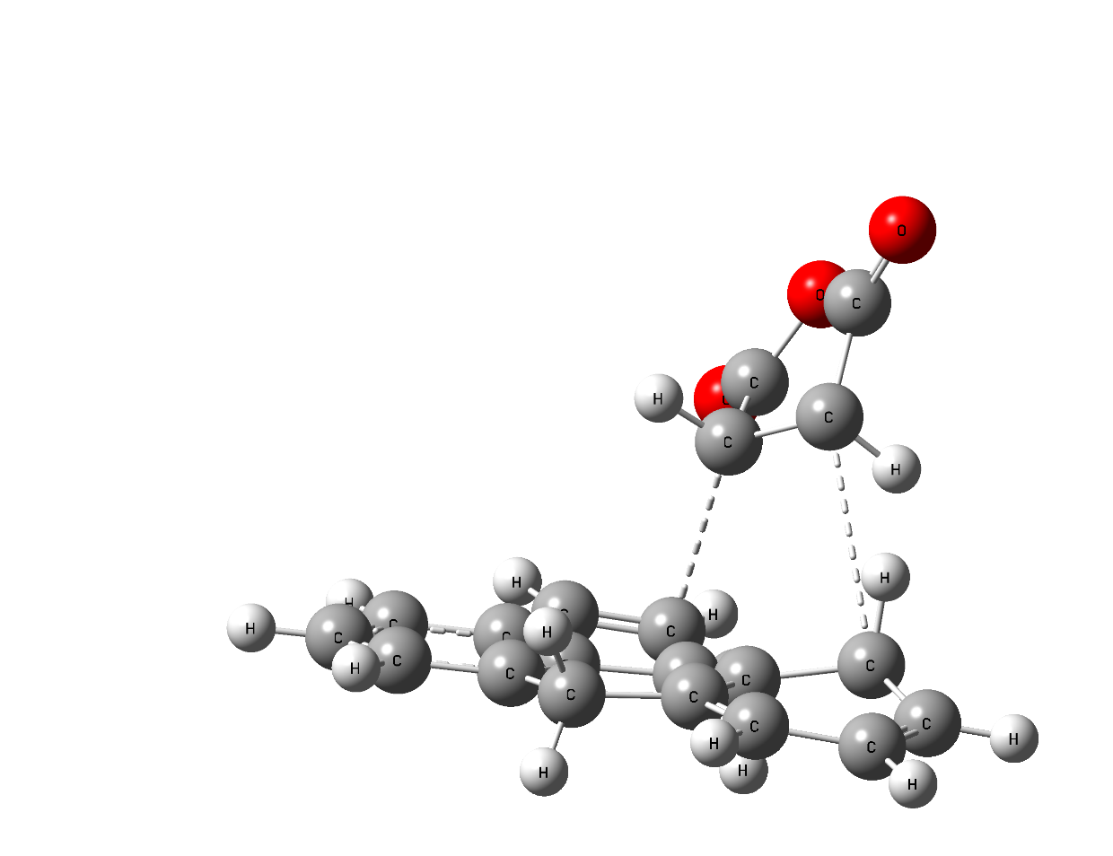
1.516Å
1.513Å
Fig. S1. M06-2X/6311++G(d,p) optimized geometry of TS1a’s structure as obtained in Gaussian 09W. Bond lengths are in angstroms.

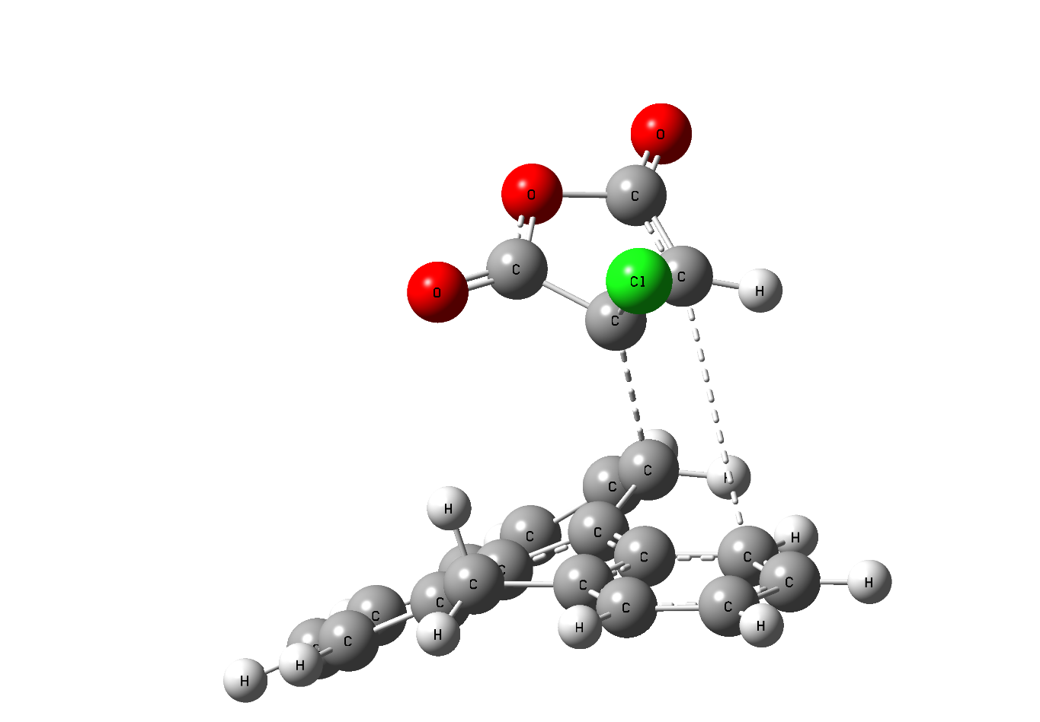
5.025Å
1.622Å
Fig. S2. M06-2X/6311++G(d,p) optimized geometry of TS1b’s structure as obtained in Gaussian 09W. Bond lengths are in angstroms.

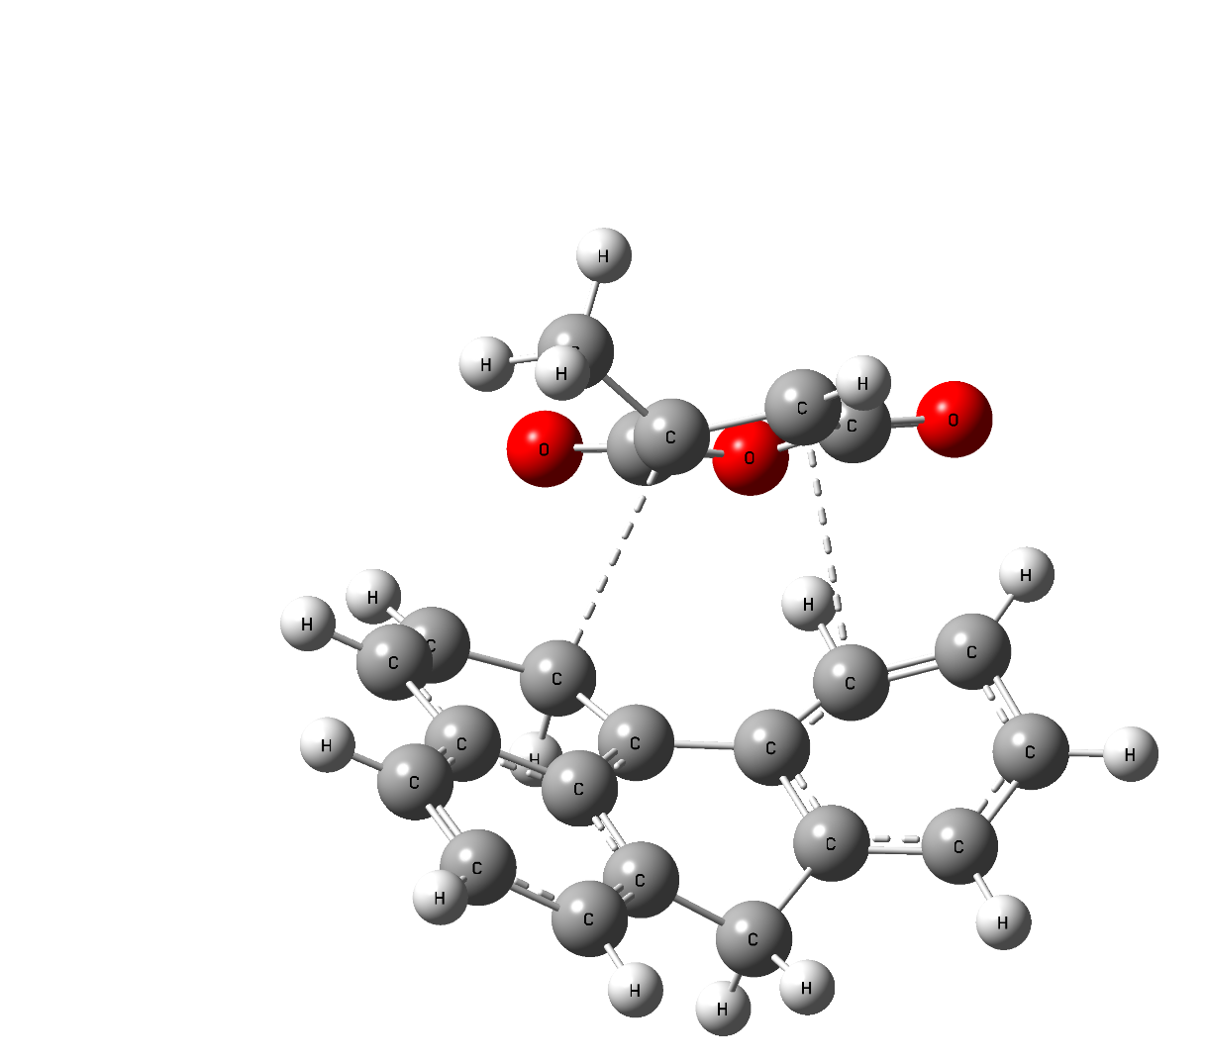
1.699Å
2.965Å
Fig. S3. M06-2X/6311++G(d,p) optimized geometry of TS1c’s structure as obtained in Gaussian 09W. Bond lengths are in angstroms.

