Supplementary Results and Methods
Identifying Robust Single-Cell 3D Genome Domain Boundaries with CellRoB

Supplementary Figures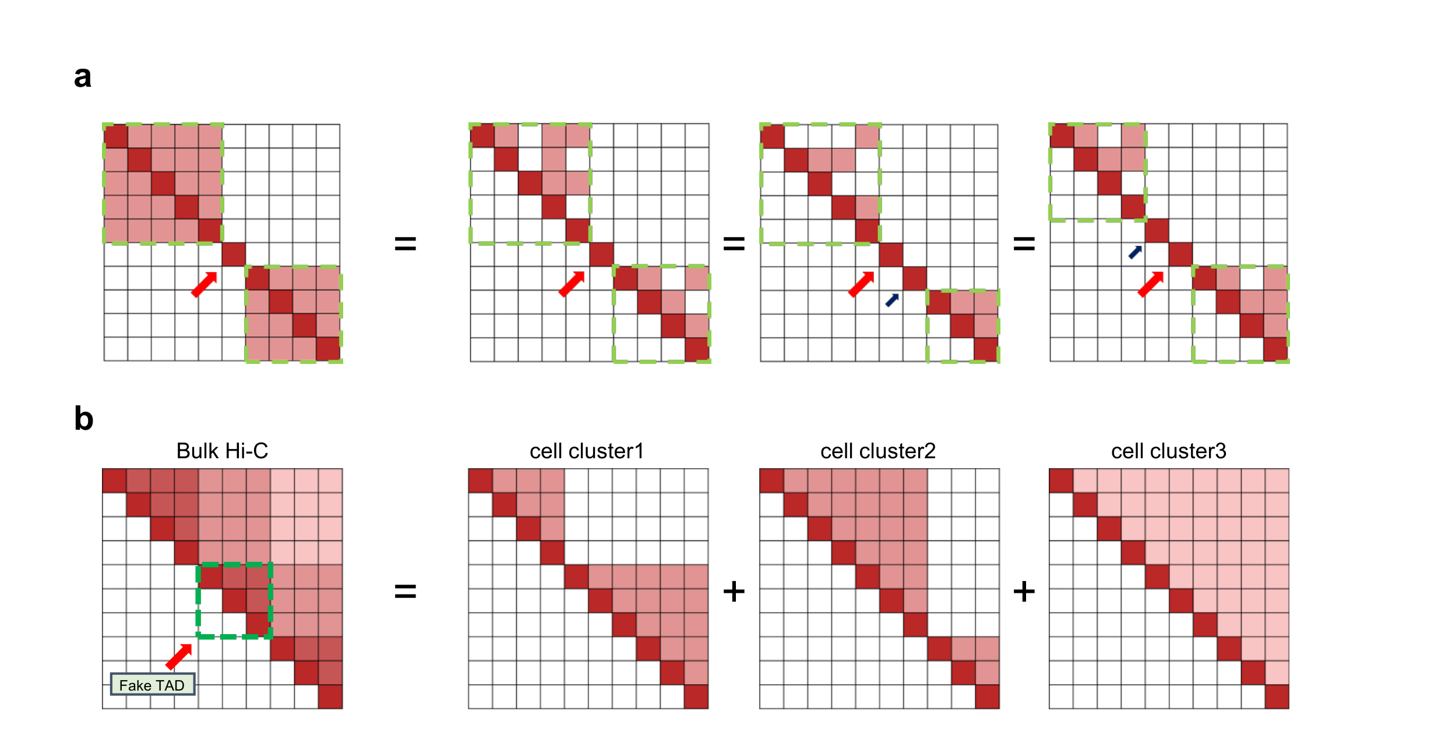
Supplementary Fig. 1 | Schematic of single‑cell versus bulk Hi‑C data. a, True chromatin contacts in an individual cell (left) contrasted with observed single‑cell Hi‑C data (right), where sparsity and technical noise can bias domain‑boundary detection. b, Bulk Hi‑C captures the ensemble‐averaged chromatin structure (shaded), which may obscure cell‑to‑cell variability and yield domain boundaries that diverge from those in any single cell.
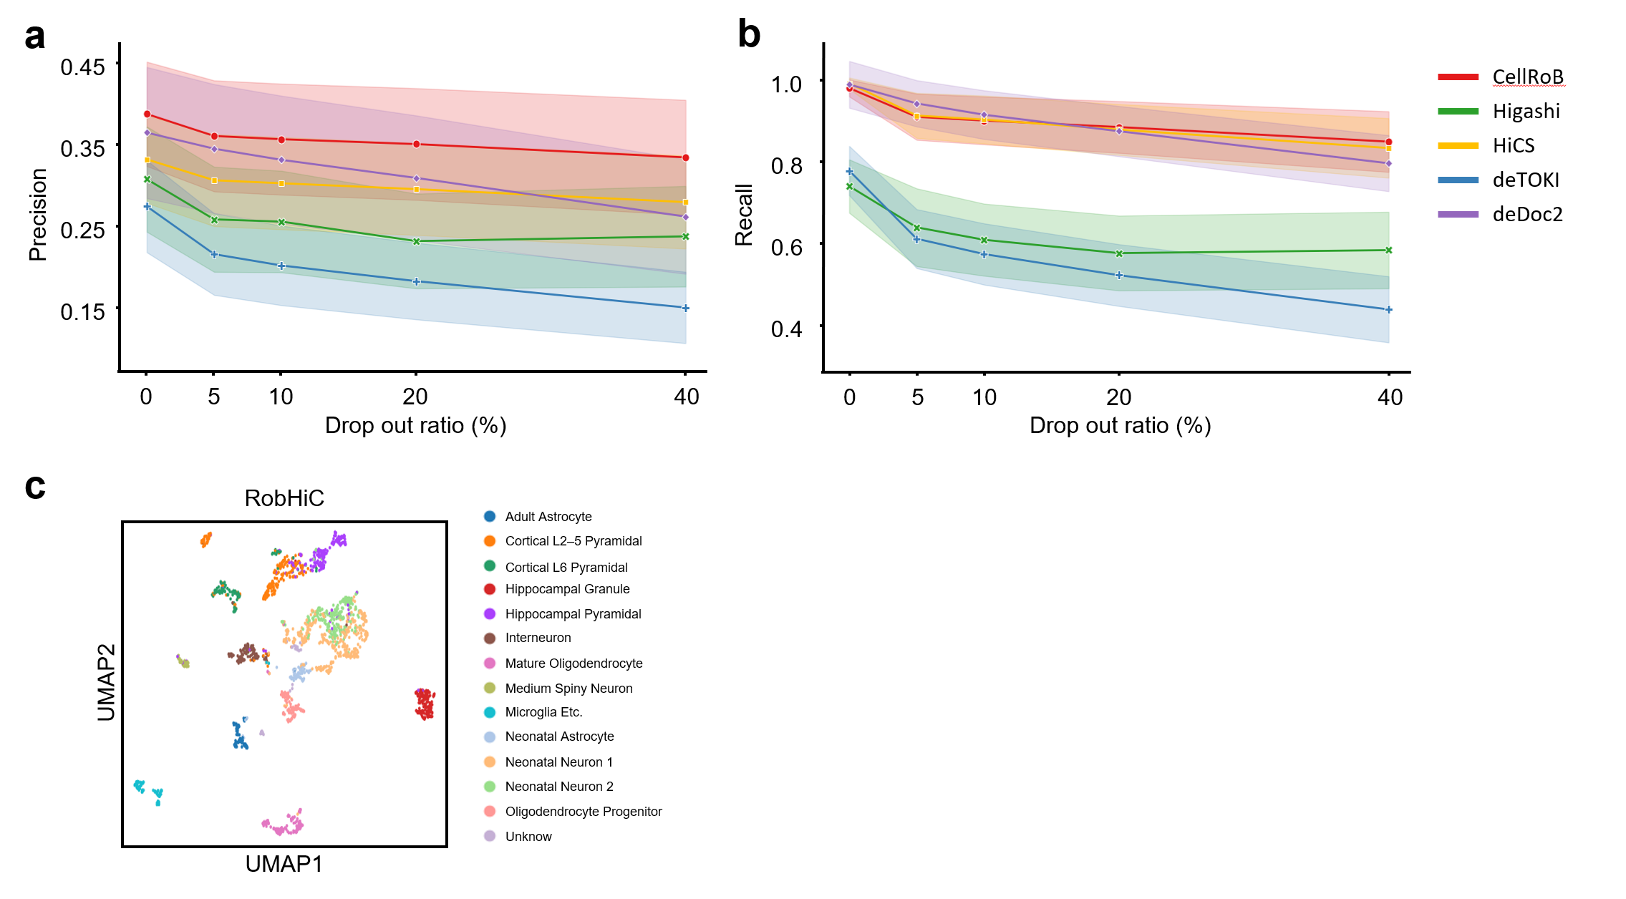
Supplementary Fig. 2 | Evaluation of the CellRoB framework. a and b, Comparison of boundary detection accuracy for CellRoB, HiCS, and other methods as single‑cell Hi‑C data drop‑out increases (e.g., Precision, Recall, or Jaccard index). c, UMAP visualization of Dip-C based on features derived from CellRoB.
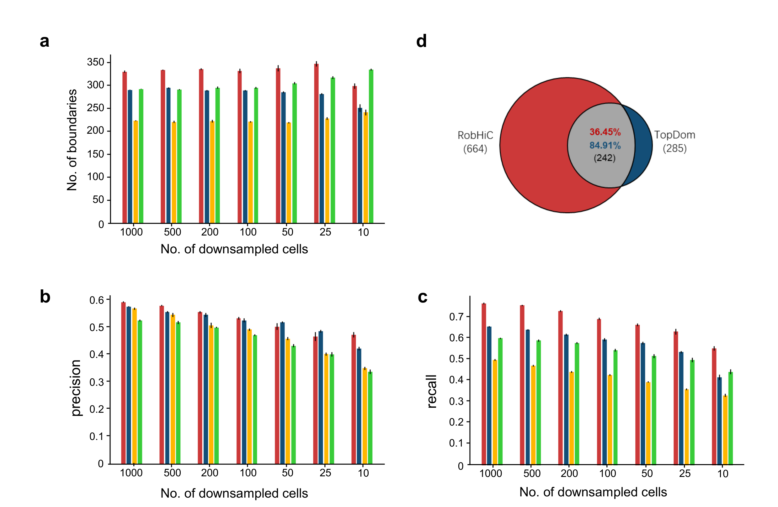
Supplementary Fig. 3 | Boundary detection performance across sampling rates and comparison. a, b and c, Total number of domain boundaries called a, precision b, and recall c by CellRoB, MSTD, IS, and TopDom at varying single‑cell Hi‑C data drop‑out rates. d, Comparison of boundaries identified by CellRoB versus TopDom.
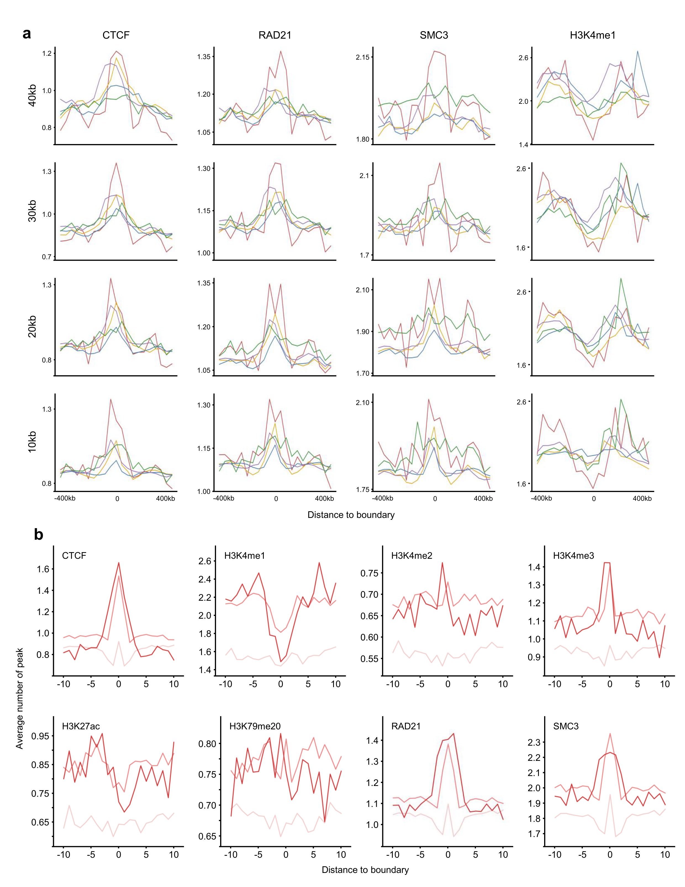
Supplementary Fig. 4 | a, Enrichment analysis of various insulator proteins across resolutions. b, Comparative enrichment of epigenomic marks at CellRoB‑identified boundaries stratified by high, medium, and low strength.
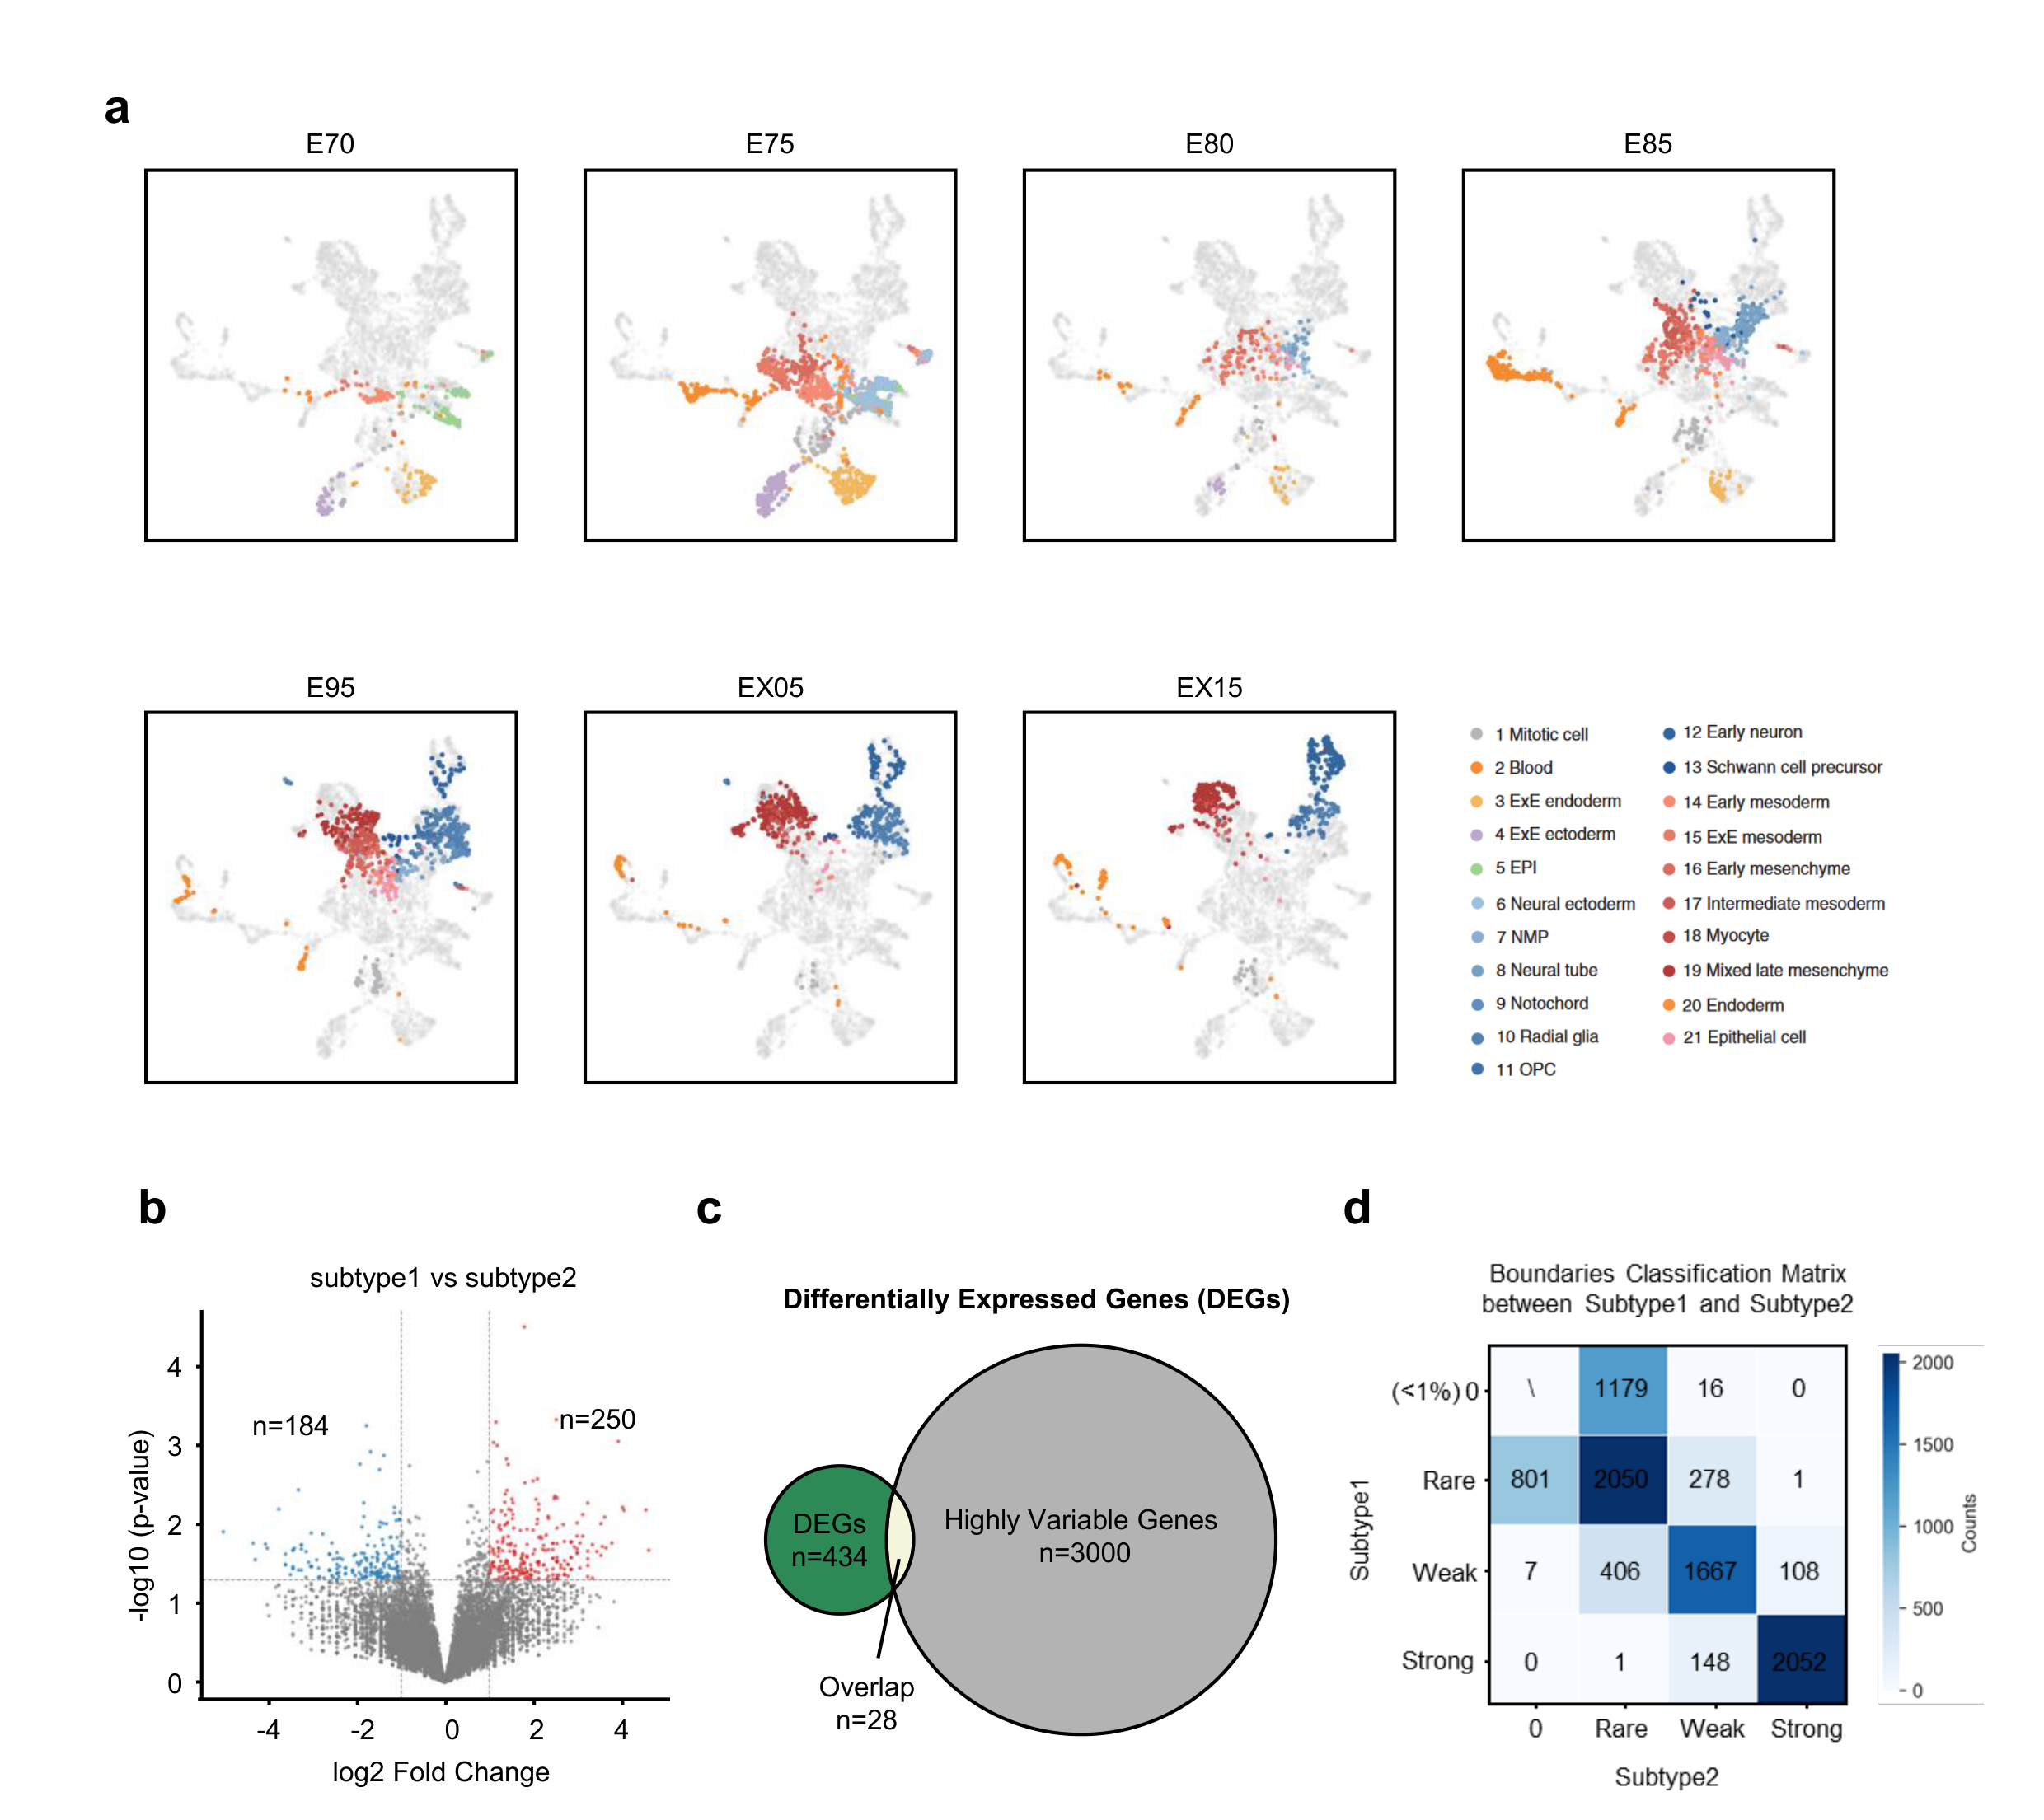
Supplementary Fig. 5 | Cell trajectory reconstruction and boundary dynamics analysis using domain boundary features. a, Low‑dimensional embedding of cells based on CellRoB‑defined domain boundary features, revealing a clear developmental trajectory. b, Differential expression analysis between Subtype1 and Subtype2 cells, highlighting transcriptomic distinctions. c, Venn diagram of overlaps among differentially expressed genes (DEGs), highly variable genes in EPI cells, and the total gene set. d, Correspondence of domain boundaries between Subtype 1 and Subtype 2, highlighting conserved and shifted boundary positions.

Supplementary Table Legends
Supplementary Table 1 | GO enrichment analysis of genes associated with rare and conserved domain boundaries in the scMicro-C dataset.
Supplementary Table 2 | GO enrichment analysis of genes associated with rare, weakly conserved, and strongly conserved domain boundaries in the Dip-C dataset.
Supplementary Table 3 | GO enrichment analysis of genes upregulated in EPI Subtype 1 and Subtype 2 in the HiRES dataset.

