Supplementary Information
  - Contextual Reversals in Visual Explanations
Mazen Hesham Elnahal
School of Computing and Data Science - Badya University
Online Resource 1 for the frozen confirmation run 6302cb864fe8. This document supplies algorithm details, additional interval tables, residual diagnostics and archive provenance. All results derive from the same verified records as the main manuscript. Reference numbers follow the expanded main manuscript.

S1 Frozen protocol and fitting splits
The Imagenette archive imagenette2-160.tgz has SHA256 64d0c4859f35a461889e0147755a999a48b49bf38a7e0f9bd27003f10db02fe5. Data, fitting-mask and bootstrap seeds are 2026101131, 2026101132 and 2026101133 respectively. Selection excludes 580 known developmental origins by path and byte hash and retains all selected errors.
The split seed is formed from the first 16 hexadecimal digits of the canonical SHA256 of [2026101132, image_id]. A NumPy generator permutes the full four-mask list and chooses its first 80 codes. Sixteen singleton codes precede them. The first 32 responses define the small fitting budget; all 96 define the larger budget. Both masks in a held-out contrast must avoid the selected 80. The comparison count can vary across image assignments.
Torch evaluation uses deterministic options with TF32 disabled and replay tolerance 0.002. The response census saves original logits, margin and target-logit scores, singleton drops and each four-region response. The size-four family contains 1,820 masks and determines 120×364 comparisons. Every comparison reuses two stored responses.

S2 Independent ordering formulation
For i<j, binary xᵢⱼ=1 means i precedes j. Maximize the sum over i<j of w(i,j)xᵢⱼ+w(j,i)(1−xᵢⱼ). For each triple i<j<k impose:
$$0 ≤ x_{ij} + x_{jk} - x_{ik} ≤ 1 (S1)$$
These constraints prevent directed three-cycles and define a transitive tournament. SciPy MILP uses relative gap zero and a 120-second per-instance time limit. All 960 planned zero-threshold margin optima are solved with gap zero and equal the dynamic-programming objectives. Certificates cover 800 grid and 160 SLIC16 instances. Dynamic programming alone supplies the other frozen thresholds.
A score tie is evaluated with one-half credit. Randomly ordering each tied score group expresses that agreement as an average over strict total orders, preserving A≤K. Truth ties and |d|≤ε are excluded before calculating the count matrix. A pair with no retained comparisons is excluded from reversal prevalence.

S3 Implementation details
Ridge minimizes squared response residuals plus a fixed diagonal penalty, with no intercept. Linear features are 16 region indicators and quadratic features add 120 pair products. The main-effect penalty is 0.32 and interaction penalty 3.2. The quadratic fixed score βᵢ+(3/14)Σⱼ≠ᵢθᵢⱼ averages the predicted contrast over three-region contexts. All parameters precede evaluation outcomes.
IG uses midpoint integration, gradient minibatches of eight and 32-step saved chunks. Attributions are summed over channels and then by region in float64 after float32 gradients. Completeness is checked at both 256 and 512 steps with limit 0.05+0.05|mₜ(x)−mₜ(reference)|. Refinement uses the grid regional vectors; it does not independently certify every possible SLIC aggregation.
Grad-CAM uses ResNet layer4[-1] and MobileNet features[-1]. Global spatial mean gradient weights are combined with convolutional activations, followed by ReLU and bilinear upsampling to 224. Regional CAM means are evaluated; IG uses signed sums. One gradient-bearing original supplies CAM per model/image and is shared across removal operators.
SLIC initially requests 32 segments with compactness 10, sigma 1 and connectivity enforcement. If fewer than 16 remain, requests of 64, 128 or 256 are tried. Adjacent regions merge by Lab-color Ward cost with lexicographic label ties until exactly 16 nonempty regions remain. Area controls rank covered pixels. Region construction uses image values, not responses.

S4 Complete primary and all-selected sensitivities
Setting | Primary reversal % | All 100 gap % | All 100 excess pp
MobileNet / Mean | 85.20 [83.36, 87.03] | 17.41 [16.76, 18.09] | 2.30 [2.02, 2.60]
MobileNet / Blur | 89.07 [87.34, 90.71] | 19.02 [18.24, 19.86] | 5.81 [5.08, 6.61]
ResNet34 / Mean | 96.86 [95.62, 97.92] | 24.45 [23.70, 25.21] | 4.67 [4.07, 5.31]
ResNet34 / Blur | 93.92 [92.33, 95.42] | 21.50 [20.73, 22.22] | 4.43 [3.76, 5.10]
Table S1 Pair reversal prevalence on 68 jointly correct originals and the two frozen outcomes repeated on all 100 selected origins. Brackets give class-stratified image-bootstrap intervals. Gap uses the complete family and excess the held-out family
The bootstrap samples images within each observed class, preserving that class’s count. Differences use paired identities. Primary eligibility varies across classes; in particular only two church images meet joint correctness. The intervals condition on observed eligibility and are not adjusted hypothesis-test decisions. The exhaustive comparisons do not enlarge the independent image sample.
Supplementary Figure 3 below compares the complete gaps of the two populations. The all-selected cohort contains the primary cohort, so these estimates are dependent. The graphic is a selection sensitivity, not an independent replication or a paired test between equally sized populations.

S5 Additional paired method comparisons
Supplementary Figure 1 gives paired differences for the main fitted methods, blur-reference IG and Grad-CAM against singleton. The contextual predictor is separately marked because it can use the shared context. Means, intervals and units are recorded in paired_method_differences.csv in Online Resource 2.
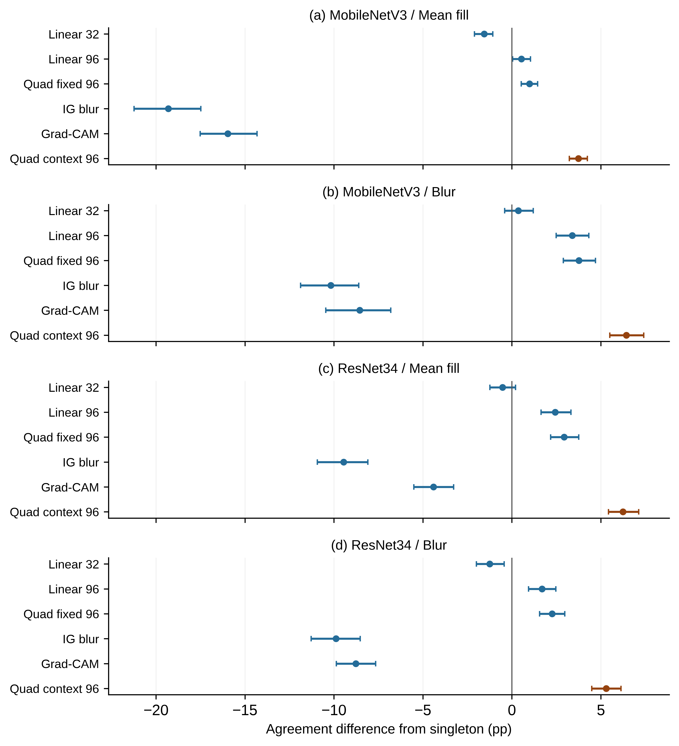
Fig. S1 Paired method-minus-singleton agreement differences on 68 originals. Panels a and b show MobileNet mean fill and blur; panels c and d show ResNet34. Error bars are 95% class-stratified image-bootstrap intervals. Blue marks fixed rankings and orange the contextual predictor; its output capability differs from a fixed order

S6 Integration residuals and matching passing subsets
Model | Reference | Runs | Pass | Completeness fail
MobileNet | Blur | 100 | 100 | 0
MobileNet | Mean | 100 | 75 | 25
ResNet34 | Blur | 100 | 100 | 0
ResNet34 | Mean | 100 | 98 | 2
Table S2 Joint IG numerical flags over all selected images. Every failure is a completeness failure, and no run fails refinement. All 200 blur-reference runs pass. In the primary cohort, MobileNet mean reference passes 59/68; the other combinations pass 68/68
Supplementary Figure 2 compares the normalized absolute completeness residual at 256 and 512 steps. A value above one fails the corresponding endpoint tolerance. Regional refinement remains a separate gate. Failure at either endpoint resolution fails the joint flag; increasing the number of steps is therefore not assumed to resolve every observed residual.
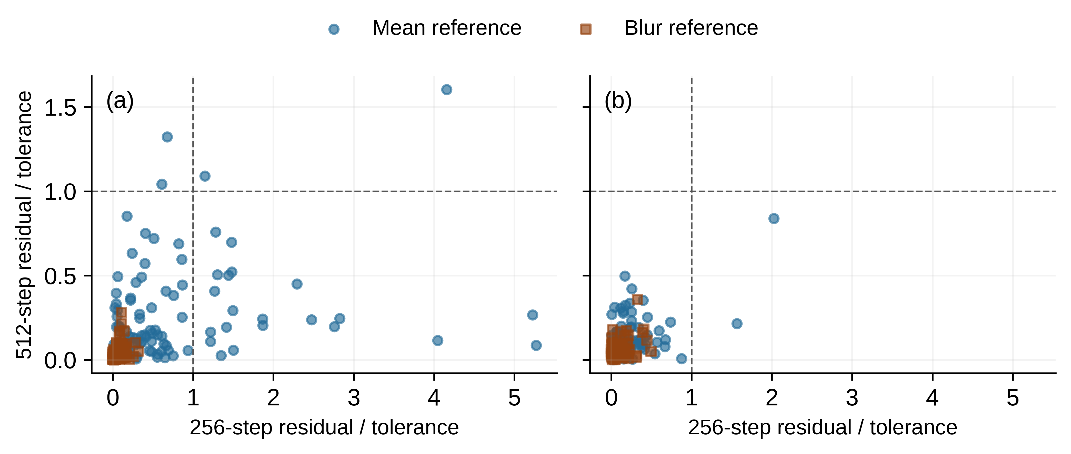
Fig. S2 IG completeness residuals divided by the frozen tolerance for all 400 runs. Panel a shows MobileNet and panel b ResNet34; circles mark mean reference and squares blur reference. Dashed horizontal and vertical lines mark a normalized residual of one. A point above or to the right of these lines fails completeness at a corresponding resolution
Operator | IG % | Singleton % | IG minus singleton pp
Blur | 59.78 | 76.67 | -16.89 [-18.89, -14.97]
Mean | 58.96 | 80.27 | -21.31 [-23.39, -19.25]
Table S3 Matching passing-only mean-reference MobileNet sensitivity on the same 59 originals. Brackets give paired image-bootstrap intervals. This population is selected by a numerical outcome and does not replace the primary analysis
The all-zero Grad-CAM map is resnet34_def1469964677a5a.json. Its regional score vector remains all ties. No corresponding image or failed IG run is replaced. The complete passing-subset records include other methods and settings.

S7 Threshold score and selection sensitivity
Setting | Margin .5 gap % | Coverage % | Logit 0 gap % | Logit .1 gap %
MobileNet / Mean | 7.09 | 59.14 | 16.29 | 13.87
MobileNet / Blur | 10.14 | 68.46 | 16.54 | 14.72
ResNet34 / Mean | 18.05 | 75.89 | 23.36 | 22.31
ResNet34 / Blur | 13.10 | 66.53 | 21.02 | 19.47
Table S4 Frozen score and threshold sensitivities on the 68-image primary cohort. Coverage refers to target-margin threshold 0.5. Full intervals and threshold-specific coverage are supplied for both scores in Online Resource 2
Supplementary Figure 3 shows complete-family gap estimates for original-image correctness conditioning. Squares identify all selected origins and circles the primary cohort. The interval width reflects each conditional image population and is not a significance test of their difference.
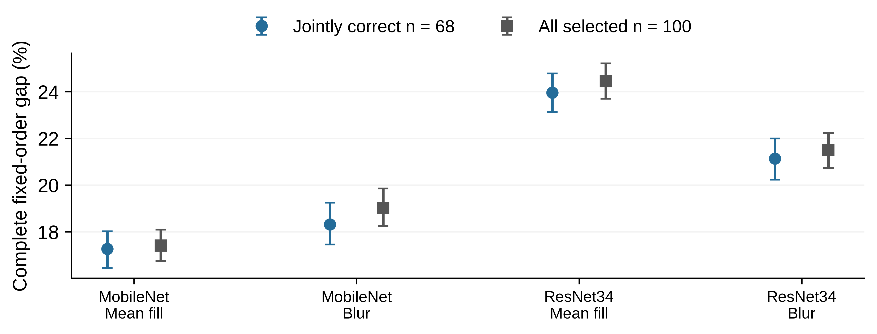
Fig. S3 Complete-family fixed-order gaps for the 68 jointly correct originals and all 100 selected originals. Circles and squares identify the populations; error bars show their respective class-stratified image-bootstrap intervals. The cohorts overlap, and this figure describes selection sensitivity

S8 Source integrity snapshots and provenance
The earlier grid-only archive has SHA256 e77ef1717a77611ee14170bd0b9ebf405c214362826b7e89f1515877f3edf9fa. The complete archive has SHA256 7164c2791f53e81284b7c441050bd87ba0f14d4a5c3d1c391dd41dc27cfdaf8b. They share the frozen run identity, source and protocol. The latest snapshot alone defines scientific outcomes.
The complete archive contains 30,394 files, including 30,392 canonical JSON records. The earlier archive contains 8,216 files and 8,212 such records. All digests and ZIP CRC checks pass. Response aggregates, saved original references and IG aggregates match their constituent records exactly; all 120 region maps have 16 nonempty regions and matching stored areas.
The complete export omitted singletons/resnet34_742168c2b303fe1c_grid_blur.json. The original checkpoint was recovered byte-for-byte from the earlier export. Both exports have identical completed jobs, run identity, model-weight records and the original singleton ledger event for this case; all 16 drops match exactly. The repaired copy preserves every original member and contains 30,395 files, 30,393 digest-verified JSON records and all 480 auxiliary singleton checkpoints. No new queries or scientific changes occur. Recovery_Report.json in Online Resource 2 records the hashes and verification.
Across 158 differing shared ResNet grid jobs, the largest shared numerical discrepancy is 0.00007629, below the 0.002 replay tolerance. Maximum changes in complete K and held-out singleton agreement are 0.00458 and 0.00501 percentage points. Arithmetic differences associated with the T4/A100 transition are plausible but do not reconstruct overwrite provenance.
Physical query accounting unions verified identical timestamp keys across snapshots, preserving 1,501 earlier-only records and counting shared events once. The union has 16,462 recorded events. Logical research counts and observed evaluations are kept distinct in the main manuscript; unlogged interruptions and wall-time/export overhead remain unknown.

S9 Developmental evidence and reproduction
The developmental census used 16 repeatedly studied images, eight per architecture without cohort overlap. It reported 17.97–25.63% best-fixed disagreement and mean additional ordering cost below 0.017 percentage points. These observations motivated the fresh confirmation, but their architecture comparison remained confounded. They are not pooled with the new cohort.
Earlier targeted transfer experiments selected reversal witnesses and varied context cardinality. Subsequent size-matched controls motivated interaction terms while reusing development cohorts. Their effects are outside the fresh primary analysis. The separate clinical RadEdit branch contributes no clinical validation to this manuscript. The new study also revises the developmental preference for Linear-32.
Online Resource 2 (Data_and_Code.zip) contains per_image.csv with 24,960 rows, summary_intervals.csv with 5,568 rows, paired contrasts, quality gates, cohort identifiers, protocol, source, audits and 960 MILP certificates. README_Reproduce.md describes the portable frozen analysis entry point using the original complete archive. requirements_CPU.txt records CPU dependencies. No GPU rerun is required to recompute scientific metrics from collected responses.
The compact data/code companion does not embed the raw checkpoint archives. Both original exports and the verified repaired copy are preserved for full archival reproduction. The Zenodo repository record for the study is https://zenodo.org/records/23304821.

