Supplementary material and supporting information

Antimycobacterial activity and preliminary characterization of a 2-thio-malonylurea derivative against clinically relevant Mycobacterium species

Patrícia C. Moreira¹, Antônio S. Machado¹, Vinícius S. Pinto², Luciano M. Lião³, Beatriz S. Gontijo⁴, José R. do Carmo Neto⁴, Jonathas X. Pereira⁴, Glaura R. de C. e C. Lima⁵, Maria Micaella R. Pereira⁶, André Kipnis⁶, Ieda M. S. Torres⁷, Yasmin C. de I. das Neves⁸, Ana Júlia Reis⁸, Pedro Almeida da Silva⁸, Ricardo Menegatti¹, Tracy Martina M. Martins^{9*}
¹Faculty of Pharmacy, Laboratory of Medicinal Pharmaceutical Chemistry (LQFM), Federal University of Goiás, Goiânia, GO, Brazil
²Goiano Federal Institute, Posse Campus, GO, Brazil.
³Nuclear Magnetic Resonance Laboratory (LabRMN), Institute of Chemistry, Federal University of Goiás, Goiânia, GO, Brazil.
⁴Institute of Tropical Pathology and Public Health (IPTSP), Cellular and Molecular Pathology Laboratory, Federal University of Goiás, Goiânia, GO, Brazil.
⁵Medical Biology of Central Public Health Laboratory of the Federal District (LACEN-DF), Brasília, DF, Brazil.
⁶Department of Biosciences and Technology, Institute of Tropical Pathology and Public Health (IPTSP), Federal University of Goiás, Goiânia, GO, Brazil.
⁷Faculty of Pharmacy, Medicine and Food Microbiology Laboratory (LAMIMA), Federal University of Goiás, Goiânia, GO, Brazil
⁸Faculty of Medicine, Federal University of Rio Grande (FAMED), Rio Grande, RS, Brazil.
⁹Faculty of Medicine, Federal University of Pará (FAMED), Altamira, PA, Brazil.

*E-mail: tracy_martina@ufpa.br # Authors with equal contributions

Summary

Fig. S1. Representative microplate-based assay biological screening against bacterial cells. 5
Fig. S2. Representative microdilution assay in microplate format for the determination of minimum inhibitory concentration (MIC) against Mycobacterium species. 6
Fig. S3. Representative microdilution assay in microplate format for the determination of minimum bactericidal concentration (MBC). 7
Fig. S4. Infrared spectrum for 5-(1-phenyl-1H-pyrazol-4-ylmethylene)-2-thioxo-dihydro-pyrimidine-4,6-dione LQFM231 (2) in KBr. 8
Fig. S5. ¹H NMR spectrum for 5-(1-phenyl-1H-pyrazol-4-ylmethylene)-2-thioxo-dihydro-pyrimidine-4,6-dione – LQFM231 (2) in DMSO-d₆. 9
Fig. S6. ¹H ¹³C HSQC NMR contour map for 5-(1-phenyl-1H-pyrazol-4-ylmethylene)-2-thioxo-dihydro-pyrimidine-4,6-dione – LQFM231 (2) in DMSO-d₆. 10
Figure S7. ¹H ¹³C HMBC NMR contour map for 5-(1-phenyl-1H-pyrazol-4-ylmethylene)-2-thioxo-dihydro-pyrimidine-4,6-dione – LQFM231 (2) in DMSO-d₆. 11
Fig. S8. Mass spectrum obtained for 5-(1-phenyl-1H-pyrazol-4-ylmethylene)-2-thioxo-dihydro-pyrimidine-4,6-dione – LQFM231 (2). 12
Fig. S9. Infrared spectrum for 5-((1-(4-fluorophenyl)-1H-pyrazol-4-yl)methylene)-2-thioxo-dihydropyrimidine-4,6(1H,5H)-dione - LQFM232 (3) in KBr. 13
Fig. S10. ¹H NMR spectrum for 5-((1-(4-fluorophenyl)-1H-pyrazol-4-yl)methylene)-2-thioxo-dihydropyrimidine-4,6(1H,5H)-dione - LQFM232 (3) in DMSO-d₆. 14
Fig. S11. ¹H ¹³C HSQC NMR contour map for 5-((1-(4-fluorophenyl)-1H-pyrazol-4-yl)methylene)-2-thioxo-dihydropyrimidine-4,6(1H,5H)-dione – LQFM232 (3) in DMSO-d₆. 15
Fig. S12. ¹H ¹³C HMBC NMR contour map for 5-((1-(4-fluorophenyl)-1H-pyrazol-4-yl)methylene)-2-thioxo-dihydropyrimidine-4,6(1H,5H)-dione – LQFM232 (3) in DMSO-d₆. 16
Fig. S13. Mass spectrum obtained for 5-((1-(4-fluorophenyl)-1H-pyrazol-4-yl)methylene)-2-thioxo-dihydropyrimidine-4,6(1H,5H)-dione - LQFM232 (3). 17
Fig. S14. Infrared spectrum for 5-((1-(2-fluorophenyl)-1H-pyrazol-4-yl)methylene)-2-thioxo-dihydropyrimidine-4,6(1H,5H)-dione - LQFM233 (4) in KBr. 18
Fig. S15. ¹H NMR spectrum for 5-((1-(2-fluorophenyl)-1H-pyrazol-4-yl)methylene)-2-thioxo-dihydropyrimidine-4,6(1H,5H)-dione - LQFM233 (4) in DMSO-d₆. 19
Fig. S16. ¹H ¹³C HSQC NMR contour map for 5-((1-(2-fluorophenyl)-1H-pyrazol-4-yl)methylene)-2-thioxo-dihydropyrimidine-4,6(1H,5H)-dione - LQFM233 (4) in DMSO-d₆. 20
Fig. S17. ¹H ¹³C HMBC NMR contour map for 5-((1-(2-fluorophenyl)-1H-pyrazol-4-yl)methylene)-2-thioxo-dihydropyrimidine-4,6(1H,5H)-dione - LQFM233 (4) in DMSO-d₆. 21
Fig. S18. Mass spectrum obtained for 5-((1-(2-fluorophenyl)-1H-pyrazol-4-yl)methylene)-2-thioxo-dihydropyrimidine-4,6(1H,5H)-dione - LQFM233 (4). 22
Fig. S19. Infrared spectrum for 5-((1-(4-chlorophenyl)-1H-pyrazol-4-yl)methylene)-2-thioxo-dihydropyrimidine-4,6(1H,5H)-dione - LQFM234 (5) in KBr. 23
Figure S20. ¹H NMR spectrum for 5-((1-(4-chlorophenyl)-1H-pyrazol-4-yl)methylene)-2-thioxo-dihydropyrimidine-4,6(1H,5H)-dione - LQFM234 (5) in DMSO-d₆. 24
Fig. S21. ¹H ¹³C HSQC NMR contour map for 5-((1-(4-chlorophenyl)-1H-pyrazol-4-yl)methylene)-2-thioxo-dihydropyrimidine-4,6(1H,5H)-dione – LQFM234 (5) in DMSO-d₆. 25
Figure S22. ¹H ¹³C HMBC NMR contour map for 5-((1-(4-chlorophenyl)-1H-pyrazol-4-yl)methylene)-2-thioxo-dihydropyrimidine-4,6(1H,5H)-dione – LQFM234 (5) in DMSO-d₆. 26
Fig. S23. Mass spectrum obtained for 5-((1-(4-chlorophenyl)-1H-pyrazol-4-yl)methylene)-2-thioxo-dihydropyrimidine-4,6(1H,5H)-dione – LQFM234 (5). 27
Fig. S24. Infrared spectrum for 5-((1-(2-chlorophenyl)-1H-pyrazol-4-yl)methylene)-2-thioxo-dihydropyrimidine-4,6(1H,5H)-dione - LQFM237 in KBr (6). 28
Fig. S25. ¹H NMR spectrum for 5-((1-(2-chlorophenyl)-1H-pyrazol-4-yl)methylene)-2-thioxo-dihydropyrimidine-4,6(1H,5H)-dione - LQFM237 (6) in DMSO-d₆. 29
Figure S26. ¹H ¹³C HSQC NMR contour map for 5-((1-(2-chlorophenyl)-1H-pyrazol-4-yl)methylene)-2-thioxo-dihydropyrimidine-4,6(1H,5H)-dione – LQFM237 (6) in DMSO-d₆. 30
Figure S27. ¹H ¹³C HMBC NMR contour map for 5-((1-(2-chlorophenyl)-1H-pyrazol-4-yl)methylene)-2-thioxo-dihydropyrimidine-4,6(1H,5H)-dione – LQFM237 (6) in DMSO-d₆. 31
Fig. S28. Mass spectrum obtained for 5-((1-(2-chlorophenyl)-1H-pyrazol-4-yl)methylene)-2-thioxo-dihydropyrimidine-4,6(1H,5H)-dione – LQFM237 (6). 32
Fig. S29. Infrared spectrum for 5-((1-(3-chlorophenyl)-1H-pyrazol-4-yl)methylene)-2-thioxo-dihydropyrimidine-4,6(1H,5H)-dione - LQFM238 (7) in KBr. 33
Fig. S30. ¹H NMR spectrum for 5-((1-(3-chlorophenyl)-1H-pyrazol-4-yl)methylene)-2-thioxo-dihydropyrimidine-4,6(1H,5H)-dione – LQFM238 (7) in DMSO-d₆. 34
Fig. S31. ¹H ¹³C HSQC NMR contour map for 5-((1-(3-chlorophenyl)-1H-pyrazol-4-yl)methylene)-2-thioxo-dihydropyrimidine-4,6(1H,5H)-dione – LQFM238 (7) in DMSO-d₆. 35
Fig. S32. ¹H ¹³C HMBC NMR contour map for 5-((1-(3-chlorophenyl)-1H-pyrazol-4-yl)methylene)-2-thioxo-dihydropyrimidine-4,6(1H,5H)-dione – LQFM238 (7) in DMSO-d₆. 36
Fig. S33. Mass spectrum obtained for 5-((1-(3-chlorophenyl)-1H-pyrazol-4-yl)methylene)-2-thioxo-dihydropyrimidine-4,6(1H,5H)-dione – LQFM238 (7). 37
Fig. S34. Infrared spectrum for 5-((1-(2-bromophenyl)-1H-pyrazol-4-yl)methylene)-2-thioxo-dihydropyrimidine-4,6(1H,5H)-dione - LQFM239 (8) in KBr. 38
Fig. S35. ¹H NMR spectrum for 5-((1-(2-bromophenyl)-1H-pyrazol-4-yl)methylene)-2-thioxo-dihydropyrimidine-4,6(1H,5H)-dione – LQFM239 (8) in DMSO-d₆. 39
Fig. S36. ¹H ¹³C HSQC NMR contour map for 5-((1-(2-bromophenyl)-1H-pyrazol-4-yl)methylene)-2-thioxo-dihydropyrimidine-4,6(1H,5H)-dione – LQFM239 (8) in DMSO-d₆. 40
Fig. S37. ¹H ¹³C HMBC NMR contour map for 5-((1-(2-bromophenyl)-1H-pyrazol-4-yl)methylene)-2-thioxo-dihydropyrimidine-4,6(1H,5H)-dione – LQFM239 (8) in DMSO-d₆. 41
Fig. S38. Mass spectrum obtained for 5-((1-(2-bromophenyl)-1H-pyrazol-4-yl)methylene)-2-thioxo-dihydropyrimidine-4,6(1H,5H)-dione – LQFM239 (8). 42
Fig. S39. Infrared spectrum for 5-((1-(3-fluorophenyl)-1H-pyrazol-4-yl)methylene)-2-thioxo-dihydropyrimidine-4,6(1H,5H)-dione - LQFM240 (9) in KBr. 43
Fig. S40. ¹H NMR spectrum for 5-((1-(3-fluorophenyl)-1H-pyrazol-4-yl)methylene)-2-thioxo-dihydropyrimidine-4,6(1H,5H)-dione – LQFM240 (9) in DMSO-d₆. 44
Fig. S41. ¹H ¹³C HSQC NMR contour map for 5-((1-(3-fluorophenyl)-1H-pyrazol-4-yl)methylene)-2-thioxo-dihydropyrimidine-4,6(1H,5H)-dione – LQFM240 (9) in DMSO-d₆. 45
Fig. S42. ¹H ¹³C HMBC NMR contour map for 5-((1-(3-fluorophenyl)-1H-pyrazol-4-yl)methylene)-2-thioxo-dihydropyrimidine-4,6(1H,5H)-dione – LQFM240 (9) in DMSO-d₆. 46
Fig. S43. Mass spectrum obtained for 5-((1-(3-fluorophenyl)-1H-pyrazol-4-yl)methylene)-2-thioxo-dihydropyrimidine-4,6(1H,5H)-dione – LQFM240 (9). 47
Fig. S44. Infrared spectrum for 5-((1-(3-bromophenyl)-1H-pyrazol-4-yl)methylene)-2-thioxo-dihydropyrimidine-4,6(1H,5H)-dione - LQFM281 (10) in KBr. 48
Fig. S45. ¹H NMR spectrum for 5-((1-(3-bromophenyl)-1H-pyrazol-4-yl)methylene)-2-thioxo-dihydropyrimidine-4,6(1H,5H)-dione – LQFM281 (10) in DMSO-d₆. 49
Fig. S46. ¹³C NMR spectrum for 5-((1-(3-bromophenyl)-1H-pyrazol-4-yl)methylene)-2-thioxo-dihydropyrimidine-4,6(1H,5H)-dione – LQFM281 (10) in DMSO-d₆. 50
Fig. S47. ¹H ¹³C HSQC NMR contour map for 5-((1-(3-bromophenyl)-1H-pyrazol-4-yl)methylene)-2-thioxo-dihydropyrimidine-4,6(1H,5H)-dione – LQFM281 (10) in DMSO-d₆. 51
Fig. S48. ¹H ¹³C HMBC NMR contour map for 5-((1-(3-bromophenyl)-1H-pyrazol-4-yl)methylene)-2-thioxo-dihydropyrimidine-4,6(1H,5H)-dione – LQFM281 (10) in DMSO-d₆. 52
Fig. S49. Mass spectrum obtained for 5-((1-(3-bromophenyl)-1H-pyrazol-4-yl)methylene)-2-thioxo-dihydropyrimidine-4,6(1H,5H)-dione – LQFM281 (10). 53
Fig. S50. Infrared spectrum for 5-((1-(4-bromophenyl)-1H-pyrazol-4-yl)methylene)-2-thioxo-dihydropyrimidine-4,6(1H,5H)-dione - LQFM282 (11) in KBr. 54
Figure S51. ¹H NMR spectrum for 5-((1-(4-bromophenyl)-1H-pyrazol-4-yl)methylene)-2-thioxo-dihydropyrimidine-4,6(1H,5H)-dione – LQFM282 (11) in DMSO-d₆. 55
Fig. S52. ¹H ¹³C HSQC NMR contour map for 5-((1-(4-bromophenyl)-1H-pyrazol-4-yl)methylene)-2-thioxo-dihydropyrimidine-4,6(1H,5H)-dione – LQFM282 (11) in DMSO-d₆. 56
Fig. S53. ¹H ¹³C HMBC NMR contour map for 5-((1-(4-bromophenyl)-1H-pyrazol-4-yl)methylene)-2-thioxo-dihydropyrimidine-4,6(1H,5H)-dione – LQFM282 (11) in DMSO-d₆. 57
Fig. S54. Mass spectrum obtained for 5-((1-(4-bromophenyl)-1H-pyrazol-4-yl)methylene)-2-thioxo-dihydropyrimidine-4,6(1H,5H)-dione – LQFM282 (11). 58
Table S1. ¹H and ¹³C NMR spectral data for 5-(1-phenyl-1H-pyrazol-4-ylmethylene)-2-thioxo-dihydro-pyrimidine-4,6-dione – LQFM231 (2) in DMSO-d₆. 59
δ ¹H (multiplicity, J Hz) 59
δ ¹³C 59
Table S2. ¹H and ¹³C NMR spectral data for 5-((1-(4-fluorophenyl)-1H-pyrazol-4-yl)methylene)-2-thioxo-dihydropyrimidine-4,6(1H,5H)-dione – LQFM232 (3) in DMSO-d₆. 60
δ ¹H (multiplicity, J Hz) 60
δ ¹³C 60
Table S3. ¹H and ¹³C NMR spectral data for 5-((1-(2-fluorophenyl)-1H-pyrazol-4-yl)methylene)-2-thioxo-dihydropyrimidine-4,6(1H,5H)-dione - LQFM233 (4) in DMSO-d₆. 61
δ ¹H (multiplicity, J Hz) 61
δ ¹³C 61
Table S4. ¹H and ¹³C NMR spectral data for 5-((1-(4-chlorophenyl)-1H-pyrazol-4-yl)methylene)-2-thioxo-dihydropyrimidine-4,6(1H,5H)-dione – LQFM234 (5) in DMSO-d₆. 62
δ ¹H (multiplicity, J Hz) 62
δ ¹³C 62
Table S5. ¹H and ¹³C NMR spectral data for 5-((1-(2-chlorophenyl)-1H-pyrazol-4-yl)methylene)-2-thioxo-dihydropyrimidine-4,6(1H,5H)-dione – LQFM237 (6) in DMSO-d₆. 63
δ ¹H (multiplicity, J Hz) 63
δ ¹³C 63
Table S6. ¹H and ¹³C NMR spectral data for 5-((1-(3-chlorophenyl)-1H-pyrazol-4-yl)methylene)-2-thioxo-dihydropyrimidine-4,6(1H,5H)-dione – LQFM238 (7) in DMSO-d₆. 64
δ ¹H (multiplicity, J Hz) 64
δ ¹³C 64
Table S7. ¹H and ¹³C NMR spectral data for 5-((1-(2-bromophenyl)-1H-pyrazol-4-yl)methylene)-2-thioxo-dihydropyrimidine-4,6(1H,5H)-dione – LQFM239 (8) in DMSO-d₆. 65
δ ¹H (multiplicity, J Hz) 65
δ ¹³C 65
Table S8. ¹H and ¹³C NMR spectral data for 5-((1-(3-fluorophenyl)-1H-pyrazol-4-yl)methylene)-2-thioxo-dihydropyrimidine-4,6(1H,5H)-dione – LQFM240 (9) in DMSO-d₆. 66
δ ¹H (multiplicity, J Hz) 66
δ ¹³C 66
Table S9. ¹H and ¹³C NMR spectral data for 5-((1-(3-bromophenyl)-1H-pyrazol-4-yl)methylene)-2-thioxo-dihydropyrimidine-4,6(1H,5H)-dione – LQFM281 (10) in DMSO-d₆. 67
δ ¹H (multiplicity, J Hz) 67
δ ¹³C 67
Table S10. ¹H and ¹³C NMR spectral data for 5-((1-(4-bromophenyl)-1H-pyrazol-4-yl)methylene)-2-thioxo-dihydropyrimidine-4,6(1H,5H)-dione – LQFM282 (11) in DMSO-d₆. 68
δ ¹H (multiplicity, J Hz) 68
δ ¹³C 68
Table S11. Clinical strains of Mycobacterium sp. Identification.* 69
Table S12: Cell viability and CC₅₀ of L929 submitted to different concentrations of LQFM238 (7). 70

Fig. S1. Representative microplate-based assay biological screening against bacterial cells.

Fig. S2. Representative microdilution assay in microplate format for the determination of minimum inhibitory concentration (MIC) against Mycobacterium species.

Fig. S3. Representative microdilution assay in microplate format for the determination of minimum bactericidal concentration (MBC).

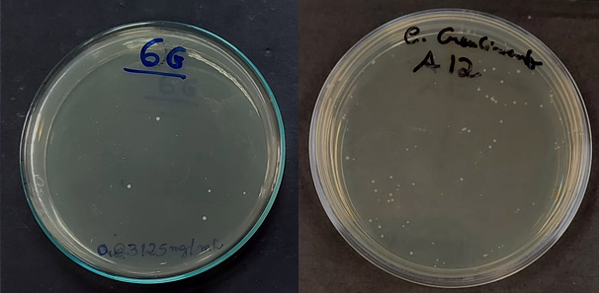

Fig. S4. Infrared spectrum for 5-(1-phenyl-1H-pyrazol-4-ylmethylene)-2-thioxo-dihydro-pyrimidine-4,6-dione LQFM231 (2) in KBr.

LQFM231
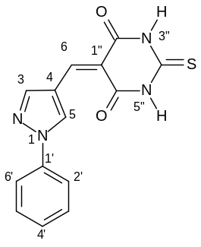
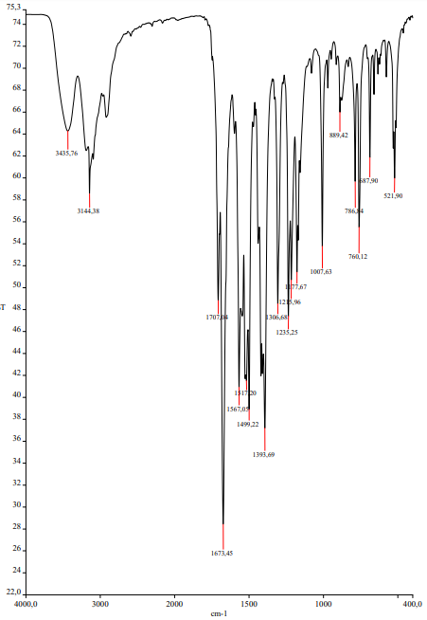

Fig. S5. ¹H NMR spectrum for 5-(1-phenyl-1H-pyrazol-4-ylmethylene)-2-thioxo-dihydro-pyrimidine-4,6-dione – LQFM231 (2) in DMSO-d₆.

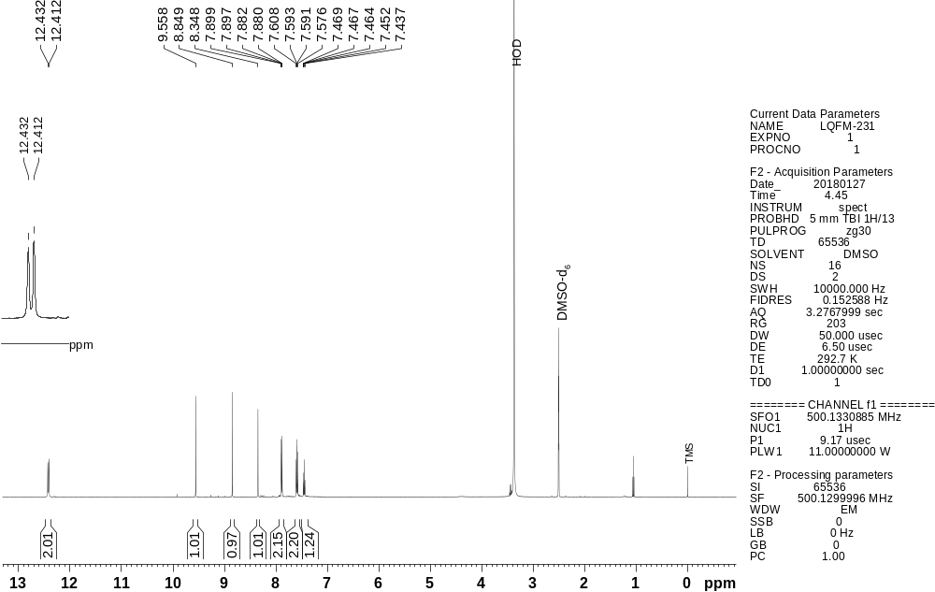

Fig. S6. ¹H ¹³C HSQC NMR contour map for 5-(1-phenyl-1H-pyrazol-4-ylmethylene)-2-thioxo-dihydro-pyrimidine-4,6-dione – LQFM231 (2) in DMSO-d₆.

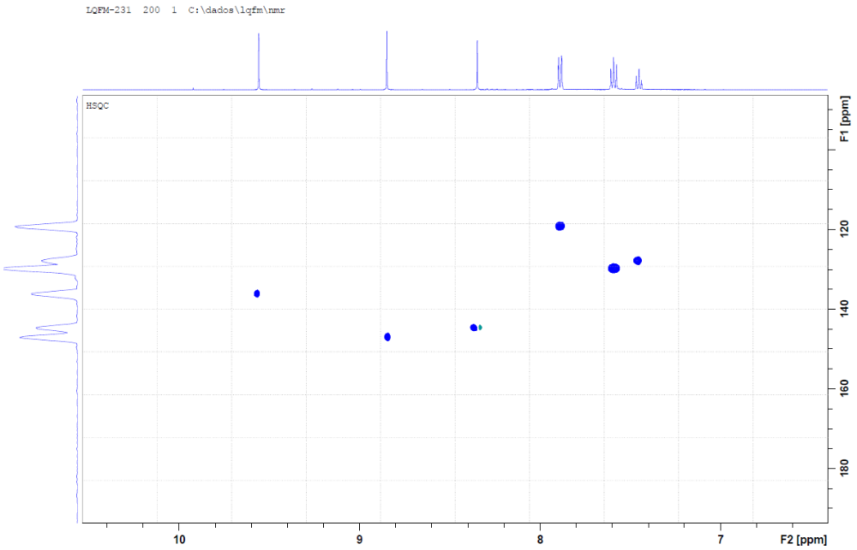

Figure S7. ¹H ¹³C HMBC NMR contour map for 5-(1-phenyl-1H-pyrazol-4-ylmethylene)-2-thioxo-dihydro-pyrimidine-4,6-dione – LQFM231 (2) in DMSO-d₆.

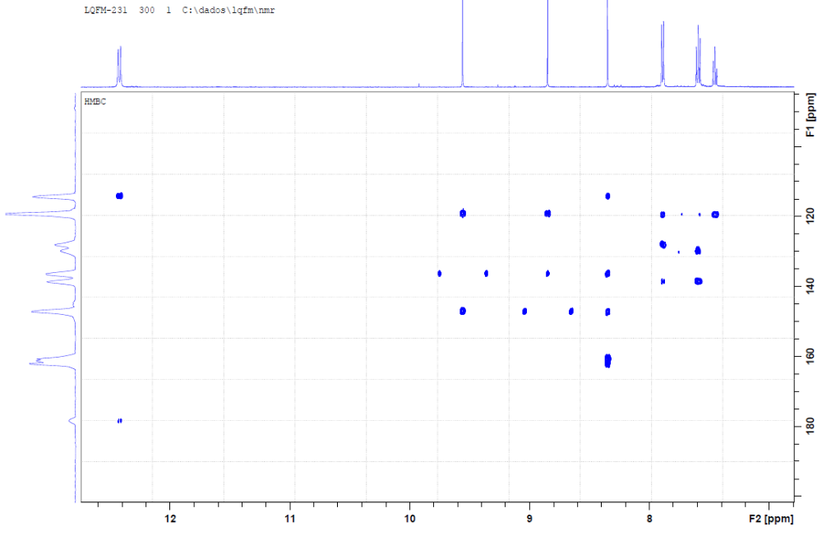

Fig. S8. Mass spectrum obtained for 5-(1-phenyl-1H-pyrazol-4-ylmethylene)-2-thioxo-dihydro-pyrimidine-4,6-dione – LQFM231 (2).

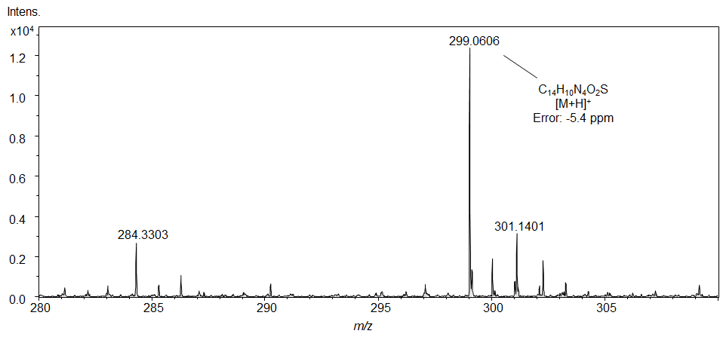

Fig. S9. Infrared spectrum for 5-((1-(4-fluorophenyl)-1H-pyrazol-4-yl)methylene)-2-thioxo-dihydropyrimidine-4,6(1H,5H)-dione - LQFM232 (3) in KBr.

LQFM232
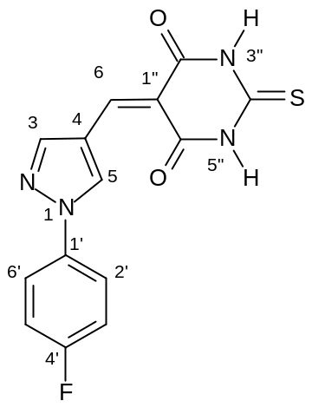
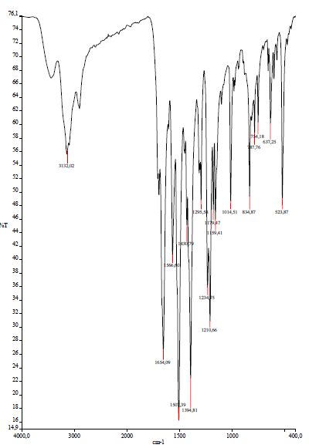

Fig. S10. ¹H NMR spectrum for 5-((1-(4-fluorophenyl)-1H-pyrazol-4-yl)methylene)-2-thioxo-dihydropyrimidine-4,6(1H,5H)-dione - LQFM232 (3) in DMSO-d₆.

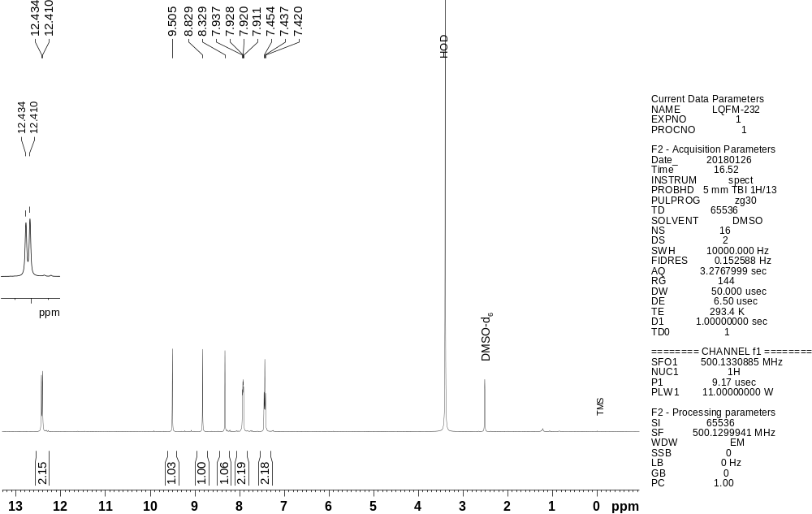

Fig. S11. ¹H ¹³C HSQC NMR contour map for 5-((1-(4-fluorophenyl)-1H-pyrazol-4-yl)methylene)-2-thioxo-dihydropyrimidine-4,6(1H,5H)-dione – LQFM232 (3) in DMSO-d₆.

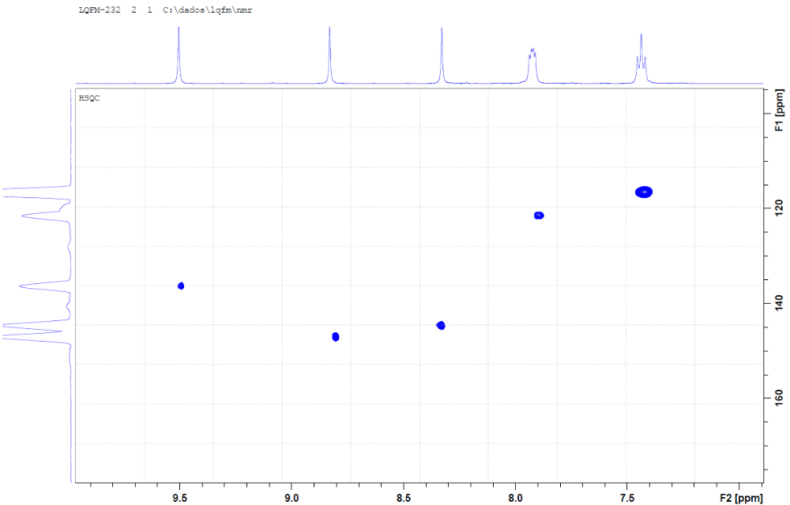

Fig. S12. ¹H ¹³C HMBC NMR contour map for 5-((1-(4-fluorophenyl)-1H-pyrazol-4-yl)methylene)-2-thioxo-dihydropyrimidine-4,6(1H,5H)-dione – LQFM232 (3) in DMSO-d₆.

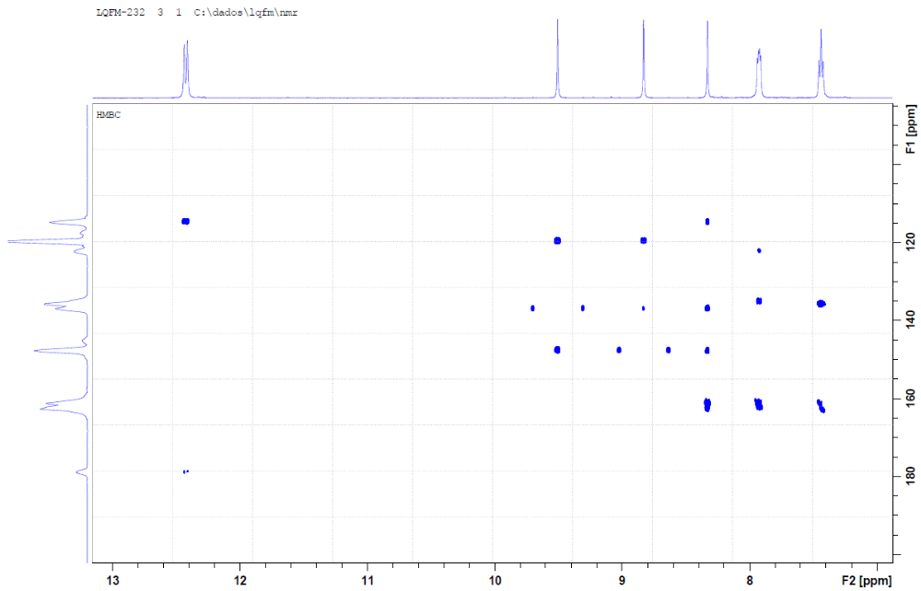

Fig. S13. Mass spectrum obtained for 5-((1-(4-fluorophenyl)-1H-pyrazol-4-yl)methylene)-2-thioxo-dihydropyrimidine-4,6(1H,5H)-dione - LQFM232 (3).
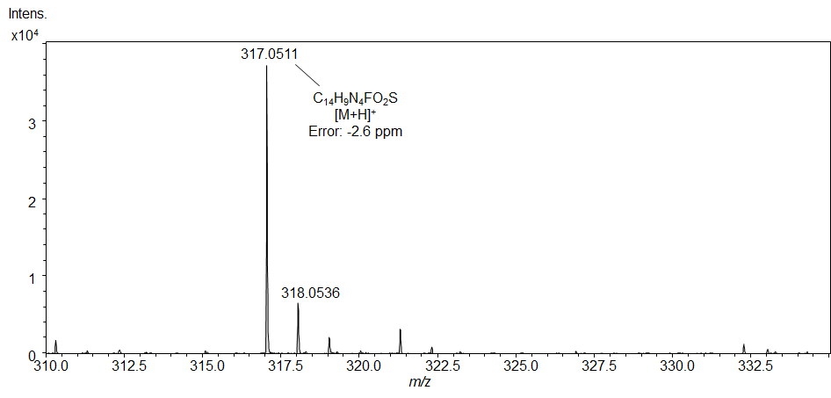

Fig. S14. Infrared spectrum for 5-((1-(2-fluorophenyl)-1H-pyrazol-4-yl)methylene)-2-thioxo-dihydropyrimidine-4,6(1H,5H)-dione - LQFM233 (4) in KBr.

LQFM233

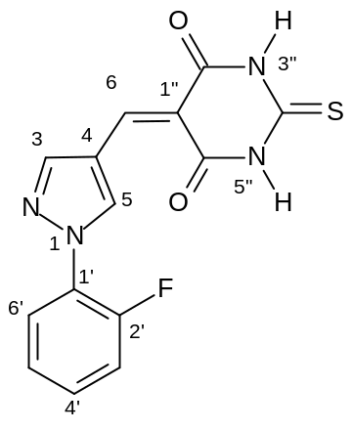
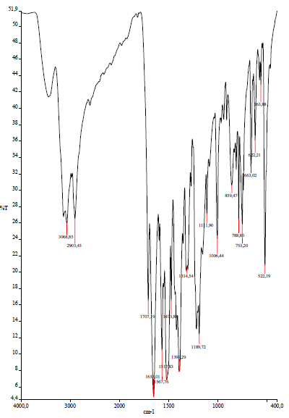

Fig. S15. ¹H NMR spectrum for 5-((1-(2-fluorophenyl)-1H-pyrazol-4-yl)methylene)-2-thioxo-dihydropyrimidine-4,6(1H,5H)-dione - LQFM233 (4) in DMSO-d₆.

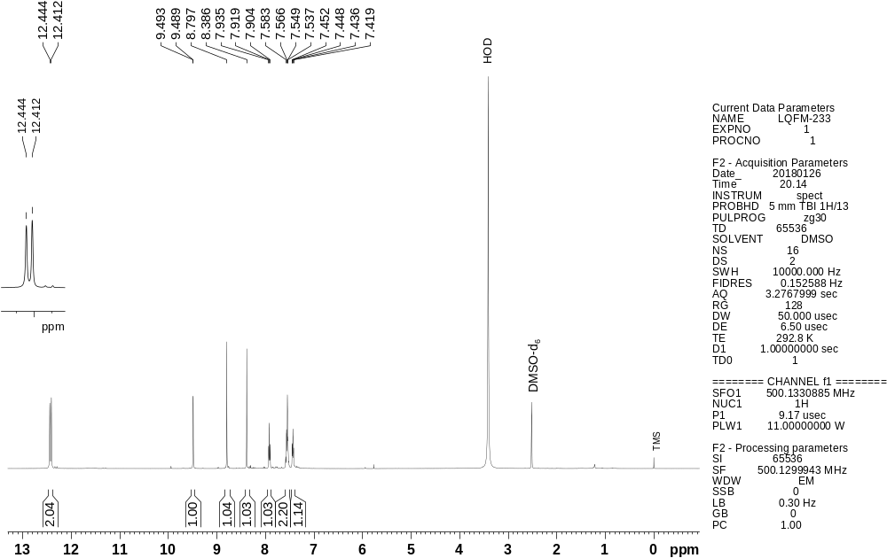

Fig. S16. ¹H ¹³C HSQC NMR contour map for 5-((1-(2-fluorophenyl)-1H-pyrazol-4-yl)methylene)-2-thioxo-dihydropyrimidine-4,6(1H,5H)-dione - LQFM233 (4) in DMSO-d₆.

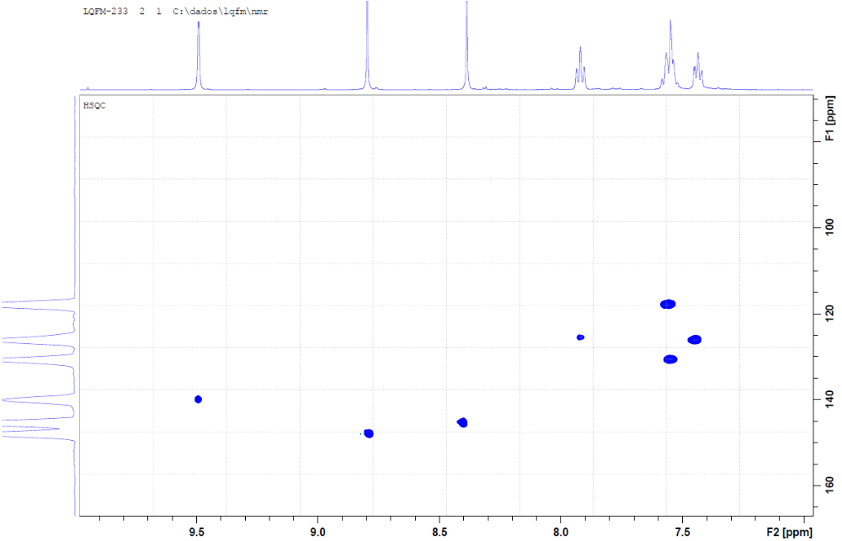

Fig. S17. ¹H ¹³C HMBC NMR contour map for 5-((1-(2-fluorophenyl)-1H-pyrazol-4-yl)methylene)-2-thioxo-dihydropyrimidine-4,6(1H,5H)-dione - LQFM233 (4) in DMSO-d₆.

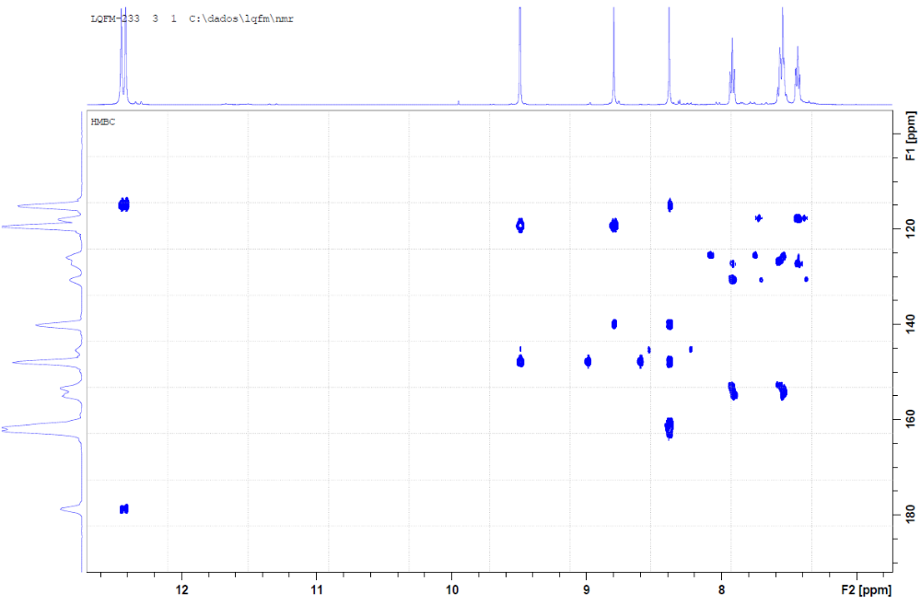

Fig. S18. Mass spectrum obtained for 5-((1-(2-fluorophenyl)-1H-pyrazol-4-yl)methylene)-2-thioxo-dihydropyrimidine-4,6(1H,5H)-dione - LQFM233 (4).

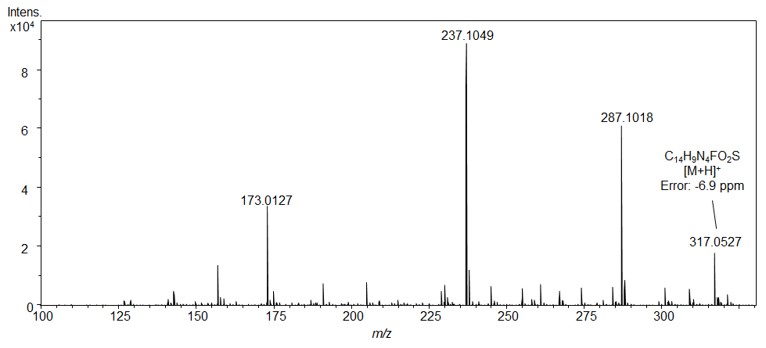

Fig. S19. Infrared spectrum for 5-((1-(4-chlorophenyl)-1H-pyrazol-4-yl)methylene)-2-thioxo-dihydropyrimidine-4,6(1H,5H)-dione - LQFM234 (5) in KBr.

LQFM234

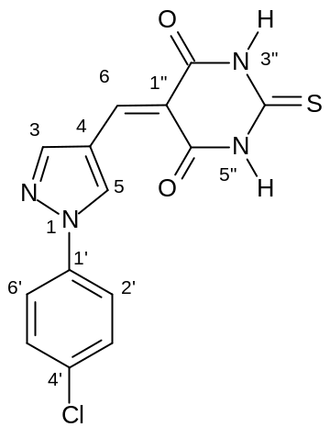
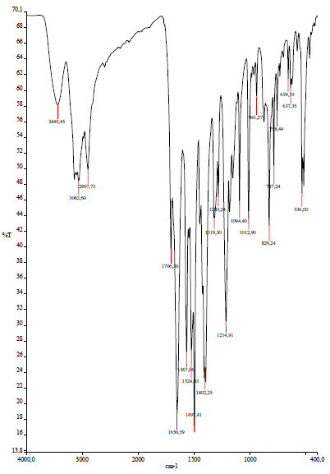

Figure S20. ¹H NMR spectrum for 5-((1-(4-chlorophenyl)-1H-pyrazol-4-yl)methylene)-2-thioxo-dihydropyrimidine-4,6(1H,5H)-dione - LQFM234 (5) in DMSO-d₆.

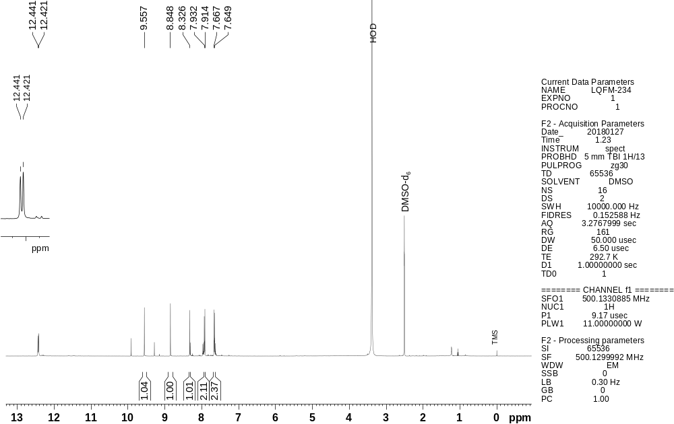

Fig. S21. ¹H ¹³C HSQC NMR contour map for 5-((1-(4-chlorophenyl)-1H-pyrazol-4-yl)methylene)-2-thioxo-dihydropyrimidine-4,6(1H,5H)-dione – LQFM234 (5) in DMSO-d₆.

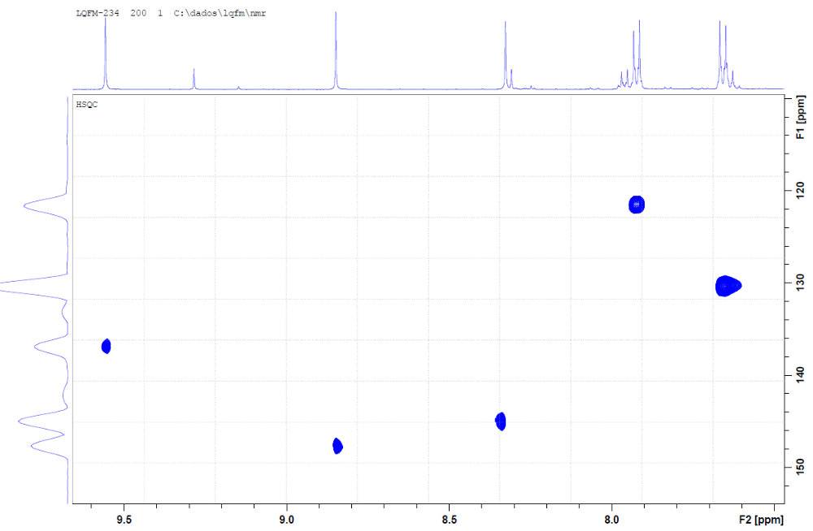

Figure S22. ¹H ¹³C HMBC NMR contour map for 5-((1-(4-chlorophenyl)-1H-pyrazol-4-yl)methylene)-2-thioxo-dihydropyrimidine-4,6(1H,5H)-dione – LQFM234 (5) in DMSO-d₆.

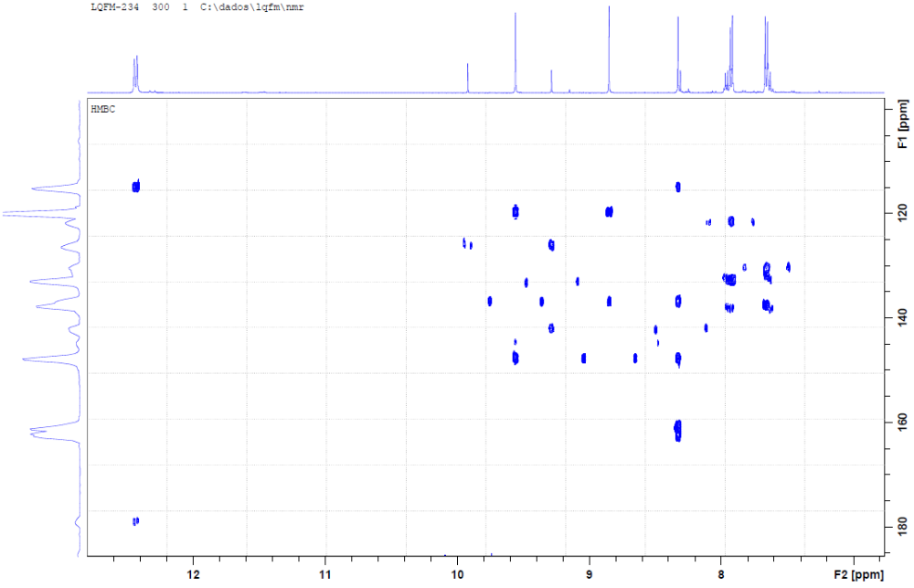

Fig. S23. Mass spectrum obtained for 5-((1-(4-chlorophenyl)-1H-pyrazol-4-yl)methylene)-2-thioxo-dihydropyrimidine-4,6(1H,5H)-dione – LQFM234 (5).

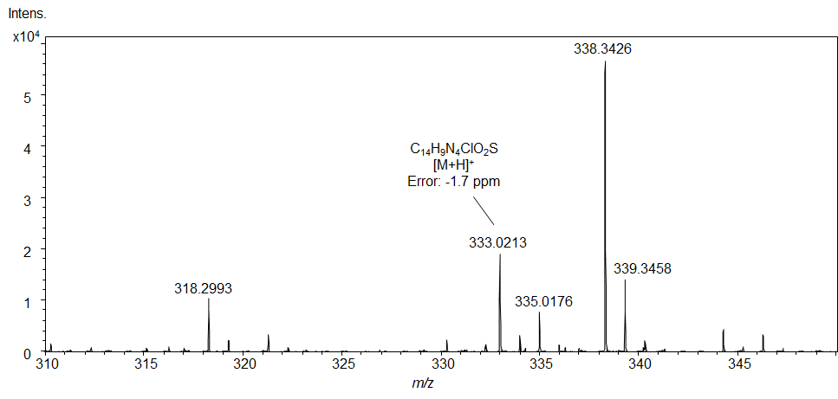

Fig. S24. Infrared spectrum for 5-((1-(2-chlorophenyl)-1H-pyrazol-4-yl)methylene)-2-thioxo-dihydropyrimidine-4,6(1H,5H)-dione - LQFM237 in KBr (6).

LQFM237

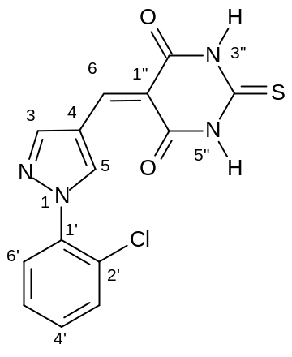
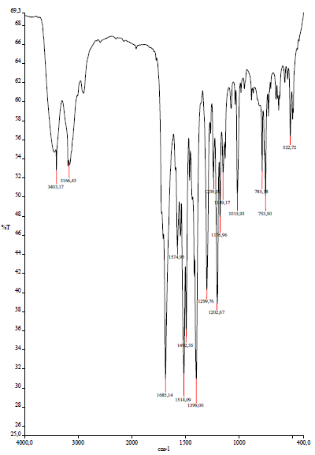

Fig. S25. ¹H NMR spectrum for 5-((1-(2-chlorophenyl)-1H-pyrazol-4-yl)methylene)-2-thioxo-dihydropyrimidine-4,6(1H,5H)-dione - LQFM237 (6) in DMSO-d₆.

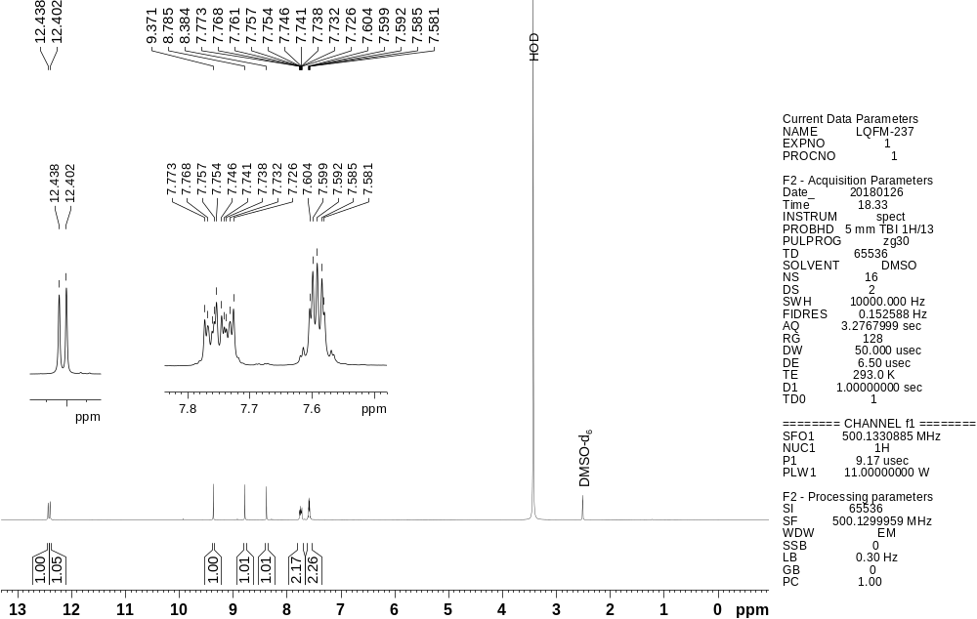

Figure S26. ¹H ¹³C HSQC NMR contour map for 5-((1-(2-chlorophenyl)-1H-pyrazol-4-yl)methylene)-2-thioxo-dihydropyrimidine-4,6(1H,5H)-dione – LQFM237 (6) in DMSO-d₆.

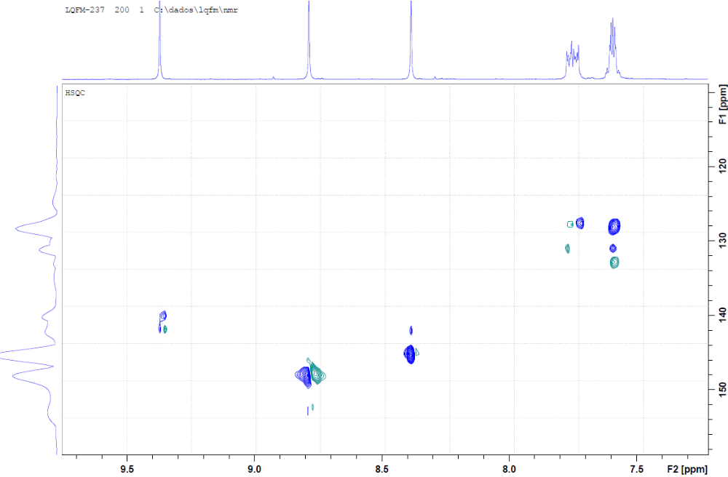

Figure S27. ¹H ¹³C HMBC NMR contour map for 5-((1-(2-chlorophenyl)-1H-pyrazol-4-yl)methylene)-2-thioxo-dihydropyrimidine-4,6(1H,5H)-dione – LQFM237 (6) in DMSO-d₆.

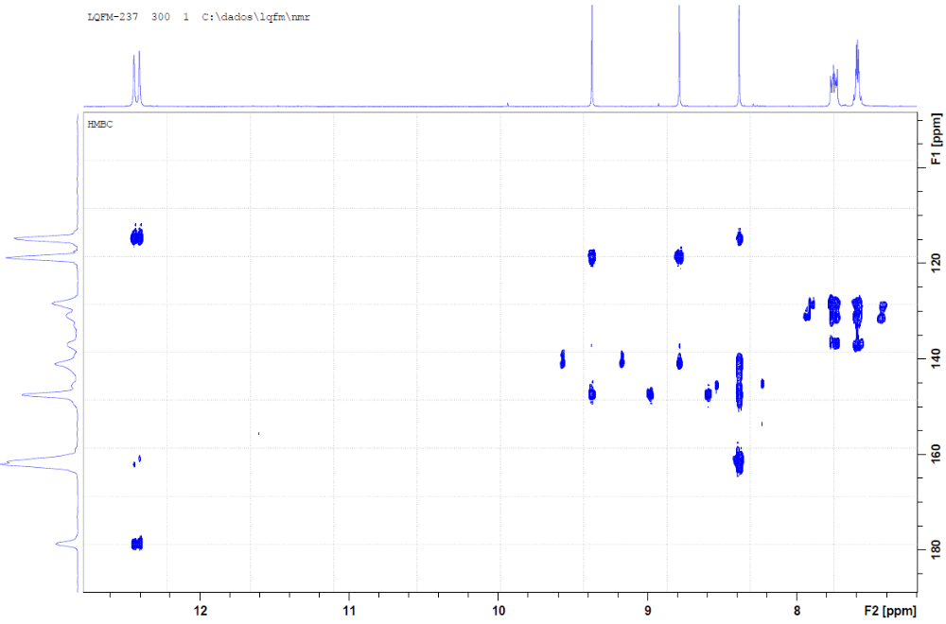

Fig. S28. Mass spectrum obtained for 5-((1-(2-chlorophenyl)-1H-pyrazol-4-yl)methylene)-2-thioxo-dihydropyrimidine-4,6(1H,5H)-dione – LQFM237 (6).

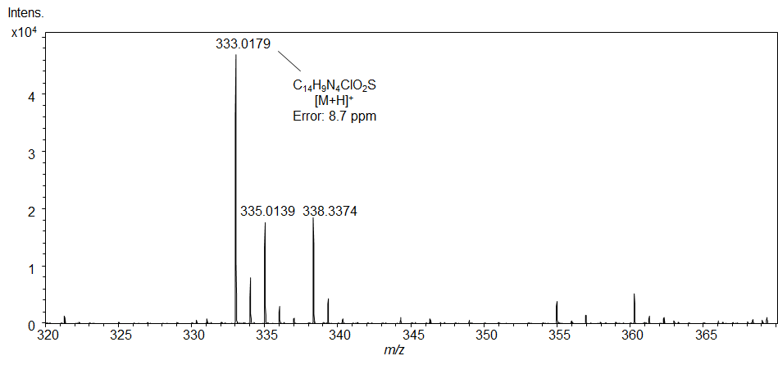

Fig. S29. Infrared spectrum for 5-((1-(3-chlorophenyl)-1H-pyrazol-4-yl)methylene)-2-thioxo-dihydropyrimidine-4,6(1H,5H)-dione - LQFM238 (7) in KBr.

LQFM238

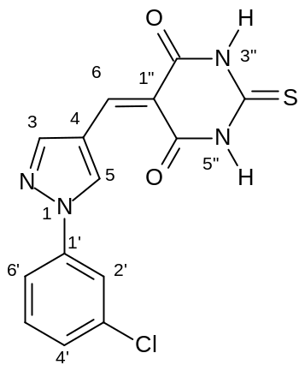

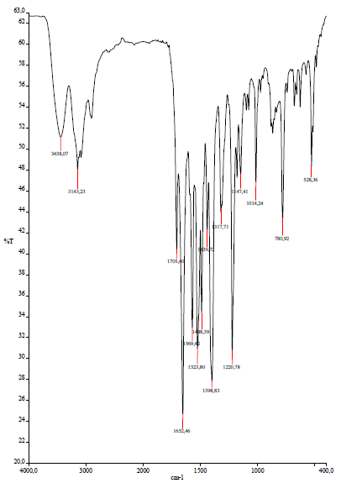

Fig. S30. ¹H NMR spectrum for 5-((1-(3-chlorophenyl)-1H-pyrazol-4-yl)methylene)-2-thioxo-dihydropyrimidine-4,6(1H,5H)-dione – LQFM238 (7) in DMSO-d₆.

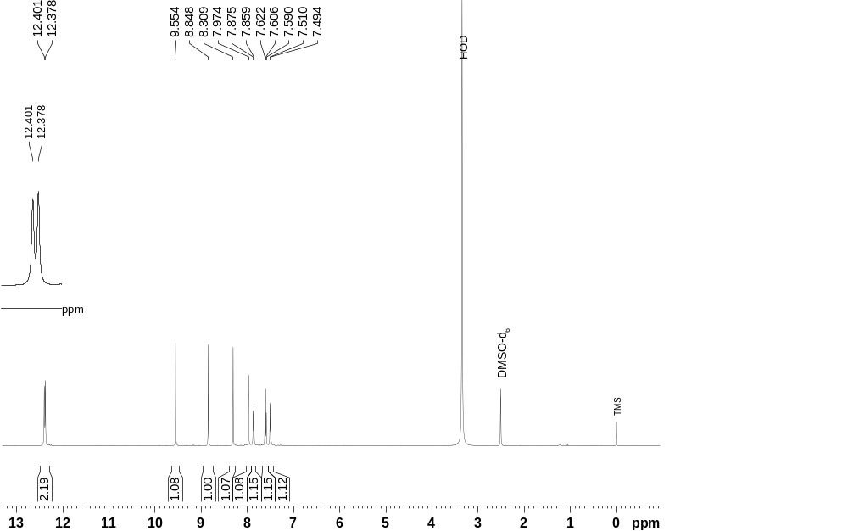

Fig. S31. ¹H ¹³C HSQC NMR contour map for 5-((1-(3-chlorophenyl)-1H-pyrazol-4-yl)methylene)-2-thioxo-dihydropyrimidine-4,6(1H,5H)-dione – LQFM238 (7) in DMSO-d₆.

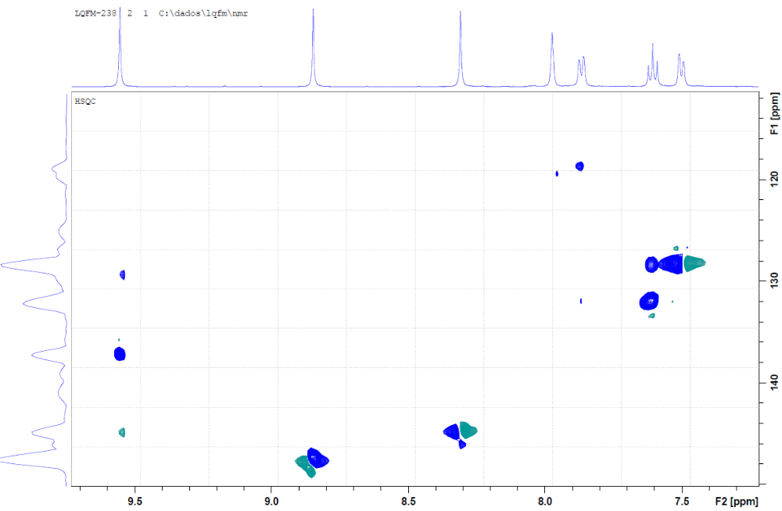

Fig. S32. ¹H ¹³C HMBC NMR contour map for 5-((1-(3-chlorophenyl)-1H-pyrazol-4-yl)methylene)-2-thioxo-dihydropyrimidine-4,6(1H,5H)-dione – LQFM238 (7) in DMSO-d₆.

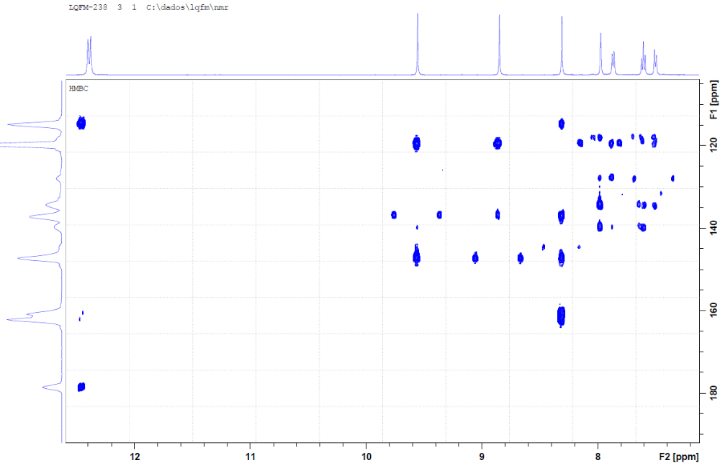

Fig. S33. Mass spectrum obtained for 5-((1-(3-chlorophenyl)-1H-pyrazol-4-yl)methylene)-2-thioxo-dihydropyrimidine-4,6(1H,5H)-dione – LQFM238 (7).

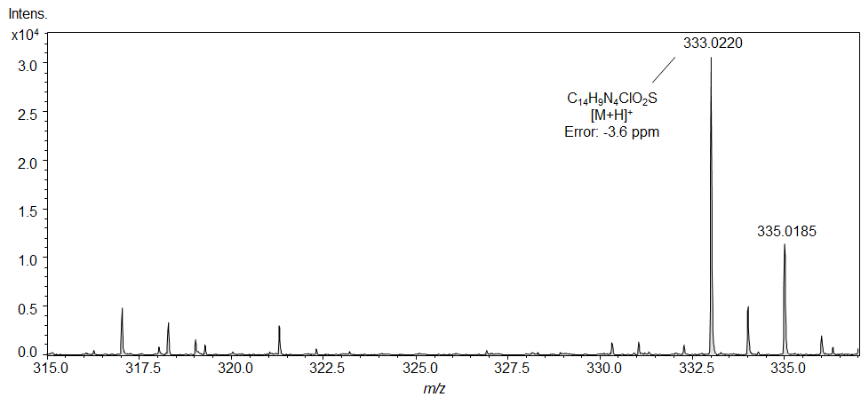

Fig. S34. Infrared spectrum for 5-((1-(2-bromophenyl)-1H-pyrazol-4-yl)methylene)-2-thioxo-dihydropyrimidine-4,6(1H,5H)-dione - LQFM239 (8) in KBr.

LQFM239

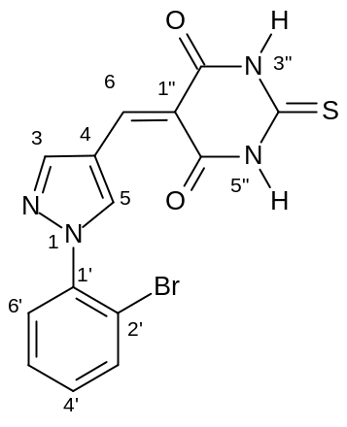
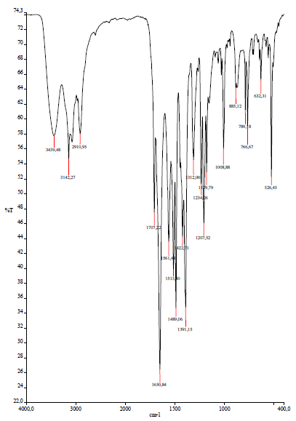

Fig. S35. ¹H NMR spectrum for 5-((1-(2-bromophenyl)-1H-pyrazol-4-yl)methylene)-2-thioxo-dihydropyrimidine-4,6(1H,5H)-dione – LQFM239 (8) in DMSO-d₆.

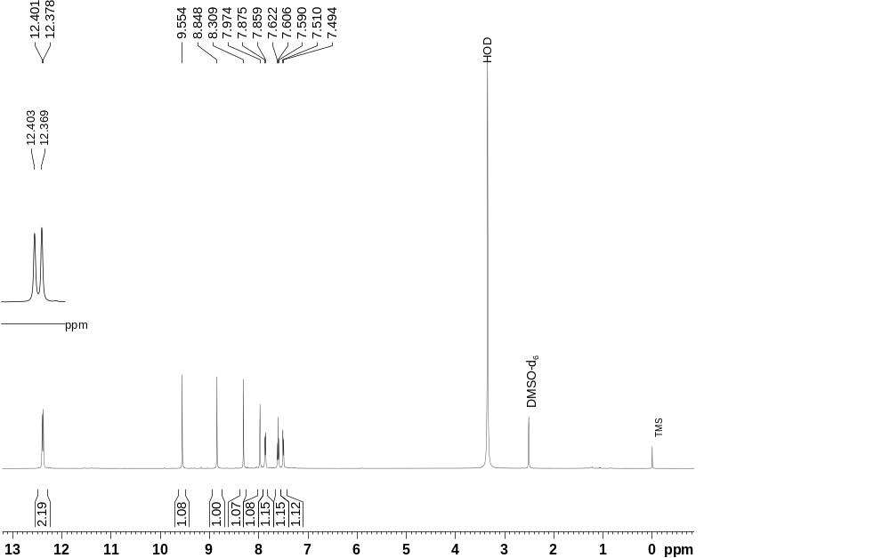

Fig. S36. ¹H ¹³C HSQC NMR contour map for 5-((1-(2-bromophenyl)-1H-pyrazol-4-yl)methylene)-2-thioxo-dihydropyrimidine-4,6(1H,5H)-dione – LQFM239 (8) in DMSO-d₆.

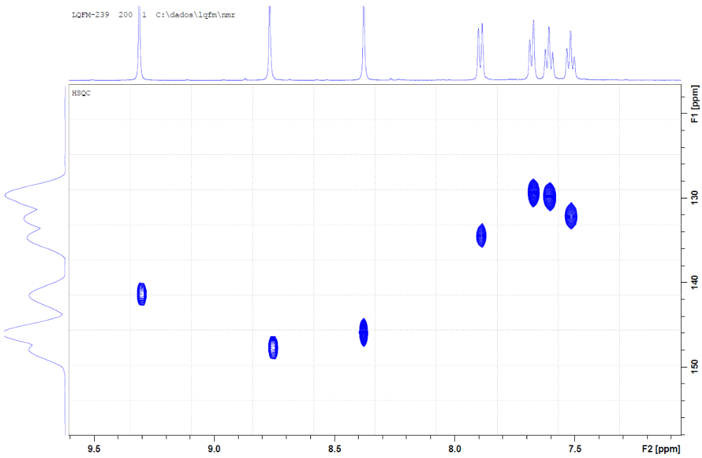

Fig. S37. ¹H ¹³C HMBC NMR contour map for 5-((1-(2-bromophenyl)-1H-pyrazol-4-yl)methylene)-2-thioxo-dihydropyrimidine-4,6(1H,5H)-dione – LQFM239 (8) in DMSO-d₆.

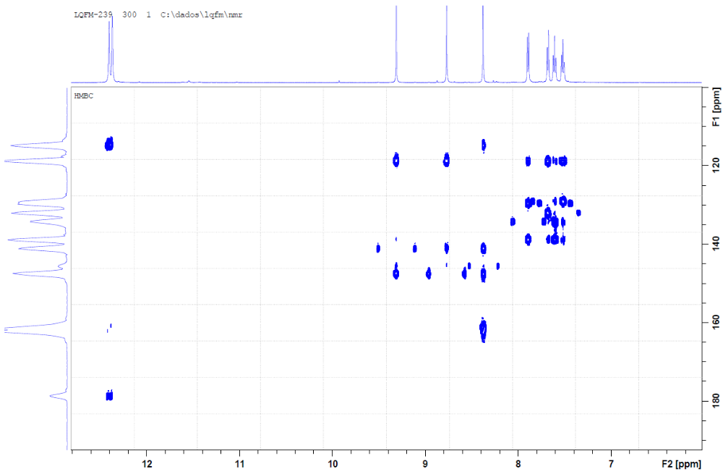

Fig. S38. Mass spectrum obtained for 5-((1-(2-bromophenyl)-1H-pyrazol-4-yl)methylene)-2-thioxo-dihydropyrimidine-4,6(1H,5H)-dione – LQFM239 (8).

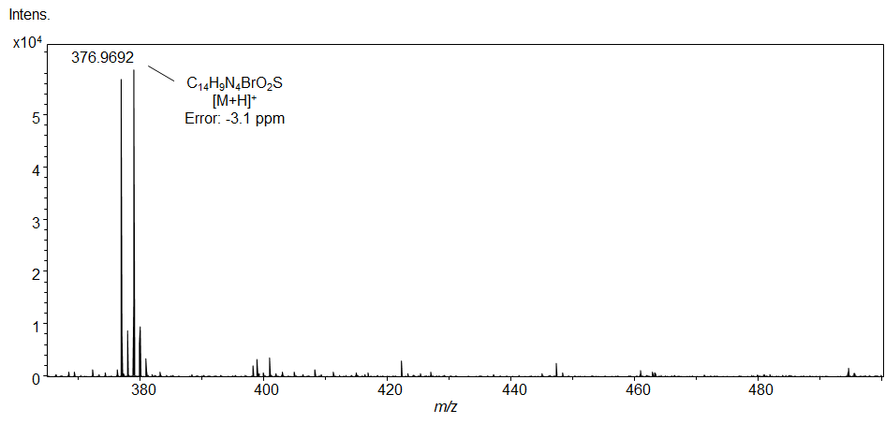

Fig. S39. Infrared spectrum for 5-((1-(3-fluorophenyl)-1H-pyrazol-4-yl)methylene)-2-thioxo-dihydropyrimidine-4,6(1H,5H)-dione - LQFM240 (9) in KBr.

LQFM240

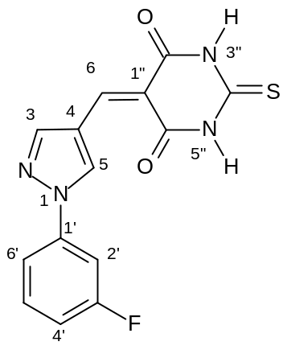
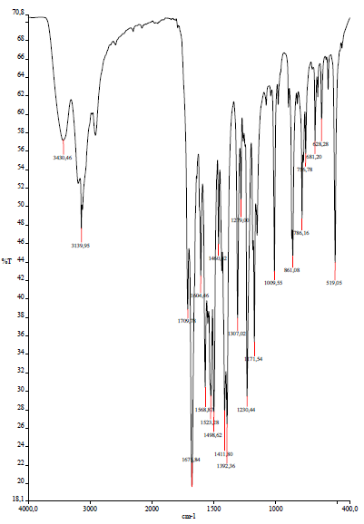

Fig. S40. ¹H NMR spectrum for 5-((1-(3-fluorophenyl)-1H-pyrazol-4-yl)methylene)-2-thioxo-dihydropyrimidine-4,6(1H,5H)-dione – LQFM240 (9) in DMSO-d₆.

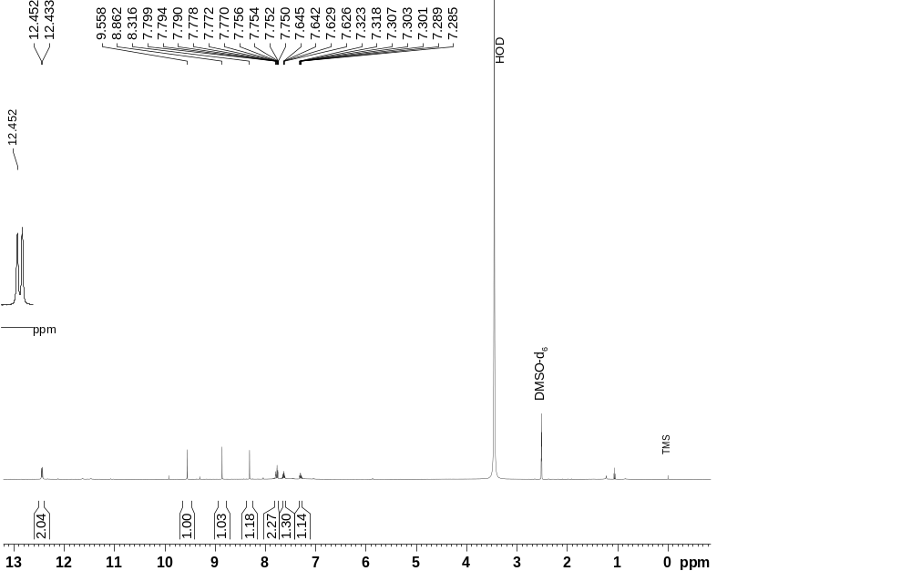

Fig. S41. ¹H ¹³C HSQC NMR contour map for 5-((1-(3-fluorophenyl)-1H-pyrazol-4-yl)methylene)-2-thioxo-dihydropyrimidine-4,6(1H,5H)-dione – LQFM240 (9) in DMSO-d₆.

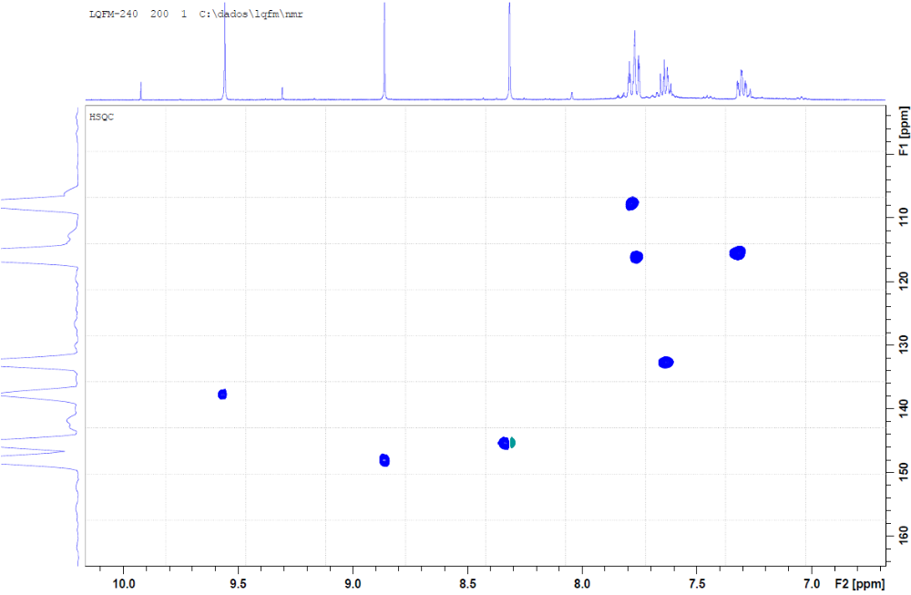

Fig. S42. ¹H ¹³C HMBC NMR contour map for 5-((1-(3-fluorophenyl)-1H-pyrazol-4-yl)methylene)-2-thioxo-dihydropyrimidine-4,6(1H,5H)-dione – LQFM240 (9) in DMSO-d₆.

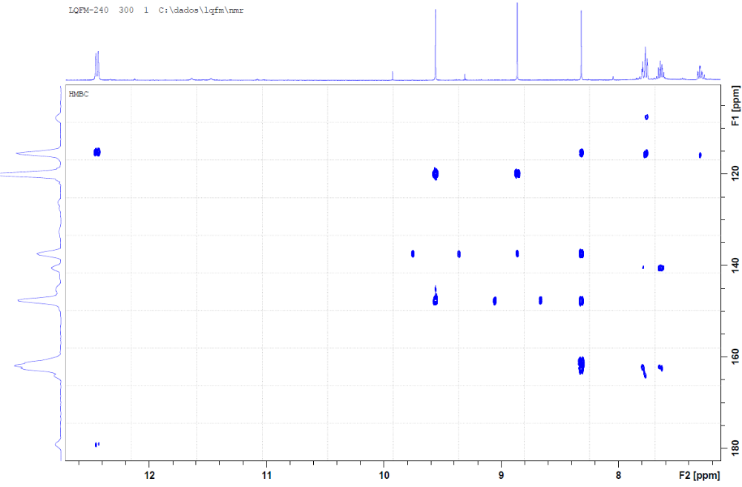

Fig. S43. Mass spectrum obtained for 5-((1-(3-fluorophenyl)-1H-pyrazol-4-yl)methylene)-2-thioxo-dihydropyrimidine-4,6(1H,5H)-dione – LQFM240 (9).

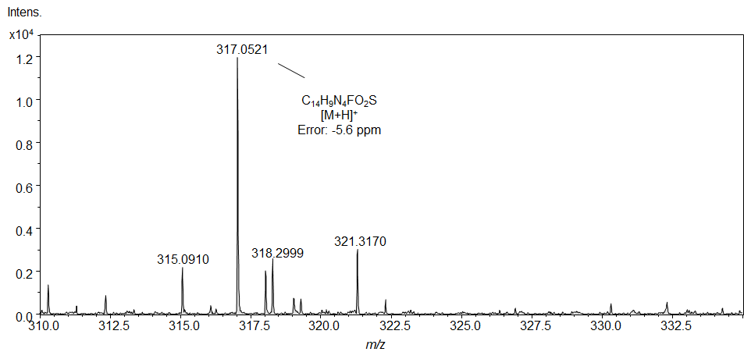

Fig. S44. Infrared spectrum for 5-((1-(3-bromophenyl)-1H-pyrazol-4-yl)methylene)-2-thioxo-dihydropyrimidine-4,6(1H,5H)-dione - LQFM281 (10) in KBr.
LQFM281

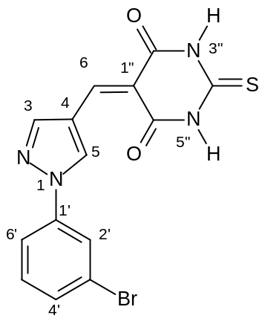
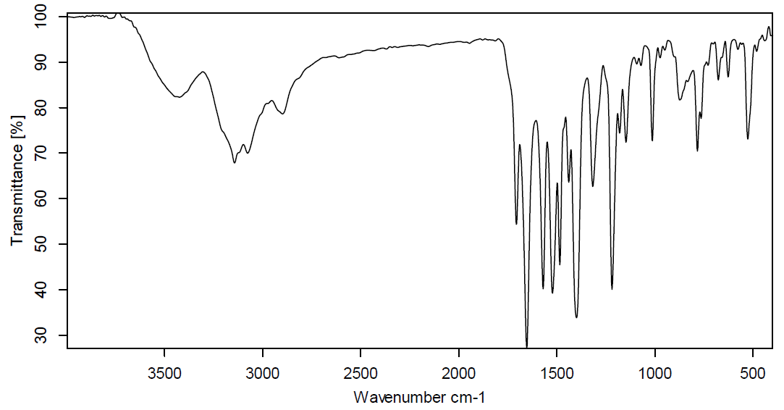

Fig. S45. ¹H NMR spectrum for 5-((1-(3-bromophenyl)-1H-pyrazol-4-yl)methylene)-2-thioxo-dihydropyrimidine-4,6(1H,5H)-dione – LQFM281 (10) in DMSO-d₆.

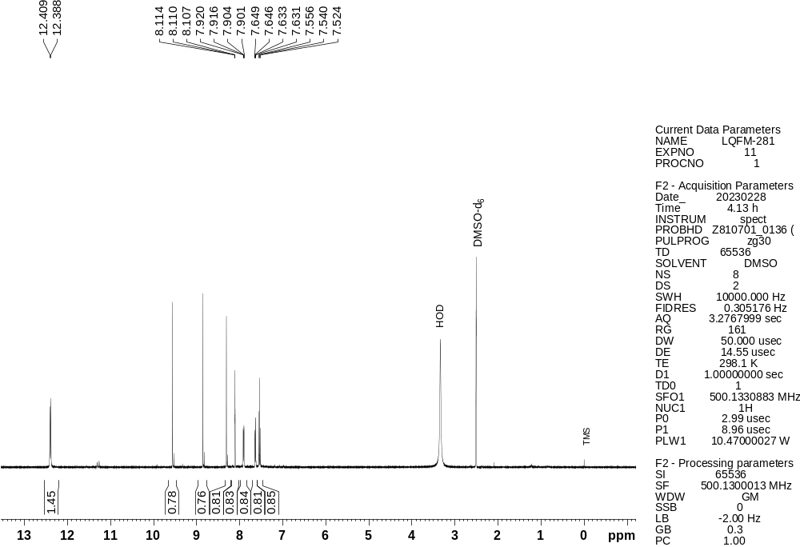

Fig. S46. ¹³C NMR spectrum for 5-((1-(3-bromophenyl)-1H-pyrazol-4-yl)methylene)-2-thioxo-dihydropyrimidine-4,6(1H,5H)-dione – LQFM281 (10) in DMSO-d₆.

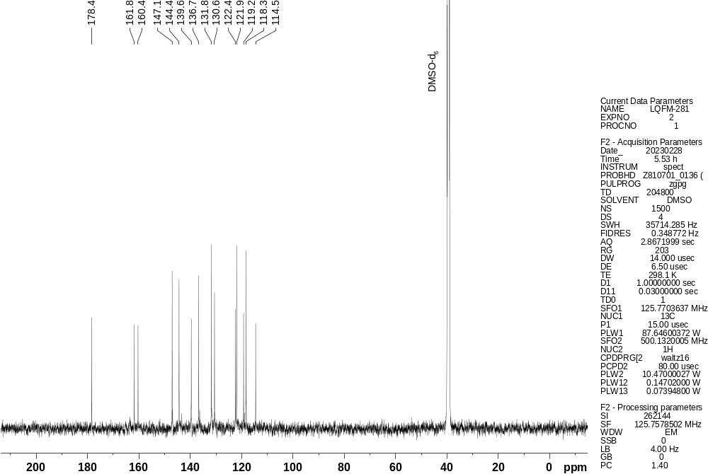

Fig. S47. ¹H ¹³C HSQC NMR contour map for 5-((1-(3-bromophenyl)-1H-pyrazol-4-yl)methylene)-2-thioxo-dihydropyrimidine-4,6(1H,5H)-dione – LQFM281 (10) in DMSO-d₆.

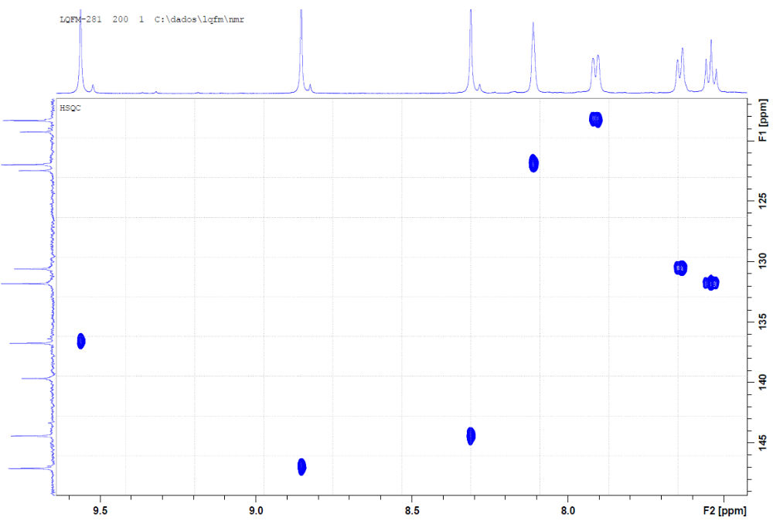

Fig. S48. ¹H ¹³C HMBC NMR contour map for 5-((1-(3-bromophenyl)-1H-pyrazol-4-yl)methylene)-2-thioxo-dihydropyrimidine-4,6(1H,5H)-dione – LQFM281 (10) in DMSO-d₆.

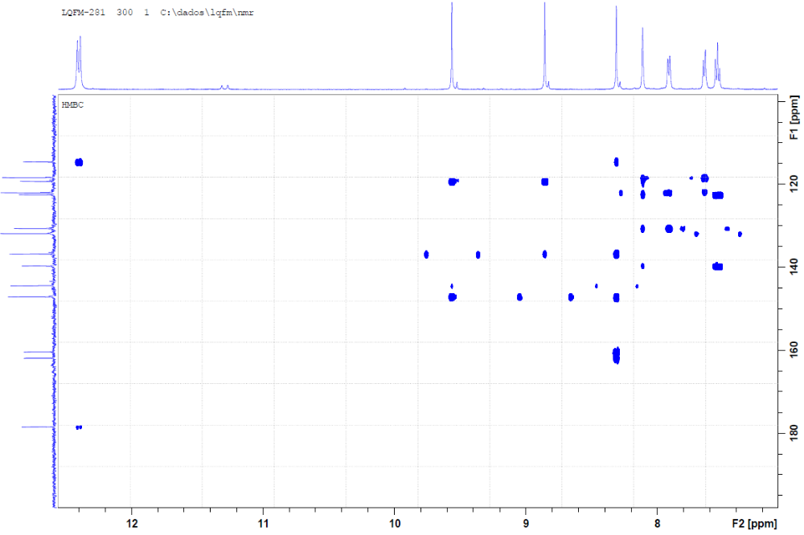

Fig. S49. Mass spectrum obtained for 5-((1-(3-bromophenyl)-1H-pyrazol-4-yl)methylene)-2-thioxo-dihydropyrimidine-4,6(1H,5H)-dione – LQFM281 (10).

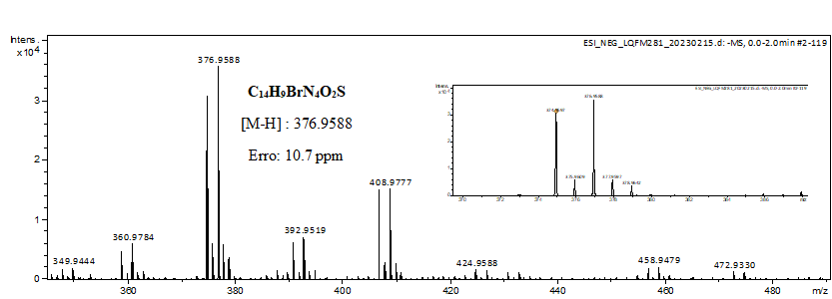

Fig. S50. Infrared spectrum for 5-((1-(4-bromophenyl)-1H-pyrazol-4-yl)methylene)-2-thioxo-dihydropyrimidine-4,6(1H,5H)-dione - LQFM282 (11) in KBr.

LQFM282

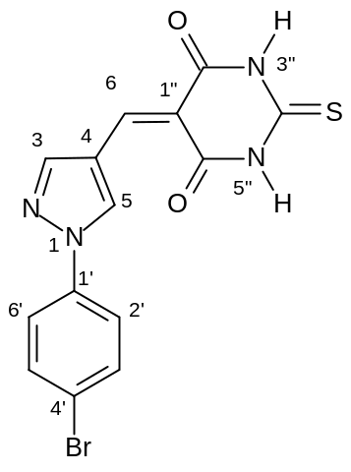
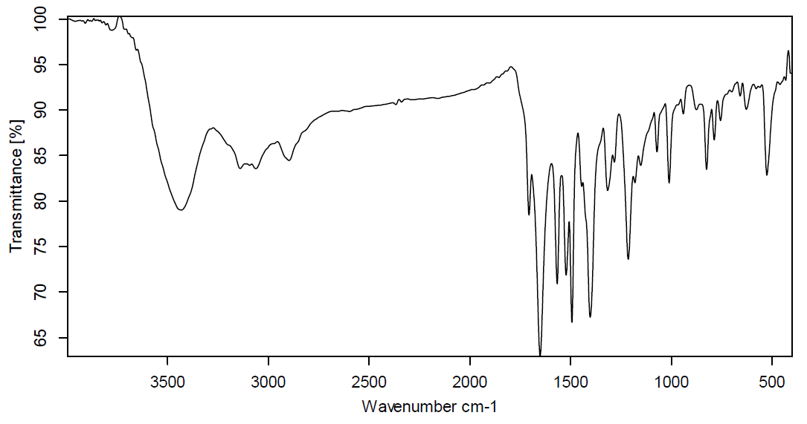

Figure S51. ¹H NMR spectrum for 5-((1-(4-bromophenyl)-1H-pyrazol-4-yl)methylene)-2-thioxo-dihydropyrimidine-4,6(1H,5H)-dione – LQFM282 (11) in DMSO-d₆.

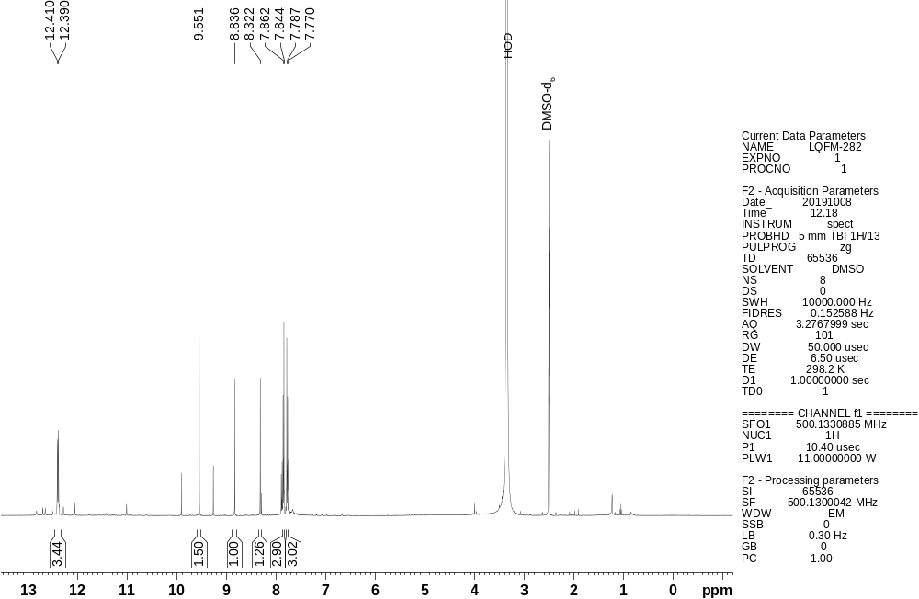

Fig. S52. ¹H ¹³C HSQC NMR contour map for 5-((1-(4-bromophenyl)-1H-pyrazol-4-yl)methylene)-2-thioxo-dihydropyrimidine-4,6(1H,5H)-dione – LQFM282 (11) in DMSO-d₆.

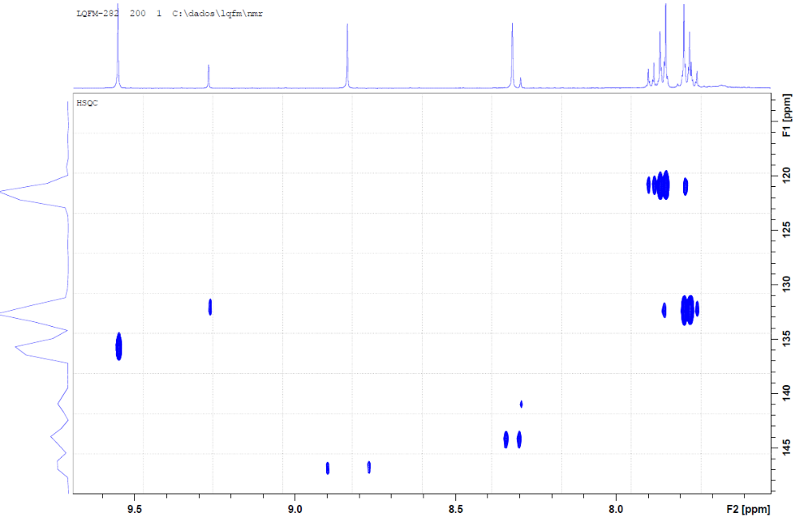

Fig. S53. ¹H ¹³C HMBC NMR contour map for 5-((1-(4-bromophenyl)-1H-pyrazol-4-yl)methylene)-2-thioxo-dihydropyrimidine-4,6(1H,5H)-dione – LQFM282 (11) in DMSO-d₆.

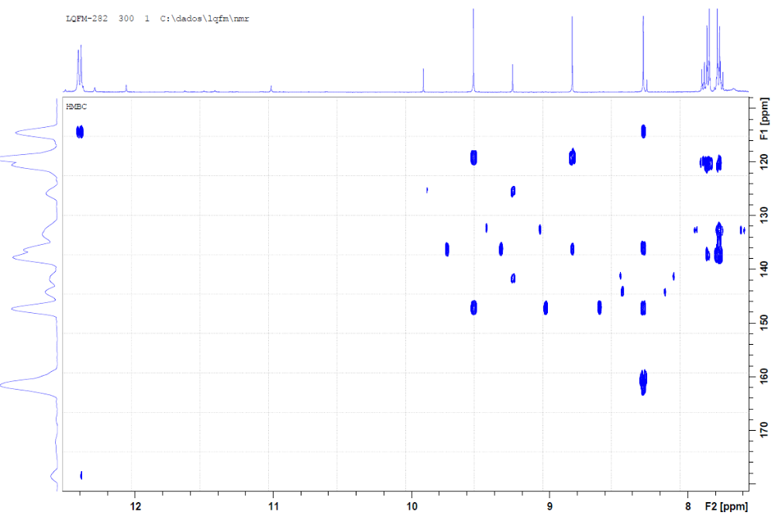

Fig. S54. Mass spectrum obtained for 5-((1-(4-bromophenyl)-1H-pyrazol-4-yl)methylene)-2-thioxo-dihydropyrimidine-4,6(1H,5H)-dione – LQFM282 (11).

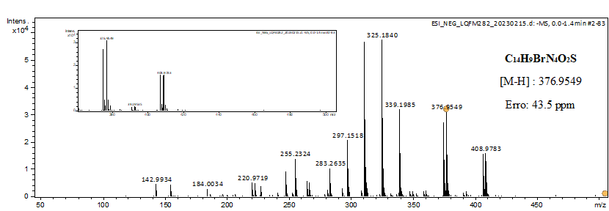

Table S1. ¹H and ¹³C NMR spectral data for 5-(1-phenyl-1H-pyrazol-4-ylmethylene)-2-thioxo-dihydro-pyrimidine-4,6-dione – LQFM231 (2) in DMSO-d₆.
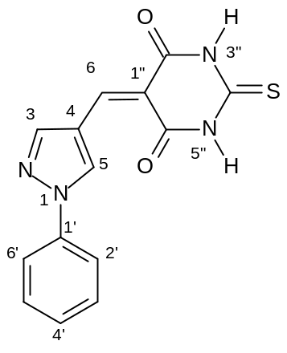
 | δ ¹H (multiplicity, J Hz) | δ ¹³C
3 | 8.85 (s) | 146.9
4 | - | 119.0
5 | 9.56 (s) | 136.0
6 | 8.35 (s) | 144.6
1’ | - | 138.5
2’, 6’ | 7.89 (ddd, 8.6; 1.2; 2.1) | 119.2
3’, 5’ | 7.59 (ddd, 8.6; 7.4; 2.1) | 129.7
4’ | 7.45 (tt, 7.4; 1.2) | 127.8
1” | - | 114.1
2”, 6” | - | 160.7; 161.9
4” | - | 178.4
NH | 12.43 (s); 12.41 (s) | -
¹H and ¹³C NMR assignments are based on ¹H and ¹H–¹³C HSQC/HMBC spectra. Measured in DMSO-d₆ at 500 MHz and 125 MHz. Multiplicities: ddd (doublet of doublet of doublet), s (singlet), tt (triplet of triplet).

Table S2. ¹H and ¹³C NMR spectral data for 5-((1-(4-fluorophenyl)-1H-pyrazol-4-yl)methylene)-2-thioxo-dihydropyrimidine-4,6(1H,5H)-dione – LQFM232 (3) in DMSO-d₆.

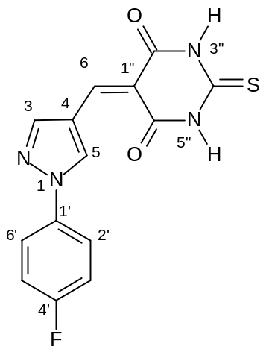
 | δ ¹H (multiplicity, J Hz) | δ ¹³C
3 | 8.83 (s) | 147.0
4 | - | 119.4
5 | 9.50 (s) | 136.3
6 | 8.33 (s) | 144.6
1’ | - | 135.6
2’, 6’ | 7.92 (dd, 8.6; 4.7) | 121.4
3’, 5’ | 7.44 (brt, 8.6) | 116.5
4’ | - | 161.7
1” | - | 114.5
2”, 6” | - | 161.1; 162.5
4” | - | 178.7
NH | 12.43 (s); 12.41 (s) | -
¹H and ¹³C NMR assignments are based on ¹H and ¹H–¹³C HSQC/HMBC spectra. Measured in DMSO-d₆ at 500 MHz and 125 MHz. Multiplicities: brt (broad triplet), dd (doublet of doublet), s (singlet).

Table S3. ¹H and ¹³C NMR spectral data for 5-((1-(2-fluorophenyl)-1H-pyrazol-4-yl)methylene)-2-thioxo-dihydropyrimidine-4,6(1H,5H)-dione - LQFM233 (4) in DMSO-d₆.

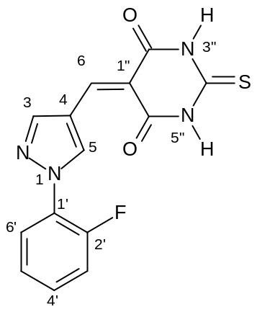
 | δ ¹H (multiplicity, J Hz) | δ ¹³C
3 | 8.80 (s) | 147.9
4 | - | 119.3
5 | 9.49 (d, 2.1) | 139.8
6 | 8.39 (s) | 145.5
1’ | - | 127.3
2’ | - | 153.8
3’ | 7.43 (ddd, 8.4; 5.7; 2.4) | 126.1
4’ | 7.61 – 7.49 (m) | 130.6
5’ | 7.92 (td, 8.1; 1.3) | 125.5
6’ | 7.61 – 7.49 (m) | 117.7
1” | - | 114.9
2”, 6” | - | 161.7; 162.5
4” | - | 178.8
NH | 12.44 (s); 12.41 (s) | -
¹H and ¹³C NMR assignments are based on ¹H and ¹H–¹³C HSQC/HMBC spectra. Measured in DMSO-d₆ at 500 MHz and 125 MHz. Multiplicities: d (doublet), ddd (doublet of doublet of doublet), m (multiplet), s (singlet), td (triplet of doublet).

Table S4. ¹H and ¹³C NMR spectral data for 5-((1-(4-chlorophenyl)-1H-pyrazol-4-yl)methylene)-2-thioxo-dihydropyrimidine-4,6(1H,5H)-dione – LQFM234 (5) in DMSO-d₆.
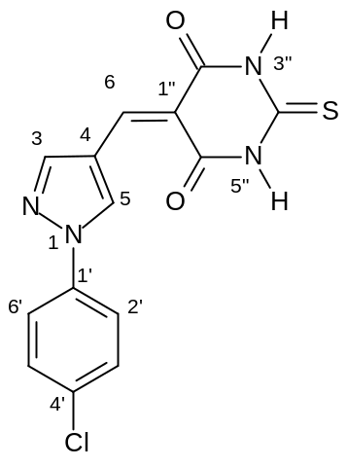
 | δ ¹H (multiplicity, J Hz) | δ ¹³C
3 | 8.85 (s) | 147.7
4 | - | 119.7
5 | 9.56 (s) | 136.9
6 | 8.33 (s) | 145.0
1’ | - | 137.4
2’, 6’ | 7.92 (d_{ab}, 8.9) | 121.5
3’, 5’ | 7.66 (d_{ab}, 8.9) | 130.3
4’ | - | 132.9
1” | - | 114.9
2”, 6” | - | 161.2; 162.2
4” | - | 179.0
NH | 12.44 (s); 12.42 (s) | -
¹H and ¹³C NMR assignments are based on ¹H and ¹H–¹³C HSQC/HMBC spectra. Measured in DMSO-d₆ at 500 MHz and 125 MHz. Multiplicities: d_{ab} (doublet in second-order system), s (singlet).

Table S5. ¹H and ¹³C NMR spectral data for 5-((1-(2-chlorophenyl)-1H-pyrazol-4-yl)methylene)-2-thioxo-dihydropyrimidine-4,6(1H,5H)-dione – LQFM237 (6) in DMSO-d₆.

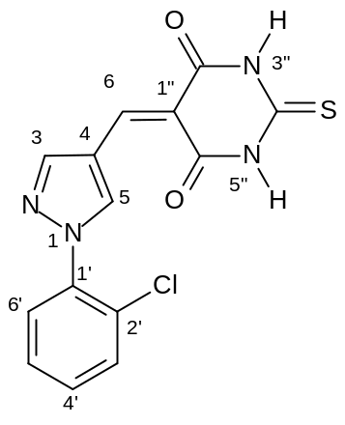
 | δ ¹H (multiplicity, J Hz) | δ ¹³C
3 | 8.79 (s) | 147.3
4 | - | 118.6
5 | 9.37 (s) | 141.1
6 | 8.38 (s) | 145.2
1’ | - | 136.7
2’ | - | 137.1
3’ | 7.75 – 7.71 (m) | 127.6
4’ | 7.59 – 7.55 (m) | 127.6
5’ | 7.63 – 7.59(m) | 131.0
6’ | 7.79 – 7.75 (m) | 130.0
1” | - | 114.6
2”, 6” | - | 160.9; 162.1
4” | - | 178.7
NH | 12.44 (s); 12.40 (s) | -
¹H and ¹³C NMR assignments are based on ¹H and ¹H–¹³C HSQC/HMBC spectra. Measured in DMSO-d₆ at 500 MHz and 125 MHz. Multiplicities: d (doublet), m (multiplet), s (singlet).

Table S6. ¹H and ¹³C NMR spectral data for 5-((1-(3-chlorophenyl)-1H-pyrazol-4-yl)methylene)-2-thioxo-dihydropyrimidine-4,6(1H,5H)-dione – LQFM238 (7) in DMSO-d₆.

 | δ ¹H (multiplicity, J Hz) | δ ¹³C
3 | 8.85 (s) | 147.7
4 | - | 119.6
5 | 9.55 (s) | 137.2
6 | 8.31 (s) | 144.8
1’ | - | 139.9
2’ | 7.97 (t, 2.1) | 119.7
3’ | - | 134.6
4’ | 7.50 (ddd, 8.1; 2.1; 0.8) | 128.4
5’ | 7.61 (t, 8.1) | 134.2
6’ | 7.87 (ddd, 8.1; 2.1; 0.8) | 118.6
1” | - | 114.8
2”, 6” | - | 160.8; 162.3
4” | - | 178.8
NH | 12.40 (s); 12.38 (s) | -
¹H and ¹³C NMR assignments are based on ¹H and ¹H–¹³C HSQC/HMBC spectra. Measured in DMSO-d₆ at 500 MHz and 125 MHz. Multiplicities: d (doublet), ddd (doublet of doublet of doublet), s (singlet), t (triplet).

Table S7. ¹H and ¹³C NMR spectral data for 5-((1-(2-bromophenyl)-1H-pyrazol-4-yl)methylene)-2-thioxo-dihydropyrimidine-4,6(1H,5H)-dione – LQFM239 (8) in DMSO-d₆.

 | δ ¹H (multiplicity, J Hz) | δ ¹³C
3 | 8.77 (s) | 147.7
4 | - | 118.6
5 | 9.31 (s) | 141.4
6 | 8.38 (s) | 145.8
1’ | - | 138.8
2’ | - | 118.8
3’ | 7.89 (dd, 8.1; 1.1) | 134.5
4’ | 7.52 (ddd, 8.1; 7.6; 1.4) | 132.2
5’ | 7.61 (ddd, 7.6; 7.9; 1.1) | 129.8
6’ | 7.68 (dd, 7.9; 1.4) | 129.4
1” | - | 114.5
2”, 6” | - | 160.8; 162.0
4” | - | 178.7
NH | 12.40 (s); 12.37 (s) | -
¹H and ¹³C NMR assignments are based on ¹H and ¹H–¹³C HSQC/HMBC spectra. Measured in DMSO-d₆ at 500 MHz and 125 MHz. Multiplicities: dd (doublet of doublet), ddd (doublet of doublet of doublet), s (singlet).

Table S8. ¹H and ¹³C NMR spectral data for 5-((1-(3-fluorophenyl)-1H-pyrazol-4-yl)methylene)-2-thioxo-dihydropyrimidine-4,6(1H,5H)-dione – LQFM240 (9) in DMSO-d₆.

 | δ ¹H (multiplicity, J Hz) | δ ¹³C
3 | 8.86 (s) | 148.1
4 | - | 119.9
5 | 9.56 (s) | 137.7
6 | 8.32 (s) | 145.4
1’ | - | 140.5
2’ | 7.78 (ddd, 10.2; 2.5; 2.3) | 107.8
3’ | - | 162.5
4’ | 7.30 (dddd, 8.5; 8.3; 2.5; 0.9) | 115.6
5’ | 7.64 (ddd, 8.3; 8.0; 2.0) | 132.8
6’ | 7.76 (ddd, 8.0; 2.3; 0.9) | 116.2
1” | - | 115.3
2”, 6” | - | 162.6; 161.2
4” | - | 179.0
NH | 12.45 (s); 12.43 (s) | -
¹H and ¹³C NMR assignments are based on ¹H and ¹H–¹³C HSQC/HMBC spectra. Measured in DMSO-d₆ at 500 MHz and 125 MHz. Multiplicities: ddd (doublet of doublet of doublet), dddd (doublet of doublet of doublet of doublet), s (singlet).

Table S9. ¹H and ¹³C NMR spectral data for 5-((1-(3-bromophenyl)-1H-pyrazol-4-yl)methylene)-2-thioxo-dihydropyrimidine-4,6(1H,5H)-dione – LQFM281 (10) in DMSO-d₆.

 | δ ¹H (multiplicity, J Hz) | δ ¹³C
3 | 8.85 (s) | 147.1
4 | - | 119.2
5 | 9.56 (s) | 136.7
6 | 8.31 (s) | 144.4
1’ | - | 139.6
2’ | 8.11 (dd, 2.1; 2.0) | 122.4
3’ | - | 121.9
4’ | 7.64 (ddd, 8.0; 2.1; 1.9) | 130.6
5’ | 7.54 (dd, 8.1; 8.0) | 131.8
6’ | 7.91 (ddd, 8.1; 2.0; 1.9) | 118.3
1” | - | 114.5
2”, 6” | - | 161.8; 160.4
4” | - | 178.4
NH | 12.41 (s); 12.39 (s) | -
¹H and ¹³C NMR assignments are based on ¹H and ¹H–¹³C HSQC/HMBC spectra. Measured in DMSO-d₆ at 500 MHz and 125 MHz. Multiplicities: dd (doublet of doublet), ddd (doublet of doublet of doublet), s (singlet).

Table S10. ¹H and ¹³C NMR spectral data for 5-((1-(4-bromophenyl)-1H-pyrazol-4-yl)methylene)-2-thioxo-dihydropyrimidine-4,6(1H,5H)-dione – LQFM282 (11) in DMSO-d₆.
 | δ ¹H (multiplicity, J Hz) | δ ¹³C
3 | 8.84 (s) | 147.2
4 | - | 119.1
5 | 9.55 (s) | 136.3
6 | 8.32 (s) | 144.2
1’ | - | 137.6
2’, 6’ | 7.85 (d_{ab}, 9.0) | 121.2
3’, 5’ | 7.78 (d_{ab}, 9.0) | 132.9
4’ | - | 120.3
1” | - | 114.3
2”, 6” | - | 161.5; 161.1
4” | - | 178.4
NH | 12.41 (s); 12.39 (s) | -
¹H and ¹³C NMR assignments are based on ¹H and ¹H–¹³C HSQC/HMBC spectra. Measured in DMSO-d₆ at 500 MHz and 125 MHz. Multiplicities: d_{ab} (doublet in second-order system), s (singlet).

Table S11. Clinical strains of Mycobacterium sp. Identification.*
Species | Identification
M. abscessus subsp abscessus | ATCC 19977
M. tuberculosis H37Ra | ATCC 25177
M. abcessus subsp. massiliense | GO06
M. abscessus subsp. abscessus | rpoB and hsp65 genes partial sequencing
M. intracellulare | rpoB and hsp65 genes partial sequencing
M. abscessus subsp. bolletii | rpoB and hsp65 genes partial sequencing
*Except for the ATCC strains, all strains were previously identified using the rpoB and hsp65 genes sequencing, for NTM strains, and mycobacterial interspersed repetitive unit-variable number tandem repeat 24-loci, insertion sequence (IS)6110 and whole-genome sequencing for M. tuberculosis strains

Table S12: Cell viability and CC₅₀ of L929 submitted to different concentrations of LQFM238 (7).

Concentration (μg/mL) | Cellular viability (%) | CC₅₀
DMSO 2% (v/v) | 98.38 ± 1.072 | 103.797 ± 40.258
Control | 96.42 ± 0.6254 | 103.797 ± 40.258
2.6 μg/mL | 93.24 ± 4.332 | 103.797 ± 40.258
5.21 μg/mL | 92.09 ± 2.392 | 103.797 ± 40.258
10.42 μg/mL | 93.72 ± 2.757 | 103.797 ± 40.258
20.84 μg/mL | 93.81 ± 2.769 | 103.797 ± 40.258
41.67 μg/mL | 72.44 ± 15.73^{ab} | 103.797 ± 40.258
-Legend: CC₅₀: cytotoxic concentration that causes death in 50% of the cells analyzed. Differences considered statistically significant when p < 0.05. ª Statistically significant different from DMSO group. ^{b} Statistically significant different from control group.

