Supplementary figures
Supplementary Fig. 1. The morphology of HN4 and HN30 after 50 mM lactate stimulation for 24 h was detected by Actin-Tracter Green. Bar:200 μm.
200μm

Supplementary Fig. 2. Transfection efficiency was detected using Western blot after HDAC3-specific siRNA transfection for 48 h.

Supplementary Fig. 3. ChIP assays were performed using isotype IgG antibody after treatment with 50μg/ml TNF-α and HDAC3-specific siRNA.

Supplementary Fig. 4. The correlation between PKM2 and CD274, FGL1 and HLA-E expression in HNSCC was analyzed from TCGA dataset.
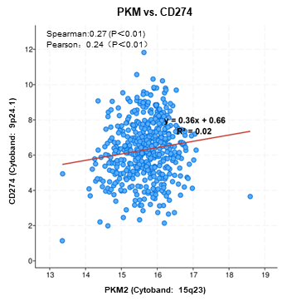
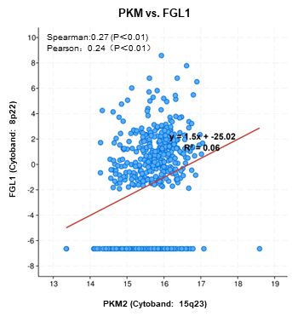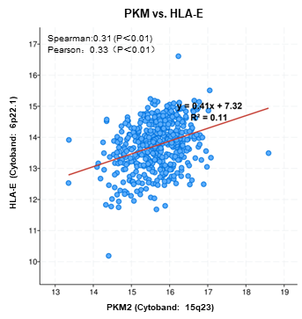
Supplementary Fig. 5. IRS of galectin-9 and LDH in HNSCC patients (n=70) and normal controls (n=18) was analyzed. The correlation between galectin-9 expression and pathological grade, TNM stage, gender and age were analyzed in HNSCC patients.

