Supplementary material

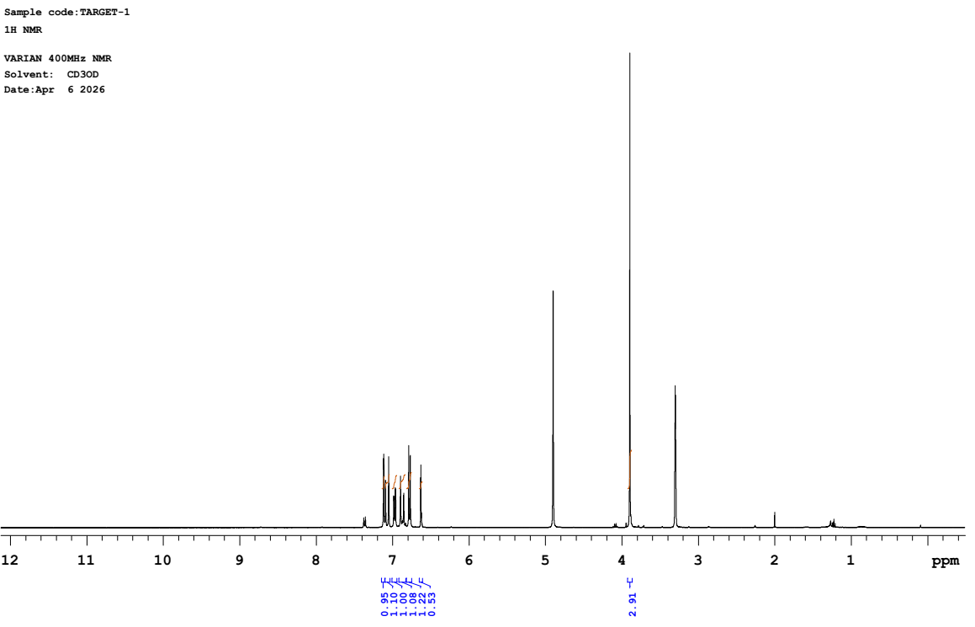

Figure S1. ¹H NMR spectrum of novel curcumin–isoniazid bis-hydrazone conjugate, confirming the proton environment and structural features of the compound

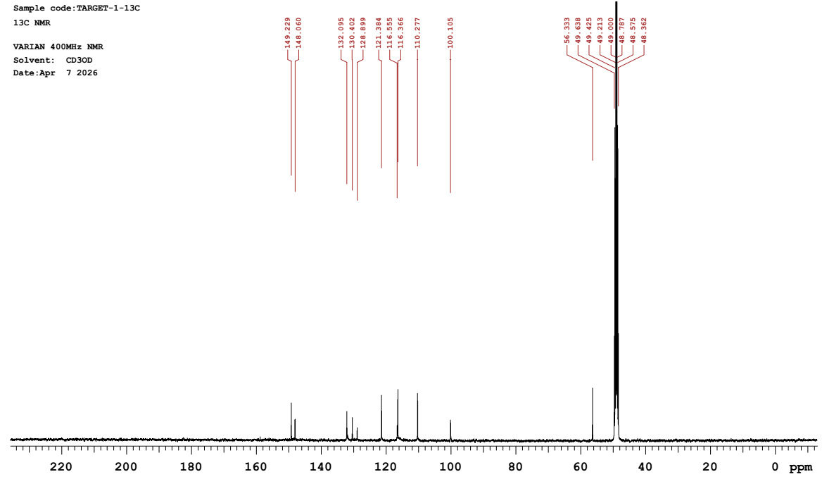

Figure S2. ¹³C NMR spectrum of novel curcumin–isoniazid bis-hydrazone conjugate, confirming the carbon environment and structural features of the compound.

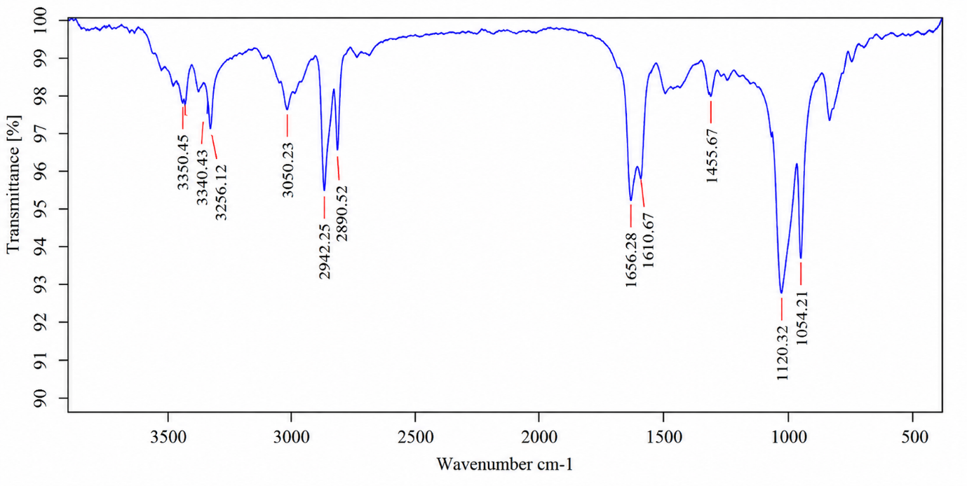

Figure S3. Fourier-transform infrared (FTIR) spectrum of novel curcumin–isoniazid bis-hydrazone conjugate,, showing the characteristic absorption bands corresponding to the functional groups present in the compound.

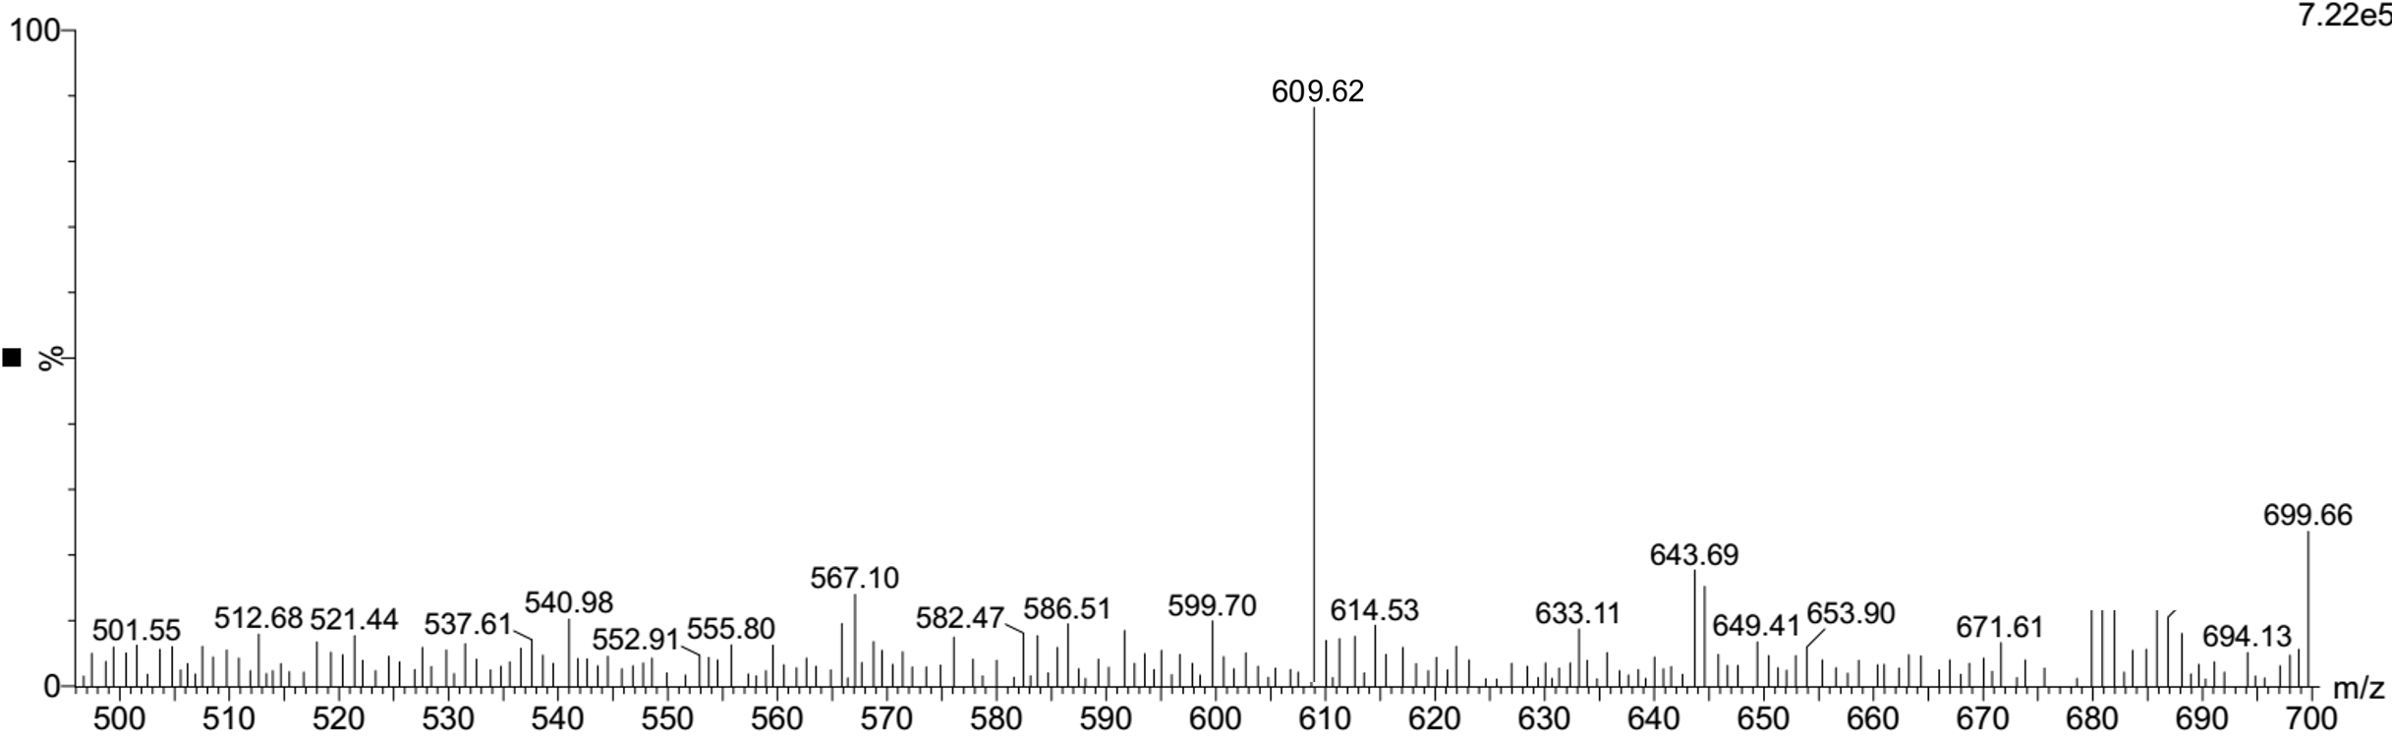

Figure S4. Mass spectrum of novel curcumin–isoniazid bis-hydrazone conjugate, showing the molecular ion peak corresponding to the molecular mass of the compound

Figure S5. Concentration-dependent inhibition of HIV-1 reverse transcriptase by novel curcumin–isoniazid bis-hydrazone conjugate

